Project 6 : Automated Cost Optimizer
Instance is in Running state before testing
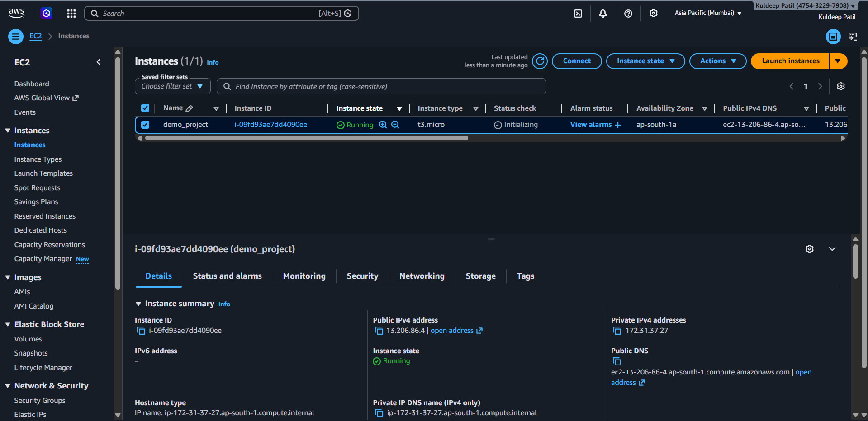

Lambda function tested successfully
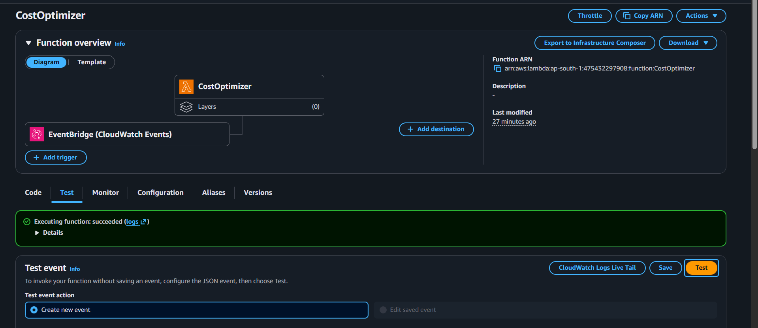

CloudWatch Log Events
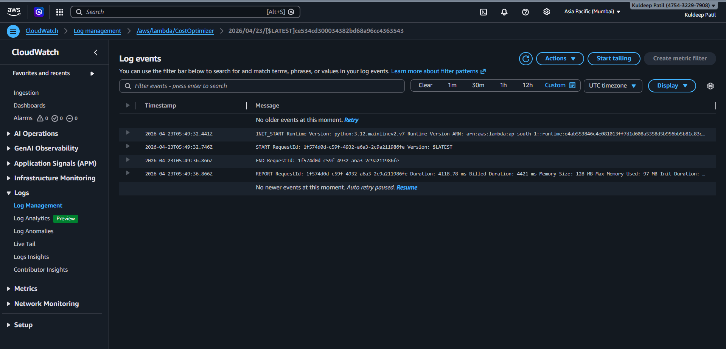

Instance is in Stopped state after testing the function
