Load Balancer Page
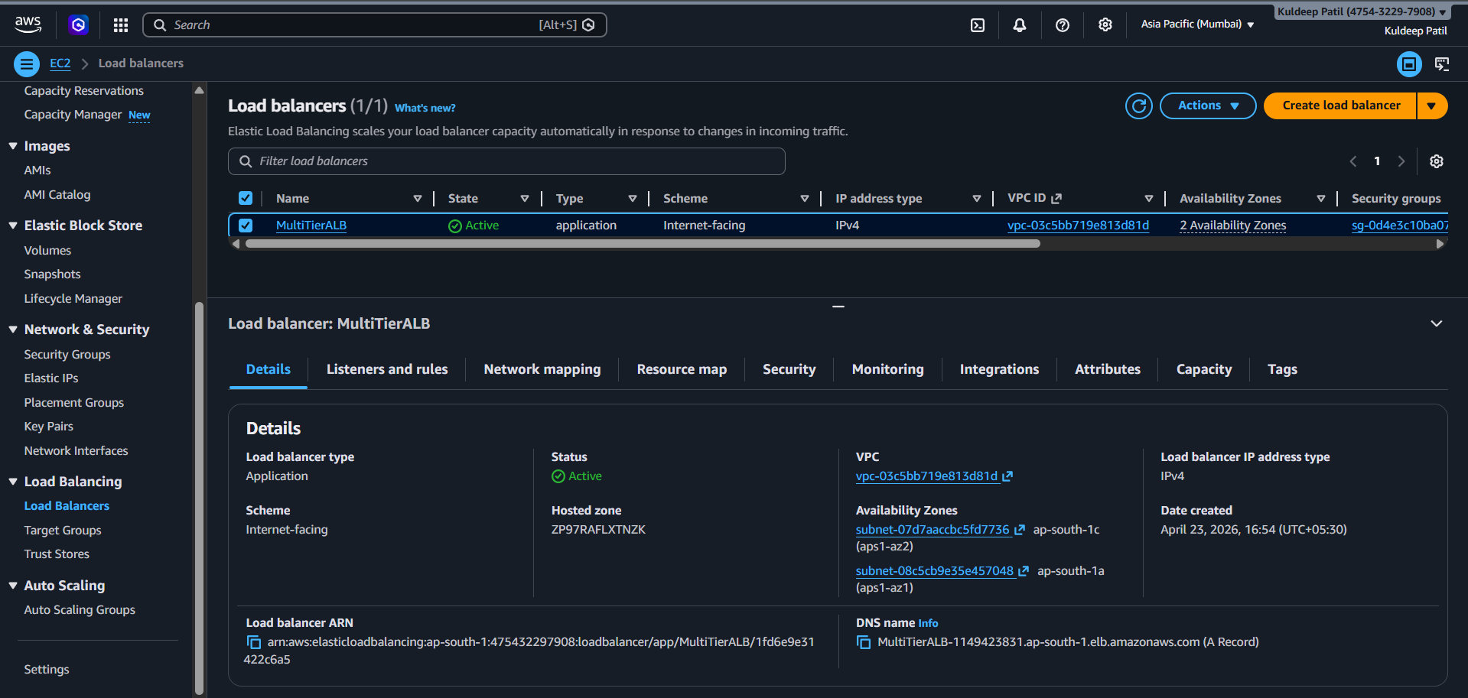
Listener Page
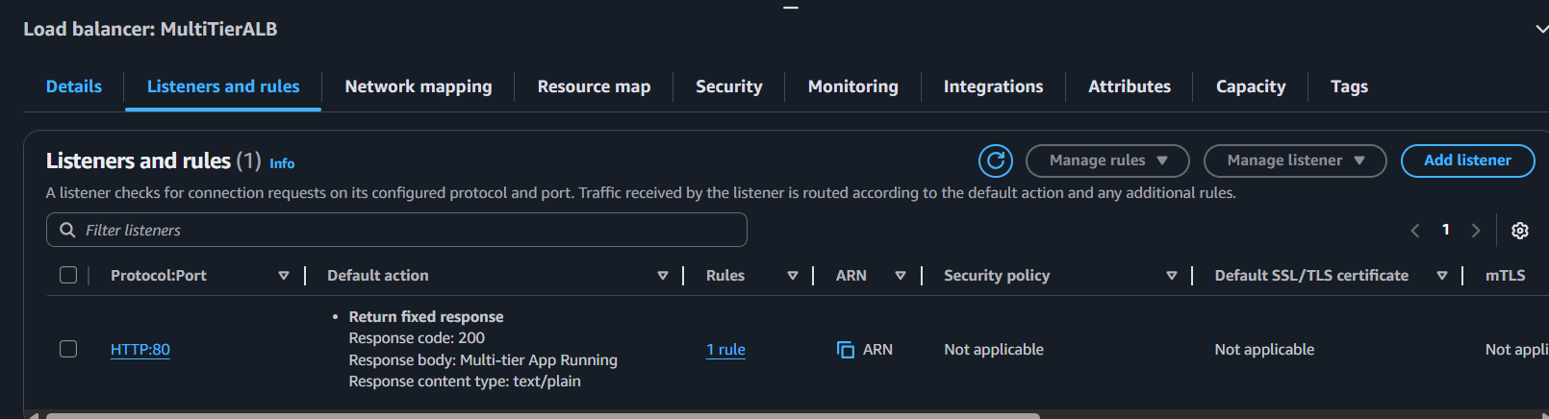
EC2 Instances Page
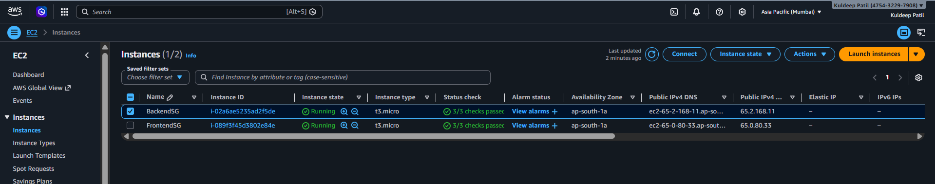
RDS Database Page
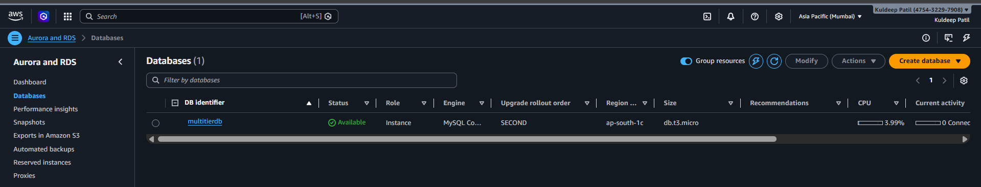

Security Groups Page
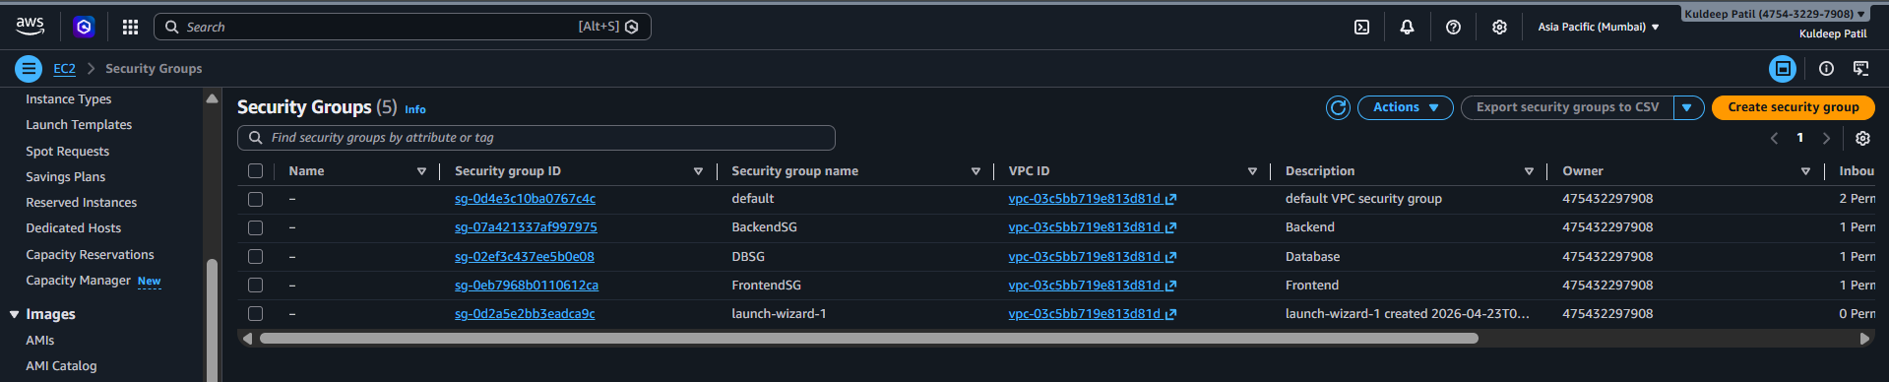

Project Output Page
