GUJARAT TECHNOLOGICAL UNIVERSITY
AHMEDABAD
Affiliated to



SAL College of Engineering

A Report on

Real Time Temperature Monitoring and Cloud Storage System using IoT

Under the Subject of

Design Engineering II A (3150001)
B. E. III, Semester-VI

Information Technology

Submitted By:

Sr. No | Enrollment No | Student Name
1 | 231130116107 | Suthar Manojkumar Dineshkumar
2 | 231130116081 | Prajapati Dhruvil Sanjaykumar
3 | 231130116091 | Kuldeep Mohansinh Rathod
4 | 231130116117 | Vrushal Rakeshkumar Rathod
5 | 241133116017 | Jaydev Yogeshkumar Nagar

Prof. Khamar Jui Ashvinbhai
Internal Guide

Prof. Jadeja Vijaysinh Kishorsinh
Head of the Department

Academic Year
(2026-27)

GUJARAT TECHNOLOGICAL UNIVERSITY
AHMEDABAD
Affiliated to

SAL College of Engineering

CERTIFICATE

This is to certify that the project report on Real Time Temperature Monitoring and Cloud Storage System using IoT
Submitted by:

Sr. No | Enrollment No | Name
1 | 231130116107 | Suthar Manojkumar Dineshkumar
2 | 231130116081 | Prajapati Dhruvil Sanjaykumar
3 | 231130116091 | Kuldeep Mohansinh Rathod
4 | 231130116117 | Vrushal Rakeshkumar Rathod
5 | 241133116017 | Jaydev Yogeshkumar Nagar

As fulfillment of the requirement for the award B.E. in Information & Communication Technology Department Semester 6th at SAL College of Engineering is the record of work that has been successfully and satisfactorily completed under supervision and guidance during the academic year 2026-27..

Prof. Khamar Jui Ashvinbhai  Internal Guide  CE/IT Department | Prof. Jadeja Vijaysinh Kishorsinh  Head of the Department  ICT Department

ABSTRACT
Real-Time Temperature Monitoring and Cloud Storage System using IoT

The project “Real-Time Temperature Monitoring and Cloud Storage System using IoT with AI/ML Prediction” focuses on developing an intelligent and scalable solution for monitoring environmental conditions. The system uses an ESP32 microcontroller integrated with a DHT22 temperature and humidity sensor to continuously collect real-time data. This data is transmitted to cloud platforms such as ThingSpeak or Firebase via the ESP32’s built-in Wi-Fi module, enabling remote access, visualization, and long-term storage. Users can monitor live temperature and humidity values through a web or mobile dashboard, where the data is presented in graphical form for better analysis. The system also includes threshold-based alert mechanisms to notify users when environmental conditions exceed safe limits, ensuring timely action in sensitive environments such as laboratories, warehouses, and data centers. To enhance the system’s intelligence, machine learning algorithms are incorporated to analyze historical data and predict future temperature trends. This predictive capability helps in early detection of anomalies and supports proactive decision-making, reducing risks and improving operational efficiency. Overall, the project demonstrates a cost-effective, reliable, and smart IoT-based monitoring system that integrates real-time sensing, cloud computing, and AI/ML-driven predictive analytics for advanced environmental management.

LIST OF FIGURES
Figure No | Figure Description | Page No
2.1 | AEIOU Canvas | 5
2.2 | Empathy Canvas | 7
2.3 | Mind Mapping | 10
3.1 | Ideation Canvas | 11
4.1 | Product Development Canvas | 14
5.1 | Learning Needs Matrix | 18

TABLE OF CONTENT
Chapter No | Chapter Title | Page No
Chapter 1 | Introduction | 1
 | 1.1 Design Thinking | 1
 | 1.2 Importance of design thinking | 1
 | 1.3 Learning tools and assignments | 1
 | 1.4 The idea to make a project | 2
Chapter 2 | Empathy Mapping | 3
 | 2.1 Why this domain | 3
 | 2.2 Observation | 3
 | 2.3 AEIOU Canvas | 3
 | 2.4 Empathy Canvas | 7
 | 2.5 Mind mapping | 10
 | 2.6 Conclusion of empathy mapping | 10
Chapter 3 | Ideation Canvas | 11
 | 3.1 Ideation Canvas (Image) | 11
 | 3.2 Ideation Canvas (people) | 11
 | 3.3 Ideation Canvas (Activity) | 12
 | 3.4 Ideation Canvas (Situation & location) | 12
 | 3.5 Ideation Canvas (Props) | 12
Chapter 4 | Product Development Canvas | 14
 | 4.1 Final Problem statement | 15
 | 4.2 PDC (purpose) | 15
 | 4.3 PDC (people) | 15
 | 4.4 PDC (Product Experience) | 16
 | 4.5 PDC (Product Functions) | 16
 | 4.6 PDC (Product Features) | 16
 | 4.7 PDC (Components) | 16
 | 4.8 PDC (Customer Revalidation) | 17
 | 4.9 PDC (Reject, Redesign, Retain) | 17
 | 4.10 PDC (Explanation) | 17
 | 4.11 PDC (Feedback) | 17
 | 4.12 PDC (Revalidation) | 17
Chapter 5 | Learning Need Matrix | 18
 | 5.1 Theory / Methods | 19
 | 5.2 Applicable Standard Principles | 19
 | 5.3 Software/ Tools /Skills | 19
 | 5.4 Components /Strength | 20
Chapter 6 | Prototype | 21
 | 6.1 Algorithm/Flowchart | 21
 | 6.2 Model/Prototyping | 22
Chapter 7 | Enhancements | 23
 | 7.1 Future Enhancements | 23
Chapter 8 | Conclusion | 24
 | 8.1 Conclusion | 24
Chapter 9 | References | 25
 | 9.1 Reference | 25
 | Appendix - I Prior Art Search | 26
 | Appendix - II Rough Proofs | 27

Chapter 1
Introduction
  - Design Thinking

Design thinking plays a crucial role in developing innovative and effective solutions to real-world problems. It is a structured and formal approach that emphasizes creativity, ideation, and problem-solving. The process begins by identifying a specific problem and understanding it deeply, followed by generating alternative ideas to solve it. Through brainstorming and iterative design, better and more practical solutions can be developed. Design thinking not only addresses present challenges but also anticipates future needs, making it a powerful methodology for creating improved and sustainable outcomes.

  - Importance of Design Thinking

Design Thinking is essential for creating user-centered and innovative solutions. It focuses on understanding the needs, experiences, and expectations of end users, ensuring that the final system is both practical and efficient. This approach encourages creativity, rapid prototyping, and continuous testing to refine solutions. It helps bridge the gap between technological capabilities and user requirements, resulting in systems that are reliable, easy to use, and effective. In the context of IoT and AI/ML-based systems, design thinking ensures that both real-time monitoring and predictive features are aligned with user needs.

  - Learning Tools and Assignments

Throughout the course, various learning tools and assignments were provided to enhance understanding of design thinking principles and IoT system development. These activities focused on improving problem-solving ability, creativity, and teamwork skills. Although the project titled “Real-Time Temperature Monitoring and Cloud Storage System using IoT with AI/ML Prediction” was not directly part of the assignments, the concepts learned—such as user research, idea generation, prototyping, and system design—were highly beneficial. These tools helped in effectively applying theoretical knowledge to develop a practical, intelligent system with real-time monitoring and predictive capabilities.

  - The Idea to Make a Project

The idea for this project originated from the need to apply theoretical knowledge to solve real-world problems using modern technologies. By observing challenges in temperature monitoring across domestic and industrial environments, the concept of an automated and intelligent system was developed. Through brainstorming, research, and analysis, the idea evolved into a solution that integrates IoT with AI/ML for both real-time monitoring and future prediction. The goal was to design a system that is cost-effective, scalable, and capable of improving efficiency while reducing manual effort. This project reflects the practical application of innovation, combining sensing, cloud computing, and predictive analytics to create meaningful impact.

Chapter 2
Empathy Mapping
2.1 Why this domain:
The Internet of Things (IoT) domain was chosen because it represents one of the most rapidly growing and impactful technologies in today's world. IoT connects physical devices to the internet, allowing real-time data collection, monitoring, and control. This domain offers endless possibilities for innovation in fields such as smart homes, healthcare, agriculture, and environmental monitoring. It combines hardware, software, and networking knowledge, making it ideal for learning practical implementation of modern technologies. Choosing this domain helps in understanding how intelligent systems can improve efficiency, accuracy, and decision-making in real-world applications.
2.2 Observation:
During the development of the project, it was observed that temperature changes in the environment can occur frequently due to various factors such as weather conditions, device heat, or room ventilation. The DHT22 sensor accurately detected these temperature and humidity variations and sent the data to the ESP32 microcontroller, which successfully uploaded it to the cloud platform. The cloud dashboard displayed the readings in real time, making it easy to monitor and analyze temperature trends. It was also observed that stable internet connectivity is essential for continuous data transmission, and even a small delay can affect real-time updates. Overall, the system worked efficiently in providing accurate and real-time temperature monitoring with smooth data storage.
2.3 AEIOU Canvas:
2.3.1 Activity:
The main activity of this project is to continuously monitor the surrounding temperature and humidity levels in real time. The DHT22 sensor senses the environmental conditions and sends the data to the ESP32 microcontroller, which processes the readings and uploads them to a cloud platform using its built-in Wi-Fi module. The collected data is then displayed on a dashboard or web interface, allowing users to observe changes in temperature and humidity anytime and from anywhere. Additionally, the system can generate alerts or notifications if the temperature exceeds a specific threshold, ensuring that users can take timely action to maintain ideal conditions.
2.3.2 Environment:
The system operates in environments where monitoring temperature and humidity is essential for maintaining product quality or safety. This includes industrial areas, laboratories, warehouses, data centers, greenhouses, and home environments. A stable Wi-Fi connection is required for smooth data transmission between the ESP32 and the cloud. The environment should also be suitable for sensor placement to ensure accurate readings away from direct heat sources, sunlight, or moisture. Since the system is designed to work continuously, it must be installed in a safe, ventilated, and electrically stable environment.
2.3.3 Interaction:
The interaction in this system happens between multiple components and users. The DHT22 sensor collects real-time temperature and humidity data and sends it to the ESP32 microcontroller. The ESP32 processes the data and transmits it to the cloud server through Wi-Fi. Once the data reaches the cloud, it is stored and visualized in an understandable format such as graphs or tables. Users interact with the system through a web or mobile dashboard, where they can view real-time readings, analyze past data, and get alerts for abnormal changes. This interaction makes the system more dynamic and user-friendly.
2.3.4 Object:
The main objects used in this project are the ESP32 microcontroller, DHT22 sensor, cloud platform, and dashboard interface.
• The DHT22 sensor is responsible for sensing temperature and humidity.
• The ESP32 acts as the brain of the system; it collects sensor data, processes it, and sends it to the cloud using Wi-Fi.
• The cloud platform serves as the storage and visualization area where data is uploaded and displayed.
• The dashboard (web or mobile interface) allows users to monitor and analyze the readings easily.
• Together, these objects form a complete IoT-based system capable of real-time monitoring, data storage, and analysis.
2.3.5 Users:
The system is designed for a wide range of users who need accurate and continuous monitoring of environmental conditions. These include laboratory technicians, warehouse managers, industrial supervisors, researchers, farmers, and even home users who want to maintain ideal room conditions. The system is user-friendly, easy to install, and does not require advanced technical knowledge. Users can access temperature and humidity data remotely from any internet-connected device, making it highly convenient and practical for day-to-day use.

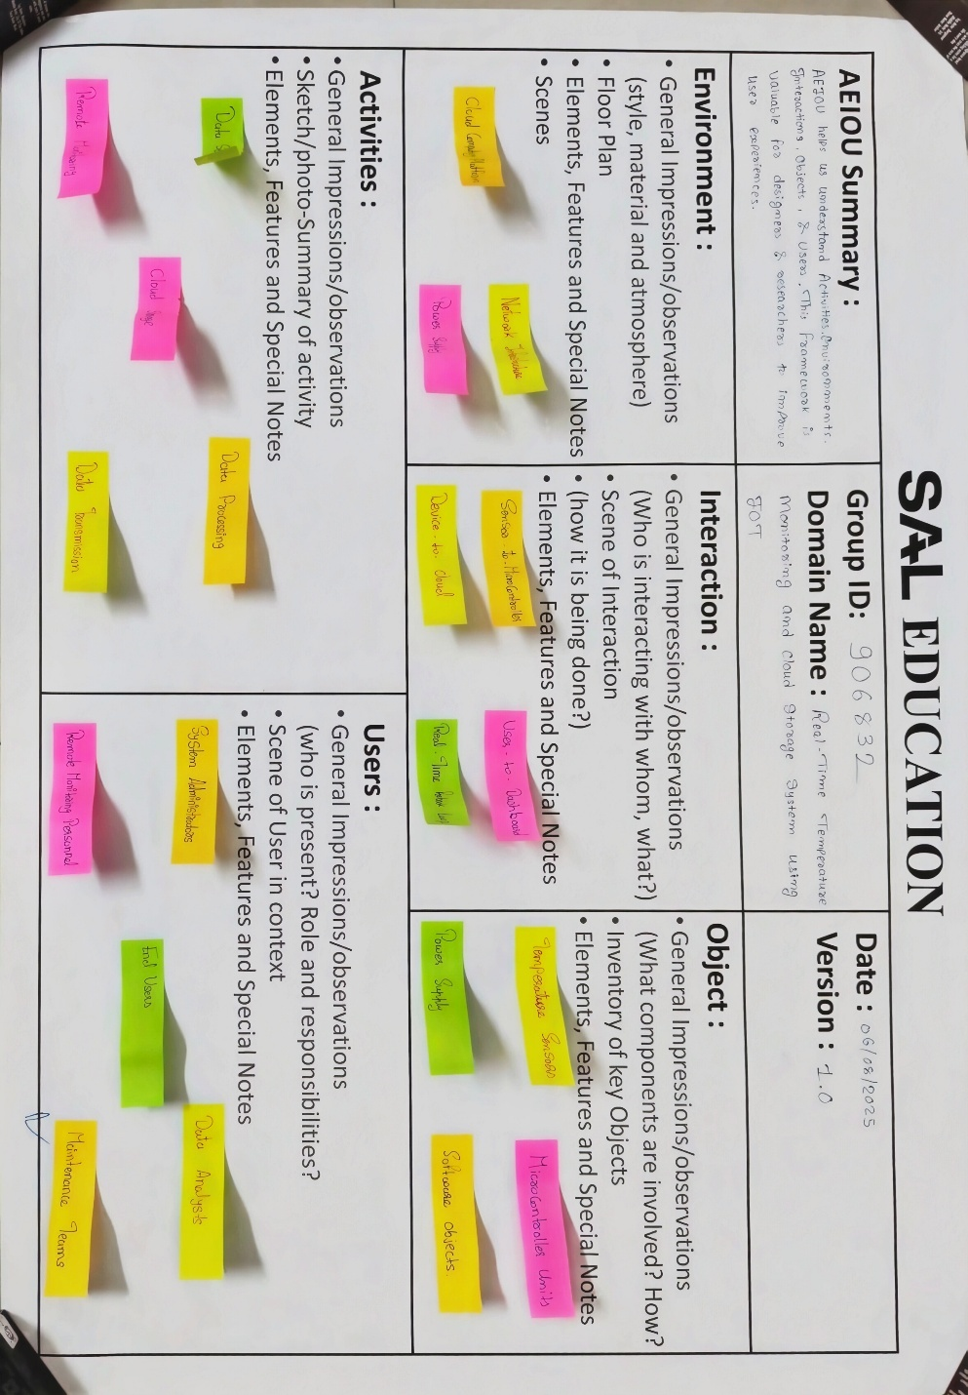
Figure 2.1 AEIOU Canvas
2.4 Empathy Canvas:
2.4.1 Users:
• Homeowners (monitoring room temperature)
• Farmers (greenhouse/crop protection)
• Industrial managers (factories, cold storage)
• IT administrators (maintaining cloud/dashboard)
• Data center operators (server room monitoring)
2.4.2 Stakeholders:
• Cloud service providers (Firebase, AWS, Thingspeak)
• End-users (who directly monitor temperature)
• Educational institutions (for learning projects)
• Government (smart city and safety policies)
• Investors/funders supporting IoT solutions

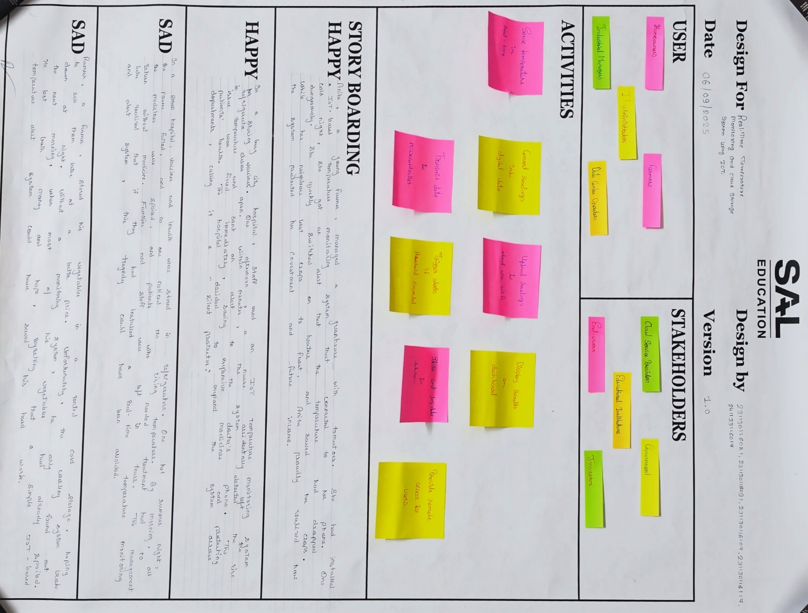
Figure 2.2 Empathy Canvas
2.5 Mind Mapping:
Mind mapping was used to explore and organize ideas related to the Real Time Temperature Monitoring and Cloud Storage System using IoT. The central topic was the project itself, with branches covering key areas such as hardware components (ESP32, DHT22), cloud platforms (Firebase, ThingSpeak), software tools (Arduino IDE), user types, applications, and future enhancements. This visual representation helped identify relationships between components, plan the project structure, and ensure all aspects were covered before development began.
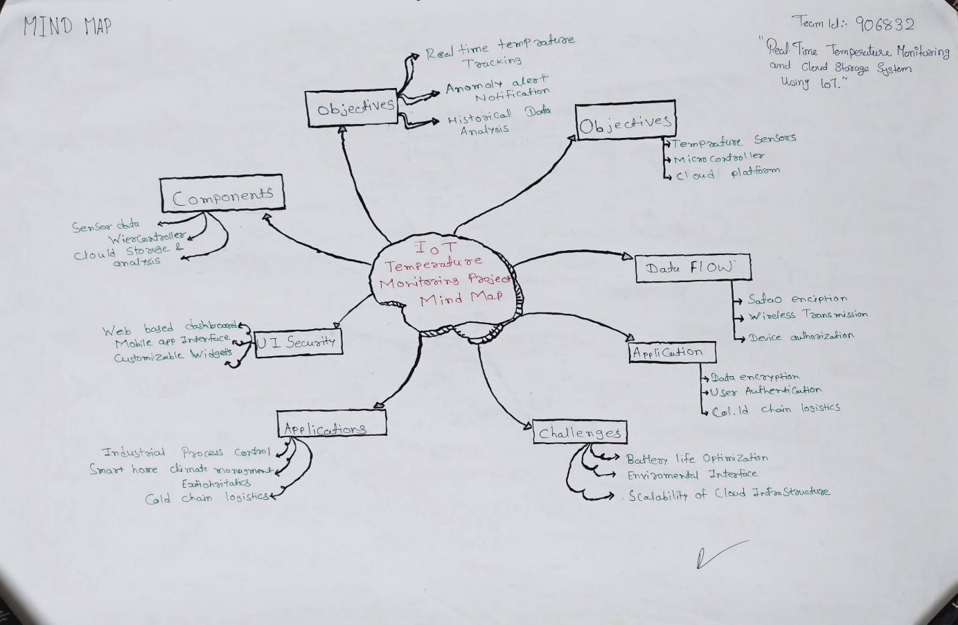
2.6 Conclusion of Empathy Mapping:
The empathy mapping exercise provided valuable insights into the real-world needs and challenges faced by users who require continuous environmental monitoring. It highlighted that various user groups such as farmers, lab technicians, warehouse managers, and homeowners have a common need for accurate, real-time temperature and humidity data accessible from anywhere. The mapping helped identify pain points like manual monitoring, delayed alerts, and lack of data history. As a result, the project was designed to address these needs with a low-cost, automated IoT-based solution that offers remote access, cloud storage, and timely notifications.

Chapter 3
Ideation Canvas
3.1 Ideation Canvas (Image):
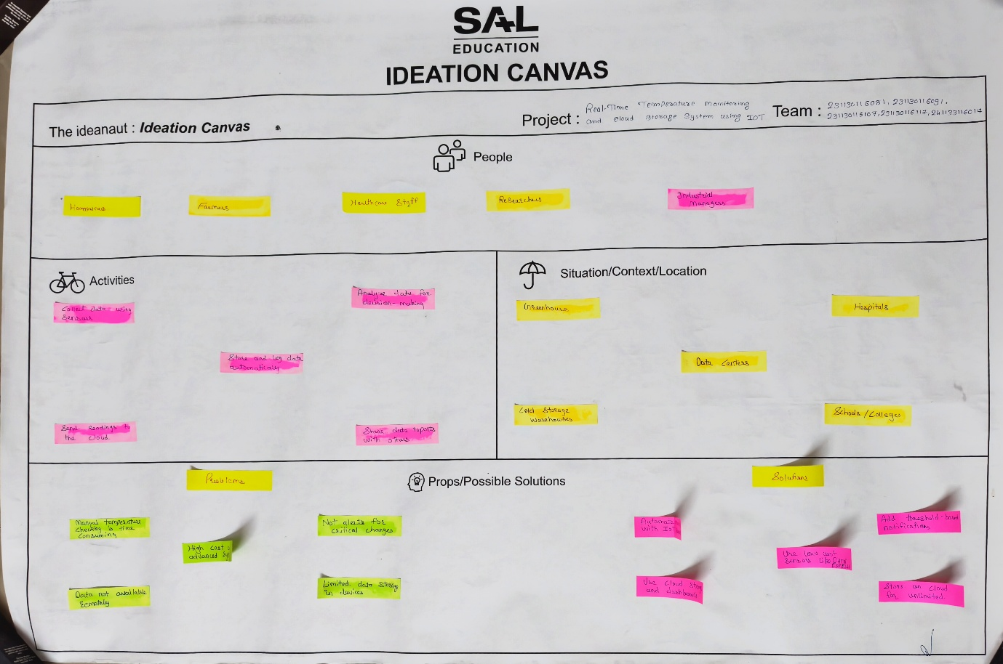

Figure 3.1 Ideation Canvas
3.2 Ideation Canvas (People):
• Farmers needing crop and greenhouse climate control
• Lab technicians requiring precise environment conditions
• Warehouse managers monitoring storage areas
• Home users wanting smart room monitoring
• Data center administrators managing server temperatures
3.3 Ideation Canvas (Activity):
• Continuous real-time temperature and humidity sensing
• Cloud data upload via Wi-Fi
• Dashboard visualization of readings
• Alert/notification generation for threshold breaches
• Historical data analysis and trend monitoring
3.4 Ideation Canvas (Situation & Location):
• Industrial factories with high-temperature environments
• Cold storage units and warehouses
• Agricultural greenhouses
• Medical and research laboratories
• Residential homes and offices
3.5 Ideation Canvas (Props):
• ESP32 microcontroller with built-in Wi-Fi
• DHT22 temperature and humidity sensor
• Cloud platforms: ThingSpeak, Firebase, Google Sheets
• Arduino IDE for programming
• Power supply (USB/adapter)
• Jumper wires and breadboard for prototyping

Team ID: 950911
Chapter 4
Product Development Canvas
4.1 Final Problem Statement:
There is no affordable, automated, and remotely accessible system to continuously monitor temperature and humidity in environments like labs, warehouses, greenhouses, and data centers. Manual monitoring is unreliable, delayed, and error-prone, leading to potential losses. The project aims to develop a real-time IoT-based temperature and humidity monitoring system using ESP32 and DHT22 with cloud data storage and remote access.
4.2 PDC (Purpose):
• To monitor real-time temperature and humidity remotely.
• To automate data collection and eliminate manual monitoring.
• To provide timely alerts for abnormal temperature changes.
• To enable cloud-based data storage for analysis and records.
4.3 PDC (People):
• Farmers needing crop protection through climate monitoring.
• Industrial managers monitoring factory environments.
• Lab technicians ensuring stable experimental conditions.
• Home users interested in smart environmental monitoring.
4.4 PDC (Product Experience):
• Easy real-time monitoring through a web/mobile dashboard.
• Instant alerts on temperature threshold breaches.
• Seamless cloud storage with access from any device.
• Simple setup with minimal technical knowledge required.
4.5 PDC (Product Functions):
• Continuous sensing of temperature and humidity.
• Data transmission to cloud via ESP32 Wi-Fi.
• Visual display on dashboard (graphs/tables).
• Threshold-based alert system.
4.6 PDC (Product Features):
• Real-time temperature monitoring.
• Cloud storage integration.
• Low power consumption.
• Compact hardware design.
• User-friendly interface.
4.7 PDC (Components):
• Temperature Sensor (DHT22).
• ESP32 microcontroller.
• Inbuilt Wi-Fi module.
• Power supply (battery/adapter).
• Jumper wires.
4.8 PDC (Customer Revalidation):
• Verified real-time monitoring.
• Checked data availability on cloud.
• Tested threshold-based alerts.
• Positive feedback from students.
• Useful in labs and projects.
• Easy to use for non-technical people.
4.9 PDC (Reject, Redesign, Retain):
Reject:
• Complex IoT platforms (too costly).
• Expensive cloud services.
• Complicated installation steps.
Redesign:
• Include battery backup.
• Improve mobile app interface.
• Optimize sensor accuracy.

Retain:
• Low-cost solution.
• Wireless communication.
• Simple design.
4.10 PDC (Explanation):
The Product Development Canvas for this project outlines the complete structure from problem identification to solution design. Starting with the final problem statement, the canvas covers the purpose, target people, expected product experience, core functions, key features, hardware components, and customer revalidation. The Reject-Redesign-Retain section reflects improvements made based on user feedback, ensuring the system remains practical, cost-effective, and user-friendly.
4.11 PDC (Feedback):
During the customer revalidation phase, users appreciated the real-time monitoring capability and the ease of accessing data remotely. They suggested adding SMS-based alert notifications and an improved mobile interface for better usability. Some users also requested a longer data retention period on the cloud for historical trend analysis.
4.12 PDC (Revalidation):
Based on feedback received, the system was revalidated with improvements including optimized threshold alert settings and better cloud dashboard visualization. The use of Firebase was reconsidered for longer data storage. The hardware setup was also simplified further to improve installation ease for non-technical users.

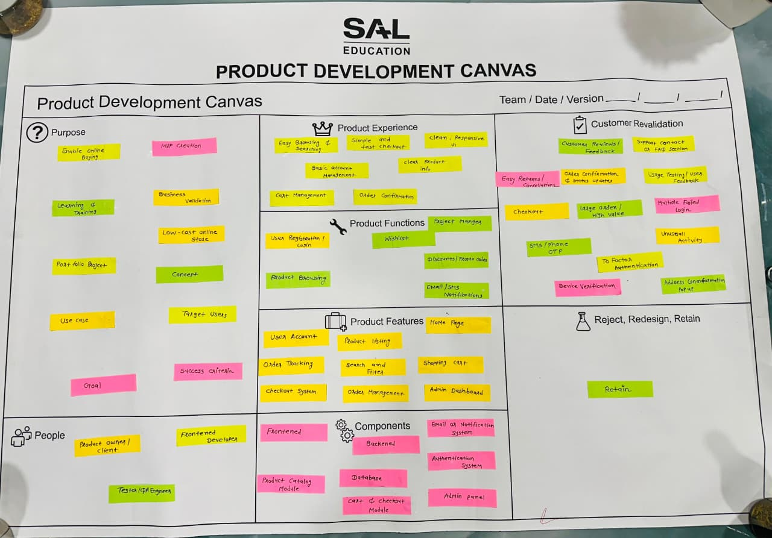

Figure 4.1 Product Development Canvas

Team ID: 950911
Chapter 5
Learning Need Matrix
5.1 Theory / Methods:
• IoT fundamentals and architecture.
• Embedded systems and microcontroller programming.
• Cloud computing concepts and platforms.
• Sensor interfacing and analog-to-digital conversion (ADC).
• Data communication protocols (MQTT, HTTP).
5.2 Applicable Standard Principles:
• IEEE IoT Communication Standards.
• Standard power supply specifications (5V for sensors).
• Sensor calibration and signal processing principles.
• IoT protocol design and cloud upload speed vs. network strength.
5.3 Software / Tools / Skills:
• Arduino IDE for microcontroller programming.
• NodeMCU firmware and cloud dashboards.
• Proteus/Tinkercad for circuit design simulation.
• ThingSpeak/Firebase simulation for cloud integration.
• Basic IoT programming and dashboard creation skills.
5.4 Components / Strength:
• ESP32 (dual-core processor with Bluetooth + Wi-Fi support).
• Firebase (real-time cloud database with fast sync).
• DHT22 sensor (high accuracy: ±0.5°C and ±2-5% RH).
• Response time testing to validate cloud data latency.
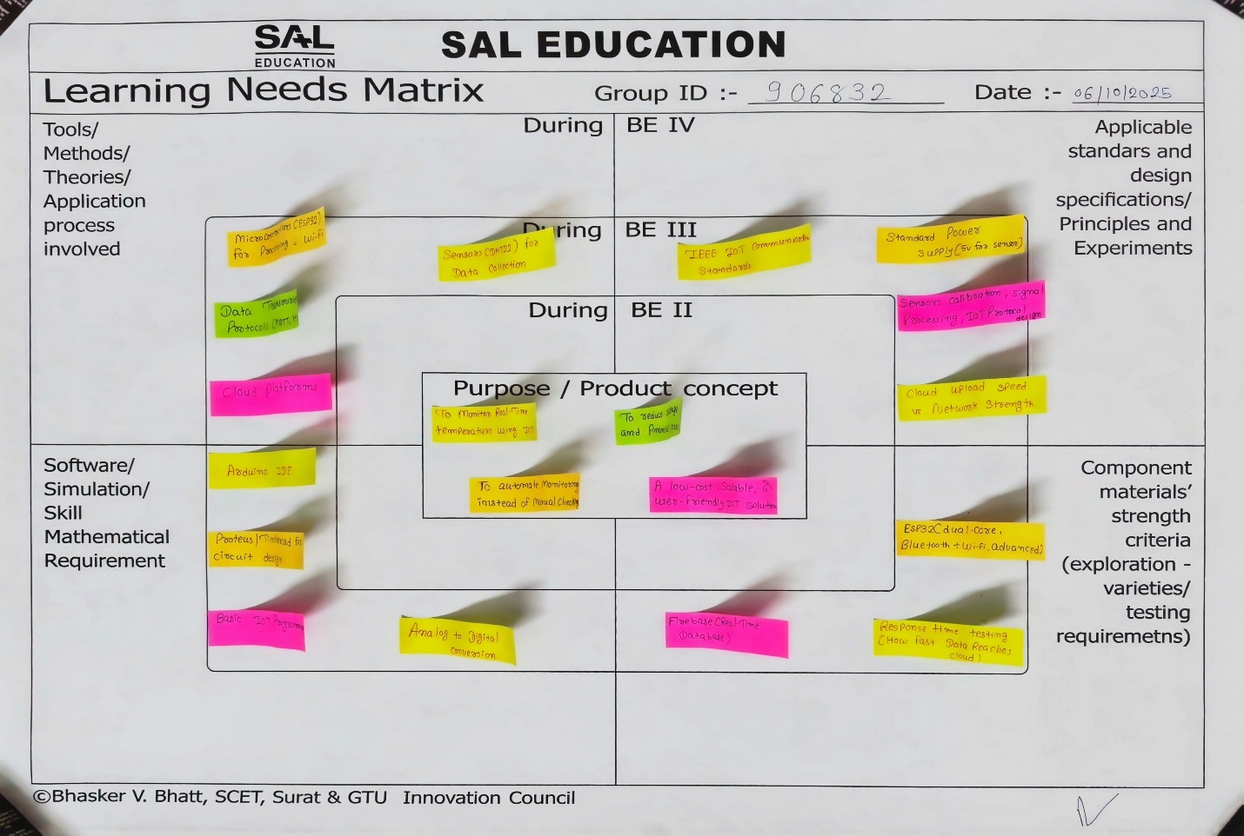
Figure 5.1 Learning Needs Matrix

Team ID: 950911
Chapter 6
Prototype
6.1 Algorithm / Flowchart:
The following flowchart illustrates the complete algorithm of the Real Time Temperature Monitoring and Cloud Storage System using IoT. The system initializes the ESP32 and DHT22 sensor, connects to Wi-Fi, and then enters a continuous loop of reading sensor data, checking thresholds, and uploading data to the cloud dashboard.

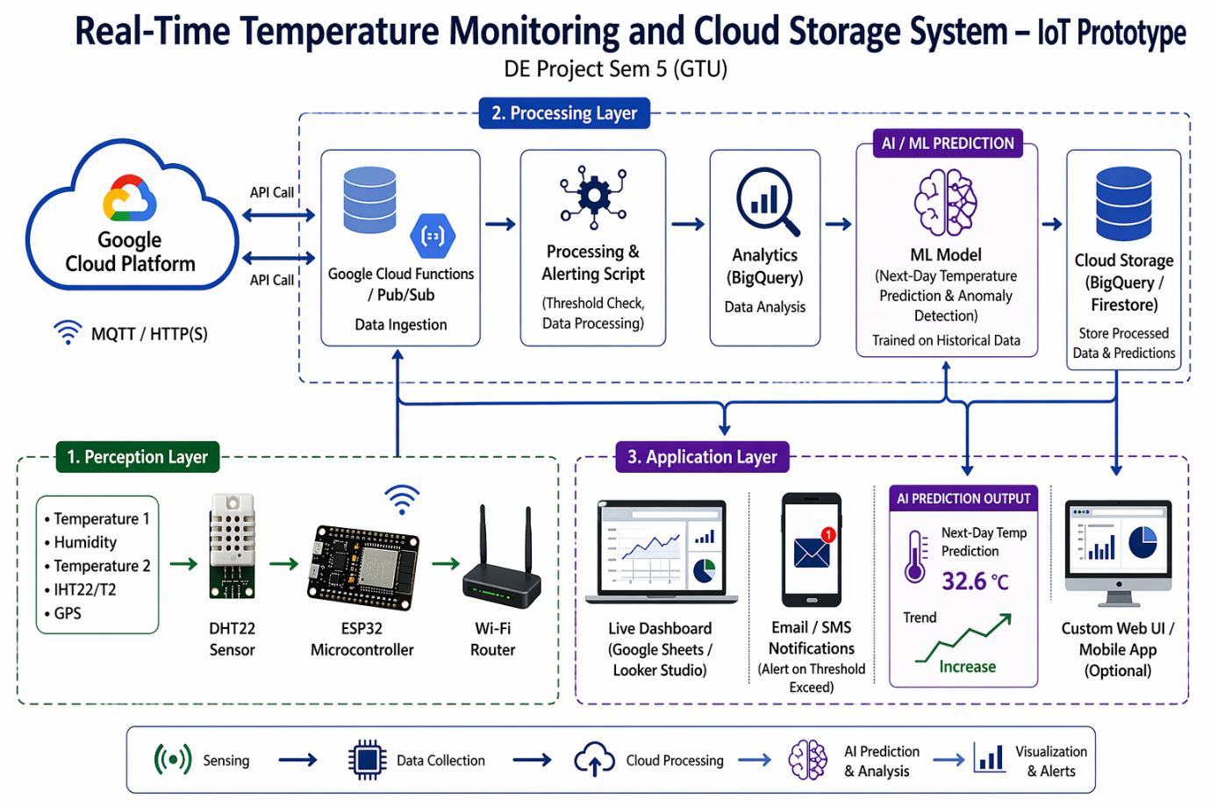
Figure 6.1 Algorithm/Flowchart
6.2 Model / Prototype:
The prototype of the Real Time Temperature Monitoring System was physically built using an ESP32 microcontroller and a DHT22 sensor. The hardware was assembled on a breadboard using jumper wires and powered via USB. The ESP32 was programmed using Arduino IDE to read temperature and humidity data from the DHT22 sensor and upload it to a cloud platform (ThingSpeak/Firebase) via Wi-Fi. The following screenshots show the working prototype and cloud dashboard.

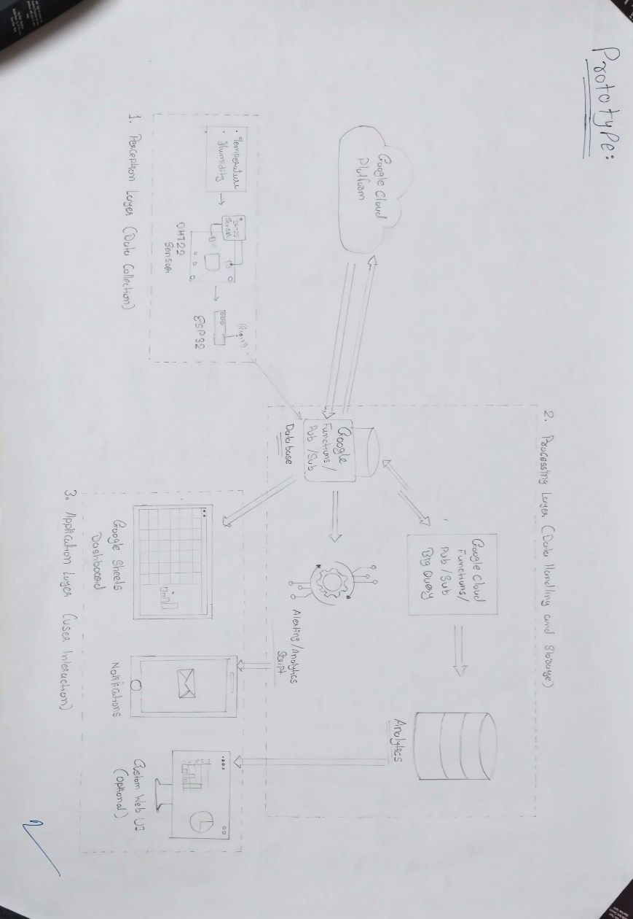
Figure 6.2 Model/Prototype
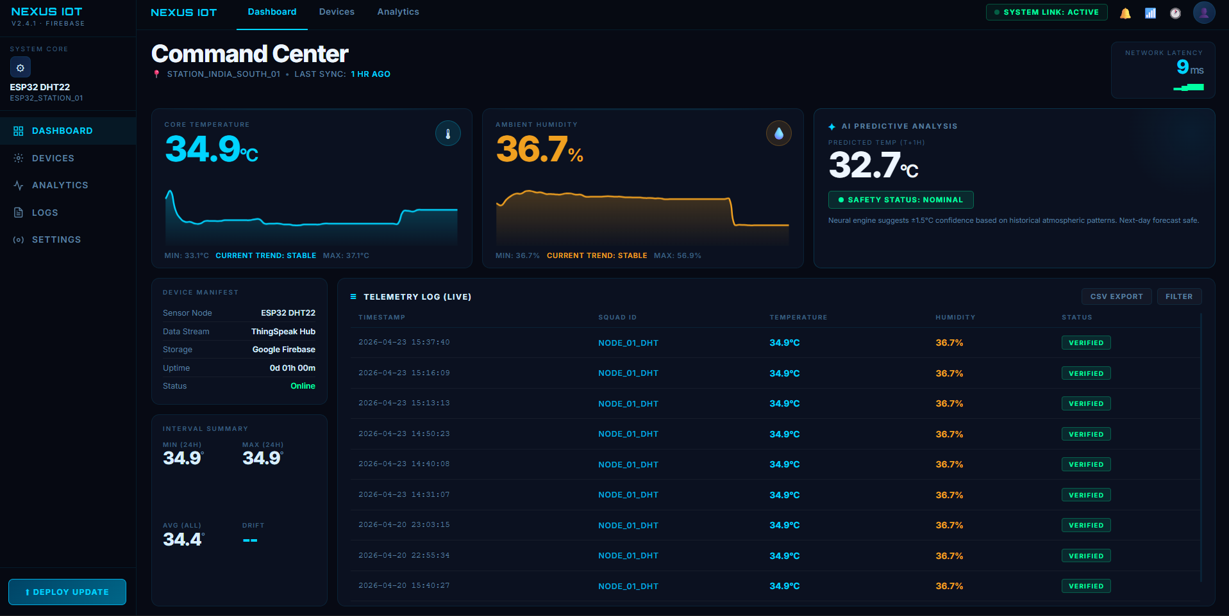

Team ID:
Chapter 7
Enhancements
7.1 Future Enhancements:
In the future, this project can be enhanced to make it more efficient and advanced. One of the main improvements could be adding multiple DHT22 sensors at different locations so that temperature and humidity can be monitored from various points in a large area like a warehouse or industry. A mobile application can also be developed to allow users to receive real-time notifications or alerts directly on their smartphones whenever the temperature goes beyond a safe limit.
The system can be upgraded to include data analysis features on the cloud, which will help users study temperature trends over time. Integration of AI or predictive algorithms could automatically detect unusual patterns and suggest preventive actions. Additionally, using solar power or battery backup can make the system more energy-efficient and useful in remote areas where electricity is not stable. In the long run, this project can evolve into a complete smart environmental monitoring system that combines temperature, humidity, and other environmental parameters for better decision-making.

Team ID: 25135
Chapter 8
Conclusion
8.1 Conclusion:
This project successfully implements a real-time temperature and humidity monitoring system using an ESP32 and DHT22, with data stored on the cloud. It enables remote access to readings, timely alerts, and automated logging, all of which reduce manual effort and improve reliability. The system shows how combining IoT, sensors, and cloud services can provide a practical and useful solution in environments where temperature control is critical.

Team ID: 25135
Chapter 9
References
9.1 References:
• Random Nerd Tutorials — "ESP32 with DHT11/DHT22 Temperature and Humidity Sensor using Arduino IDE" — https://randomnerdtutorials.com
• AI tools like ChatGPT, Gemini
• Instructables — "IoT-based Indoor Environment Monitoring With ESP32 and DHT22" — https://www.instructables.com
• ThingSpeak (IoT analytics & data visualization platform) — https://thingspeak.mathworks.com
• Esp32io — "ESP32 – DHT22 Tutorial" — https://esp32io.com/tutorials/esp32-dht22
• Research article: "A Prototype IoT Temperature And Humidity Monitoring ESP32 Based"

Team ID: 25135
Appendix - I
Prior Art Search

1. ESP32 Datalogging to Google Sheets (tutorial) — Random Nerd Tutorials.
Summary: Step-by-step guide to securely log ESP32 sensor data into Google Sheets using a Google Service Account / Sheets API.
Relevance: Demonstrates reliable, production-oriented methods for sending ESP32 data to Google Sheets for robustness.

2. ESP32: Getting Started with Firebase (Realtime Database) — Random Nerd Tutorials.
Summary: Tutorial showing how to create a Firebase project and push/read realtime data with an ESP32 (includes timestamping and example code).
Relevance: Shows a cloud storage alternative (Firebase) that is scalable and realtime, useful if you choose Firebase instead of or alongside Google Sheets.

3. Complete ESP32 IoT Temperature and Humidity Monitor (project) — Instructables.
Summary: Maker project that reads DHT sensors with ESP32, logs data to the web/Google Sheets, and implements threshold alerts and simple control (fan/heater).
Relevance: Closest DIY project-level prior art: proves feasibility of DHT ESP32 cloud Sheets with alerting and control.

Team ID: 25135
Appendix - II
Rough Proofs

1. Sensor Data Testing:
• The DHT22 sensor was connected to the ESP32 and tested on the Arduino IDE serial monitor.
• Verified that real-time temperature and humidity values were displayed correctly.

2. Wi-Fi Connectivity Check:
• ESP32 successfully connected to local Wi-Fi using SSID and password.
• Serial monitor confirmed "Wi-Fi connected" and IP address assigned.

3. Cloud Data Upload Test:
• Data sent from ESP32 to Google Sheets via Google Apps Script URL.
• Each reading (Temperature, Humidity, Timestamp) appeared correctly in the sheet.

4. Continuous Monitoring Validation:
• Sensor readings updated every 60 seconds.
• Observed consistent logging without missing entries.

5. Accuracy Check:
• DHT22 readings compared with a digital thermometer — variation within ±0.5°C and ±2% humidity, confirming accuracy.

