**Computer Network**

**Practicals**

Name - Kuldeep Saini

College Roll no – 20201415

University roll no – 20020570017

Course – BSc computer science (Hons)

SUBMITTED TO – Mr. Nikhil Rajput

**Set 1**

1. **Simulate Cyclic Redundancy Check (CRC) error detection algorithm for noisy channel.**

**Output: -**

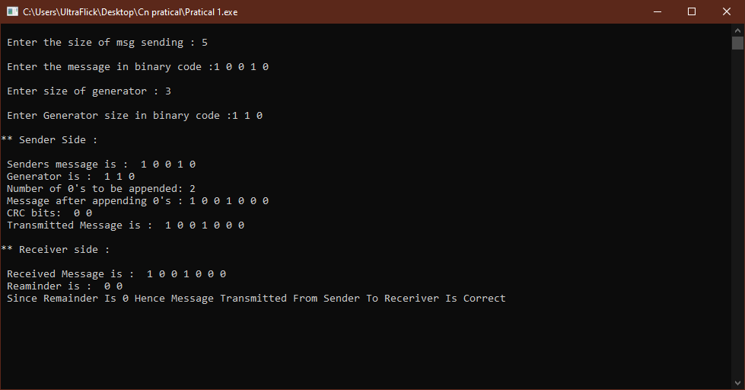

**Description: -**

CRC or Cyclic Redundancy Check is a method of detecting accidental changes/errors in the communication channel.   
CRC uses Generator Polynomial which is available on both sender and receiver side. An example generator polynomial is of the form like x3 + x + 1. This generator polynomial represents key 1011. Another example is x2 + 1 that represents key 101.

**Modulo 2 Division:**  
The process of modulo-2 binary division is the same as the familiar division process we use for decimal numbers. Just that instead of subtraction, we use XOR here.

In each step, a copy of the divisor (or data) is XORed with the k bits of the dividend (or key).

The result of the XOR operation (remainder) is (n-1) bits, which is used for the next step after 1 extra bit is pulled down to make it n bits long.

When there are no bits left to pull down, we have a result. The (n-1)-bit remainder which is appended at the sender side.

1. **Simulate and implement selective repeat sliding window protocol.**

**Output: -**

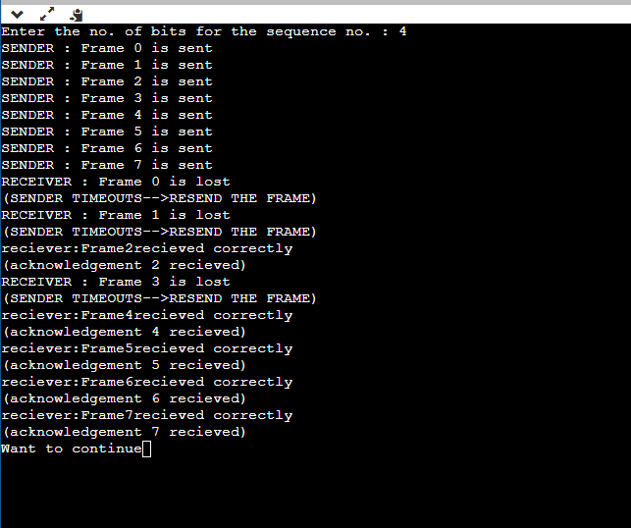

**Description: -**

Selective Repeat Protocol (SRP):

This protocol (SRP) is mostly identical to GBN protocol, except that buffers are used and the receiver, and the sender, each maintains a window of size. SRP works better when the link is very unreliable. Because in this case, retransmission tends to happen more frequently, selectively retransmitting frames is more efficient than retransmitting all of them. SRP also requires full-duplex link. Backward acknowledgments are also in progress.

Sender’s Windows (Was) = Receiver’s Windows (Wr).

Window size should be less than or equal to half the sequence number in SR protocol. This is to avoid packets being recognized incorrectly. If the size of the window is greater than half the sequence number space, then if an ACK is lost, the sender may send new packets that the receiver believes are retransmissions.

Sender can transmit new packets as long as their number is with W of all un-ACKed packets.

Sender retransmit un-ACKed packets after a timeout – Or upon a NAK if NAK is employed.

Receiver ACKs all correct packets.

Receiver stores correct packets until they can be delivered in order to the higher layer.

In Selective Repeat ARQ, the size of the sender and receiver window must be at most one-half of 2^m.

Efficiency of Selective Repeat Protocol (SRP) is same as GO-Back-N’s efficiency:

Efficiency = N/ (1+2a)

Where a = Propagation delay / Transmission delay

Buffers = N + N

Sequence number = N (sender side) + N (Receiver Side)