**Database Assignment**

**Query – 1**

**Write a query to fetch the number of employees working in the department ‘Admin’**

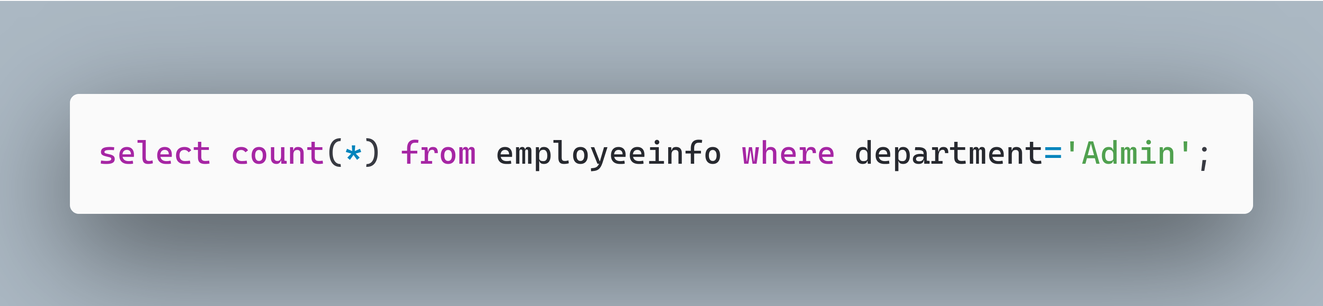

**Query – 2**

**Write a query to retrieve the first four characters of EmpLname from the EmployeeInfo table.**

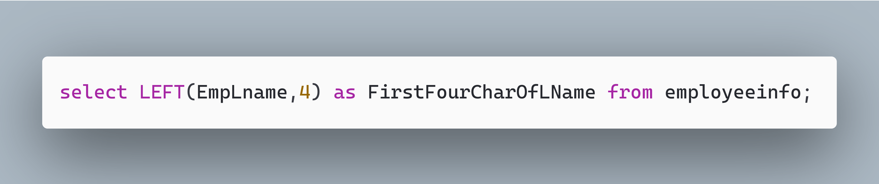

**Query – 3**

**Write a query to find all the employees whose salary is between 50000 to 100000.**

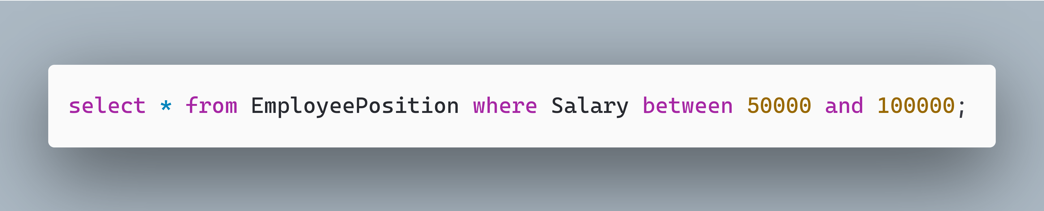

**Query – 4**

**Write a query to find the names of employees that begin with ‘S’**

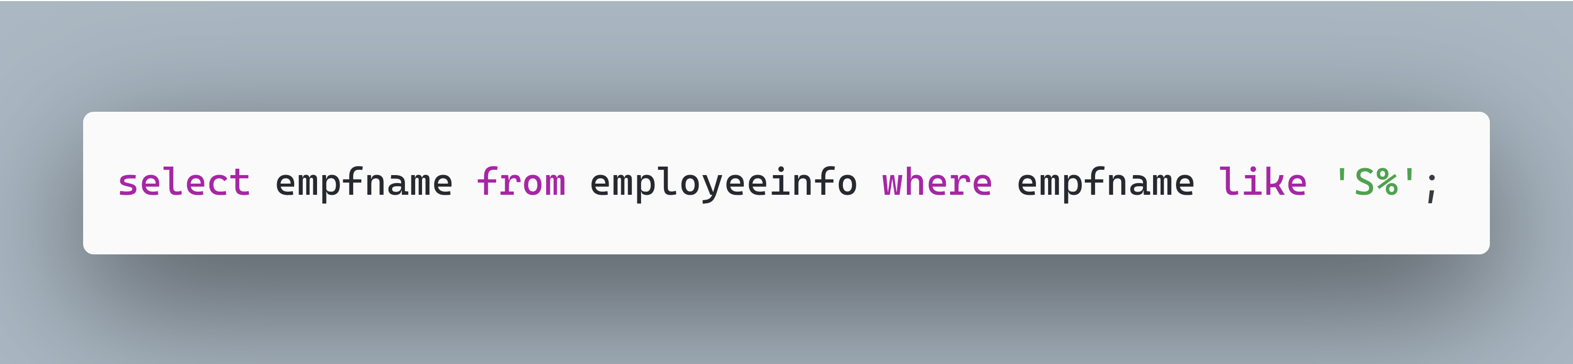

**Query – 5**

**Write a query to fetch top N records order by salary. (ex. top 5 records)**

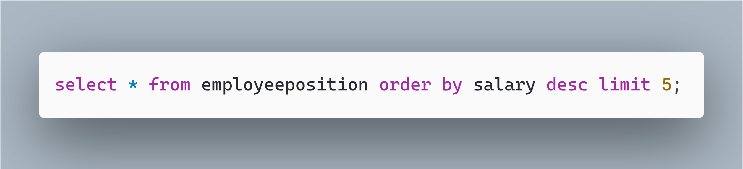

**Query – 6**

**Write a query to fetch details of all employees excluding the employees with first names, “Sanjay” and “Sonia” from the EmployeeInfo table.**

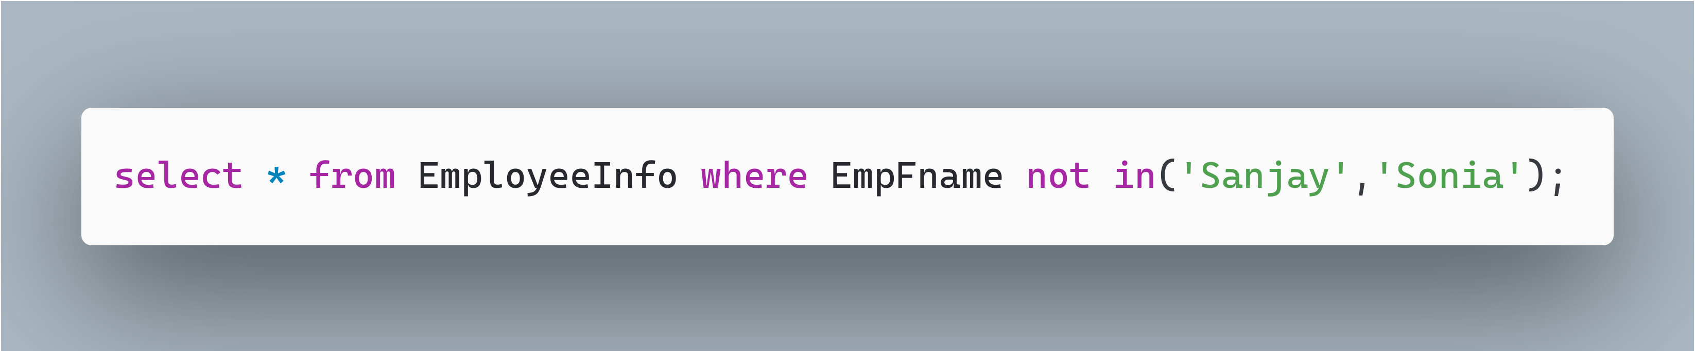

**Query – 7**

**Write a query to fetch the department-wise count of employees sorted by department’s count in ascending order.**

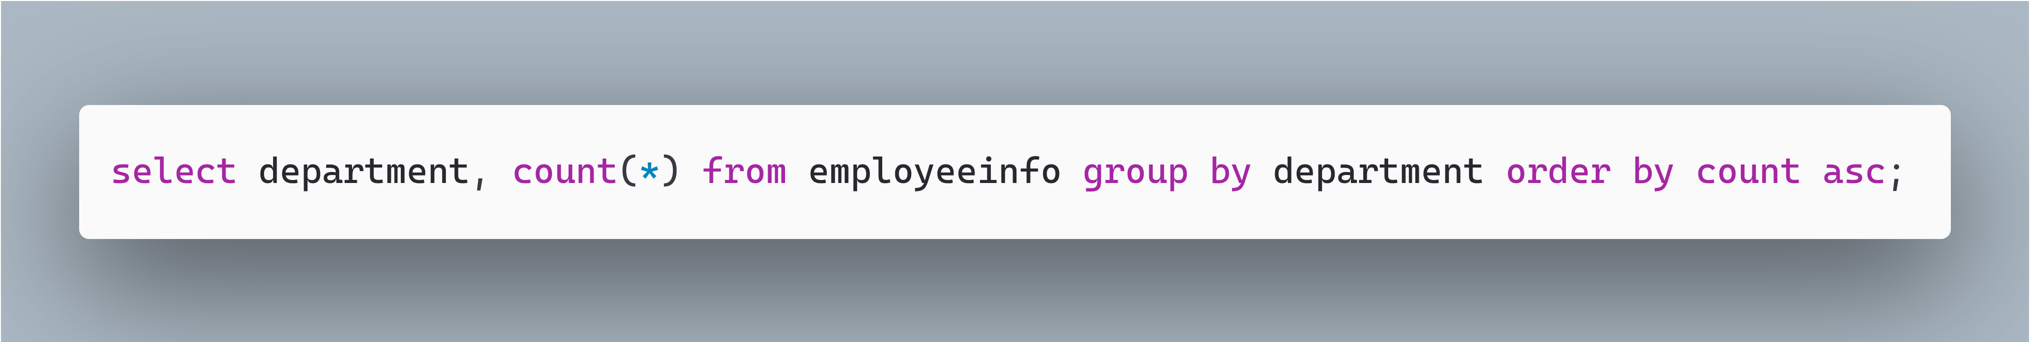

**Query – 8**

**Write a query to retrieve duplicate records from a table.**

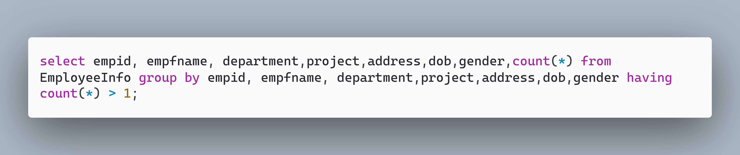

**Query – 9**

**Write a query to retrieve Departments who have less than 2 employees working in it.**

