 

INSTITUTE FOR ADVANCED COMPUTING

AND

SOFTWARE DEVELOPMENT

AKURDI, PUNE

DOCUMENTATION ON

# IDPS using Snort/Suricata and alert notification via mail

# PG-DITISS March-2023

*SUBMITTED BY:*

**GROUP NO: 26**

**SANSKAR GUPTA (233452)**

**KULDEEP PATEL (233416)**

# 

# MR. KARTIK AWARI MR. ROHIT PURANIK

PROJECT GUIDE CENTRE COORDINATOR

# 

**INDEX**

|  |  |  |
| --- | --- | --- |
| **CHAPTER NO.** | **TITLE** | **PAGE NO.** |
| **1** | **Introduction** | **3** |
| **2** | **Problem Statement** | **4** |
| **3** | **Proposed Solution** | **5** |
| **4** | **Technology used** | **6** |
| **5** | **Information about IDPS tools** | **7** |
| **6** | **Advantages of IDPS tools with example** | **8** |
| **7** | **Architecture of Snort and Suricata** | **9,10** |
| **8** | **Alert system process** | **11** |
| **9** | **Implementation Screenshots** | **12-22** |
| **10** | **Future Enhancement** | **23** |
| **11** | **Conclusion** | **24** |
| **12** | **References** | **25** |

1. **Introduction:**

**Intrusion detection and prevention systems (IDS/IPS)** are security tools that monitor network traffic for malicious activity. IDS systems detect intrusions, while IPS systems can also prevent them.

**Snort and Suricata** are two popular open-source IDS/IPS systems. They are both capable of detecting a wide range of threats, including network scanning, port scanning, and denial-of-service attacks.

**Alert notification** is an important feature of IDS/IPS systems. It allows you to be notified of potential threats so that you can take action to mitigate them. Email is a common method for alert notification.

In this project, we will use Snort or Suricata to detect intrusions and send alerts via email. We will also configure the system to detect specific threats, such as network scanning or port scanning.

In this project we will demonstrate how to use Snort or Suricata to protect a network from malicious activity. It will also show how to configure alert notification to ensure that you are notified of potential threats in a timely manner.

1. **Problem Statement:**

Network security is a critical issue for businesses of all sizes. Intrusions and other malicious activities can cause significant damage, including data loss, financial losses, and reputational harm.

IDS/IPS systems are an important tool for protecting networks from malicious activity. However, they can be complex to configure and maintain. Additionally, they can generate a large number of alerts, which can make it difficult to identify and respond to real threats.

1. **Proposed Solution:**

This project will use Snort or Suricata to detect intrusions and send alerts via email. The system will be configured to detect specific threats, such as network scanning or port scanning. This will help to reduce the number of false alerts and make it easier to identify and respond to real threats.

The project will also demonstrate how to use Snort or Suricata to protect a network from malicious activity. It will also show how to configure alert notification to ensure that you are notified of potential threats in a timely manner.

Benefits:

The benefits of this project include:

* Improved network security
* Reduced number of false alerts
* Easier identification and response to real threats
* Increased visibility into network traffic
* Improved compliance with security standards

1. **Technology Used:**

**4.1 Hardware Requirement :**

• RAM: 16 GB

• HDD: 512GB

**4.2 Software Requirement :**

• Operating System: Windows 10

• Tool: VMWare Workstation Pro

1. **Information about IDPS tools:**

Snort is an open-source, free and lightweight network intrusion detection system (NIDS) software for Linux and Windows to detect emerging threats. It is one of the most popular IDS tools available. Snort can be used to detect a wide range of threats, including network scanning, port scanning, and denial-of-service attacks. It can also be used to detect more advanced threats, such as malware and zero-day attacks.

Suricata is another popular open-source IDS/IPS system. It is similar to Snort in many ways, but it offers some additional features, such as multi-threading and support for more protocols. Suricata is also more flexible than Snort, making it a good choice for advanced users.

Both Snort and Suricata are capable of detecting a wide range of threats. The choice of which tool to use depends on your specific needs and requirements. If you are looking for a lightweight and easy-to-use IDS tool, Snort is a good choice. If you need a more powerful and flexible IDS tool, Suricata is a good option.

Here are some of the key features of Snort and Suricata:

**Snort**:

Lightweight and easy to use

Wide range of detection capabilities

Active community of users and developers

Large library of rules and signatures

**Suricata**:

More powerful and flexible than Snort

Multi-threaded architecture for improved performance

Support for more protocols

Active community of users and developers

Large library of rules and signatures

1. **Advantages of IDPS tools with example:**

**Some of the advantages of IDPS tools:**

**Improved network security:** IDPS tools can help to protect networks from a variety of threats, including malware, denial-of-service attacks, and network intrusions.

**Reduced number of false alerts:** IDPS tools can be configured to filter out false alerts, which can help to reduce the workload on security teams.

**Easier identification and response to real threats:** IDPS tools can help to identify real threats more quickly, which can help to reduce the damage caused by these threats.

**Increased visibility into network traffic:** IDPS tools can provide visibility into network traffic, which can help to identify potential threats and vulnerabilities.

**Improved compliance with security standards:** IDPS tools can help organizations to comply with security standards, such as PCI DSS and HIPAA.

**Here are some specific examples of how IDPS tools have been used to improve network security:**

* In 2017, the Mirai botnet was used to launch a massive denial-of-service attack against Dyn, a major DNS provider. The attack disrupted access to a number of popular websites, including Twitter, Netflix, and PayPal. IDPS tools were used to identify and block the attack, helping to mitigate the damage.
* In 2018, the WannaCry ransomware attack infected over 200,000 computers worldwide. The attack encrypted files on infected computers and demanded a ransom payment to decrypt them. IDPS tools were used to identify and block the attack, helping to protect many organizations from being infected.
* In 2019, the NotPetya ransomware attack infected over 100,000 computers worldwide. The attack was particularly destructive, causing billions of dollars in damage. IDPS tools were used to identify and block the attack, helping to protect many organizations from being infected.

These are just a few examples of how IDPS tools can be used to improve network security. IDPS tools are an important part of a layered security approach, and they can help to protect organizations from a variety of threats.

1. **Architecture of Snort and Suricata:**

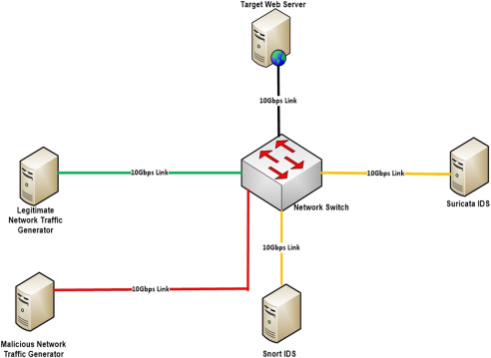

**Diagram 1**

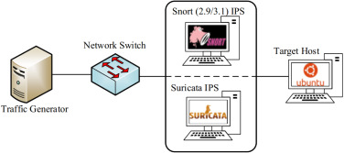

**Diagram 2**

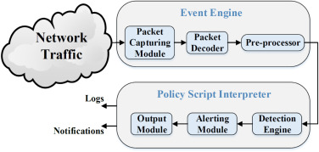

**Diagram 3**

1. **Alert system process:**

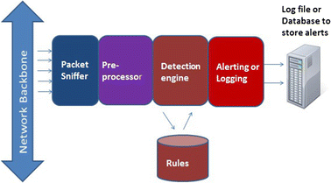

**Diagram 4**

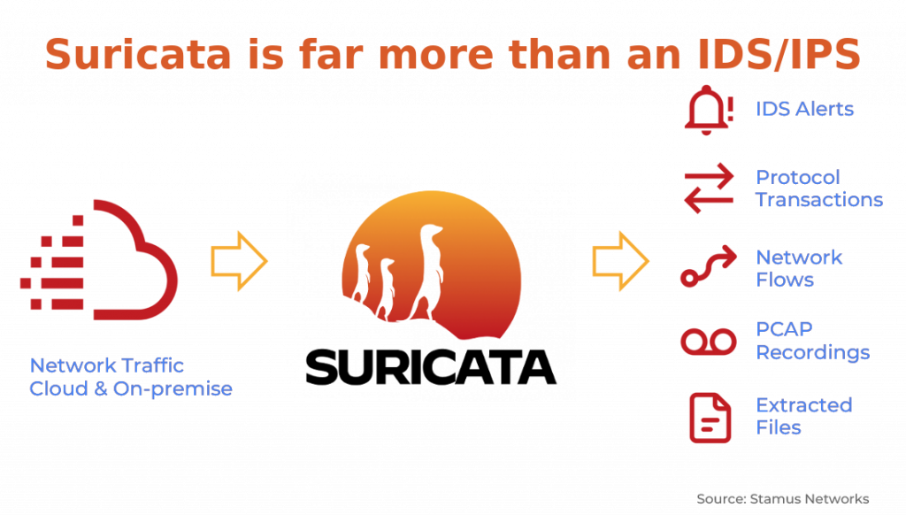

**Diagram 5**

#### 

1. **Implementation Screenshots:** 
   1. In Ubuntu system, first we have to install suricata and for installation we have to refer official documentation of suricata.
   2. After installation we have to enable suricata service and also we have to check the status of suricata.
   3. Also, there are some free sources available for suricata. We can enable those sources and install some extra and efficient libraries for suricata.
   4. Now, to configure suricata we have to set network ip address and interface of system where suricata is running.

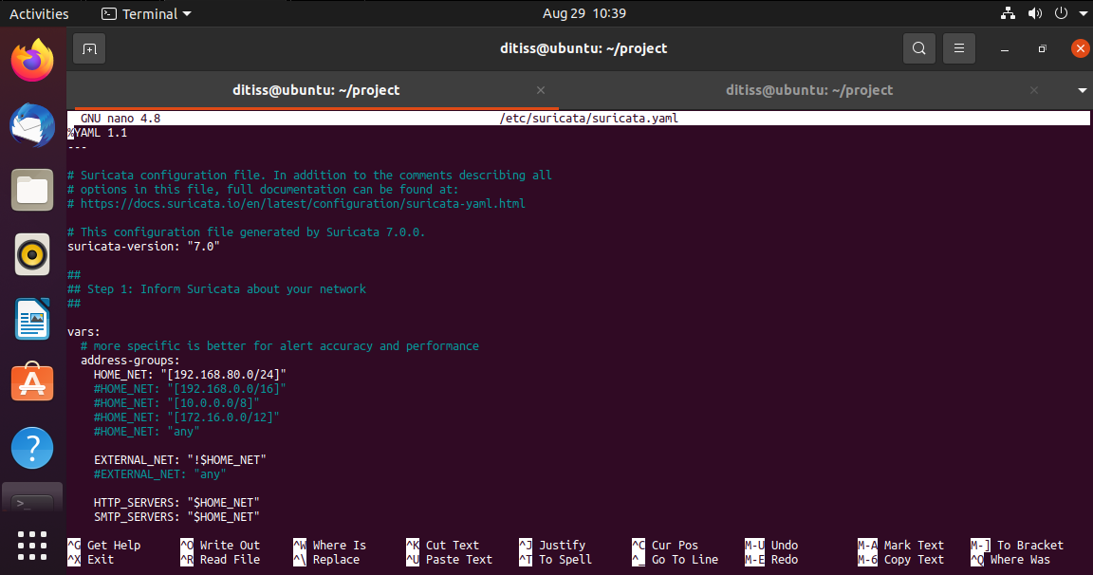

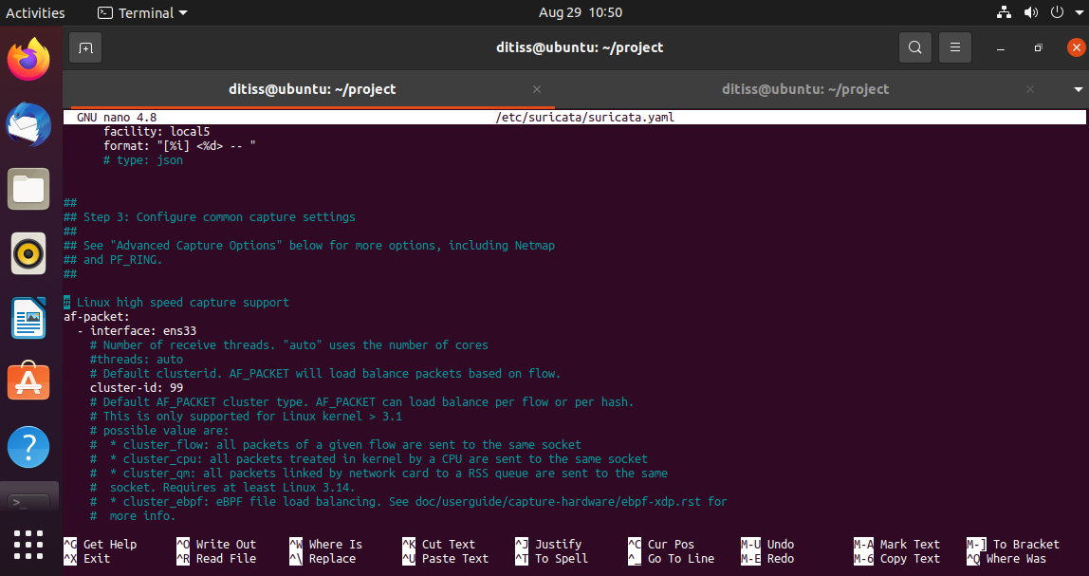

* 1. Now, we have to configure suricata rule files by adding some widely referred alert rules.

Note: We have to set rules in /etc/suricata/local.rules path.

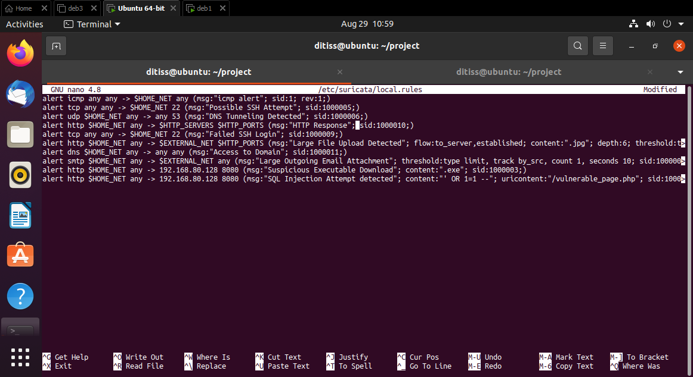

In this rule set, there are alert commands based on:

. Icmp packets

. tcp (ssh login and fail)

. udp (DNS tunneling)

. http (http server and ports)

. smtp (For email)

. dns (Access to any existing domain)

* 1. After confirming all the rules, we have to paste the rule file in the main yaml file of suricata.

Note: Yaml file is in /etc/suricata/suricata.yaml

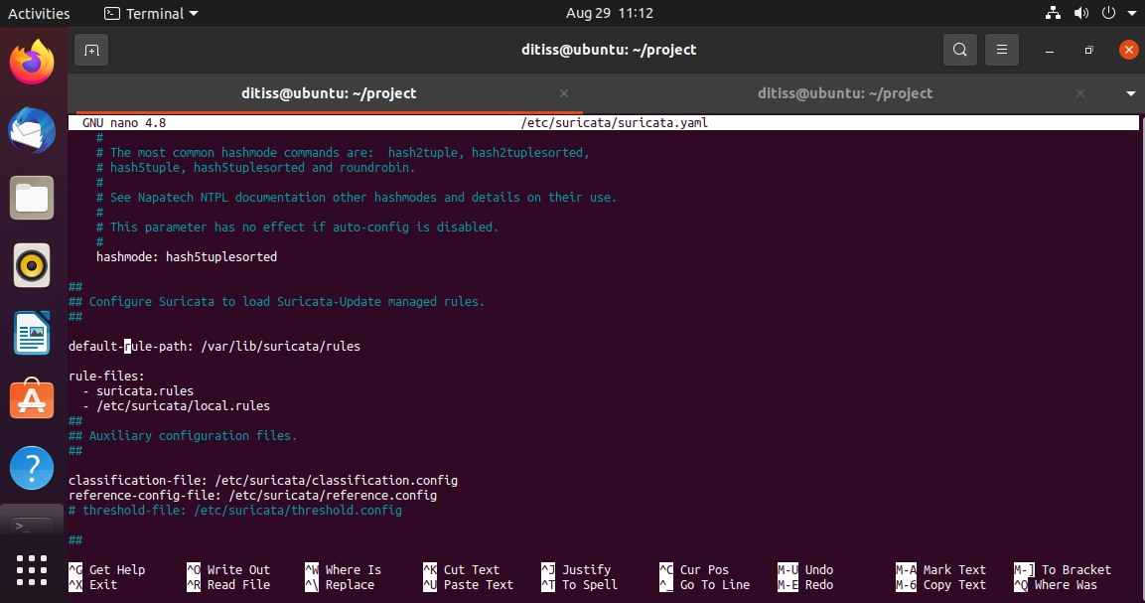

# Now, we have to test the configuration file of suricata to check whether all the rules are mentioned accurately.

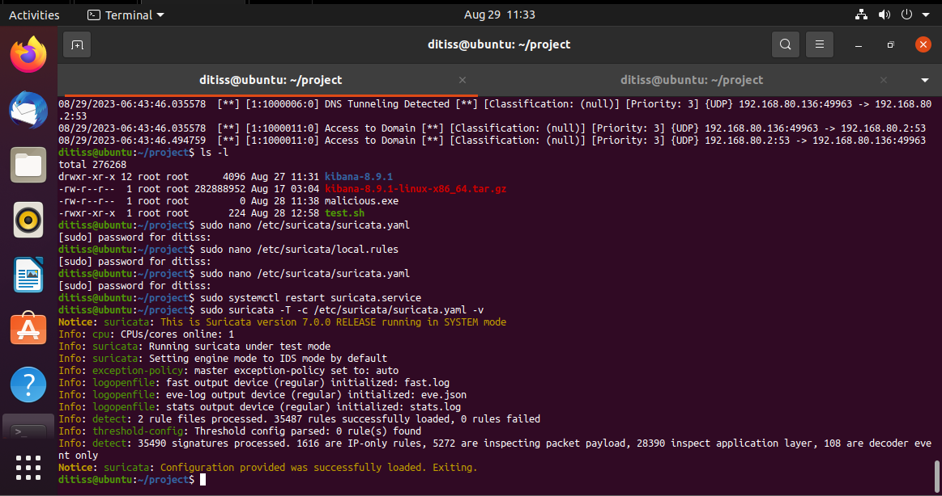

* 1. Now, to check the output or final alert logs we have to run log command.

Note: Logs are stored in /var/log/suricata/fast.log.

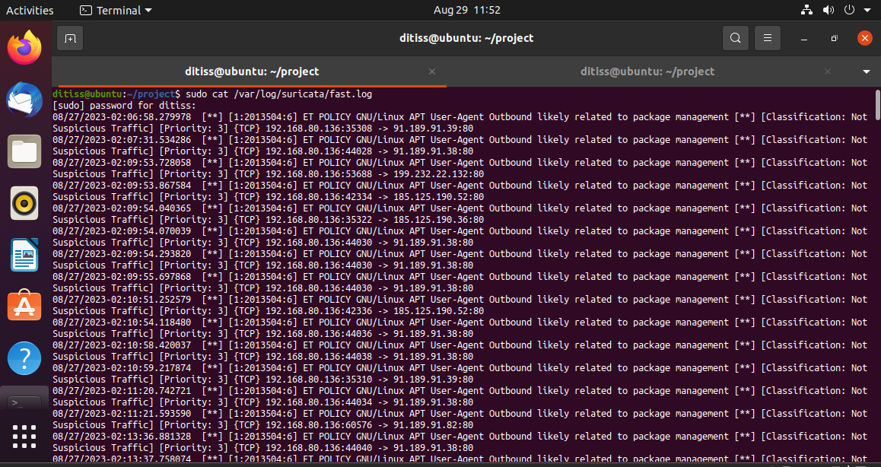

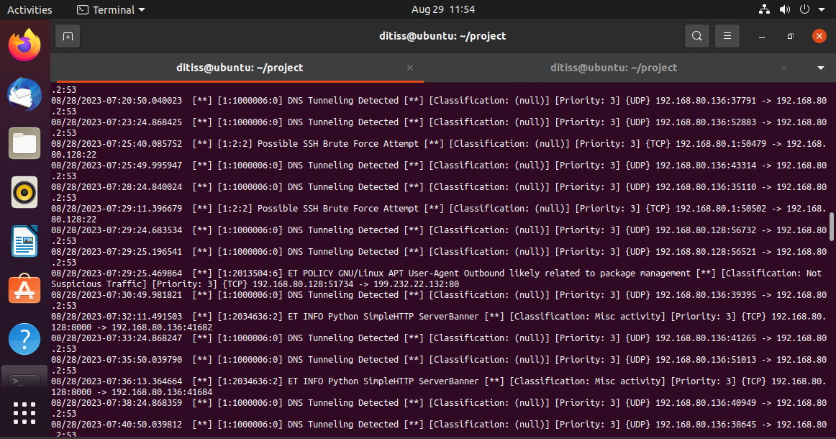

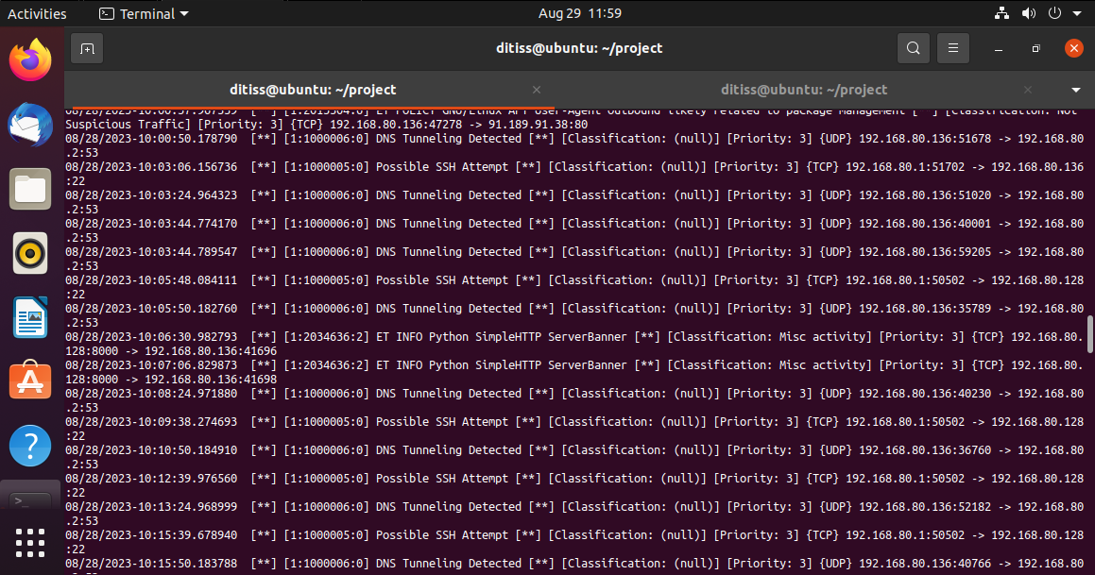

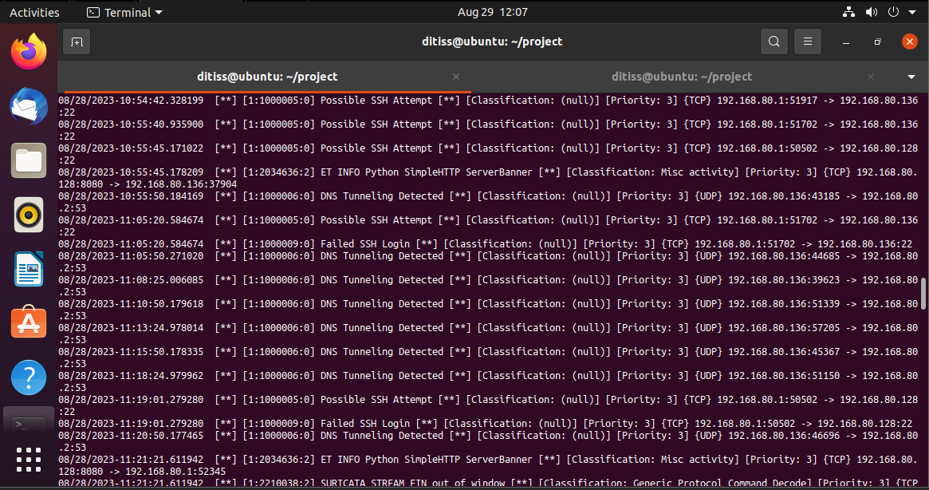

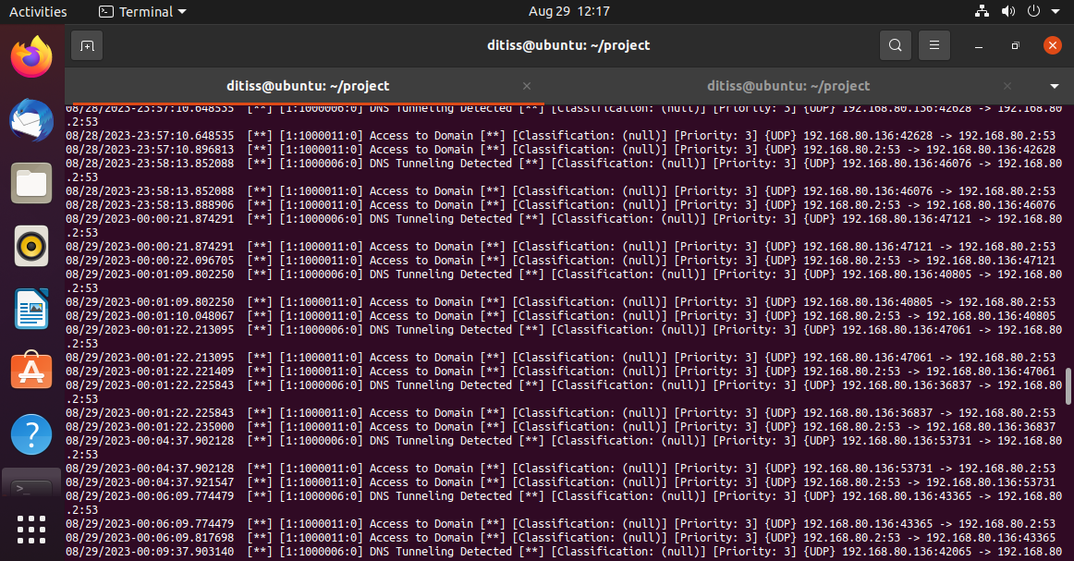

1. **Future Enhancement:**

Here are some ideas for future enhancements for your project:

* Use a more powerful IDPS tool: If you are using Snort, you could consider using Suricata instead. Suricata is more powerful and flexible than Snort, and it offers some additional features, such as multi-threading and support for more protocols.
* Use a cloud-based IDPS tool: Cloud-based IDPS tools are becoming increasingly popular. These tools offer a number of advantages, such as scalability, ease of deployment, and cost-effectiveness.
* Integrate your IDPS with other security tools: You could integrate your IDPS with other security tools, such as firewalls and intrusion prevention systems. This would allow you to get a more comprehensive view of your network security and to take a more proactive approach to threat detection and mitigation.
* Use machine learning to improve your IDPS's detection capabilities: Machine learning can be used to improve the detection capabilities of IDPS tools. This is because machine learning can be used to identify patterns in network traffic that are indicative of malicious activity.
* Automate the response to IDPS alerts: You could automate the response to IDPS alerts. This would allow you to take action on alerts more quickly and efficiently.
* Use a SIEM tool to correlate IDPS alerts with other security data: A SIEM tool can be used to correlate IDPS alerts with other security data, such as firewall logs and network traffic data. This can help you to identify and investigate potential threats more effectively.

1. **Conclusion:**

In conclusion, this project has demonstrated how to use Snort or Suricata to detect intrusions and send alerts via email. The system was configured to detect specific threats, such as network scanning or port scanning. This helped to reduce the number of false alerts and made it easier to identify and respond to real threats.

The project also showed how to configure alert notification to ensure that you are notified of potential threats in a timely manner. This is an important step in protecting your network from malicious activity.

The project has several limitations. First, it only uses a single IDPS tool. In a real-world environment, you would likely use a combination of IDPS tools to get a more comprehensive view of your network security. Second, the project does not address the issue of false positives. False positives are alerts that are generated by the IDPS tool but are not caused by malicious activity. You will need to configure the IDPS tool to filter out false positives so that you can focus on real threats.

Despite these limitations, the project has demonstrated the basic concepts of IDPS and alert notification. This is a good starting point for further research and development.

1. **References:**

**.** [**https://suricata.io/**](https://suricata.io/)

**.** [**https://www.snort.org/**](https://www.snort.org/)

**.** [**https://bard.google.com/**](https://bard.google.com/)

**.** [**https://www.youtube.com/**](https://www.youtube.com/)

**. Some extra notes and suggestions from mentors.**