HALVERN AIR
Retailing & Distribution Modernization Program
Enterprise Architecture Definition Document
A TOGAF Architecture Development Method (ADM) Case Study
Preliminary Phase through Phase H — Full ADM Cycle
Prepared by: Enterprise Architecture Function
Document Reference: HAL-EA-RDM-001 | Version 1.0
August 2026
FICTIONAL CASE STUDY — Halvern Air, all named individuals, and all figures in this document are invented for demonstration and portfolio purposes. This document does not describe any real airline, and no figures herein should be relied upon as real-world data.

Table of Contents
1. Executive Summary 4
2. Preliminary Phase — Governance & Principles 5
2.1 Architecture Principles 5
2.2 Governance Framework Setup 5
3. Phase A — Architecture Vision & Scope 7
3.1 Problem Statement & Target-State Vision 7
3.2 Scope Boundaries 7
3.3 Success Metrics 8
3.4 Stakeholder Map 8
3.5 Business Case Summary 9
4. Phase B — Business Architecture 11
4.1 As-Is Business Architecture 11
4.2 To-Be Business Architecture 11
4.3 Business Capability Map 12
4.4 Business Footprint 13
5. Phase C — Information Systems Architecture 15
5.1 Application Architecture 15
5.2 Data Architecture 16
5.3 Data Ownership / Domains 17
6. Phase D — Technology Architecture 19
6.1 Reference Architecture Pattern 19
6.2 Technology Standards 19
7. Phase E — Opportunities & Solutions 21
7.1 Gap Analysis 21
7.2 Solution Building Blocks 21
7.3 Vendor Evaluation 22
8. Phase F — Migration Planning 23
8.1 Migration Roadmap 23
8.2 Transition Architecture — State 1 23
9. Phase G — Implementation Governance 25
9.1 Non-Compliance Handling 25
9.2 Architecture Contracts 25
10. Phase H — Change Management 26
11. Architecture Decision Records 27
Appendix A — Diagram Catalog Index 28
Appendix B — Disclaimer 29

1. Executive Summary
Halvern Air sells seats the way the industry sold them twenty years ago: fixed, filed fares distributed through travel agencies and online agents, with no ability to bundle bags, seats, or upgrades into a single attractive offer, and a loyalty program that can take up to two days to post a point. Two of Halvern’s largest distribution partners — representing an estimated 38% of indirect-channel bookings — have stated that they will deprioritize, and in one case phase out, content that is not delivered through the industry’s modern NDC (New Distribution Capability) standard, within 24 months. Ancillary revenue per passenger runs at roughly 60% of the benchmark achieved by comparable regional carriers, largely because Halvern’s systems cannot merchandise the way theirs do.
The Enterprise Architecture function recommends building a new retailing platform in front of Halvern’s existing Passenger Service System (PSS) — not replacing it. This platform constructs modern, bundled, dynamically priced offers and distributes them via NDC to travel agents and online agents, while the PSS continues doing what it already does reliably: booking, ticketing, and getting passengers on aircraft. A full core-system replacement was evaluated and rejected (ADR-001) as carrying a three-to-five-year timeline and a single high-stakes cutover risk that the 24-month distribution deadline cannot absorb. The recommended approach delivers in four waves over 24 months with no forced outage of any existing sales channel.
The program is estimated at $26.2M in one-time capital investment, with incremental annual operating cost of roughly $6.0M once live, offset by an estimated $11.6M in annual savings and revenue uplift at steady state. On a strict three-year cash basis the program does not fully recover its capital investment through savings alone (simple payback of approximately 4.7 years); it becomes economically compelling once the estimated $16M+ in revenue at risk from losing NDC-required distribution channels is weighed in. The Program Steering Committee approved the business case with a checkpoint at the Wave 2 gate to validate early ancillary-revenue results before releasing the second half of the capital.
This document is the consolidated Architecture Definition Document for the program, compiled across all phases of the TOGAF Architecture Development Method — Preliminary Phase governance setup through Phase H change management — and is intended as a single, self-contained reference of the architecture, its rationale, and its governance.

2. Preliminary Phase — Governance & Principles
Before Phase A vision work began, Halvern’s CIO chartered an Architecture Review Board (ARB) and a lightweight governance framework, specifically to avoid repeating the pattern that produced the current fragmented PSS landscape: multiple delivery teams making locally optimal, globally inconsistent integration decisions with no forum for cross-cutting review.

2.1 Architecture Principles
Twelve architecture principles were ratified by the ARB and govern every subsequent decision in this program. Each ADR and architecture contract in this document cites these principles by number.
# | Principle | Statement (Condensed)
1 | PSS Remains System of Record | Bookings, ticketing, and check-in/boarding state stay authoritative on the PSS until a separately governed decision replaces it.
2 | Offer & Order Are First-Class Concepts | Offer and Order are modeled as new domain entities, distinct from the legacy PNR record.
3 | Channels Decoupled from Fare Filing | All channels consume a common internal offer construction service; none integrate directly against PSS fare tables.
4 | Buy Before Build | Undifferentiated capability is bought and configured; custom build is reserved for Halvern’s commercial differentiation logic.
5 | Assume Eventual Consistency | No component may assume synchronous, single-transaction consistency across PSS and the new platforms.
6 | Loyalty Ledger Is Immutable & Event-Sourced | Accrual/redemption is an append-only event log; balance is always a derived projection.
7 | PCI Scope Minimized by Design | No new service persists or logs raw cardholder data; new components integrate with the existing tokenized payment boundary.
8 | Decisions Recorded & Reversible by Default | Every architecturally significant decision is an ADR, reviewed at each quarterly principles review.
9 | Compliance Is Non-Negotiable, Implementation Is Not | NDC schema, PCI DSS, and data-protection conformance are mandatory; how Halvern implements them is open to judgment.
10 | Built for Multi-Channel Reuse | No new component is approved for a single consuming channel without an ARB waiver.
11 | One Owning System per Data Domain | Each data domain has exactly one designated system of record; all others hold read-only views.
12 | Architecture Scales Down as Well as Up | Reference patterns must fit Halvern’s actual scale (~120 aircraft, ~9M passengers/year), not default to hyperscale complexity.

2.2 Governance Framework Setup
The ARB is chaired by the Head of Enterprise Architecture and has seven standing voting members: the Chair; VP Commercial / Revenue Management; VP IT Operations; the CISO (or delegate); Head of Loyalty & Customer; and the Lead Solution Architects for the PSS Domain and the Retailing Platform. Delivery team leads and vendor architects attend as non-voting contributors when their workstream is on the agenda. The Program Sponsor (Chief Commercial Officer) receives ARB minutes but does not sit on the board, preserving separation between sponsorship and architecture governance.
The ARB operates on four cadences: a biweekly, 90-minute standing review; a 48-hour fast-track path for low-risk changes; a quarterly review of the principles and the ADR log; and a formal go/no-go review at each migration wave boundary. Escalation runs from delivery-team level, to the standing ARB, to the CIO (for votes the ARB cannot resolve), to the cross-functional Program Steering Committee for any decision with more than 10% of a wave’s budget or more than four weeks of schedule impact.
This structure — light enough to run biweekly without becoming a bottleneck, but with a documented escalation path to executive sponsorship — was a deliberate trade-off. A heavier, weekly-review model was considered and rejected: with roughly 8–10 delivery workstreams active at peak, a weekly cadence was projected to add an estimated 1.5 FTE-equivalent of coordination overhead for marginal additional risk reduction.
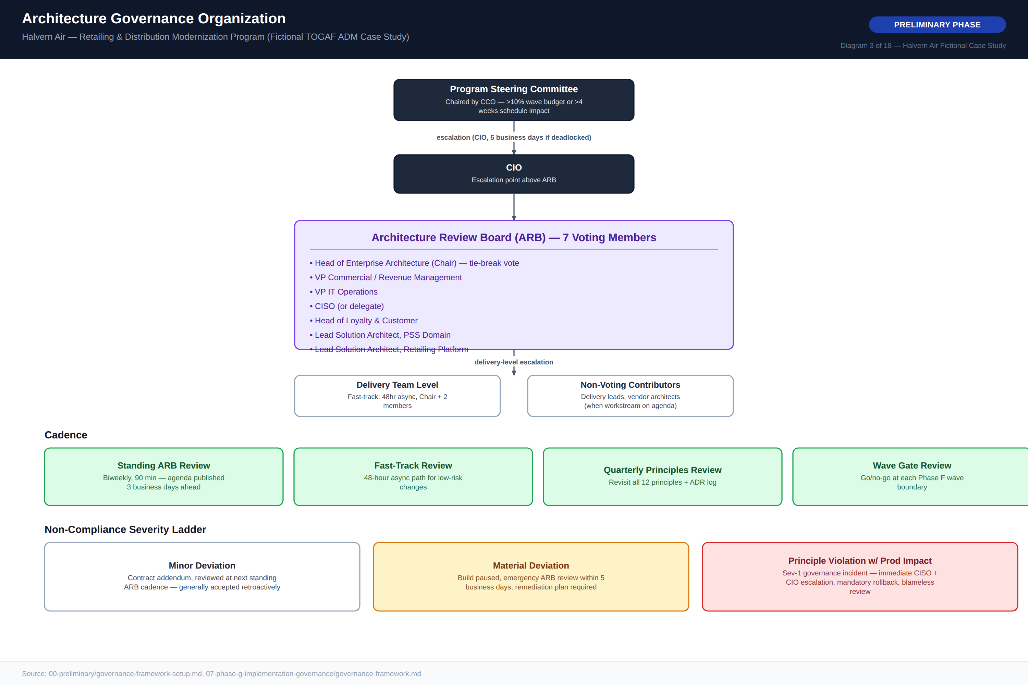
Diagram 3 — Architecture Governance Organization

3. Phase A — Architecture Vision & Scope

3.1 Problem Statement & Target-State Vision
Halvern’s PSS landscape was assembled over roughly 15 years as separate reservations, inventory, and departure-control systems, integrated point-to-point with no shared offer or order data model. It supports traditional filed fares but cannot express bundled fares, ancillary-inclusive offers, or dynamically priced propositions — now the baseline expectation for airline retailing. Three forces make this an urgent architecture problem: a commercial gap (ancillary revenue at ~60% of benchmark), a loyalty gap (24–48 hour batch-only accrual), and a channel deadline (two partners representing ~38% of indirect bookings deprioritizing non-NDC content within 24 months).
By program end, Halvern will distribute NDC-conformant, dynamically priced, bundled offers through a retailing platform positioned in front of the existing PSS; support real-time loyalty accrual and redemption as a first-class part of the offer/order flow; retire point-to-point channel integrations in favor of a single internal offer construction service; and maintain full backward compatibility with GDS/EDIFACT distribution throughout the transition. The vision is deliberately evolutionary: the PSS continues doing what it does reliably while a new retailing layer progressively takes over offer construction and distribution logic.
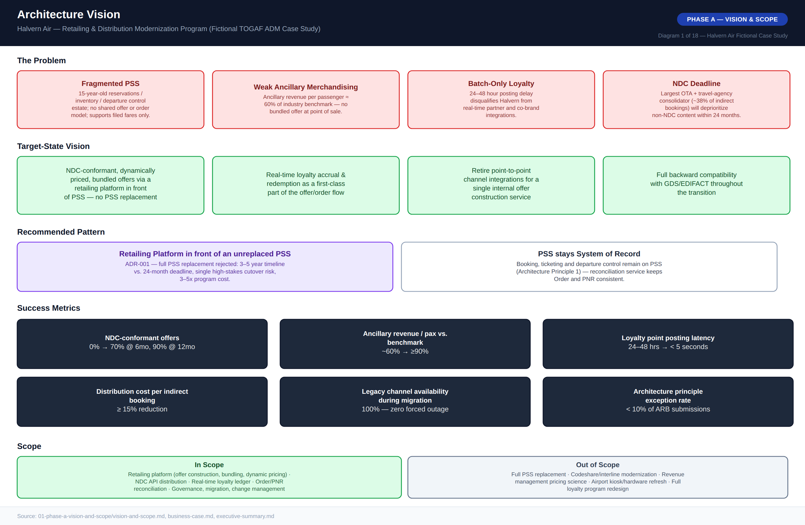
Diagram 1 — Architecture Vision One-Pager

3.2 Scope Boundaries
In scope: the retailing platform (offer construction, bundling, dynamic pricing hooks); NDC API distribution conformant with IATA NDC schema; real-time loyalty ledger architecture; reconciliation architecture between offer/order and the legacy PNR model; and the governance, migration, and change management required to deliver all of the above.
Explicitly out of scope, each evaluated and rejected specifically because including it would extend the program beyond the 24-month channel deadline: full PSS replacement (ADR-001); codeshare/interline systems modernization; revenue management pricing science (the rules engine is in scope, the pricing science that populates it is not); airport departure-control hardware/kiosk refresh; and full loyalty program redesign (only the real-time technical ledger capability is in scope).

3.3 Success Metrics
Metric | Baseline (Today) | Target (Program End)
NDC-conformant offers, % of indirect bookings | 0% | 70% @ 6mo, 90% @ 12mo
Ancillary revenue per passenger vs. benchmark | ~60% | ≥90%
Loyalty point posting latency | 24–48 hours (batch) | <5 seconds (real-time)
Distribution cost per indirect booking | Baseline fee schedule | ≥15% reduction
Legacy channel availability during migration | N/A | 100% — zero forced outage
Architecture principle exception rate | N/A | <10% of ARB submissions

3.4 Stakeholder Map
Fourteen stakeholders were assessed on power and interest to determine engagement strategy, from the Program Sponsor and CIO (both High/High, managed closely) through external Distribution Partners (Low direct power but High interest, kept informed and engaged through partner account management) to the existing Loyalty Platform vendor (Low/Medium, monitored). A full RACI matrix governs eleven categories of program-level decision across eight accountable roles, anchored by the CIO as Accountable for delivery risk and the ARB as Responsible for architecture governance decisions.
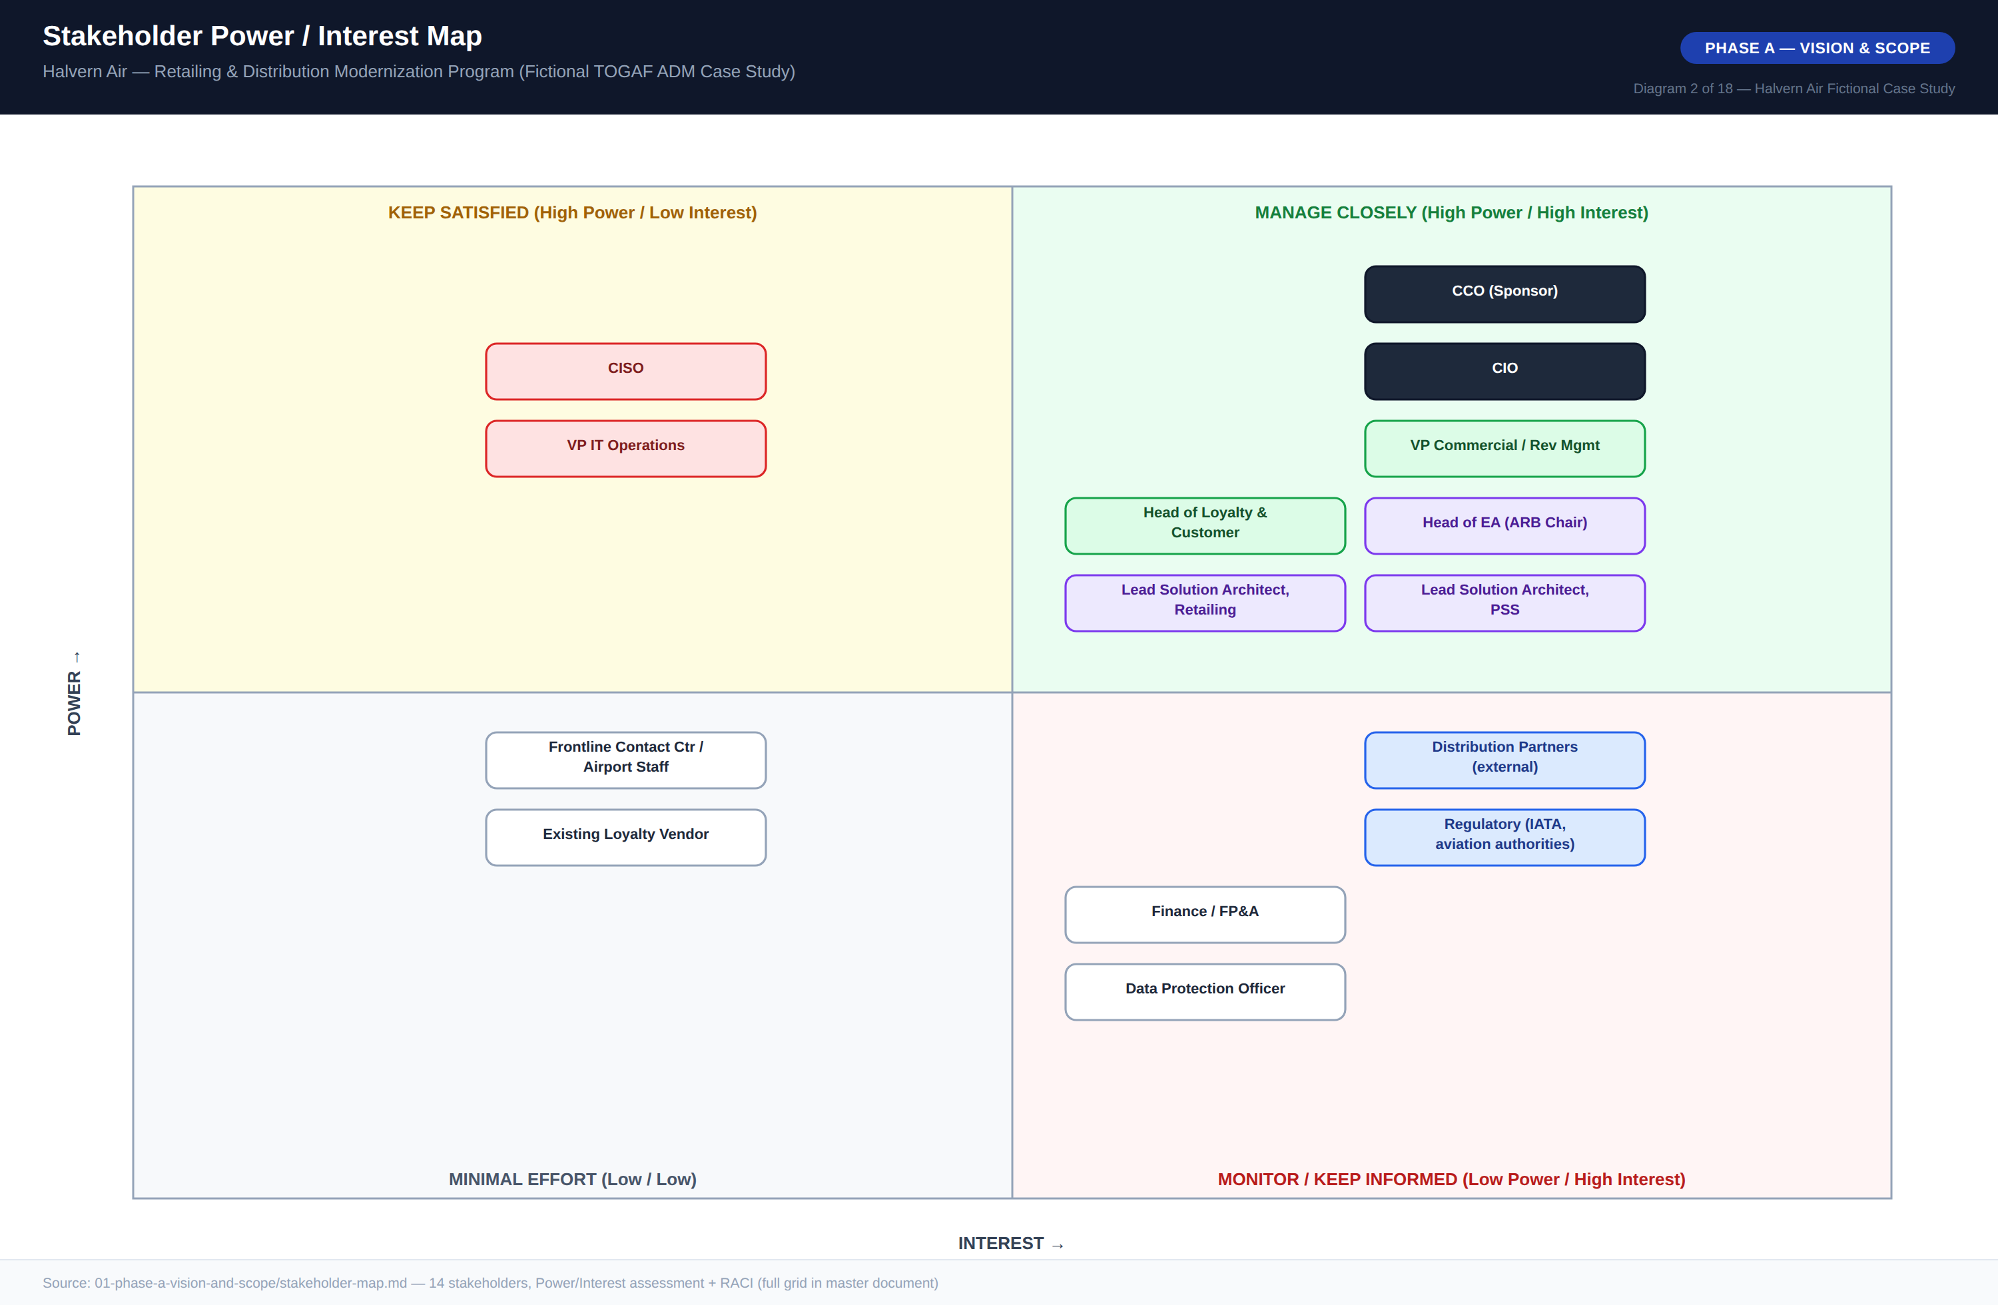
Diagram 2 — Stakeholder Power / Interest Map

3.5 Business Case Summary
The business case is built from nine capex line items totaling $26.2M (dominated by the $6.9M PSS reconciliation integration effort and $5.0M NDC API integration/onboarding effort, each measured in person-months at a $16,500 blended rate), against $6.0M of incremental annual opex and $11.6M of offsetting annual value once at steady state — principally an estimated $8.1M/year from closing the ancillary-revenue gap and $2.7M/year from GDS/OTA distribution-fee avoidance. Full breakdown, the three-year TCO comparison against doing nothing, and the payback/ROI calculation appear in Diagram 18 and are reproduced in the corresponding financial tables in Section 7.
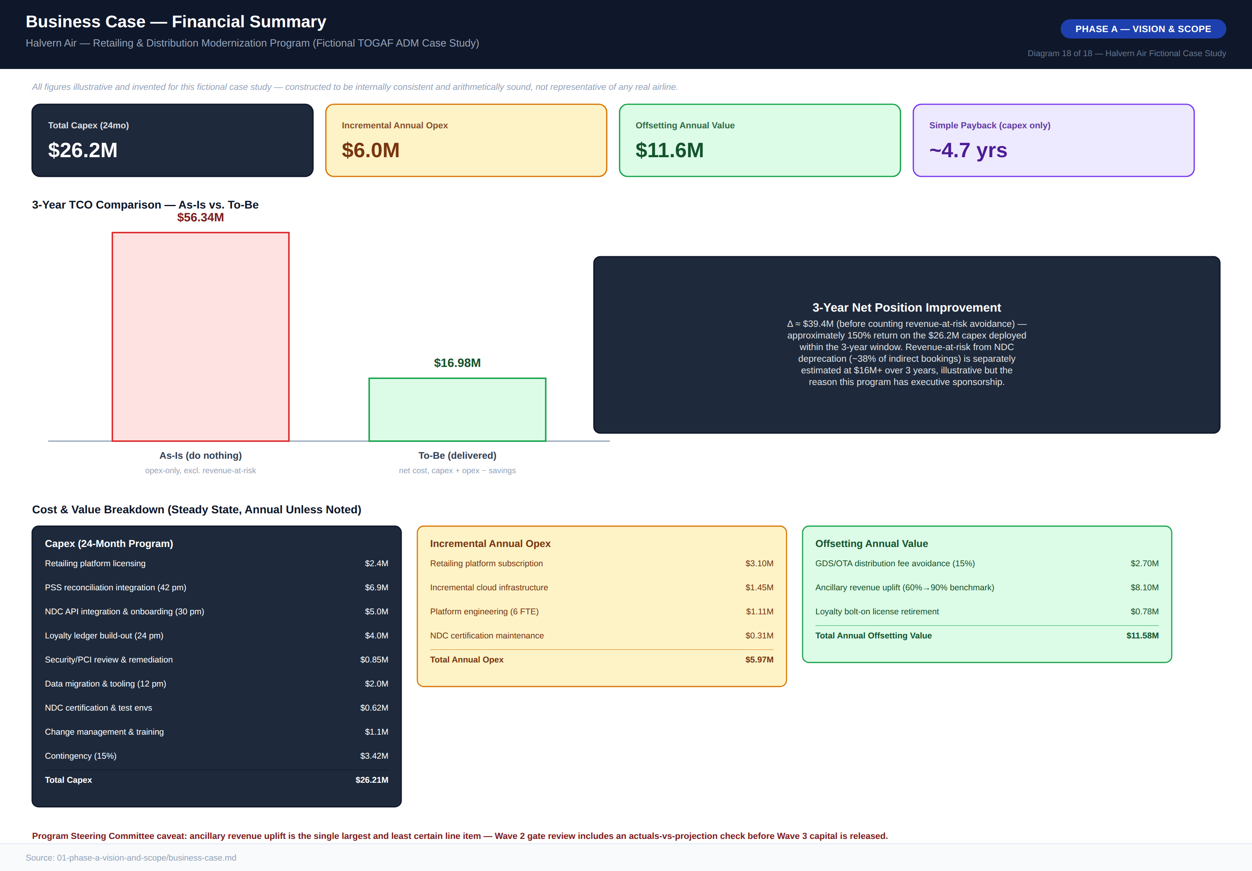
Diagram 18 — Business Case Financial Summary

4. Phase B — Business Architecture

4.1 As-Is Business Architecture
Halvern’s current retailing and distribution model is organized around filed fare distribution: fares are pre-computed and made available to channels as static, pre-priced classes. A travel agent or OTA search reaches the PSS through a GDS edge connection; pricing has no visibility into ancillary inventory, loyalty status, or bundling logic. Ancillaries are sold in a separate transaction on the website’s storefront, unconnected to the GDS shopping flow. Loyalty accrual happens in a nightly batch job reading completed-flight data, typically with a 24–48 hour delay. Every new channel partner wanting deeper integration has required a custom, point-to-point project against the PSS — five such integrations delivered in four years, averaging 7–9 months each, none sharing a common component.
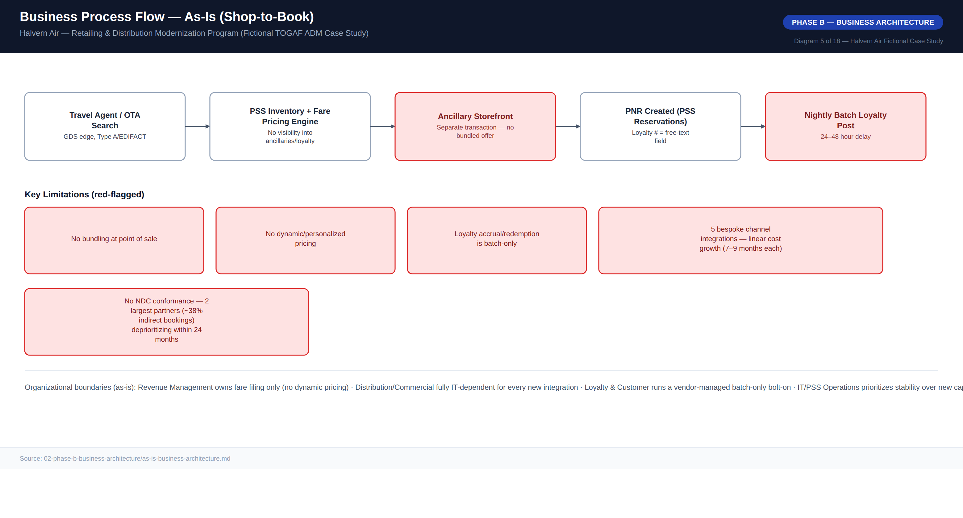
Diagram 5 — Business Process Flow, As-Is (Shop-to-Book)

4.2 To-Be Business Architecture
In the target state, any channel’s shopping request reaches a single Offer Construction Service that bundles PSS inventory, ancillary inventory, pricing rules, and loyalty status into one priced proposition. The customer accepts a single bundled offer; the Order Management Service orchestrates the underlying PSS booking and becomes the IATA ONE Order-aligned commercial source of truth. Loyalty accrual reflects within seconds via a real-time ledger. What deliberately stays the same: departure control, check-in, and boarding remain fully on the PSS — explicitly excluded from scope under Architecture Principle 1, since touching them risks operationally critical, safety-adjacent systems for no commensurate benefit.
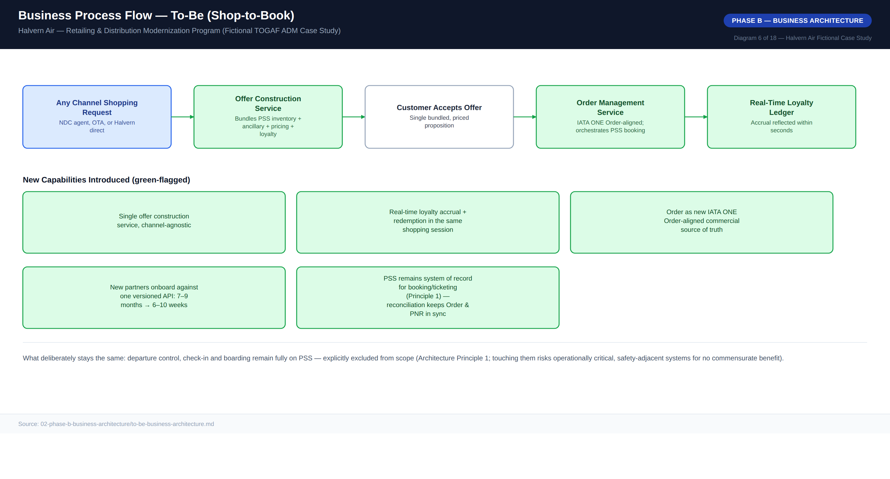
Diagram 6 — Business Process Flow, To-Be (Shop-to-Book)

4.3 Business Capability Map
Thirteen business capabilities were rated by the ARB against comparable regional-carrier benchmarks on a 1–5 maturity scale, As-Is versus Target. The three largest gap/priority combinations — NDC Distribution (0→4), Offer Bundling / Ancillary Merchandising (1→4), and Real-Time Loyalty Accrual (1→5) — anchor Waves 1 and 2 of the migration roadmap. One capability, GDS/EDIFACT Distribution, is deliberately allowed to regress in relative priority (a negative gap) as investment shifts to NDC while legacy distribution is maintained, not enhanced.
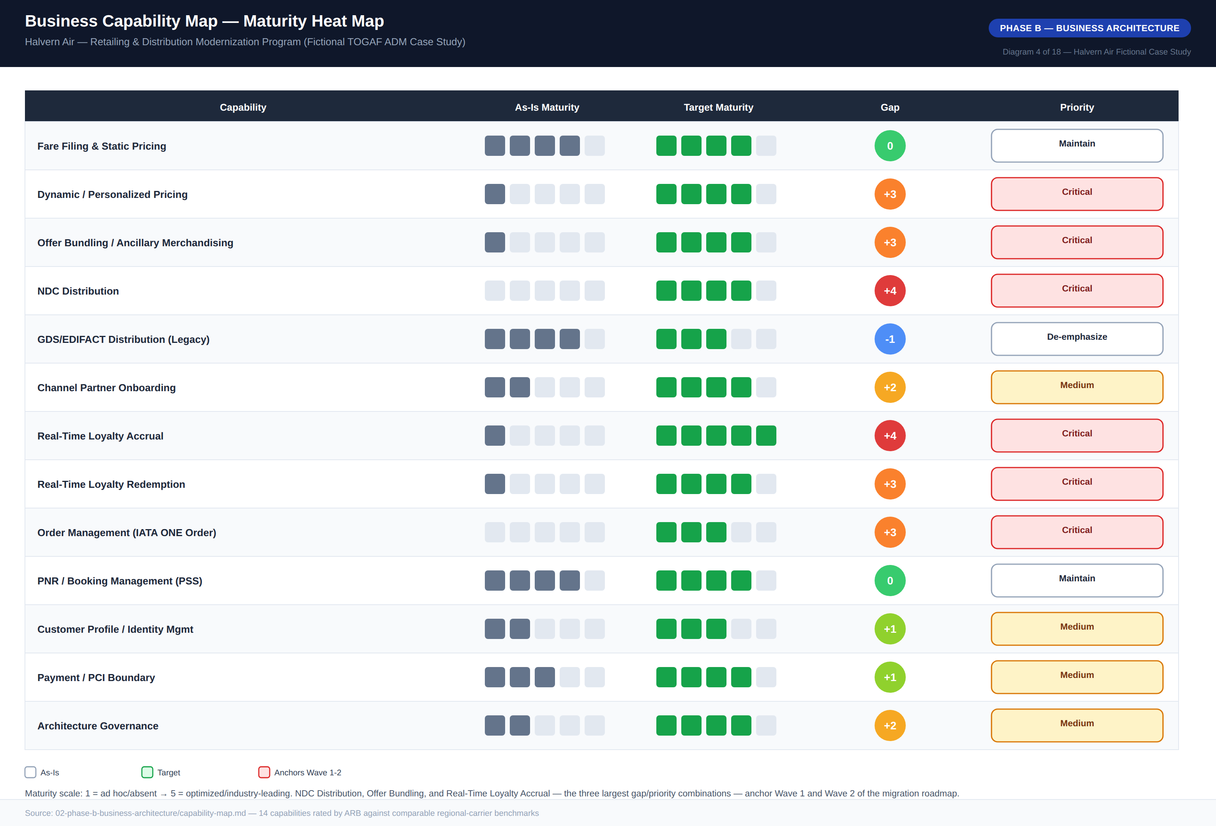
Diagram 4 — Business Capability Map, Maturity Heat Map

4.4 Business Footprint
The business footprint traces each organizational unit through its business function, key process, supporting application, and technology platform — both legacy and net-new. A new function, Retailing & Offer Management, is introduced specifically to own the Offer Construction and Order Management services; Architecture & Governance is carried as its own row given the program’s reliance on the ARB for cross-cutting decision rights.
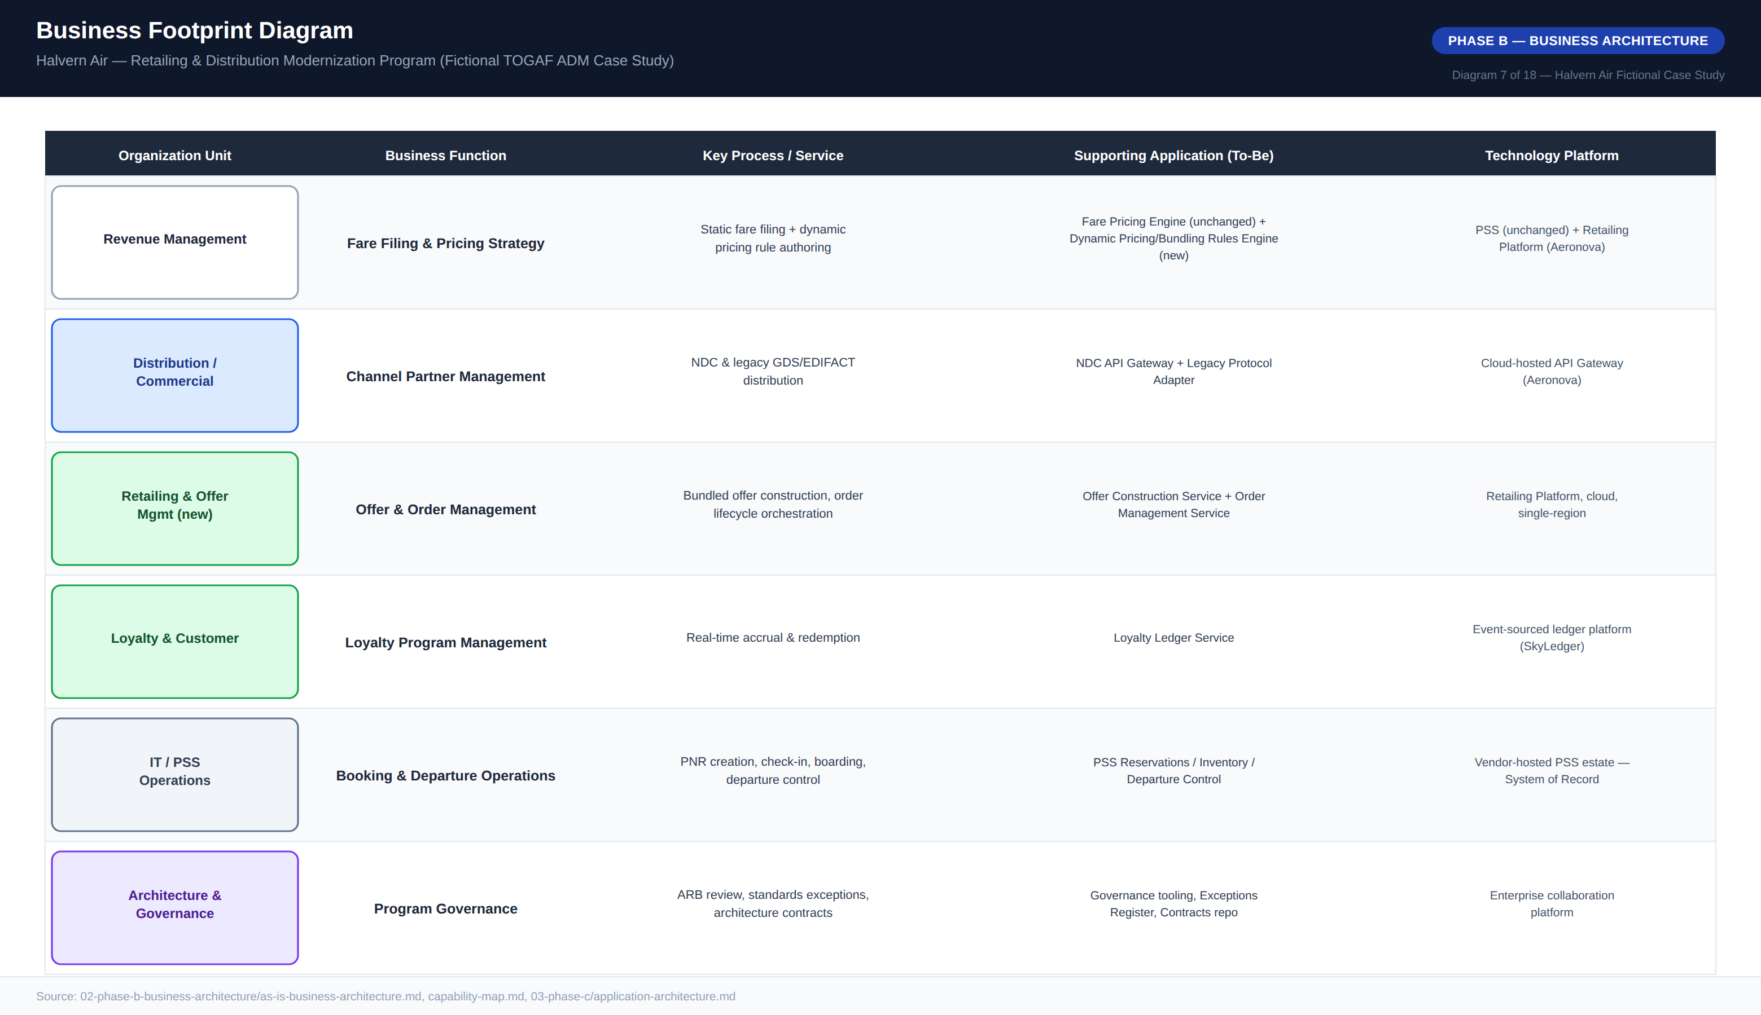
Diagram 7 — Business Footprint Diagram

5. Phase C — Information Systems Architecture

5.1 Application Architecture
The as-is application landscape is dominated by the PSS suite — three loosely coupled applications (Reservations, Inventory, Departure Control) integrated through the vendor’s proprietary internal messaging — surrounded by a constellation of point solutions with no API gateway, no shared integration platform, and no service that any two applications both depend on. Every connection is genuinely point-to-point, the direct cause of the linear cost growth described in Section 4.1.
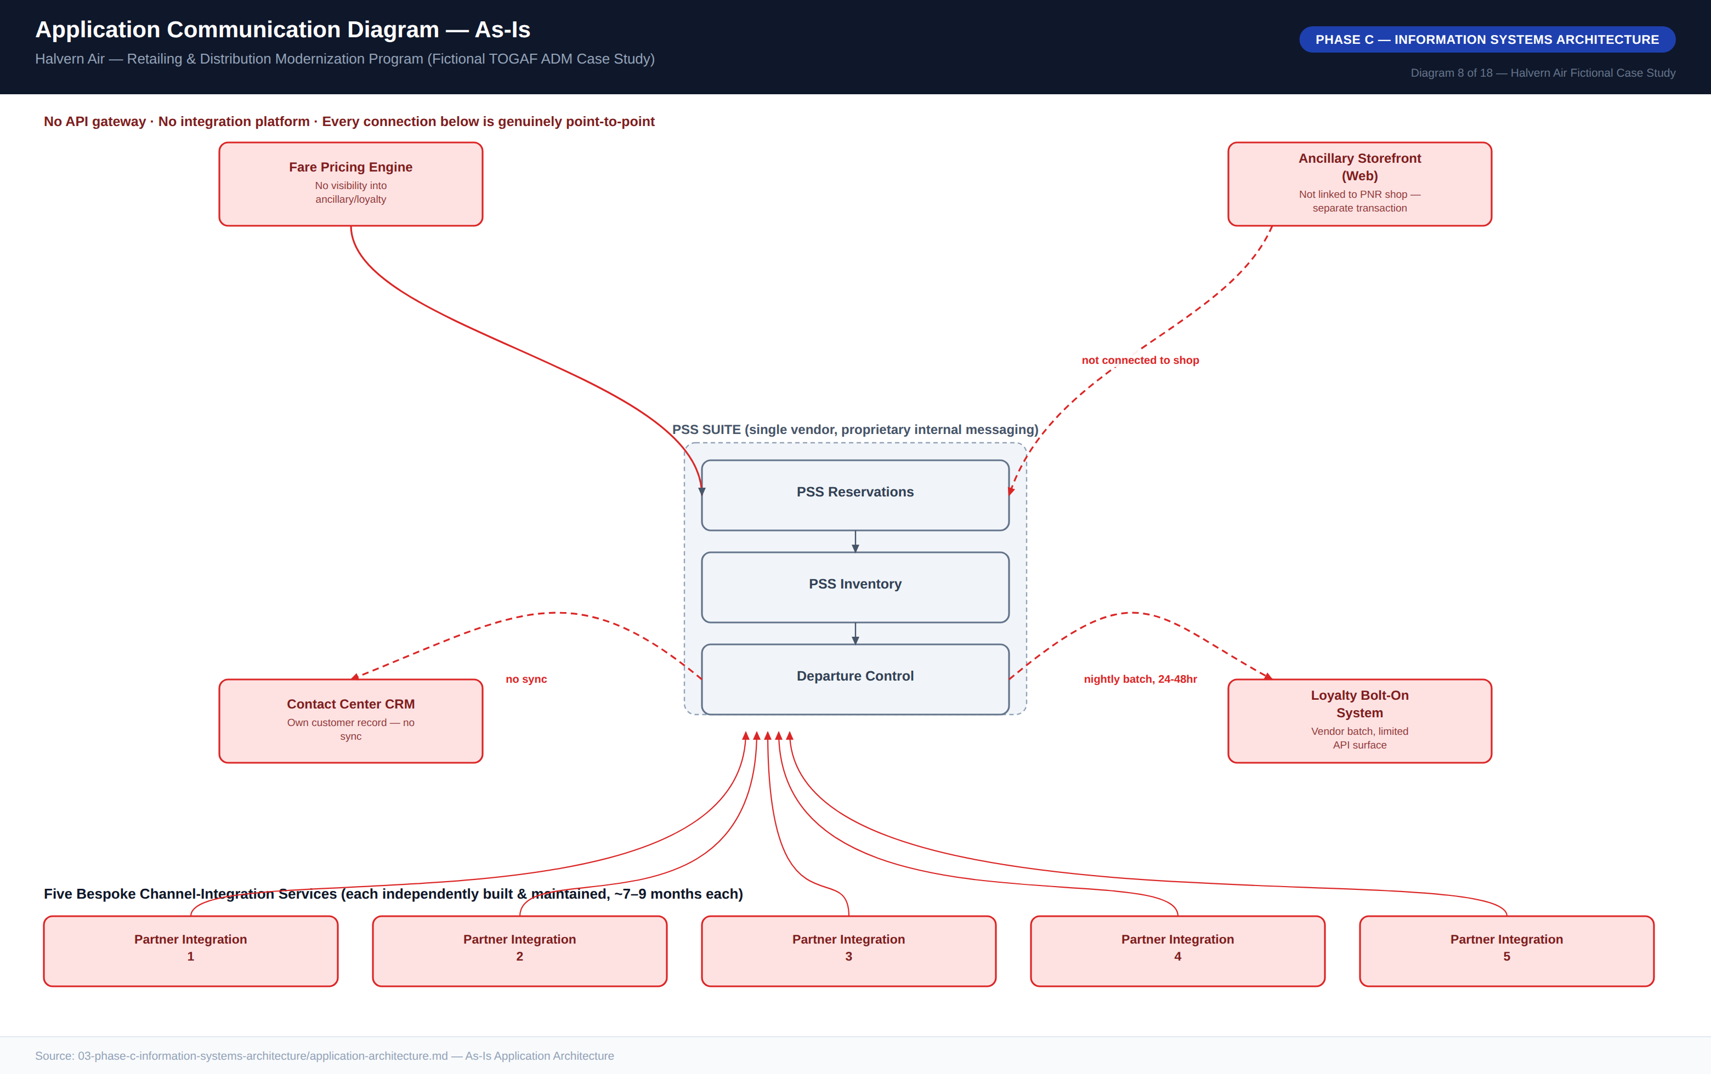
Diagram 8 — Application Communication Diagram, As-Is
The to-be architecture introduces a Retailing Platform as a new application layer decomposed into four components — Offer Construction, Order Management, Loyalty Ledger, and a transitional Reconciliation Service — fronted by a single NDC API Gateway that also fronts the existing GDS/EDIFACT channel via a protocol adapter. Communication across the system-of-record boundary is deliberately API-mediated and asynchronous (Architecture Principle 5); an earlier design proposing direct database-level replication from the PSS for read performance was rejected by the ARB as a direct violation of Architecture Principle 3 and a known failure pattern from Halvern’s existing point-to-point integrations.
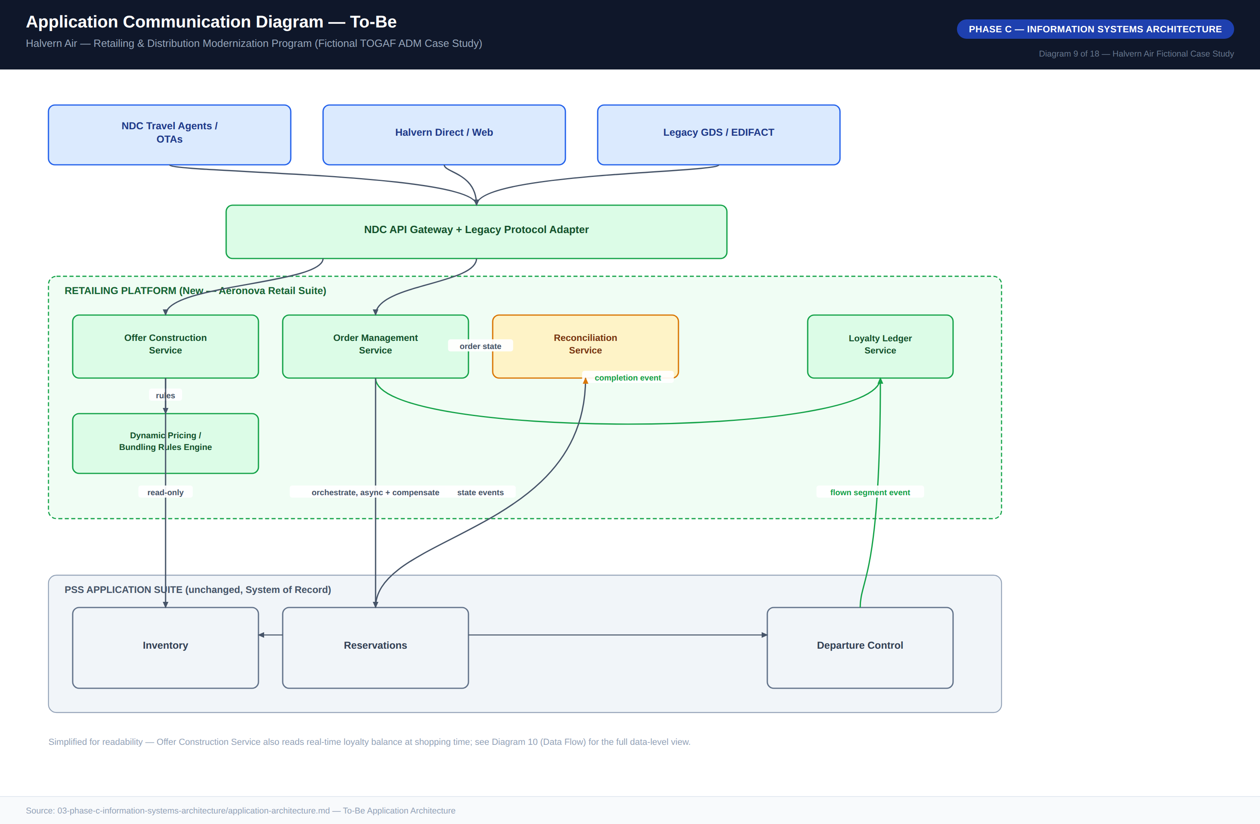
Diagram 9 — Application Communication Diagram, To-Be

5.2 Data Architecture
Halvern’s data landscape today is defined by fragmented ownership: the PNR is the closest thing to a central entity, but it is a semi-structured, text-based record never intended to carry structured ancillary, bundling, or loyalty-transaction data. Customer profile data is independently held in four systems with no automated synchronization. The to-be architecture introduces two new first-class data domains — Offer and Order — and a properly event-sourced Loyalty Ledger, each with a single designated owning system per Architecture Principle 11.
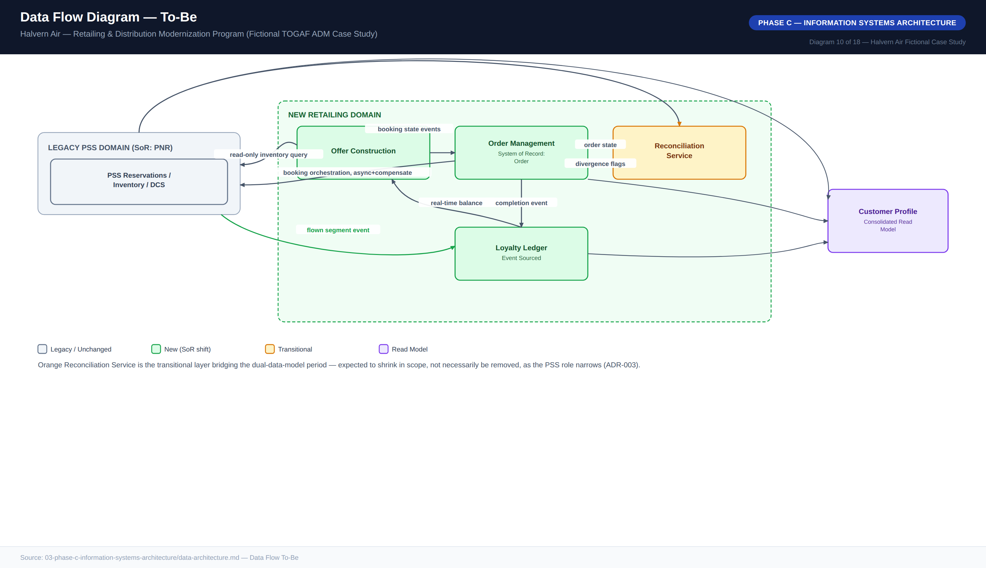
Diagram 10 — Data Flow Diagram, To-Be

5.3 Data Ownership / Domains
PNR/Booking remains owned by PSS Reservations, unchanged, as the confirmed booking and ticketing record. Order becomes the new system of record for commercial truth, owned by Order Management, reconciled against but distinct from the PNR. Offer is transient by design — not persisted as commercial truth once expired or unaccepted. The Loyalty Ledger is an append-only event log with balance always a derived projection. Customer Profile remains a partial, read-only consolidated view; full profile-system-of-record consolidation was identified as a real gap but deliberately deferred, since closing it fully requires touching contact-center CRM and web identity systems outside this program’s chartered scope.
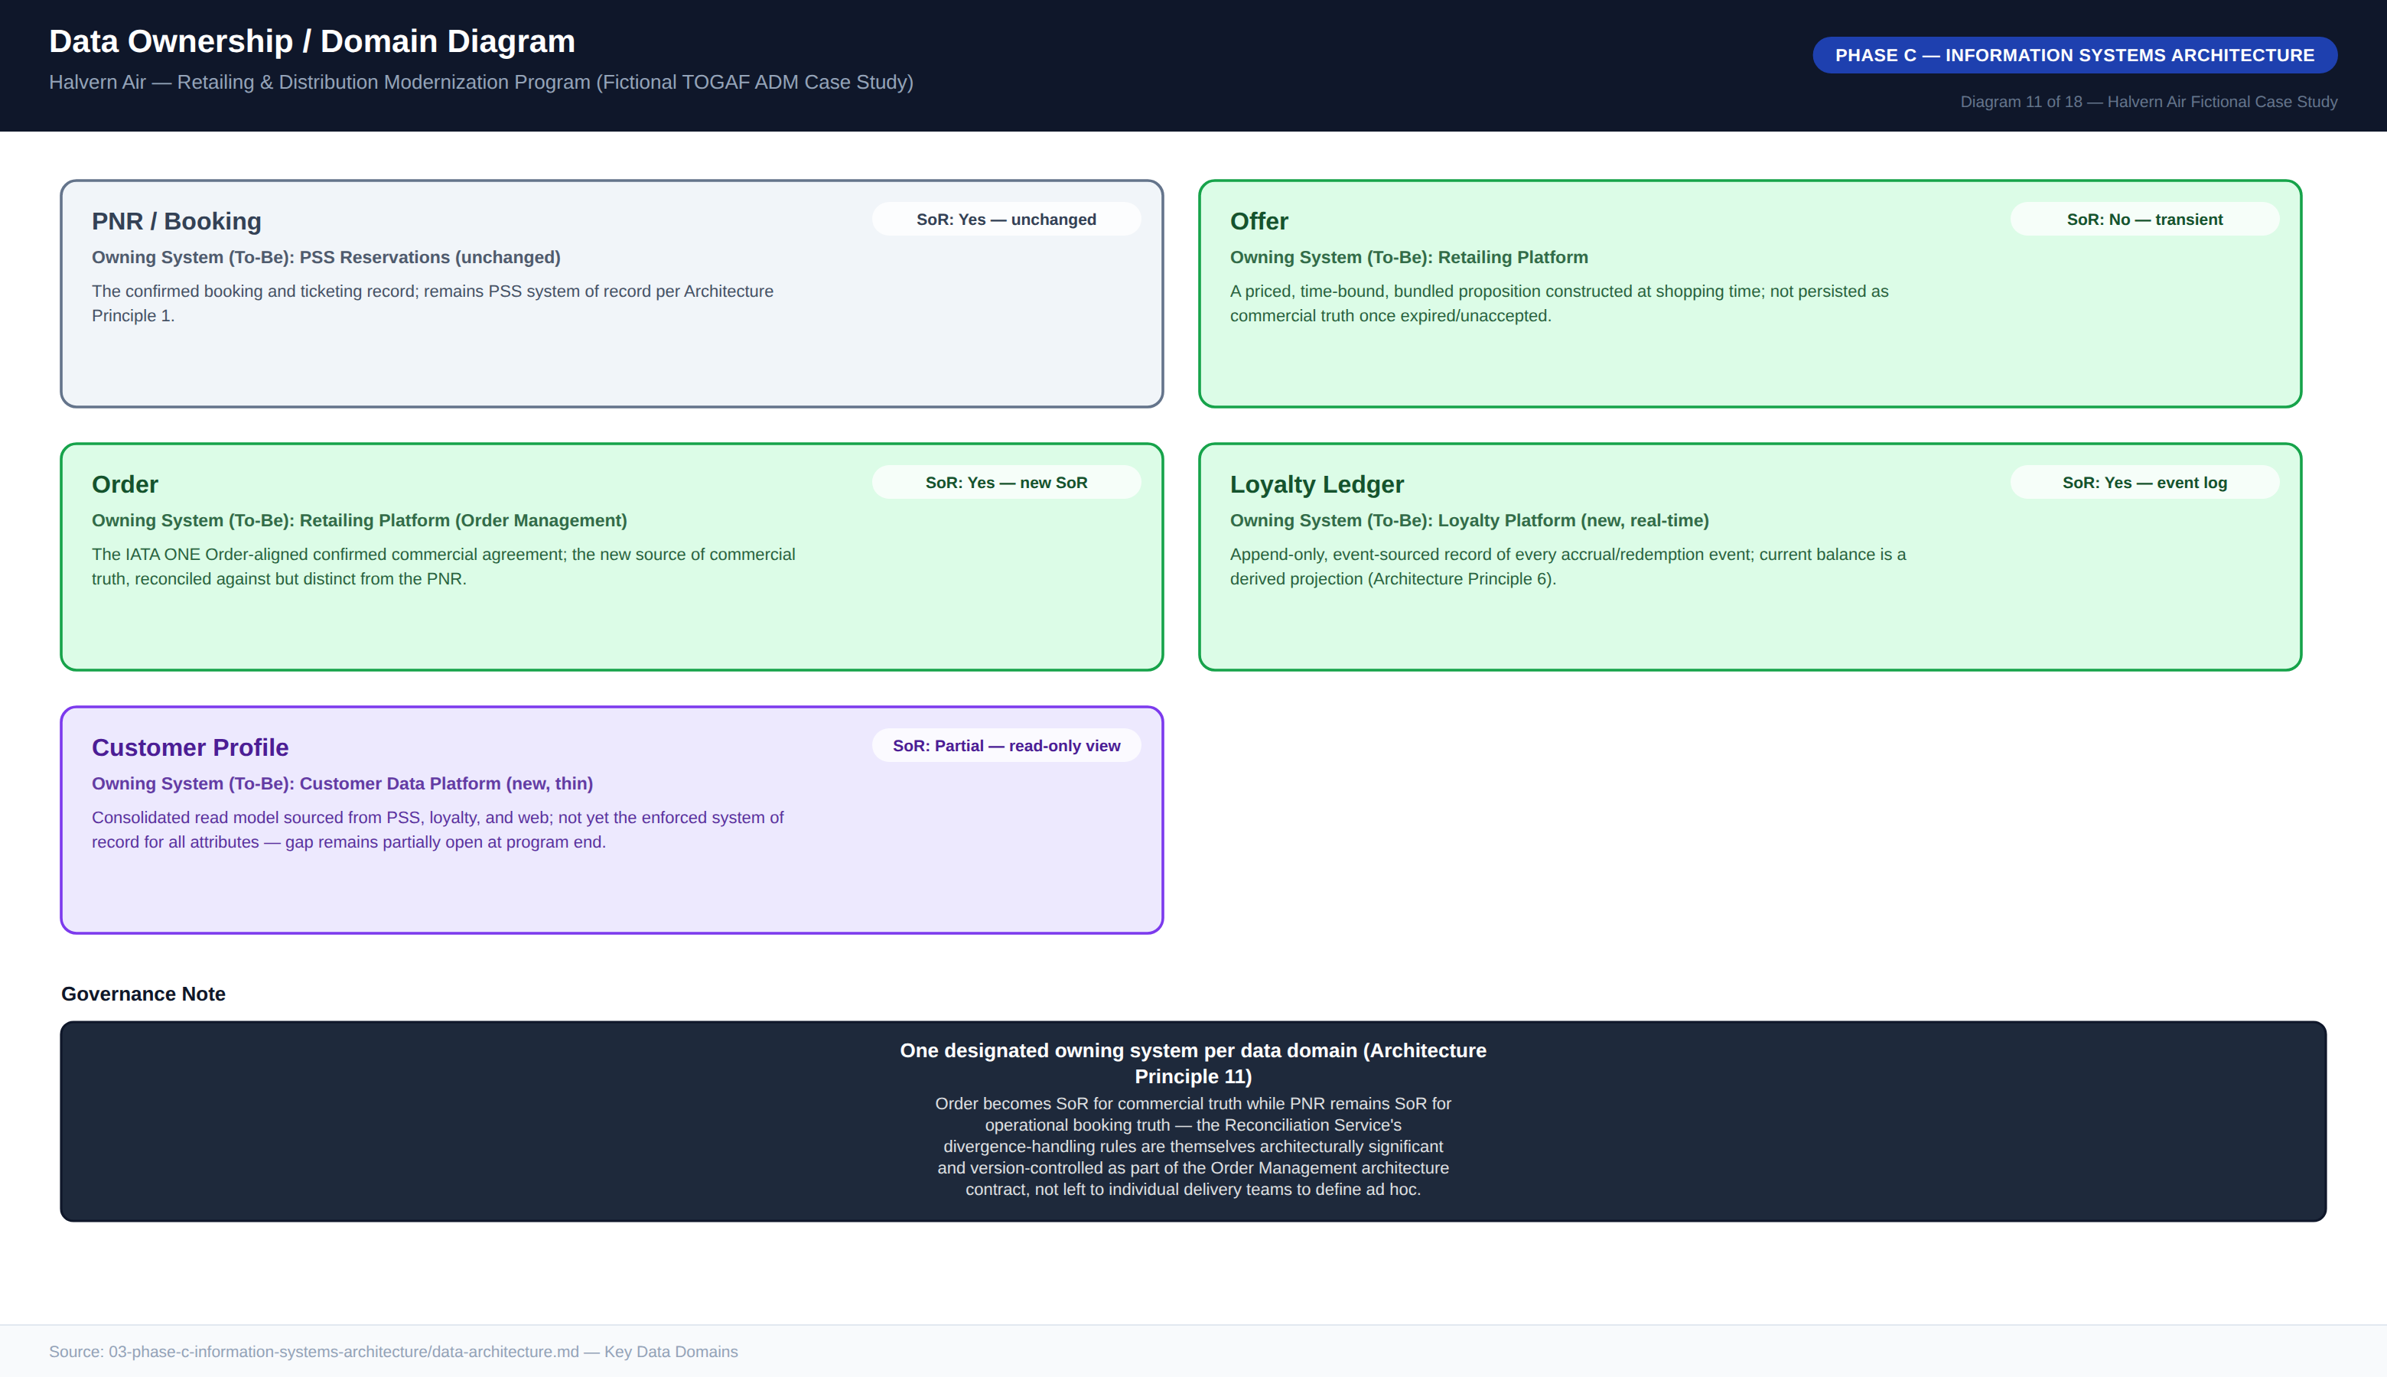
Diagram 11 — Data Ownership / Domain Diagram

6. Phase D — Technology Architecture

6.1 Reference Architecture Pattern
The core technology pattern selected for the program is a retailing platform positioned in front of an unreplaced legacy PSS. The pattern is applicable only when all of five conditions hold — PSS operational stability, a distribution/retailing (not core-PSS) business driver, appetite for an 18–30 month dual-data-model period, a PSS vendor exposing stable APIs, and genuine engineering capacity to build new platform software — and should be rejected in favor of a different approach when the PSS itself is the source of business pain, when a vendor contract makes the extra integration layer commercially unviable, when the organization cannot tolerate a multi-year dual-model period, when the carrier is below roughly 1–2M passengers/year (the pattern’s fixed opex floor is not justified), or when a full PSS replacement is already planned for other reasons.
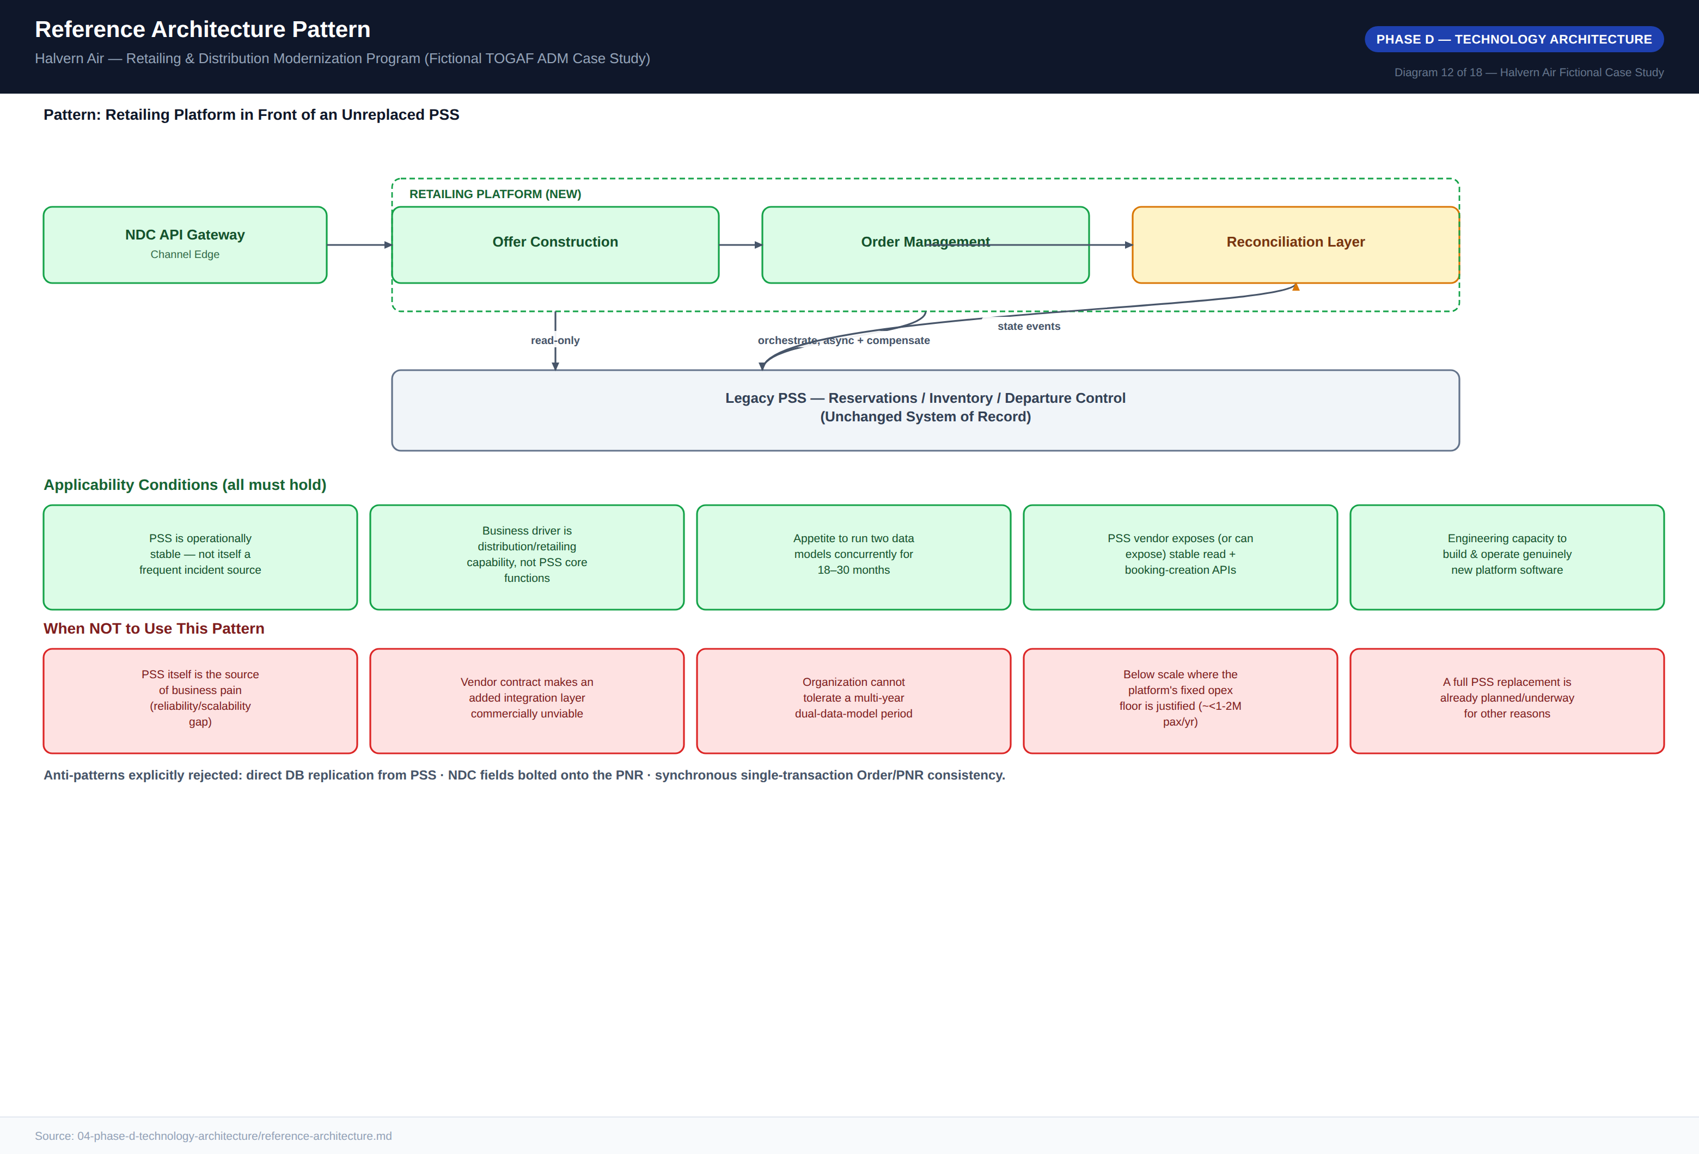
Diagram 12 — Reference Architecture Pattern

6.2 Technology Standards
The approved stack spans distribution/messaging standards (IATA NDC Schema 21.3 baseline with an upgrade path to 23.1, IATA ONE Order alignment, current-version EDIFACT for the legacy channel, PCI DSS v4.0), platform and infrastructure standards (a commercial, contract-first API gateway; a managed, durable event backbone; single-region cloud hosting for the retailing platform; an append-only event store for the loyalty ledger; the existing enterprise identity provider; and the existing observability stack, extended rather than duplicated), and integration standards (REST/JSON or the approved event backbone only, semantic-style API versioning with a 12-month deprecation notice, and PSS interaction exclusively through the vendor-supported API layer). Exceptions require a written ARB request with a stated expiry date; regulatory and standards-conformance items are never grantable exceptions, only implementation-layer choices are.
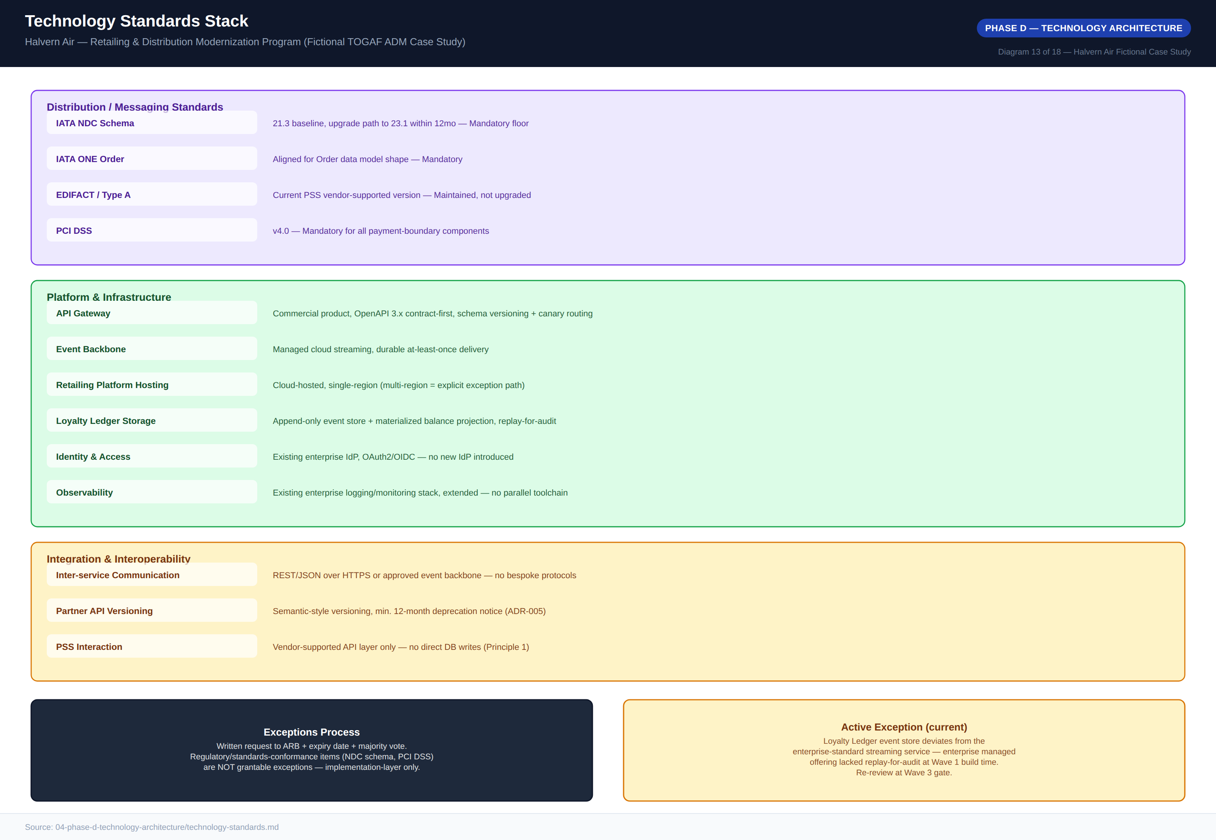
Diagram 13 — Technology Standards Stack

7. Phase E — Opportunities & Solutions

7.1 Gap Analysis
Gaps are derived directly from the capability-map maturity deltas and prioritized on a High/Medium/Low scale weighted by business impact and delivery complexity. Three gaps are rated Critical and anchor Wave 1 specifically because delaying them delays everything downstream: the absence of any NDC-conformant distribution capability, the absence of bundled offer construction at point of sale, and the absence of any PNR/Order reconciliation mechanism (Halvern-specific, with no vendor product available to close it). Two gaps — full customer-profile consolidation and PSS core modernization — were identified but deliberately excluded from this program’s roadmap as out of chartered scope.

7.2 Solution Building Blocks
Each target capability is decomposed into a discrete Solution Building Block marked Buy, Build, or Configure per Architecture Principle 4. The NDC API Gateway, Order Management core, and Dynamic Pricing Rules Engine are bought and configured, since they represent undifferentiated or commodity capability. Offer Construction and the Loyalty Ledger are built on top of bought infrastructure, since their business logic is where Halvern’s commercial differentiation lives. The Reconciliation Service and the Legacy Protocol Adapter are the only components built entirely from scratch — both are Halvern- and PSS-specific enough that no vendor product fits, and both are sequenced earliest in the migration roadmap precisely because their build risk, not their business value, is schedule-critical.
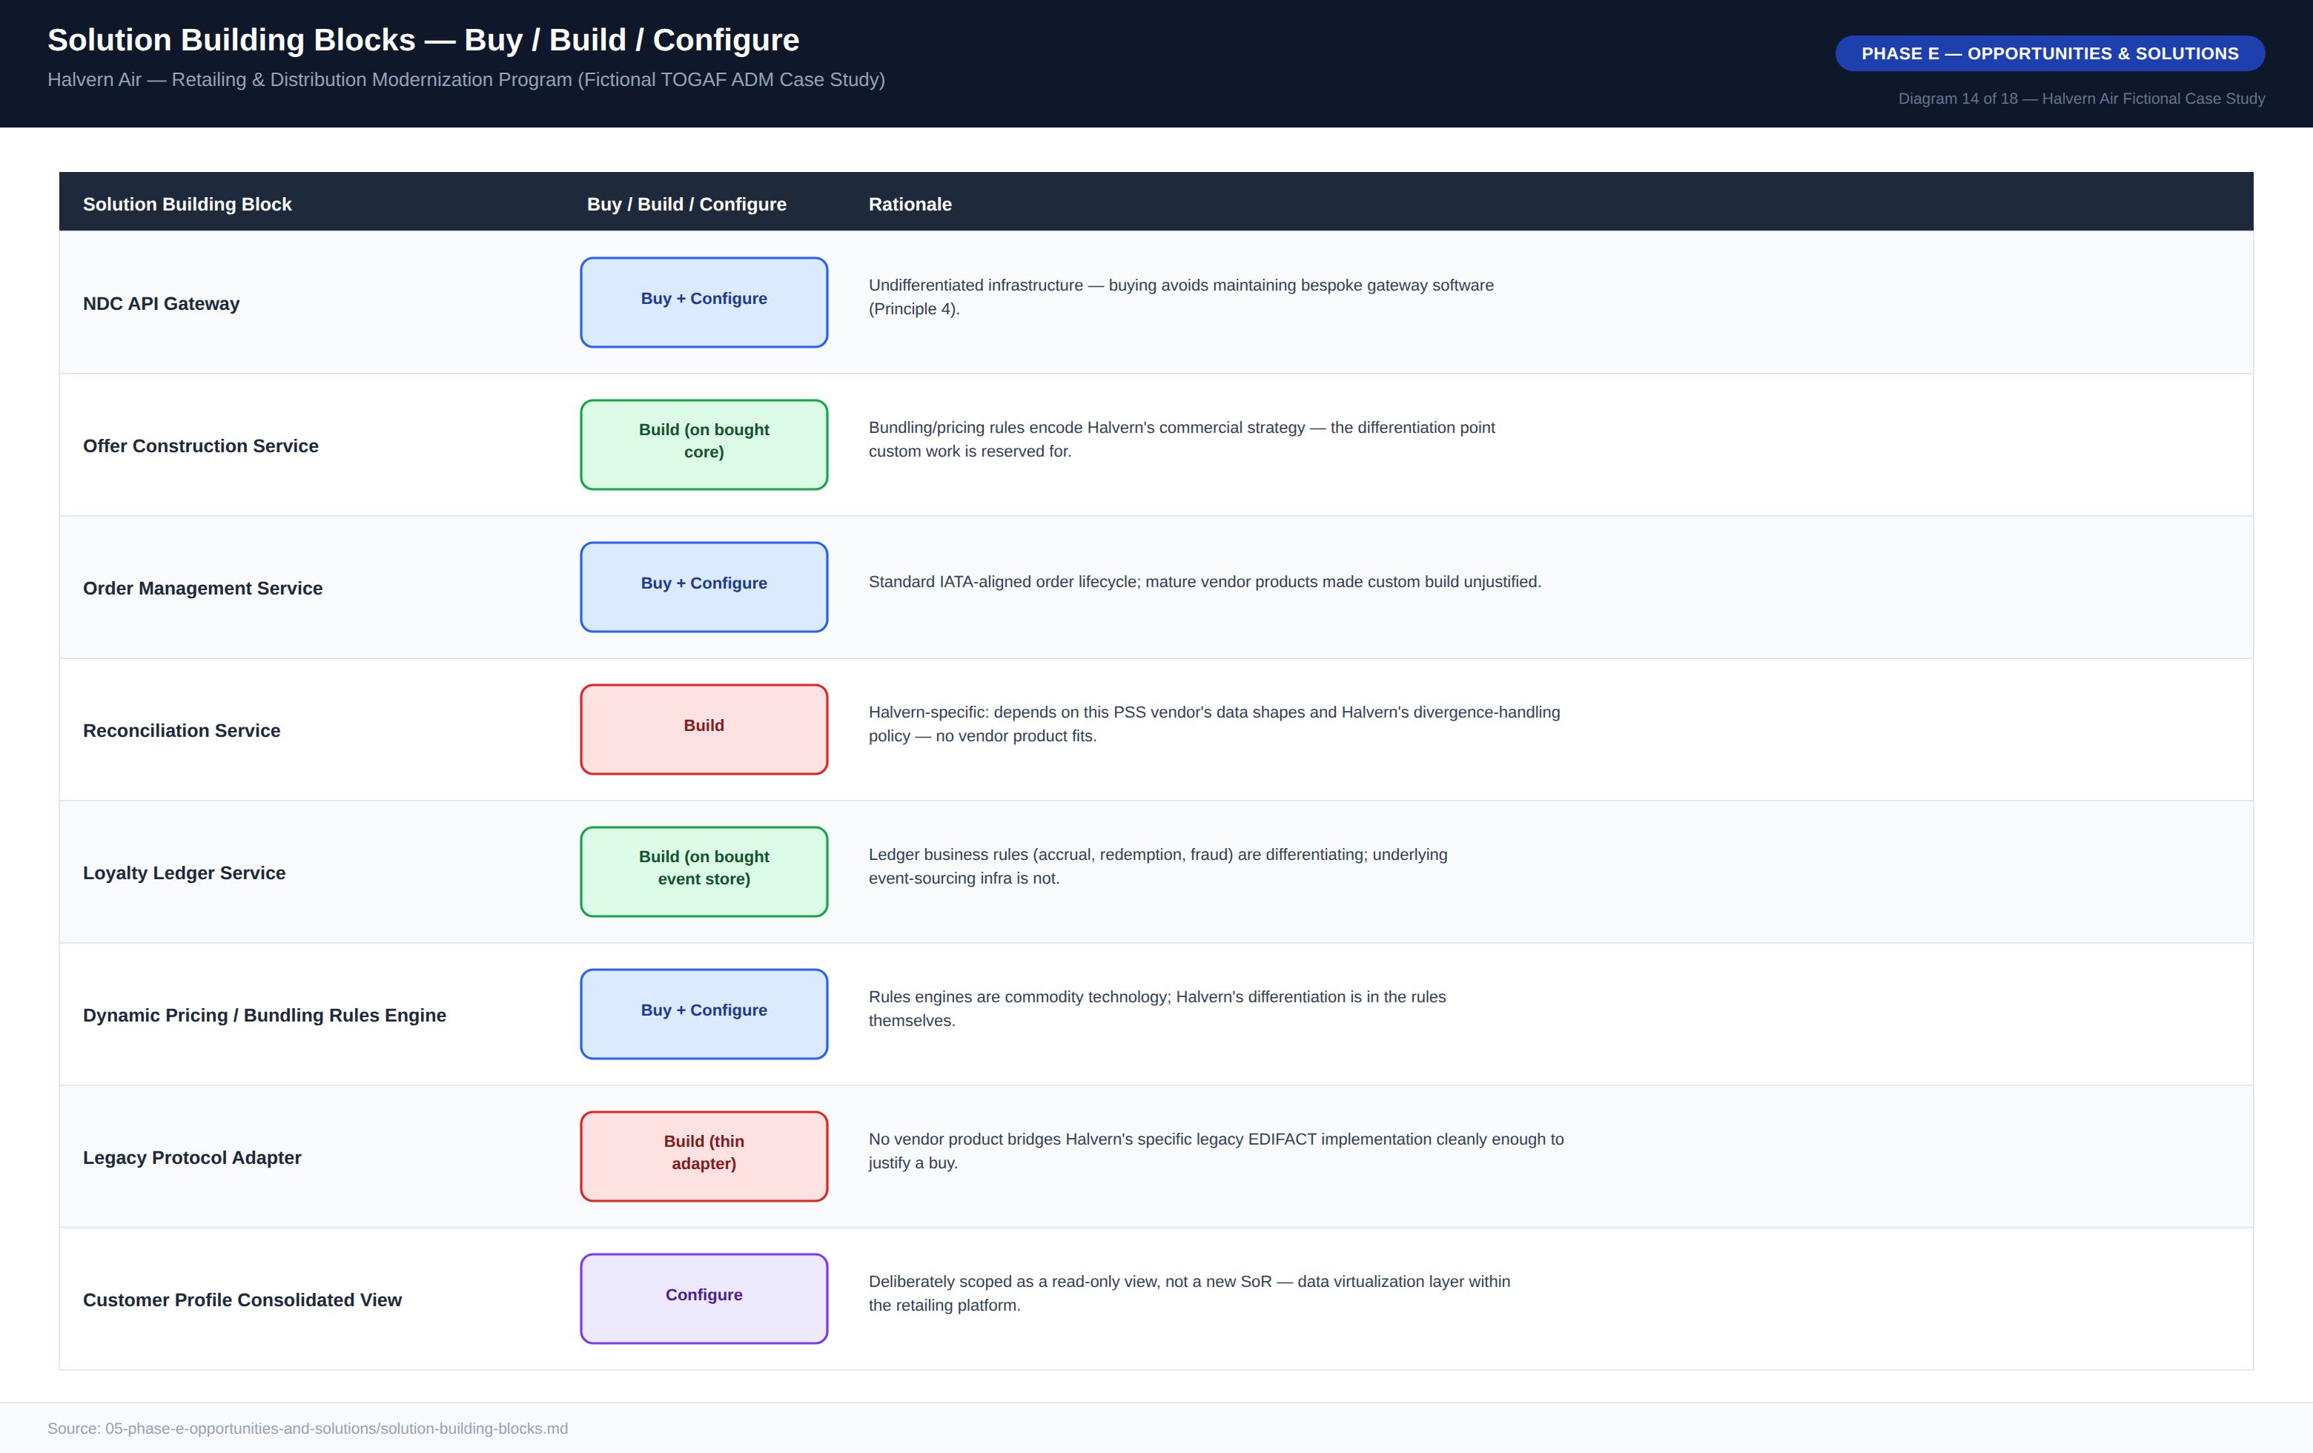
Diagram 14 — Solution Building Blocks, Buy / Build / Configure

7.3 Vendor Evaluation
Four vendors were scored against eight weighted criteria, with NDC schema conformance (20%) and order management maturity (15%) weighted highest given the compliance deadline. Vendor A — Aeronova Retail Suite — is recommended as the core retailing platform with a weighted score of 3.95, ahead of Vendor B (Farepoint Distribution Cloud, 3.70), which was rejected primarily on vendor stability and airline-domain reference risk despite competitive integration-flexibility and timeline scores, and remains the ARB’s documented fallback should Vendor A contract negotiations fail. Vendor D — SkyLedger Systems — scored lowest overall (2.45) as a full platform but highest of any candidate on loyalty-specific capability (5/5), and is recommended as a deliberate best-of-breed selection for the Loyalty Ledger Service alone.
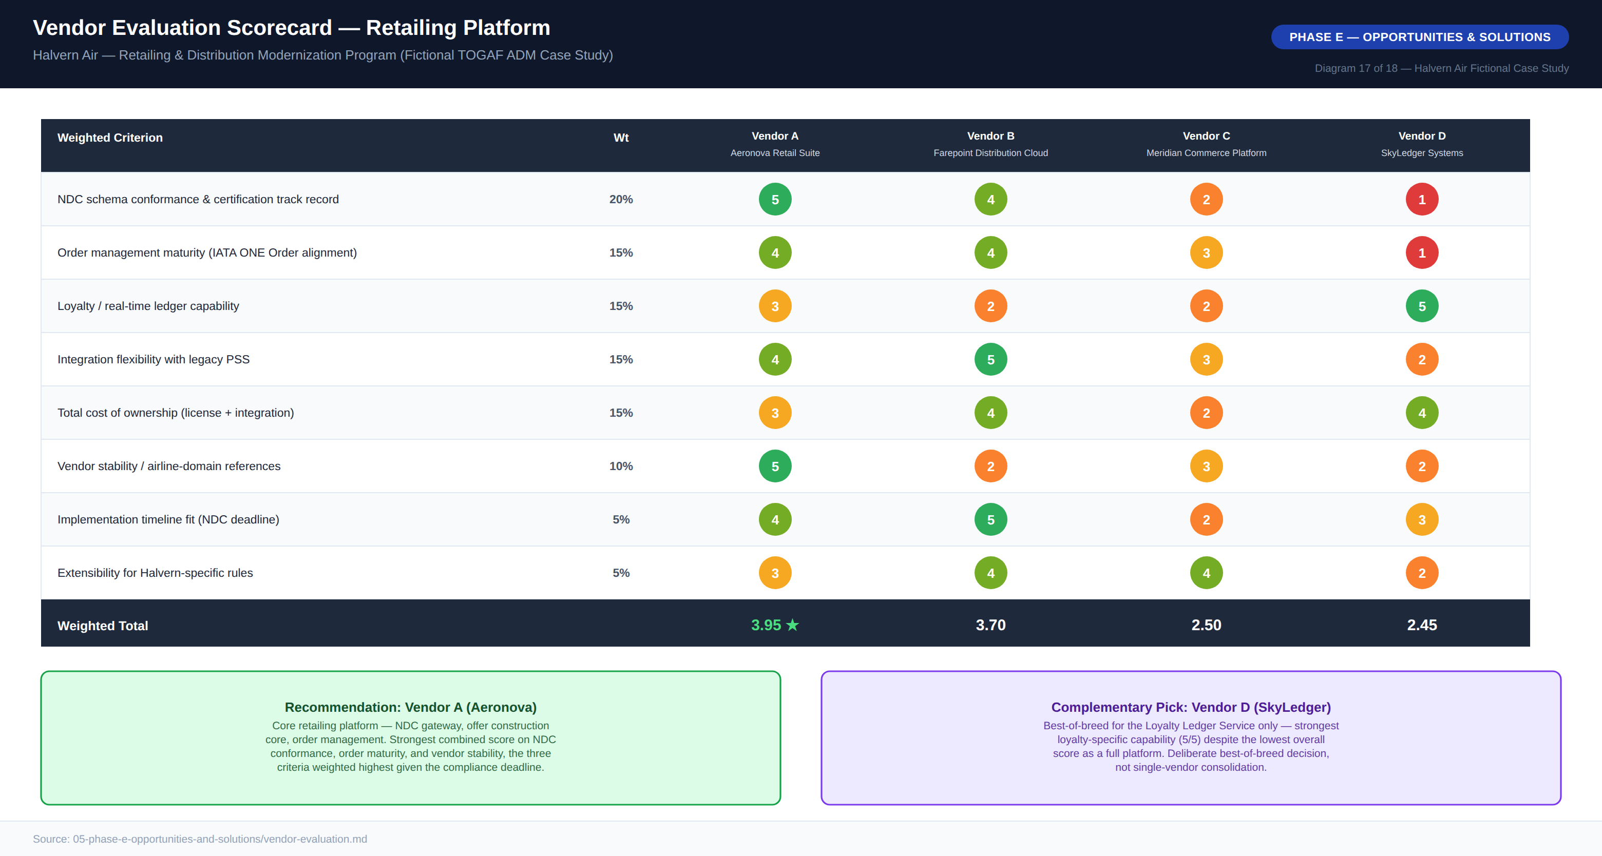
Diagram 17 — Vendor Evaluation Scorecard

8. Phase F — Migration Planning

8.1 Migration Roadmap
The roadmap runs four waves over 24 months, sequenced so that the highest-risk, longest-lead-time, most Halvern-specific components — the Reconciliation Service and core Offer Construction — start earliest, even though they are not user-visible until later waves. An alternative sequencing that would have front-loaded the customer-visible NDC Gateway first, to show early external progress, was considered and rejected by the ARB: standing up channel-facing NDC connectivity before the Reconciliation Service exists would create a period where confirmed NDC orders have no mechanism to reconcile against PSS bookings, an unacceptable operational risk under Architecture Principle 5. Waves deliberately overlap — Wave 2 begins before Wave 1 fully closes — and each wave carries an implicit 10–15% schedule buffer reflected in the business case’s contingency capex line.
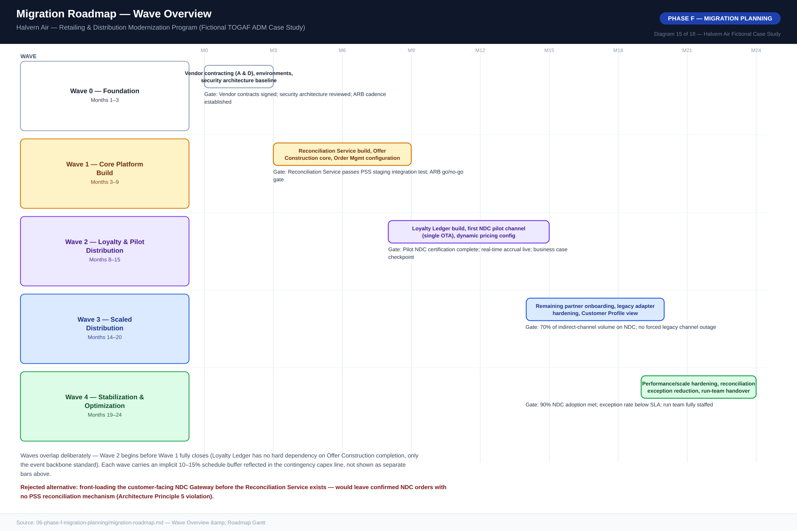
Diagram 15 — Migration Roadmap, Wave Overview

8.2 Transition Architecture — State 1
A 24-month program spent entirely "in between" needs its own architecturally defined intermediate states. Transition State 1, Pilot Parallel Operation, is held for the duration of Wave 2: the Reconciliation Service and Offer Construction core are live in production but limited to a single pilot NDC partner, while the vast majority of booking volume continues through the legacy path with no visibility into the new Order or Offer domains. Two loyalty data paths run concurrently by design — real-time for the pilot channel, legacy batch for everyone else — converging into the same balance projection; this is accepted as necessary, not a defect, and exists specifically to validate reconciliation-rule correctness, real-time ledger behavior, and the business case’s ancillary-revenue assumption under real but contained risk before Wave 3 exposes the pattern to full volume.
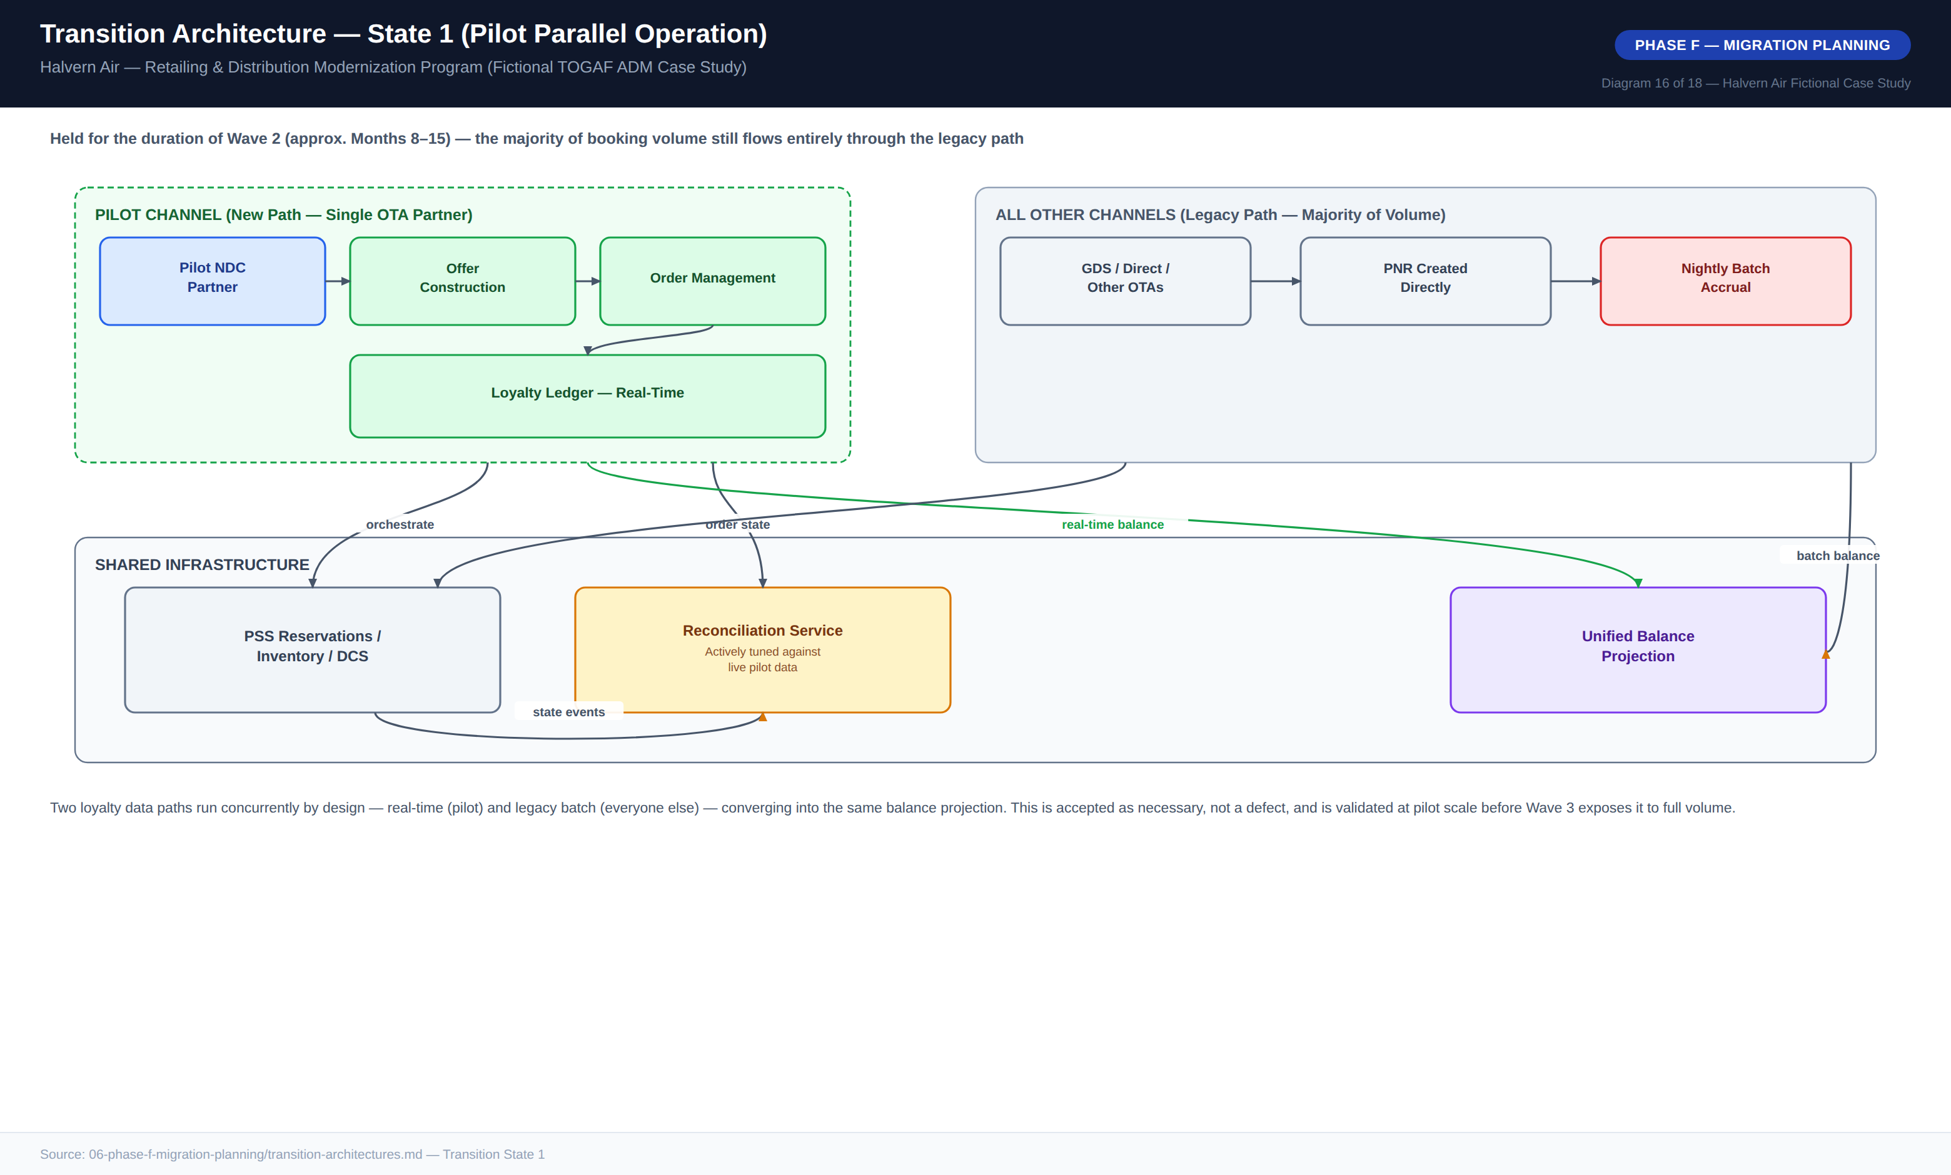
Diagram 16 — Transition Architecture, State 1 (Pilot Parallel Operation)

9. Phase G — Implementation Governance
Phase G governance ensures that what actually gets built during Waves 0–4 conforms to the architecture decided in Phases A–E, rather than drifting under delivery pressure. Five compliance checkpoints apply across the delivery lifecycle: Architecture Contract Sign-Off before build begins, Design Review before implementation, a full ARB Wave Gate Review at the end of each wave, a Production Readiness Review before any component reaches real traffic, and a Post-Implementation Conformance Audit 90 days after each wave’s go-live.

9.1 Non-Compliance Handling
Non-compliance is classified into three severities. A minor deviation is logged as a contract addendum and generally accepted retroactively at the next standing ARB cadence. A material deviation — for example, a component bypassing the reconciliation service or writing directly to a domain it does not own — pauses build work pending an emergency ARB review within five business days. A principle violation with production impact is treated as a Sev-1 governance incident with immediate CISO and CIO escalation and a mandatory rollback.
During Wave 1, a delivery team proposed writing order-completion status directly back into a PSS custom field to simplify a Commercial reporting requirement. This was flagged at Design Review as a material deviation — a second, unapproved write path into the PSS, violating Architecture Principles 1 and 11. The ARB rejected the shortcut and directed the team to satisfy the reporting need via the Reconciliation Service’s existing event stream instead, a one-week delay against an estimated multi-month cost of unwinding an undocumented PSS write path had it shipped undiscovered.

9.2 Architecture Contracts
An architecture contract is the formal agreement between the ARB and a delivery team, translating an approved Solution Building Block into an accountable delivery commitment. Every contract states its scope, its alignment against each of the twelve principles, its reference-architecture conformance, its data-ownership statement, its integration contracts, its non-functional requirements, applicable governance checkpoints, acceptance criteria, and named accountable parties. The worked example for the Reconciliation Service (Contract AC-2026-014) sets a reconciliation-detection latency target of 10 minutes under normal load, a manual-exception rate below 2% by end of Wave 2, and 99.9% availability, consistent with its position as a dependency for Order confirmation across every channel. This formality was a deliberate choice: a lighter, verbal or chat-thread agreement model used earlier in Halvern’s history was explicitly rejected for this program after post-incident reviews traced root cause, in two prior integration failures, to ambiguity over which team owned ongoing conformance once a component moved into steady-state operation.

10. Phase H — Change Management
An architecture that is technically correct but organizationally unadopted delivers none of the business case’s projected value — the ancillary revenue uplift and distribution-cost savings depend entirely on Revenue Management, Distribution/Commercial, and Loyalty & Customer actually using the new capabilities as designed. This plan treats organizational adoption as a first-class deliverable with the same governance rigor as the technical architecture.
Stakeholder Group | Nature of Change | Severity
Revenue Management | Gains ownership of bundling/dynamic pricing rules configuration — a genuinely new skill | High
Distribution / Commercial | Shifts from IT-dependent bespoke projects to self-service partner onboarding | High
Loyalty & Customer | Gains real-time visibility and control; must retire the vendor batch-cycle mental model | Medium-High
Contact Center / Frontline | New tools for real-time redemption alongside legacy PNR tools during transition | Medium
IT / PSS Operations | Insulated from most channel-driven change; must operate the new reconciliation service | Medium
Finance / FP&A | New Order-based reporting model alongside continued PNR-based reporting | Medium
A change champions network — one nominated representative per affected business function — was established specifically to surface adoption friction early, modeled on a prior Halvern change program where the absence of such a network was identified as a contributing factor to slow adoption. Adoption metrics are reviewed alongside the technical wave-gate criteria at each ARB gate review: a wave is not considered fully successful on adoption grounds alone if the technical criteria pass but adoption metrics lag, and the Program Steering Committee has authority to direct additional change management investment before authorizing the next wave’s capital release.

11. Architecture Decision Records
Five ADRs anchor the architecturally significant decisions in this program. Each follows the standard Status / Context / Decision / Alternatives Considered / Consequences / Governance Impact format and is cross-referenced from the architecture contracts and technology standards that depend on it.

ADR-001: Retailing Platform in Front of PSS, Not Full Replacement
A new retailing platform sits in front of the existing PSS, which remains system of record. Full replacement was rejected on timeline (3–5 years vs. a 24-month deadline), cutover risk, and cost (an estimated 3–5x this program’s capex). Accepted trade-off: an 18–24 month dual-data-model period requiring a reconciliation layer.

ADR-002: Offer & Order Owned by the Retailing Platform, Not the PSS
Offer and Order are first-class domains owned by the new platform, aligned to IATA ONE Order, kept consistent with the PNR via reconciliation rather than merged into one model. Extending the PNR schema directly was rejected as a workaround that would permanently couple Halvern to the PSS vendor’s schema roadmap.

ADR-003: Asynchronous, Event-Driven Reconciliation Between Order and PNR
Reconciliation consumes state-change events from both domains and either auto-resolves within a bounded window or flags for manual review — no synchronous two-phase commit (rejected: no PSS API support, and would couple order confirmation availability to PSS uptime) and no nightly batch (rejected: a 24-hour detection window is unacceptable for confirmed commercial orders).

ADR-004: Event-Sourced, Append-Only Loyalty Ledger
Every accrual/redemption is an immutable ledger event; balance is a derived projection. A simpler mutable-balance-with-locking design was rejected because it solves double-spend but not the auditability requirement that is itself a named business driver.

ADR-005: NDC API Versioning — Parallel-Version Support, Not Forced Migration
The gateway supports N and N-1 major schema versions concurrently with a minimum 12-month deprecation notice. A single-current-version design was rejected as putting the entire distribution channel at the mercy of the slowest partner’s re-certification speed.

Appendix A — Diagram Catalog Index
The full reference diagram catalog for this program comprises 18 diagrams spanning the Preliminary Phase through Phase F, delivered as high-resolution PNG files alongside this document.
No. | Diagram Title | ADM Phase
01 | Architecture Vision One-Pager | Phase A
02 | Stakeholder Power / Interest Map | Phase A
03 | Architecture Governance Organization | Preliminary
04 | Business Capability Map, Maturity Heat Map | Phase B
05 | Business Process Flow, As-Is (Shop-to-Book) | Phase B
06 | Business Process Flow, To-Be (Shop-to-Book) | Phase B
07 | Business Footprint Diagram | Phase B
08 | Application Communication Diagram, As-Is | Phase C
09 | Application Communication Diagram, To-Be | Phase C
10 | Data Flow Diagram, To-Be | Phase C
11 | Data Ownership / Domain Diagram | Phase C
12 | Reference Architecture Pattern | Phase D
13 | Technology Standards Stack | Phase D
14 | Solution Building Blocks, Buy / Build / Configure | Phase E
15 | Migration Roadmap, Wave Overview | Phase F
16 | Transition Architecture, State 1 | Phase F
17 | Vendor Evaluation Scorecard | Phase E
18 | Business Case Financial Summary | Phase A

Appendix B — Disclaimer
This entire document — Halvern Air, all named individuals and roles, all vendor names (Aeronova Retail Suite, Farepoint Distribution Cloud, Meridian Commerce Platform, SkyLedger Systems), and every dollar figure, metric, and date — is a fictional case study constructed for architecture-practice demonstration purposes. Figures are designed to be internally consistent and arithmetically sound so that the reasoning pattern is transparent, not to represent any real airline’s actual data. No inference should be drawn about any real company, product, or individual.

