TORVANE MOBILITY GROUP
Dealer Network & Connected Vehicle Platform Modernization
Enterprise Architecture Definition Document
A TOGAF Architecture Development Method (ADM) Case Study
Preliminary Phase through Phase H — Full ADM Cycle
Prepared by: Enterprise Architecture Function
Document Reference: TMG-EA-DCP-001 | Version 1.0
August 2026
FICTIONAL CASE STUDY — Torvane Mobility Group, all named individuals, and all figures in this document are invented for demonstration and portfolio purposes. This document does not describe any real automotive OEM, and no figures herein should be relied upon as real-world data.

Table of Contents
1. Executive Summary 4
2. Preliminary Phase — Governance & Principles 5
2.1 Architecture Principles 5
2.2 Governance Framework Setup 5
3. Phase A — Architecture Vision & Scope 7
3.1 Problem Statement & Target-State Vision 7
3.2 Scope Boundaries 7
3.3 Success Metrics 8
3.4 Stakeholder Map 8
3.5 Business Case Summary 9
4. Phase B — Business Architecture 11
4.1 As-Is Business Architecture 11
4.2 To-Be Business Architecture 11
4.3 Business Capability Map 12
4.4 Business Footprint 13
5. Phase C — Information Systems Architecture 15
5.1 Application Architecture 15
5.2 Data Architecture 16
5.3 Data Ownership / Domains 17
6. Phase D — Technology Architecture 19
6.1 Reference Architecture Pattern 19
6.2 Technology Standards 19
7. Phase E — Opportunities & Solutions 21
7.1 Gap Analysis 21
7.2 Solution Building Blocks 21
7.3 Vendor Evaluation 22
8. Phase F — Migration Planning 23
8.1 Migration Roadmap 23
8.2 Transition Architecture — State T2 23
9. Phase G — Implementation Governance 25
9.1 Non-Compliance Handling 25
9.2 Architecture Contracts 25
10. Phase H — Change Management 26
11. Architecture Decision Records 27
Appendix A — Diagram Catalog Index 28
Appendix B — Disclaimer 29

1. Executive Summary
Torvane Mobility Group runs on a 15-year-old, on-premises Dealer Management System (DMS) monolith with no real-time cross-dealer inventory visibility across its roughly 600 franchised dealers. Any dealer needing to check whether another dealer holds a matching vehicle must call, fax, or email — a manual process with no service-level commitment — and the resulting inventory blindness is estimated to cost $1.8M per year in lost sales. At the same time, Torvane’s EV and connected-vehicle telemetry pipeline was architected for the current fleet volume and cannot scale to the growth already underway, and the parts supply chain runs on 24–48 hour batch EDI with no real-time visibility into supplier stock or in-transit status.
The Enterprise Architecture function recommends an event-driven integration backbone positioned in front of the existing DMS core — not a DMS replacement. Domain-owned services publish events that independent consumers subscribe to, letting cross-dealer inventory visibility, EV telemetry ingestion, and parts ordering all modernize without a single, high-stakes DMS cutover. A full big-bang DMS replacement was evaluated and rejected (ADR-001) as carrying an unacceptable single point of failure across 600 dealers in one cutover event; indefinite parallel systems and a function-first migration were also rejected. The recommended approach delivers across six migration waves over three years with no forced outage of dealer operations at any point.
The program is estimated at $28.03M in total cost over three years — roughly $1.4M more than the $26.66M three-year cost of doing nothing — with steady-state annual savings of $2.32M once fully live, principally from inventory-visibility lost-sales recovery, parts batch-process labor and expediting cost avoidance, and legacy vendor license retirement. Payback is approximately seven months after go-live, and the five-year total cost of ownership comparison shows a net savings of $3.26M versus the as-is trajectory — roughly 236% return on investment over five years. A downside case modeling a 20% cost overrun and 25% lower savings still yields payback by Year 4, Month 4 and a five-year ROI of approximately 95%. The Program Steering Committee approved the business case with a checkpoint at the Wave 2 gate to validate early lost-sales-recovery results before releasing further capital.
This document is the consolidated Architecture Definition Document for the program, compiled across all phases of the TOGAF Architecture Development Method — Preliminary Phase governance setup through Phase H change management — and is intended as a single, self-contained reference of the architecture, its rationale, and its governance.

2. Preliminary Phase — Governance & Principles
Before Phase A vision work began, Torvane’s CDTO (Chief Digital & Technology Officer) chartered an Architecture Review Board (ARB) and a governance framework, specifically to avoid repeating the pattern that produced the current fragmented DMS landscape: multiple regional and functional teams making locally optimal, globally inconsistent integration decisions with no forum for cross-cutting review.

2.1 Architecture Principles
Twelve architecture principles were ratified by the ARB and govern every subsequent decision in this program. Each ADR and architecture contract in this document cites these principles by number.
# | Principle | Statement (Condensed)
1 | Dealer Operations Continuity Is Non-Negotiable | No architecture decision may risk an outage or degradation of core dealer sales, service, or parts operations for any franchised dealer.
2 | Data Is a Shared Enterprise Asset | Data domains are modeled and owned for enterprise-wide reuse, not siloed to the team or region that first created them.
3 | Buy Commodity, Build Differentiated | Undifferentiated capability is bought and configured; custom build is reserved for Torvane’s commercial differentiation logic.
4 | Design for Eventual Consistency | No component may assume synchronous, single-transaction consistency across the DMS core and the new platforms.
5 | Security and Privacy Are Designed In | Security and privacy controls are integral to architecture design, not retrofitted after build.
6 | Loosely Coupled, Independently Deployable Services | Services are built to be deployed, scaled, and changed independently of one another.
7 | Architecture Decisions Are Explicit and Recorded | Every architecturally significant decision is an ADR, reviewed at each quarterly principles review.
8 | Cloud-Native by Default | New platform components are built cloud-native unless an explicit, ARB-approved exception applies.
9 | Interoperate Through Standards | Integration uses approved open standards and schemas rather than bespoke, point-to-point protocols.
10 | Architecture Serves Measurable Outcomes | Every architecturally significant investment is tied to a measurable business outcome tracked at wave gates.
11 | Minimize Data Duplication | Each data domain has exactly one designated system of record; all others hold read-only views or event-derived projections.
12 | Design for Resilience to Regional and Vendor Failure | Multi-region and multi-vendor failure modes are considered explicit design inputs, not incident-response afterthoughts.

2.2 Governance Framework Setup
The ARB is chaired by the VP of Enterprise Architecture and has seven standing voting members: the Chair; the CISO; VP Dealer Operations; VP Connected Vehicle & Telematics; Head of Data Governance; Director of Cloud Platform Engineering; and a Finance Business Partner. Two non-voting advisory seats are held for delivery leads and dealer-operations advisory input when their workstream is on the agenda. The Program Sponsor (CDTO) chairs the Program Steering Committee and receives ARB minutes but does not sit on the ARB itself, preserving separation between sponsorship and architecture governance.
The ARB operates on four cadences: a biweekly, 90-minute standing review; an ad hoc path resolving time-sensitive items within three business days; a quarterly review of the principles and the ADR log; and a formal go/no-go review at each migration wave boundary. Escalation runs from Solution Architect / delivery level, to the standing ARB, to the Program Steering Committee (chaired by the CDTO) for any decision with material capital or timeline impact, and finally to cross-program CDTO arbitration if the Steering Committee cannot resolve it. A waiver process allows a documented exception to any principle for up to twelve months, subject to four stated requirements and ARB majority vote.
This structure — light enough to run biweekly without becoming a bottleneck, but with a documented four-step escalation path to executive sponsorship — was a deliberate trade-off. A heavier, weekly-review model was considered and rejected: at peak, with multiple regional delivery workstreams active simultaneously, a weekly cadence was projected to add meaningful coordination overhead for marginal additional risk reduction.
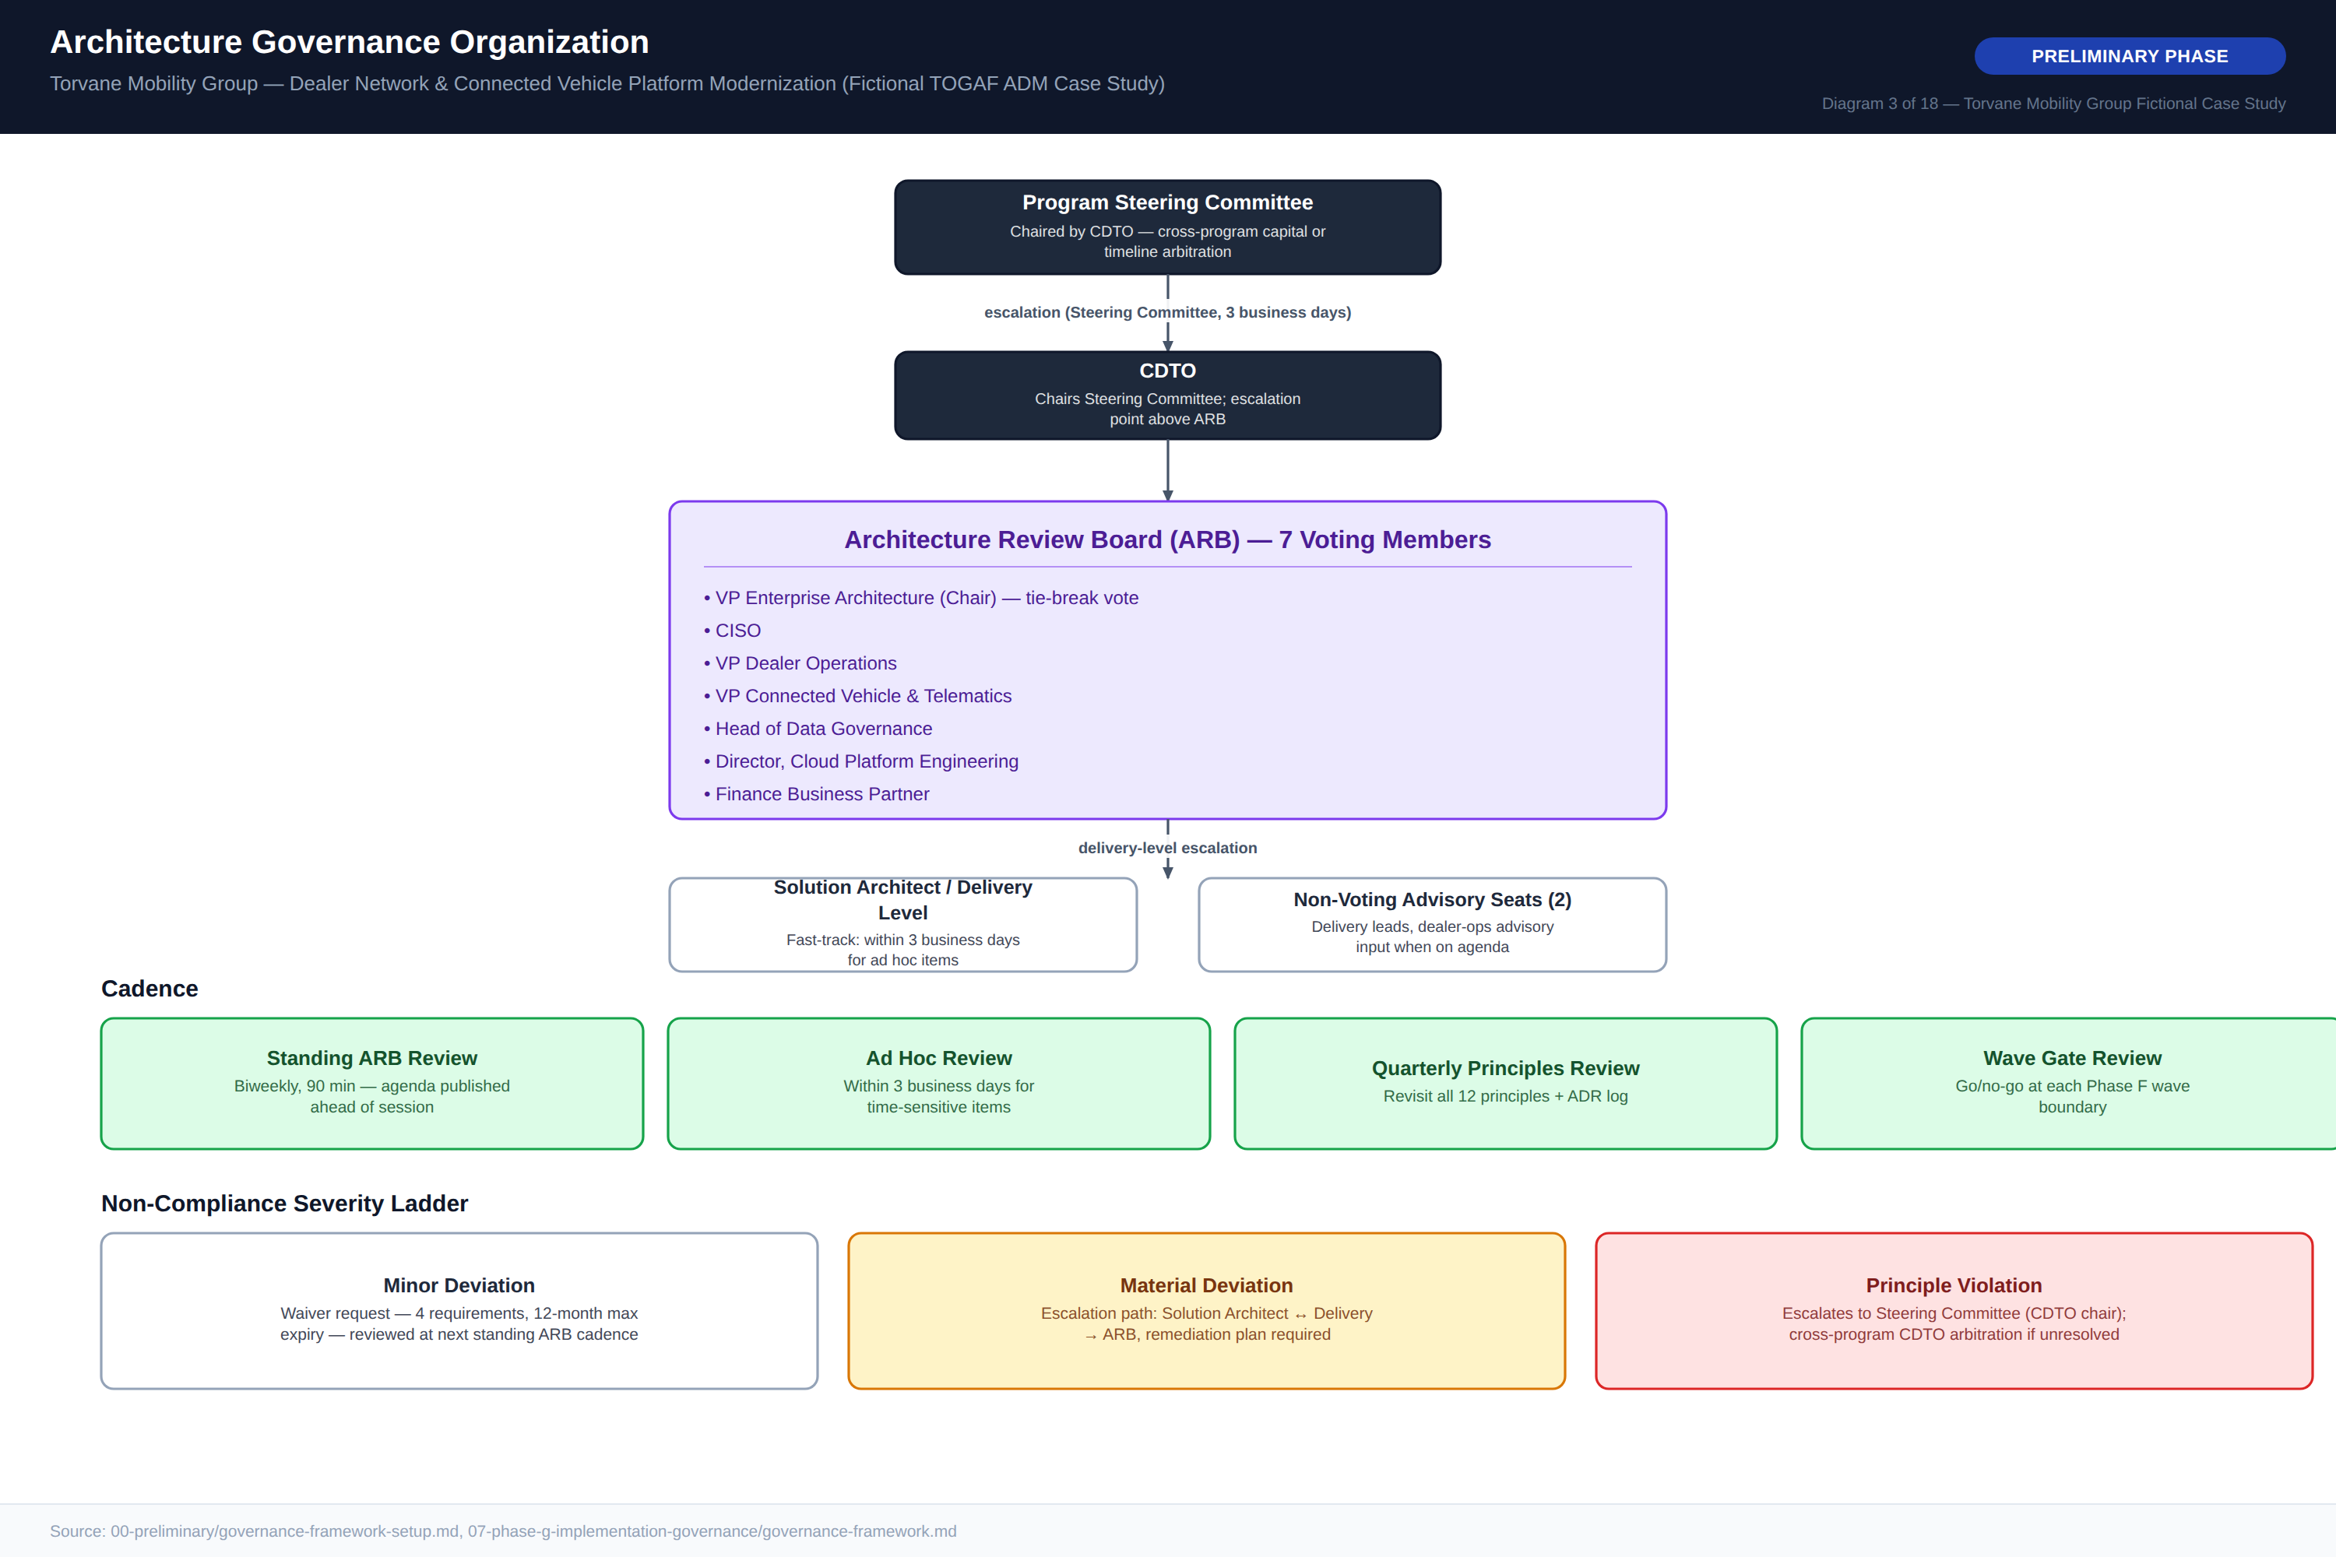
Diagram 3 — Architecture Governance Organization

3. Phase A — Architecture Vision & Scope

3.1 Problem Statement & Target-State Vision
Torvane’s DMS landscape was assembled roughly 15 years ago as an on-premises monolith with no shared cross-dealer inventory model. It supports single-dealer inventory management reliably but has no service for cross-dealer visibility, forcing every transfer inquiry across the ~600-dealer network into a manual phone, fax, or email process with no SLA. Three forces make this an urgent architecture problem: a commercial gap ($1.8M/year in lost sales from inventory-visibility gaps), a scale gap (the EV/connected-vehicle telemetry pipeline cannot scale past current fleet volume even as EV production grows), and a supply-chain gap (24–48 hour batch-only parts EDI with no real-time supplier visibility).
By program end, Torvane will offer sub-30-second cross-dealer inventory visibility via an event-sourced read model; support EV/connected-vehicle telemetry ingestion at 100,000+ vehicle capacity — five times current volume; complete parts orders in under 15 minutes via a real-time/EDI-hybrid integration; and run the new platform at 99.9% availability with a 15-minute recovery time objective across multiple regions. The vision is deliberately evolutionary: the DMS core continues doing what it does reliably — title-adjacent recordkeeping, financing-adjacent workflows, and service-bay operations — while a new integration layer progressively takes over cross-dealer visibility and telemetry logic.
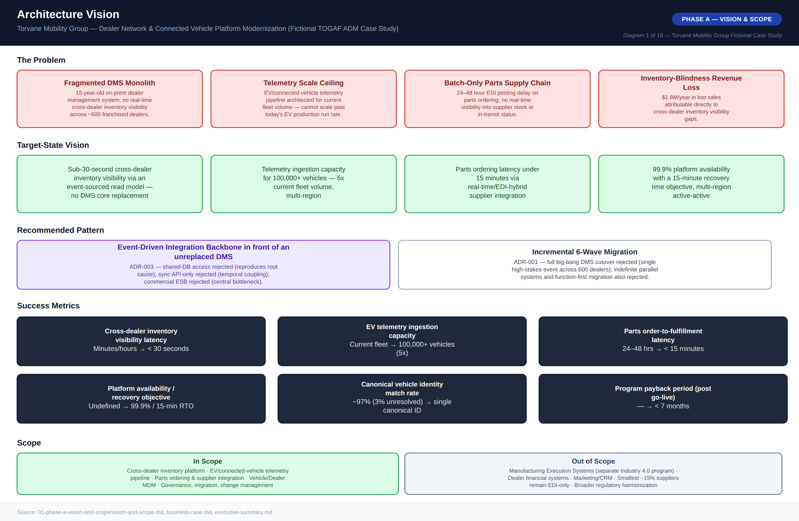
Diagram 1 — Architecture Vision One-Pager

3.2 Scope Boundaries
In scope: the cross-dealer inventory platform (event-sourced read model, real-time visibility); the EV/connected-vehicle telemetry ingestion pipeline; parts ordering and supplier integration; Vehicle/Dealer Master Data Management; and the governance, migration, and change management required to deliver all of the above.
Explicitly out of scope, each evaluated and excluded specifically to keep the three-year program focused: Manufacturing Execution Systems, which are addressed by a separate Industry 4.0 program; dealer financial systems; marketing and CRM systems; the smallest roughly 15% of parts suppliers, who remain on EDI-only integration rather than being migrated to real-time; and broader regulatory harmonization work beyond what this program’s scope requires.

3.3 Success Metrics
Metric | Baseline (Today) | Target (Program End)
Cross-dealer inventory visibility latency | Minutes to hours (manual) | < 30 seconds
EV/connected-vehicle telemetry ingestion capacity | Current fleet volume | 100,000+ vehicles (5x)
Parts order-to-fulfillment latency | 24–48 hours (batch EDI) | < 15 minutes
Platform availability / recovery objective | Not formally defined | 99.9% / 15-minute RTO
Canonical vehicle identity match rate | ~97% (4 legacy identifiers, ~3% unresolved) | Single canonical ID, near 100%
Program payback period (post go-live) | N/A | < 7 months

3.4 Stakeholder Map
Fifteen stakeholders were assessed on power and interest to determine engagement strategy, from the CDTO (Program Sponsor, Accountable) and CFO (Accountable/Consulted) through the externally facing Dealer Network Advisory Council — deliberately capped at Consulted/Informed given its status as an external elected body — to the existing DMS vendor (Low/Low, minimal effort). A full RACI matrix governs program-level decisions, anchored by the CDTO as Accountable for delivery risk, the CISO as Accountable for security, and the Head of Data Governance as Responsible for Phase C data-architecture decisions.
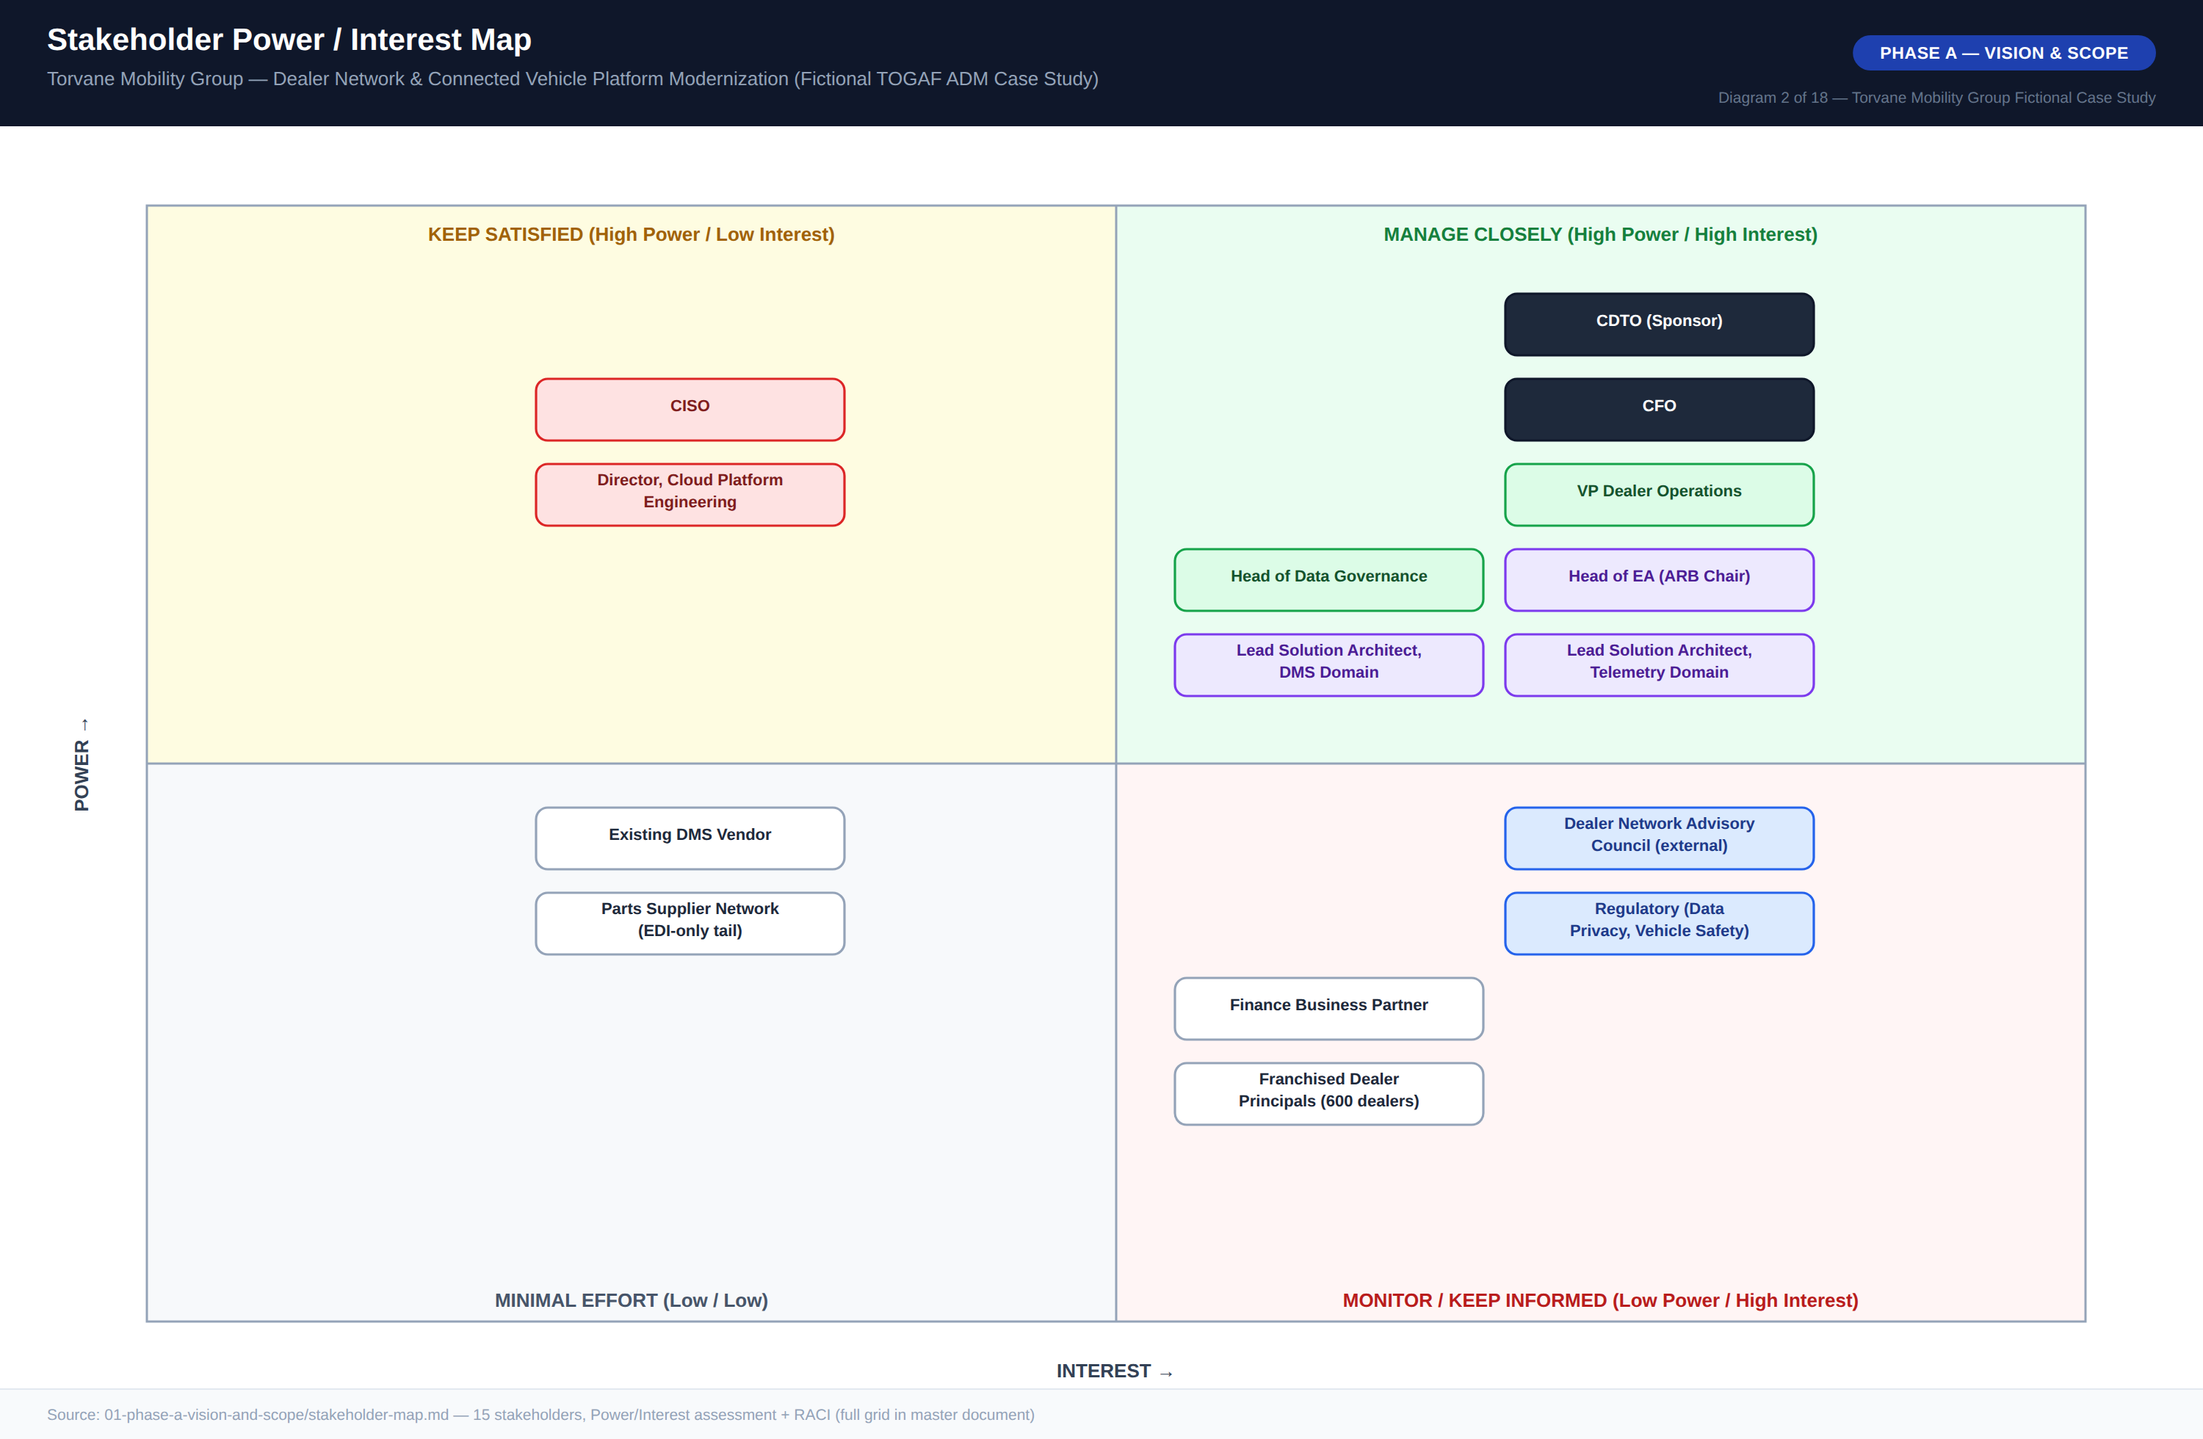
Diagram 2 — Stakeholder Power / Interest Map

3.5 Business Case Summary
The business case totals $28.03M over the three-year program — dominated by the $6.20M integration event backbone and platform build and the $5.80M cross-dealer inventory read model / DMS integration effort — against $3.25M of incremental annual opex and $5.56M of offsetting annual value once at steady state, principally $1.95M/year from parts batch-process labor and expediting cost avoidance and $1.81M/year from legacy DMS/telemetry vendor license retirement. Full breakdown, the five-year TCO comparison against doing nothing, and the payback/ROI calculation appear in Diagram 18 and are reproduced in the corresponding financial tables in Section 7.
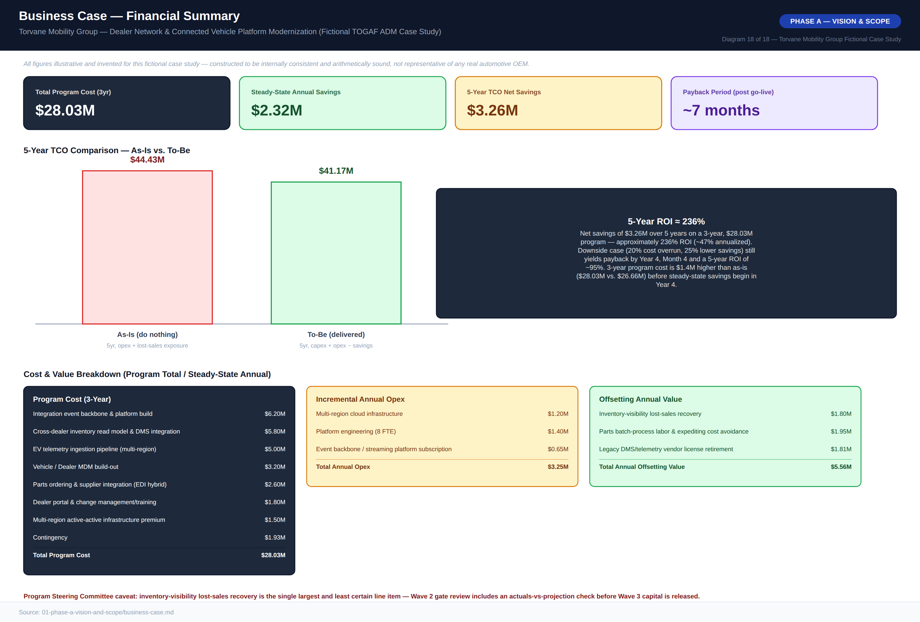
Diagram 18 — Business Case Financial Summary

4. Phase B — Business Architecture

4.1 As-Is Business Architecture
Torvane’s current cross-dealer vehicle transfer process is organized entirely around single-dealer visibility: a dealer can only see its own local DMS inventory. Locating a matching vehicle at another dealer requires a manual phone, fax, or email inquiry with no service-level commitment, followed by manual reconciliation as staff cross-check availability by hand. Confirmed transfers are logged into the DMS only after the fact, via paper or batch process, and the nightly batch DMS sync means inventory state can be stale for up to 24 hours across all ~600 dealers — the direct cause of the $1.8M/year lost-sales estimate.
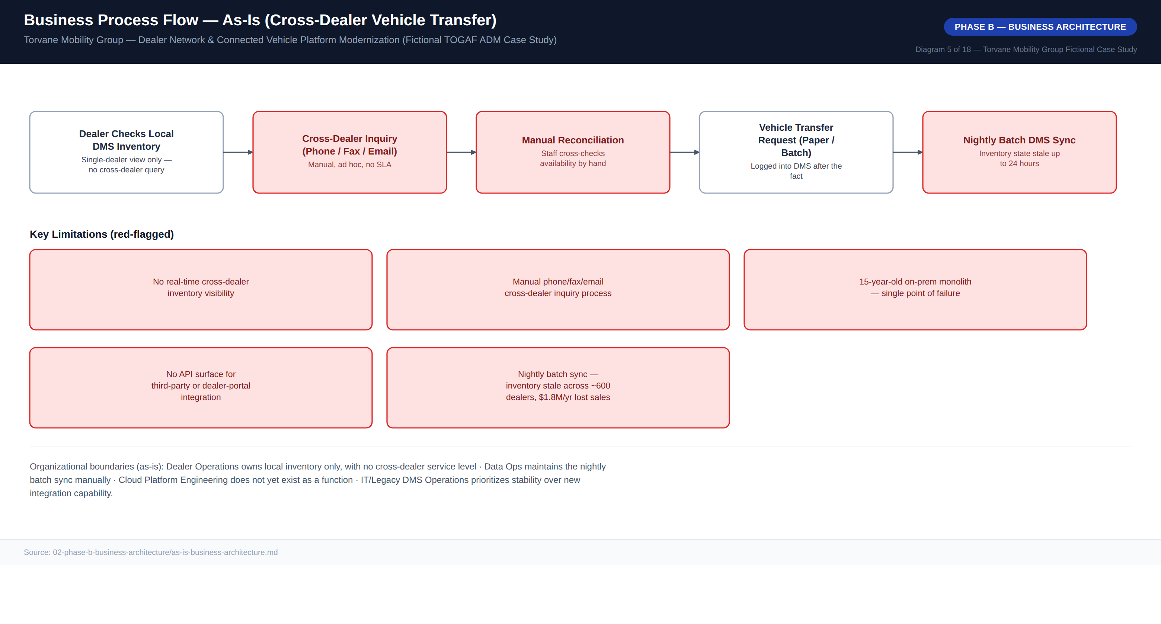
Diagram 5 — Business Process Flow, As-Is (Cross-Dealer Vehicle Transfer)

4.2 To-Be Business Architecture
In the target state, a dealer or customer inventory search on any channel — dealer portal, web, or in-store — reaches a single Cross-Dealer Inventory Read Model, updated on every vehicle.status.changed event published to the event backbone rather than written point-to-point. Real-time availability is confirmed within seconds across all ~600 dealers; a transfer or reservation request is itself published as an event, and inventory state converges everywhere within seconds. What deliberately stays the same: title transfer, financing-adjacent recordkeeping, and service-bay operations remain fully on the DMS core — explicitly excluded from scope under Architecture Principle 1, since dealer operations continuity is non-negotiable.
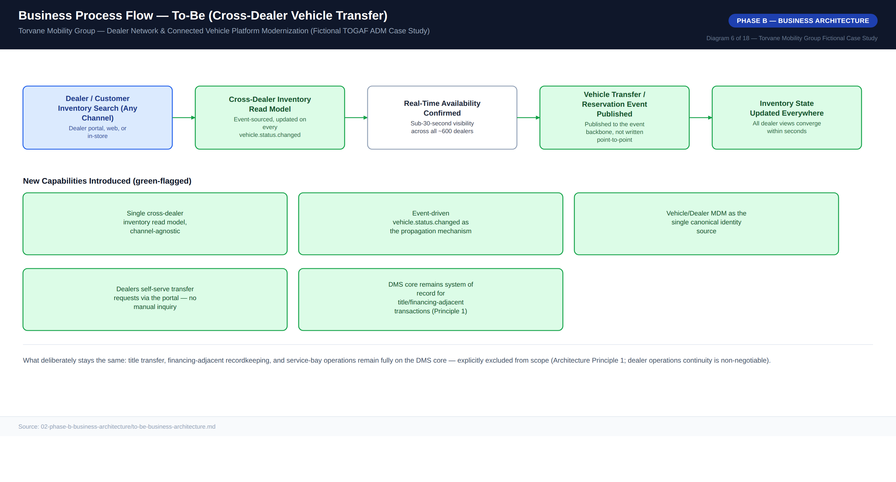
Diagram 6 — Business Process Flow, To-Be (Cross-Dealer Vehicle Transfer)

4.3 Business Capability Map
Thirteen business capabilities were rated by the ARB against comparable regional-OEM benchmarks on a 1–5 maturity scale, As-Is versus Target. Integration Backbone (Event-Driven) carries the single largest gap (1→5), followed by Vehicle Inventory Visibility (Cross-Dealer) and Cloud Platform Operations (both gap of 3) — these three anchor Waves 0 and 1 of the migration roadmap. Capabilities already reasonably mature today, such as Dealer Portal / Sales Workflow and Service Scheduling (both gap of 1), are prioritized later in the roadmap.
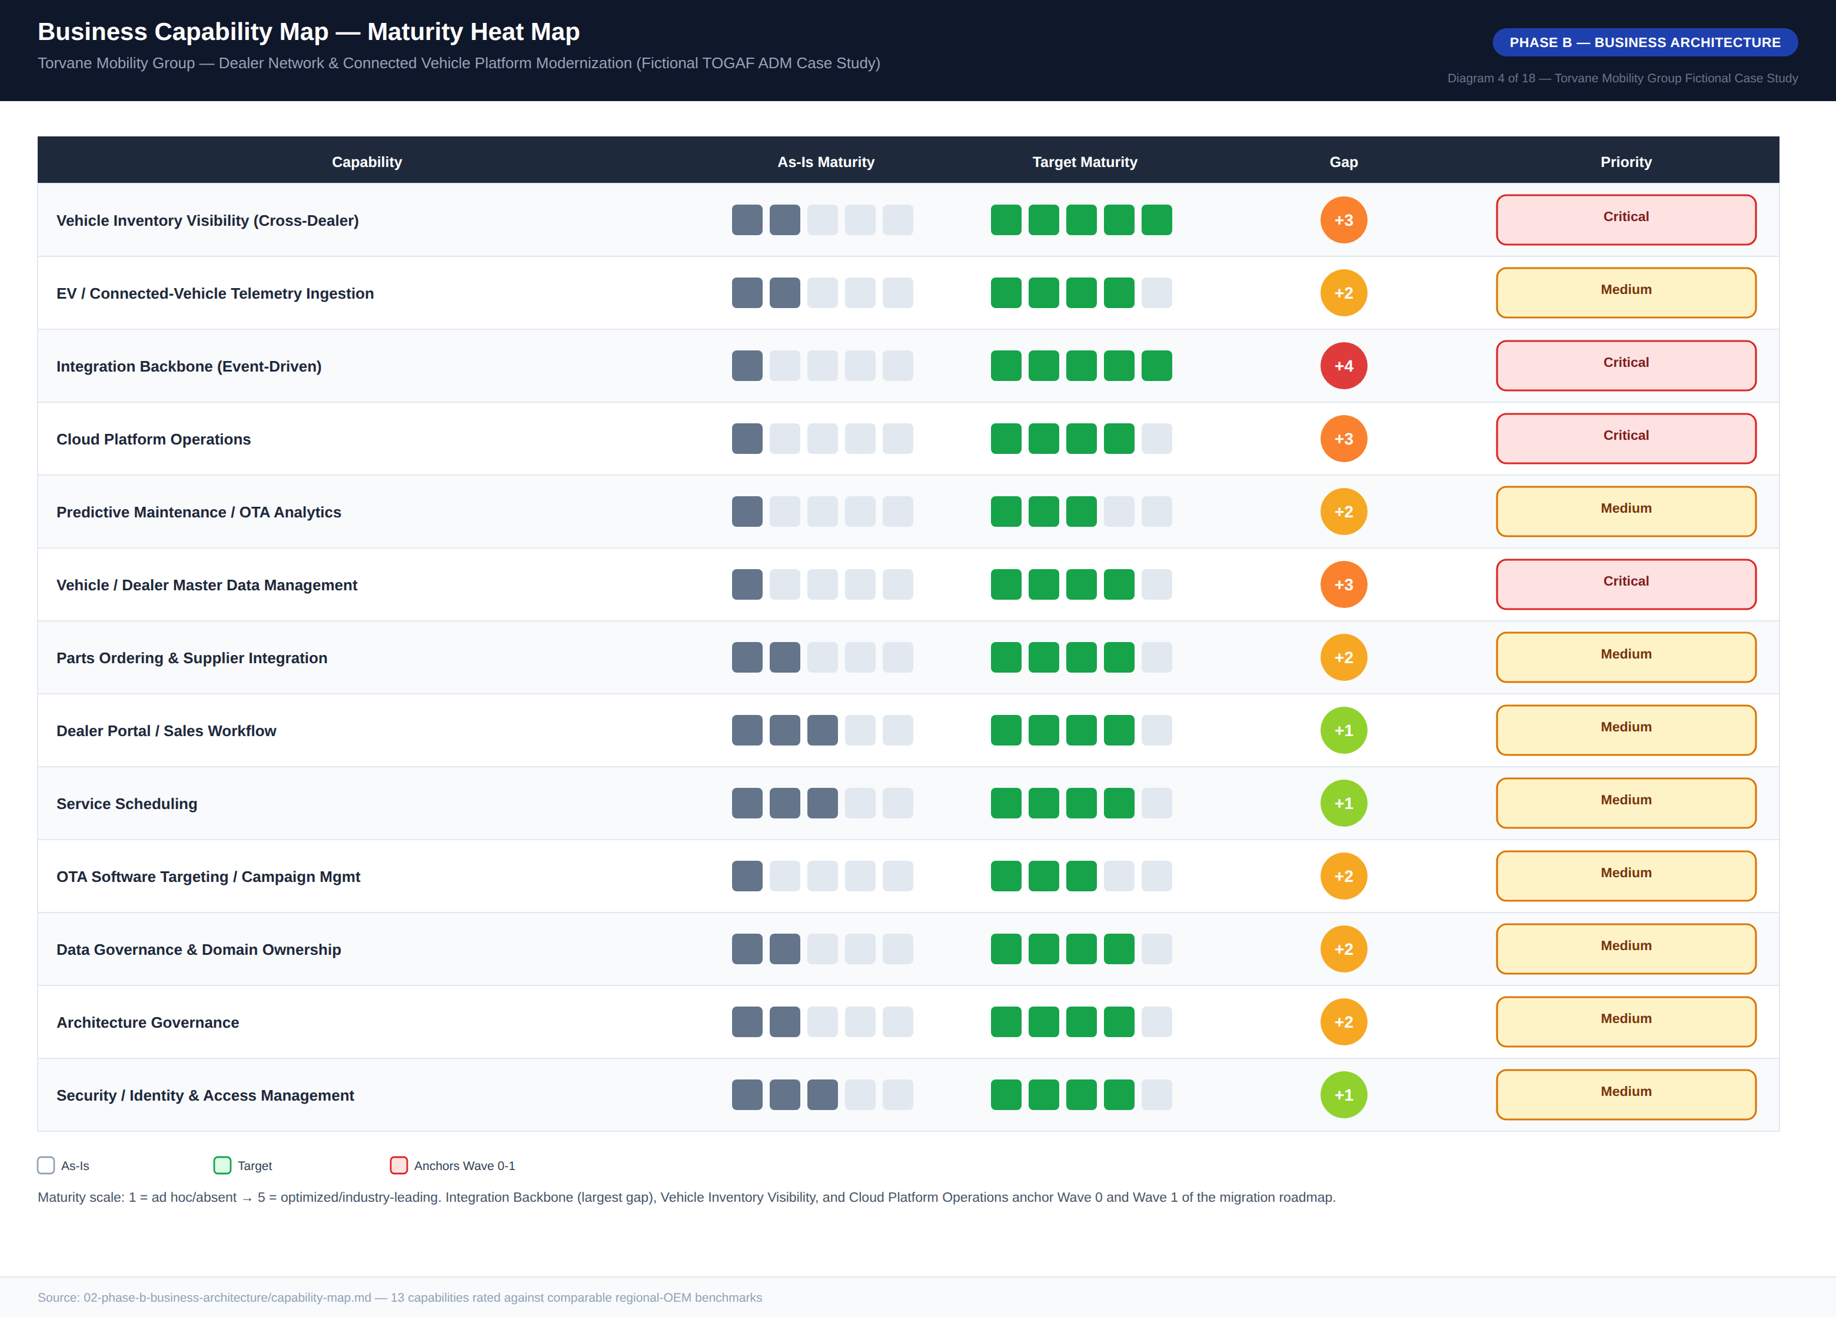
Diagram 4 — Business Capability Map, Maturity Heat Map

4.4 Business Footprint
The business footprint traces each organizational unit through its business function, key process, supporting application, and technology platform — both legacy and net-new. A new function, Connected Vehicle & Telematics, is introduced specifically to own EV telemetry ingestion, predictive maintenance, and OTA software targeting; Data Governance is carried as its own row given the program’s reliance on federated data domain ownership (ADR-004); Architecture & Governance is carried separately given the program’s reliance on the ARB for cross-cutting decision rights.
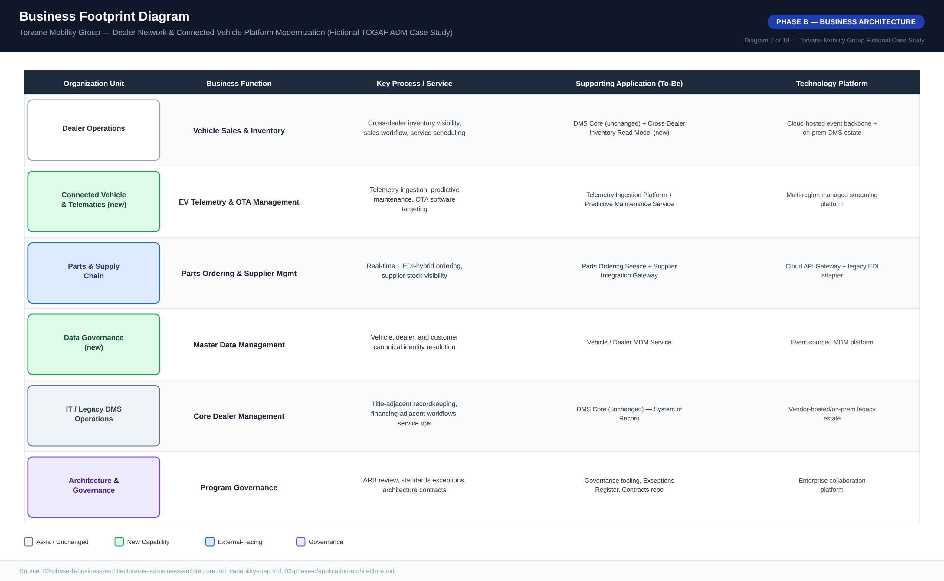
Diagram 7 — Business Footprint Diagram

5. Phase C — Information Systems Architecture

5.1 Application Architecture
The as-is application landscape is dominated by the Core DMS — three loosely coupled modules (Inventory, Sales/F&I, Service Scheduling) integrated through the vendor’s proprietary internal messaging — surrounded by a constellation of point solutions with no API gateway, no shared integration platform, and no service that any two applications both depend on: a capacity-bound, single-region Telemetry Ingestion Platform; a batch-only EDI Gateway for parts; four divergent regional dealer portals with no shared inventory read model between them; and a legacy vehicle ID registry with four independent identifier schemes and roughly 3% unresolved match rate. Every connection is genuinely point-to-point, the direct cause of the linear integration-maintenance cost growth this program is designed to eliminate.
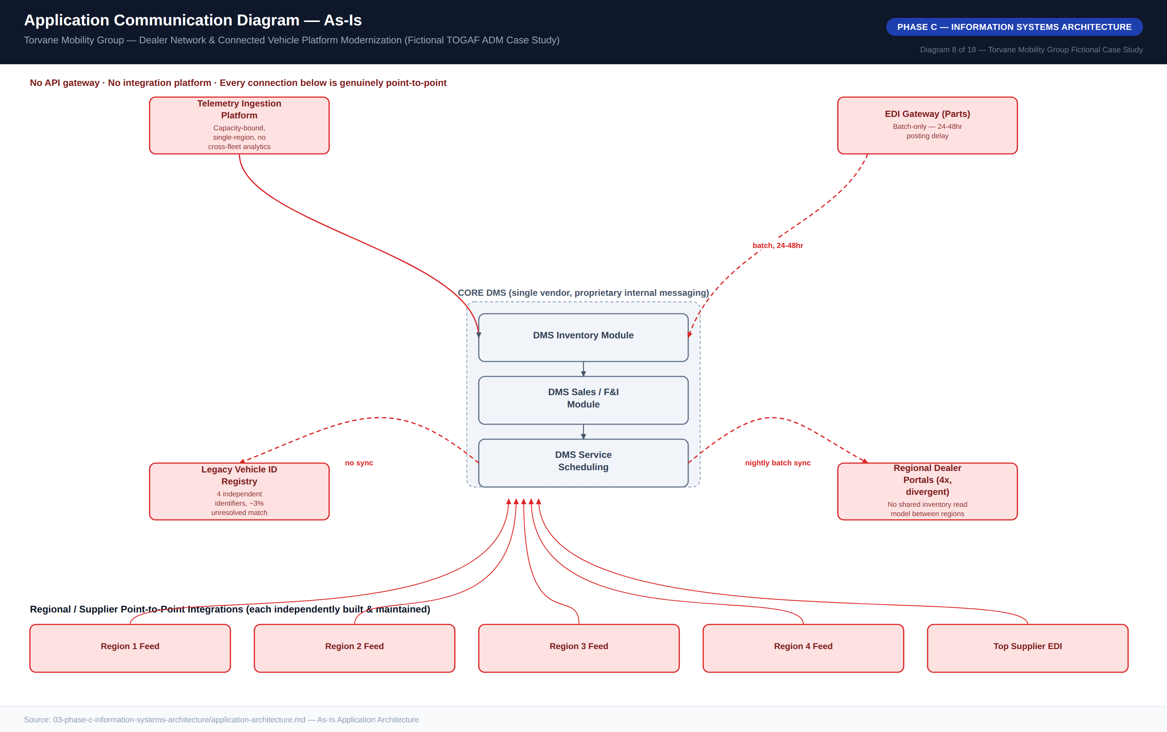
Diagram 8 — Application Communication Diagram, As-Is
The to-be architecture introduces an Integration Event Backbone as a new application layer decomposed into four components — Cross-Dealer Inventory Service, Parts Ordering Service, Telemetry Ingestion, and a transitional DMS Reconciliation Bridge — fronted by a single API Gateway that also fronts the legacy EDI supplier tail via a protocol adapter, and underpinned by a Vehicle/Dealer MDM Service for canonical identity. Communication across the system-of-record boundary is deliberately API-mediated and asynchronous (Architecture Principle 4); an earlier design proposing direct database-level replication from the DMS for read performance was rejected by the ARB as a direct violation of Architecture Principle 6 and a known failure pattern from Torvane’s existing point-to-point integrations.
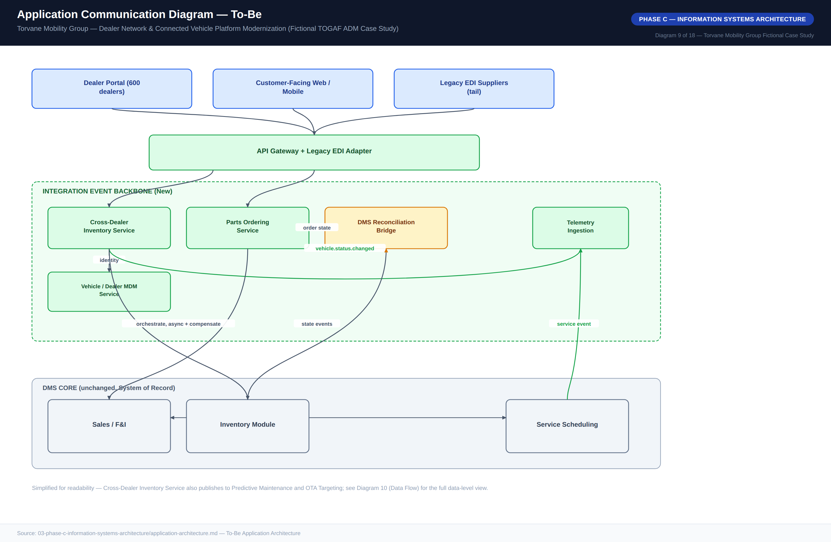
Diagram 9 — Application Communication Diagram, To-Be

5.2 Data Architecture
Torvane’s data landscape today is defined by fragmented ownership: four independent vehicle identifier schemes coexist across regional systems, with roughly 3% of records unresolved to a single canonical vehicle. Dealer identity is similarly fragmented across four divergent regional portal identifier schemes. The to-be architecture introduces two new first-class event-log data domains — Inventory State and Telemetry Event — and a canonical Vehicle/Dealer MDM as the single new system of record for identity, each with a single designated owning system per Architecture Principle 11.
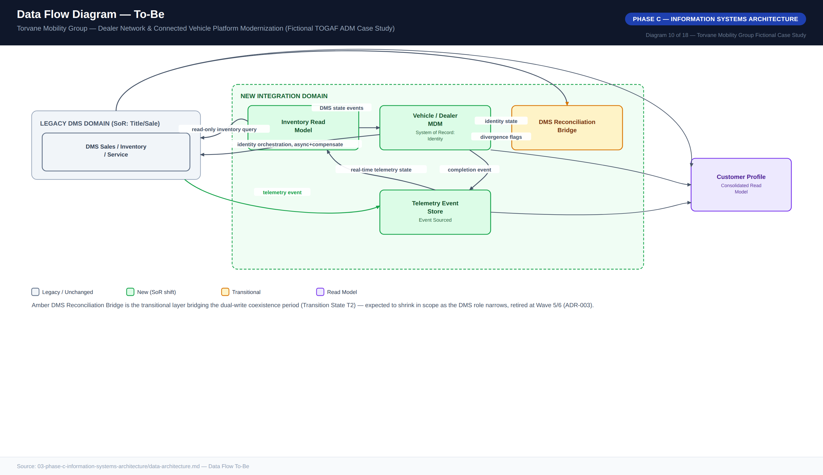
Diagram 10 — Data Flow Diagram, To-Be

5.3 Data Ownership / Domains
Vehicle Identity and Dealer are newly owned by the Vehicle/Dealer MDM service, resolving the four legacy identifier schemes into a single canonical source under federated ownership (ADR-004). Inventory State and Telemetry Event are both append-only event logs — current availability and current telemetry readings are always derived projections, never directly written state. Customer Profile remains a partial, read-only consolidated view sourced from the DMS, telemetry, and dealer portal; full profile-system-of-record consolidation was identified as a real gap but deliberately deferred, since closing it fully requires touching systems outside this program’s chartered scope.
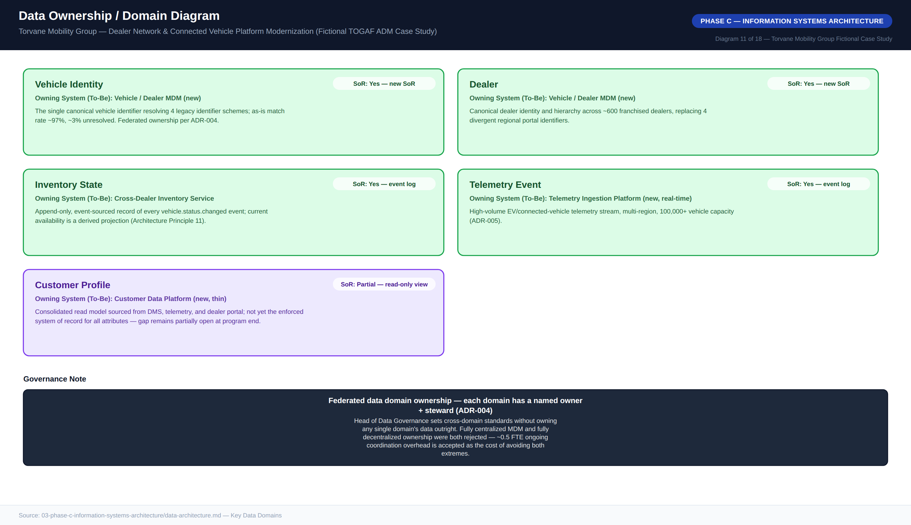
Diagram 11 — Data Ownership / Domain Diagram

6. Phase D — Technology Architecture

6.1 Reference Architecture Pattern
The core technology pattern selected for the program is an event-driven integration backbone positioned in front of an unreplaced legacy DMS. The pattern is applicable only when all of five conditions hold — DMS operational stability, a cross-dealer/telemetry (not core-DMS) business driver, appetite for an 18–30 month dual-write coexistence period, a DMS vendor exposing stable read and write APIs, and genuine engineering capacity to build new platform software — and should be rejected in favor of a different approach when strict consistency requirements cannot be relaxed, when the integration is low-volume and single-consumer, when the organization cannot tolerate async failure modes, when a regulatory point-to-point mandate applies, or when a natural batch cadence already fits the business process.
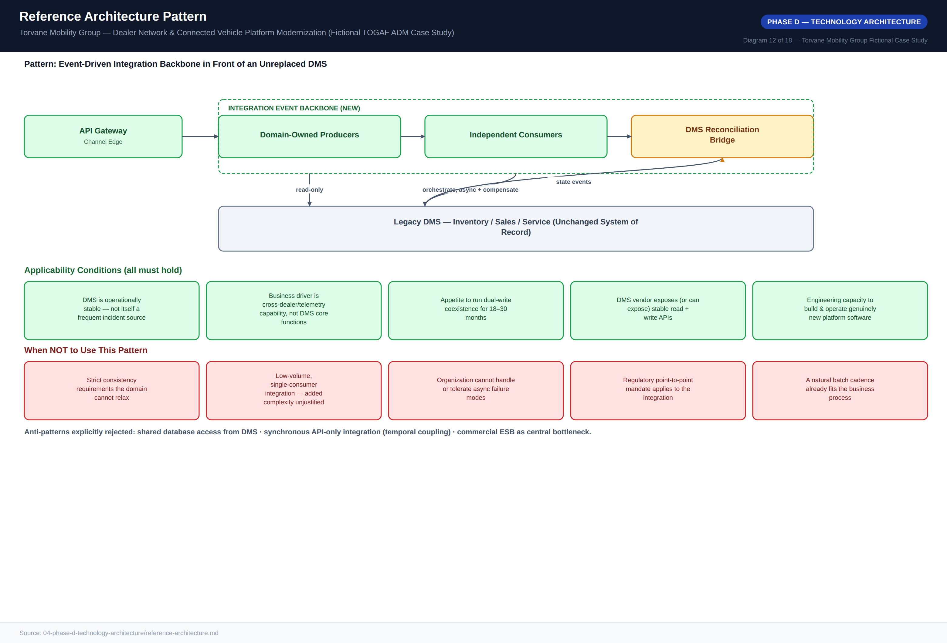
Diagram 12 — Reference Architecture Pattern

6.2 Technology Standards
The approved stack spans platform and infrastructure standards (an approved multi-region hyperscaler; managed, durable partitioned event streaming as the mandatory integration backbone; a commercial, contract-first API gateway; managed Kubernetes as the standard deployment target; managed relational and event-store data storage; and the existing enterprise observability stack, extended rather than duplicated), identity, security and operations standards (the existing enterprise identity provider via OAuth2/OIDC; a standard infrastructure-as-code toolchain; and centralized secrets management), and integration standards (REST/JSON or the approved event backbone only, schema-registry-enforced messaging contracts with a 12-month deprecation notice, and the current supplier-supported EDI version maintained, not upgraded, for the EDI-only supplier tail). Exceptions require a written ARB request with a stated expiry date and majority vote, capped at a 12-month term; regulatory and conformance items are never grantable exceptions, only implementation-layer choices are. Three exceptions are currently active, each re-reviewed at the next applicable wave gate.
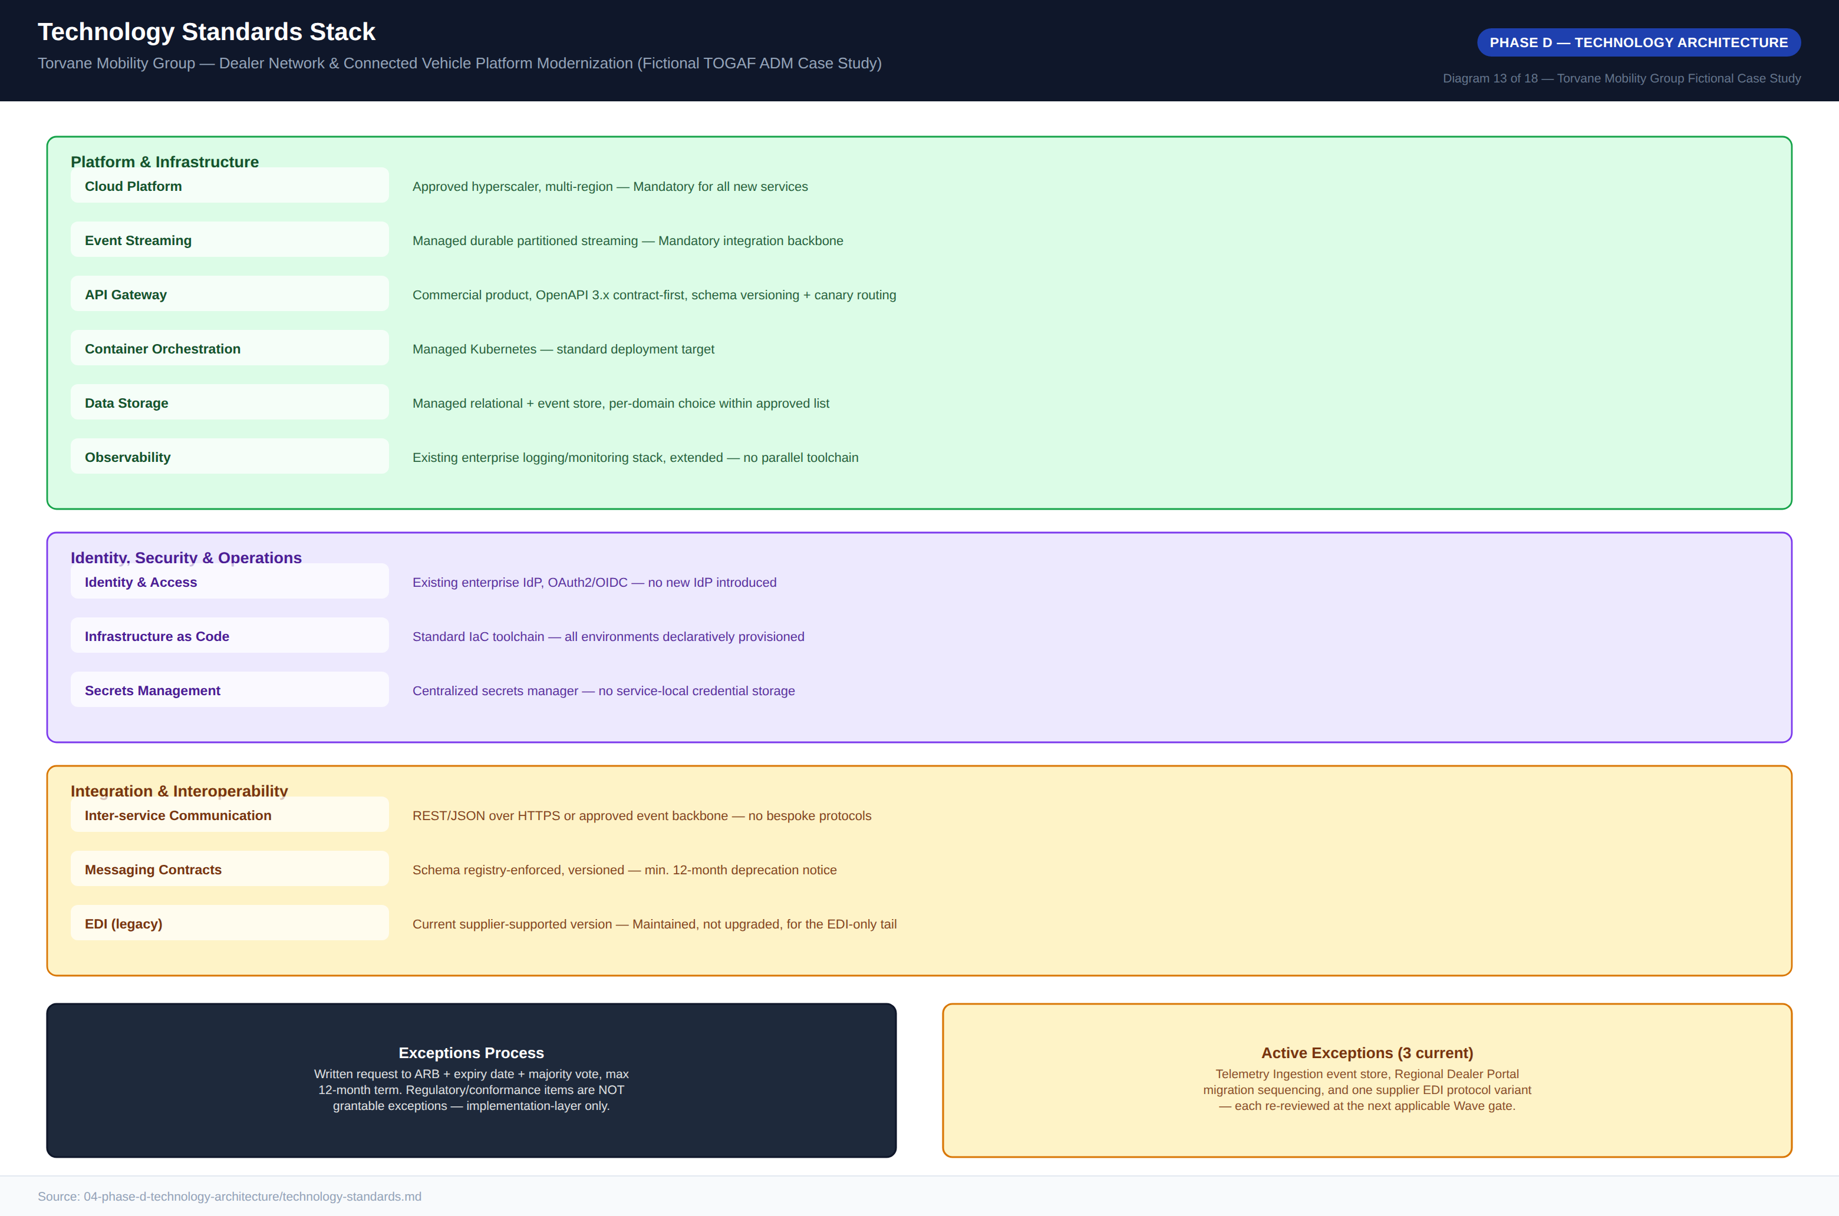
Diagram 13 — Technology Standards Stack

7. Phase E — Opportunities & Solutions

7.1 Gap Analysis
Gaps are derived directly from the capability-map maturity deltas and prioritized on a Critical/Medium/Maintain scale weighted by business impact and delivery complexity. Twelve gaps were registered; the event-driven integration backbone gap is rated Critical and the largest, alongside cross-dealer inventory visibility and telemetry scaling — all three anchor Wave 0 and Wave 1 specifically because delaying them delays everything downstream. Parts latency and canonical vehicle identity resolution follow as High-priority gaps sequenced into Wave 1 and Wave 3. Two gaps — full customer-profile consolidation and manufacturing-execution-system modernization — were identified but deliberately excluded from this program’s roadmap as out of chartered scope.

7.2 Solution Building Blocks
Each target capability is decomposed into a discrete Solution Building Block marked Buy, Build, or Configure per Architecture Principle 3. The Commercial DMS Core, Integration Event Backbone, and API Gateway are bought, since they represent undifferentiated or commodity capability. The Cross-Dealer Inventory Read Model, EV Telemetry Pipeline, and Vehicle/Dealer MDM are built on top of bought infrastructure, since their business logic is where Torvane’s differentiation lives. OTA Software Targeting is the only component built entirely from scratch and flagged high-risk — no vendor product fits its DMS-linked, fleet-segmentation eligibility rules — and it is sequenced with that risk explicitly acknowledged.
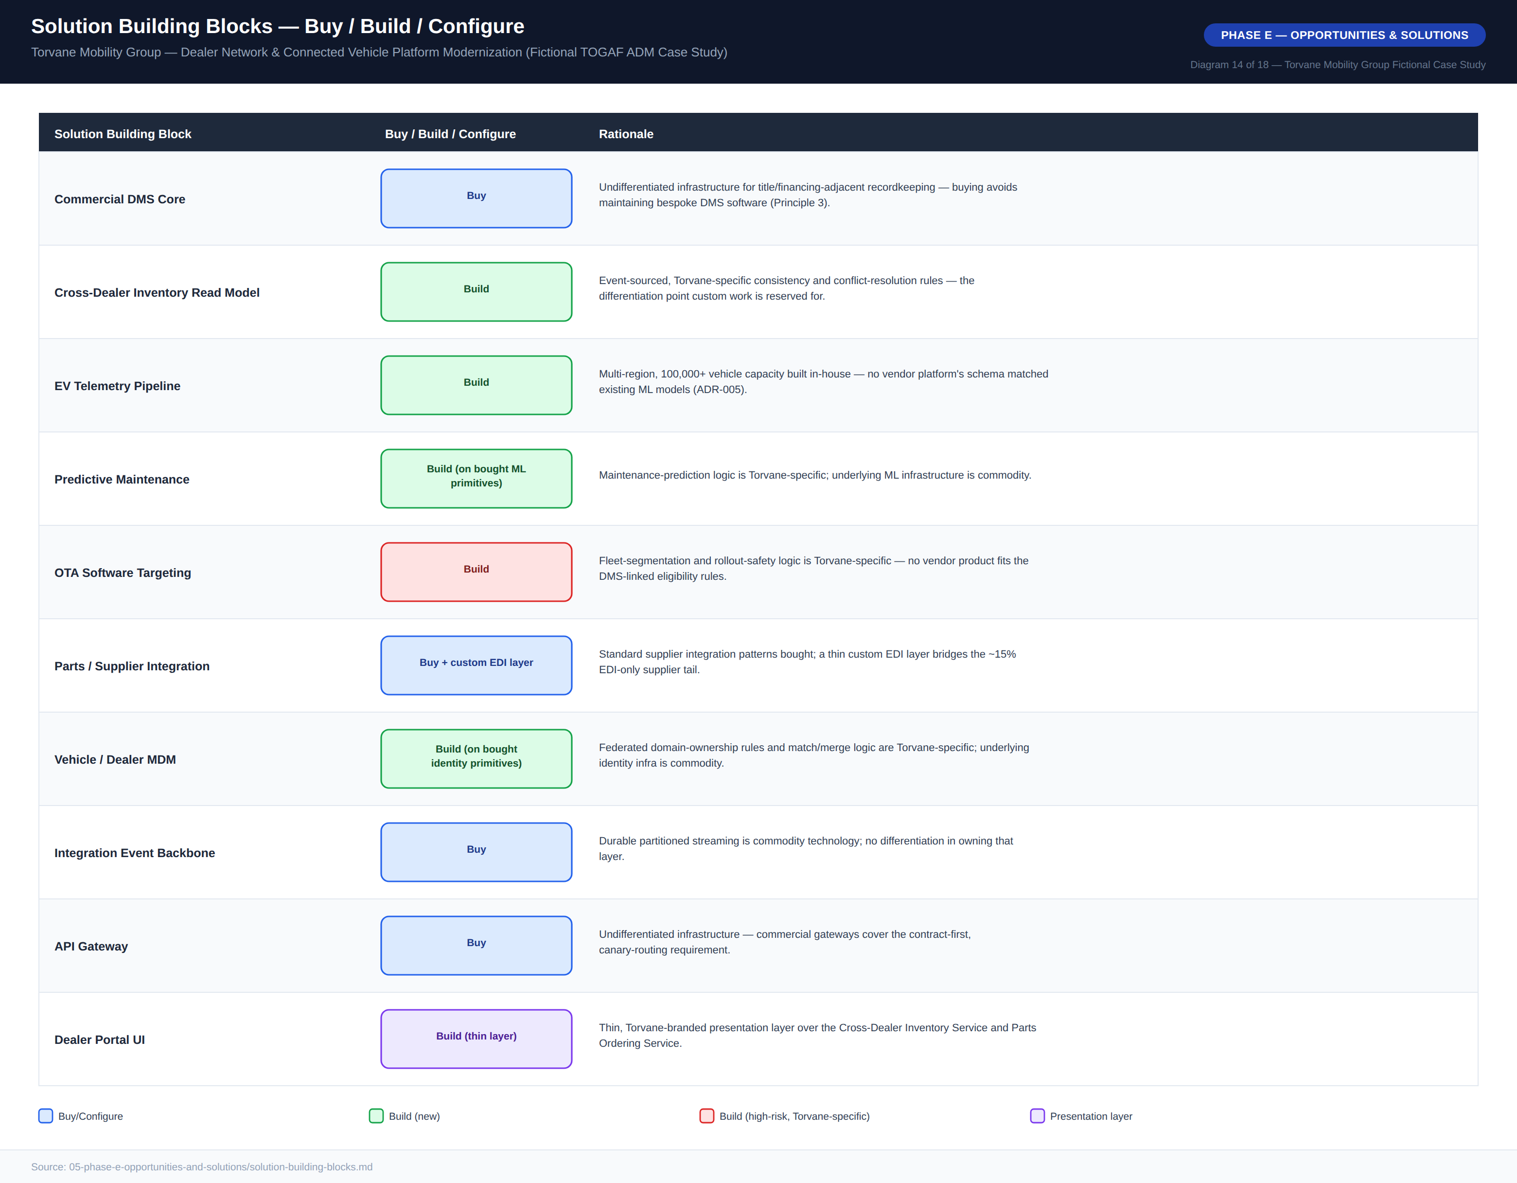
Diagram 14 — Solution Building Blocks, Buy / Build / Configure

7.3 Vendor Evaluation
Four vendors were scored against eight weighted criteria, with real-time inventory visibility and cross-dealer read model API maturity (20%) weighted highest given the program’s core objective. Vendor A — Meridian Drive Platform — is recommended as the core DMS integration platform with a weighted score of 4.10, ahead of Vendor C (Northlane Retail Cloud, 3.95), which came a close second but lost out on implementation timeline fit for Wave 1 pilot readiness. Vendor D — Cascade Dealer OS — scored lowest of the leading three (3.40) but posted the best total cost of ownership of any candidate (5/5), and is retained as the ARB’s documented fallback should Meridian contract negotiations or Wave 0 integration testing surface unresolved risk. Vendor B (Ferrous DMS Suite), a legacy hybrid offering, was rejected outright at 2.80.
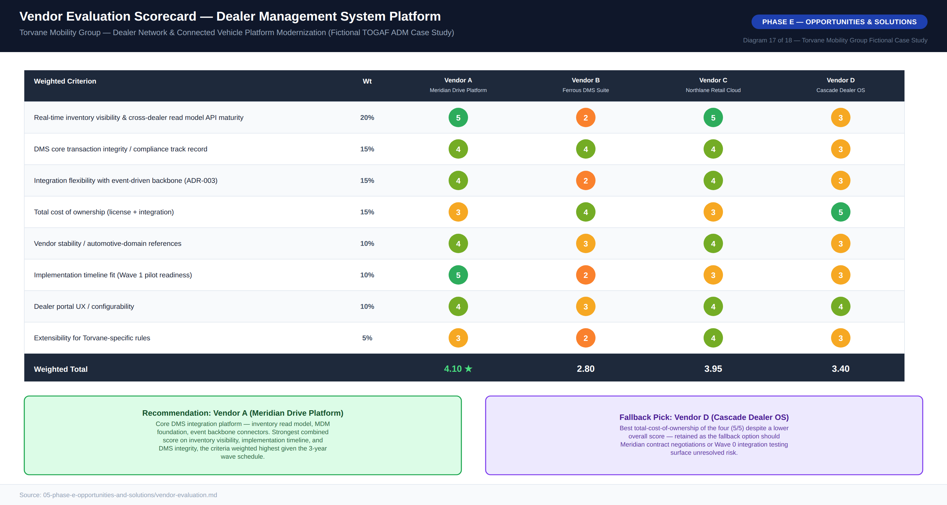
Diagram 17 — Vendor Evaluation Scorecard

8. Phase F — Migration Planning

8.1 Migration Roadmap
The roadmap runs seven waves over three years, sequenced so that EV telemetry — which has no hard dependency on the Cross-Dealer Inventory Service, only on the event backbone standard — is de-risked on lower-stakes traffic first, ahead of broad inventory rollout. Wave 1’s pilot deliberately covers 40 dealers rather than a smaller 15-dealer pilot, sized specifically to surface realistic cross-region conflict patterns before Wave 2 commits capital at scale. An alternative sequencing that would have front-loaded the customer-facing dealer portal before the DMS Reconciliation Bridge exists was considered and rejected by the ARB: standing up dealer-facing inventory transfer functionality before the bridge exists would leave confirmed inventory transfers with no DMS reconciliation mechanism, a direct Architecture Principle 5 violation.
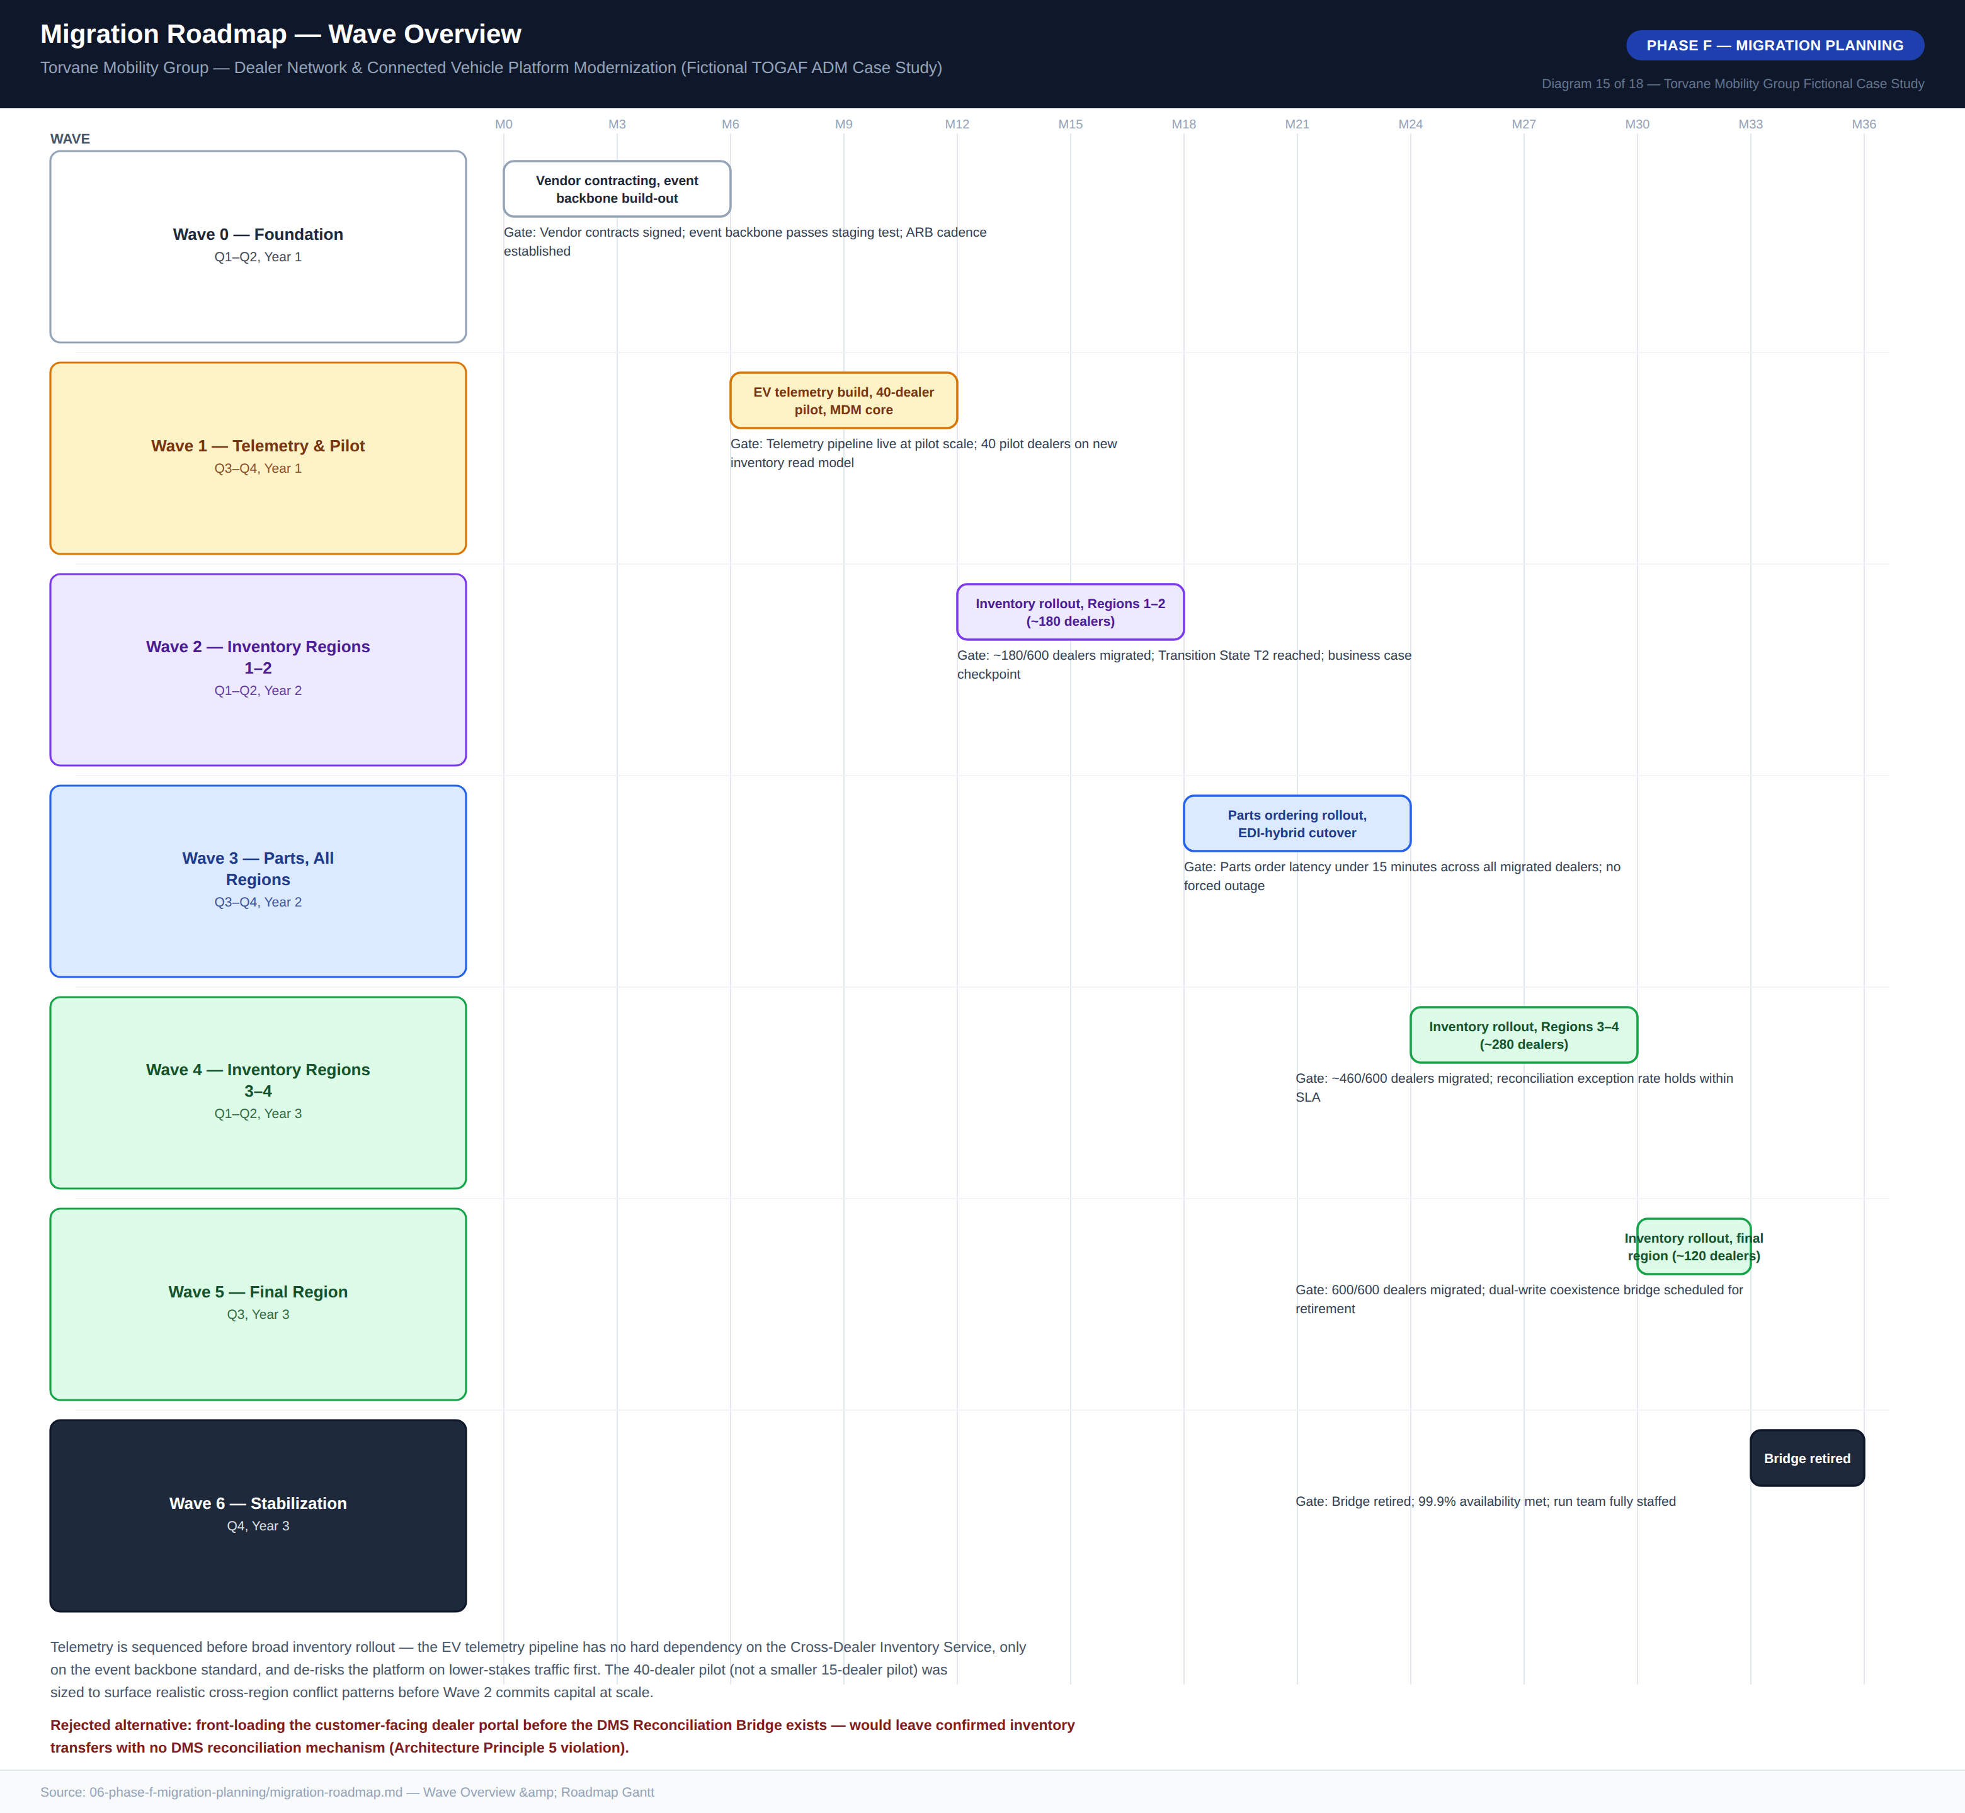
Diagram 15 — Migration Roadmap, Wave Overview

8.2 Transition Architecture — State T2
A three-year program spent largely “in between” needs its own architecturally defined intermediate states. Transition State T2, Dual-Write Coexistence, is reached at the end of Wave 2 — with roughly 180 of 600 dealers migrated to the new inventory read model — and is sustained through Wave 5, at an estimated cost of approximately 14 person-months of dual-support-process overhead, before the DMS Reconciliation Bridge is retired at Wave 5/6. Two inventory data paths run concurrently by design during this period — real-time for migrated regions, legacy batch for unmigrated regions — converging into the same unified inventory projection; this is accepted as necessary, not a defect, and is validated at Region 1–2 scale before Wave 4 exposes the pattern to full volume.
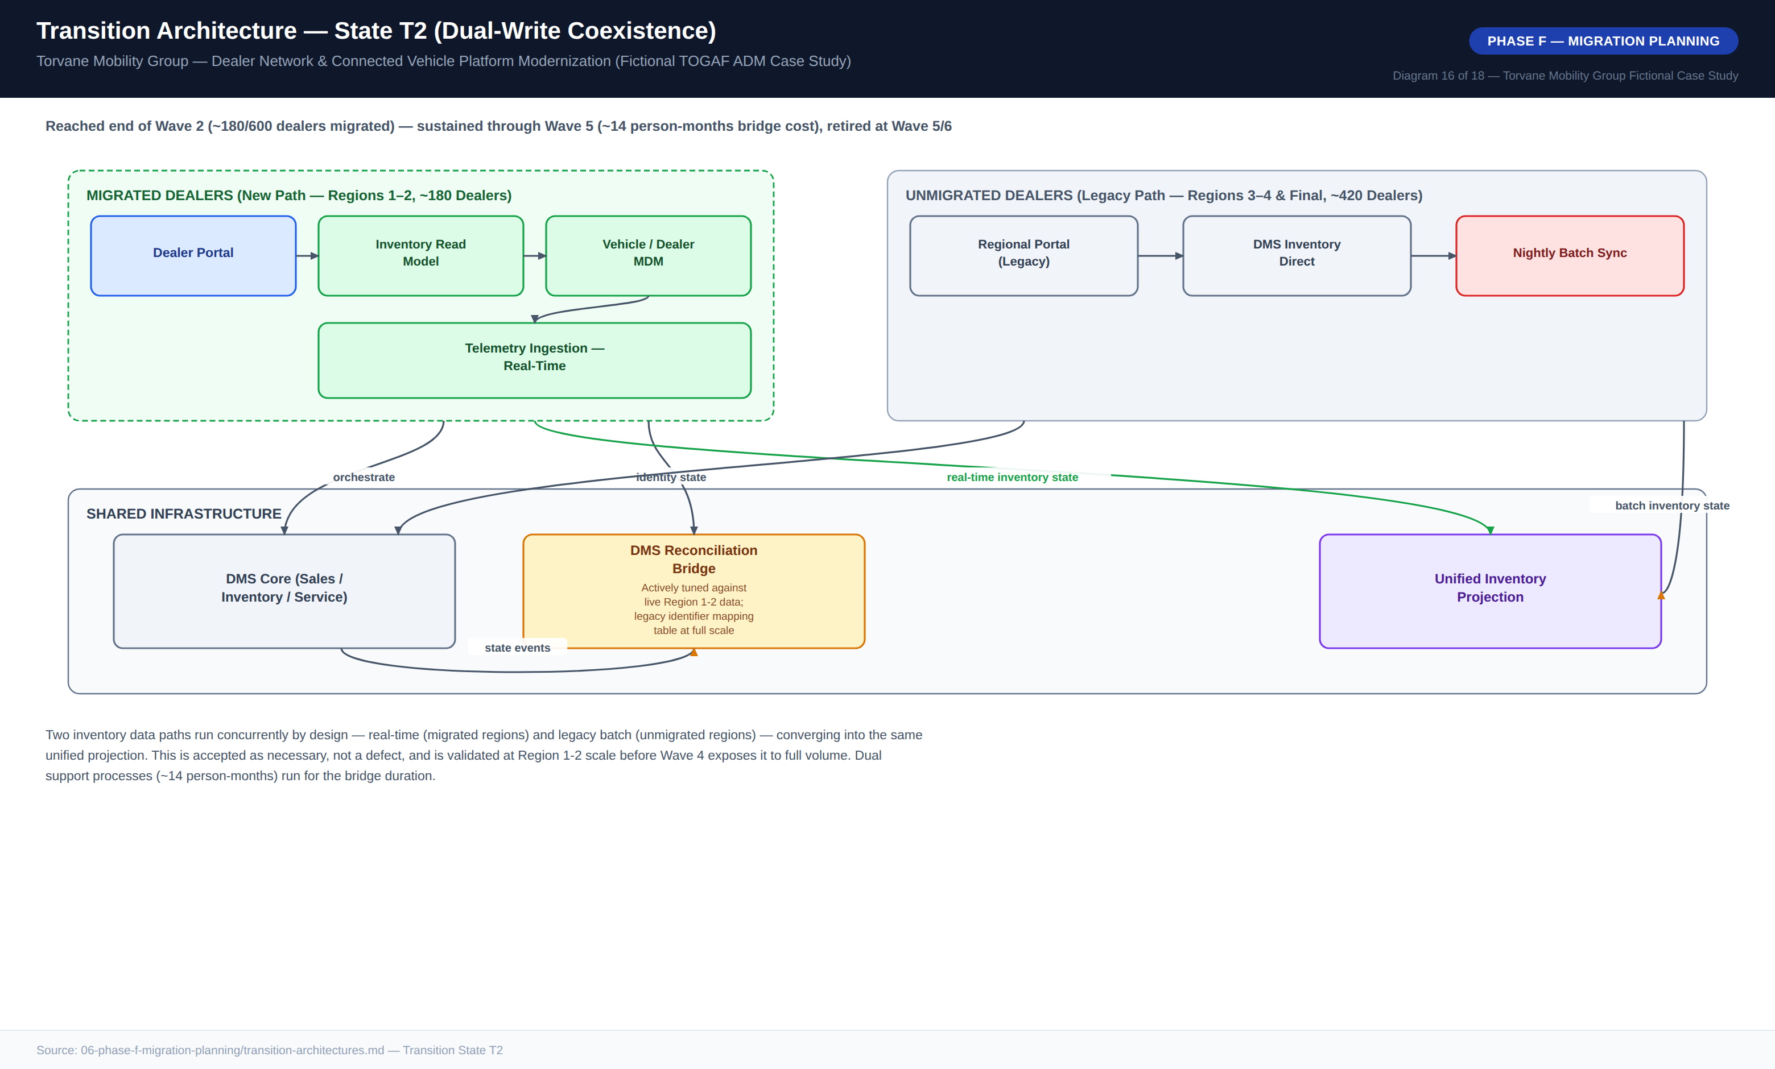
Diagram 16 — Transition Architecture, State T2 (Dual-Write Coexistence)

9. Phase G — Implementation Governance
Phase G governance ensures that what actually gets built during Waves 0–6 conforms to the architecture decided in Phases A–E, rather than drifting under delivery pressure. Four compliance checkpoints apply across the delivery lifecycle: a Design Review before implementation, a Pre-Integration checkpoint before a component touches the event backbone or the DMS, a Pre-Cutover checkpoint before any dealer is migrated, and a Post-Go-Live review after each wave, each with a named gate owner.

9.1 Non-Compliance Handling
Non-compliance is classified into three severities. A minor deviation is logged as a waiver request — four requirements, twelve-month maximum expiry — and reviewed at the next standing ARB cadence. A material deviation escalates from Solution Architect through Delivery to the ARB, with a remediation plan required. A principle violation escalates to the Program Steering Committee (CDTO chair), with cross-program CDTO arbitration if still unresolved.
During Wave 1, a delivery team proposed writing inventory-transfer completion status directly back into a DMS custom field to simplify a regional reporting requirement. This was flagged at Design Review as a material deviation — a second, unapproved write path into the DMS, violating Architecture Principles 1 and 11. The ARB rejected the shortcut and directed the team to satisfy the reporting need via the Cross-Dealer Inventory Service’s existing event stream instead, a short delay against an estimated multi-month cost of unwinding an undocumented DMS write path had it shipped undiscovered.

9.2 Architecture Contracts
An architecture contract is the formal agreement between the ARB and a delivery team, translating an approved Solution Building Block into an accountable delivery commitment, structured across eight parts covering scope, principle alignment, reference-architecture conformance, data-ownership statement, integration contracts, non-functional requirements, governance checkpoints, and acceptance criteria. The worked example for the Cross-Dealer Inventory Read Model sets a propagation-latency target of 30 seconds at p95 and 90 seconds at p99, 99.9% multi-region active/active availability, specific event schema contracts, a checkpoint schedule tied to Wave 2 months, and a two-hour rollback path via feature flag. This formality was a deliberate choice: a lighter, verbal or chat-thread agreement model used earlier in Torvane’s history was explicitly rejected for this program after post-incident reviews traced root cause, in prior integration failures, to ambiguity over which team owned ongoing conformance once a component moved into steady-state operation.

10. Phase H — Change Management
An architecture that is technically correct but organizationally unadopted delivers none of the business case’s projected value — the lost-sales recovery and parts-cost-avoidance savings depend entirely on dealer sales, service, and parts staff, and the new Cloud Platform Engineering and Data Ops functions, actually using the new capabilities as designed. This plan treats organizational adoption as a first-class deliverable with the same governance rigor as the technical architecture.
Stakeholder Group | Nature of Change | Severity
Dealer Sales / Service / Admin Staff | Gains real-time cross-dealer inventory visibility and a new self-service transfer workflow | Medium
Parts Ops Planners | Shifts from batch EDI cycles to real-time/EDI-hybrid ordering — a genuinely new operating rhythm | High
Data Ops Team | Role redefinition around federated data domain stewardship (ADR-004) | High
Cloud Platform Engineering | Entirely new team stood up to operate the integration event backbone | High
IT Support | Insulated from most dealer-facing change; must support the new DMS reconciliation bridge | Medium
Finance / FP&A | New event-driven reporting model alongside continued DMS-based reporting | Medium
Training is wave-aligned and delivered train-the-trainer style with role-specific tracks, so that each dealer only trains on the capabilities live in its region at that point in the rollout. Adoption metrics — including champion training completion (target 100%) and active usage within 60 days of go-live (target ≥85%) — are reviewed alongside the technical wave-gate criteria at each ARB gate review: a wave is not considered fully successful on adoption grounds alone if the technical criteria pass but adoption metrics lag, and the Program Steering Committee has authority to direct additional change management investment before authorizing the next wave’s capital release.

11. Architecture Decision Records
Five ADRs anchor the architecturally significant decisions in this program. Each follows the standard Status / Context / Decision / Alternatives Considered / Consequences / Governance Impact format and is cross-referenced from the architecture contracts and technology standards that depend on it.

ADR-001: Incremental 6-Wave Migration, Not Big-Bang DMS Cutover
The DMS is migrated dealer-by-dealer and region-by-region across six waves over three years, rather than in a single cutover event. Big-bang cutover was rejected as an unacceptable single point of failure across all 600 dealers simultaneously; indefinite parallel systems and a function-first migration were also rejected. Accepted trade-off: an 18–30 month dual-write coexistence period requiring a reconciliation bridge.

ADR-002: Multi-Region Active/Active Topology for Tier-1 Services
Tier-1 services run active/active across multiple regions to meet the 15-minute RTO target. Single-region active/passive was rejected — projected RTO of 25–45 minutes exceeds the 15-minute budget — as was a hybrid edge-plus-core design and a single-region strict-consistency design. Accepted trade-off: approximately 18% higher infrastructure cost and six additional weeks added to the Wave 2 timeline.

ADR-003: Event-Driven Integration Backbone as the Default Pattern
Domain-owned producers publish events that independent consumers subscribe to, via a durable, partitioned, at-least-once-delivery event backbone. Shared database access from the DMS was rejected as reproducing the current root cause; synchronous API-only integration was rejected for the temporal coupling it introduces; a commercial ESB was rejected as a central bottleneck. Accepted trade-off: an estimated 150-day Wave 0 build-out cost for the backbone itself.

ADR-004: Federated Data Domain Ownership Model
Each data domain has a named owner and steward; the Head of Data Governance sets cross-domain standards without owning any single domain’s data outright. Fully centralized MDM was rejected as an unacceptable single bottleneck for change; fully decentralized ownership was rejected as reproducing today’s fragmentation; ownership-by-first-mover was rejected as arbitrary. Accepted trade-off: approximately 0.5 FTE of ongoing cross-domain coordination overhead.

ADR-005: EV Telemetry Ingestion Built In-House, Multi-Region, 100,000+ Vehicle Capacity
The telemetry pipeline is built in-house at five times projected fleet volume, multi-region from day one. A commercial IoT platform was rejected on schema incompatibility with Torvane’s existing ML models; vertical scaling of the existing pipeline was rejected as addressing an architectural bottleneck, not a capacity limit; a single-region re-architecture was rejected for lacking resilience to regional failure.

Appendix A — Diagram Catalog Index
The full reference diagram catalog for this program comprises 18 diagrams spanning the Preliminary Phase through Phase F, delivered as high-resolution PNG files alongside this document.
No. | Diagram Title | ADM Phase
01 | Architecture Vision One-Pager | Phase A
02 | Stakeholder Power / Interest Map | Phase A
03 | Architecture Governance Organization | Preliminary
04 | Business Capability Map, Maturity Heat Map | Phase B
05 | Business Process Flow, As-Is (Cross-Dealer Vehicle Transfer) | Phase B
06 | Business Process Flow, To-Be (Cross-Dealer Vehicle Transfer) | Phase B
07 | Business Footprint Diagram | Phase B
08 | Application Communication Diagram, As-Is | Phase C
09 | Application Communication Diagram, To-Be | Phase C
10 | Data Flow Diagram, To-Be | Phase C
11 | Data Ownership / Domain Diagram | Phase C
12 | Reference Architecture Pattern | Phase D
13 | Technology Standards Stack | Phase D
14 | Solution Building Blocks, Buy / Build / Configure | Phase E
15 | Migration Roadmap, Wave Overview | Phase F
16 | Transition Architecture, State T2 | Phase F
17 | Vendor Evaluation Scorecard | Phase E
18 | Business Case Financial Summary | Phase A

Appendix B — Disclaimer
This entire document — Torvane Mobility Group, all named individuals and roles, all vendor names (Meridian Drive Platform, Ferrous DMS Suite, Northlane Retail Cloud, Cascade Dealer OS), and every dollar figure, metric, and date — is a fictional case study constructed for architecture-practice demonstration purposes. Figures are designed to be internally consistent and arithmetically sound so that the reasoning pattern is transparent, not to represent any real automotive OEM’s actual data. No inference should be drawn about any real company, product, or individual.

