1 Google Chrome Extension Installation 2

# Google Chrome Extension Deployment

* Download the smily_chrome_Extension.zip folder located in the box location <https://medtronic.app.box.com/folder/75939658880>
* Extract the folder and save it on the preferred location on your machine.
* Open google Chrome click on settings

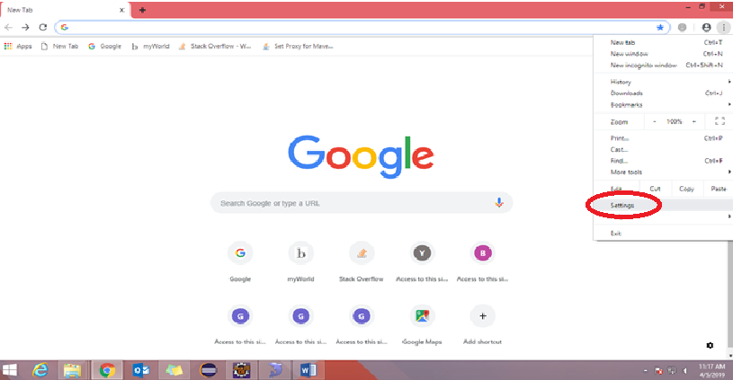

* Again, click on settings

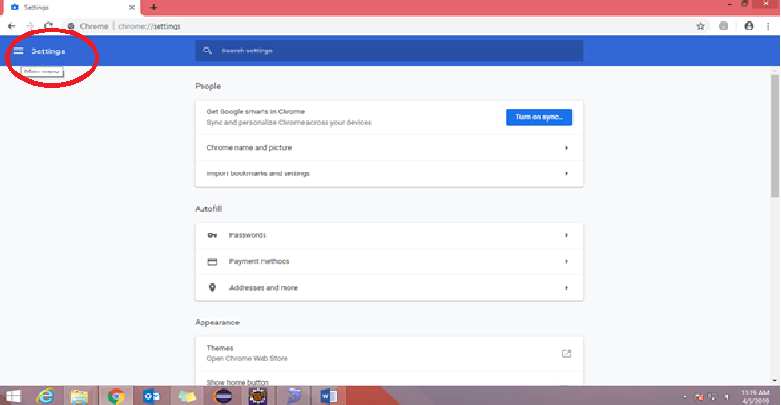

* Click on the Extensions

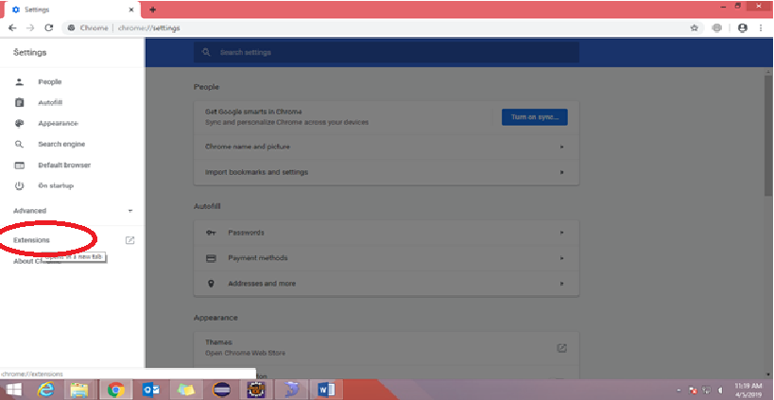

* Push the developer mode ON
* Click on Load Unpacked

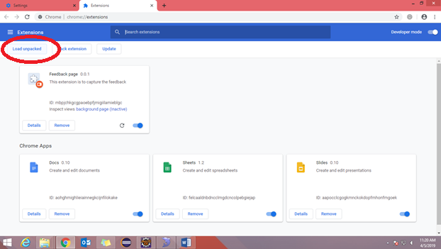

* Select your smily chrome extension project folder where manifest.json file is exist

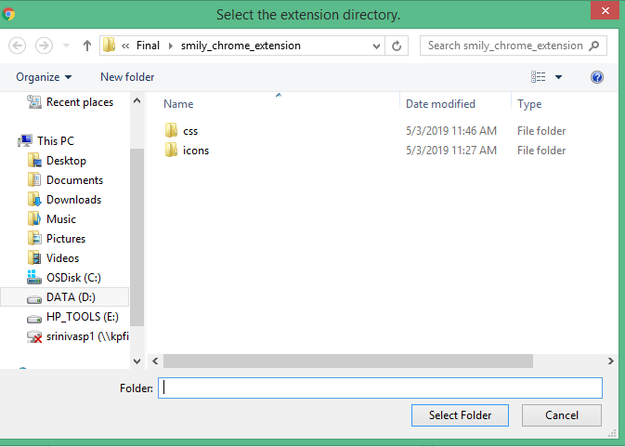

* Click on Update

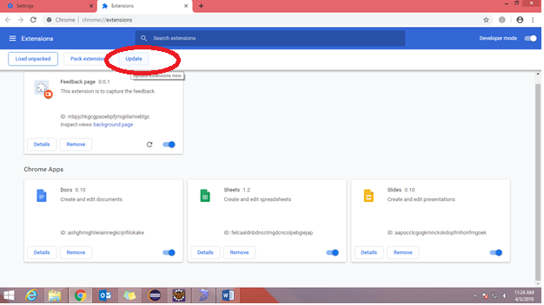

* Once you are done with above procedure, please turn off the Developer Mode
* Close the existing chrome window and relaunch the chrome browser and hit the link <http://10.158.35.231:8090/BrowserFeedback/feedback.jsp>.
* Enter your Medtronic network credentials, when asked (in some cases).
* Test the extension with the Medtronic sites
* Click on ‘Remove’ button to **uninstall** feedback extension from browser

