1 MYSQL 2

2 Feedback Application Deployment 2

# MYSQL

1. Open SQLyog Community tool (download from <https://sqlyog.en.softonic.com/> ) and connect to database

Enter connection name, host address, username, password and port (new connection) of MySQL server

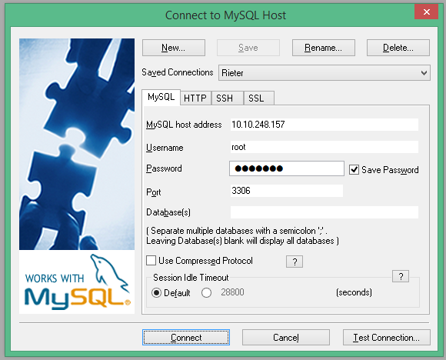

1. Copy schema sql script to SQLyog Community – query editor window and execute the script -BE_MySQL.sql (using execute current query option)

# Feedback Application Deployment

* Make sure MySQL scripts are executed (if any)
* Create war file – using eclipse – right click on project – click on export – WAR file

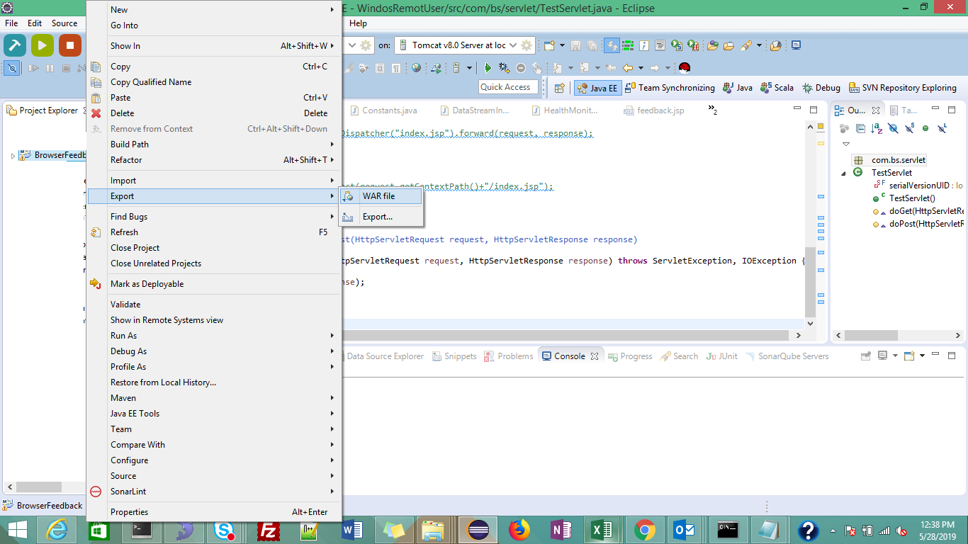

* Provide Web Project name, and destination folder to generate war file and click on finish

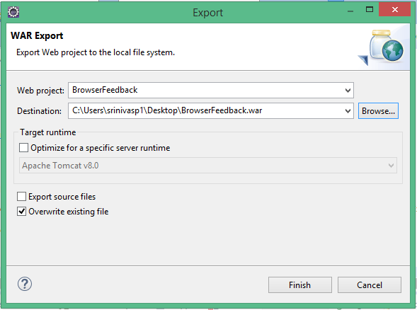

* Copy BrowserFeedback.war file to <tomcat_installed directory>/webapps folder and restart the server
* Stop tomcat server – go to <tomcat_installed directory>/bin/ folder and run shutdown.bat
* Start tomcat server – go to <tomcat_installed directory>/bin folder and run /startup.bat