1 IE Extension Deployment 2

# IE Extension Deployment

* Download the Newfolder.zip folder located within IE extension in the box location <https://medtronic.app.box.com/folder/75965207521>
* Extract the folder and save it on the preferred location on your machine.
* Click on setup.exe file

Note: please close Internet Explorer before installation

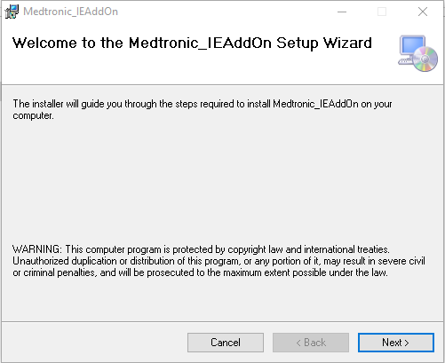

* Click on Next

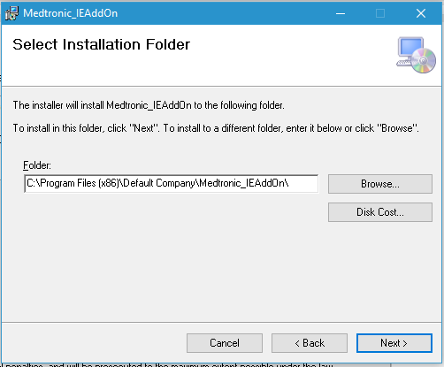

* Click on Next

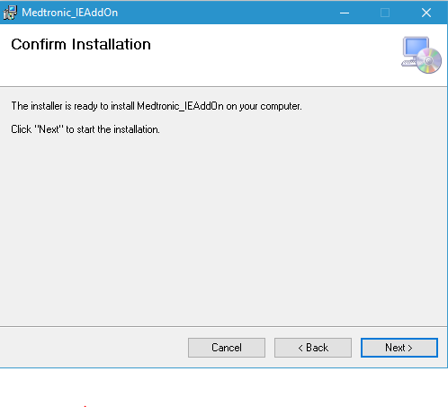

* Click on Next

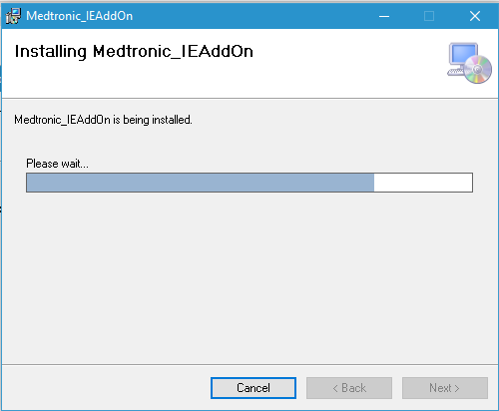

* After successful installation close the window

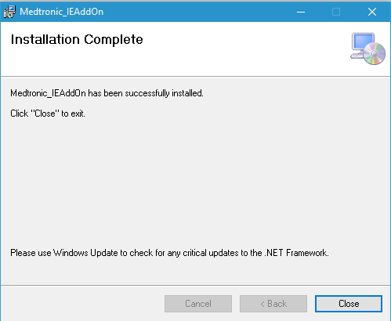

* Click on Medtronic.IEAddOnSetup(1.0.0).exe file. Select ‘Repair Medtronic_IEAddOn’ option and click finish

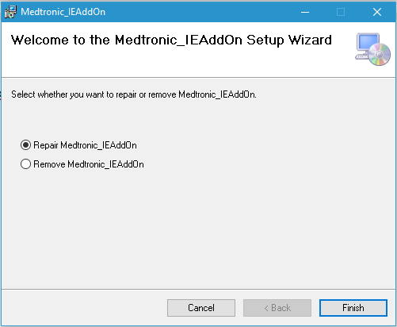

* Close the window after successful installation

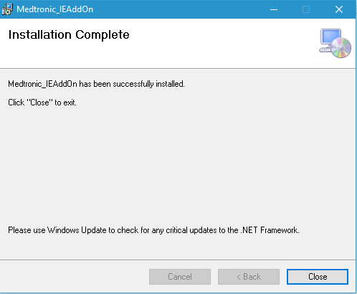

* Click on setup.exe file again and select ‘Repair Medtronic_IEAddOn’ option and click finish

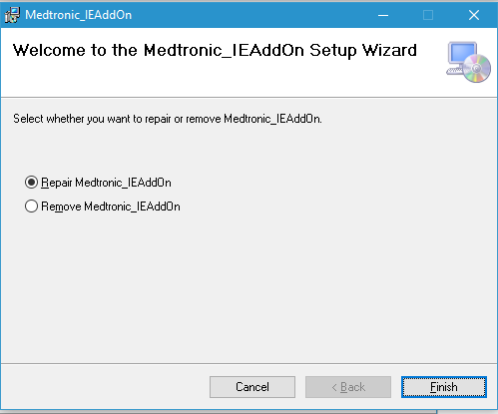

* Close the window after successful installation

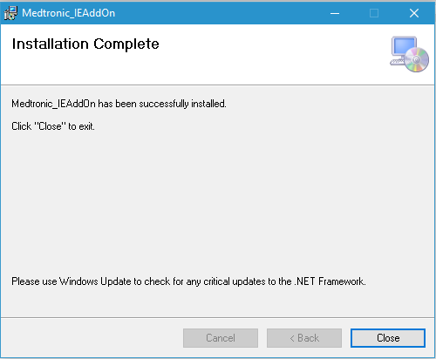

* Open Internet Explorer after installation, Medtronic Feedback Extension will appear in command bar
* **To uninstall the addon** : Go to “Control Panel - Programs and Features and uninstall Medtronic_IEAddOn

