|  |  |
| --- | --- |
| **Purpose** | The purpose of this document to gather detail requirement that allows user to provide feedback for the current web applications they are viewing. It will allow users to provide feedback through Internet Explored (IE11) and Chrome (66 and above) browser extension |
| **Scope** | Create feedback extension for Internet Explorer (11) and Chrome browsers to capture user feedback of Medtronic applications (web) accessing through browser |
| **Owner** | Medtronic |

# Flow Diagram

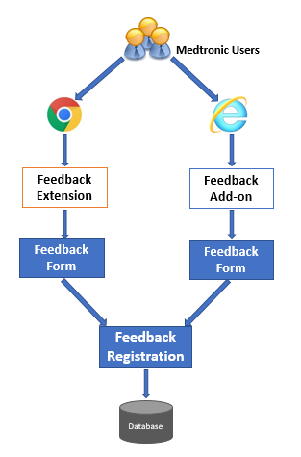

# Requirements Listing

|  |  |
| --- | --- |
| Requirements # | Requirement |
| Browser Extension - Feedback | Description: Feedback extension will be available on Internet Explorer  (IE11) & Chrome browser (66+) to allow users to provide feedback for current applications  Actors: Medtronic Users  Pre-Condition(s): Browser extension should be installed & available on required browsers  Flow:   1. Extension icon should be enabled whenever user types relevant (matching) URL in browser address bar. It should be disabled for other URLs 2. On click of extension icon, it should display smiley and Frown face icons 3. On click of smiley or frown face icon, it should save smiley / frown feedback information and display feedback dialog box with provision to enter feedback information 4. Following information will be stored on database and success message should be displayed on screen  * Dynamic IP address of user machine – (example: 192.168.1.101) * URL - (example: https://medtronic.com/contact/4144347) * Timestamp – (sample data: 2019-04-09 15:47:01) * Result – (0-smiley or 1-frown face) * User ID – windows login user id  1. This feedback window will have following fields (refer screens#) 2. Header – it will have following text, “THANK YOU FOR YOUR FEEDBACK” and “We really appreciate your comments” 3. Text area – allows user to enter feedback 4. Send & Close buttons 5. On click of Send button, it should store feedback text 6. On click close button, feedback window will be closed 7. Tool tip should be displayed on mouse over on extension icon and smiley or frown face icons |
| Browser Extension - Feedback | Post-Condition(s): Feedback information will be saved  Validation Rules:   1. Browser extension icon should be allowed for Medtronic applications only (based on URLs – medtronic.com) 2. Feedback text is non-mandatory 3. Feedback text maximum length should not be more than 500 characters   Screens:  Smiley face feedback form: |
|  | Frown face feedback form: |

# Terms and Definitions

# [Definition for terms, words, abbreviations, acronyms - especially those that have different meanings for different people e.g. reverse logistics, UBD (use by date or use before date), ERP, etc.]

|  |  |
| --- | --- |
| Term | Definition |
|  |  |
|  |  |
|  |  |

# Reference Table [Optional]

# [Include references to other World Quality documents if needed – do not refer to external documents or documents not referenced in the text]

|  |  |
| --- | --- |
| Document Number | Document Title |
|  |  |
|  |  |
|  |  |

# Revision History

|  |  |  |  |
| --- | --- | --- | --- |
| Revision | Description of change | Documents impacted | Minor/Major |
| 1.0d | Requirement specification for Browser Extension project initial draft |  | Major |
| 1.0 | Review changes (by Sachin More) added   1. Users image added to flow diagram 2. Sample data add for feedback points 3. Validation rules section added |  | Minor |
| 1.1 | Smiley and Feedback workflow changes added |  | Major |