LLD
Low level Design

Feedback Extension

Contents
1. Introduction 4
1.1. Purpose 4
1.2. Scope 4
2. Database 5
2.1. Feedback 5
3. Flow Details 6
3.1. Chrome Browser Extension 6
3.2. IE Browser Add-on (TBD) 7
3.3. Feedback Registration 7
4. Validation 8
4.1. Chrome Browser Extension 8
4.2. IE Browser Add-on 8
4.3. Feedback Registration 8
5. Components 9
5.1. Scripts 9
5.2. UI (HTML) 9
5.2.1 Chrome Browser Extension 9
5.2.2 IE Browser Extension 10
5.3. Configuration 12

Document History
Version | Date | Description | Author | Reviewed By
0.1 | 10-Apr-2019 | Initial draft created with chrome extension details | Jitendra Bonde
0.2 | 10-Apr-2019 | Added feedback registration servlet changes | Jitendra Bonde
0.2 | 11-Apr-2019 | IE 11 browser feedback extension detail added | Dipesh Tare | Srinivas P
1.0 | 11-Apr-2019 | Review changes added (screen shots & script details) | Jitendra Bonde
1.1 | 30-Apr-2019 | Smiley flow changes and screen shots updated | Dipesh Tare | Srinivas P
1.2 | 10-May-2019 | Frown face work flow changes added | Srinivas P

Reference Documents
ID | Ref | Version |  | Date | Title
REF_1 | Requirement |  | 1 |  |  | BrowserExtension-Requirement_Specification

Terminology & Abbreviations
Term | Definition
LLD | Low Level Design document
IE | Internet Explorer

Distribution List
Company | Name | Function
Medtronic | Medtronic | Medical technology, services, solutions
Birlasoft | Birlasoft Limited | IT Services

Introduction

Purpose
The purpose of this document is to discuss low level design of browser extension development details for IE and Chrome browsers. In this we have the following sub modules:
- Chrome Extension
- IE 11 Add-on
- Feedback Registration

Scope
This document will cover scope of the following sub modules implementation.
- Chrome Extension
- IE 11 Add-on
- Feedback Registration

Database

Feedback
Schema Name | MEDTRONIC_BE
Table | FEEDBACK
Comment | This table contains feedback information
Column | Data Type | Null | Comments
ID | INT | NOT NULL | Primary key column
ADDRESS | VARCHAR (50) | NULL | Ip address of client machine
URLPATH | VARCHAR (500) | NULL | Application URL details – full path of URL
FEEDBACK | VARCHAR (500) | NULL | User feedback
RESULT | TINYINT (4) | NOT NULL | 0 – smiley and 1 – frown face
CREATION_DATE | TIMESTAMP | NOT NULL | Creation time stamp
USER_ID | VARCHAR (50) | NULL | Windows machine user login ID

Flow Details

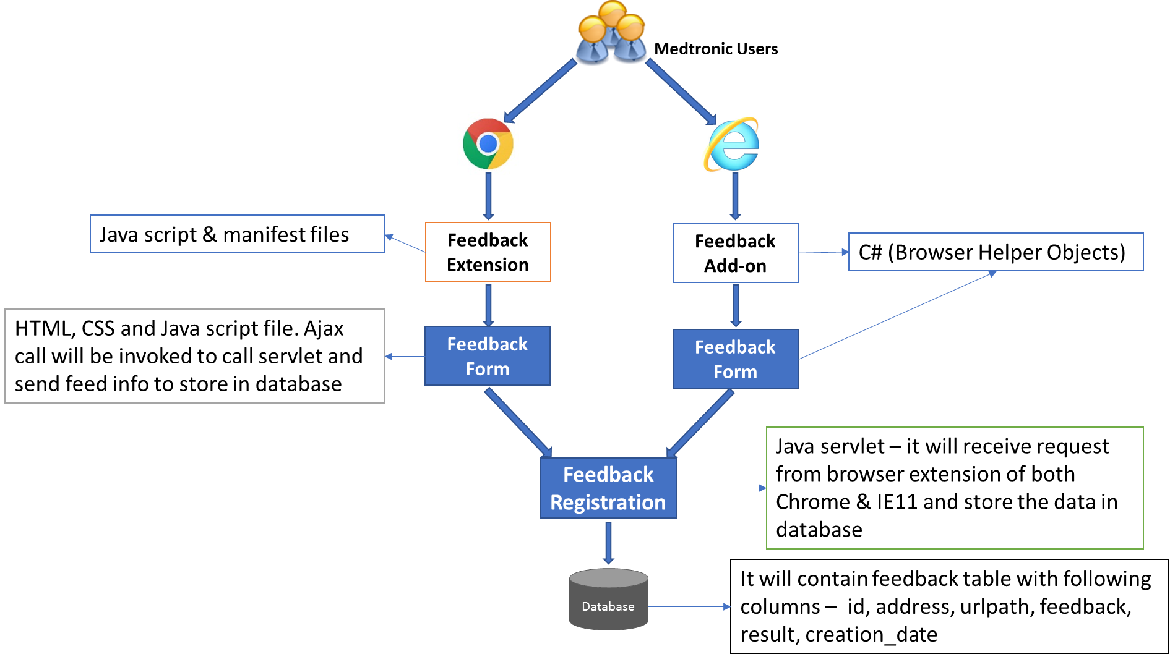
Browser Extension Flow Details

Chrome Browser Extension
- This feedback extension will allow Medtronic users to provide feedback for current applications
- After extension registration, feedback extension icon will be displayed on browser next to address bar. By-default this icon is in disabled mode
- If user enter valid Medtronic application URLs (defined in background.js file), extension icon will be enabled. background.js script will act as browser runtime environment listener, it will validate user enter URLs with defined URLs, if matching then feedback extension icon will be enabled else disabled
- On click of extension icon, it will open small window which contains smiley face feedback and frown face feedback links (popup.html)
- If user clicks on smiley / frown icon, it will call popup.js -> saveSmiley() function, this method will call feedback servlet (refer #3.3) through web request and open feedback page
- Feedback page will contain heading (Thank you for your feedback and We really appreciate your comments), feedback text area, send and close buttons (refer#5.2.1)
- On click of Send button, popup.js -> send () function will be called, it will call feedback servlet (refer #3.3) through ajax call and update user feedback
- On click of Close button, popup.js -> close () function will be called and feedback screen will be closed

IE Browser Add-on (TBD)
- This feedback extension will allow Medtronic users to provide feedback for current applications
- After extension registration, feedback extension icon will be displayed on browser on command bar.
- When user clicks feedback extension icon, its will display window with message saying - “Feedback can be given to Medtronic application only ” for non-medtronic applications
- If user enter valid Medtronic application URLs which contains medtronic and clicks on extension icon, it will open window which contains smiley face and frown face feedback icons (IEModule.cs -> IE11CommandItem_OnClick ())
- If user clicks on smiley / frown icon will invoke - SmiileyPopup.cs,-> pictureBoxSmile_Click() it will call SmiileyPopup.cs -> CallServletAndInsertDataToDatabaseOnSmile() method, to call feedback servlet (refer #3.3) through web request and open feedback page
- Feedback page will contain heading (Thank you for your feedback and We really appreciate your comments), feedback text, send and close buttons
- On click of Send button, FeedbackForm.cs -> btnSend_Click() method will be called, it will call feedback servlet (refer #3.3) through web request and update the user feedback comments
- On click of Close button, FeedbackForm.cs -> btnClose_Click() function will be called and feedback screen will be closed

Feedback Registration

- Feedback registration module will receive data from Chrome & IE 11 extension feedback screen.
- Chrome & IE 11 extension feedback screen -> send button will invoke FeedbackServlet.java → doGet() method.
- FeedbackServlet.java → doGet() will perform following steps
- Read feedback screen data from HTTPRequest objects (URL path, IP address, feedback text, smiley or frown face feedback)
- Connect to database (MySQL)
- Store feedback data to table
- return the response (success / failure)
- Following parameters will be stored in database table
- Hostname
- URL path
- Description
- Type (Smiley - 0 / Frown – 1)
- User login ID (window machine user login id)
- Creation Date
- Following table will be used to store feedback data – feedback (refer#2)

Validation

Chrome Browser Extension
- Feedback extension icon should be enabled for Medtronic applications URLs only (URL should contain Medtronic keywork - defined in background.js file), for other URLs, it should be disabled
- Feedback field is non – mandatory field
- Feedback text should not be more than 500 characters
- On click of smiley / frown icon user feedback should be capture by-default, if user provides feedback comments then it will get updated against that captured feedback

IE Browser Add-on
- For non-medtronic application, feedback extension will not allow users to provide feedback
- Same as #4.1 (except # 1)

Feedback Registration
NA

Components

Scripts

Sr. No. | Name | Description
 | manifest.json | manifest.json file is mandatory file for every extension using WebExtension APIs must contain. This file will allow user to specify metadata about the extension such as name, version and specify extension's functionality
 | background.js | It will act as chrome browser run time event listener to read url information type in address bar and matches with defined Medtronic applications URLs, it will enable / disable extension icon based URLs
 | popup.html | It will contain two sections – smiley & from face icons & feedback form. User can provide feedback this form
 | Popup.js | It will contain functions to send feedback data and close feedback window
 | FeedbackServlet.java | This class will read and save feedback data.  doGet() method read request data (from feedback extension) and call saveFeedback() method to save data to database
 | IEModule.cs | This will be starting point for feedback extension, it will have feedback extension registration and click event open feedback window
 | SmiileyPopup.cs | This will contain smiley and frow face screen layout and methods to invoke feedback form

UI (HTML)

Chrome Browser Extension
Enabled feedback extension

Disabled feedback extension

Smiley and Frown face feedback screen
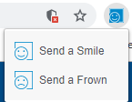

Frown Feedback screen
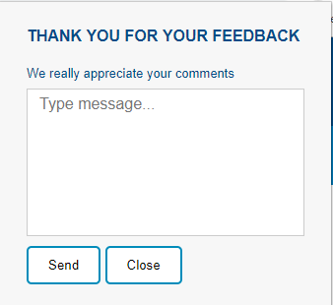

Smiley Feedback screen

IE Browser Extension
Browser feedback extension
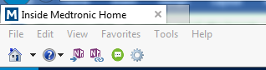

Smiley and Frown face feedback screen
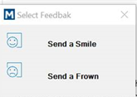sss

Frown Feedback screen
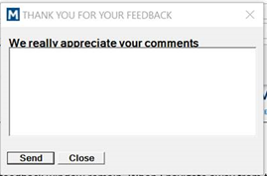

Smiley Feedback screen

Configuration
1. db.properties (Feedback Registration) – it will contain MySQL database connection details

