L2 - Investment Accounting

Version 1.1




Cognizant Technology Solutions US Corporation
500, Glenpointe Center West
Teaneck, NJ 07666
www.cognizant.com
The information contained in this document is confidential, and intended for the named recipient only. This information is the sole property of “Cognizant“, duplication or disclosure by any other person is strictly prohibited. If you have received this documentation by mistake, please notify sender immediately.
Table of Content
1. Introduction – Need for Investment 5
1.1 Types of investment 5
1.2 Classification of Financial Assets 5
2. Mutual Funds 8
2.1 Different Categories of Mutual Funds 9
2.1.1 By Structure 9
2.1.2 By Investment Objective 10
2.2 Business process in a Mutual Fund 11
2.2.1 Front Office 11
2.2.2 Middle Office 12
2.2.3 Back Office 13
3. Investment Accounting 15
3.1 Steps involved in Investment accounting 17
3.2 Processes involved in Investment accounting 18
3.3 Inputs to calculate NAV 19
3.4 Market Value of Investments 20
3.4.1 Pricing Methodology 20
3.4.2 Choosing the Pricing Sources 23
3.4.3 Reconcile Price 24
3.4.4 Release Price 24
3.5 Corporate Actions 24
3.5.1 Corporate Action execution 25
3.6 Amortization 29
3.6.1 Amortization Adjustment accounts 32
3.7 Interest Accrual 33
3.7.1 Interest Accrual calculation 34
3.7.2 Post Interest Accrual 37
3.7.3 Interest Bought/sold on Trades 38
3.7.4 Withholding Tax Calculation 39
3.7.5 Write-Off process 39
3.8 Valuation 39
3.8.1 Positions Valuation Computation 40
3.8.2 Subsidiary Valuations Computation 42
3.8.3 NAV Computation and Unit Cost Sheet 44
3.8.4 Process Unit Cost Sheet 45
3.8.5 Share Class NAV Calculation 46
4. Regulations concerning Investment Accounting 48
4.1 Recognition and De-recognition – IAS 39 49
4.2 Measurement – IAS 39 49
4.3 Regulatory and Accounting Standards: Hedge accounting 50
4.4 Valuation of Portfolio Securities by Investment Companies 51
4.5 Statutory Requirements 52
4.5.1 Current Net Asset Value 52
4.5.2 Readily Available Market Quotation 52
4.6 Fair Value Determinations 53
4.6.1 Statement of Financial Accounting Standards No. 157 (FAS 157) 53
4.6.2 FAS 157 Inputs 54
5. Global Trends in Investment Accounting 56
5.1 Portfolio accounting Outsourcing 56
5.2 Need for outsourcing portfolio accounting 56
5.3 Open Source Portfolio Accounting 56
5.4 Investment Accounting Products in Market 57
5.4.1 Advent 57
5.4.2 State Street 58
5.4.3 SunGard 58
5.4.4 Eagle Corporation 59
6. Investment Accounting in other AMCs 61

1. Introduction – Need for Investment

Investing is the act of committing money or capital to an endeavor with the expectation of obtaining an additional income or profit. The excess income that we earn over and above our current expenditure, which normally is saved, can be invested in different ways to earn additional income. The benefits of investment are:
- Earn return on your idle resources
- Generate a specified sum of money for a specific goal in life
- Make a provision for an uncertain future
- And to save tax of course

1.1 Types of investment
The different ways or forms in which investments can be made are.
- Physical assets like real estate, gold, commodities etc.
- Financial assets such as fixed deposits with banks, small saving instruments with post offices, shares, tax saving bonds, mutual funds, insurance and provident fund.
Investment in physical asset is done buy purchasing the asset directly from the market and does not require an investment company. Such investments are subject to market risk associated with that commodity. Investments in physical assets can also be done through derivative contracts like commodity forwards & futures, which are again traded in the Futures & Options market.
Investment in financial asset is not as simple as doing a market transaction as in the case of physical assets. There are different financial assets available to suit the risk appetite, return expectations and holding period requirements. Each of these assets requires specialized investment company.

1.2 Classification of Financial Assets
Some of the popular financial assets for investment are:

Savings Bank Account is often the first banking product people use, which offers a low interest.

Fixed Deposits with Banks are also referred to as term deposits and minimum investment period for bank FDs is 7 days. Fixed Deposits with banks are for investors with low risk appetite, and may be considered for 6-12 months investment period as normally interest on less than 6 months bank FDs is likely to be lower than money market fund returns.

Post Office Savings: Post Office Monthly Income Scheme is a low risk saving instrument, which can be availed through any post office.

Public Provident Fund: A long term savings instrument with a maturity of 15 years and interest payable at 8% per annum compounded annually. A PPF account can be opened through a nationalized bank at anytime during the year and is open all through the year for depositing money.

Company Fixed Deposits: These are short-term (six months) to medium-term (three to five years) borrowings by companies at a fixed rate of interest which is payable monthly, quarterly, semi-annually or annually.

Bonds: It is a fixed income (debt) instrument issued for a period of more than one year with the purpose of raising capital. The central or state government, corporations and similar institutions sell bonds. A bond is generally a promise to repay the principal along with a fixed rate of interest on a specified date, called the Maturity Date.

Stocks: One can invest in the stocks of the company either through the initial public offer or through the stock exchange. When an investor purchases stocks, or equities he becomes a part owner of the business. This entitles the investor to vote at the shareholders' meeting and allows him to receive any profits that the company allocates to its owners.

Mutual Funds: A mutual fund is simply a financial intermediary that allows a group of investors to pool their money together with a predetermined investment objective. The mutual fund will have a fund manager who is responsible for investing the pooled money into specific securities (usually stocks or bonds). When you invest in a mutual fund, you are buying shares (or portions) of the mutual fund and become a shareholder of the fund.
While each of these financial assets requires specialized Investment Company and are regulated by a central body, Mutual funds are known as pooled investment vehicles (PIV) and invest in all other types of financial assets, thereby requiring professional and sophisticated investment management skills and regulation compliant reporting and disclosure. This document discusses in detail about the benefits, types of mutual funds, the business processes and operations involved in a Mutual fund and the regulatory accounting and reporting requirements enforced.
There are other types of Pooled Investment Vehicles like Pension Funds, Hedge Funds, Insurance funds and Separately Managed Accounts (SMA), which like Mutual funds, also requires professional management. Even though the management and regulatory requirements are different for the above investment types, the underlying accounting requirements are the same and will be discussed briefly in this document.

2. Mutual Funds
Mutual funds are one of the best investments ever created because they are very cost efficient and very easy to invest in (you don't have to figure out which stocks or bonds to buy). By pooling money together in a mutual fund, investors can purchase stocks or bonds with much lower trading costs than if they tried to do it on their own. But the biggest advantage to mutual funds is diversification. The basic characteristics of a Mutual Fund are:

- Investors can directly purchase mutual fund shares from the fund itself (or through a broker for the fund) or in case of Mutual fund traded in the exchange, the fund can be purchased from the exchange (typically in case of close ended fund).

- The price that investors pay for mutual fund shares is the fund's per share net asset value (NAV) plus any shareholder fees that the fund imposes at the time of purchase (such as entry loads).

- Mutual fund is a perpetual entity, in other words the Mutual funds are sold on a continuous basis. Mutual funds generally create and sell new shares to accommodate new investors

- Mutual fund shares are "redeemable," meaning investors can sell their shares back to the fund (or to a broker acting for the fund)

Advantages
- Professional Management — Professional money managers research, select, and monitor the performance of the securities the fund purchases.
- Diversification of risk— Diversification is an investing strategy that can be neatly summed up as "Don't put all your eggs in one basket." Spreading investments across a wide range of companies and industry sectors can help lower downside risk if a company or sector fails. Some investors find it easier to achieve diversification through ownership of mutual funds rather than through ownership of individual stocks or bonds.

- Inexpensive — Investment in individual shares is expensive. Mutual funds accommodate investors who don't have a lot of money to invest by setting relatively low amounts for initial purchases, subsequent monthly purchases, or both.

- Liquidity — Mutual fund investors can readily redeem their shares at the current NAV — plus any fees and charges assessed on redemption — at any time

Disadvantages
- Costs despite Negative Returns — Investors must pay sales charges, annual fees, and other expenses regardless of how the fund performs. Also, depending on the timing of their investment, investors may also have to pay taxes on any capital gains distribution they receive — even if the fund went on to perform poorly after they bought shares.

- Lack of Control — Investors typically cannot ascertain the exact make-up of a fund's portfolio at any given time, nor can they directly influence which securities the fund manager buys and sells or the timing of those trades.

- Uncertainty of Price— With an individual stock, investor can obtain real-time (or close to real-time) pricing information with relative ease by checking financial websites or by calling your broker. A stock's price changes can be tracked from hour to hour — or even second to second. By contrast, with a mutual fund, the price at which unit is purchased or redeemed will typically depend on the fund's NAV, which the fund might not calculate until many hours the investor has placed his order. In general, mutual funds must calculate their NAV at least once every business day, typically after the major U.S. exchanges close.

2.1 Different Categories of Mutual Funds
Mutual Funds can be broadly classified based on its structure and its investment objectives.

2.1.1 By Structure

Based on the structure of the fund, a mutual fund can be classified into two types Open-ended funds and Closed ended funds:

- Open-ended funds: Open-ended plans do not have a fixed maturity period. Investors can buy or sell units at NAV-related prices from and to the mutual fund on any business day. These schemes have unlimited capitalization, there is no cap on the amount one can buy from the fund and the unit capital can keep growing. These funds are not generally listed on any exchange. Open-ended plans are preferred for their liquidity. Such funds can issue and redeem units any time during the life of a scheme. Hence, unit capital of open-ended funds can fluctuate on a daily basis.

- Close-ended funds: Close-ended plans have fixed maturity periods. Investors can buy into these funds during the period when these funds are open in the initial issue. Such schemes cannot issue new units except in case of bonus or rights issue. However, after the initial issue, investor can buy or sell units of the scheme on the stock exchanges where they are listed. The market price of the units could vary from the NAV of the scheme due to demand and supply factors, investors’ expectations and other market factors.

2.1.2 By Investment Objective

Mutual funds can be further classified based on the nature of investment (i.e., the type of asset in which the money is invested) and the investment objective of the fund. Some of the board categories are:

- Equity Funds - Invest primarily in equity shares of companies. Some of common types of Equity funds that are floated in the market include Growth Funds – Invest primarily in stocks of well established companies with above average growth potential, Sector Funds – Invests primarily in companies pertaining to a particular industry sector like Technology Fund would invest only in companies that operate in the Technology Industry, Global Equity Fund – Invest Primarily in stocks that are traded worldwide, and Index funds – tracks the performance of a particular stock index.

- Bond Fund - Invest in fixed income instruments issued by government or corporate entities. Some of the common types of bond funds that are floated in the market include Corporate bond fund, High Yield Funds and Capital/Principal protection funds

- Hybrid Funds – Invest in a mix of equities, fixed Income securities and derivative instruments. Some common types of hybrid funds that are floated in the market are balanced funds and flexible portfolio funds.

- Money Market/Liquid Funds- Invest primarily in short-term and money market instruments.

2.2 Business process in a Mutual Fund
There are three major divisions in a Mutual Fund organization viz., the front office, middle office and the back-office. Eagle product suites support the critical middle and back office functions of the mutual fund organization.

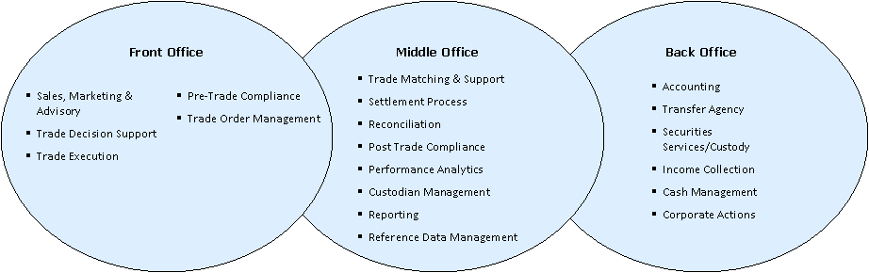

2.2.1 Front Office
The major functions involved in a typical mutual fund front office are:
- Sales, Marketing & Advisory: Investment management firm must constantly market their product & services to attract & increase assets under management (AUM). The Sales and marketing team of any Investment Management firm interfaces with the clients and ensures widening of new relationships and deepening of the existing ones. This division in turn draws heavily on the other functions of research, and portfolio management in order to sell the Investment management company’s services to the clients.
- Trade Decision Support: Investment management firms have a host of research analysts who analyze the universe of equities, fixed income and derivatives instruments and prepare reports and recommendations on them. The portfolio managers use these reports as the basis for their trading decisions.
- Trade Order Management: Investment manager makes the critical decision on what stock to invest or divest based on the investment objective of the fund. Research Analyst Team supplements the investment manager’s decisions. Once the investment manager decides on a trade, the trade is passed on to an order management system. This order management system routes the trade to the market place where the trade will be executed. The different stages of the trade from order entry to final confirmation of execution is managed by the order management system.
- Pre-Trade Compliance: Before the order is sent out for execution, pre-trade compliance function ensures that the order is within the regulatory limits.
- Trade Execution: This function involves routing the order to the market place and execution of the order. The order management system is linked to the systems at the marketplace for routing the orders. The trade is then executed at the respective marketplace and the details of execution are passed on to the order management system.

2.2.2 Middle Office
The major functions involved in a mutual fund middle office are:
- Trade Matching & Support: This business functions involves matching the trade details with the counterparties. Once a trade is executed, the details of the trade are passed on to the custodian for trade matching. The investment management firm confirms/rejects the trade on the trade matching report prepared by the custodian.
- Settlement Process: This function involves settlement of the trades with the exchanges and in case of off-market deals with the counter parties.

For an Investment management organization, above-mentioned functions are typically handled by custodians.

- Reconciliation: One of the critical functions involved in the middle office is Reconciliation. Securities Positions and the cash balances with the custodian are reconciled with the balances in the books of the investment manager organization. In case of an investment management organization are sub-advised by multiple advisors, this function also involves position reconciliation with these sub-advisors.
- Performance Analytics: Performance measurement, attribution and reporting are an important function in the mutual fund organization. It constitutes the feedback loop that provides inputs for portfolio rebalancing and other management decisions. It enables analysis of performance across various dimensions to provide a meaningful understanding and evaluation of portfolio performance.
- Reporting: This function involves client reporting, legal, tax and other regulatory reporting requirements for the mutual fund.
- Reference Data Management: Reference data is the static information to support the various operational processes in the investment management firm. These are the fundamental data based on which the various operations execute their activities. Reference data is typically sourced from external data vendors like Bloomberg, Reuters or from internal systems.

2.2.3 Back Office
Accounting is the core function in the back-office of the Mutual Fund Organization. Accounting function involves accounting for the trades executed by the fund, income and expense accruals and finally computation of the net assets value of the fund. A net asset value is the price at which the unit holder buys/sells the units of the fund.
Net Asset Value (Per Share) = (Current Market Value of Investments (in the portfolio) + Income receivables – expense payables)/ Total No. of Units Outstanding
An investment company calculates the NAV of a single share (or the "per share NAV") by dividing its NAV by the number of shares that are outstanding. For example, if a mutual fund has an NAV of $100 million, and investors own 10,000,000 of the fund’s shares, the funds per share NAV will be $10. Because per share NAV is based on NAV, which changes daily, and on the number of shares held by investors, which also changes daily, per share NAV also will change daily. Most mutual funds publish per share NAVs in the daily newspapers. The major sub-process required involved in the computation of Net Asset Value of the fund are:
- Trades Accounting: This function involves accounting for the trades executed in the front office of the Mutual Fund. In case of the fund being sub-advised by multiple sub-advisors, the trades will be accounted with the trade feeds from the sub-advisors.
- Capital Stock accounting: This function involves accounting for the capital subscription/redemption by the unit holders of the fund. The net capital stock inflows/outflows are received from the transfer agent of the fund.
- Pricing: Pricing is the function of marking to market all the investments held in the fund. As discussed in the section above, NAV for an account is computed by summing the current market value of the portfolio with the net income accruals. Pricing process computes the current market value of the portfolio. For the purpose of arriving at the current market value of the portfolio, accounting application interfaces with external data vendors like JJ Kenny, IDC.
- Income and Expenses Accrual: Function of accounting of all Income and expenses accrual for the fund.
- Corporate Actions: This function involves accounting for the corporate actions in relation to the securities held in the portfolio.
Other back office functions like Transfer Agency, Security Servicing/Custody, Income Collection and Cash Management are outsourced to Custodians and Transfer agencies.
The entire processes involved in accounting are automated owing to the complexity and the regulatory requirements involved. Subsequent sections discuss the Methodology, Rules and Regulations followed in an Investment Accounting system.

3. Investment Accounting
Eco System View Investment Accounting
A typical Investment Accounting system interacts with several players and systems in order to perform the Middle and Back office functions of a Mutual Fund Organization. The view below depicts the interaction of the Investment Accounting system with systems
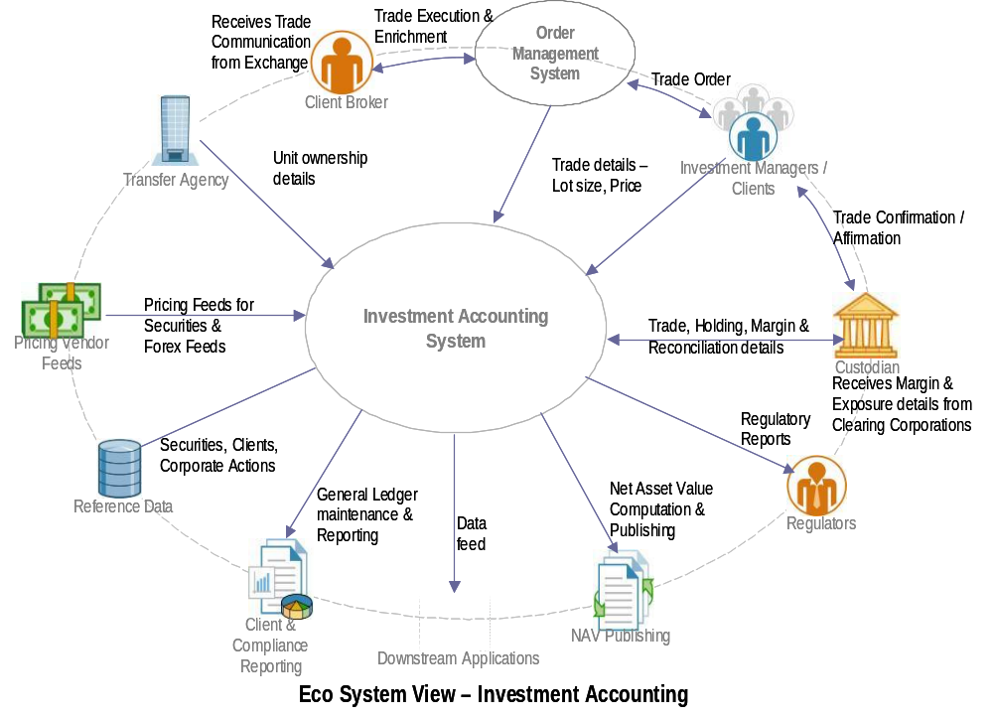
like the Order Management System, Client & Compliance Reporting System, NAV Calculation System and with several players like the Transfer Agents, Pricing Feed Vendors, Regulatory Authorities and the Custodian of the Mutual Fund and the flow of information amongst the various entities. This view also indicates the Data Stores and other downstream applications that the accounting system may interact with.
Functional View of Investment Accounting
The functional view indicates in detail the functions performed by an Investment Accounting System and the flow of information among the various entities of the system. The typical functions performed by an Investment Accounting system include
- Trade Processing – Receiving trade information from Client/Investment Managers, Custodians and Transfer Agent, Processing any reconciliation of the trade and Maintaining the Lot level holding details for all accounts

- Pricing – Determination of the Price of each security held by the Fund. Several Methodologies and Sources are used to determine the price depending on the requirement of the fund

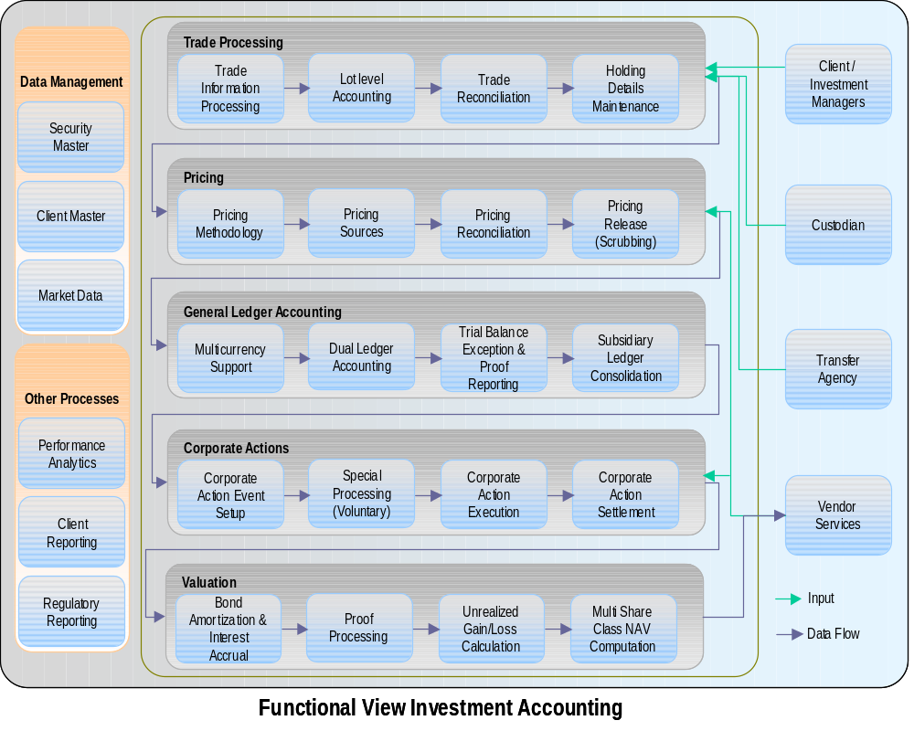

- General Ledger Accounting – Multicurrency Dual Ledger accounting which maintains accounts in Base Currency, Local Currency, Accrual Currency and Settlement Currency. Adjustments are also posted for Unrealized Gain or Loss due to derivates and/or Forex exposures on a Mark-to-Market basis. Accounting consolidation from a Subsidiary Ledger is also performed.

- Corporate Actions – Posting adjustments to the General Ledger on execution of a corporate action. In case of Voluntary Corporate Actions, posting happens according to the choice of the client

- Valuation – Determination of the total value of the securities held by the fund less the liabilities. This function requires input from the Pricing, General Ledger and Corporate Actions entity to process the total fund value.

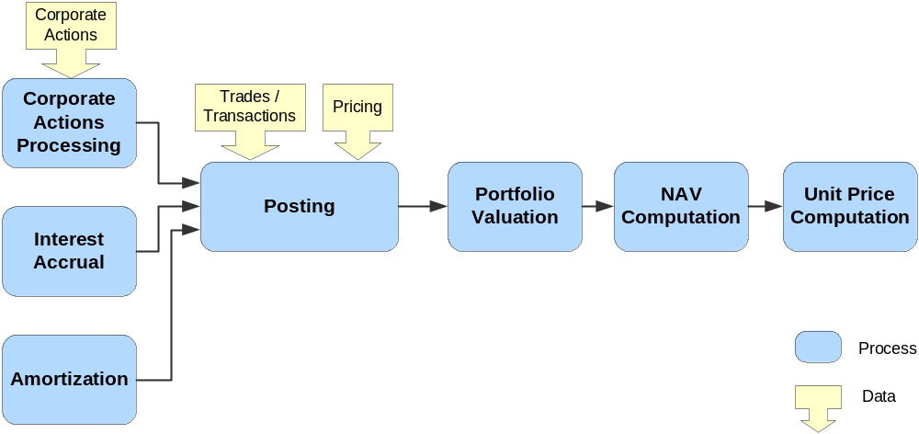
3.1 Steps involved in Investment accounting

- Post the transactions (buying and selling of securities) and other related activities (like management fees, admin charges, trustee/custodian fees) on the portfolio in the ledgers following the accounting standards
- Execute and settle corporate action (if any).
- Get the market Value of the Investments
- Calculate and post the interest accruals in the account. Interest accrual is the process of accounting the interest income due on bonds.
- Calculate and adjust amortization. Amortization is the process of posting cost adjustment entries only for bond securities bought at discount or at premium so that, at the time of maturity the book cost of the investment equals the maturity value.
- Next step is the start of the valuation process where the unrealized gains/loss on positions and the subsidiary valuation are computed. Subsidiary valuation involves the computation of unrealized currency gains/loss on investment interest and dividend receivables.
- Calculate NAV and process Unit Price

3.2 Processes involved in Investment accounting
As a part of the Investment Accounting process, a mutual fund is required to follow the following processes based on its investment objective and perform appropriate calculations and reporting
- NAV calculation (Net Asset Value) – It is the book value of the assets in the fund less the liabilities. It is calculated on a daily basis and is useful in determining the per share price of the fund. NAV changes on a daily basis as the value of the assets and liabilities of the fund changes daily. Section 2(a) of the Investment Company Act 1940 governs NAV calculation and reporting.

- Multi-class share accounting (sector and class allocations) – For funds issuing different share classes to investors, share class level pricing, accounting and disclosure is mandatory

- SEC yield – Also known as standardized yield, this yield figure reflects the dividend and interest earned during the period of accounting. This yield gives the effective rate of interest that and investor can receive in the future. It also provides a measure of fair comparison of bond funds

- Rule 2a - 7 processing – This rule of the Investment Company Act of 1940, regulates the share price calculation of Money Market funds using the Amortized Cost method or Penny Rounding method and also governs the required procedure for each of this method of calculation.

- Tax equalization – This is very important for cross border funds and funds trading in international asset (assets from countries other than the domiciled country). The fund is required to pay the tax differential across different countries while charging the domicile country tax rates to the clients, ensuring that the clients are charged a single tax rate irrespective of the different country assets traded by the fund.

- Fair value pricing – According to Financial Accounting Standards 157, funds are expected to price the shares using a market-based approach. Such calculation requires use of market information from transactions of similar assets in a principal market.

- Stable value/traditional GICs – Stable Value funds forms a part of qualified retirement plans (401(k) plans) that protects principal and accumulated interests and provides penalty free liquidity. Guaranteed Income Contracts are Stable value products offered by insurance companies, which guarantees a principal payment and a fixed or floating interest payment to the investor. Such funds are governed by the pension investments regulations

- 529 Plan – It is a tax advantaged savings plan legally known as qualified tuition plans which are designed to encourage savings for future college costs. Such funds are governed by Section 529 of the Internal Revenue Code

- Fund of funds Accounting – An investment fund that holds a portfolio of other investments is known as Fund of Funds (FoF). Such fund requires information from the constituent funds for NAV calculation and accounting.

- NAV trial balance – Prepared at the end of every reporting period to ensure that the ledger entries (buy or sell of assets) in the funds books are mathematically correct.

- Shareholder reports – Mutual funds are expected to provide Quarterly Shareholder’s reports and Portfolio Disclosures to its shareholders

3.3 Inputs to calculate NAV
- Market Value of Investments
- Corporate Actions Data
- Amortization
- Interest and Expense Accrual
- Securities Trade Transactions
- Manual Inputs – Ex. In case of unavailability of Market value of a security from the pricing vendors, market value can be entered manually to complete calculation.
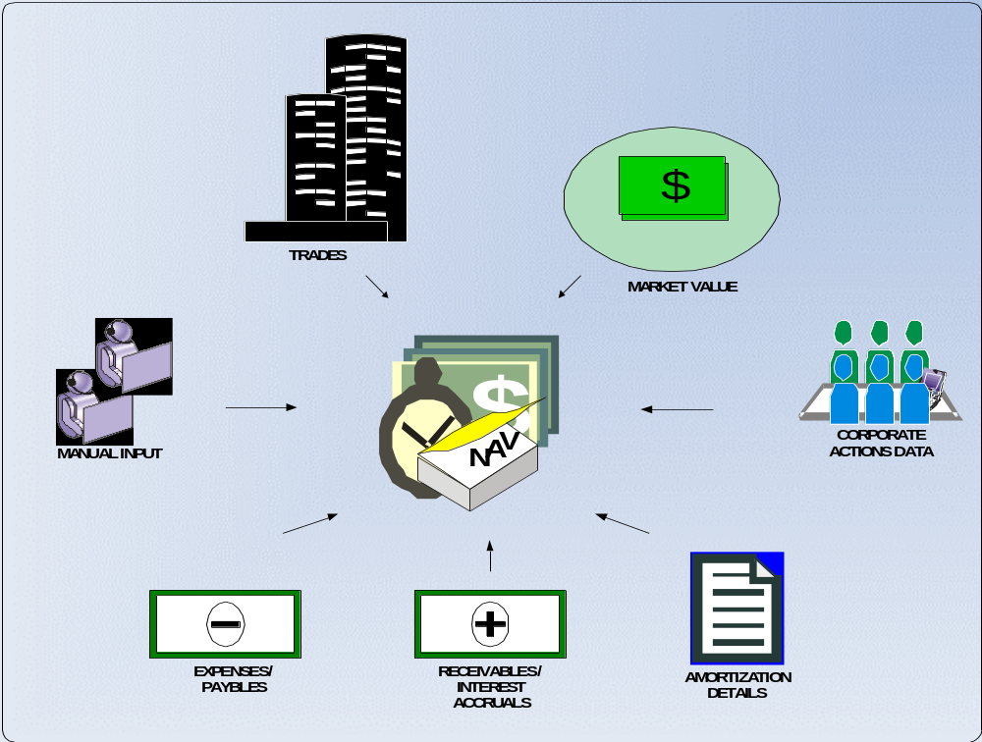

3.4 Market Value of Investments
To compute the “Net Asset Value per unit” (NAV), it is necessary to have the current market value of the securities held in a particular portfolio. For the purpose of arriving at the current market value of the portfolio, the investment accounting system interfaces with various pricing vendors, who supply the current market prices for the securities.
The various functions in Pricing can be broadly classified into:
  - Pricing Methodologies
  - Pricing Sources
  - Pricing reconciliation (Variance Analysis, movement in daily prices)
  - Pricing releases

3.4.1 Pricing Methodology
Various pricing methodologies are adopted to perform valuation of different security types held in a Portfolio. The pricing methodology would be selected based on the type of assets in a given portfolio.
Following table depicts the pricing methodology adopted in the valuation of different security types:
Asset Type | Valuation Methodology
Insurance Contracts and Short Term Assets  (An asset is considered short-term if the number of days between issuance and maturity is less than one year) | Book Value  Alternatively, internally generated Matrix Pricing can be used for pricing (Eurodollar CDs, Banker Acceptances, Commercial Paper, T-Bills, FNMA/FHLMC, Other US Government obligations and Short-term municipals maturing within a year of issue)
US Fixed Income Assets | Bears Stearns evaluated prices (i.e. matrix prices) are derived using a benchmark security and a spread in basis points. The benchmarks (typically Treasuries or bellwether corporate issues) are updated real-time and reflect market conditions throughout the day. The spreads are assigned by Bears Stearns traders and are adjusted as market conditions change. As benchmarks move, the assets assigned to these benchmarks also move.
US Corporate Bonds | Bears Stearns evaluated prices. Corporate bond evaluations typically reflect the market as of 2.30 pm EST. All other evaluations reflect the market as of 3.00 pm EST.
US Government Securities | Closing prices of US Treasuries as of 3.00 pm EST Bear Stearns supplies these prices.
US Mortgaged backed Securities | Bear Stearns Matrix Prices or Bear Stearns Seasoned Matrix Prices.
US Private Placements | Bear Stearns prices. Bear Stearns sets up a pricing model based on the information available in the prospectus, certificate copy of the private placements.
US CMO’s and Asset Backed Securities | Priced based on evaluation model. The evaluation model considers factors such as underlying collateral characteristics, prepayment speed assumption, average life and benchmark spreads.
US Municipals | Prices supplied by JJ Kenny. Some are hand priced by Kenny.
Listed US Equities and Close-end funds | Composite close price. (Average of Close price in all exchanges where the security is traded). In case a security is not traded on any particular day, the mean of the current bid and ask prices is used as the official price.
Non-NASDAQ over the counter US Equities | Current bid price, if Current bid weren’t available consider ask price.
US Options | Last traded price, if the price falls between current bid and asked. If the last traded price is less than current bid, the bid price is considered official. If it is higher than the current ask price. The ask price is the official price.  If the security did not trade, the mean of current bid and ask is the official price.  If only a bid or an asked price is available for an option, the price is reviewed by the firm and compared to the last official price, the strike price and the price of the underlying security. After this review, the current bid or asked may be considered the official price.
UK and Other International Markets | For UK assets, the latest Jobber quote price or mid price is the official price. For non-UK, non-Canadian assets, the local exchanges reported price (usually the latest available trade price) is the official price.
Canadian Equities | The last available traded price or current bid from a local exchange. . If the security is listed in more than one exchange it is priced based on volume or an exchange hierarchy (if no trading occurred). Toronto, Montreal, Vancouver, and Alberta are the exchange hierarchy as defined by the firm.
Canadian Bonds | Priced by FRI evaluation model.
Over the counter International assets | Priced by IDC, Telesphere or FRI through their pricing contracts in the local markets or through Reuters contributor pages.
Over the counter Currency Options | Priced using Black-Scholes pricing model. This model takes into consideration the Option strike price, expiration date, market risk free rates and applicable volatilities.

3.4.2 Choosing the Pricing Sources
The pricing source for a security, is determined based on the type the security and the various pricing vendors, the firm subscribes to. The firm interfaces with multiple vendors for pricing of securities and FX rates; a vendor is selected based on the security type. A client can choose an alternate vendor also apart from the primary vendor. The firm works interactively with pricing vendors, industry groups, brokers, investment managers and clients to keep pace with the changing securities markets and the impact to pricing. The investment accounting system doesn’t price any securities but is depended on the vendors (with an exception for Matrix prices). The firms would also typically have one primary (official) source for Foreign Exchange rate and one alternate source.
The firm notifies the pricing vendor on the pricing methodology to be adopted for a particular asset type and the pricing vendor adheres to the method and supplies the prices accordingly.
The following table illustrates an example of different standard price sources used for different securities:
Security Type | Official Vendor | Other Vendors*
Fixed Income Pricing - U.S.
-Corporate Bonds,  -Government Bonds | • Bear Stearns | - IDC  - Bloomberg  - Brokers  - Prudential  - American Securities
-Mortgage-Backed  -ARMS | • Bear Stearns | - Bloomberg
- CMO’s  - Asset Backed Securities | • IDC  • Trepp  • Bear Stearns  • Street Software Technology, Inc. | - Brokers  - Prudential  - American Securities  - Bloomberg
-Municipals | • J.J. Kenny (via Bear Stearns) | - IDC
-Treasury/GNMA Options | • Bloomberg
-Private Placements | • Bear Stearns | - Prudential  - American Securities
Equity Pricing – U.S. | • IDC (includes exchange traded equity options)
Futures/Options on Futures | • Reuters | - Bloomberg
Open Ended Funds | • IDC | - Reuters  - Bloomberg
International Pricing | • IDC  • Telesphere  • Reuters | - FRI Corporation  - Morgan Stanley  - Bloomberg  - Financial Times
International Pricing - Canadian | • FRI Corporation | - Reuters  - Bloomberg  - IDC  - Telesphere  - Morgan Stanley  - Financial Times
Foreign Exchange Rates | • Reuters | - Bloomberg  - Morgan Stanley (WM Rates)

3.4.3 Reconcile Price
A pricing exception could arise due to anyone of the following reasons:
- There is no official price
- The official price is not current
- The current price varies beyond tolerance limit
Pricing reconciliation is a function of identification of any exceptions in the prices of the securities, taking corrective actions to rectify the pricing exception. Pricing team rectifies the pricing exceptions by Manual Pricing. On rectification of the pricing exceptions, the pricing status for a vendor feed would be modified, which means the prices supplied by the vendor, is ready for valuation.

3.4.4 Release Price
The last and the final step in the pricing process is the releasing of the prices of securities to be used in valuation. This process of reconciling and releasing of prices, for valuation is referred to as “Scrubbing”.

3.5 Corporate Actions
Corporate action denotes any event, which brings material changes to a stock. A corporate action is initiated by the issuer of the security and not by the investor of the securities. Some examples of corporate actions are Cash Dividends, Bonus, Stock-splits and Merger.
There are two types of corporate actions Mandatory corporate action and Voluntary corporate action.
Mandatory: A Non-voluntary corporate action is any corporate event that affects all shareholders of the security in a uniform manner across the board and results in a transaction based on the eligible holding on ex-date of the corporate action event. All holders of the security on the ex-date are eligible for the corporate actions. No action on the part of the security holder is required. It is also called a mandatory corporate action. Ex. Cash Dividend, Name Change, and Interest
Voluntary: A voluntary corporate action is a corporate event in which more than one option is offered and the holder of the securities exercises a decision regarding participation. Accounts, which have exercised the options, are only eligible for the corporate actions.
Ex. Merger Withdrawal, Spin-off, Security Withdrawal, Stock Dividend, Stock Split.
The main corporate action processes involved in the investment accounting system are corporate action execution and corporate action settlement.

3.5.1 Corporate Action execution
Corporate action execution is the process, which determines and reports the corporate actions for the account- holders of the given security as of ex-date. Corporate action execution also results in posting to relevant general ledgers (as applicable to the corporate action transaction type). The corporate action execution processes for different corporate actions are as follows:
- Dividends
There are two types of dividends a company can issue:
- Cash Dividends
- Stock dividends
Typically only one or the other is issued at a specific period of time (either quarterly, bi-annually or yearly) but both may occur simultaneously. When a dividend is declared and issued, the equity of a company is affected because the distributable equity (retained earnings and/or paid-in capital) is reduced. A cash dividend is straightforward. For each share owned, a certain amount of money is distributed to each shareholder. In stock dividend certain percentage of extra stocks are distributed among the shareholders

- Cash Dividend
Cash dividend is the money paid to stockholders, normally out of the corporation's current earnings or accumulated profits.
A cash dividend corporate action results in a cash inflow in all eligible accounts.
- Eligible dividend amount is computed by multiplying the holdings in the account with the dividend per unit. At the time of posting the dividend accrual entry the applicable withholding tax is also computed and posted. Similar to the interest income processing, the relevant tax rates are computed.
- All dividend accruals are first computed based on the security accrual currency and the base currency equivalent is computed based on the relevant exchange rate.

- Stock Dividend
Stock dividend also referred as “Bonus” is a corporate action in which corporate distributes the earnings or the accumulated profits in form of stocks of the corporate.
Example: A stock dividend of 10%, for example, means that for every 10 shares owned, the shareholder receives an additional share. If the company has 1,000,000 shares outstanding (common stock), the stock dividend would increase the company's outstanding shares to a total of 1,100,000.

This corporate action results in increase of the current holdings of the stock in an account.
- Effective date, apply date and new share rate (which determines the bonus ratio) has to be specified for execution of the corporate action event.
- Only holdings of the stock gets increased and the investment cost doesn’t change

- Merger Withdrawal/Deposit Accrual
Merger is a corporate action event in which one company merges with another company and the shares of the merge out company ceases to exist and the shareholders of merge out company are allotted shares of the new company.
For merger new share rate should be specified, price per share is optional. If the security type is “B”, “D” or “G” price per share (if specified) should be a percentage of par. The merger ratio between two companies and the cost to be carried forward from the cost of acquisition of the merge-out company to the merge-in company is specified. The relevant GL posting is done.

- Taxable Merger Withdrawal/Deposit Accrual
Taxable merger is a type of merger transaction, which is taxable.

- Security Withdrawal/Deposit Accrual
Security withdrawal is a corporate action event in which the security ceases to exist, and it is withdrawn from the market. A Security withdrawal corporate action event can be clubbed with a security deposit or processed as security withdrawal event only.
For a conversion/exchange, new share rate (exchange ratio between old share and new share) and new cost rate (cost to be carried forward to the new share from the old share) to be specified.
For merger, new share rate must be specified. Price per share is optional. If the security type is B, D, or G, Price per Share (if specified) must be a percentage of par.

- Stock Split
Stock split is a corporate action type where the face value of the stock is reduced and the number of equity shares outstanding in the company is increased. This does not result in any change in the equity capital of the company. This corporate action is usually carried out by a corporate to increase the liquidity in the share and for encouraging more retail participation in the company. So why would a firm issue such an action? More often than not, the board of directors will approve (and the shareholders will authorize) a stock split in order to increase the liquidity of the share on the market.
The result of the 2-for-1 stock split in our example above is two-fold:
- The drop in share price will make the stock more attractive to a wider pool of investors
- The increase in available shares outstanding on the stock exchange will make the stock more available to interested buyers.
Hence the value of the company, or its market capitalization (shares outstanding x market price/share), does not change, but the greater liquidity and higher demand on the share will typically drive the share price up, thereby increasing the company's market capitalization and value.
Example: A company announcing a 2-for-1 (2:1) stock split, for example, will distribute an additional share for every one outstanding share, so the total shares outstanding will double. If the company had 50 shares outstanding, it will have 100 after the stock split. At the same time, because the value of the company and its shares did not change, the price per share will drop by half. So if the pre-split price was $100 per share, the new price will be $50 per share.

- Spin Offs
Spin-off is a corporate action where a corporate hives-off any part/division of its existing business into new undertaking, the shareholders of the existing undertaking will be allotted additional shares in the new undertaking. Apply date, ex-date, post date, new share rate, and new cost rate (the cost to be carried forward) from the old security have to be stated at the time of setting up of the corporate action event.
A spin off occurs when an existing publicly-traded company sells a part of its assets or distributes new shares in order to create a newly independent company. Often the new shares will be offered through a rights issue to existing shareholders before they are offered to new investors (if at all). Depending on the situation, a spin-off could be indicative of a company ready to take on a new challenge or one that is restructuring or refocusing the activities of the main business. It is of two types:
Non-taxable Spin-off - Spin-off transactions which results in cost adjustment for the old security and the cost adjusted will be carried forward in the new security.
Taxable Spin-off - Taxable spin-off is a Spin-off transaction, which is taxable. Apply Date, ex-date, post date, new share rate, and price per share have to be stated at the time of setting up this type of corporate action event.
A taxable Spin-off transaction doesn’t result in a cost adjustment entry for the old security. It results in the increment of holdings in the new (receiving) security with the appropriate cost being computed based on the price per share at the time of corporate action event. The debit side of the cost is accounted in the investments at average cost and the credit side is accounted in dividend income (which is taxable GL head)

- Name Change
When a corporate changes its name, the new name of the corporate has to be incorporated.

- Payable in Kind Bonds
“Payable in kind” is a corporate action event applicable in bonds. Under this corporate action event, the bond issuer instead of paying the interest to the holders of the bond, issues securities equivalent to the interest payment. In most cases, the maturity of the bonds equals the maturity of the original issue.

- Rights and Warrants Issue
Rights issue is a corporate action event in which existing shareholders have the privilege to buy a specified number of new shares from the firm at a specified attractive price within a specified time. A rights issue is offered to all existing shareholders individually and may be rejected, accepted in full or (in a typical rights issue) accepted in part by each shareholder.
Rights can be renounce-able (can be sold separately from the share to other investors during the life of the right) or non-renounce-able (shareholders must either take up the rights or let them lapse. Once the rights have lapsed, they no longer exist).
To issue rights the financial manager has to consider:
- Subscription price per new share
- Number of new shares to be sold
- Value of rights
- Effect of rights on the value of the current share
- Effect of rights to existing and new shareholders
A right to a share is generally issued on ratio basis (e.g. one-for-three rights issue). Because the company is getting the shareholders' money in exchange for issuing rights, a rights issue is a source of funds for the company issuing it.

- Corporate action Settlement
Final step in a corporate action processing is settlement. Settlement is the function in which the corporate action proceeds are received from the issuer (for example, in case of Cash dividend corporate action on the settlement date, the cash proceeds is received from the corporate). At the time of actual posting of corporate action settlement, the realized currency gain/loss is computed (Local currency settlement date exchange rate – exchange rate used for dividend accrual).

- Foreign Income distributions (FID’s) - Non-taxable for all accounts
When a company (having multi-national operations) earns money through its operations in foreign countries it may declare two types of dividends—a regular dividend and a Foreign Income Distribution (FID). As taxes have already been paid to the foreign country, when shareholders receive dividend income designated as FID it is exempt of all taxes (foreign and domestic), regardless of the account’s domicile. As tax withholding and reclaim processing are unique, the investment accounting system differentiates the foreign income distribution through a tax code.

3.6 Amortization
Amortization is an accounting procedure that gradually decreases/increases the book value of an asset through periodic cost adjustments entries. In the investment accounting system scenario, Amortization adjustments are adjustments to the cost basis of a bond bought at a premium or discount so that, at maturity the cost equals par (i.e., face value), thus recognizing income or expense over the life of the bond rather than realizing a gain or loss at maturity. This income is in addition to interest accruals. The investment accounting system supports the processing of amortization adjustments for both domestic and international securities and for standard types of bonds (corporate, U.S. Treasury, asset backed, and municipal) and unique types (for example, payment-in-kind, acquisition discount, step, deep discount, and zero coupon).
There are two standard types of amortization/accretion:
a) Market Premium Amortization - For bonds bought at a premium (Price paid is higher than the par value)
b) Market Discount Amortization – For bonds bought at a discount (Price paid is lower than the par value)
On the investment accounting system each account chooses whether to amortize at all and, if so, whether to recognize market premium amortization and/or market discount accretion. Specific holdings can also be excluded from amortization.
There are two methods of calculation of Amortization adjustments:
- Straight line method of Amortization
- Constant yield method of Amortization
An account can select the amortization method to be used in computation of the amortization adjustment entries.

  - Straight- Line Method of Amortization
Under this method, the amount of the bond premium amortization is the same each month. Divide the number of months the bond was during the year by the number of months from the beginning of the tax year (or, if later, the date of acquisition) to the date of maturity or earlier call date.
Straight- Line Method of Amortization
Amortization = (HC x N) / A
Where HC = Premium/discount amount
A = Number of months from acquisition
N = Number of months during period

Then multiply the result by the bond premium (reduced by any bond premium amortization claimed in earlier years). This gives you the bond premium amortization for the year.
  - Constant Yield (Scientific Yield or Effective Yield) method of Amortization
Figure the bond premium amortization for each accrual period as follows.
Step 1: Determine the yield. The yield is the discount rate which when used in figuring the present value of all remaining payments to be made on the bond (including payments of qualified stated interest), produces an amount equal to your basis in the bond. Figure the yield as on the date of acquisition of the bond. It must be constant over the term of the bond and must be figured to at least two decimal places when expressed as a percentage.
Step 2: Determine the accrual periods. We can choose the accrual periods to use. They may be of any length and may vary in length over the term of the bond, but each accrual period can be no longer than 1 year and each scheduled payment of principal or interest must occur either on the first or the final day of an accrual period. The computation is simplest if accrual periods are the same as the intervals between interest payment dates.
Step 3: Determine the bond premium for the accrual period. To do this, multiply the adjusted acquisition price at the beginning of the accrual period by the yield. Then subtract the result from the qualified stated interest for the period.
The adjusted acquisition price at the beginning of the first accrual period is the same as the basis. After that, it is the basis decreased by the amount of bond premium amortized for earlier periods and the amount of any payment previously made on the bond other than a payment of qualified stated interest.
Constant Method of Amortization
Let the Purchase Price of the bond is ‘P’, Coupon ‘C’ %, Maturity ‘Y’ years, Semi-annual interest; Yield to Maturity is ‘Y’%. The following table shows the computations.

Year Amortization Adjustments
Year ‘n’ the total income earned on the bond for Year ‘n’ is:
I= Amortized carried cost of the bond (for year ‘n-1’) * Yield to maturity of the bond; Or I = [A*(n-1)]* Y
For Year 0, An-1 = P (purchase price)

Amortization adjustment for year ‘n’ will be:
A = Total income as computed above – Interest payment received = I – C

Amortized carried cost of the bond at the end of Year ‘n’:
An = Amortized Cost as of Year ‘n-1’ + Amortization adjustment = (An-1 + A)

Computation of Yield to Maturity
In order to calculate constant yield amortization, the yield-to-maturity (or yield-to-target-date) has to be computed. Yield to maturity is the rate of return anticipated on the bond if it were held till the maturity date. Securities Industry Association (SIA) has published standard formulae to be used in computation of Constant yield. The investment accounting systems generally use these standard formulae for computation of the amortization adjustments.

3.6.1 Amortization Adjustment accounts
The accounts can be broadly classified into four types based on their tax status and valuation period;
a) Tax-lot Intra-day accounts- Accounts for which holdings are maintained at lot level/acquisition level and portfolios are valued during the day. Only for these types of accounts daily amortization is possible.
b) Tax-lot Overnight Accounts- Accounts for which holdings are maintained with lot level/acquisition level detail and portfolios are valued only during the overnight process
c) Average Cost Intra-day accounts - accounts for which holdings are maintained at the position level rather than the lot level and portfolios are valued during the day.
d) Average Cost Overnight Accounts - Accounts for which holdings are maintained at the position level rather than the lot level and portfolios are valued only during the overnight process

Amortization adjustments can be done in one of the frequencies via:
- Daily Amortization
- Period-end Amortization, which is initiated at the end of a defined period
- Mid-Period Posting Adjustments which results in posting of amortization adjustments entries due to “Buy”, “Security Deposit” or “sell” of securities.

Since par value on foreign bonds is denominated in the local currency, local cost is used as the basis for the calculation. The basic calculation (straight line or constant yield) is performed to arrive at an amortization amount in the local currency. Then a “Local Base Rate” is calculated by dividing the current base cost by the current local cost. The amortization amount in local currency is multiplied by the calculated Local Base Rate to arrive at the amortization amount in base currency.
- Short-term securities of any type are amortized using the straight-line method, regardless of the calculation method specified by the account. (Less than one year to maturity)
- Premium convertible bonds, in accordance with industry standards bonds do not amortize.
- Amortization is not processed while a security is in default. When a security comes out of default, amortization is initiated at the holding level, which will be the catch up amortization.
- Debt positions held short are not amortized.

3.7 Interest Accrual
Interest accrual is the process of accruing the interest income on debt/bond securities. On basis of interest payment, debt securities can be broadly classified into two types fixed coupon payment instruments and zero coupon instruments. A fixed coupon instruments pays fixed rate of interest during the tenure the bond and whereas a zero-coupon instrument are issued at discount to the par value and doesn’t pay interest during the tenure of the bond.

Different type of debt securities uses different methodology for computation of interest accruals. Twelve different methods of interest accruals are explained in this document. Interest accrual entries are posted both in the local ledger and in the base ledger, the local amounts are denominated in the securities accrual currency. Foreign tax expenses and the adjustment towards currency gain/loss are automatically computed and posted at the time of interest receipt.

On buy and sell transactions, the investment accounting system automatically computes and post the interest payable/receivable to/from the seller/buyer of the bond (interest accrued between the settlement date of the bond and the last interest payment date). Negative interest bought/sold can also be processed.

3.7.1 Interest Accrual calculation
The inputs required for this process are Interest rates, accrual class (interest method/formula to be used) and interest frequency (frequency in which interest payments are made). Interest accrual process is run daily as part of the valuation cycle. The position on which the interest accrual has to be computed is also required as the input. The following table shows the Interest accrual formula for different interest accrual classes.

Interest Accrual Class | Description | Formula
Class 00- No auto  Accrual | No automated interest accruals are generated. No interest accruals are generated /posted by the system. | Daily accrual amount = 0
Class 01- Actual/actual | This interest accrual class is primarily used for interest computation on treasury bonds | Daily accrual amount = (units * rate)/payments per year pay period end date- pay period start date where,  Units = outstanding positions  Rate= interest/income rate  Payments per year = derived from payment frequency  Pay period end/start date = derived from accrual dates
Class 02-  Actual/366 | This interest accrual class is primarily used for interest computation on foreign bonds. | Daily accrual amount = (units * rate)/ 366  where,  Units = outstanding positions  Rate = interest/income rate
Class 03- 30/360 day basis | This interest accrual class is primarily used for interest computation on corporate bonds. To compute the daily accrual amount, the annual interest is divided by 360. | Daily accrual amount = (units * rate)/360  where  Units = outstanding positions  Rate = interest or income rate
Class 04- actual receipts | No automated interest accrual, accounted on receipt basis. | Daily accrual amount = 0
Class 05- Actual/360 discount | This accrual method is used computation of interest income for discounted bonds, under this method. The accrual method is computed by dividing the discount amount by the number of days in the life of the bond. for tax lot intra-day accounts this method generates the cost adjustment entry and not interest accrual entry. | Daily accrual amount = (Discount amount)/  (Maturity date – Settlement date  where,  Discount amount = Redemption value (par value * holdings) – Purchase cost  Maturity date = maturity date or redemption date  Settlement date = settlement date
Class 06- Actual/360 | This method is used for interest accrual on interest bearing notes. The payment is accrued over the actual number of days based on a 360 day year basis. | Daily accrual amount = (units * rate)/ 360  where  Units = outstanding positions  Rate = interest or income rate
Class 07- effective yield | This method is used for interest accrual on interest bearing notes bought at a discount. The stated interest rate is combined with the discount to calculate an effective yield. For these types of bonds no amortization is done. | Daily accrual amount = (Units * effective yield)/ 360  where,  Effective yield = discount rate + rate  Discount rate = (Discount amount * 360)/  [(Units - discount amount) * (maturity date – settlement date)]  Discount amount = (units – purchase cost)
Class 08-  Actual/365 | Under this method the annual interest is divided by 365 days to compute the daily interest accrual amount. this method is commonly used for interest accrual on foreign bonds. | Daily accrual amount =(units * rate)/365  where,  Units = outstanding positions  Rate = interest or income rate
Class 09- 30/360/actual | Interest is calculated on a 30/360 day basis, but the accrual amount is equally spread over the actual amount of days in the pay period. this accrual class is used for accruing interest income on corporate bonds. | daily accrual amount =(Units * rate * pay period days)/  {360*(actual pay period days)}  where,  Units = outstanding positions  Rate = interest/income rate  Pay period days = period on 360 days basis  Actual pay period days = next interest payment date - last interest payment date
Class 10- actual/365 equal payments | The annual interest is divided by 365 to compute the daily accrual amount and adjustment is made at the end of each semi-annual pay period to adjust the accrual to 1/2 annual amount. an adjustment is also made on day 183 of a 184 pay period to actually back off 1/2 day’s accrual to bring the amount to 181.5 days of accrual. these types of accruals are processed for Canadian bonds | Daily accrual amount = (units* rate)/ 365  where,  Units = outstanding positions  Rate = interest/income rate
Class 11- calendar spread 30/360 | Under this method, interest is calculated on a 30/360-day basis but is then spread out over the actual amount of days in the month. | Daily accrual amount = [(units * rate* 30)* days in month]/360  where,  Units = outstanding positions  Rate = interest/income rate
Class 12- 30e/360 | Under this method, the interest is calculated on a 30/360 day basis and interest is accrued 30 days per month, but months with 31 days do not accrue on 30th of the month and three days of accruals are done on February 28th and two days of accruals are done on February 29th (for leap year). | Daily accrual amount = (units * rate)/360  where,  Units = outstanding positions  Rate = interest/income rate

3.7.2 Post Interest Accrual
Interest accrual posting debits the interest receivable GL head and credits the interest income GL head. Interests are first recorded in the accrual currency of the security in the local ledger and base equivalent of the accrual is computed and updated in the base currency ledger based on the spot exchange rate on the valuation date.
In cases where the accrual currency of the security is different from the base currency, the subsidiary valuation process computes the unrealized currency gain/loss on the interest receivable. At the time of posting the interest receipts realized currency gains and losses are computed and posted to the respective GL heads. The investment accounting system maintains average accrual exchange rate on all accrual records. This amount represents the composite exchange rate with which local accruals have been converted to base over time. Average exchange rate is used to calculate the realized/unrealized currency gain/loss and similarly used in the computation of realized currency gain/loss on sale of the securities.

Average exchange rate is computed as:
Average exchange rate:
(Local earned+ Local bought)/ (Base-Earned + Base-bought)

3.7.3 Interest Bought/sold on Trades
In trades where the settlement date of the transactions is greater than the last interest payment date of the bond, the buy trade will result in payment of interest to the seller of the bond from last interest payment date till settlement date of the bond. In case of sell transaction, it will result in the receipt of interest from the seller of the bond.
There are situations when the settlement date of the trade bond is close to the next interest payment date. In such cases, though the bond is sold, the seller would still receive the interest payment as the securities are not yet transferred to the buyer. At the time of the purchase of the bond no interest are paid to the seller of the bond, but in contrary, the net settlement amount to the seller is computed by deducting the interest due from the settlement date to the next interest payment date, this interest is called ”Negative” interest. “Negative” interest bought decreases the receivable and negative interest sold increases the receivable.
The net interest receivable for position is computed as:
Net Interest receivable:
Interest Accrued+ Interest Paid- Interest Sold- Interest Received

The realized currency gain and loss are computed and posted at the time of posting the interest receipts. The realized currency gain/loss is computed as:
Realized Currency Gains/Loss:
Local currency amount * Valuation date exchange rate – Base currency accruals

3.7.4 Withholding Tax Calculation
Interest income received by the account is subject to withholding tax depending upon the tax status of the account. The gross accrual is divided into net income (after withholding tax), reclaim (refundable withholding tax), expenses (non-refundable withholding).
The tax component on interest income comprises:
a) Withholding tax (sum of foreign expenses, foreign reclaim, domestic expenses and domestic reclaim)
b) Foreign Expenses (Non recoverable foreign tax)
c) Foreign Reclaim (Recoverable foreign tax)
d) Domestic expenses (Non recoverable domestic tax)
e) Domestic reclaims (Recoverable tax)

3.7.5 Write-Off process
Write-offs are performed for any accrual meeting all of the following criteria:
- Pay date is a past date
- Interest received or sold is greater than zero, or interest bought is negative
- Gross base receivable is less than the write-off tolerance margin defined for that accrual class (example: floating rate bonds)

3.8 Valuation
Valuation is the process through which the current realizable/marketable value of a portfolio is computed, which is ultimately used for computation of Net assets value per unit of the fund (account). In the investment accounting system, valuation process comprise income accruals (interest income and amortization process), computation and posting of Unrealized gain/loss on positions (so that the book value of investments represent the current realizable/marketable value), valuation/re-valuation of foreign currency receivables and payables and posting of Unrealized currency gain/loss (so that book value of receivables/payables represent the current realizable/payable value).

- FX Rate tenor/basis for Unrealized Gain/loss computation
At the time of setting-up of the account, the client can define the FX rate tenor (Spot rate or forward rate) to be used for the UGL computation on Subsidiary ledgers (Interest receivables, Dividend receivables, Pending trade settlements and Pending FX Contracts). UGL’s on Positions are always computed on the valuation date spot exchange rate. FX mid rate (Average of bid and offer rate) is used as the basis for the computation of the UGL’s.

- Unrealized Gains/Loss Posting rules
As part of the Valuation process, UGL’s computed for positions and subsidiary ledgers are posted to the pre-defined General ledgers heads. Rules are set for each of the UGL’s the account head to be used for debiting and crediting. (For Example: GL heads for UGL’s on a long position, UGL on a short position, UGL on currency gains, UGL on Pending trades, UGL on Interest/Dividend receivables, UGL’s on purchased call).

Dividend accruals can have different components like Net Income, Tax Reclaim and Expenses. The tax structure is based on the security type, tax status of the account and domicile country of the firm. Rules are defined for each of the components of the dividend.

3.8.1 Positions Valuation Computation
Position valuation comprises computation and posting of the unrealized gain/loss on the investments for both foreign and domestic securities and computation and posting of unrealized gain/loss on currency. Position valuation comprises of the following computational heads:

- Unrealized Gains/Loss on Positions
- Unrealized Gains/Loss on Investments on Foreign security
- Unrealized Gains/Loss on Short Positions
- Unrealized Gains/Loss for tax lot accounts
- Unrealized Gains/Loss for accounts compliant with FASB 52 and AICPA SOP 93-4
- Unrealized gains/loss on Positions on Foreign Currencies
- Margin on Futures and Options

- Unrealized Gains/Loss on Positions
Unrealized gains/loss on positions is the difference between the current market/realizable value of the investments and the cost incurred in acquiring the investments. The unrealized gains/loss on positions is posted to the respective general ledgers heads so that, the book value of the investments equals the current market value of the investments (Book Value Adjustment).

In cases where the security local currency is different from that of the account base currency, unrealized gains/loss on the security can be classified into types, viz., unrealized gains/loss on Investments and Unrealized gains/loss on Currency movements.

- Computation of Unrealized Gains/Loss on Investments on Foreign security
In cases where the security currency is different from that of the account base currency, the Unrealized Gain/Loss on such investment comprises of UGL’s on investment and UGL’s on currency. UGL’s on this security will be divided into gains/loss due to the investment and gains/loss due to currency appreciation/depreciation. The GL posting will also be done separately under both these heads. Unrealized Investment Gain/Loss on the holding is computed as:
Unrealized Investment Gain/Loss on Holding
(Local Market Value * Average Acquisition Exchange rate) - Base Cost

Unrealized currency Gain/Loss on holding are computed as per the formula given below:
Unrealized Currency Gain/Loss on Holding
[{(Local Market Value* Valuation date Spot Exchange rate) - Base Cost} –
Unrealized Investment Gain/Loss on the holding]

- Computation of Unrealized Gains/Loss on Short Positions
Short position occurs when an account sells stocks, which it doesn’t own. Shares must be borrowed before the sale, to make good the delivery to the buyer. Eventually, the shares must be bought back to close out the transaction. This technique is used when the account or the client believes the stock price will go down. Unrealized gains/loss has to be computed in the same way as that of the long position as:
Unrealized Gains/Loss on Short positions
(Local Market value* Average acquisition exchange rate – Base cost)

- Computation of UGL’s for tax lot accounts
UGL computation and posting process is similar to that adopted for average cost accounts, with an exception that the UGL’s are computed at each lot level and summed up at the positions level for UGL posting.

- Computation of UGL’s compliant with FASB 52 and AICPA SOP 93-4
Unrealized Gain/Loss calculations on non base currency holdings for Average cost and tax lot accounts are:
Unrealized Investment Gain/Loss on a Holding Calculation:
(Local Market Value minus Local Cost) * Valuation Date Spot Exchange Rate

Unrealized Currency Gain/Loss on a Holding Calculation:
[((Local Cost * Valuation Date Spot Exchange Rate) - Base Cost]

- Computation of Unrealized gains/loss on Positions on Foreign Currencies
An account can hold positions on foreign currencies (which is different from the base currency of the account) as part of its portfolio. These currency positions are marked to market, to determine the unrealized gains/loss due to currency appreciation/ depreciation. There is no unrealized gain/loss on investments, as the value of the foreign currency remains the same during the holding period.

Unrealized Currency gains/loss on Currency
(Local currency*Valuation date spot Exchange rate) – (Local currency * Average exchange rate)

- Computation of Margin on Futures and Options
Futures are booked as zero cost in the investment accounting system. Futures and options follow daily settlement process and on each day the market-to-market positions in futures are posted as Journal entries. Margins money movement on account of futures and options transactions are handled in the investment accounting system.

3.8.2 Subsidiary Valuations Computation
Subsidiary valuation involves the computation of unrealized currency gains/loss on investment interest and dividend receivables. Income accruals are computed and accounted on the accrual currency of the security and the base currency equivalent of the accrual is computed by converting the local currency accruals with the applicable exchange rate on the accrual date. The exchange rate on the income accrual date can be different from that of the valuation date exchange rate, the valuation process in the investment accounting system computes the Unrealized Currency gains/loss on these receivables and account these unrealized currency gains/loss in the respective GL heads.

- Computation of Unrealized Gain/Loss’s on Interest receivables
Interest accrual is the process of accounting interest income on a bond, based on an accrual class and methodology defined in the security master of the bond. Interest accruals are computed and accounted on the accrual currency of the security and the base currency equivalent of the accrual is computed by converting the local currency accruals with the applicable exchange rate on the accrual date.

Prudent accounting practices require mark to market the receivables with its current realizable value. Please note that the valuation process only posts the incremental UGL to the GL heads on a daily basis (amount to be posted under UGL, UGL as of the valuation date – UGL as outstanding one day minus the posting date)

Unrealized Gain/Loss on interest receivables:
(Local Currency accrual* Valuation Date spot/forward exchange rate) - Base currency accruals

- Unrealized Gain/Loss on dividend receivables
Unrealized currency gains/loss on dividend receivables arises when the dividend accrual currency on a security is different from the base currency of the account. Dividend receivables in the foreign currency are marked to market, to arrive at the current realizable value in the base currency. The difference between the current realizable value of the dividend receivable in the base currency and the base currency equivalent computed on the accrual date provides the unrealized currency gains/loss on dividend receivables. It should be noted that the valuation process only posts the incremental UGL to the GL heads on a daily basis (amount to be posted under UGL, UGL as of the valuation date – UGL as outstanding one day minus the posting date).

A dividend corporate action can have different components (Gross dividend accrual, the withholding tax payable, reclaim tax and the expenses), the unrealized currency gains/loss is computed for each of the component of the receivable.
Unrealized Gain/Loss on dividend receivables:
(Local Currency accrual * Valuation Date spot/forward exchange rate) - Base currency accruals

- Computation of UGL’s on pending trades settlement
Account can enter into a trade transaction where the settlement currency for the trade is different from that of the account base currency and settlement date is in future. The trades are accounted in the investment accounting system on the execution date and in the settlement currency, the base equivalent for the trade is computed based on the applicable exchange rate on the trade date. The applicable exchange rate between the settlement currency and the account base currency on valuation date can be different from the trade date exchange rate. The valuation process computes such unrealized currency gains/loss on pending trade settlements and posts them to the respective GL heads. Please note that the valuation process only posts the incremental UGL to the GL heads on a daily basis (amount to be posted under UGL, UGL as of the valuation date – UGL as outstanding one day minus the posting date).

Unrealized Gain/Loss on pending trades:
(Local currency net settlement amount * Valuation date spot Exchange rate) – Base currency equivalents on the trade date

- Computation of UGL on FX contracts
FX contracts are drawn either to hedge the open FX positions or for trading purposes. The unrealized gains/loss on these positions is computed by comparing the contracted FX rate with the valuation date FX rate. The valuation process computes the current realizable value of the FX contract and posts the unrealized currency gains/loss on the FX contracts to the respective GL heads. Please note that the valuation process only posts the incremental UGL to the GL heads on a daily basis (amount to be posted under UGL, UGL as of the valuation date – UGL as outstanding one day minus the posting date)

3.8.3 NAV Computation and Unit Cost Sheet
One of the important functions in the investment accounting system is the computation of Net assets value for Mutual Funds. The process involved in the computation of Net Assets value (NAV) for these Funds is referred as Unit Cost sheet.

Total Net Assets Value of the fund is sum of all market value of the investments underlying the fund and its net current assets. The Net asset value divided by the units in issue of the fund determines the Net Assets Value per unit of the fund.

- Multi-Share Class functionality
Multi-Share class is a feature whereby a Management Company can issue multiple classes of shares/units under a single Fund. Typically share classes, are differentiated by the charging structure, income distribution methodology and other factors. These share class differences will results in varying share class value.

Each share class will therefore, have its own share price calculated and published. This requires establishment of a separate NAV for each share class to facilitate calculation of the individual share class prices. In crude terms, this entails apportioning the overall fund NAV between the share classes, with appropriate share class level adjustments made to the account for different charging structures and treatments.

- Multi-Share Class Pricing Model
The Multi-share class-pricing model adopted in the investment accounting system is based on the use of share class factors and notional units. Each share class has its own share class factor, which is multiplied by the class’ current shares in issue to establish notional shares in issue for each share class. The proportion of notional shares held by each share class represents the share class’ current proportion of overall fund value (as on that valuation point), and the fund NAV is apportioned accordingly. Share class factors are incrementally adjusted at the end of each valuation point to account for changes in the value of each share class due to class specific activity. The adjusted Share class factors are then carried forward for use at the next valuation point. Each share class will have its own Net Assets Value per unit calculated and published and have a separate security identifiers (SEDOL) numbers.

The basic principles underlying the multi-share class pricing are:
- Apportioning the fund assets between the share classes, with appropriate adjustments for class specific differences such as Management service charges.
- Each share class should be treated as if it were a fund in its own right. Activity in one share class should in no way impact the other share class of the fund.
This ensures that the shareholders investing in the multi-share class structure are not at a disadvantageous position.

3.8.4 Process Unit Cost Sheet
Once the valuation process is completed and locked, Unit Cost sheet is initiated. The unit cost sheet process determines the total net assets value of the fund and the proportion of the net assets value pertaining to the each of sub-classes in the fund, determined by share class factor and units in issue.

The apportionment of the fund between the share classes for pricing purposes will be performed at overall NAV level only. Fund investments, liquid assets, payables and receivables will not be individually allocated between the share classes and no breakdown of share class NAV will therefore be available for enquiry or reporting.

3.8.5 Share Class NAV Calculation
- Process Initiation
The NAV for each share class is automatically calculated when the overall fund NAV is generated (i.e. when Unit Cost Sheet is initiated). Any subsequent re-initiation of the UCS will recalculate the share class NAVs accordingly.

- Establish the last valuation Point
The first and foremost step in UCS process is the establishment of the last valuation point for the fund. The last valuation point is the most recent Dealing or Distribution valuation for the fund. It does not include Informational or Period End valuations - these are ignored.

- Calculate Share Class Proportions
The next step in share class NAV calculation is to establish the proportion of total fund value, which each share class represents (as on that valuation point).

Firstly, the share class factors are brought forward from the previous valuation point. If no Share Class factor is found for a particular share class, it will be assumed to be new and the Share Class factor will be taken from the Class of Units.

Notional Shares in Issue are established for each share class by multiplying the current Shares in Issue by the Share Class Factor, which was established for that share class at the last valuation point.
Notional Shares In Issue:
Shares In Issue x Conversion Share Class Factor from Previous VP

Each Share Class Proportion is then calculated, as a percentage, by dividing Notional Shares in Issue for the share class by Total Notional Shares in Issue.
Share Class Proportion %:
Share Class Notional Shares In Issue/Total Notional Shares In Issue

- Calculate Class Specific Movements (CSMs)
The movements in class specific items since the last valuation point must be established for each share class to facilitate the fund apportionment processes.

The investment accounting system defines which GLs are class specific and which to each share class each relates. The movement in individual class specific GLs since the last valuation point and the accumulated totals for the fund and each share class will be calculated.

- Calculate Share Class NAVs
The total fund NAV excluding all CSMs since the last valuation point is allocated between the share classes using the current Share Class Proportions. The CSMs for each class are then added to the NAV proportion allocated to each in order to arrive at the final Share Class NAV. Thus if the fund has dual NAVs (bid and offer) then individual bid and offer NAVs are calculated for each share class.

Share Class NAV
Fund NAV Prior to CSMs x Share Class Proportion + Share Class CSMs

- Share Class Factor
To calculate the price of the sub-classes of the fund, it is necessary to establish a separate NAV for each of the share class. Share Class Factors when multiplied with the units in issue for the sub-class of the fund, determines the share of the sub-class of the fund in the total net assets value of the fund.

Formula for computation of Share Class factor is:
New Share Class Factor:
(Old Share Class Factor x Share Class NAV less CSMs)/ Share Class NAV

4. Regulations concerning Investment Accounting

Regulatory and Accounting Standards: Securities Trade Transactions

The accounting and reporting for the transactions or trades are carried out as per the prevailing accounting standards.

- IAS 32 Financial Instruments: Disclosure and Presentation and
- IAS 39 Financial Instruments: Recognition and Measurement guidelines are used for this purpose.

IAS 39 requires that all assets and liabilities be classified into one of five categories, which dictate the accounting treatment, as shown in the table below. Items are measured either at fair value, or at amortized cost so as to record a constant effective yield.
Category | Description | Measured At Value | Measured at Amortized cost
Loans & Receivables | Unquoted loan whether originated or acquired, where there is no intent to sell the asset in the short term |  | 
Held to Maturity (“HTM”) | Debt Assets acquired by the entity, to be held to maturity |  | 
Held ‘at fair value through profit and loss’ (‘FVP”) | All Derivatives (except for those eligible for hedge accounting).  Other items intended to be actively traded.  Any item designed as such at the origination, including liabilities. |   To P&L | Record at cost if fair value cannot be reliably measured (very limited use only for unquoted equity instruments and derivatives thereon)
Available for sale (“AFS”) | All assets not in the above categories | To equity-unless impaired-but interest is recorded in p&l based on the asset’s effective yield | Record at cost if fair value cannot be reliably measured (very limited use only for unquoted equity instruments and derivatives thereon)
Non Trading Liabilities | Other Liabilities |  | 

4.1 Recognition and De-recognition – IAS 39
A financial asset or liability is recognized when the entity becomes a party to the instrument contract. A financial liability is de-recognized when the liability is extinguished. A financial asset is de-recognized when and only when:
- The contractual rights to the cash flows from the asset expire or
- The entity transfers substantially all the risks and rewards of ownership of the asset or
- The entity transfers the asset; while retaining some of the risks and rewards of ownership, but no longer has control of the asset (i.e. the transferee has the ability to sell the asset). The risks and rewards retained are recognized as an asset.

4.2 Measurement – IAS 39
Financial assets and liabilities are initially recognized at fair value. Subsequent measurement depends on how the financial instrument is categorized:

- At amortized cost using the effective interest method
- Held-to-maturity investments: non-derivative financial assets with fixed or determinable payments and maturity that the entity has positive intention and ability to hold till maturity.
- Loans and receivables: non-derivative financial assets with fixed or determinable payments that are not quoted in an active market.
- Financial liabilities that are not held for trading and not designated at fair value through profit or loss.
- At fair value
- At fair value through profit or loss: Financial asset or liability that is classified as held for trading, is a derivative or has been designated by the entity at inception as at fair value through profit or loss.
- Available-for-sale financial assets: Non-derivative financial assets that do not fall within any of the other categories. The unrealized movements in fair value are recognized in equity until disposal or sale, at which time, those unrealized movements from prior periods are recognized in profit or loss.

If there is objective evidence that a financial asset is impaired, the carrying amount of the asset is reduced and impairment loss is recognized. A financial asset carried at amortized cost is not carried at more than the present value of estimated future cash flows. An impairment loss on an available-for-sale asset that reduces the carrying amount below acquisition cost is recognized in profit or loss.

4.3 Regulatory and Accounting Standards: Hedge accounting
IAS 39 provides for two kinds of hedge accounting, recognizing that entities commonly hedge both the possibility of changes in cash flows (i.e. a cash flow hedge) and the possibility of changes in fair value (i.e. a fair value hedge). Strict conditions must be met before hedge accounting is applied:
- There is formal designation and documentation of a hedge at inception.
- The hedge is expected to be highly effective (i.e. the hedging instrument is expected to almost fully offset changes in fair value or cash flows of the hedged item that are attributable to the hedged risk).
- Any forecast transaction being hedged is highly probable.
- Hedge effectiveness is reliably measurable (i.e. the fair value or cash flows of the hedged item and the fair value of the hedging instrument can be reliably measured).
- The hedge must be assessed on an ongoing basis and be highly effective.

When a fair value hedge exists, the fair value movements on the hedging instrument and the corresponding fair value movements on the hedged item are recognized in profit or loss. When a cash flow hedge exists, the fair value movements, on the part of the hedging instrument that is effective, are recognized in equity until such time as the hedged item affects profit or loss. Any ineffective portion of the fair value movement on the hedging instrument is recognized in profit or loss.

Key steps to achieving a qualifying hedge are:
1. Identify the type of hedge – fair value, cash flow, or net investment
2. Identify the hedged item(s) or transaction
3. Identify the nature of the risk being hedged and the period being hedged
4. Identify the hedging instrument
5. Demonstrate that the hedge will be highly effective
6. Document all the above from the start of the hedge relationship
7. Monitor effectiveness

The following table summarizes the key accounting treatment for qualifying hedges.
Accounting Treatment | Fair Value hedges | Cash flow hedges
Gain or loss on hedging instruments | Recognized immediately in P & L | To the extent the hedge is effective, in equity
Adjustment to hedging item | Change in fair value due to the hedge risk recognized immediately in P & L | N/A
Hedged ineffectiveness is recorded in P & L | By default | Calculated
Gain or loss in equity is transferred to P & L | N/A | At the same time as the change in the hedged cash flows or related non-financial asset or liability is recognized in P & L

4.4 Valuation of Portfolio Securities by Investment Companies
The valuation of portfolio securities remains an important issue for investment companies and their boards of directors. As a result of the SEC’s market timing investigations, the SEC required more disclosure from funds, regarding valuation policies and procedures. SEC has also instituted enforcement actions against funds and their boards, including fund independent directors, in situations where portfolio securities were not properly valued.

Since 1969, the SEC has issued five major interpretations on the valuation standards required by the investment Company Act of 1940, as amended (the 1940 Act). The issuance by the Financial Accounting Standards Board (FASB) in September 2006 of Statement of Financial Accounting Standards No. 157 (FAS 157) on Fair Value Measurements will require investment companies to factor into their valuation processes the measurement principles set forth in FAS-157, as well as prior SEC guidance on fair value. ‘FAS-157’ is applicable to financial statements for fiscal years ending after November 15, 2007, as well as any interim periods within such fiscal years.

4.5 Statutory Requirements

4.5.1 Current Net Asset Value
The Investment Company Act of 1940*, as amended (the 1940 Act), requires all open-end investment companies to sell and redeem their shares at a price based on its “current net asset value.” Section 2(a) (32) of and Rule 2a-4 under the 1940 Act defines “current net asset value” as the amount that reflects calculations made substantially in accordance with the following guidelines:
- Portfolio securities for which market quotations are readily available must be valued at current market value
- Other securities and assets for which market quotations are not readily available must be valued at fair value as determined in good faith by the company’s board of directors
- Changes in portfolio holdings must be reflected no later than the first business day following the trade date

*Note: The 1940 Act does not define “readily available market quotation,” “fair value,” or the term “good faith” in the context of the valuation of portfolio securities and assets.

4.5.2 Readily Available Market Quotation
There are several definitions of Readily Available Market Quotation (RAMQ). Any exchange-traded security would generally have a readily available market quotation. Securities regularly traded by dealers in the 144A institutional market are also generally considered to have readily available market quotations. Other securities that are not listed on an exchange, but are regularly traded by dealers, are considered to have readily available market quotations.

At this point two questions arise:
- At what point do thinly traded securities not have a regularly available market quotation?
- What are the events that can cause a security to have a price that is not considered a readily available market quotation?

According to the Staff division of the SEC, a security is said to be not having ‘Readily Available Market Quotation’ in the following situations:
- When the market for the security closes before the fund values its securities (typically 4:00 p.m. Eastern time, when the major U.S. exchanges close)
- When a security is subject to a trading halt and the halt remains in effect at the end of the day
- When entire markets close, as a result of a significant event (weather, terrorism, natural disasters or massive electrical outages)
- When markets close due to scheduled holiday
- When there is no trading in a security or
- When another “significant event” occurs, either with respect to an individual issuer, or with respect to a sector, the economy or a country as a whole.

Once is has been determined that market quotations are not readily available for a security, that security must be valued, in good faith, at its fair value.

4.6 Fair Value Determinations
The SEC first issued guidance on fair valuation determinations in the context of restricted securities in the Accounting Series Release No. 113 (ASR 113) (October 21, 1969). That release was followed by Accounting Series Release No. 118 (ASR 118) (December 23, 1970), in which the SEC sought to provide more general valuation guidelines. These guidelines helped in formulating FAS 157, an accounting standard for Fair Value measurement of Registered Securities.

As a result of FASB’s adoption of FAS 157, investment company boards now also need to take into account FASB’s framework for measuring fair value in generally accepted accounting principles. FASB adopted FAS 157 to provide issuers with more consistent definitions of fair value and better guidance for making fair value measurements.

4.6.1 Statement of Financial Accounting Standards No. 157 (FAS 157)
Fair Value — FAS 157 defines fair value as the price that would be received to sell an asset or paid to transfer a liability in an orderly transaction between market participants at the measurement date. This definition requires an investment company to use fair value measurements to determine the exit price for a security, and not the price that would be paid to acquire the asset (an entry price). Fair value is a market-based measurement, not an entity specific measurement, so that the fair value price is what the owner would receive upon the sale of the asset, and is not the intrinsic value of the asset.

Under FAS 157, a fair value measurement assumes the exchange of an asset in an orderly transaction between market participants to sell the asset on the measurement date. A fair value measurement also assumes that the transaction occurs in the principal market for the asset, or in the absence of a principal market, the most advantageous market for the asset.

Valuation Techniques and Inputs — Under FAS 157, companies should use one or more of the following valuation techniques in making fair valuations: market approach, income approach, and/or cost approach. Investment companies typically use a market approach due to the nature of their assets. The market approach uses the price and other relevant information generated by market transactions involving identical or comparable assets.

4.6.2 FAS 157 Inputs
FAS 157 uses the term “inputs” to refer to the assumptions market participants would make in pricing the asset or liability. Inputs can be either be
- Observable – inputs developed based on market data obtained from sources independent of the investment company
- Unobservable – inputs developed by the investment company that reflect its own assumptions regarding the assumptions other market participants would use in pricing the asset
A hierarchy of inputs for fair value measurement techniques is set forth in FAS 157. The highest priority is given to quoted prices (unadjusted) in active markets for identical assets (Level 1 inputs), and the lowest priority is given to unobservable inputs (Level 3 inputs). The level that is used is the lowest level in which the fair value measurement in its entirety falls when an input is significant.

Level 1 inputs — According to FAS 157, a quoted price in an active market provides the most reliable evidence of fair value and shall be used to measure fair value whenever available unless:
- The reporting entity holds a large number of similar assets (for example, debt securities) required to be measured at fair value and a quoted price in an active market might be available, but not readily accessible for each of the assets individually. In that case, fair value may be measured using an alternative pricing method that does not rely exclusively on quoted prices (for example, matrix pricing).
- There has been a significant event after the close of the market. In this circumstance, closing quoted prices may not accurately reflect fair value at the measurement date. In the case of Level 1 inputs, the quoted price shall not be adjusted because of the size of the position held relative to the trading volume (the Blockage Factor).

Level 2 inputs — The next highest priority to Level 1 inputs are Level 2 inputs, which are observable inputs other than quoted prices. Examples of Level 2 inputs are:
- Quoted prices for similar assets in active markets.
- Quoted prices for identical or similar assets in non-active markets.
- Inputs other than quoted prices that are observable (for example, interest rates and yield curves).
- Inputs that are derived principally from or corroborated by observable market data by correlations or other means.
Level 2 inputs include matrix pricing. Matrix pricing is a mathematical technique used principally to value debt securities without relying exclusively on quoted prices of specific security, but rather on the security’s relationship to other benchmark securities. Level 2 inputs would also include pricing evaluations provided by independent pricing services.

Level 3 inputs — The lowest priority level in the hierarchy is Level 3 inputs. These inputs are unobservable inputs based primarily upon the investment company’s assumption on the assumptions that market participants would use in pricing an asset (including assumptions about risk). Unobservable inputs are developed based on the best information available in the circumstances, which might include the investment company’s own data. It is not necessary for an investment company to undertake all possible efforts to obtain information for Level 3 inputs, but the company cannot ignore information about market participants that is reasonably available without undue cost or effort. Again, the investment company is looking for an exit price.

5. Global Trends in Investment Accounting

5.1 Portfolio accounting Outsourcing
The Outsourcing market has grown in a major way in a few years time and companies today have started outsourcing all kinds of services, be it a high-end service or low-end service to offshore destinations.

A company is said to be outsourcing when it makes use of the services of a third party in order to do some of its in house/internal work. So in this way portfolio accounting outsourcing involves a company to delegate its portfolio accounting work to an independent organization specializing in portfolio accounting management. Most insurance and financial companies today have started outsourcing their portfolio accounting in a quest to cut costs and get specialized service for a lesser price. And it's paying off well

5.2 Need for outsourcing portfolio accounting
Portfolio accounting may involve a wide range of accounting related functions such as Contract Audit, Asset Administration, Lease Reconciliation, Lease Reporting, reports and database management and a lot more. These functions are not only tedious they are also time consuming and need specialized workforce. By outsourcing their Portfolio accounting functions companies can better concentrate on their business like establishing new financial support sources, developing and offering better investment programs, creating new lease contracts, developing new loan contracts and so on. They can get access to latest technologies and experienced skilled labor at a low cost, which would benefit them immensely to increase profitability, provide better service and cut costs at the same time. This is the reason why most companies today decide to outsource their portfolio accounting functions.

5.3 Open Source Portfolio Accounting
Open source accounting software from companies like Compiere or Open Systems, Inc. offers much lower costs for the product, installation, initial training and verification of proper implementation, as compared to competing products from major commercial providers. A free product, cleverly named Free Accounting Software, from Support Chain Technology, is another option for those with adequate internal resources to support it. Criteria for evaluating open source accounting software is fairly straightforward: a common feature set, level and quality of support and documentation, training, updates and new releases, and activity level in user groups for additional support.

5.4 Investment Accounting Products in Market
The Figure shows the different solutions the respondents use for their PAS needs based on survey conducted by Gartner.
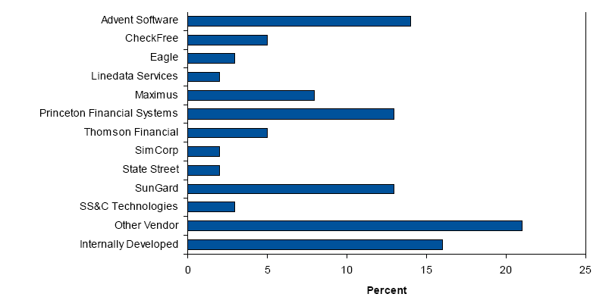
* Source: Gartner (Nov 2006)

5.4.1 Advent
Advent offers integrated software solutions for automating and integrating data and workflows across the investment management organization, as well as the information flows between the investment management organization and external parties. Advent products are intended to increase operational efficiency, improve the accuracy of client information and enable better decision-making. Each solution focuses on specific mission-critical functions of the investment management organization and is tailored to meet the needs of the particular client, as determined by size, assets under management and complexity of the investment environment.
Geneva®: Portfolio accounting engine that powers the Investment Accounting & Unit Pricing module with advanced features such as:
- Support for all investment products, strategies and instruments
- Real-time model eliminates all batch processes
- Full sub-ledger and general ledger accounting and reporting
- Automated corporate actions processing
- One-click error correction
- Reporting for complete data reproducibility and audit trail
- Message-based integration

Axys®: Portfolio management, reporting and accounting solution. Axys includes the following selected features:
- Diverse security coverage
- Supports the CFA Institute’s AIMR-compliant presentation of performance measurement and reporting
- Tax-sensitive investment management tools
- Integration with more than 400 data providers, trust accounting, general ledger and other third-party portfolio analytic tools
- Customizable reporting and graphics for management reporting, decision support and client presentation
- Investment Tracking and Reporting

5.4.2 State Street
Through its subsidiary Princeton Financial Systems, State Street offers investors the state-of-the-art PAM® suite of portfolio management and accounting products. PAM automates the entire investment process and delivers full multicurrency capabilities to address the needs of today's sophisticated investors.

PAM®: PAM for Mutual Funds comes with following features:
- Simultaneous NAV calculation for multi-class funds.
- As-Of Date reporting
- Expense-cap feature for equitable allocation of expenses.
- Multiple expense caps handling capability
- Multi-class processing.
- Automatic computation of SEC yields and total returns on a rolling 30-day basis
- Support SEC (for registered funds) required journals
- Reporting PAM for Mutual Funds provides the journals.
- Provides complete support for "Green Blank" Schedule D.

5.4.3 SunGard
SunGard Investment Management Systems provides in-house and ASP solutions to the buy-side investment management industry for trading, portfolio management, compliance, investment accounting, investor accounting, private banking and performance measurement and attribution. Its annual revenue for the financial year 2005-2006 is $4 billion.
InvestOne Enterprise®: InvestOne Enterprise is a global, real-time, straight-through processing investment accounting solution that processes over $10 trillion in assets including pension funds, mutual funds, hedge funds, bank commingled funds, master trust accounts, offshore trusts, UK unit trusts, OEIC's, money market funds, insurance portfolios, separate and private accounts. InvestOne Enterprise's investment accounting system capabilities include:
- Integrated general ledger
- Multi-currency accounting
- Mutual fund accounting
- Multiple class and master/feeder accounting
- Real time portfolio valuation
- Portfolio segmentation
- Daily cash management reports
- Exception reporting

InvesTier®: InvesTier is SunGard’s product offering, for broad range of Pooled Funds and Alternative Investments. The areas served are:
- Hedge Funds
- Funds-of-Funds
- Multi-Manager Funds
- Multi-Currency Funds
- Multi-Class and Series Funds
- Master-Feeder and Nested Funds
- Family Trusts
- Onshore US Limited Partnerships and Offshore Corporations and Unit Trusts
- Registered 40 Act Hedge Funds

5.4.4 Eagle Corporation
Eagle, a Mellon Financial CompanySM, is a global provider of financial services technology. Eagle’s Web-based systems automate internal systems to support STP requirements of money managers, mutual funds, hedge funds and brokers, plan sponsors, banks, corporate trusts and insurance companies. Eagle provides solutions for portfolio management, investment accounting, performance measurement, attribution, AIMR/GIPS compliance, reporting, messaging, reference data management and outsourcing.
Eagle PACE®: PACE is a Web-based investment data hub, warehouse, and portfolio management system designed to integrate dissimilar analytic and market data with portfolio accounting and trade data, across all asset types, for buy-side investment managers.
Eagle STAR®: STAR is a Web-based investment accounting system designed for high transaction volumes offering unparalleled performance levels. The Eagle STAR transaction engine comes with the following core accounting features:
- Investment accounting
- Income processing
- Corporate actions and reorganizations
- Security cost accounting
- Cash management
- Proceeds and realized gain/loss
- Receivable and payable tracking
- Investment ledger
- Reporting

6. Investment Accounting in other AMCs
The other Asset Management Companies are Pension Funds, Hedge funds and Insurance. The underlying accounting processes followed in these AMCs are very similar to that of a mutual fund. However the regulatory requirements and the investment philosophies among these AMCs differ greatly. As a result there could be changes in the frequency of reporting and disclosures to shareholders as mentioned in the investment prospectus. The other functions of the Middle and Back office of the fund organization is expected to be similar to a mutual fund and hence doesn’t require a specific mention.

Document Revision History
# | Description | Date | Version | Created / Modified / Reviewed By
1 | Initial Version | 11-Mar- 2007 | 0.0 | Prasanth B, Girish R, Harini R
2 | Updated with SME comments (Mukund, Sathya) | 11-Sep-2007 | 1.0 | Lakshmi Narayanan
3 | Updated with Eco system View and Functional View of IA system | 15-Nov-2007 | 1.1 | Lakshmi Narayanan

