+91 7413912366



1 77777 66666

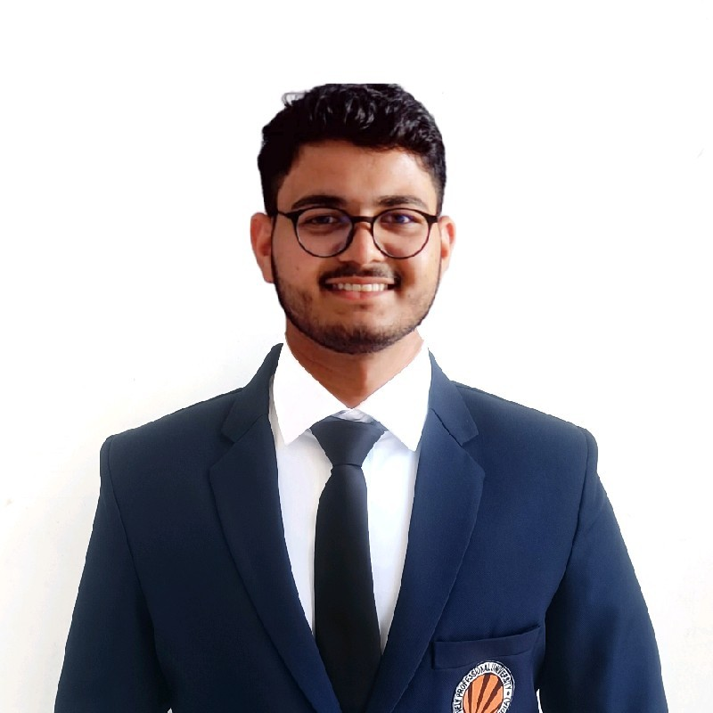

KUL DEEP VARMA

www.linkedin.com/in/ kul-deep-varma-4150bb225/

Kuldeepvarma7413@gmail.com



SOFTWARE ENGINEER ASPIRANT



Churu, Rajasthan

https://github.com/kuldeepvarma7413



SUMMARY

Seeking growth opportunities for organizations, technical expertise lies in C++, C, Python, Java, and JavaScript. Demonstrating a strong sense of responsibility and a passion for quality service, the goal is to contribute to both organizational success and personal development.

TECHNICAL SKILLS

Programming languages: C++, C, Python, JavaScript, Dart, Kotlin

Web Development: HTML5, CSS, jQuery, JSON, Angular, Bootstrap

Mobile App Development: Flutter, Android Jetpack

Data Management: MySQL

CERTIFICATIONS

Working with Data in Android | Coursera | Oct’23

Advanced Programming in Kotlin | Coursera | Oct’23

Create the User Interface in Android Studio | Coursera | Sep’23

App Development for IOS & Android | Programming Pathshala | Jul’23

Computer Organization and Design | Udemy | Feb’23

Computer Networks | Udemy | Nov’22

Database Management System | greatlearning | Oct’22

Friendly, Adaptable to work on any

team

Observant and hands on learner

Inquisitively solves problems

Understanding and caring to others

Organized, accountable and decisive

POWER SKILLS

EXTRA CURRICULAR ACTIVITIES

Participated in hackathon named “Tech-A-Thon” Feb'23

Participated in hackathon named “Byte Bash” Oct'23

INTERNSHIP

Frontend Developer Intern Mar'23

EVE HEALTHCARE CENTRES PVT. LTD. | Greater Noida, IN

Domain: Frontend Development |Programming Languages: Flutter and Dart Excelled in dynamic collaboration, designing and implementing user-friendly web apps.

Resolved bugs swiftly, ensuring seamless web app operation with strong problem-solving.

Hands-on with HTML, CSS, JavaScript and Jquery, enhancing skills for innovative project contributions.

PROJECTS

Blood bank Android App July'23

Domain: Android Development |Programming Languages: Flutter and Dart Constructed a App for ease of availability of blood to users (request/donate).

Developed features like find donors, donate blood, messages, history, settings, login and signup.

Utilized Firebase to handle backend requests for application, and used dart to respond back.

Medic World – Pharmacy Management System APR'23

Domain: System application | Programming Languages: Java Built a software application to manage medicines, orders and pharmacists

Used MySQL to manage the data of all transactions, keeping bill receipts/pdfs.

Explored Java Swing library and implemented user friendly UI.

Spotify Clone - frontend Mar'23

Domain: Web development | Languages: HTML, CSS

Built a Website that include landing, premium, support, download and signup pages.

Used CSS to make the webpages user friendly.

Explored more about CSS for dipper knowledge.

StudySync – Digital Notes Management Oct'23

Domain: Full Stack Web development | Languages: HTML, CSS, JavaScript, Bootstrap, Python

Building a Website that provides pdf files of many subjects taught in university.

Used CSS, JavaScript to make the webpages user friendly, interactive and responsive.

Explored Django and python to handle client side requests and respond back to them with required data.

ACHIEVEMENTS

3 Star Rating in CPP on HackerRank Mar'22-Present

869,019 Worldwide rank on leetcode and 28 present streak Jul’22-Present

EDUCATION

B.Tech. in Computer Science Aug '21 - Present Lovely Professional University | Phagwara, IN

CGPA 8.09

Higher Secondary Jun '19 - Mar '20

Gyan Bharti Senior Secondary School | Churu, Rajasthan, Scored 71%