THEORY ASSIGNMENT

Q 1 = Define Graphic Design:-

Graphic design is the art and practice of planning and projecting ideas and experiences through visual and textual content. It involves combining elements such as typography, imagery, color, and layout to communicate messages clearly and effectively. Graphic design can be found in physical forms (like posters and packaging) and digital forms (such as websites, social media, and mobile apps).

**2. Importance of Graphic Design in Today’s Digital Age:**

In the digital age, graphic design plays a critical role in how individuals and organizations communicate, build brands, and engage with audiences. Here’s why it's so important:

* **Visual Communication:** With the human brain processing visuals faster than text, design helps convey messages quickly and effectively across digital platforms.
* **Brand Identity:** Strong design builds brand recognition and trust. Logos, color schemes, and consistent visuals help distinguish brands in a crowded digital space.
* **User Experience (UX):** Good design improves navigation and usability on websites and apps, making them more accessible and enjoyable for users.
* **Marketing and Advertising:** Eye-catching visuals are essential for digital marketing campaigns on platforms like Instagram, YouTube, and Google Ads.
* **Content Engagement:** Infographics, social media graphics, and interactive designs increase audience engagement and information retention.
* **Credibility and Professionalism:** Professionally designed content gives businesses and individuals more credibility, influencing consumer decisions and perception.

In short, graphic design is not just about making things look good—it’s about making communication more effective in a digital-first world.

**Description:**  
Graphic design is essential in advertising for creating compelling visuals that attract attention and promote products, services, or ideas.

**1. Advertising**

**Description:**  
Graphic design is essential in advertising for creating compelling visuals that attract attention and promote products, services, or ideas.

**Applications:**

* Print ads (magazines, newspapers, billboards)
* Digital ads (social media, Google Ads, email campaigns)
* Motion graphics for video commercials

**Role of Design:**

* Captures attention quickly
* Delivers a clear message or call-to-action
* Enhances emotional appeal and brand recall

**2. Web Design**

**Description:**  
Web design focuses on the visual and functional aspects of websites and digital platforms, ensuring that content is both attractive and user-friendly.

**Applications:**

* Layout and structure of websites
* UI (User Interface) design for apps
* Responsive design for mobile and desktop

**Role of Design:**

* Improves user experience (UX)
* Guides navigation and interaction
* Reflects brand identity online

**3. Branding**

**Description:**  
Branding involves creating a unique identity for a company or product, and graphic design plays a central role in visually expressing that identity.

**Applications:**

* Logos and brand marks
* Business cards, packaging, stationery
* Brand guidelines (fonts, colors, imagery)

**Role of Design:**

* Builds brand recognition and loyalty
* Creates a consistent visual identity
* Differentiates a brand from competitors

Each of these fields relies on graphic design not only for visual appeal but also for effective communication, functionality, and emotional impact.

Q 2 = ELEMENTS OF DESIGN:

**1. Line**

**Definition:** A line is a continuous mark made on a surface by a moving point. It can be straight, curved, thick, thin, horizontal, vertical, or diagonal.

**Role in Design:**

* Creates structure and outlines
* Guides the viewer’s eye
* Conveys movement, direction, or emotion (e.g., sharp lines feel aggressive; curved lines feel soft)

**2. Shape**

**Definition:** A shape is a two-dimensional, enclosed area created by lines or contrast in color or texture. Shapes can be geometric (like squares and circles) or organic (free-form or natural shapes).

**Role in Design:**

* Forms the basic structure of a composition
* Can represent objects, symbols, or abstract ideas
* Helps in creating balance and emphasis

**3. Form**

**Definition:** Form is the three-dimensional version of a shape. It has depth, as well as height and width.

**Role in Design:**

* Adds realism and volume to artwork
* Used in 3D design, sculpture, architecture, and realistic illustrations
* Can be created using light, shadow, and perspective

**4. Space**

**Definition:** Space refers to the area around, between, and within objects. It can be positive (the objects themselves) or negative (the empty areas around objects).

**Role in Design:**

* Creates depth and dimension
* Helps organize design elements
* Allows the design to "breathe" and avoid clutter

**5. Texture**

**Definition:** Texture is the surface quality of an object—how it looks or feels. It can be real (tactile) or implied (visual).

**Role in Design:**

* Adds depth and interest
* Makes elements look more realistic or expressive
* Can create mood or convey a particular style

**6. Color**

**Definition:** Color is the visual perception of light wavelengths. It includes hue (name of the color), saturation (intensity), and brightness (lightness or darkness).

**Role in Design:**

* Evokes emotions and sets the tone
* Attracts attention and creates visual hierarchy
* Enhances brand identity and message

**7. Value**

**Definition:** Value refers to the lightness or darkness of a color or tone.

**Role in Design:**

* Adds contrast and depth
* Helps create a sense of form and volume
* Guides focus and visual flow in a design

~ Here are **examples of how each of the seven fundamental elements of design** can be used in practical design projects:

**1. Line**

**Example:** In website design, lines are often used to separate sections of content or create navigation menus.

* **Use case:** A horizontal line might separate a header from the main content.
* **Effect:** It helps guide the viewer’s eye across the page and organizes content visually.

**2. Shape**

**Example:** In logo design, simple geometric shapes (like circles, triangles, and squares) are used to create strong, memorable visuals.

* **Use case:** The Nike logo uses a curved, organic shape (the swoosh).
* **Effect:** Shapes help in creating unique identities and visual balance.

**3. Form**

**Example:** In product packaging, 3D mockups and illustrations are used to show how a product looks from different angles.

* **Use case:** A bottle of perfume shown with shadows and highlights to appear realistic.
* **Effect:** Adds realism and helps customers visualize the physical product.

**4. Space**

**Example:** In minimalist poster design, negative space is often used to highlight a central image or message.

* **Use case:** A movie poster with a central figure and lots of empty background space.
* **Effect:** Emphasizes the subject and makes the design feel clean and focused.

**5. Texture**

**Example:** In packaging design, textures can be implied through visuals (like a wood grain pattern) or physically applied (like embossing).

* **Use case:** A coffee brand might use a burlap texture to imply natural, organic quality.
* **Effect:** Adds a tactile or visual experience that enhances brand storytelling.

**6. Color**

**Example:** In branding, color is used to evoke emotion and make a brand instantly recognizable.

* **Use case:** Red for Coca-Cola (energy and excitement), blue for Facebook (trust and calm).
* **Effect:** Sets tone, affects mood, and helps users associate colors with specific brands or feelings.

**7. Value**

**Example:** In black-and-white photography or grayscale posters, designers use value to create contrast and depth.

* **Use case:** A portrait with a high contrast between light and dark areas to emphasize facial features.
* **Effect:** Enhances focus and creates visual interest without relying on color.

Q 3. Principles of Design:

**1. Balance**

**Definition:** Balance is the distribution of visual weight in a design. It makes a composition feel stable and harmonious.

**Types:**

* **Symmetrical Balance:** Equal weight on both sides (like a mirror image).
* **Asymmetrical Balance:** Unequal but still visually balanced.
* **Radial Balance:** Elements arranged around a central point.

**Effect:** Prevents a design from feeling lopsided or chaotic.

**2. Contrast**

**Definition:** Contrast is the difference between elements that makes them stand out.

**Examples:** Light vs. dark, big vs. small, smooth vs. rough, color vs. black and white.

**Effect:** Creates visual interest, draws attention, and helps important elements stand out.

**3. Emphasis**

**Definition:** Emphasis is used to draw attention to a specific part of a design—usually the focal point.

**Examples:** Bold colors, large fonts, or placing an object in the center.

**Effect:** Guides the viewer’s eye to the most important information first.

**4. Movement**

**Definition:** Movement guides the viewer’s eye through a composition in a specific direction or flow.

**Examples:** Curved lines, leading lines, or sequencing elements in a certain order.

**Effect:** Creates a sense of action or progression and helps tell a visual story.

**5. Pattern**

**Definition:** Pattern is the repeated use of elements such as shapes, lines, or colors in a consistent way.

**Examples:** Wallpaper, textiles, or backgrounds in a web design.

**Effect:** Adds visual interest, consistency, and structure.

**6. Rhythm**

**Definition:** Rhythm is the repetition or alternation of elements to create a sense of organized movement.

**Types:**

* **Regular Rhythm:** Predictable and evenly spaced.
* **Random Rhythm:** Irregular, but still connected.
* **Flowing Rhythm:** Natural and smooth, like waves or curves.

**Effect:** Adds energy, harmony, and flow to the design.

**7. Unity**

**Definition:** Unity means all design elements work together to create a cohesive whole.

**Examples:** Consistent color scheme, font style, and spacing across a brochure.

**Effect:** Makes the design feel complete and organized, not random or scattered.

~ **1. Balance**

* **How it helps:** Ensures the design feels stable and organized.
* **Impact:** A well-balanced layout prevents discomfort or confusion, keeping the viewer focused and interested.

**2. Contrast**

* **How it helps:** Highlights key elements and makes content stand out.
* **Impact:** Improves readability, draws attention to important areas (like calls to action), and adds visual excitement.

**3. Emphasis**

* **How it helps:** Directs the viewer’s eye to the most important part of the design.
* **Impact:** Ensures the message is received clearly and immediately, making communication effective.

**4. Movement**

* **How it helps:** Guides how the viewer naturally navigates through the design.
* **Impact:** Creates flow and narrative, making the experience intuitive and engaging.

**5. Pattern**

* **How it helps:** Adds visual interest through repetition and predictability.
* **Impact:** Makes the design feel consistent and can reinforce branding or identity.

**6. Rhythm**

* **How it helps:** Creates a sense of organized motion or flow.
* **Impact:** Keeps the viewer engaged, making the design feel alive and dynamic rather than static or dull.

**7. Unity**

* **How it helps:** Brings all the elements together into a cohesive whole.
* **Impact:** Prevents confusion and clutter, making the design easy to understand and professionally polished.

**In Summary:**

These principles work **together** to:

* Capture and hold attention
* Organize information logically
* Create emotional and aesthetic appeal
* Guide the viewer's experience

**PRACTICAL ASSIGNMENT**

POSTER

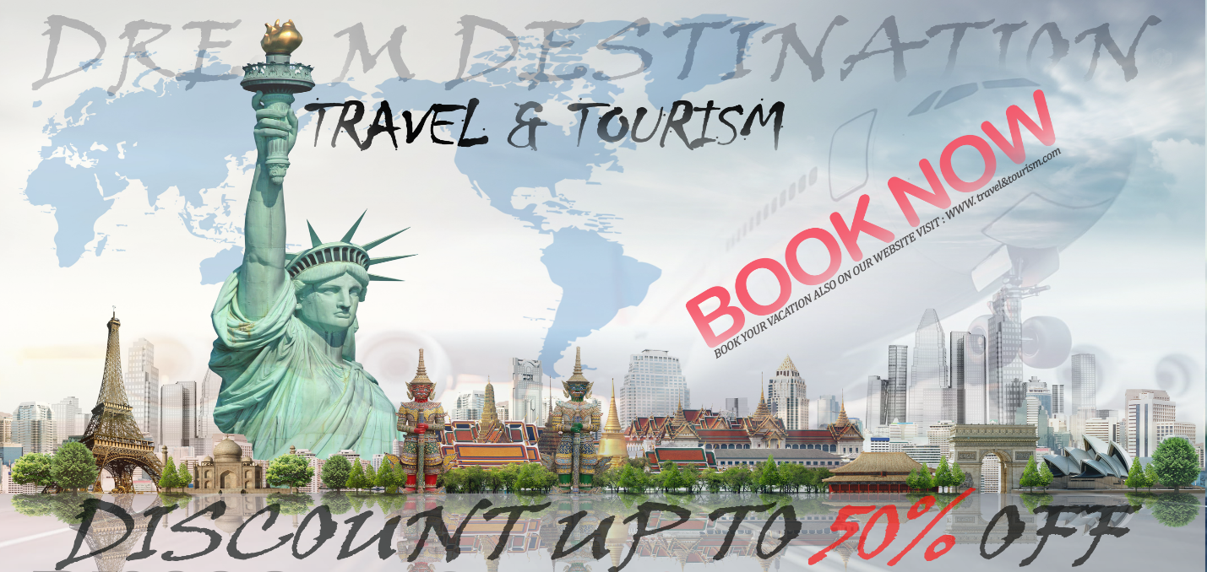

ADVERTISEMENT 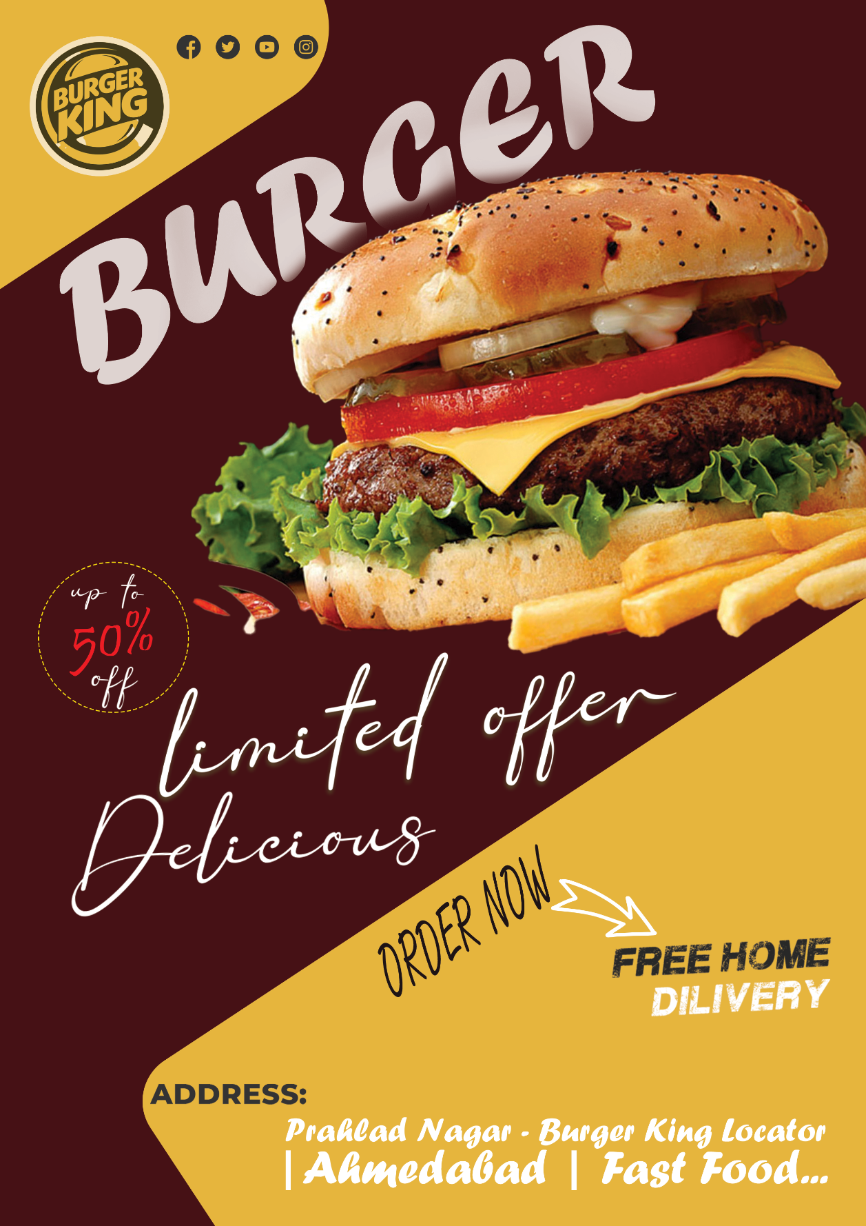MAGAGINE

