**CorelDraw Assignment**

**Theory Assignments**

**Assignment 1: Introduction to CorelDRAW**

**● Objective: Understand the interface and basic features of CorelDRAW.**

**● Tasks:**

**1. Describe the CorelDRAW workspace layout and its components (toolbars, property**

**bar, drawing area).**

**2. Explain the purpose of differentfile formats (CDR, AI, EPS, PDF) and their use cases.**

**3. Discuss the concept of vector graphics versus raster graphics.**

**4. Describe what Coreldraw is and how it differs from Illustrator.**

ANSWER:-

1. CorelDRAW Workspace Layout and Its Components

The CorelDRAW workspace is designed to be intuitive and customizable, offering a range of tools for creating vector graphics. Its main components include:

Toolbox (Toolbars): Located on the left side, it contains tools for creating and editing objects (e.g., Pick Tool, Shape Tool, Text Tool, Rectangle Tool, etc.).

Property Bar: Situated directly under the standard menu bar, it changes dynamically based on the selected tool or object, displaying relevant options like font, size, fill color, and more.

Drawing Area: The central part of the workspace where you create and edit your artwork. It represents the printable page or canvas.

Docker Panels: Panels on the right side (e.g., Object Manager, Color Palette, Layers) that provide advanced options and controls.

Status Bar: Located at the bottom, it shows information about the selected object, such as color, dimensions, and position.

Rulers and Guidelines: These help with accurate object placement and alignment.

2. Purpose of Different File Formats

Each file format serves a unique purpose in design and printing workflows:

CDR (CorelDRAW File): Native file format for CorelDRAW. It preserves all editable layers, effects, and objects. Ideal for continued editing in CorelDRAW.

AI (Adobe Illustrator File): Native to Adobe Illustrator. It’s a widely-used vector format and often used for sharing between CorelDRAW and Illustrator users.

EPS (Encapsulated PostScript): A cross-platform vector format. Suitable for printing and importing into various graphic software, preserving high-quality vector data.

PDF (Portable Document Format): Universally used for document sharing. Maintains vector properties and is ideal for print-ready designs, brochures, and client proofs.

3. Vector Graphics vs Raster Graphics

Vector Graphics:

Made using paths defined by mathematical formulas.

Can be resized without losing quality.

Ideal for logos, icons, and typography.

File types: CDR, AI, EPS, SVG.

Raster Graphics:

Made up of pixels (bitmap images).

Lose quality when scaled up.

Suitable for photographs and complex images.

File types: JPG, PNG, BMP, TIFF.

Summary: Vector graphics are resolution-independent, while raster graphics are resolution-dependent.

4. What is CorelDRAW and How It Differs from Illustrator

CorelDRAW is a professional vector graphics editor developed by Corel Corporation. It is widely used for logo design, page layout, sign making, and print design.

Differences Between CorelDRAW and Adobe Illustrator:

Feature CorelDRAW Adobe Illustrator

Platform Windows-only (macOS support recently added) Cross-platform (Windows & macOS)

User Interface Simplified and user-friendly for beginners More complex, industry-standard

File Format Native format is .CDR Native format is .AI

Learning Curve Easier for new users Steeper, but more customizable

Integration Works well with Corel PHOTO-PAINT Better integration with Adobe Creative Cloud apps

**Assignment 2: Understanding Tools and Panels**

**● Objective: Learn aboutthe various tools and panels in CorelDRAW.**

**● Tasks:**

**1. Explain the function of essential tools in CorelDRAW (Pick Tool, Shape Tool, Text**

**Tool, etc.).**

**2. Describe the use ofthe Color Palette and how to create custom colors.**

**3. Discuss the importance ofthe Object Manager panel for organizing artwork.**

ANSWER:-

1. Essential Tools in CorelDRAW

a. Pick Tool

Function: The Pick Tool is used to select, move, resize, and rotate objects on the canvas.

Shortcut: Spacebar or P

Usage Example: After drawing a shape, use the Pick Tool to reposition or resize it.

b. Shape Tool

Function: Allows users to edit the shape of objects by adjusting nodes, curves, and lines.

Shortcut: F10

Usage Example: Modify a rectangle by dragging its corner nodes to create a custom shape.

c. Text Tool

Function: Used to create and edit text. It allows for both paragraph and artistic text.

Shortcut: F8

Usage Example: Add a title or label to your artwork, and format the font, size, and alignment.

d. Rectangle Tool

Function: Draws rectangles and squares.

Shortcut: F6

Usage Example: Create layout grids, borders, or design blocks.

e. Ellipse Tool

Function: Draws circles and ellipses.

Shortcut: F7

Usage Example: Make logos, buttons, or round elements.

f. Freehand Tool

Function: Used for drawing freeform lines or curves.

Shortcut: F5

Usage Example: Sketch creative shapes or paths for artistic effects.

g. Zoom Tool

Function: Zooms in or out of a specific area on the canvas.

Shortcut: Z

Usage Example: Focus closely on a detailed section for editing.

2. Color Palette and Custom Colors

Color Palette

Location: Usually on the right side of the interface.

Function:

Quickly apply fill and outline colors to objects.

Supports different color models (RGB, CMYK, etc.).

Right-click to change the outline color, left-click to change the fill color.

Creating Custom Colors

Use the Color Docker:

Go to Window > Dockers > Color Palettes > Color Palette Manager.

Edit Colors:

Double-click any color swatch or use the Color Picker.

Save Custom Palette:

Create and save your own palette under a unique name for consistent branding.

3. Object Manager Panel

What It Is:

A panel that shows all objects, layers, and pages in your current document.

Why It’s Important:

Organizes Artwork:

Manage complex designs by controlling which elements appear on which layers.

Visibility and Locking:

Turn visibility on/off and lock objects to prevent accidental changes.

Layer Control:

Helps separate different parts of a project (e.g., background, text, graphics).

Object Hierarchy:

Easily rearrange the order of objects (what’s in front or behind).

Where to Find:

Go to Window > Dockers > Object Manager.

**Assignment 3: Color Theory and Application**

**● Objective: Understand color theory and its application in design.**

**● Tasks:**

**1. Discuss the color wheel and the significance of primary, secondary, and tertiary**

**colors.**

**2. Explain the concepts of RGB and CMYK color modes.**

**3. Describe how to create color harmonies (complementary, analogous, triadic) in**

**CorelDRAW.**

ANSWER:-

1. The Color Wheel and the Significance of Primary, Secondary, and Tertiary Colors

The color wheel is a circular diagram that organizes colors in a way that shows relationships between primary, secondary, and tertiary colors. It serves as a foundational tool for understanding color relationships and creating visually pleasing designs.

Primary Colors:

These are the three base colors that cannot be created by mixing other colors. They are:

Red

Blue

Yellow

All other colors on the wheel are derived from these.

Secondary Colors:

These are created by mixing two primary colors in equal parts:

Green = Blue + Yellow

Orange = Red + Yellow

Purple (Violet) = Red + Blue

Tertiary Colors:

These are formed by mixing a primary color with a neighboring secondary color. Examples include:

Red-Orange

Yellow-Green

Blue-Violet

There are six tertiary colors in total.

Understanding these categories helps designers build harmonious color palettes and evoke specific moods or effects in their work.

2. RGB and CMYK Color Modes

Color modes determine how colors are represented digitally or in print.

RGB (Red, Green, Blue):

Used for: Digital screens (websites, monitors, mobile devices).

Color creation: Light-based colors are added together. When combined at full intensity, they create white.

Color range: RGB has a wide gamut, meaning it can produce more vibrant colors, but they might not print accurately.

Best for: Digital artwork, websites, and anything viewed on a screen.

CMYK (Cyan, Magenta, Yellow, Black):

Used for: Printing processes.

Color creation: Ink-based colors are subtracted from white light. The more you add, the darker the color becomes.

Color range: More limited than RGB but ensures print accuracy.

Best for: Brochures, posters, business cards, or any design that will be printed.

3. Creating Color Harmonies in CorelDRAW

In CorelDRAW, you can use color theory principles to create balanced and appealing color schemes. Here’s how to create different harmonies:

a. Complementary Colors

These are opposite each other on the color wheel (e.g., red and green).

In CorelDRAW:

Use the Color Harmonies docker (Window > Dockers > Color Harmonies).

Select your base color.

Choose the Complementary harmony type.

CorelDRAW will automatically suggest a color that contrasts well with your base.

b. Analogous Colors

These are colors that sit next to each other on the wheel (e.g., blue, blue-green, green).

In CorelDRAW:

Open the Color Harmonies docker.

Choose Analogous as the harmony rule.

Adjust the number of steps to include more or fewer related hues.

c. Triadic Colors

These are evenly spaced around the color wheel (e.g., red, yellow, blue).

In CorelDRAW:

Use the Color Harmonies docker again.

Select Triadic harmony.

The software will generate two additional colors that form a triangle with your base color on the wheel.

CorelDRAW's real-time previews and interactive color wheel make it easy to visualize and apply these harmonies to your designs effectively.

Assignment 4: Working with Text

● Objective: Explore texttools and typography in CorelDRAW.

● Tasks:

1. Explain the differenttext options available in CorelDRAW (paragraph text, artistic

text).

2. Discuss how to manipulate text (kerning, leading, and tracking) and apply text

effects.

3. Describe how to converttextto curves and its importance in design.

ANSWER:-

1. Different Text Options in CorelDRAW

CorelDRAW provides two main types of text for design work:

a. Artistic Text

Definition: Artistic Text is used for short phrases, titles, headings, logos, or decorative text.

Features:

Easily scalable and stylized.

Supports effects like shadows, outlines, and distortion.

Can follow a path (e.g., curved or circular).

b. Paragraph Text

Definition: Paragraph Text is used for longer passages of text, such as body content, articles, brochures, and blocks of text.

Features:

Allows for full text formatting (alignment, columns, text wrapping).

More suitable for text-heavy documents.

Placed inside a text frame that can be resized.

2. Manipulating Text in CorelDRAW

Typography adjustments enhance readability and design consistency. CorelDRAW allows fine control over text using the following options:

a. Kerning

Definition: Adjusts the space between specific pairs of characters.

Use: Improves visual spacing and avoids awkward gaps in titles or logos.

b. Leading (Line Spacing)

Definition: Controls the vertical space between lines of text.

Use: Useful in paragraph text to make reading more comfortable and layout more appealing.

c. Tracking

Definition: Adjusts spacing uniformly between all characters in a word or sentence.

Use: Enhances visual style or fits text better within a given space.

Text Effects:

CorelDRAW supports various text effects, including:

Drop Shadows: Adds depth and dimension.

Text on a Path: Aligns text along curves or shapes.

Envelopes: Distorts text into different shapes.

Extrude and Bevel: Adds 3D depth to artistic text.

3. Converting Text to Curves

How to Convert:

Right-click the text and select “Convert to Curves” or press Ctrl + Q.

Why It’s Important:

Preserves Fonts: Ensures that the text appears exactly as designed, even on systems without the original font installed.

Custom Editing: Allows individual modification of letter shapes using node editing tools.

Prepress and Printing: Prevents font substitution errors during printing or file transfer.

Design Flexibility: Enables merging, welding, and combining with shapes for advanced graphics work.

Practical Assignment 1: Create a Simple Logo

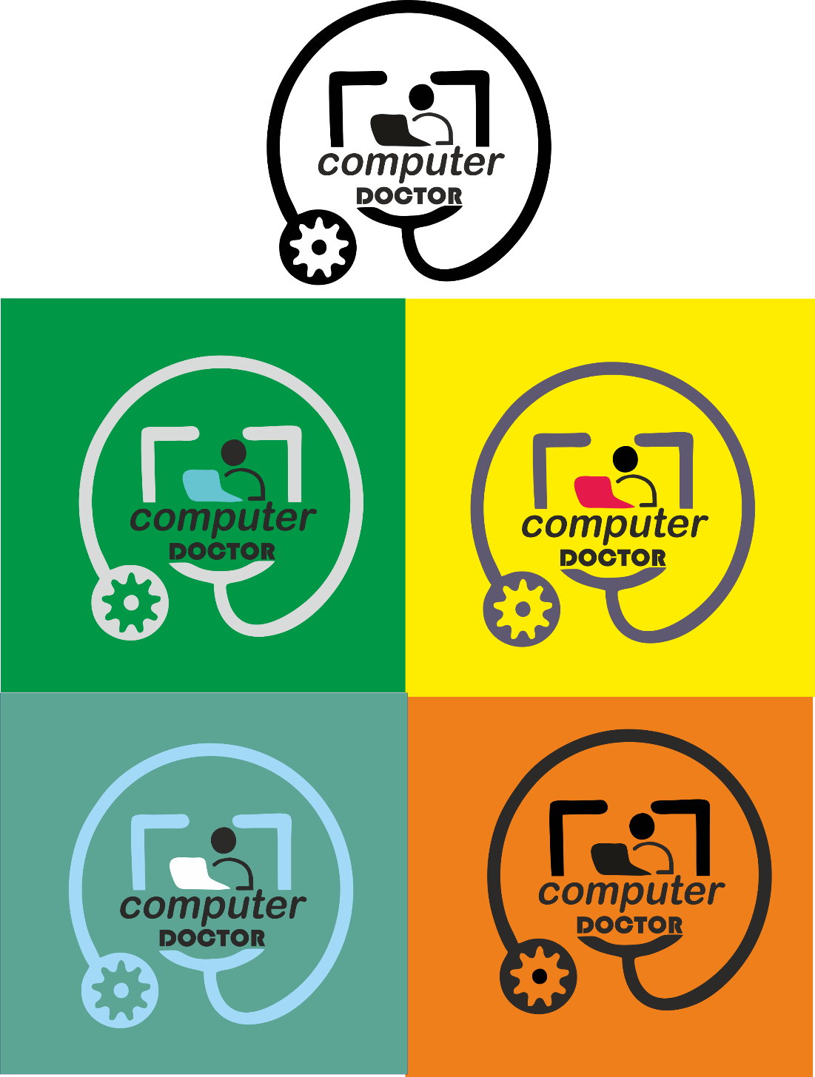

Practical Assignment 2: Poster Design



Practical Assignment: 3 infographic Design



Practical Assignment 4: Business Card Design

