**UNIVERSITY PERFORMANCE REPORT**

**Team Members:**

**Ketki Kule 001549838**

**Aishwarya Lamture 001528479**

**Aishwarya Sawant 002191784Performance Measurement Application for Universities**

1. **Introduction**

The universities are ranked by the quality of education provided by them and the professional growth of its students. This performance measurement application enables universities to measure the standing of its departments. This solution uses the feedback from the alumni and factors like faculty, courses, infrastructure, and GPA in the educational system that contributed to their growth over 5 years to determine the performance rating of the university.

1. **Proposed Solution**

Our proposed solution will involve a set of factors that impact the quality of education to determine the performance rating of the university.

This solution depends on fragments such as course rating, faculty rating, shared resources rating and profession of the alumni.

We focus on the courses enrolled by the students and the faculty assigned to that course. We also take into consideration the average GPA of that batch. Students would be asked to rate the courses on 3 basis – rating for the syllabus of the course, structure of the course and the infrastructure used for the course. Apart from this, students can also rate the shared resources of the university such as library, cafeteria, career placements, etc. These ratings would then be averaged out to determine the overall rating of the course.

We have considered few additional factors which would be rated by the alumni of the university. We focus on the professional growth of the alumni over 5 years after their graduation. Alumni feedback includes inputs like their role in the organization (Jr. Developer/Sr. Developer etc.), salary growth and number of promotions achieved over 5 years period. There will be a predefined matrix which would determine the rating of the salary growth and number of promotions based on their position in the matrix. For example, if an alumni received 1 promotion over 5 years, then as per below matrix his rank for this category is 2.

So, to encapsulate, performance of the university will be measured by mainly these factors –

1. Salary growth over a period of 5 years
2. Number of promotions over a period of 5 years
3. Rating of each course enrolled during graduation
   1. Rating of the syllabus of the course
   2. Rating of the structure of the course
   3. Rating of the infrastructure used for the course such as classroom
4. Average GPA of the batch
5. Average rating of the shared resources of the university
   1. Rating of the library
   2. Rating of the cafeteria
   3. Rating of the health services
   4. Rating of the student council
   5. Rating of the college placements
   6. Rating of the student workshops
   7. Rating of the college campus hygiene
6. **Entities**

Entities involved in the proposed model are -

1. Department: This entity contains attributes related to the department of the university
2. Student directory: This directory will hold all the student of the university
3. Alumni: Each alumnus will have attributes like – name, year of graduation, current organization, salary raise, number of promotions, current designation/role, list of enrolled courses, GPA
4. Faculty catalog: This directory will hold all the faculties of the university
5. Faculty: Each faculty will have attribute like Faculty ID, name, list of rating based on courses taught
6. Courses catalog: This directory will hold all the courses offered by the university
7. Course: Each course will have attribute like course ID, name, faculty ID of the assigned faculty, rating based on syllabus, rating based on structure
8. Job Description: This entity holds attributes related to job for an alumni
9. Shared Resources: This entity holds attributes for rating the shared resources of the university such as library, cafeteria, health services, etc.
10. **UML Class Diagram**

1. **Sequence Diagrams**

* **General Sequence of the user**

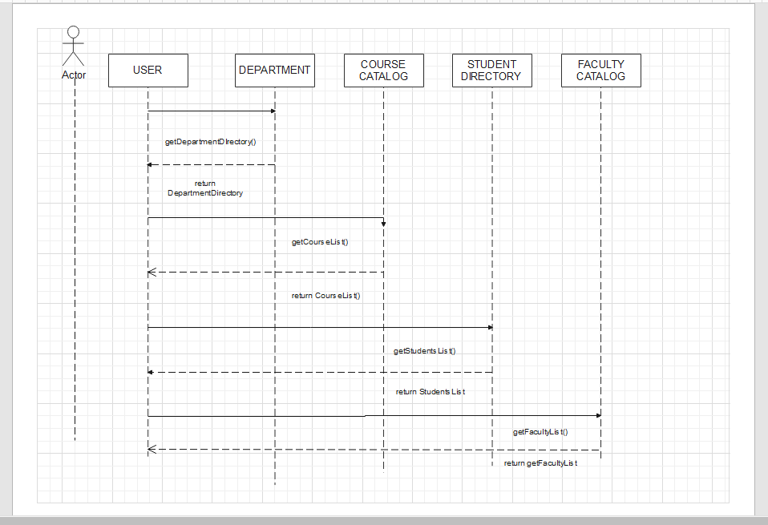

Figure 1: General User

* **Alumni**

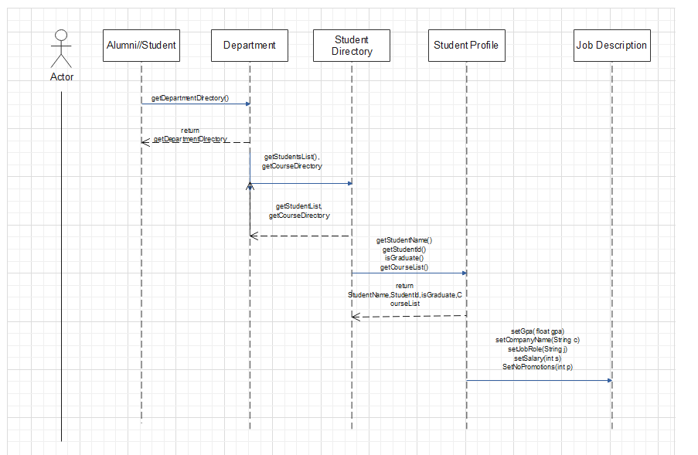

Figure 2: Alumni

* **Student**

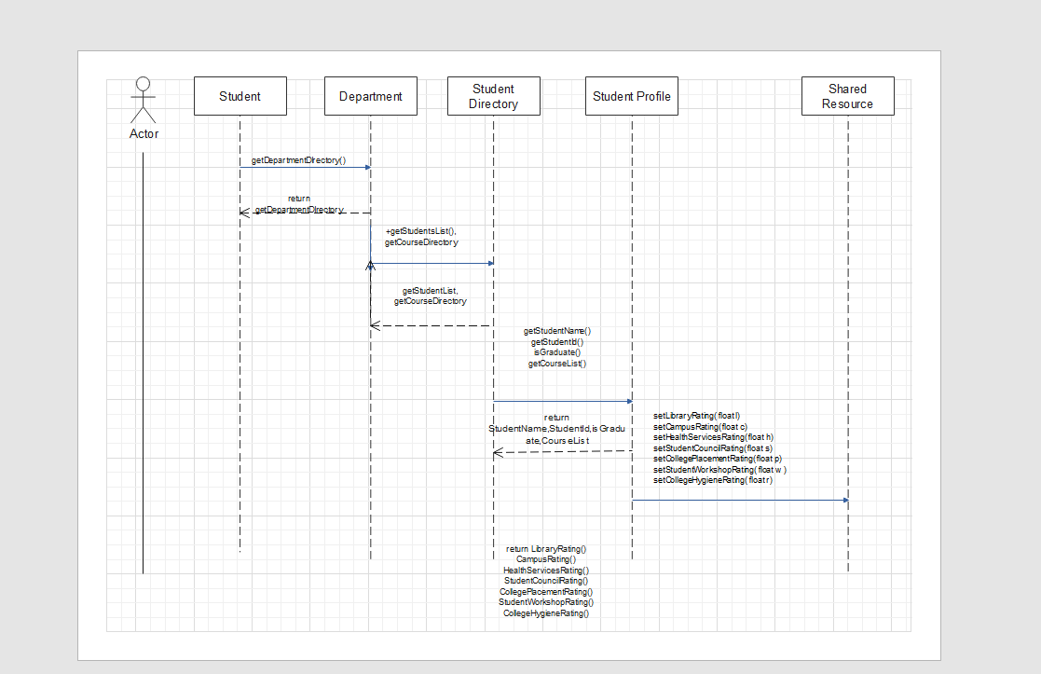

Figure 3: Student

* **Faculty**

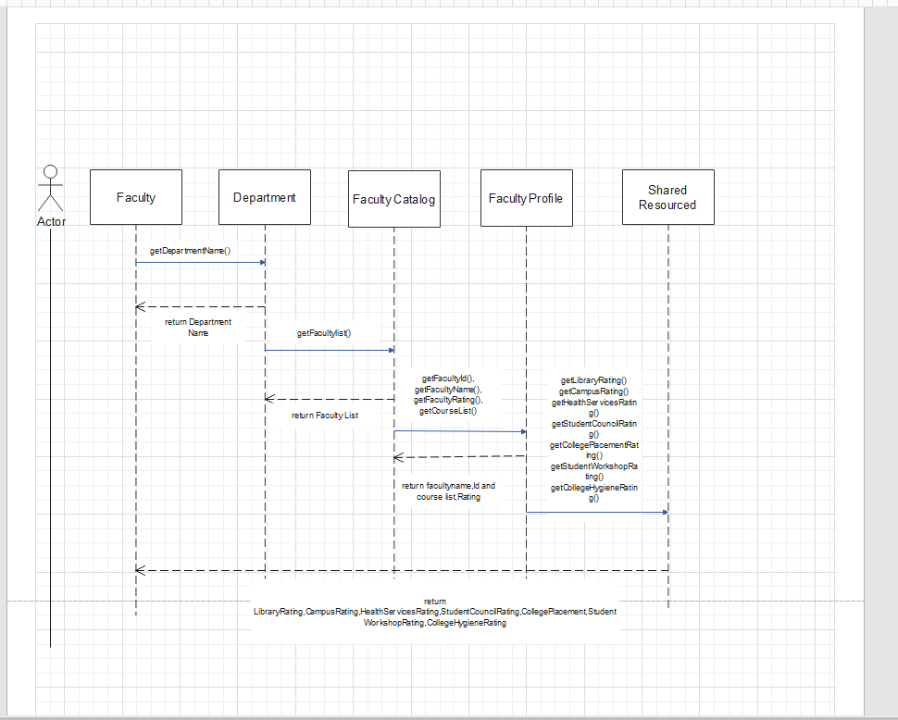

Figure 4: Faculty

**Sequence Diagram in Detail:**

The flow in which the actors will access data from various roles.

* **Alumni—Actor**
* Alumni actor will retrieve the data from the department directory along with the data from student directory i.e., Course List and Student List (student name, Id, status).
* IsGraduate () function helps us to understand whether the user is student or an Alumni.
* Also, the Alumni can set the various parameters that are required for analysing the overall performance.
* An alumni can set his/her salary, Company name, Job role, GPA, Promotions.
* Alumni can create their profile using NU ID.
* **Student -- Actor**
* The Student actor will retrieve the data from the department, student list along student name, Course List, whether the student is an Alumni or student.
* Also, the student can set the rating of various services like Library, Campus, Health Services, Student Council, College Placement, student workshop, College Hygiene.
* **Faculty-Actor**
* The Faculty actor will retrieve the data from the department, Faculty profile and shared resources.
* Data such as department name, faculty list with name, Id, Course List, Rating such as Library Rating, Campus Rating, Health Rating, Student Council Rating, College Placement Rating, Student Workshop Rating, College Hygiene Rating.

**GUI Representation:**

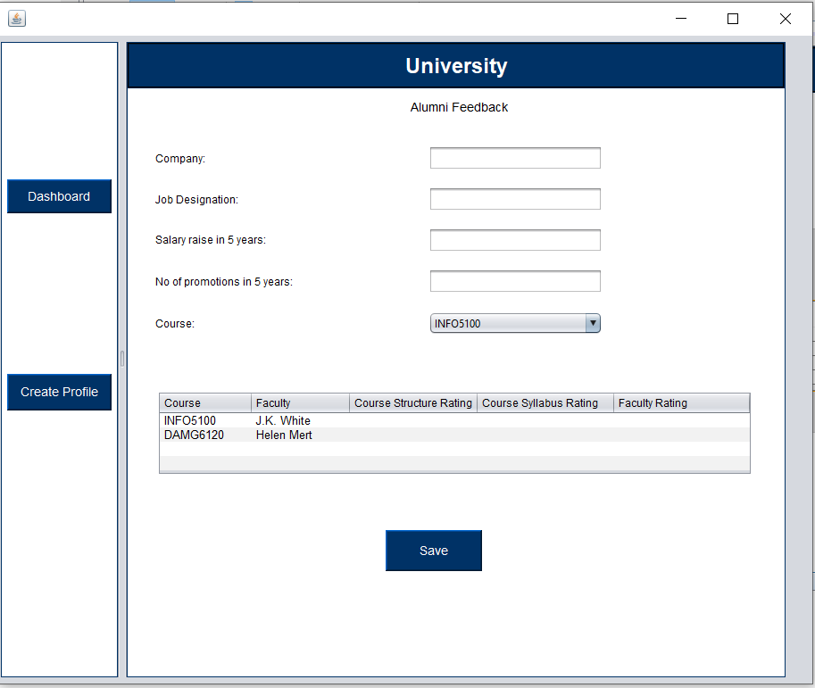

Figure 1: Create Alumni Feedback

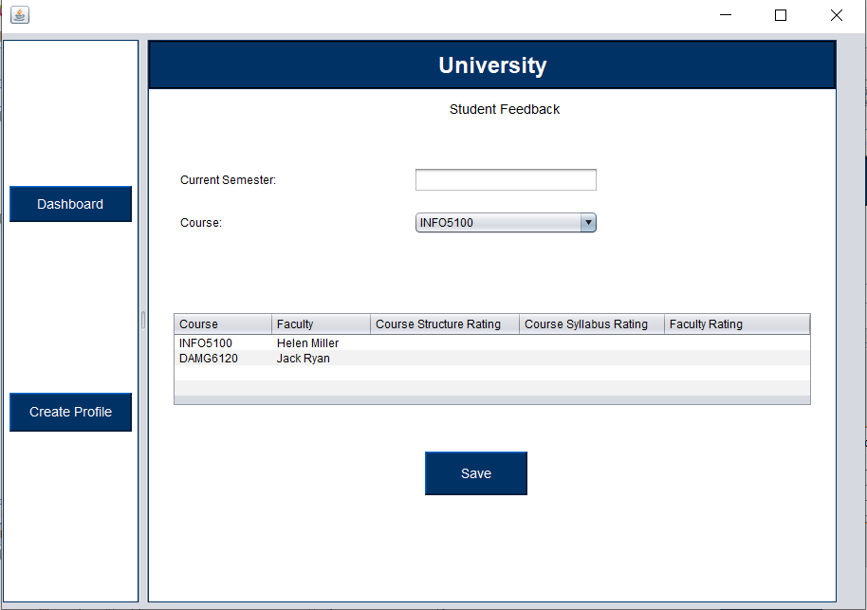

Figure 2: Create Student Feedback

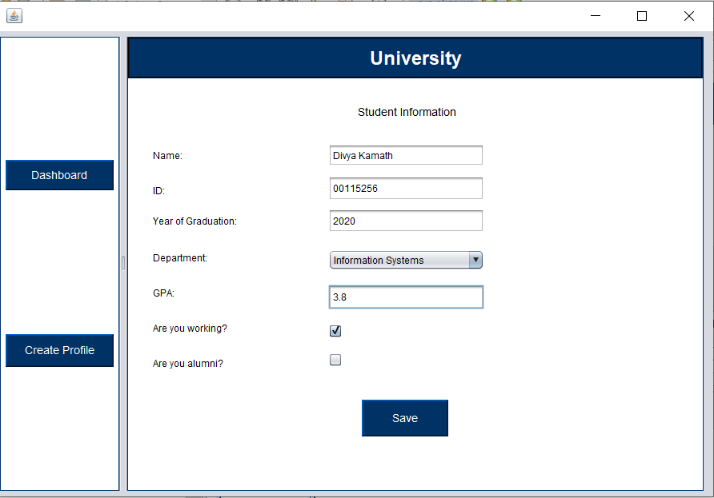

Figure 3: Create Profile

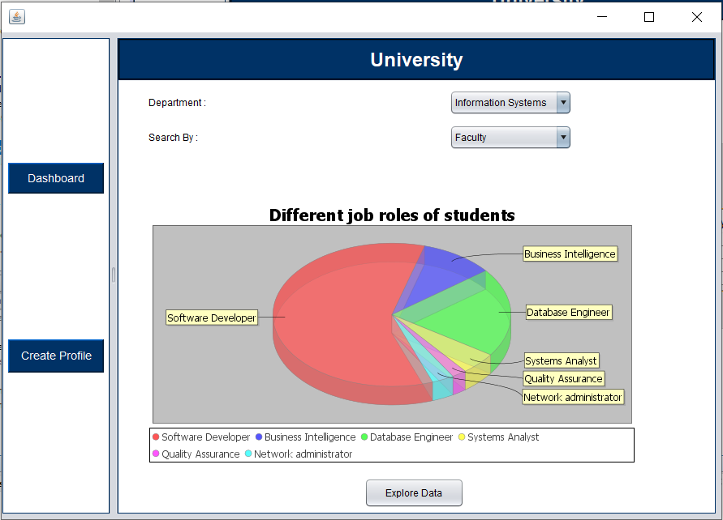

Figure 4 : Dashboard Landing Page

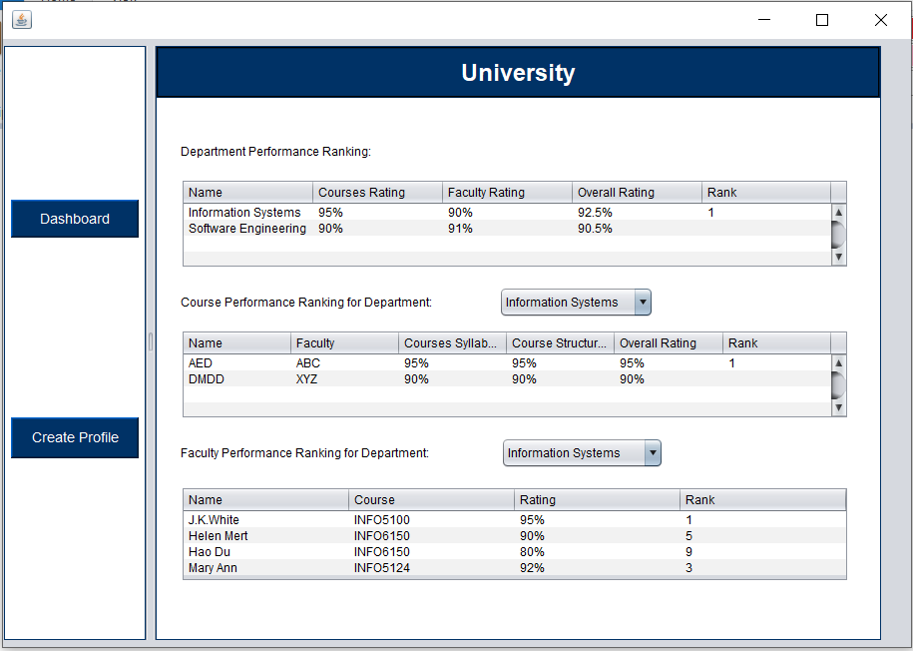

Figure 5 : Dashboard

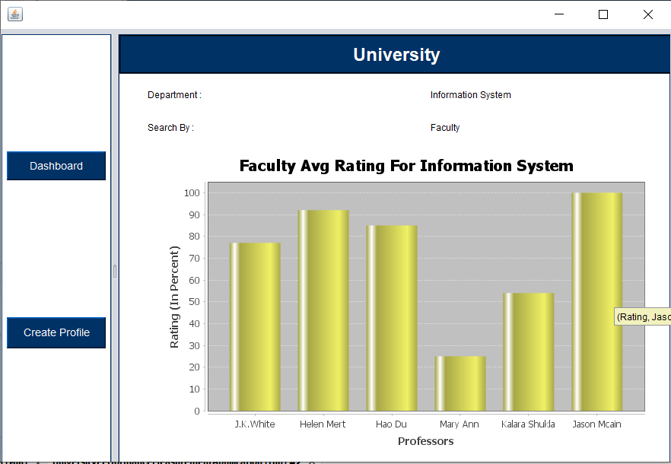

Figure 6 : Faculty Dashboard

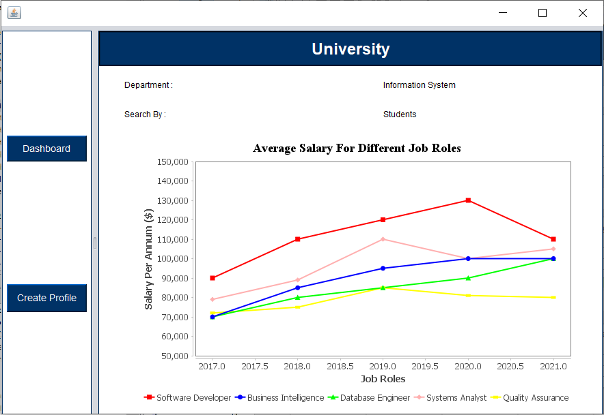

Figure 7 : Alumni Dashboard

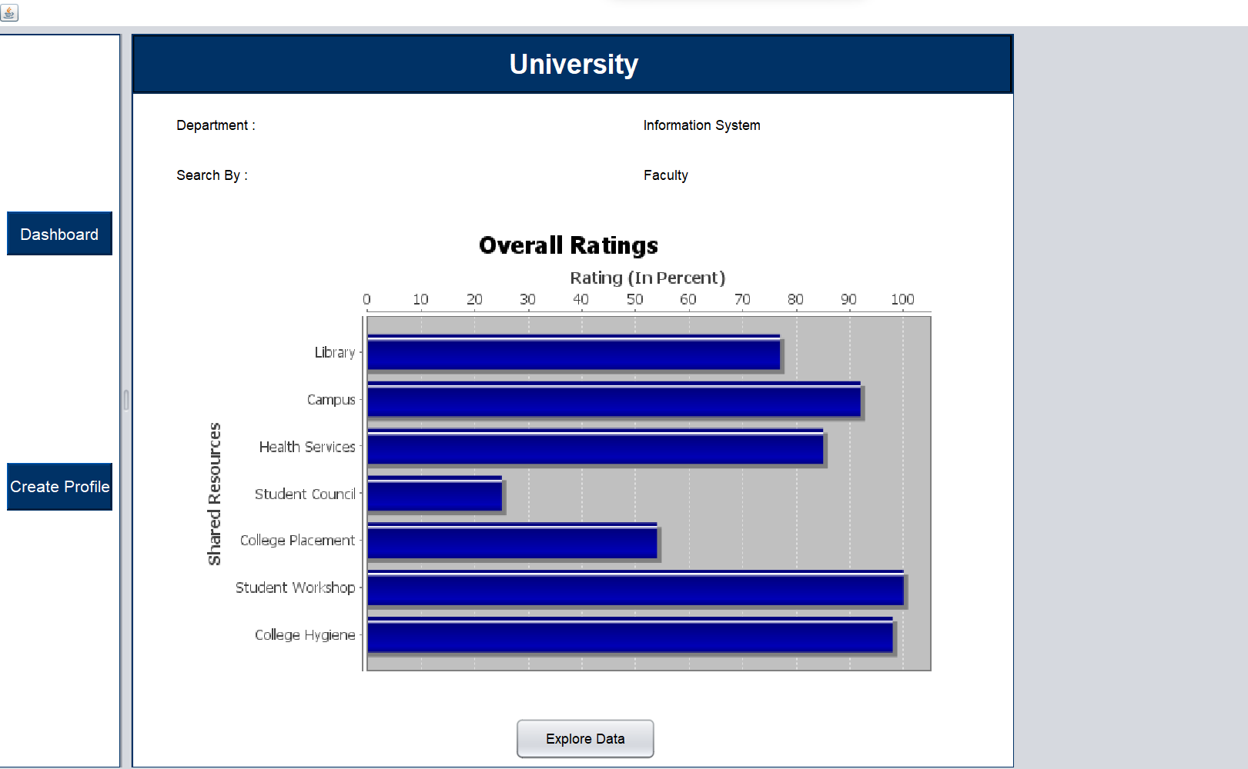

Figure 8 :Overall Rating