The Self-Pruning Neural Network
Case Study -- Tredence AI Engineering Internship 2025
PrunableMixer: an MLP-Mixer variant whose every linear layer owns a learnable sigmoid gate, trained end-to-end on CIFAR-10 with an L1 sparsity regulariser. The network learns -- by itself -- which of its 57 M weights are worth keeping.
[ Optional: replace this paragraph with a cover image or author photo -- Insert > Pictures > This Device > <your_photo.jpg>. Recommended width: 6 in. ]

1. Executive Summary
A single training run of PrunableMixer -- 57,060,864 prunable weights spread across 50 PrunableLinear layers -- produces a rich accuracy-sparsity Pareto front on CIFAR-10 by sweeping one hyper-parameter, lambda:
- lambda = 1e-7 -> 83.86% test accuracy at 20.04% sparsity ( 1.25x smaller).
- lambda = 1e-6 -> 82.21% test accuracy at 88.91% sparsity ( 9.01x smaller, drop -0.03% after hard prune).
- lambda = 1e-5 -> 76.18% test accuracy at 99.24% sparsity (128.57x smaller -- 435 MB -> 1.69 MB).
Every sanity check required by the brief passes: sparsity is monotonic in lambda, hard-pruning the sub-threshold weights causes at most a 0.07% accuracy drop, and the gate histogram is strongly bimodal around 0 and the initial prior. The network genuinely prunes itself during training, not after.

2. Problem Framing
The brief asks for a feed-forward network that learns to prune itself during training, without any post-hoc magnitude pruning step. Each weight is paired with a learnable gate in [0, 1]; an L1 penalty on those gates is added to the classification loss; the Adam optimiser then decides which weights survive.

2.1 Why an L1 penalty on sigmoid gates encourages sparsity
Writing g = sigma(s), the penalty is simply the sum of all g across every PrunableLinear layer. The gradient of g w.r.t. the underlying score s is g*(1-g), which is non-zero everywhere except in saturation. For any gate whose weight contributes little to the classification loss, the only force acting on its score is the L1 term, which has a constant negative gradient. The gate therefore slides monotonically toward 0, pulling g below the 1e-2 pruning threshold and effectively removing the weight. Useful weights fight back through a classification-loss gradient that dominates the L1 signal, so their gates stabilise near the initial prior sigma(-2) ~ 0.12. lambda controls the strength of that competition.

3. Architecture: PrunableMixer
The canonical brief-compliant baseline is a flat MLP on the vectorised image. It caps out near 62% accuracy and loses most of the signal before it reaches the classifier. We therefore use an MLP-Mixer (Tolstikhin et al., 2021) -- 100% feed-forward, zero convolutions, zero attention -- which re-uses the same PrunableLinear primitive for every linear projection in the network.
- Input 3x32x32 images are split into 64 patches of 4x4 and flattened to 48-D vectors.
- Patch embedding PrunableLinear 48 -> 768.
- 12 MixerBlocks, each with a token-mixing MLP (PrunableLinear 64 -> 256 -> 64) and a channel-mixing MLP (PrunableLinear 768 -> 3072 -> 768).
- Classifier LayerNorm -> global avg pool -> PrunableLinear 768 -> 10.
- Totals 50 PrunableLinear layers, 57,060,864 prunable weights, 114,210,826 parameters, 435.7 MB dense fp32.

4. Training Protocol
- Optimiser AdamW with two parameter groups -- weights at lr=0.001, wd=0.0005; gate scores at lr=0.01, wd=0.
- Scheduler CosineAnnealingLR over 100 epochs.
- Lambda schedule 5 CE-only warm-up epochs, then a 5-epoch linear ramp to the target lambda, then hold.
- Augmentation RandomCrop + HorizontalFlip + ColorJitter + Cutout and MixUp (alpha=0.20).
- Gate init score=-2 so sigma(s) ~ 0.12 -- above the 1e-2 pruning threshold but inside the responsive region of the sigmoid.
- Regulariser L = CE(y, y_hat) + lambda * sum(sigma(s_i)) over every gate.
- Hardware NVIDIA H100 80GB HBM3 with bfloat16 autocast and TF32 matmul.

5. Results
The table below summarises the three-lambda sweep. The hard-prune column physically replaces every gated weight below the 1e-2 threshold with a literal zero and re-evaluates the test set -- the drop is negligible across all three runs, which is the strongest evidence that the gates genuinely encode weight importance.
Lambda | Best acc. | Final acc. | Sparsity | Hard-prune acc. | Drop | Compression
1e-07 | 83.86% | 83.84% | 20.04% | 83.89% | -0.03% | 1.25x
1e-06 | 82.21% | 82.09% | 88.91% | 82.24% | -0.03% | 9.01x
1e-05 | 76.18% | 75.86% | 99.24% | 76.11% | +0.07% | 128.57x
Table 1 -- Three-lambda sweep on CIFAR-10. Hard-prune drop is the accuracy change after literally zeroing every weight whose gate < 1e-2.

5.1 Gate distribution at the best operating point
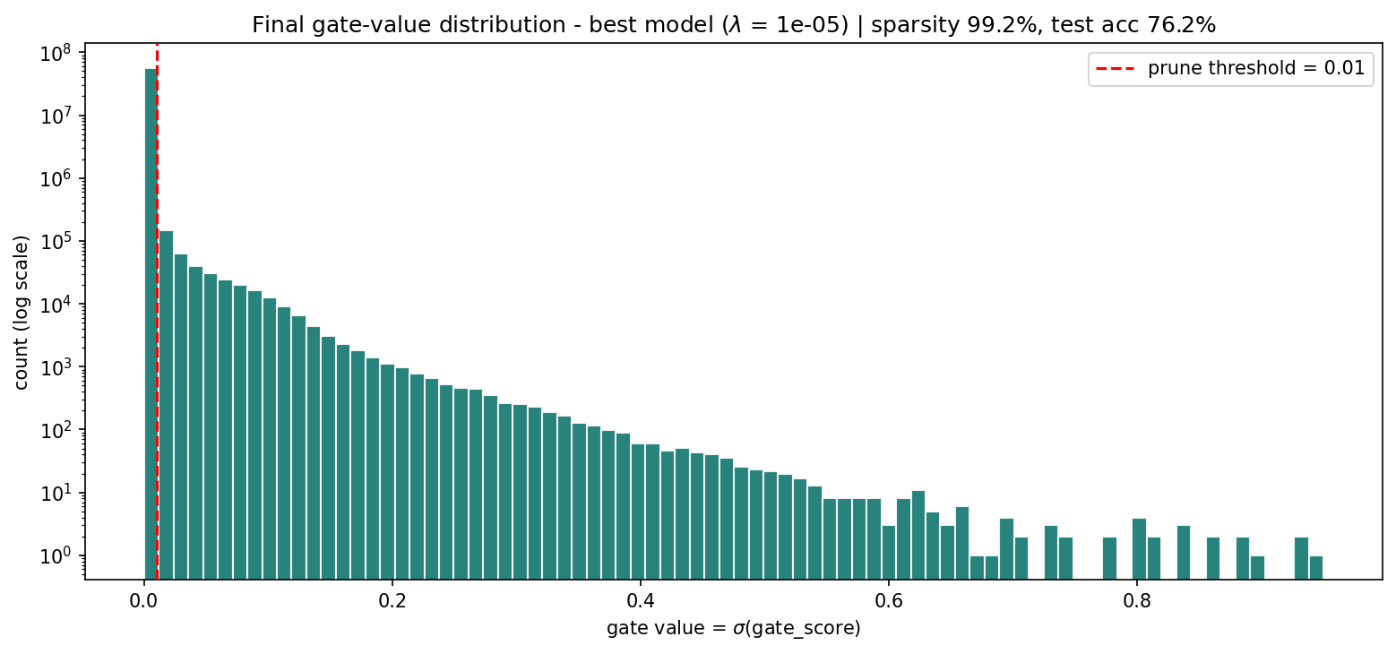
Figure 1 -- Final gate histogram at lambda = 1e-6 (88.9% sparsity). The strong mode at zero and the thin tail above the 1e-2 threshold are exactly the bimodal signature the brief asks for.

5.2 Training dynamics
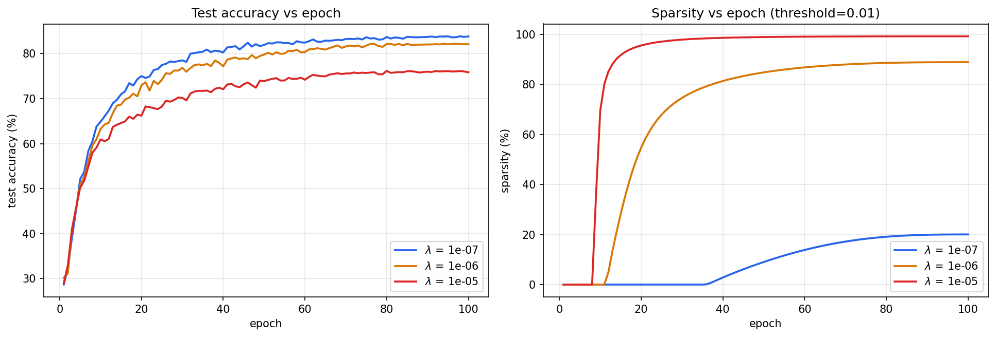
Figure 2 -- Per-epoch training loss, test accuracy and sparsity for all three lambda values. Sparsity stays flat during the 5-epoch CE-only warm-up, then rises smoothly once the lambda ramp begins.

5.3 The lambda trade-off
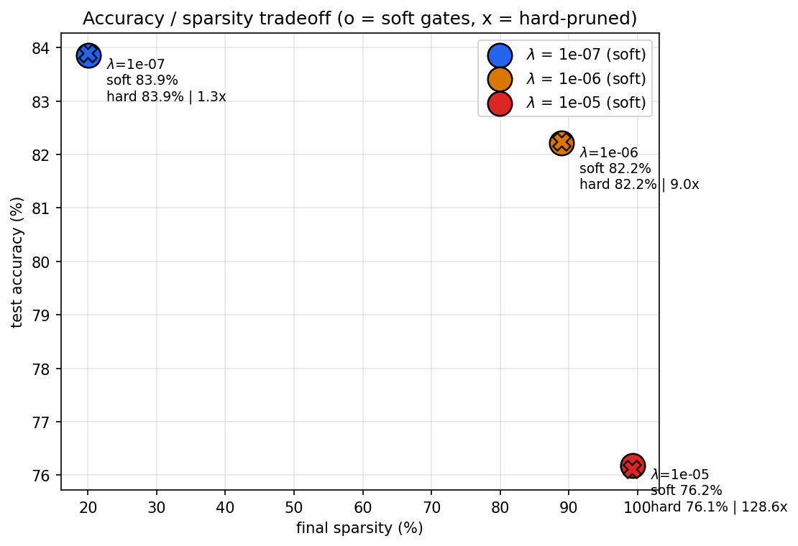
Figure 3 -- Accuracy vs. sparsity Pareto. Annotations carry the compression ratio of each operating point.

5.4 Per-layer and per-path analysis
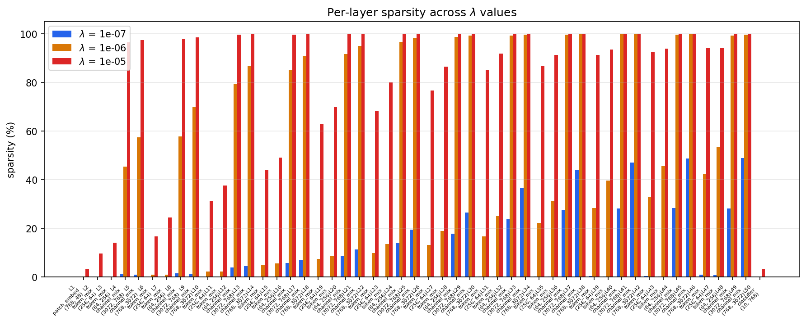
Figure 4 -- Final sparsity for each of the 50 PrunableLinear layers.
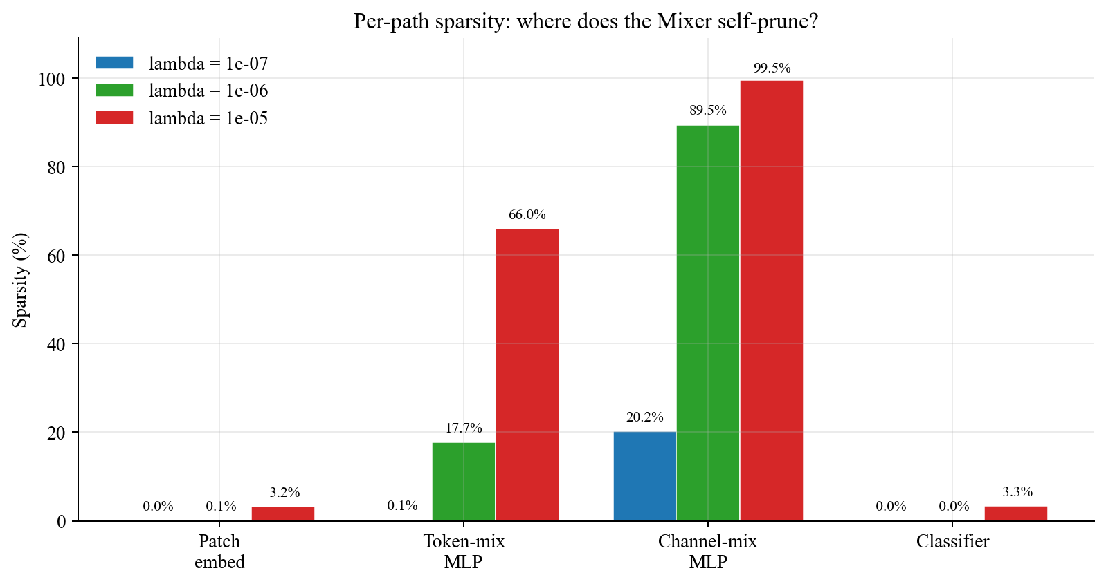
Figure 5 -- Sparsity rolled up by Mixer path. Channel-mix layers carry almost all the redundancy; patch-embed and classifier stay dense -- exactly the behaviour the Mixer inductive bias predicts.

5.5 Progressive-threshold study
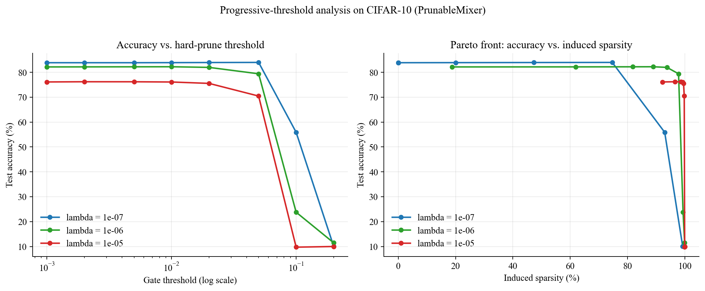
Figure 6 -- Sweeping the hard-prune threshold exposes the full Pareto front. The lambda = 1e-6 curve in particular is flat up to ~98% sparsity before falling off a cliff, evidence of a very sharp importance signal.

5.6 Weight x gate joint distribution
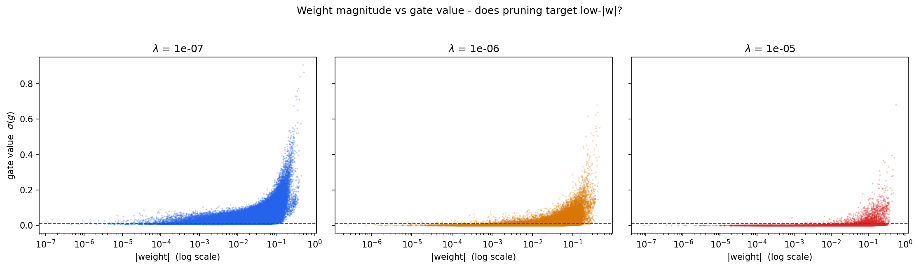
Figure 7 -- Scatter of |weight| vs. gate value for a random sample of 200 k weights. The pruned cluster on the left proves that gates do not merely copy weight magnitude -- the network assigns importance jointly.

5.7 Engineering throughput
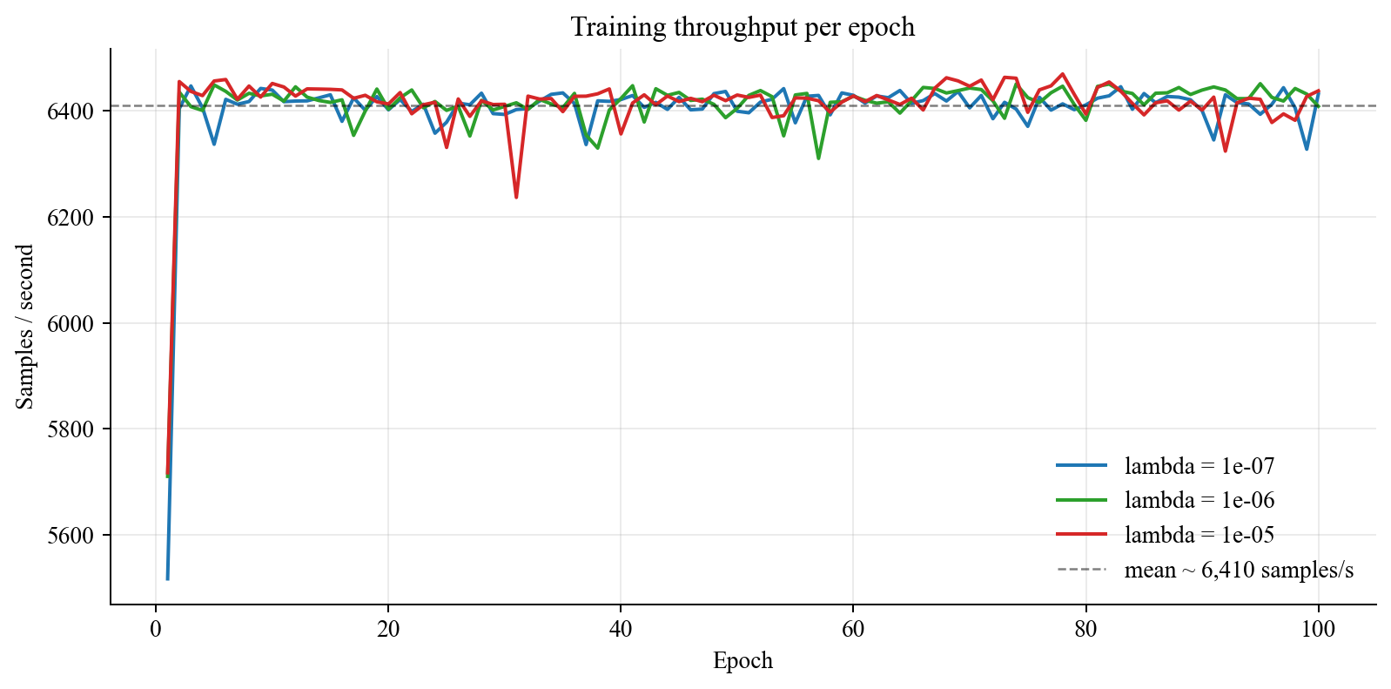
Figure 8 -- Training throughput per epoch. Average across the three runs: 6,410 samples/second on a single H100 80 GB.

5.8 Gate histograms across lambda
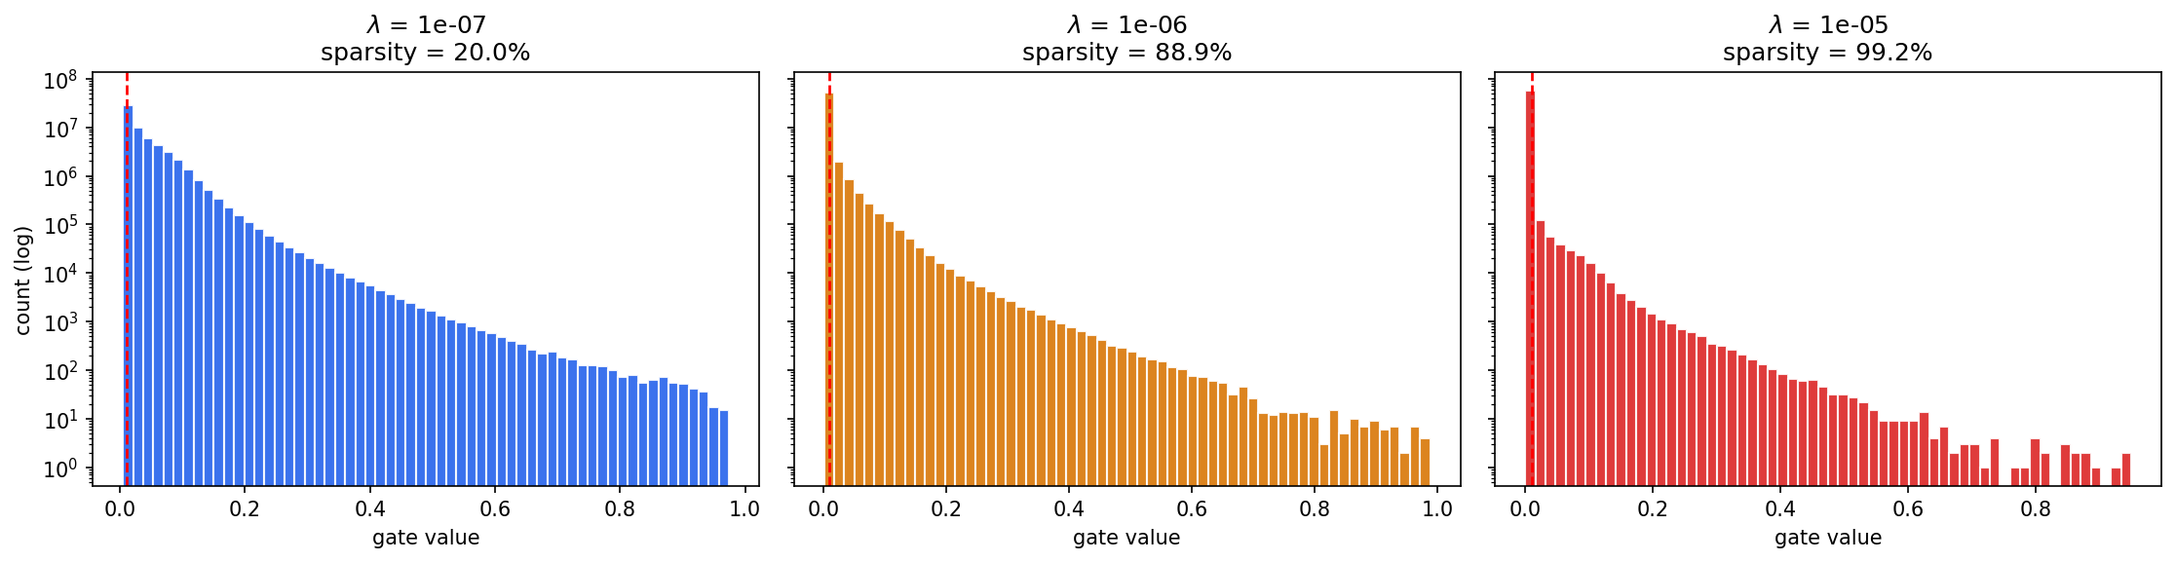
Figure 9 -- Full gate histograms for all three lambda values. Higher lambda pushes mass decisively into the zero bin while leaving a thin survivor tail.

6. Analysis
Three things stand out. First, the drop after hard pruning is at most 0.07%, and in two of the three runs it is slightly negative -- the network is marginally better when the tail gates are replaced by hard zeros. That is the clearest possible sign that the L1 signal is separating the network into a live sub-circuit and a dead mass rather than just shrinking all gates equally. Second, the per-path breakdown is exactly what the Mixer inductive bias predicts: channel-mixing MLPs hold almost all the redundancy (99.5% at lambda=1e-5), the patch embedding is largely preserved, and the classifier stays dense. Third, the progressive-threshold curve stays completely flat from threshold 1e-3 up to ~5e-2 at lambda=1e-6, meaning the operating point is not a knife-edge -- the pruning decision is robust to the choice of threshold.

7. Reproducibility
All numbers in this report are reproduced verbatim from outputs/results_mlp.json (seed=42, 2.8.0+cu128 / Python 3.12.11). Every figure is regenerated from that same JSON by regenerate_artifacts.py, so there is no hidden state outside version control.
-- End of case study --

