Co-design Group 25214 “PinkPong”
Notes
Uliana Kozlova, Mikhail Berdyugin & Anna Litasova, 2026
CONTENT

INTRODUCTION 3
Project Description 3
Additions 3
DESCRIPTION OF ADDITIONS TO THE HARDWARE 4
Subcircuits 4
Ball spin 7
Ball diffusion and the influence of bat position on the ball's vertical speed 8
Game modes 8
Screen displaying win / loss 9
DESCRIPTION OF ROBOT’S OPERATION AND ITS CONNECTION TO THE HARDWARE 10
Connecting the robot to the hardware 10
The software 11

INTRODUCTION

Project Description
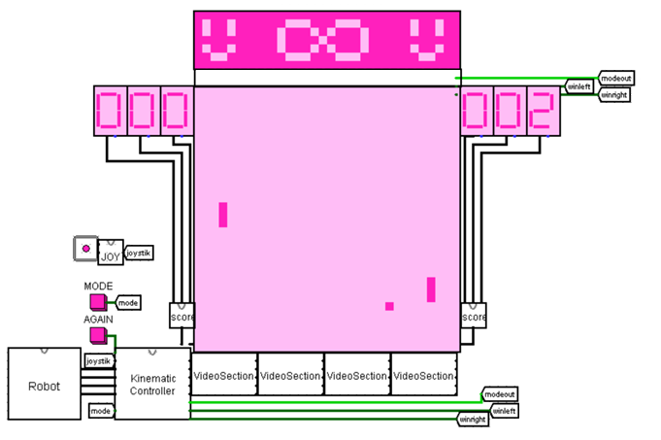
Figure 1 - The appearance of the game
(The project is an implementation of "TV Tennis" for one player. Logisim is used for the hardware part: the kinematic controller, video subsystem, and I/O interface. The CdM-8 processor runs the robot program, which predicts the ball's trajectory and moves the right bat)

Additions
- Ball spin relative to the horizontal axis based on bat movement up/down
- Ball diffusion (random change in vertical speed when hitting the floor/ceiling)
- Hitting different pixels of the bat affects the ball's vertical speed
- Two games mode
- Screen displaying the game mode and win/loss
- Smooth bats movement
- Since the speed value can be between -4 and 3, -4 becomes 3 when ball hits. The robot takes this into account when calculating the trajectory.

DESCRIPTION OF ADDITIONS TO THE HARDWARE

Subcircuits
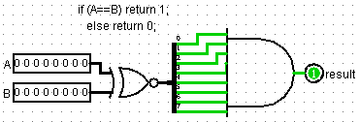
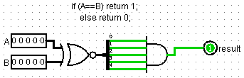
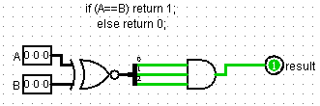
Blocks from figures 2, 3 and 4 are equality comparators of different bit widths (8, 5, and 3 bits). They compare numbers A and B bitwise using an XOR element: if all corresponding bits match completely, 1 is output to result. In any other case, the output will be 0. They are used for quickly comparing two numbers, when you only need to know whether they are equal or not.
Figure 2 - Equal8Bits
Figure 3 - Equal5Bits
Figure 4 - Equal3Bits

Figure 2 - Equal8Bits
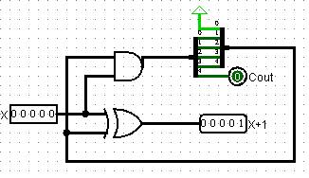
Next subcircuits (fig. 5) adds one to the input value of 5-bit X. The XOR element computes the new bit value, and the AND generates the carry into the next digit. The result is output to X+1, and the overflow signal is output to Cout.
Figure 5 - Inc5Bits
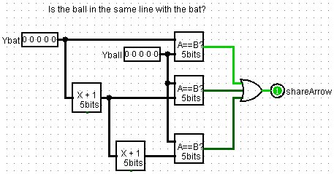
Block from figure 6 compares the vertical position of the ball (Yball) with the vertical position of the bat (Ybat) using its own bitwise comparators. The result of the comparison is a single shared signal, shareArrow, which determines whether the coordinate of at least one pixel of the bat matches the pixel of the ball or not.
Figure 6 - Inrange
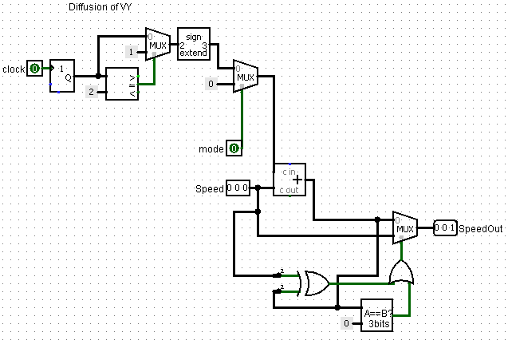
Subcircuit “Diffusion” (fig. 7) uses a 2-bit random number generator to introduce changes to the ball's vertical speed in normal mode. This makes the hit angle less predictable, and the multiplexers ensure that the resulting speed at the SpeedOut output does not exceed the allowed limit and does not be-come equal to 0.
Figure 7 - Diffusion
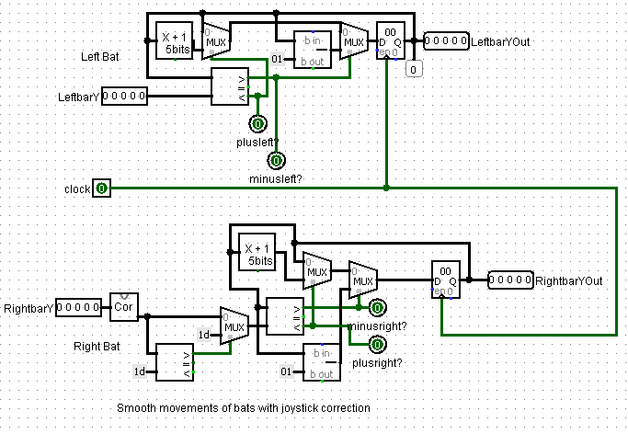
Block for bats (fig. 8) controls the smooth vertical movement of the left and right bats. The circuit compares the current bat value with the new one, and depending on this, sets the bat's "speed" – 1, 0, -1. It then adds the bat's speed to its previous position. This ensures that the bats move by exactly 1 pixel per 1 clock cycle. It also passes the speed values (if any) to the kinematic controller for changing ball spin.
Figure 8 - Bats
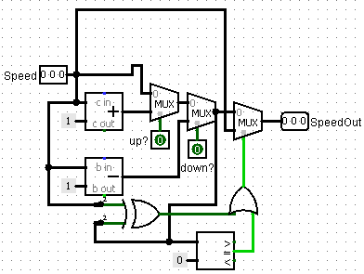
Subcircuit from figure 9 calculates the updated value of the ball's vertical speed depending on the zone of its impact with the bat. It takes the current speed (Speed) and, if the up? or down? signals are active, its value is increased or decreased by one using adders, changing the bounce angle. If the ball hits the center, the original speed passes through the multiplexer system unchanged. The final result is output to SpeedOut via multiplexers.
Figure 9 - BatReflectVy
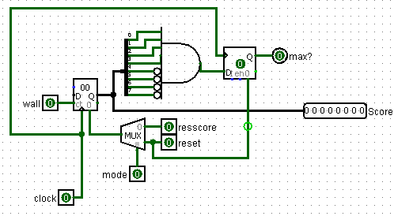
Block “Score” (fig. 10) is responsible for score counting and determining the end of the game. When the ball collides with a wall, the value at the Score output increases, and when it reaches the maximum, the AND element activates the win signal max?. Score reset is implemented via a multiplexer using the reset or resscor signals, which provide reset for different game modes. If the mode is normal, this block prevents the counter from going above 15.
Figure 10 - Score
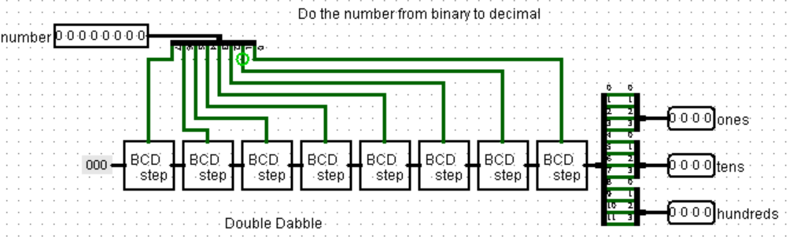
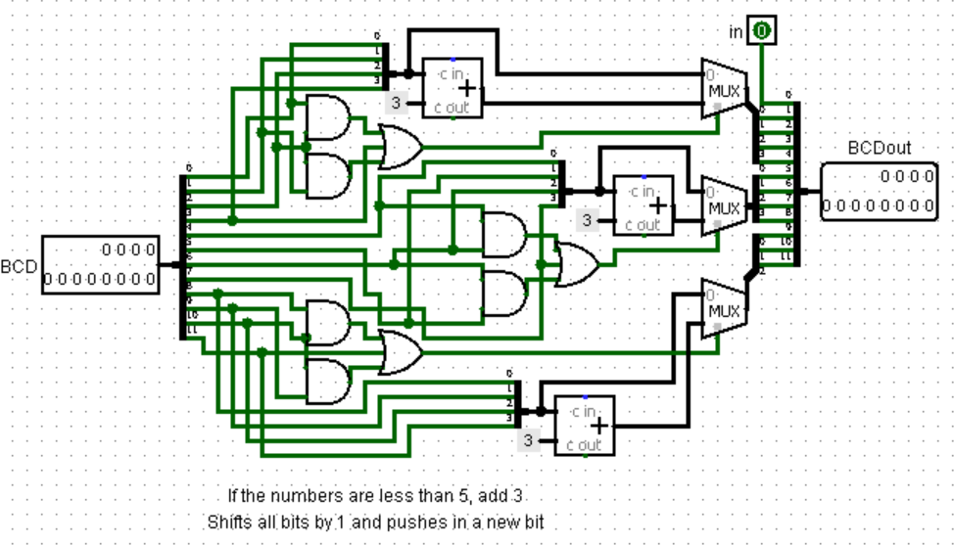
Subcircuits “Miniscore” and “BCDstep” (fig. 11 and 12) convert an 8-bit number into 3 4-bit digits for displaying the score on hexadecimal indicators (but in the decimal number system). Each BCDstep implements the double dabble algorithm. It first checks whether a digit is 5 or more. If it is, it adds 3; otherwise, it leaves the digit unchanged. Adding 3 prevents the digit from becoming 10 or more after the next shift, which would be invalid in decimal (BCD). After the correction, the block shifts the entire number one bit to the left and moves a new binary bit into the least significant position. Binaryto3Dig contains a chain of 8 BCDsteps, with each one shifting in a new bit of the original number.
Figure 11 - Miniscore
Figure 12 - BCDstep
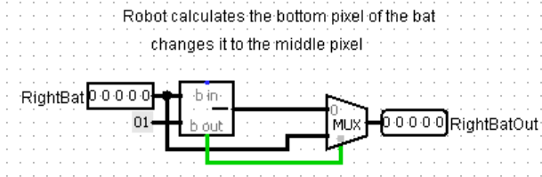
Next block (fig. 13) corrects the position of the robot's bat. The bat is displayed relative to the top pixel, so the robot calcu-lates exactly that one, and to reduce calculation error, the circuit shifts the bat down by 1 pixel (in this case, the pixel calculated by the robot ends up in the middle of the bat).
Figure 13 - CorrectRightBat

Ball spin
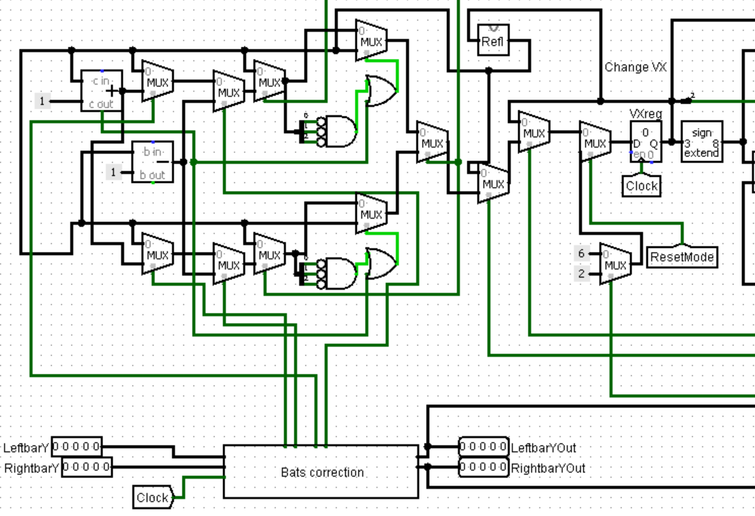
The block (figure 14) is responsible for changing the horizontal speed. The multiplexers process collision signals, calсulating how the ball's speed should change upon impact using the Reflect subcircuit. The circuit also takes into account the bat speed signals coming from the Bats subcircuit. If a bat hit occurs and the bat was moving up at that moment, the ball's speed increases by one. If it was moving down, it decreases by one. It also checks that the sum/difference does not change the sign of the speed and that the speed does not become equal to 0; otherwise, the speed remains unchanged.
Figure 14 - Ball spin

Ball diffusion and the influence of bat position on the ball's vertical speed
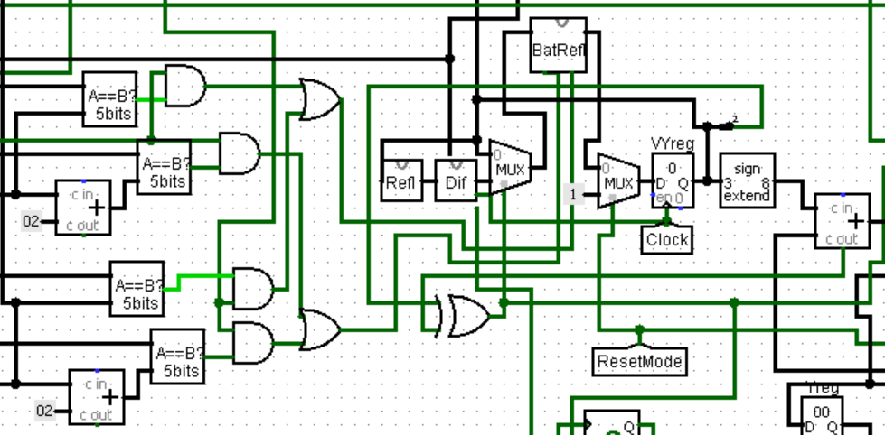
The part of Kinematic Controller from figure 15 is responsible for changing the vertical speed. In the event of a bounce off the wall or floor, it changes the speed to the opposite using the Reflect subcircuit, then engages diffusion. It checks whether the ball has hit the top or bottom pixel of the bat; in this case, it changes the speed using the BatReflectVy subcircuit.
Figure 15 - Changing vy

Game modes
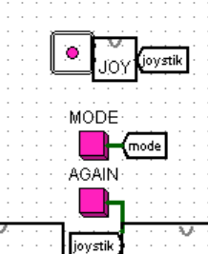
The game has two modes. Player can change it with the bottom (fig. 16). Their main difference is that in the second mode – let's call it "infinite" – there is no way to beat the robot; it will always correctly predict the ball's trajectory. In the classic mode, however, there is diffusion when hitting the ceiling and floor, due to which the ball can change its trajectory in the opponent's half of the field – at that moment, the robot no longer calculates the new position. In addition, in infinite mode, the counters work up to 255 points, and when a new point is reached after 255, they simply start over from zero. In classic mode, the maximum is 15 points, followed by a win or loss, upon reaching which the game cannot be continued without switching the mode or pressing the AGAIN button. Otherwise, including in the robot's logic, the modes do not differ.
Figure 16 - Bottom for changing mode

Screen displaying win / loss
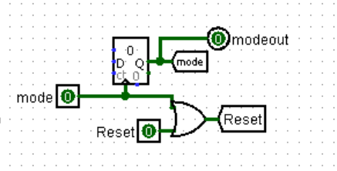
On the main screen, the player has a button that, when pressed, changes the mode, resets the counters, and starts the game over in the new mode. In the kinematic controller, this is implemented using a counter whose clock input is replaced by the button input. Also, this switch is connected to Reset so that the game starts over when a new mode is selected (fig. 17).
Figure 17 - Modes in Kinematic Controller


The chip itself, which displays the mode or loss/win on the screen (figures 18-20), consists primarily of multiplexers that supply the required constant depending on the conditions input from outside.
Figure 20 - Diplay showing endless mode
Figure 19 - Display showing loss
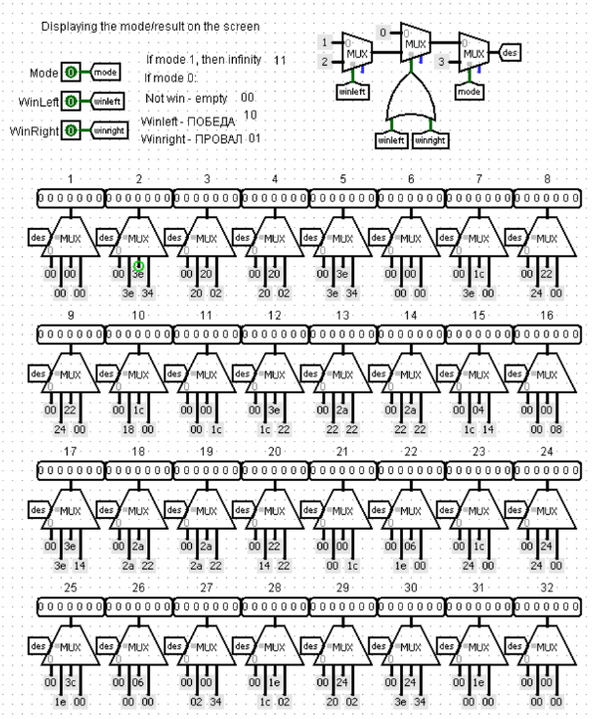
Figure 18 - Subcircuit for display

DESCRIPTION OF ROBOT’S OPERATION AND ITS CONNECTION TO THE HARDWARE

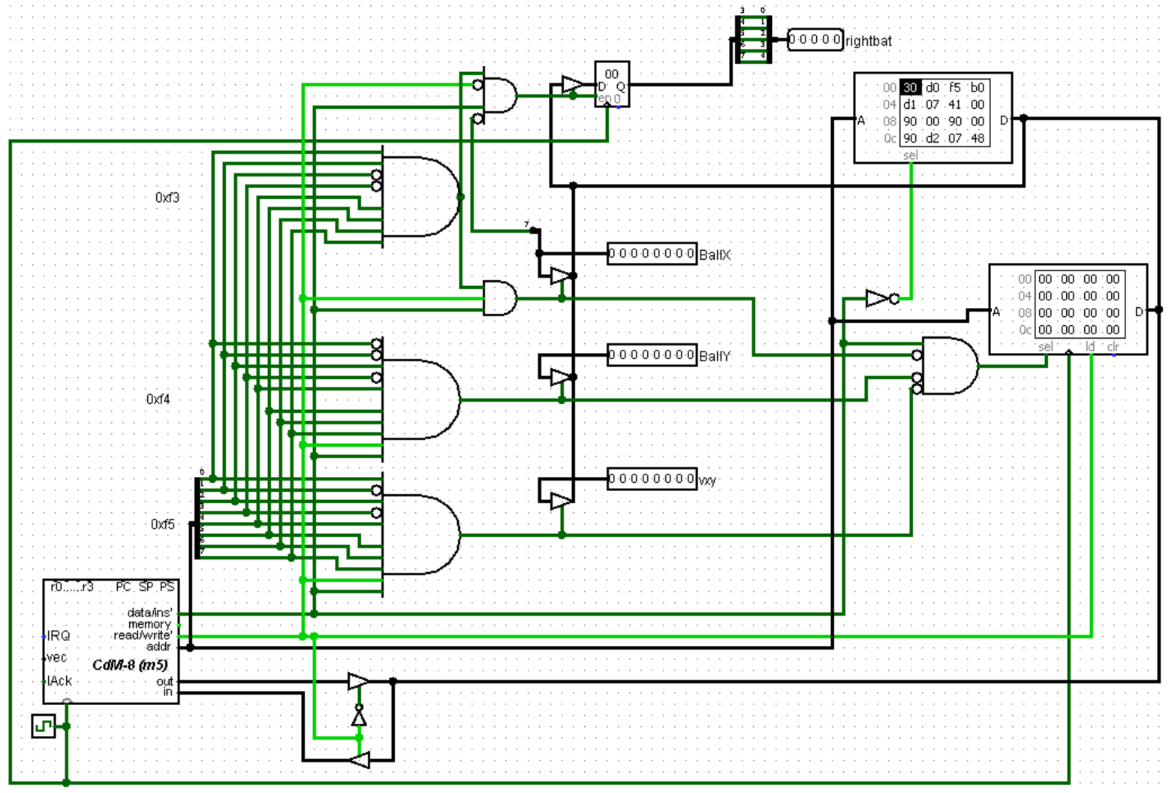
Connecting the robot to the hardware
Figure 21 - Process
The robot is built on the CdM-8 processor, which interacts with the hardware part via I/O ports. The robot's program is stored in ROM. A stack in RAM is used for temporary data storage.
The processor fetches the current ball state (X, Y, vx, vy) from the I/O ports at addresses 0xF3–0xF5, and also controls the right bat (rightbat) via port 0xF3. To pick the right port, there's a circuit that compares the address against a constant using AND gates. The kinematic controller runs on a clock that's 14 times slower than the processor's, so the robot has time to finish its calculations.

The software
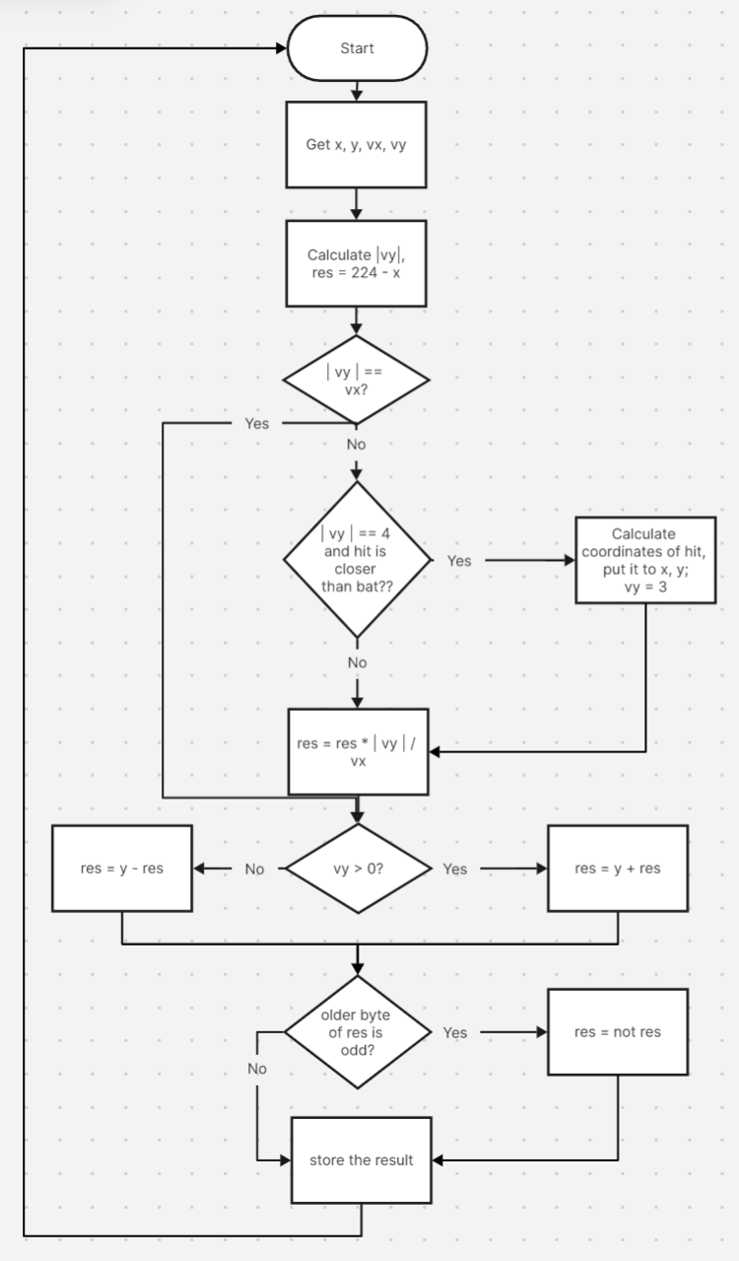
The robot's execution flow is organised as an unconditional branch, and the processor runs without a hardware reset to keep performance as high as possible. Each time through the loop, the robot works out the new bat position with the formula $Y_{new}=Y+\left(224-X\right)*vy÷vx$.
Figure 22 - AI algorithm
The following describes individual parts of the code that may be difficult to understand. Program uses 16-bit arithmetic to calculate the new bat position and correctly account for bounces.
To speed up the robot's operation, the program compares the horizontal and vertical speeds (code 1), and if they are equal, it jumps to calculating the result and accounting for bounces, since in this case the speeds cancel out in the formula.
# if vx = vy, no operations, go to #finish
If
cmp r1, r0
is eq
push r3 # push vy sign in stack
ldi r3, 224
sub r3, r2
ldi r3, 0xf4
ld r3, r3
push r3 # push y to stack
ldi r3, 0x00
br finish
fi
The code 2 takes the absolute value of vy so that there is no need to perform many comparisons for 7 different speeds. It saves the original sign of vy – if negative, it loads 1 into r3; otherwise, 0 remains in r3.
Code 1

ldi r3, 0x04
and r0, r3
if
tst r3
is ne
neg r0
ldi r3, 0x07
and r3, r0
ldi r3, 0x01
fi
Code 2
If the original vy = -4, the robot must take into account when calculating the trajectory that it will change to 3, not to 4 (code 3). In this case, the ball's bounce coordinates are first calculated using the formula x = x + vx * (y/4), y = 0. The code also contains a check for where the bounce will occur – if it happens after the bat hit, then nothing needs to be changed, and the original values are preserved. Otherwise, the new co-ordinates are saved, the speed changes to 3, and the data is fed for further calculations.
if
cmp r3, r0
is eq
# get y from stack
pop r3
inc r3 # add 3 to y to round up
inc r3
inc r3
move r3, r3 #clear flags to get no effect on shr
shr r3
move r3, r3
shr r3
move r3, r0
# push vx to stack to remember it
push r1
dec r1
# calculate vx * (y / 4)
while
tst r1
stays gt
add r0, r3
if
is cs
ldi r1, -1
fi
dec r1
wend
add r3, r2
if
is cs
ldi r1, -1
fi
ldi r3, 31
add r2, r3
if
is cs
ldi r1, -1
fi
# r1 check where the hit will be
# if it's further than the bat, returns the original coordinates
if
tst r1
is lt
ldi r3, 0xf4
ld r3, r3
ldi r2, 0xf3
ld r2, r2
ldi r0, 4
pop r1 # get vx from stack
else
# if the hit is closer than racket
# put new coordinates
ldi r3, 0
pop r1 # get vx from stack
pop r0 # get vy sign from stack
ldi r0, 0
push r0 # push new vy sign to stack
ldi r0, 3
fi
push r3 # push new y to stack
fi
Code 3
Multiplication in the code 4 is performed by comparing the current vertical speed with constants from 1 to 4. To simplify the algorithm, it first determines whether the speed is even, and then sum operations are carried out (as many times as the multiplication requires).
# even -> r3 == 0, not even -> r3 == 1
if
tst r3
is eq
# if vy == 2 or vy == 4
add r2, r2
addc r3, r3
ldi r1, 0x04
if # vy == 4
cmp r0, r1
is eq
clr r1
add r2, r2
addc r1, r1
add r3, r3
add r1, r3
fi
else
if # vy == 3
cmp r0, r3
is eq
clr r3
else
clr r3
add r2, r2
addc r3, r3
clr r0
add r1, r2
addc r0, r3
fi
fi
Code 4
Division is implemented similarly to multiplication (code 5). Since the positive horizontal speed (at which the robot's calculations take place) can be from 1 to 3, it is first compared with 2, and then with 3 (no operations are performed for a value of 1). Division by three is carried out using the operation $X=\left(X+85\right)*\frac{85}{256}$, since this approximately equals $X=X*\frac{1}{3}$, but executes much faster than a loop subtracting three from the current number.
ldi r1, 0x02
if
# if vx == 2
cmp r1, r0
is eq
move r3, r3
shra r3
shr r2
else
ldi r1, 0x03
if # vx == 3
# x / 3 is close to (x * 85 + 85) / 256, faster then cycle
cmp r1, r0
is eq
# * 85
move r3, r1
move r2, r0
shla r0
shl r1
shla r0
shl r1
add r0, r2
addc r1, r3
shla r0
shl r1
shla r0
shl r1
add r0, r2
addc r1, r3
shla r0
shl r1
shla r0
shl r1
add r0, r2
addc r1, r3
# + 85
ldi r0, 0x55
add r0, r2
ldi r0, 0x00
addc r0, r3
# / 256
move r3, r2
clr r3
fi
fi
Code 5
pop r3
if
tst r3
is ne
not r2
not r1
inc r2
if
is cs
inc r1
fi
fi
add r0, r2
if
is cs
inc r1
fi
Next block (code 6) is responsible for checking the sign of the vertical speed. This value is retrieved from the stack, and if the speed was negative, the sign of the previously obtained value needs to be changed. Since the arithmetic is 16-bit, the high and low byte registers are processed separately. The ball's y-coordinate is then added to the obtained value.
Code 6
After all operations are completed, it is necessary to determine the number of hits and change the value accordingly. When a negative number is obtained (checked by the most significant bit), it must be changed to a positive one, since coordinates cannot be negative. Next, the number of bounces is checked by the number of times 255 is exceeded; if the count is even, nothing is done; otherwise, the number is inverted.
#if r1 is neg than the res is neg
# we need to neg it because coordinate can be less than 0
if
tst r1
is lt
not r2
not r1
inc r2
if
is cs
inc r1
fi
fi
ldi r0, 1
and r0, r1
# is elder bytes odd?
# elder bytes is count of hits
# if it's odd we need to do 255 - res
if
tst r1
is ne
not r2
fi
Code 7

