Вариант 50



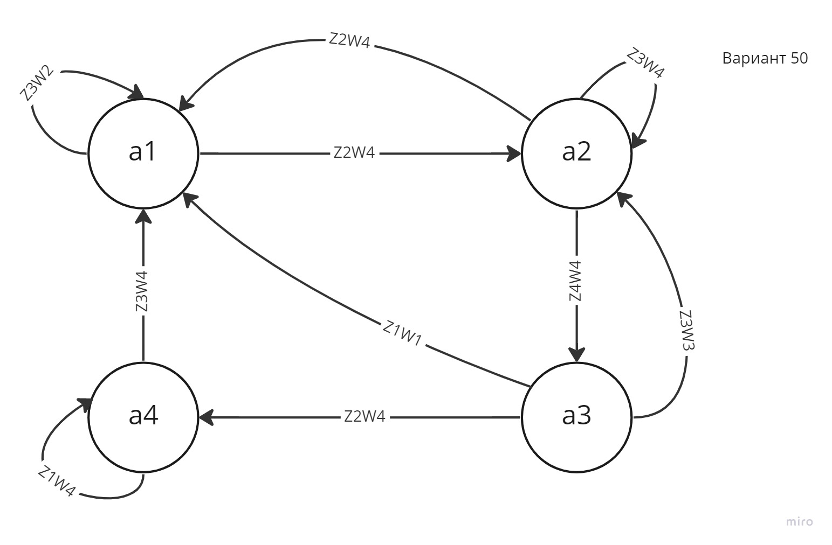

|  |  |  |  |  |  |  |  |  |  |
| --- | --- | --- | --- | --- | --- | --- | --- | --- | --- |
|  | ai | a1 | | a2 | | a3 | | a4 | |
| Zj |  |
| Z1 | | - | | - | | a1 |  | a4 |  |
|  | W1 |  | W4 |
| Z2 | | a2 |  | a1 |  | a4 |  | - | |
|  | W4 |  | W4 |  | W4 |
| Z3 | | a1 |  | a2 |  | a2 |  | a1 |  |
|  | W2 |  | W4 |  | W3 |  | W4 |
| Z4 | | - | | a3 |  | - | | - | |
|  | W4 |

|  |  |  |  |  |  |  |  |  |
| --- | --- | --- | --- | --- | --- | --- | --- | --- |
| Входные сигналы | | | Выходные сигналы | | | Сигналы памяти | | |
| Состояние входа | Биты кода | | Состояние выхода | Биты кода | | Внутреннее состояние | Биты кода | |
| x1 | x2 | у1 | у2 | Q1 | Q2 |
| Z1 | 0 | 0 | W1 | 0 | 0 | a1 | 0 | 0 |
| Z2 | 0 | 1 | W2 | 0 | 1 | a2 | 0 | 1 |
| Z3 | 1 | 0 | W3 | 1 | 0 | a3 | 1 | 0 |
| Z4 | 1 | 1 | W4 | 1 | 1 | a4 | 1 | 1 |

|  |  |  |  |  |  |  |  |  |  |  |
| --- | --- | --- | --- | --- | --- | --- | --- | --- | --- | --- |
| Таблица переходов | |  |  |  |  | Таблица выходов | |  |  |  |
|  |  |  |  |  |  |  |  |  |  |  |
| x1x2 | Q1Q2 | | | |  | x1x2 | Q1Q2 | | | |
| 00 | 01 | 10 | 11 |  | 00 | 01 | 10 | 11 |
| 00 |  |  | 00 | 11 |  | 00 |  |  | 00 | 11 |
| 01 | 01 | 00 | 11 |  |  | 01 | 11 | 11 | 11 |  |
| 10 | 00 | 01 | 01 | 00 |  | 10 | 01 | 11 | 10 | 11 |
| 11 |  | 10 |  |  |  | 11 |  | 11 |  |  |

|  |  |  |  |  |  |
| --- | --- | --- | --- | --- | --- |
| x1x2/Q1Q2 | | 00 | 01 | 11 | 10 |
|  |
| 00 | | * | * | 1 | 0 |  |
| 01 | | 1 | 1 | * | 1 |  |
| 11 | | * | 1 | * | * |  |
| 10 | | 0 | 1 | 1 | 1 |  |
|  |  |  |  |  |  |  |
| x1x2/Q1Q2 | | 00 | 01 | 11 | 10 |  |
|  |
| 00 | | * | * | 1 | 0 |  |
| 01 | | 1 | 1 | * | 1 |  |
| 11 | | * | 1 | * | * |  |
| 10 | | 0 | 1 | 1 | 1 |  |
|  |  |  |  |  |  |  |
| x1x2/Q1Q2 | | 00 | 01 | 11 | 10 |  |
|  |
| 00 | | * | * | 1 | 0 |  |
| 01 | | 1 | 1 | * | 1 |  |
| 11 | | * | 1 | * | * |  |
| 10 | | 0 | 1 | 1 | 1 |  |
|  |  |  |  |  |  |  |
| y1 = Q2 + x2 + x1*Q1*!Q2 | | |  |  |  |  |

|  |  |  |  |  |  |
| --- | --- | --- | --- | --- | --- |
| x1x2/Q1Q2 | | 00 | 01 | 11 | 10 |
|  |
| 00 | | * | * | 1 | 0 |  |
| 01 | | 1 | 1 | * | 1 |  |
| 11 | | * | 1 | * | * |  |
| 10 | | 1 | 1 | 1 | 0 |  |
|  |  |  |  |  |  |  |
| x1x2/Q1Q2 | | 00 | 01 | 11 | 10 |  |
|  |
| 00 | | * | * | 1 | 0 |  |
| 01 | | 1 | 1 | * | 1 |  |
| 11 | | * | 1 | * | * |  |
| 10 | | 1 | 1 | 1 | 0 |  |
|  |  |  |  |  |  |  |
| x1x2/Q1Q2 | | 00 | 01 | 11 | 10 |  |
|  |
| 00 | | * | * | 1 | 0 |  |
| 01 | | 1 | 1 | * | 1 |  |
| 11 | | * | 1 | * | * |  |
| 10 | | 1 | 1 | 1 | 0 |  |
|  |  |  |  |  |  |  |
| y2 = Q2 + x2 + !x1 | |  |  |  |  |  |

|  |  |  |  |  |  |
| --- | --- | --- | --- | --- | --- |
| x1x2/Q1Q2 | | 00 | 01 | 11 | 10 |
|  |
| 00 | | * | * | 1 | 0 |  |
| 01 | | 0 | 0 | * | 1 |  |
| 11 | | * | 1 | * | * |  |
| 10 | | 0 | 0 | 0 | 0 |  |
|  |  |  |  |  |  |  |
| x1x2/Q1Q2 | | 00 | 01 | 11 | 10 |  |
|  |
| 00 | | * | * | 1 | 0 |  |
| 01 | | 0 | 0 | * | 1 |  |
| 11 | | * | 1 | * | * |  |
| 10 | | 0 | 0 | 0 | 0 |  |
|  |  |  |  |  |  |  |
| x1x2/Q1Q2 | | 00 | 01 | 11 | 10 |  |
|  |
| 00 | | * | * | 1 | 0 |  |
| 01 | | 0 | 0 | * | 1 |  |
| 11 | | * | 1 | * | * |  |
| 10 | | 0 | 0 | 0 | 0 |  |
|  |  |  |  |  |  |  |
| d1 = x1*x2 + !x1*Q1*Q2 + !x1*x2*Q1 | | | |  |  |  |

|  |  |  |  |  |  |
| --- | --- | --- | --- | --- | --- |
| x1x2/Q1Q2 | | 00 | 01 | 11 | 10 |
|  |
| 00 | | * | * | 1 | 0 |  |
| 01 | | 1 | 0 | * | 1 |  |
| 11 | | * | 0 | * | * |  |
| 10 | | 0 | 1 | 0 | 1 |  |
|  |  |  |  |  |  |  |
| x1x2/Q1Q2 | | 00 | 01 | 11 | 10 |  |
|  |
| 00 | | * | * | 1 | 0 |  |
| 01 | | 1 | 0 | * | 1 |  |
| 11 | | * | 0 | * | * |  |
| 10 | | 0 | 1 | 0 | 1 |  |
|  |  |  |  |  |  |  |
| x1x2/Q1Q2 | | 00 | 01 | 11 | 10 |  |
|  |
| 00 | | * | * | 1 | 0 |  |
| 01 | | 1 | 0 | * | 1 |  |
| 11 | | * | 0 | * | * |  |
| 10 | | 0 | 1 | 0 | 1 |  |
|  |  |  |  |  |  |  |
| d2 = x2*!Q2 + !x2*!Q1*Q2 + !x1*Q1*Q2 + x1*Q1*!Q2 | | | | | |  |