1. <https://www.kaggle.com/learn/intro-to-machine-learning>
2. <https://www.kaggle.com/learn>
3. Step 2 <https://www.kaggle.com/learn/intermediate-machine-learning>
4. Step 3 - <https://www.kaggle.com/learn/time-series>, следующий, не делал

Imputation:

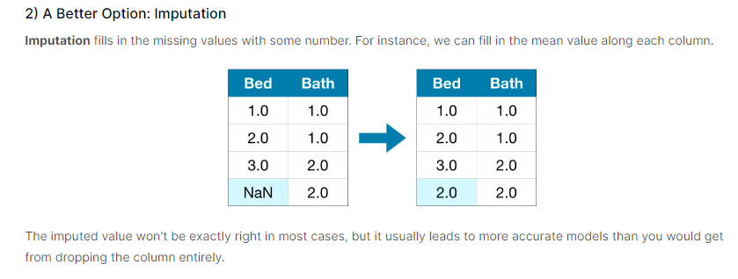

One-Hot Encoding:

***! One-hot encoding generally does not perform well if the categorical variable takes on a large number of values (i.e., you generally won't use it for variables taking more than 15 different values).***

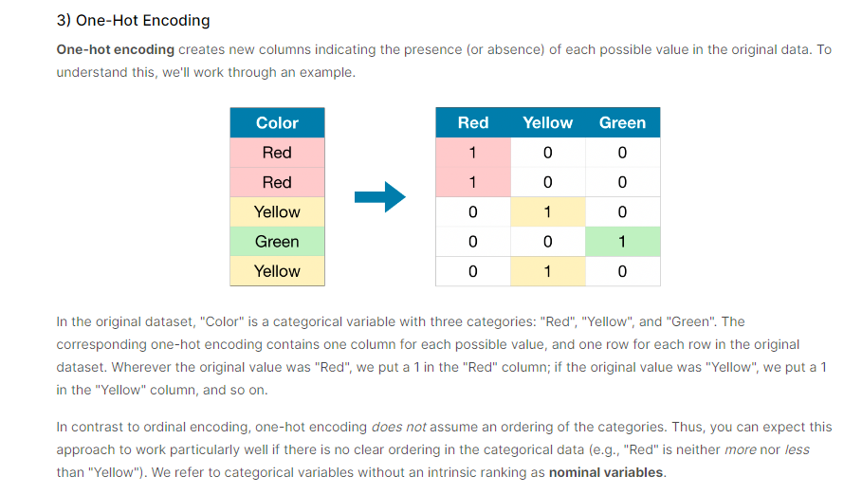

Cross-Validation:

