Supplementary files.

- Synteny
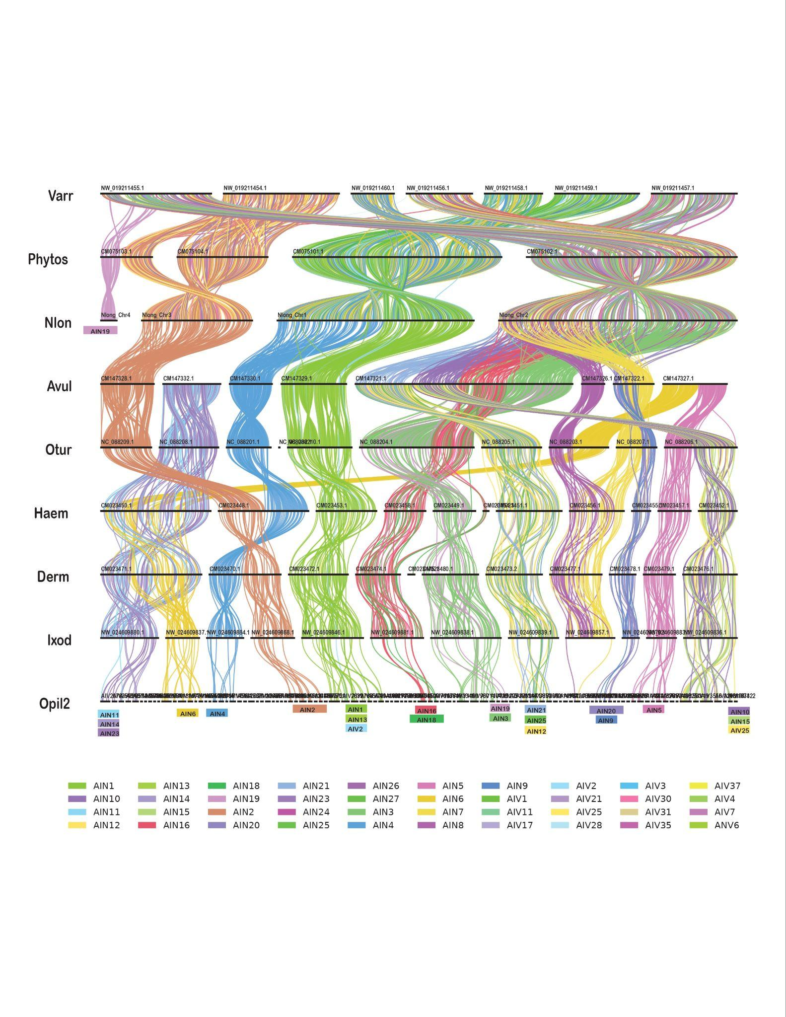
1.1- Synteny analyses of acarine taxa using ODP.

Figure 1.1- A ribbon plot depicting conserved macrosynteny within genomes of Varroa destructor, Phytoseiulus persimilis, Neoseiulus longispinosus, Argas vulgaris, Ornithodoros turicata, Haemaphysalis longicornis, Dermacentor andersoni, Ixodes scapularis and Indiacarus sp. using Parasitiformes linkage groups (ParaLG).
1.2- Oxford dot plots (ODPs) of acarine taxa

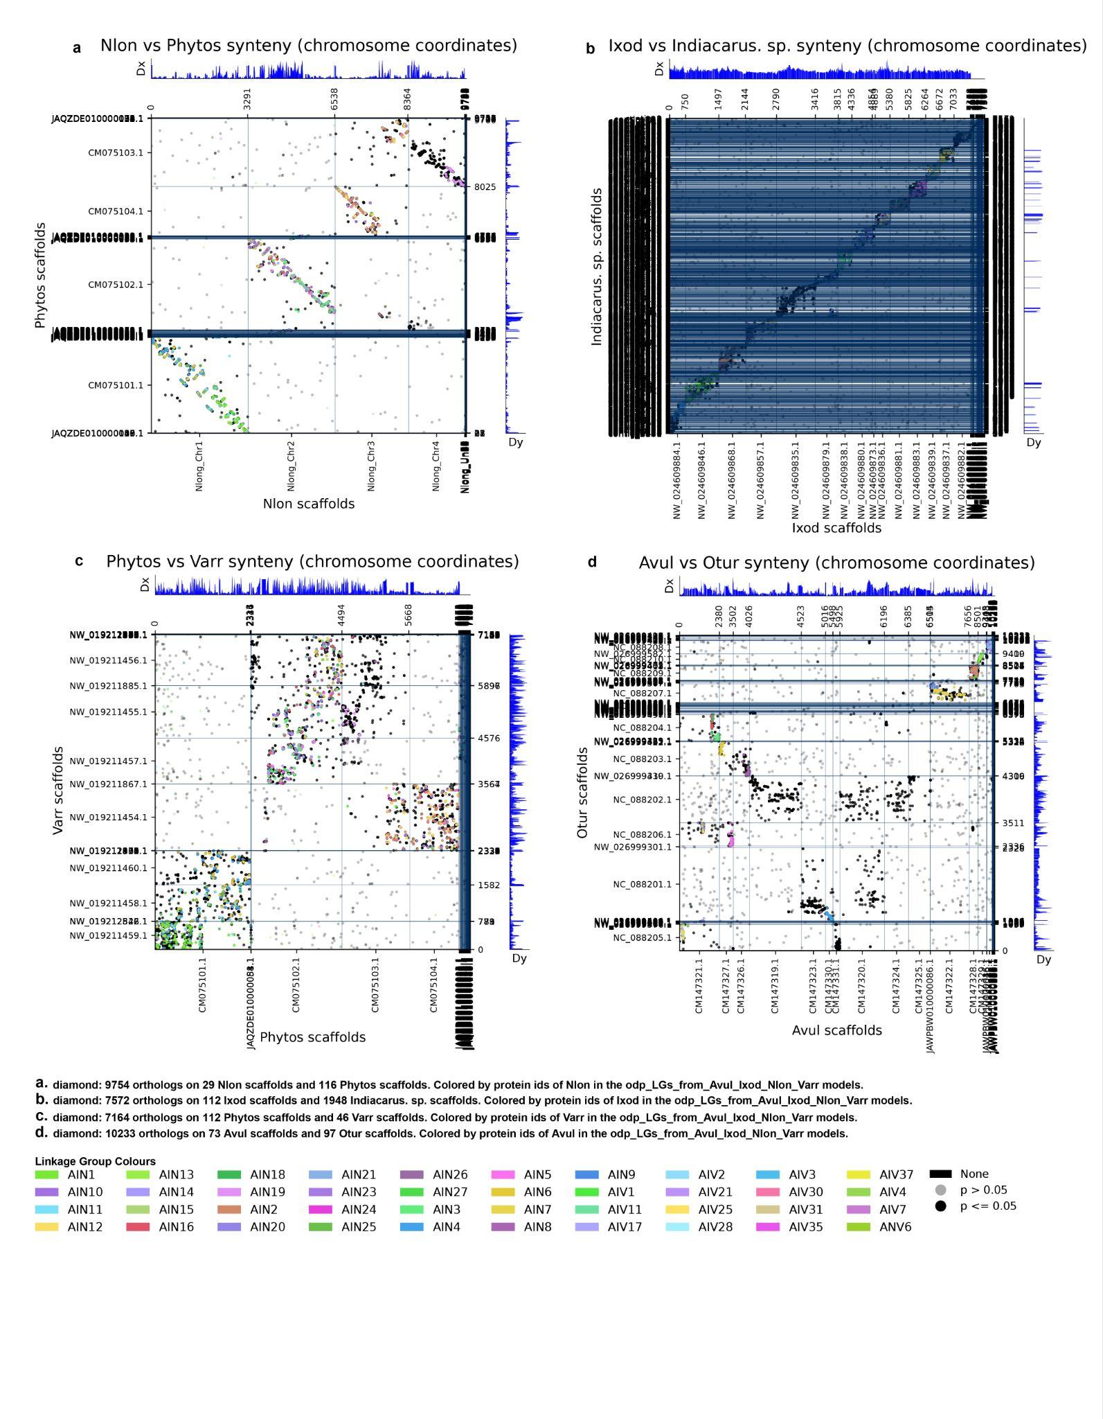
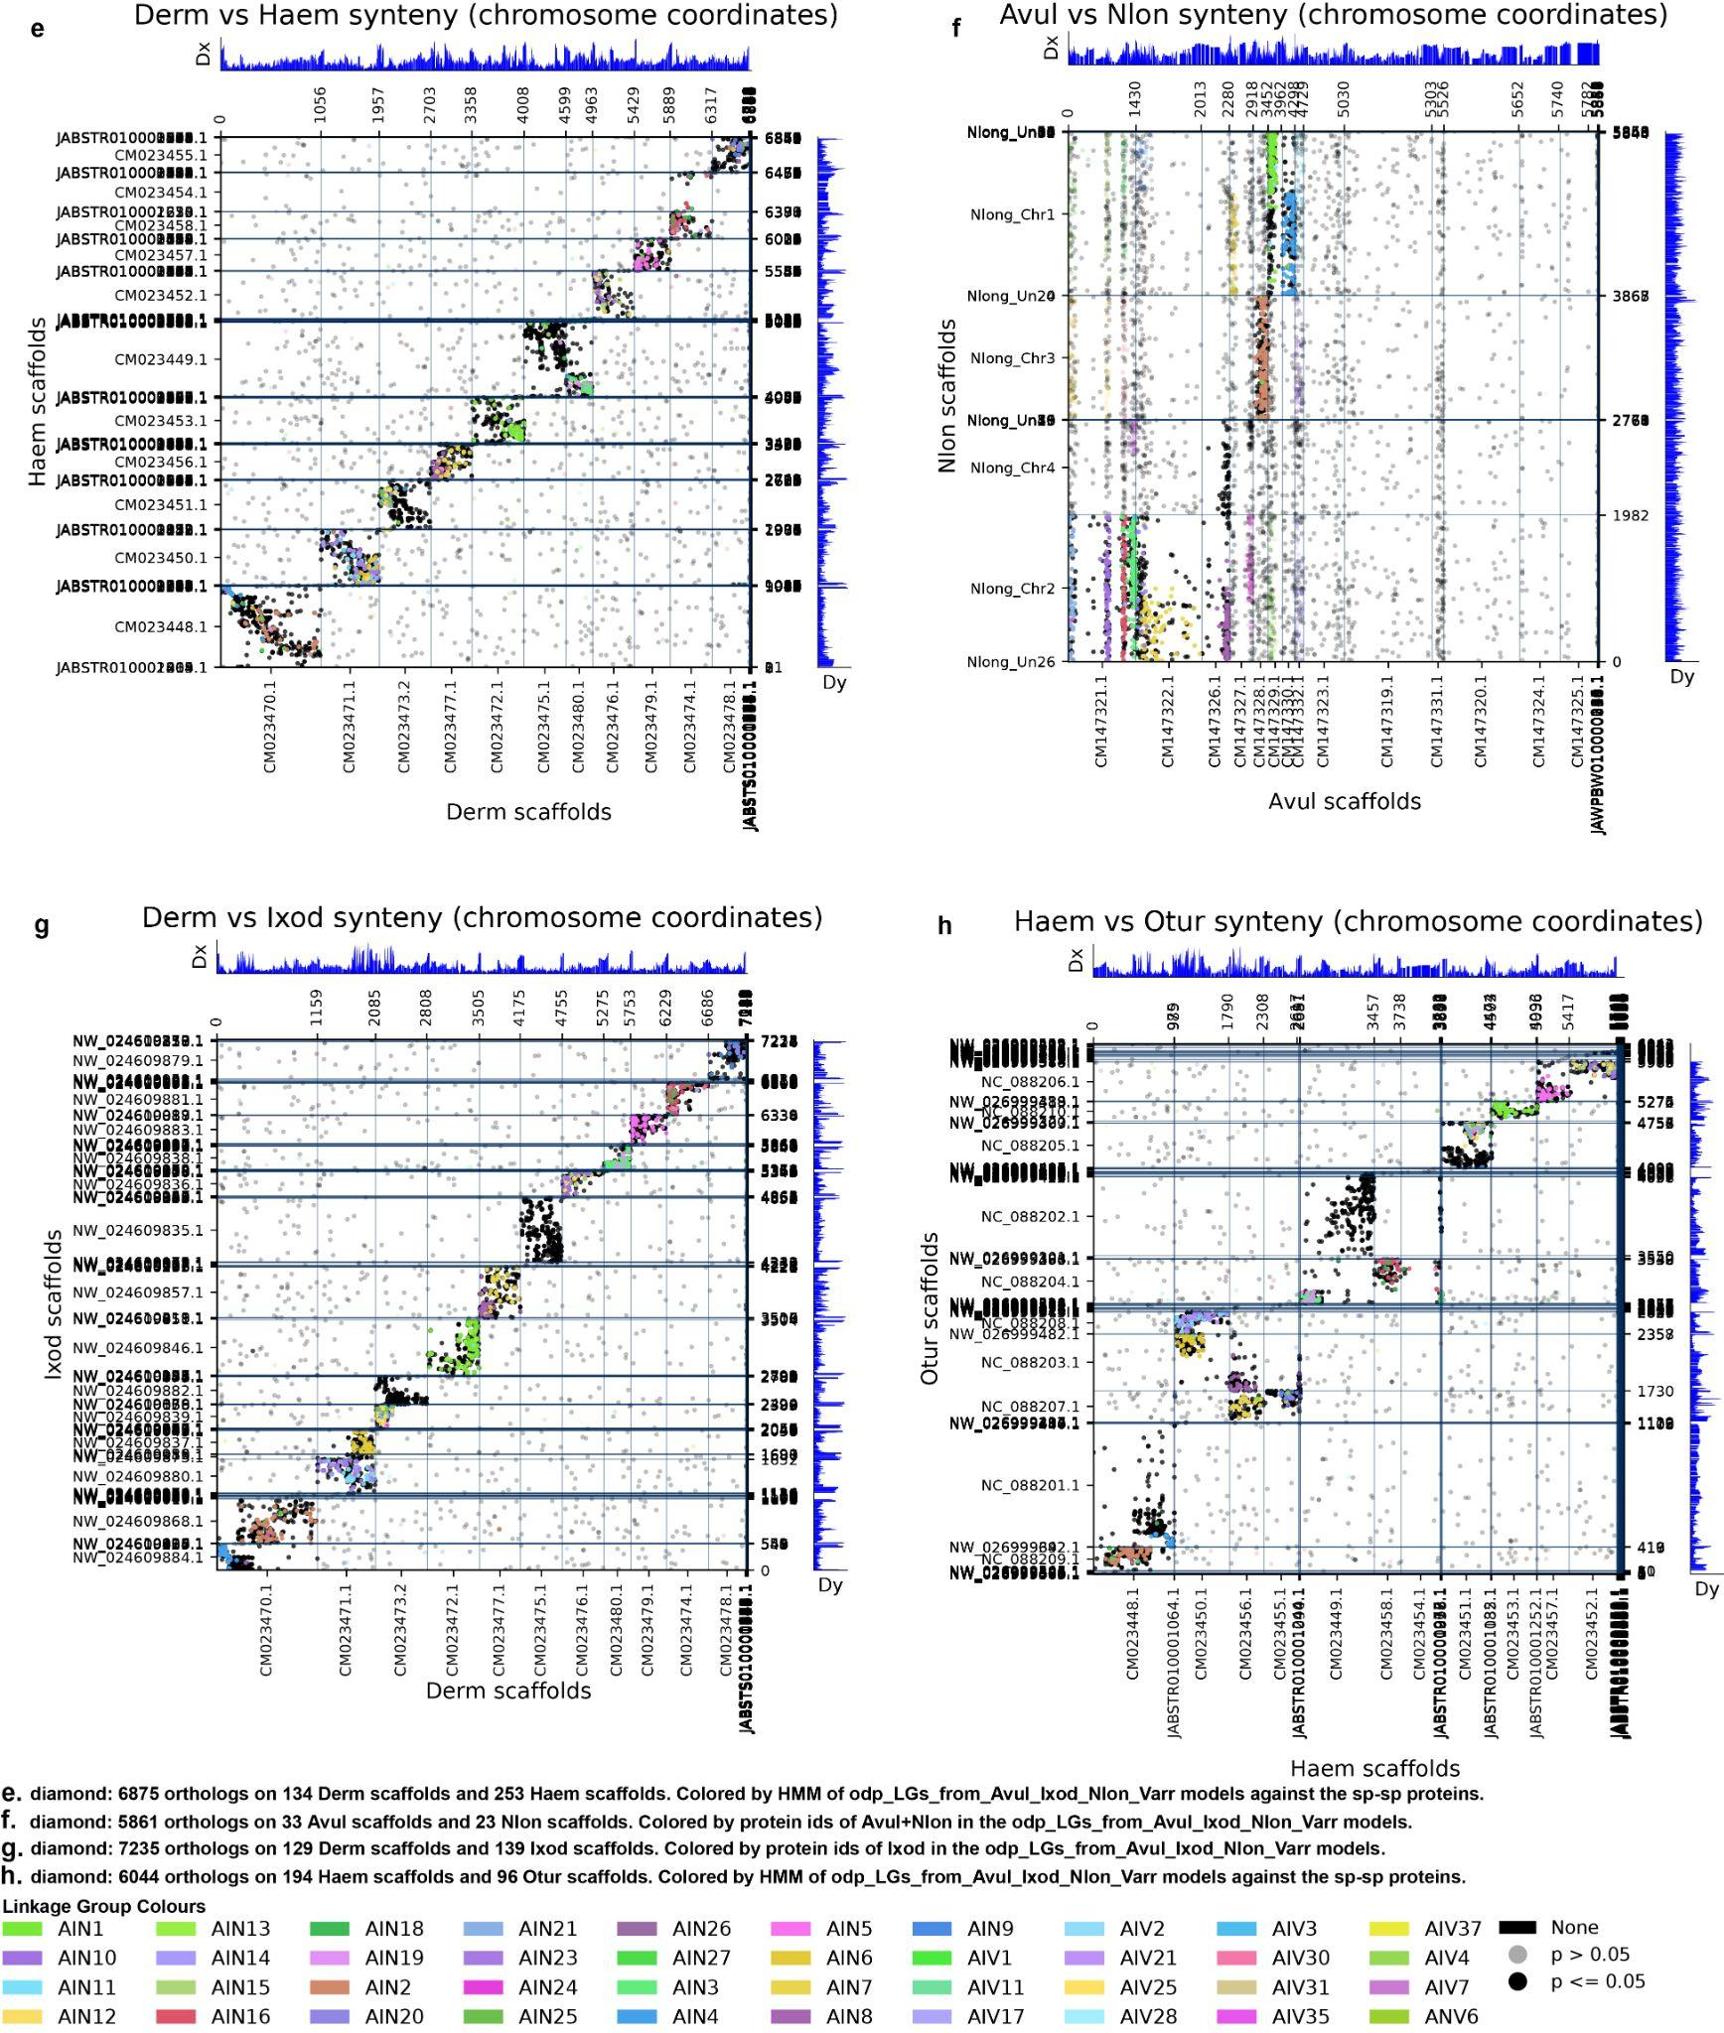

Figure 1.2- Oxford dot plots showing genomic comparison between a) Neoseiulus longispinosus and Phytoseiulus persimilis, b) Ixodes scapularis and Indiacarus sp., c) Phytoseiulus persimilis and Varroa destructor, d) Argas vulgaris and Ornithodoros turicata, e) Dermacentor andersoni and Haemaphysalis longicornis, f) Argas vulgaris and Neoseiulus longispinosus , g) Dermacentor andersoni and Ixodes scapularis, and h) Haemaphysalis longicornis and Ornithodoros turicata.
1.3- Self-synteny circos plot of acarine taxa
a b

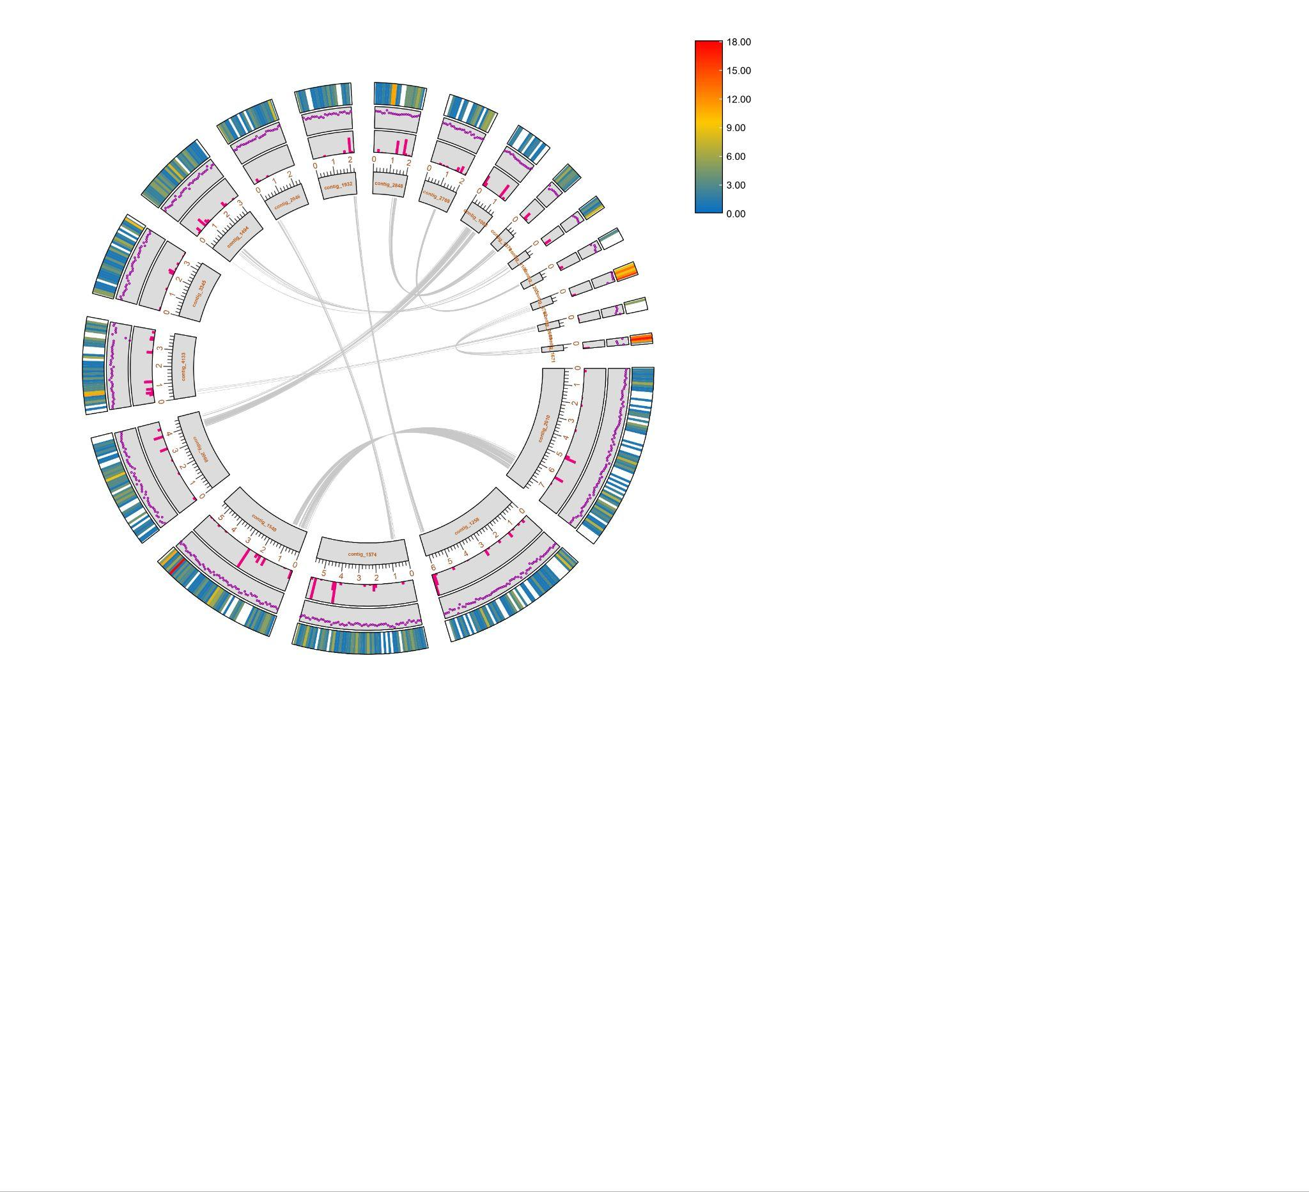
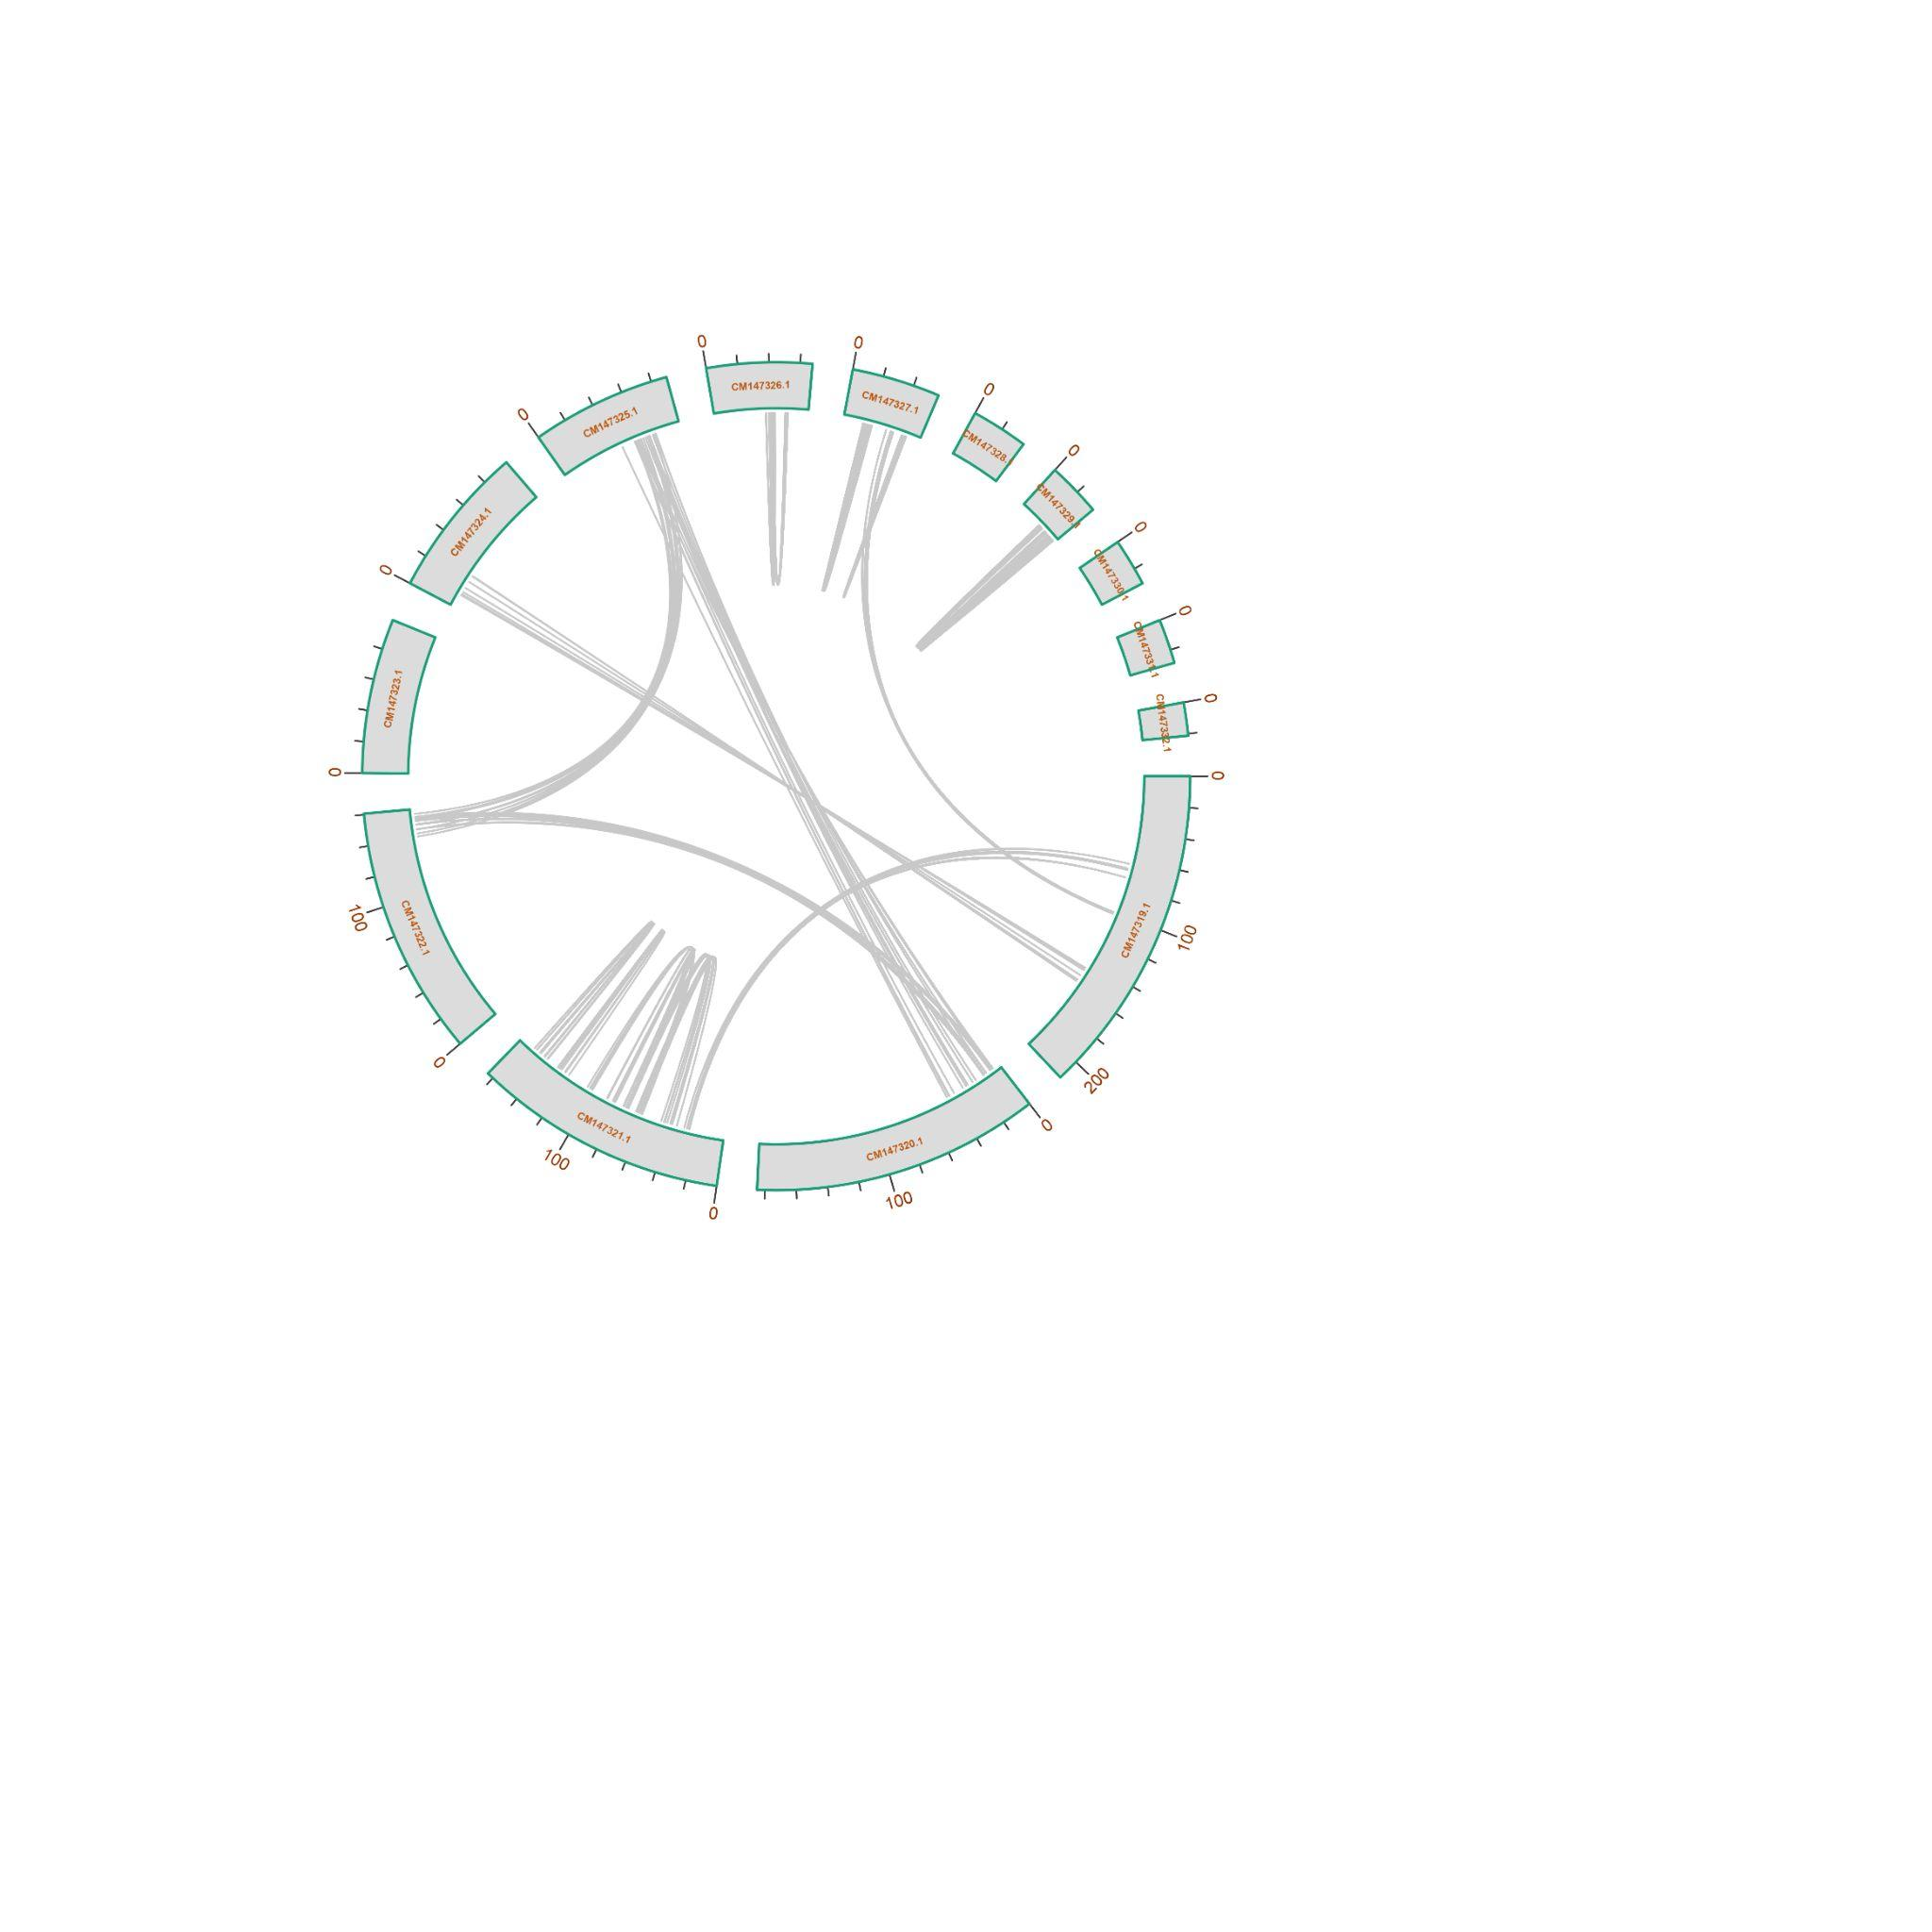

c d

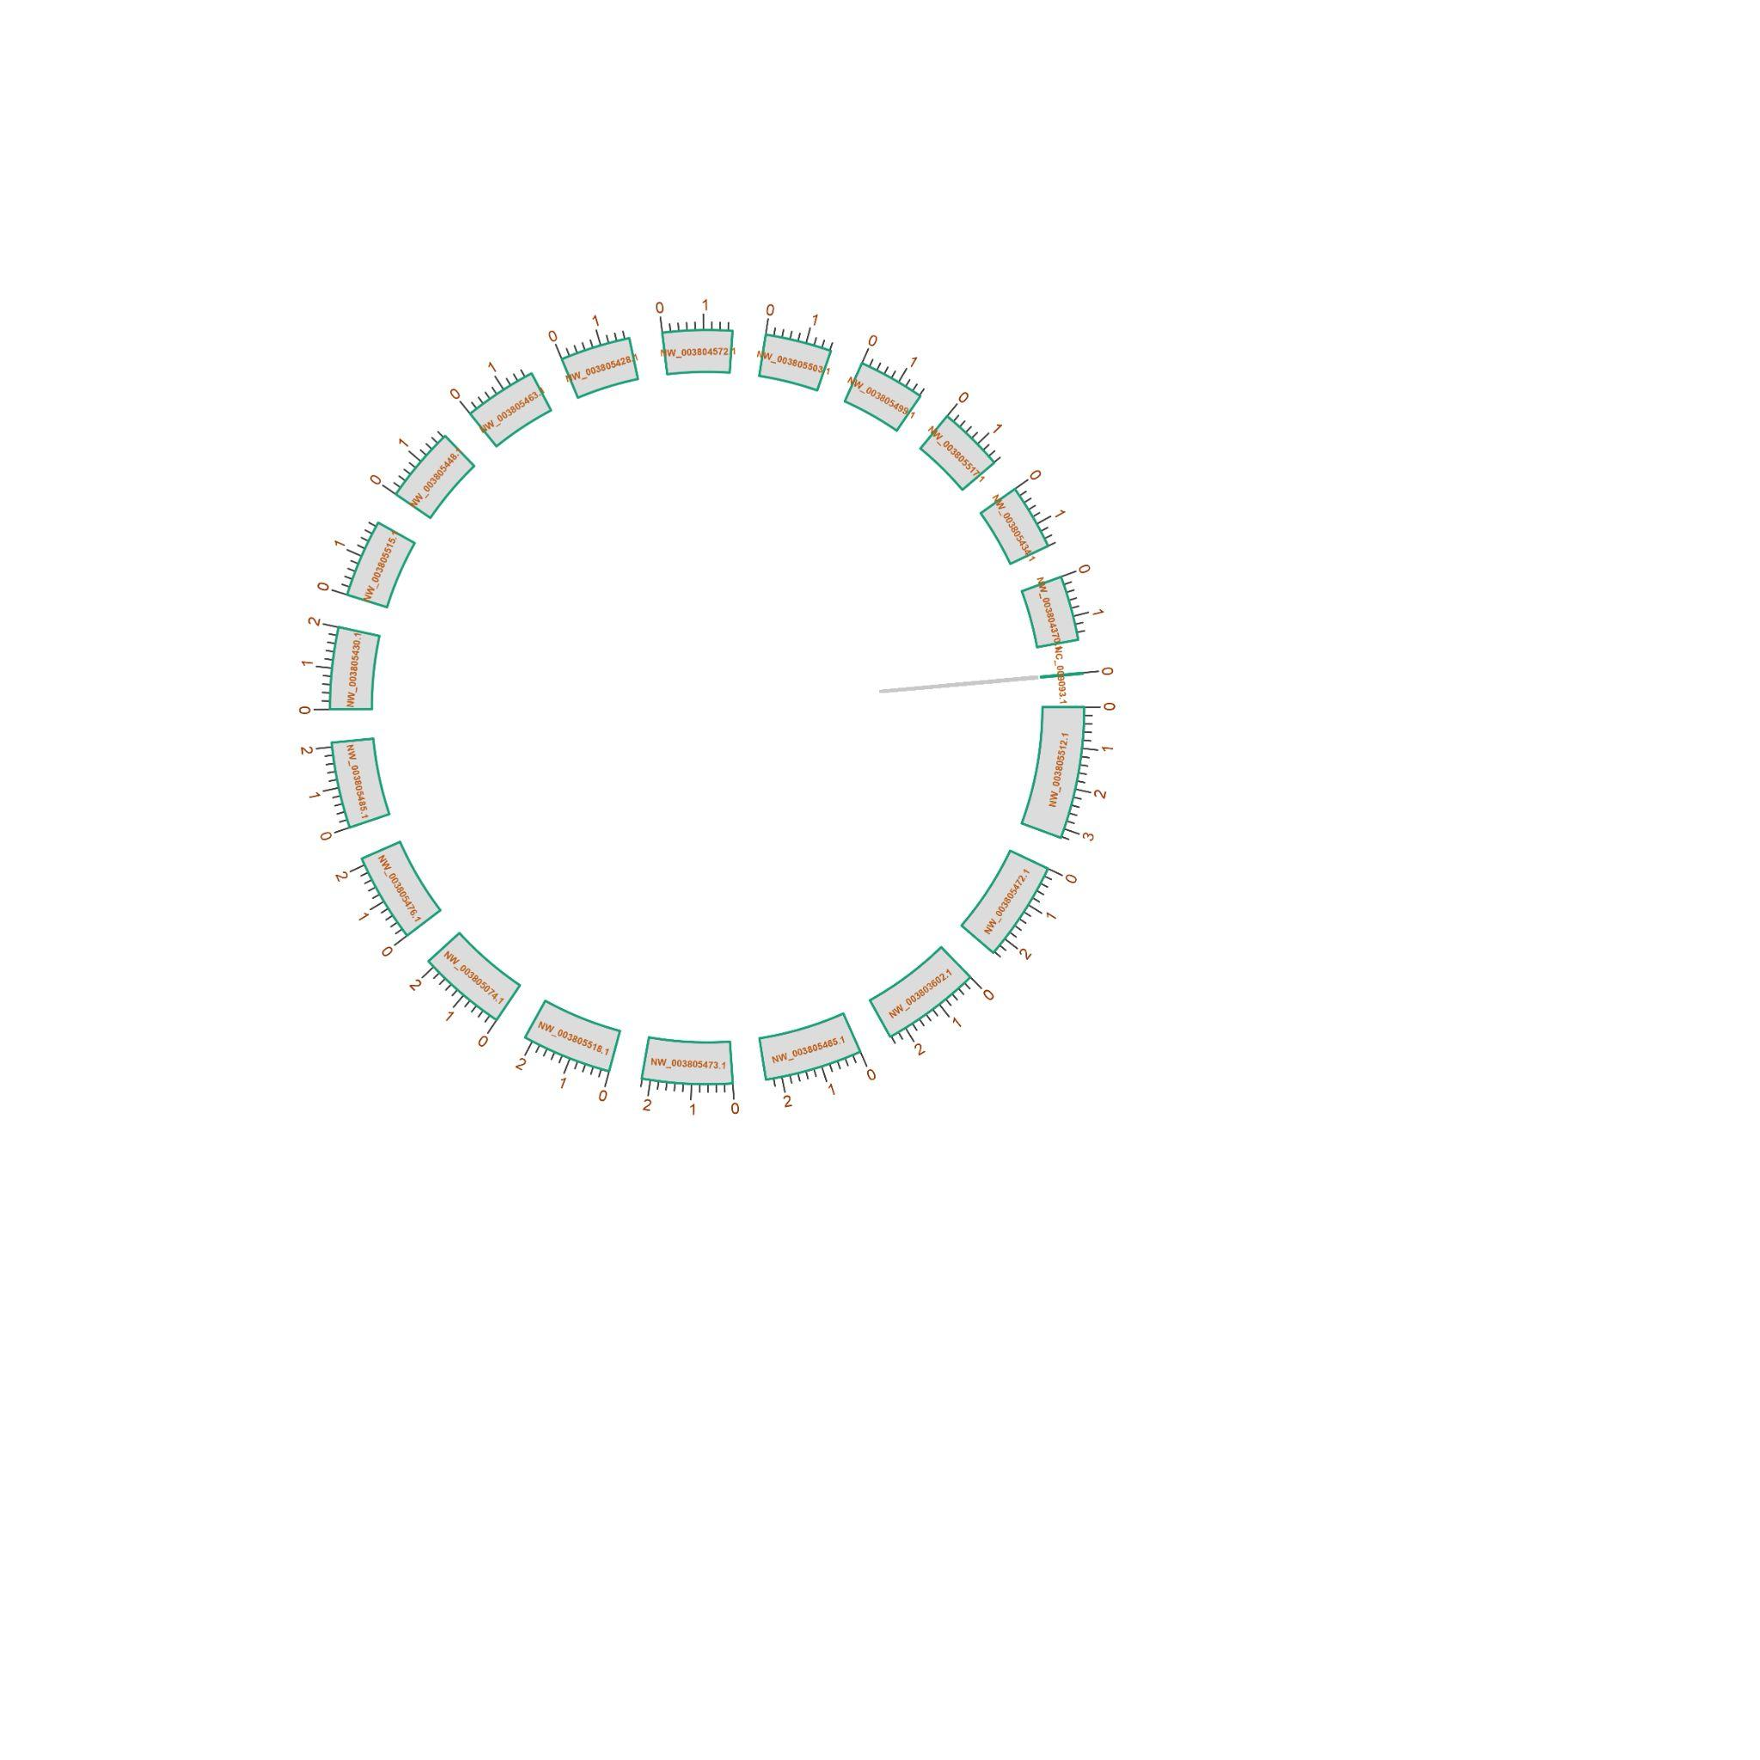
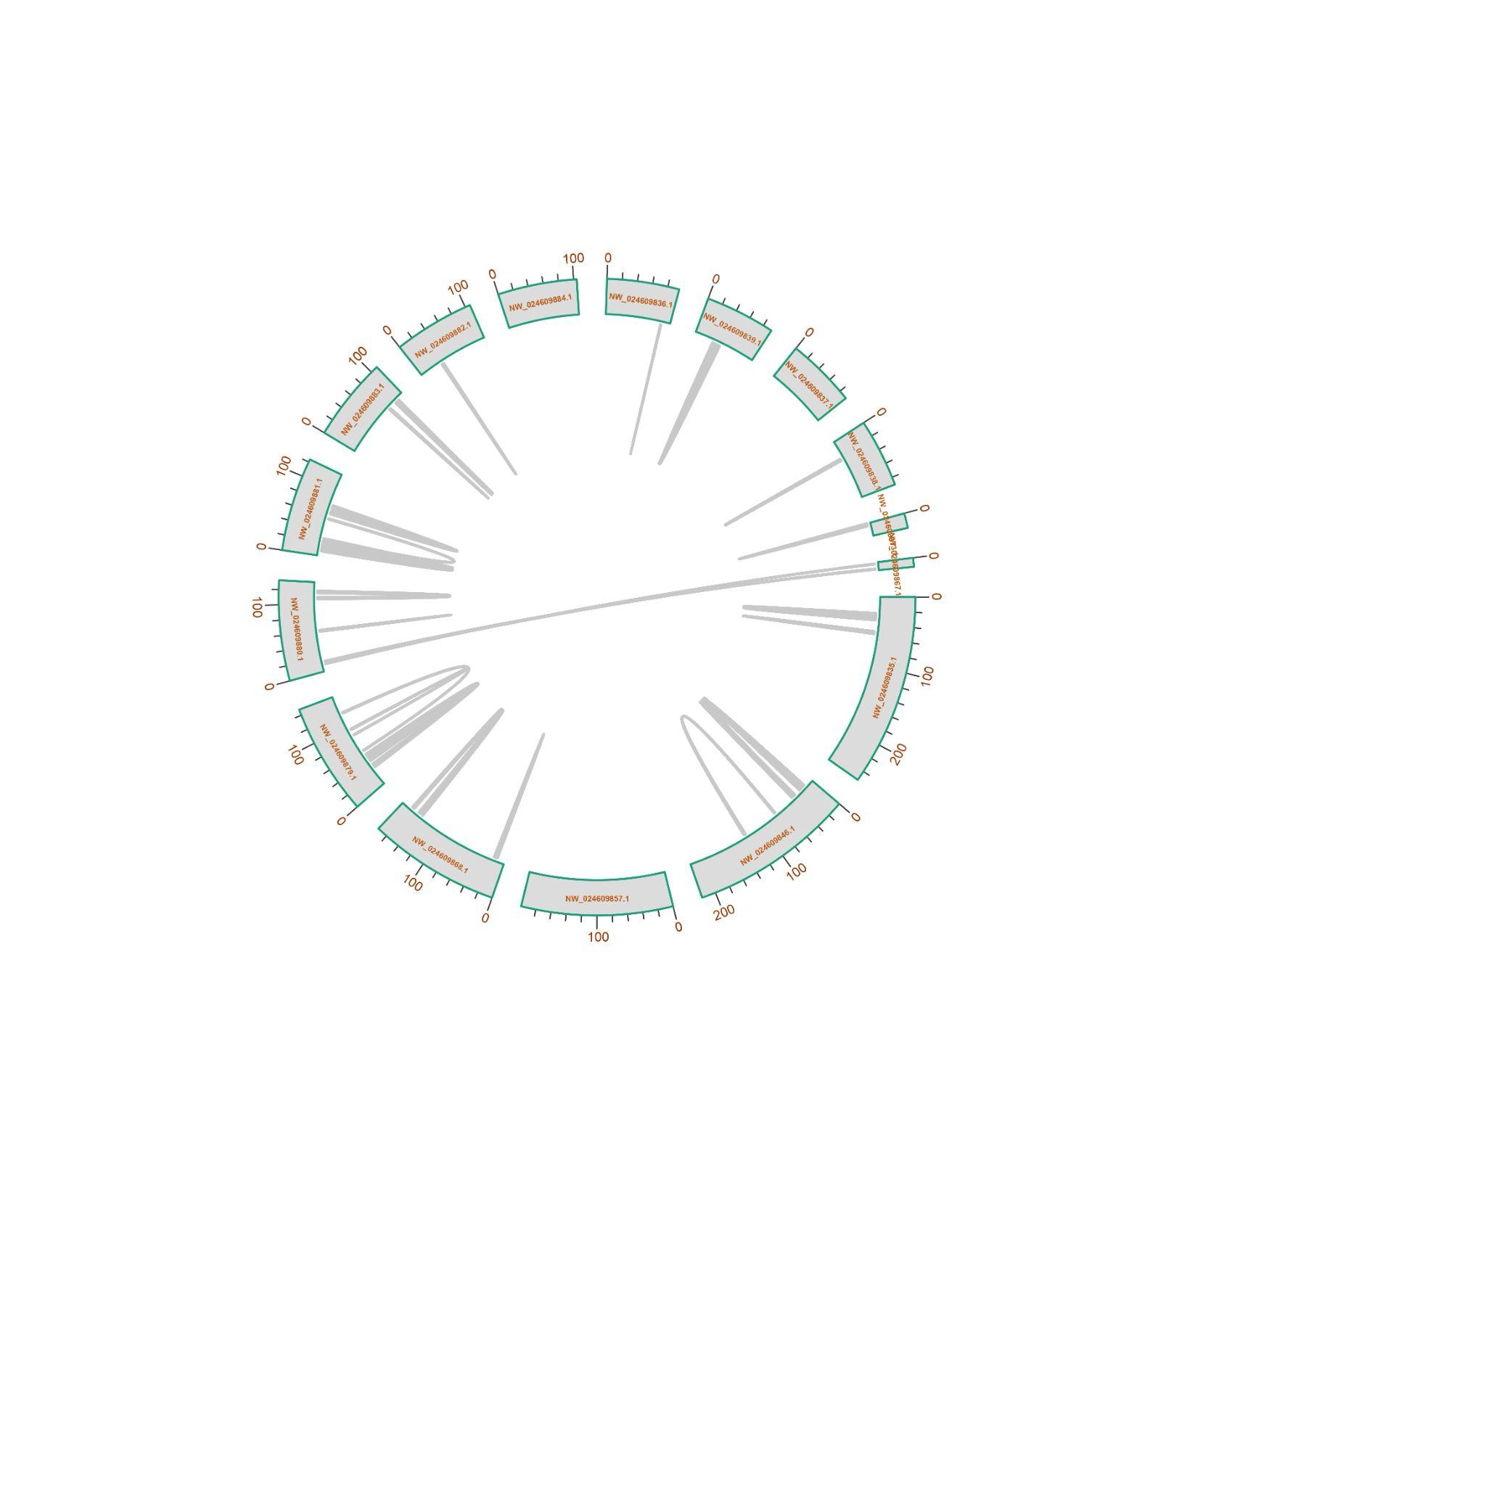

e f

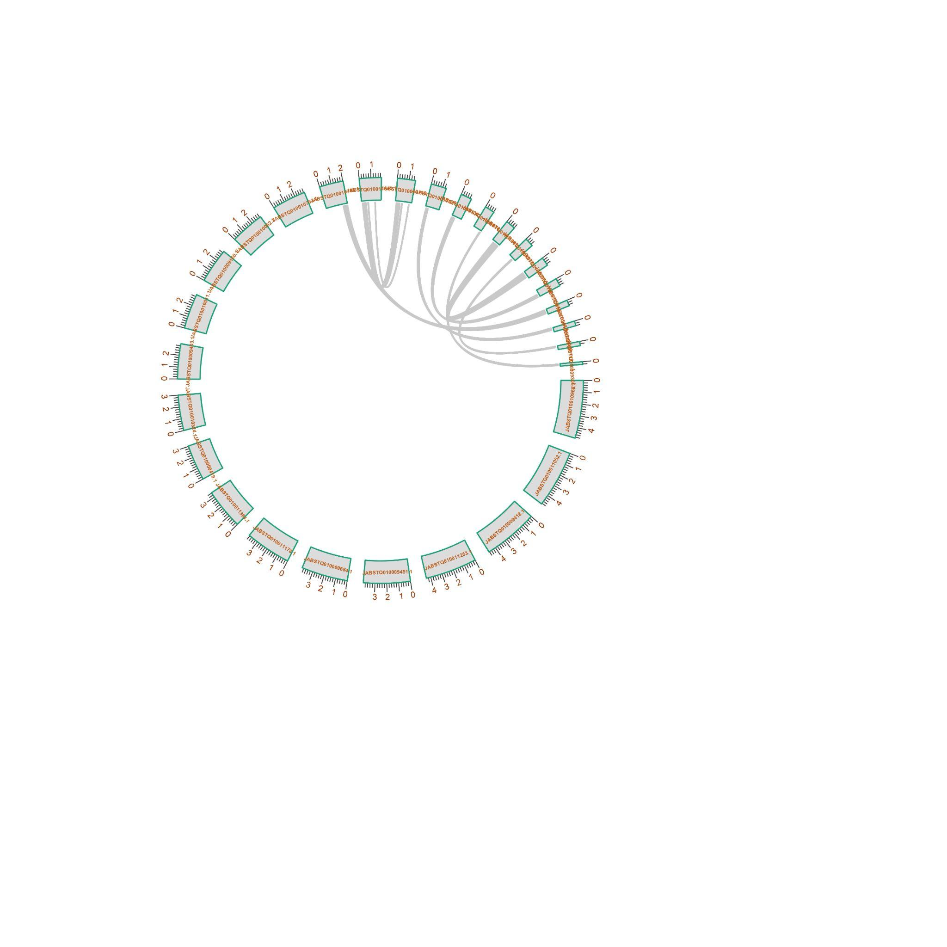
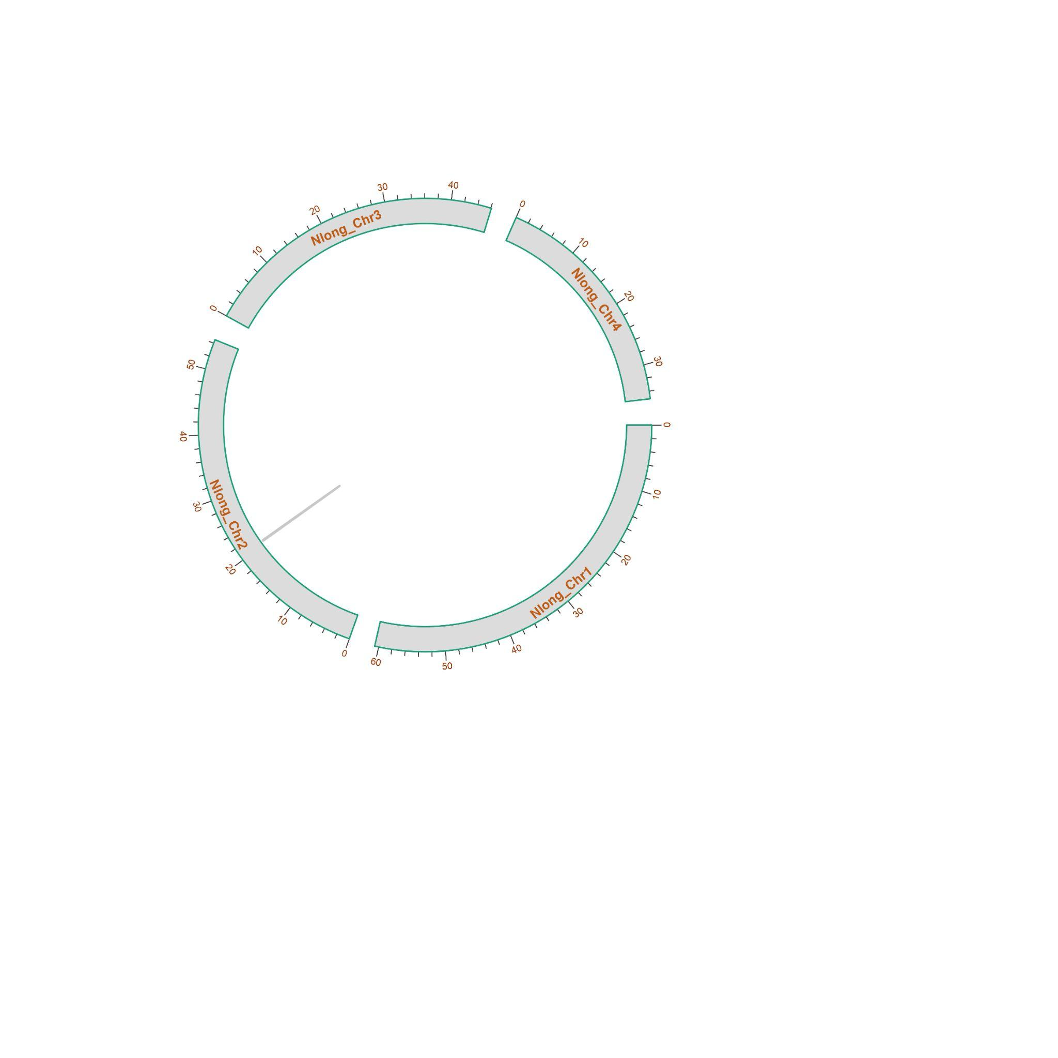
g h
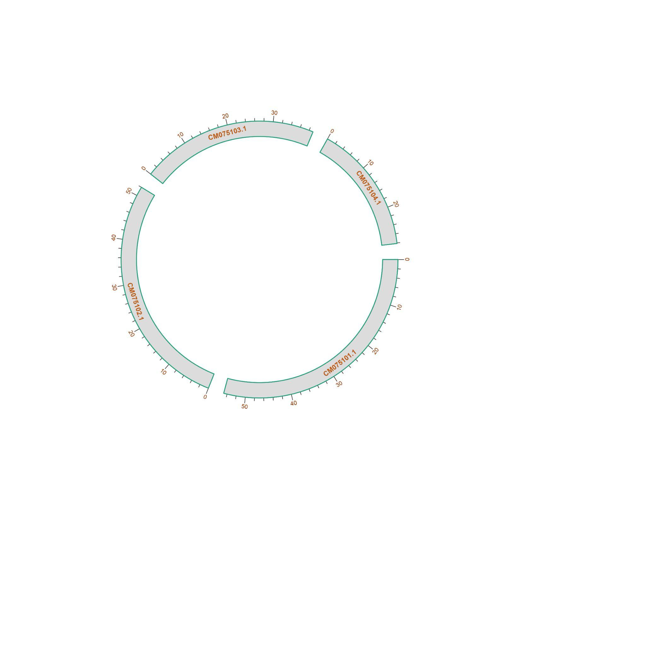
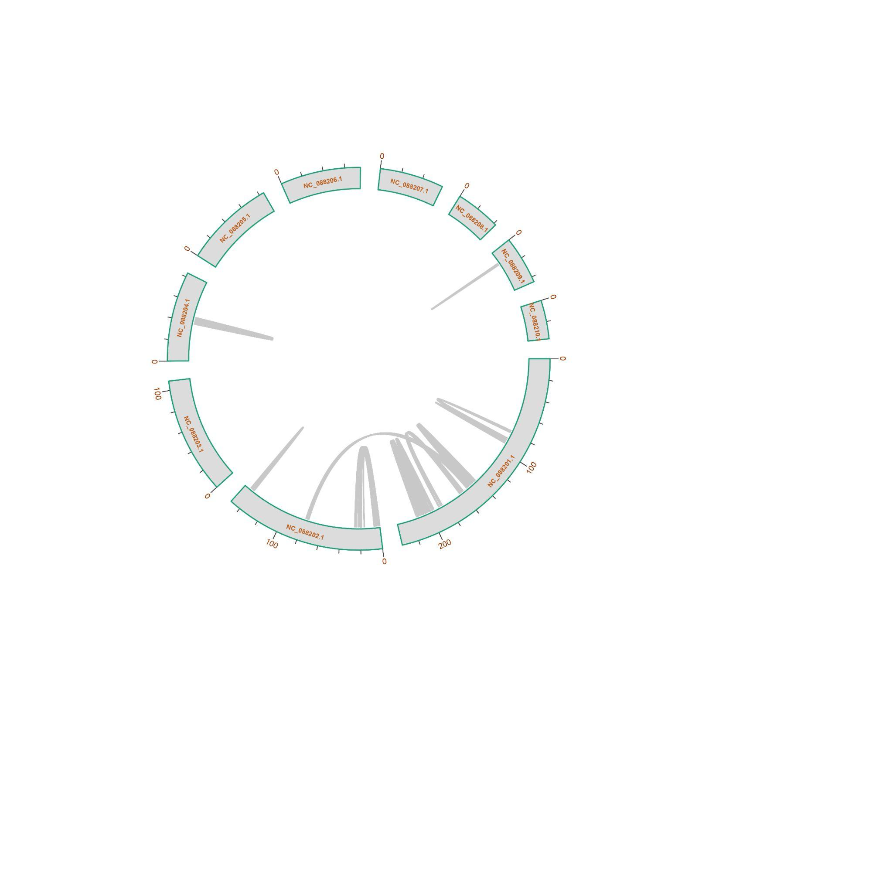

i j
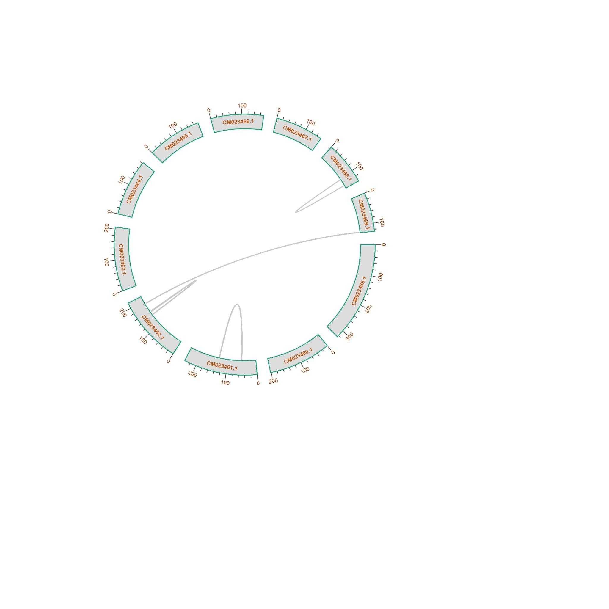
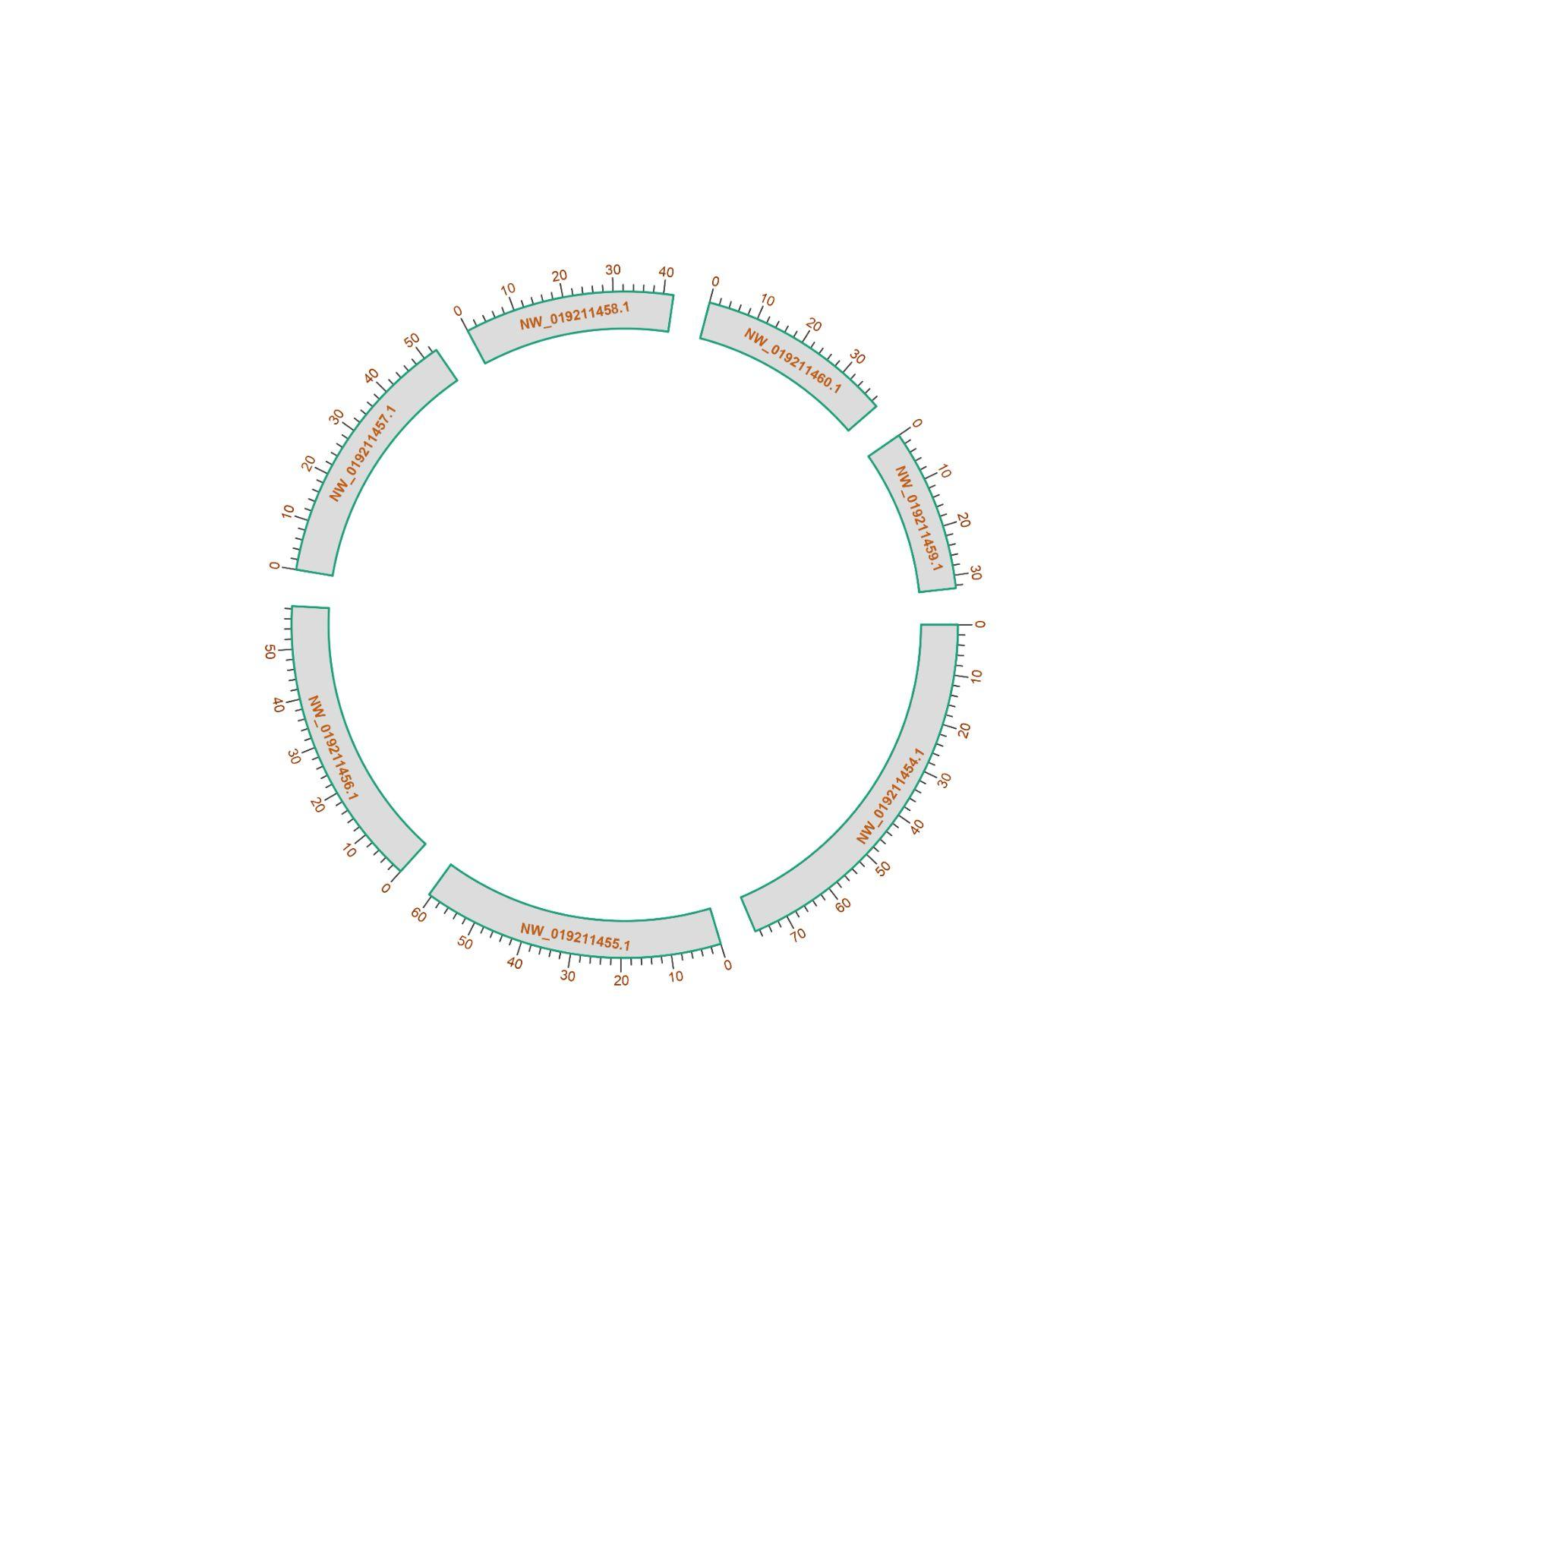

Figure 1.3- Self synteny plots showing genomic architecture of individual acarine taxa a) Indiacarus sp., b) Argas vulgaris, c) Ixodes scapularis, d) Galendromus occidentalis, e) Neoseiulus longispinosus, f) Ixodes pacificus, g) Phytoseiulus persimilis, h) Ornithodoros turicata, i) Varroa destructor and j) Rhipicephalus microplus.

- Genomic resources
2.1 Genome assembly of Indiacarus sp.
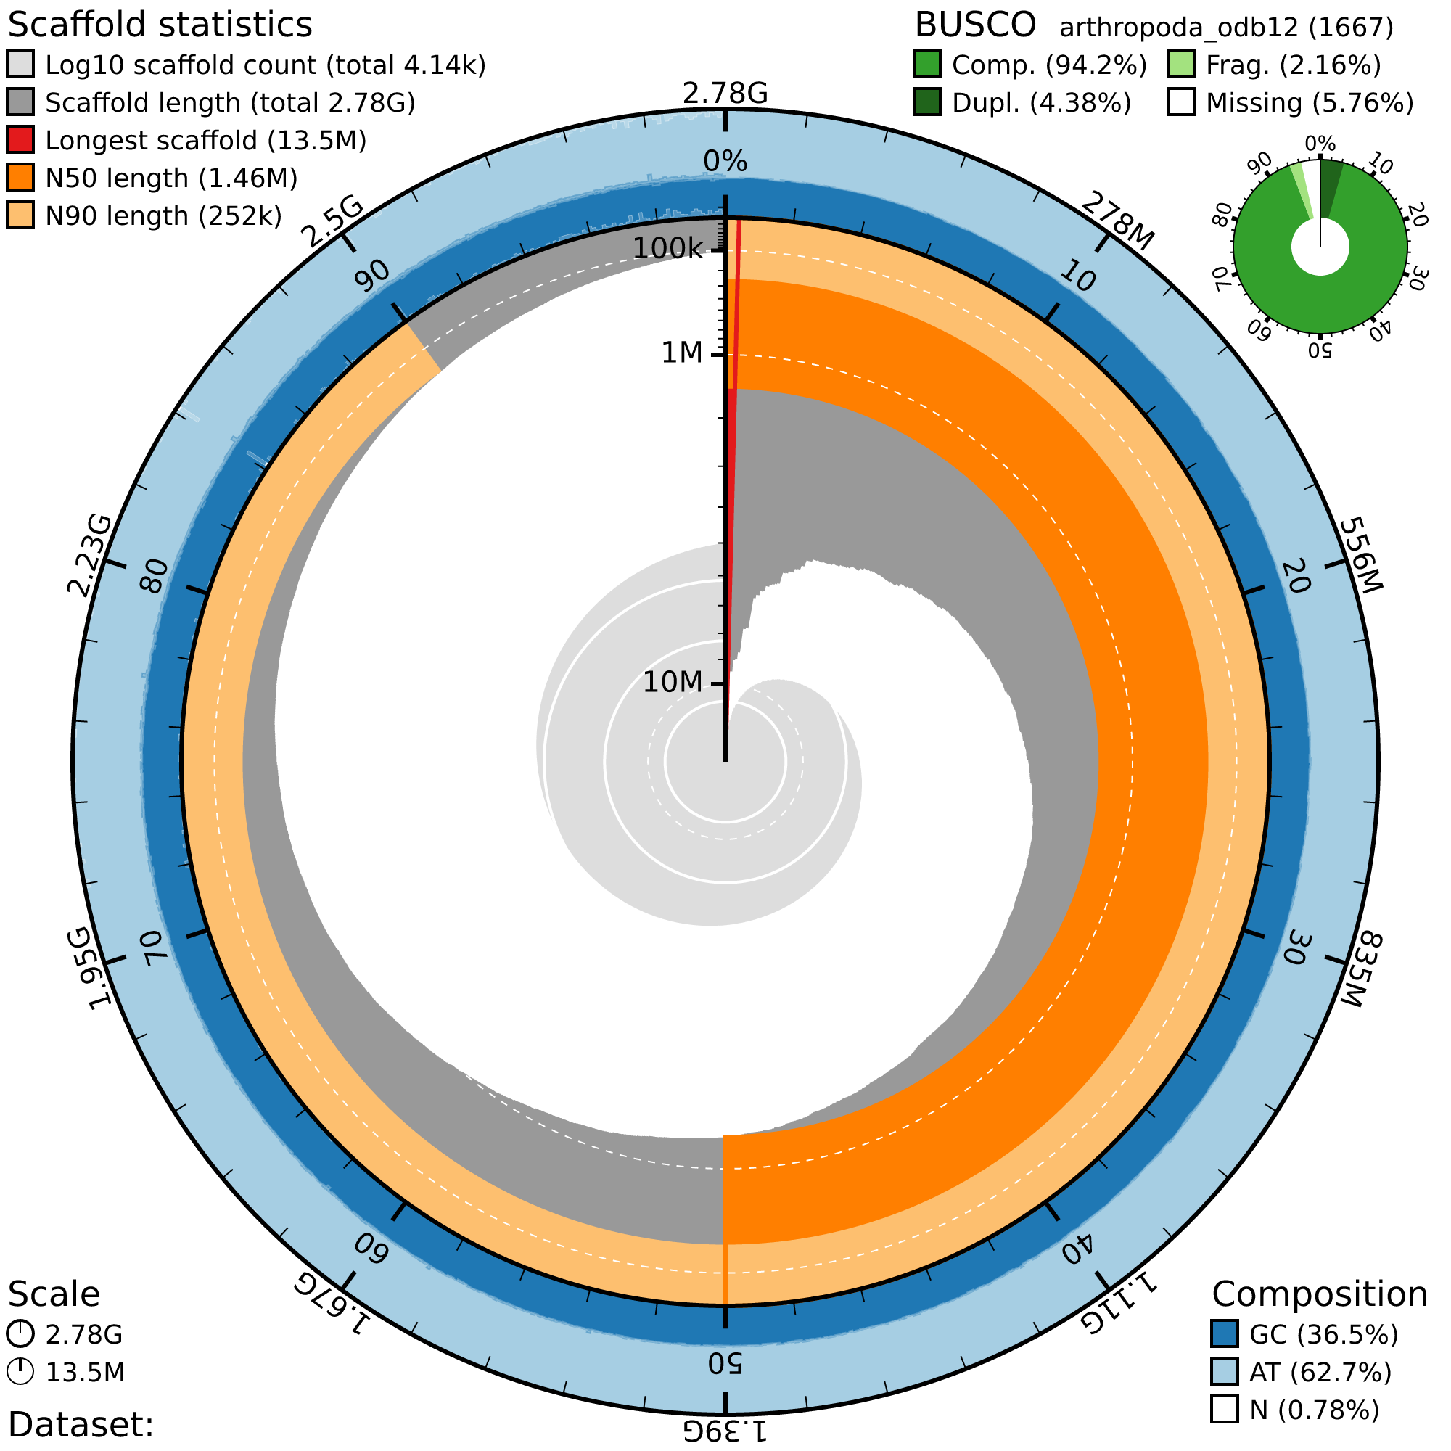

Figure 2.1- Snail plot showing the genome assembly (2.78 Gb) of Indiacarus sp. with 94.2% BUSCO completeness, 36.5% GC content and 1.46 Mb N50 length.

TABLES

2.1- Genome sizes of acarine taxa

Order | Family | Species Name | Genome size (Mbp) | GenBank Accession
Mesostigmata | Phytoseiidae | Galendromus occidentalis | 151.460383 | AFFJ01
Mesostigmata | Phytoseiidae | Neoseiulus longispinosus | 199.210599 | JBMPPP01
Mesostigmata | Phytoseiidae | Phytoseiulus persimilis | 181.015949 | JBKEIU01
Mesostigmata | Laelapidae | Varroa destructor | 368.813097 | BEIS01
Ixodida | Argasidae | Argas vulgaris | 1340.163888 | JAWPBW01
Ixodida | Argasidae | Ornithodoros turicata | 1071.364447 | JAZGRI01
Ixodida | Ixodidae | Ixodes scapularis | 2510.615084 | JADPSH02
Ixodida | Ixodidae | Ixodes persulcatus | 2444.74277 | JABSTQ01
Ixodida | Ixodidae | Rhipicephalus microplus | 3265.175345 | JBCGZX01
Opilioacarida | Opilioacaridae | Indiacarus sp. | 2782.328633 | This study

2.2- Repeats element proportions in Parasitiform genomes.

2.3- GC content of taxa used in this study.

Order | Family | Species Name | GC content
Mesostigmata | Phytoseiidae | Galendromus occidentalis | 51.58
Mesostigmata | Phytoseiidae | Neoseiulus longispinosus | 50.24
Mesostigmata | Laelapidae | Phytoseiulus persimilis | 51.55
Mesostigmata | Phytoseiidae | Varroa destructor | 40.92
Ixodida | Ixodidae | Argas vulgaris | 48.71
Ixodida | Ixodidae | Ornithodoros turicata | 45.82
Ixodida | Argasidae | Ixodes scapularis | 46.16
Ixodida | Argasidae | Ixodes persulcatus | 46
Ixodida | Ixodidae | Rhipicephalus microplus | 45.79
Opilioacarida | Opilioacaridae | Indiacarus sp. | 36.79

FILES

File 2.1- Parasitiformes linkage group designed using A.vulgaris, I.scapularis, N.longispinosus and V.destructor.

File 2.2- miRNA copy number of taxa used in this study.

File 2.3- Gene Density of taxa used in this study.

File 2.4- Intron length of taxa used in this study.

File 2.5- Gene compactness of taxa used in this study.

File 2.6- Exon lengths of taxa used in this study.

File 2.7- Repeat TE landscape of taxa used in this study.

