# INVESTIGATION – 001 - DNS Traffic Analysis

Analyst – Manas Kulkarni
Date – 28 / 08 / 2026
Tool – Wireshark
Capture – SBT-PCAP4.pcap
Objective – Analyse DNS Query & response Behaviour

Scenario -
- A workstation was observed generating DNS traffic. The Objective is to identify the DNS queries, response,& determine weather the behaviour appears normal.

Objective -
- what DNS server was contacted?
- which domains were queried?
- which record types were requested?
- were query successful?
- were any anomalous queries observed?
- how many DNS request total were sent?
- how many DNS response were Received?
- Number of failed response?
- Were there any NXDOMAIN responses?

Evidence -
P cap -
- SBT-PCAP4.p cap
Time -
- 817.814000 milliseconds
Total Packets Captured (DNS/MDNS)-
- 36 out of 7241

Methodology -
1. Reviewed capture summary.
2. Examined protocol hierarchy.
3. Filtered DNS traffic.
4. Identified client and DNS server.
5. Analysed DNS queries.
6. Analysed DNS responses.
7. Investigated unusual responses.
8. Documented findings.

Key Filters -

Filters | Purpose | Result
1 . “ ip.src == 192.168.43.53 ” | To find the source ip address from which the request is sent by client | All fields where source ip is 192.168.43.53 and request is sent
2 . “ip.dst == 192.168.43.1” | To find the destination ip address where the request is sent | All the fields where destination IP is 192.168.43.1 and the request is received
3. “dns.qry.type == 1” | Returns the requested record type A | Types of the record of the requested request ex: A,AAAA
4. “dns.flags.rcode == 3” | To know that if the record is NXDOMAIN or not | Resulted in 3 entries which have NXDOMAN
5. “dns.flags.response == 0 and ip.src == 192.168.43.53” | This checks that how many request have been sent by this specific IP over DNS/MDNS Protocol | Resulted in 18 entries which have sent request by this IP
6. “dns.flags.response == 1 and dns.flags.rcode != 0” | This checks how many failed request were there | This resulted in 3 failed request to display
7. “dns.flags.response ==0” | This check total no of request sent | This resulted in the 19 entries
8 . “dns.flags.response ==1” | This check total no. response were given | This resulted in 17 entries
9. “mdns” | This check mdns based records | This resulted in 2 entries

Key Findings – Successful Requests and Response

# | Frame | Client IP | DNS Server | Domain | Type | TxID | Returned Address
1 | 250 | 192.168.43.53 | 192.168.43.1 | signaler-pa.googleapis.com | A | 0x1523 | 172.217.25.138
2 | 435 | 192.168.43.53 | 192.168.43.1 | securityblue.team | A | 0x84b5 | 3.9.68.12
3 | 436 | 192.168.43.53 | 192.168.43.1 | ssl.gstatic.com | A | 0x40ae | 172.217.167.99
4 | 4437 | 192.168.43.53 | 192.168.43.1 | Mobile-gtalk.l.google.com | A | 0x4d10 | 74.125.200.188
5 | 857 | 192.168.43.53 | 192.168.43.1 | android.l.google.com | A | 0x86b3 | 172.217.167.78,  172.217.25.142,  172.217.25.46
6 | 2076 | 192.168.43.53 | 192.168.43.1 | update.googleapis.com | A | 0x7ebd | 216.58.203.99
7 | 2089 | 192.168.43.53 | 192.168.43.1 | firebaseperusertopics-pa.googleapis.com | A | 0x430a | 172.217.167.74
8 | 2090 | 192.168.43.53 | 192.168.43.1 | googlehosted.l.googleusercontent.com | A | 0xd8d0 | 172.217.25.129
9 | 2093 | 192.168.43.53 | 192.168.43.1 | fonts.googleapis.com | A | 0x1f3f | 172.217.167.74
10 | 2137 | 192.168.43.53 | 192.168.43.1 | safebrowsing.googleapis.com | A | 0x928d | 216.58.200.106
11 | 2497 | 192.168.43.53 | 192.168.43.1 | gstaticadssl.l.google.com | A | 0x2a5a | 172.217.167.67
12 | 2983 | 192.168.43.53 | 192.168.43.1 | www.gstatic.com | A | 0x9f75 | 172.217.167.67
13 | 2984 | 192.168.43.53 | 192.168.43.1 | clients.l.google.com | A | 0xe63c | 216.58.203.110
14 | 3303 | 192.168.43.53 | 192.168.43.1 | e4518.dscx.akamaiedge.net | A | 0x10fd | 104.83.206.150

NXDOMAIN Responses-

# | Frame | DNS Server | Client IP | Domain | Type | TxID | Returned Address
1 | 707 | 192.168.43.1 | 192.168.43.53 | a.root-servers.net | SOA | 0x9049 | No IP returned  (NXDOMAIN)
2 | 708 | 192.168.43.1 | 192.168.43.53 | a.root-servers.net | SOA | 0x2fe7 | No IP returned  (NXDOMAIN)
3 | 805 | 192.168.43.1 | 192.168.43.53 | a.root-servers.net | SOA | 0x32f8 | No IP returned  (NXDOMAIN)

MDNS related responses:-

No. | Frame No. | Source IP | Source Port | Destination IP | Destination Port | Queried to
1. | 3303 | 192.168.43.53 | 5353 | 224.0.0.251 | 5353 | _googlecast._tcp.local
2. | 3304 | fe80::1057::d0b8::d52a::7ea7 | 5353 | ff02::fb | 5353 | _googlecast._tcp.local

Screenshots -

1. All DNS packets displayed -
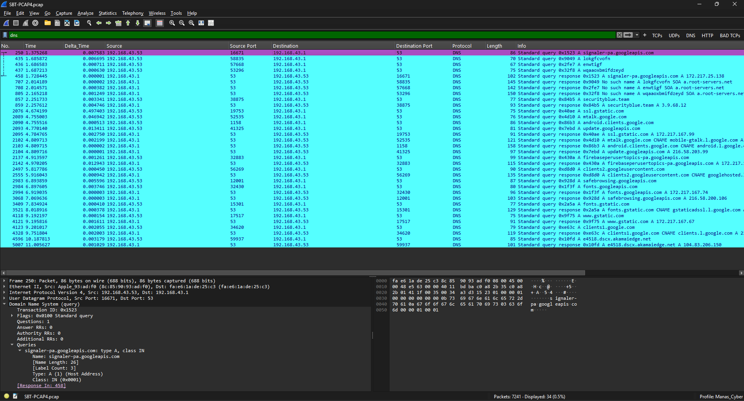

2. Requests Sent -

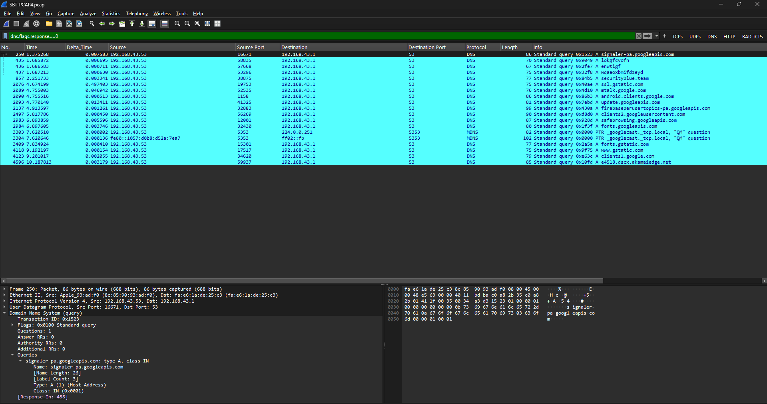
3. Responses Received -

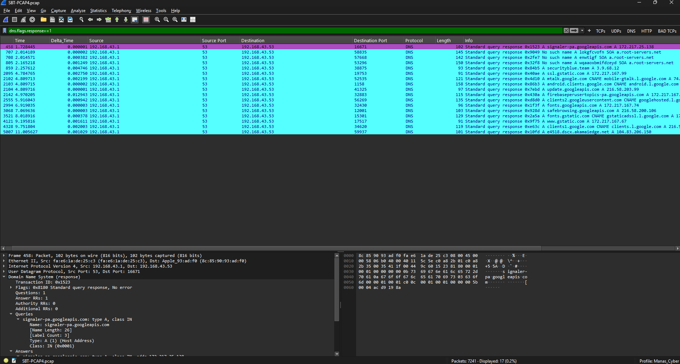

4. Failed responses -

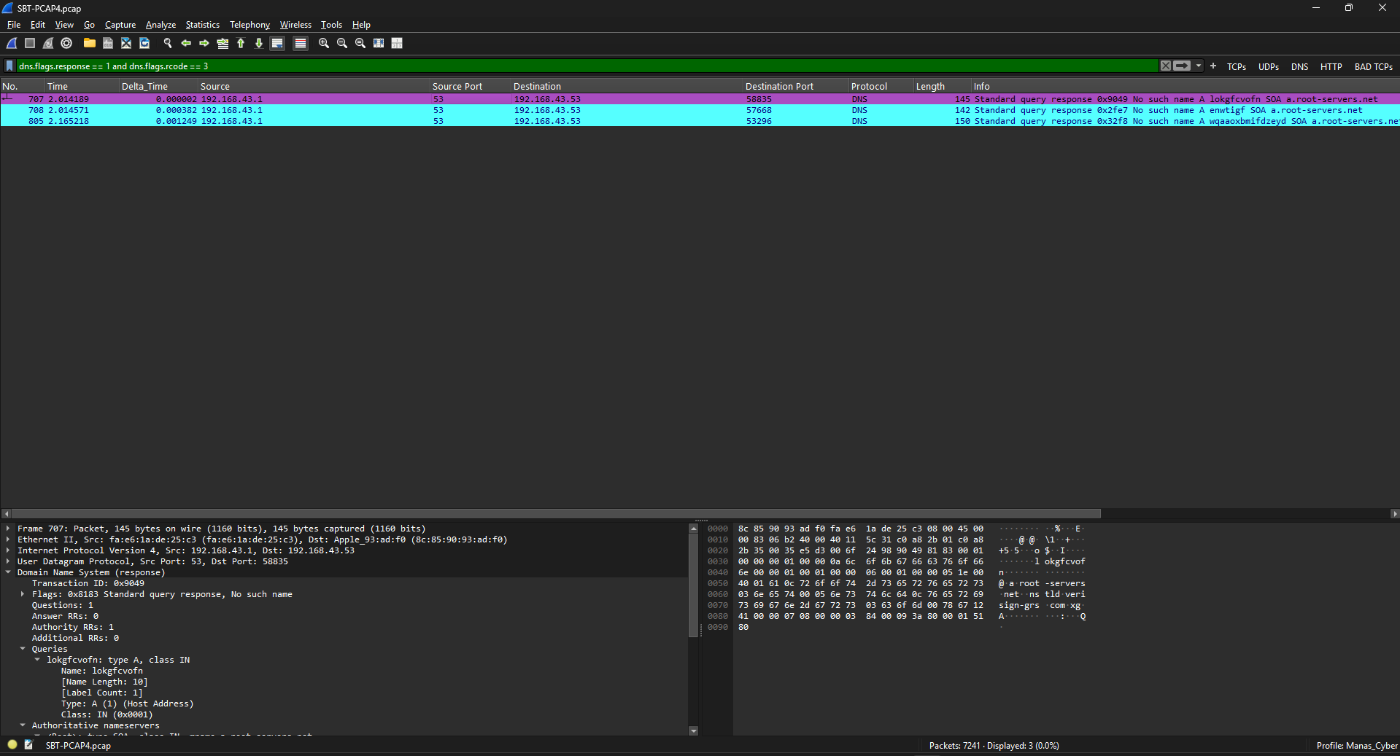

Analysis -
The captured traffic shows DNS communication between the client and the DNS server. The analysed packets primarily contain standard DNS queries, including A-record requests. Three NXDOMAIN responses were identified, indicating that the queried names were reported as non-existent. No clear indicators of DNS tunnelling, data exfiltration, or command-and-control (C2) activity were identified in the traffic examined. Threat-intelligence checks were performed on the queried domains; their results should be interpreted within the scope of the checks conducted. These findings are limited to the available capture and do not establish that the host is free of compromise.

Conclusion
Verdict: No clear suspicious DNS pattern was identified in the traffic examined; findings are limited to this capture and the checks documented.

Lesson Learned -
Learned
- DNS requests use UDP in this capture.
- NXDOMAIN means the queried domain did not resolve.
- Display filters do not modify the original capture.
- Meaning of the returned query type (A,AAAA,SOA,etc)
- Analysis of packet in detail

Improved
- DNS filtering
- Packet correlation
- Timeline construction

Still Need Practice
- DNS tunnelling
- Advanced Security analysis

References
- Wire shark User Guide
- Wire shark Display Filter Reference
- PCAP source
- ChatGPT

