# INVESTIGATION – 002 – ICMP Analysis

Analyst – Manas Kulkarni
Date – 30 / 08 / 2026
Tool – Wireshark
Capture – SBT-PCAP5.pcap
Objective – Analyse ICMP Query & response Behaviour

Scenario -
- A workstation was observed generating ICMP traffic. The Objective is to identify the ICMP queries, response,& determine weather the behaviour appears normal or malicious.

Objective -
- what was the Source IP?
- what was the Destination IP?
- How many Echo Request were there?
- How many Echo Response were there?
- Number of missing packets?
- were there any packet Loss?
- mode of traffic (Unidirectional / Bidirectional)

Evidence -
P cap -
- SBT-PCAP5.p cap
Time -
- 817.814000 milliseconds
Total Packets Captured -
- 14 ICMP Packets out of 205 Total packets

Methodology -
1. Reviewed capture summary.
2. Examined protocol hierarchy.
3. Filtered ICMP traffic.
4. Identified client and ICMP server.
5. Analysed ICMP Queries.
6. Analysed requests and responses.
7. Investigated unusual responses.
8. Documented findings.

Key Filter -

No. | Filter | Purpose | Result
1 | “ icmp “ | To identify the icmp through out the traffic | Resulted in the 14 icmp traffic packets
2 | “ icmp.type == 8 “ | To filter the echo requests from traffic | Resulted in the 7 packets of requests
3 | “ icmp.type == 0 “ | To filter out the echo response from the traffic | Resulted in the 7 packets of response
Key Findings -

Requests from ==>

No. | Source IP | Destination Ip | type
1 | 192.168.56.1 | 192.168.56.111 | 8 (request)

Response from ==>

No. | Source IP | Destination IP | Type
1 | 192.168.56.111 | 192.168.56.1 | 0 (response)

Questions -

1.How many Total ICMP capture – 14 capture
2.How many Echo Requests – 7 capture
3.TTL value for requests – 84
4.TTL value for response – 64
5.Is there any RTT Spike & at what time – RTT spike value – 0.520 ms At time – 6.539224 s
6.Maximum and Minimum and Mean RTT – 0.520(max), 0.224(min), mean (0.34443 ms)
7.Was there any ICMP packet from Malicious/Unexpected source – No
8.Was the traffic unidirectional or bidirectional – Bidirectional, echo requests travel from the first host to the second, and echo replies travel back.
9.Was there any packet loss or Missing packet – No unmatched echo requests were identified in the examined capture.

Screenshot -
1.ICMP Packet Capture -
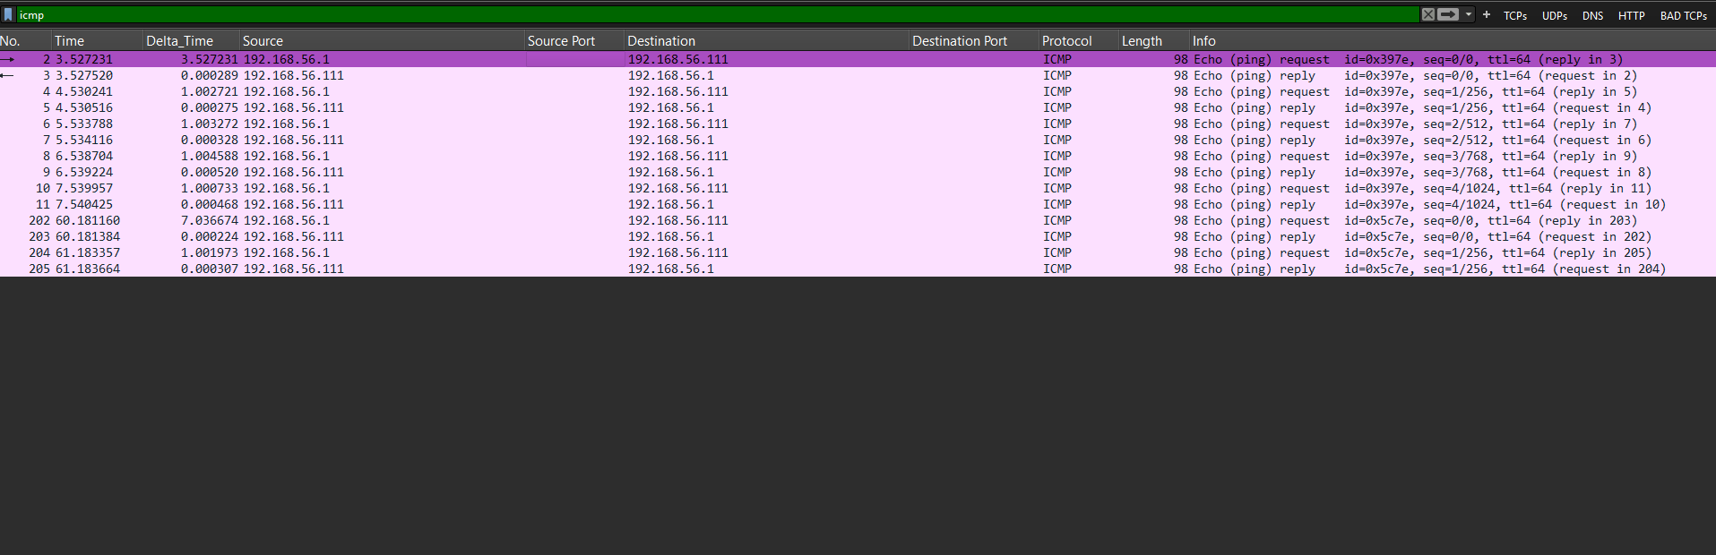

2.ICMP Requests

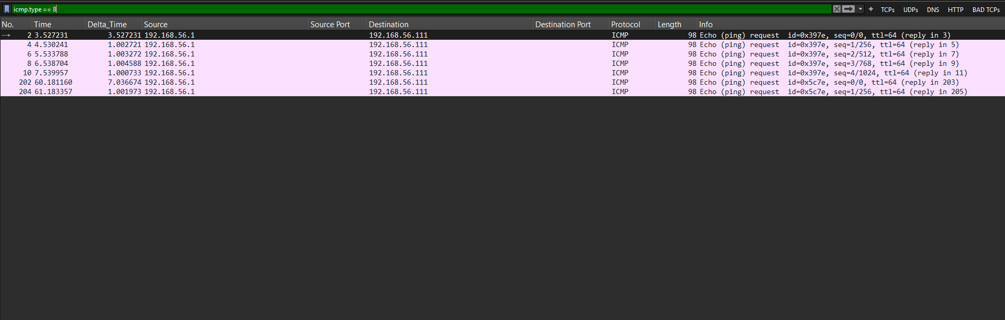

3.ICMP Response -

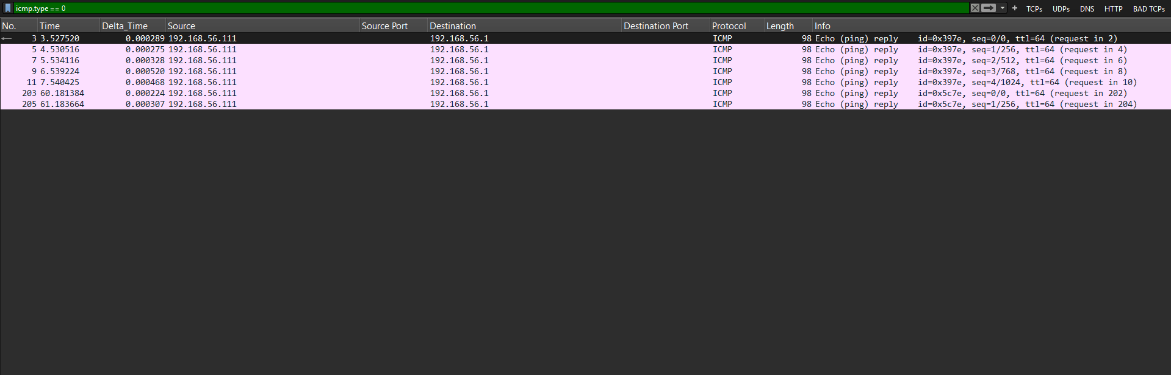

Analysis -
The capture contains 14 ICMP packets, consisting of seven echo requests and seven echo replies between 192.168.56.1 and 192.168.56.111. This indicates bidirectional ICMP communication. No obvious ICMP flooding pattern was identified in the examined packets. These observations are limited to the available capture and do not independently establish that the hosts are free of compromise.
Verdict -- No clear suspicious ICMP behaviour identified in the examined traffic.

References -
- Wireshark User Guide
- Wireshark Display Filter Reference
- PCAP source

Lesson Learned -
- ICMP sits on top of IP protocol as a companion
- ICMP is used to report network errors and support diagnostics, such as ping.
- Display filters do not modify the original capture.
- ICMP types and code values ( 03:Destination Unreachable,05:Redirection, etc.)

Improved -
- ICMP filtering
- Packet correlation
- Timeline construction

Still Need Practice -
- ICMP Security concepts
- ICMP tunneling
- Advanced Network analysis

