## INVESTIGATION – 003 – TCP HANDSHAKE ANALYSIS

Analyst – Manas Kulkarni
Date – 31 / 08 / 2026
Tool – Wireshark
Capture – SBT-PCAP5.pcap
Threat Intelligence – Virus-total
Objective – Analysis for TCP Handshake Communication

Scenario -
- A workstation was observed generating TCP traffic . The Objective is to identify the TCP queries, communication, & determine weather the behaviour appears normal.

Objective -
- Who initiated the Communication?
- What is the source and destination IP?
- what is the source and destination port No?
- what was the initial SYN?
- Was the SYN/ACK received?
- was the Connection established?
- was there any retransmission or RST flag?
- How long did each 3-way handshake take (time from SYN to ACK)?
- how many total 3 way handshake were there?

Evidence -
P cap -
- SBT-PCAP5.p cap
Time -
- 807.000 milliseconds
Total TCP Packets Captured -
- 190 out of 205 Total Packets

Methodology -
1. Reviewed capture summary.
2. Examined protocol hierarchy.
3. Filtered TCP traffic.
4. Identified TCP (3 way Handshake) traffic.
5. Analysed TCP initial communication.
6. Investigated unusual responses.
7. Documented findings.

Key Filters -

No. | Filters | Purpose | Result
1. | “ tcp ” | Filters out every TCP protocol related packets from traffic. | Resulted in the 190 packets out of 205 packets from traffic.
2. | “tcp.flags.syn == 1 && tcp.flags.ack == 0” | Filters out the packets where the initial SYN packet is there for initiating the handshake. | Resulted in the 3 packets which suggests the 3 possible handshakes.
3. | “ tcp.flags.fin== 1 ” | This filters out the packets where the connection is terminated. | Resulted in the 6 packets where the connection in terminated from both client and server.
4. | “tcp.analysis.retransmission” | This check that it the data were retransmitted. | Resulted in zero(0) packets which were retransmitted.
5 | “http” | This filters out the packets which have used the http protocol. | Resulted in the 2 packets one request and other responses.

Initial SYN -

No. | Timeline | Source IP | Source Port | Destination IP | Destination Port | Seq. No. | TCP Flags | Window size
1. | 12.5089 | 192.168.56.1 | 50156 | 192.168.43.111 | 8000 | 0 | (SYN,ECE,CWR) | 65535

Key findings -

Handshakes -

No. | Timeline  (start – end) | Source IP | Source Port | Destination IP | Destination Port | Initiated termination | IRTT  (Initial RTT)
1. | 12.5089 – 12.5207 ms | 192.168.43.1 | 50156 | 192.168.43.111 | 8000 | 192.168.56.111 | 295.000 ms
2. | 23.5775 – 41.0273 ms | 192.168.56.1 | 50157 | 192.168.43.111 | 22 (ssh) | 192.168.56.1 | 304.000 ms
3. | 53.1436 – 53.1444 ms | 192.168.43.1 | 50159 | 192.168.43.111 | 3016 | 192.168.43.111 | 208.000 ms

Questions -

1. How many TCP connections (3-way handshakes) were initiated during the capture?
== > There were 3 handshake initiated.

2. How many connections closed normally (FIN/ACK sequence) vs. abnormally (RST)?
== > Every connection is closed possibly and connection closed abnormally are 0.

3. Was there any port scanning activity (many SYNs to different ports from one source)?

== > No, there no obvious port scanning activity found.

4. Total number of TCP packets in the capture?
== > 190 out 205

5. Were there any spoofed source IPs (connections that don't match expected topology)?
== > No, Both the IP 192.168.43.1 and 192.168.43.111 both checked by Threat Intelligence and a not spoofed or compromised.

Screenshot -
1.TCP packets -
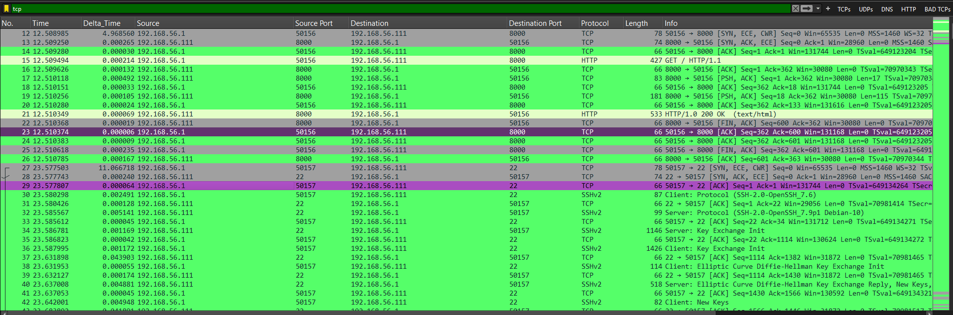

2.SYN Flag -

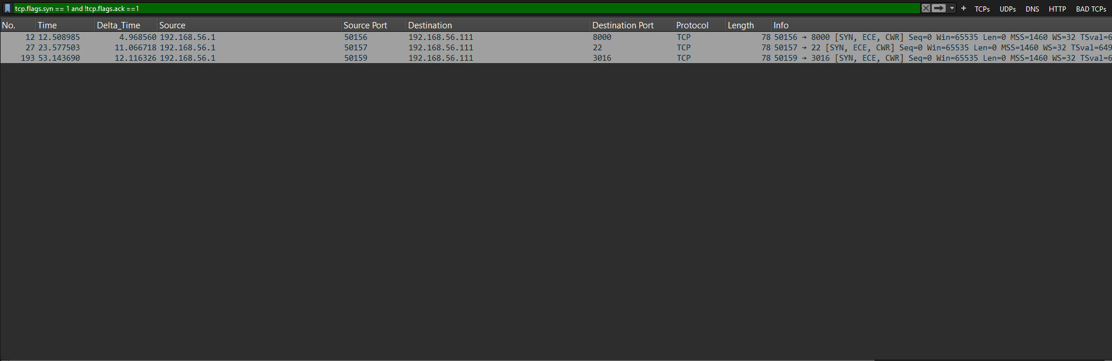

3. FIN Flag -

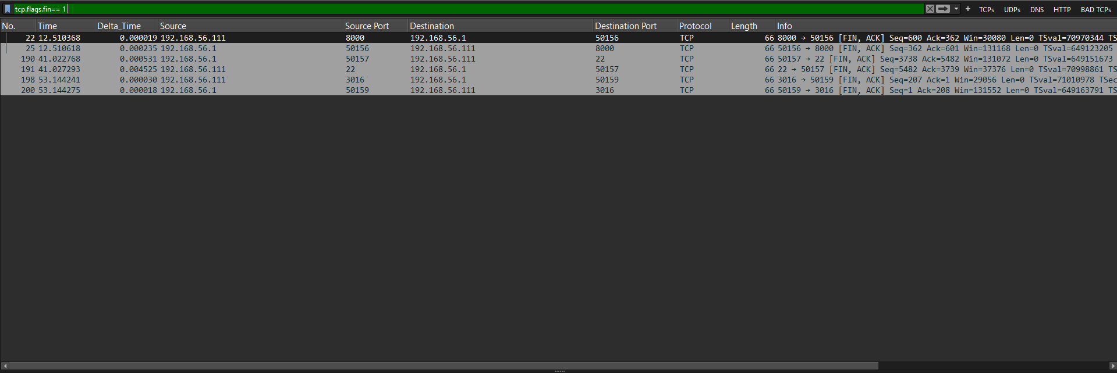

Analysis -
The capture contains TCP communication between the identified endpoints. No retransmissions were identified using the applied display filter. No obvious port-scanning pattern was identified in the examined traffic. However, the handshake sequences and FIN/RST connection outcomes require verification. The available evidence does not establish whether the endpoints were compromised or whether IP spoofing occurred.

Conclusion
Verdict: Inconclusive pending verification.
No clear TCP anomaly has been established from the findings currently documented. Further verification of the handshake sequences and connection termination behaviour is required before making a confident overall assessment.

Lesson Learned -
Learned
- SSH (port 22) packets analysis
- How the 3-way handshake works
- Display filters do not modify the original capture.
- Meaning of the TCP Flags (SYN,ACK,FIN,ECE,CWR, etc)
- Analysis of packet in detail

Improved
- TCP filtering and analysis
- Packet correlation
- Timeline construction

Still Need Practice
- TCP tunnelling
- Advanced Security analysis

References
- Wire shark User Guide
- Wire shark Display Filter Reference
- PCAP source
- ChatGPT

