# INVESTIGATION – 004 - UDP Traffic Analysis

Analyst – Manas Kulkarni
Date – 2 / 09 / 2026
Tool – Wireshark
Capture – SBT-PCAP4.p cap
Objective – Analyse UDP Traffic Behaviour

Scenario -
- A workstation was generating UDP traffic. The Objective is to identify the UDP queries, response,& determine weather the behaviour appears normal.

Objective -
- what is the source and destination IP?
- Total No. Of captured packets?
- Time since the first captures?
- which are the protocols present ?
- how many packets are captured for identified protocols?
- were any anomalous queries observed ?
- IP Communicated the most?

Evidence -
P cap -
- SBT-PCAP4.p cap
Time -
- 14.9065 seconds
Packets Captured -
- 3290 UDP Packets out of 7241 Total Packets

Methodology -
1. Reviewed capture summary.
2. Examined protocol hierarchy.
3. Filer UDP traffic.
4. Analysed UDP traffic.
5. Investigated unusual responses.
6. Documented findings.

Key filters -

No. | Filters | Purpose | Result
1. | “udp” | This filter displays the UDP protocol packets through out the traffic. | This resulted in the 3290 packets out of 7241 from traffic.
2. | “udp.port == 53” | This filters out the packets which have port no 53 which is DNS from traffic | This resulted in 34 packets of the DNS .
3. | “udp.port == 443” | This filters out the every packets which have the 443 port which is of HTTPS | Resulted in the 3253 packets in total.

Key findings -

Most Communicated -

No. | Source IP | Source Port | Destination IP | Destination Port | Packets Transfer | Bytes | Packets A – B | Packets B – A | Rel start
1. | 192.168.43.53 | 65329 | 172.217.25.29 | 443 | 3156 | 4MB | 505 | 2651 | 5.916517

Questions -
1.were there any packets with data length = 0?
== > No zero-length UDP payloads were identified in the examined traffic.
2. what is the average the length of the packets?
== > The reported average packet length was 1,350 bytes.
3. which protocol are present?
==> DNS(53) and HTTPS(443)
4. how many packets are there of identified protocols?
==> DNS – 34, HTTPS – 3253
5. were there any suspicious packets or any IP?
==> No clearly suspicious packets or IP addresses were identified during the UDP traffic review. This finding is limited to the traffic examined and does not establish that all activity was benign.

Screenshot -

1.UDP filtering

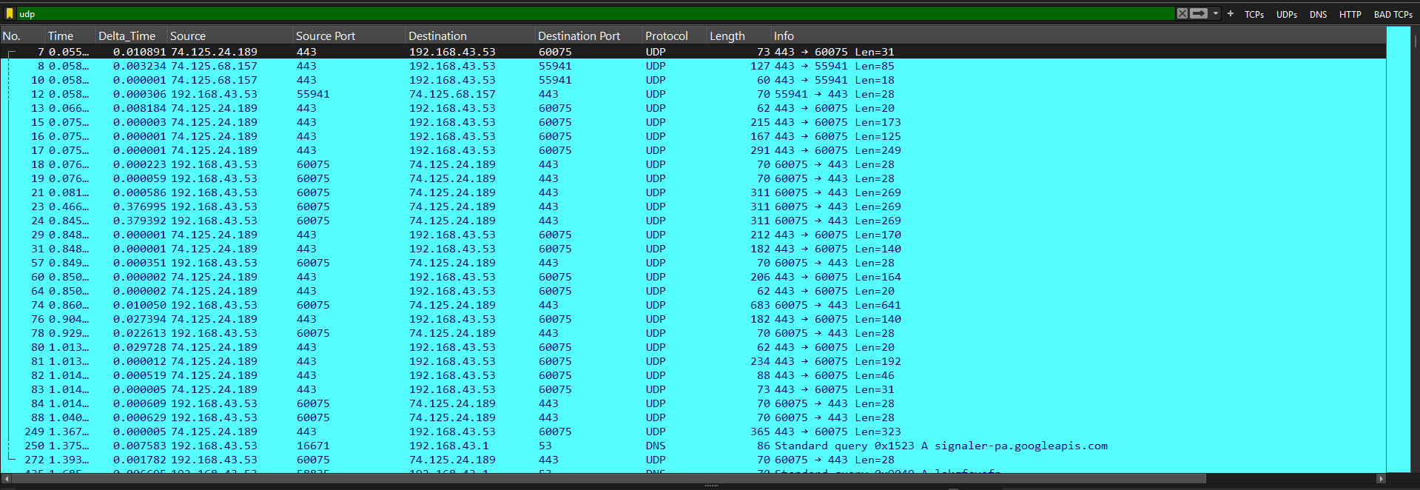

2.filtering out the port (53) DNS

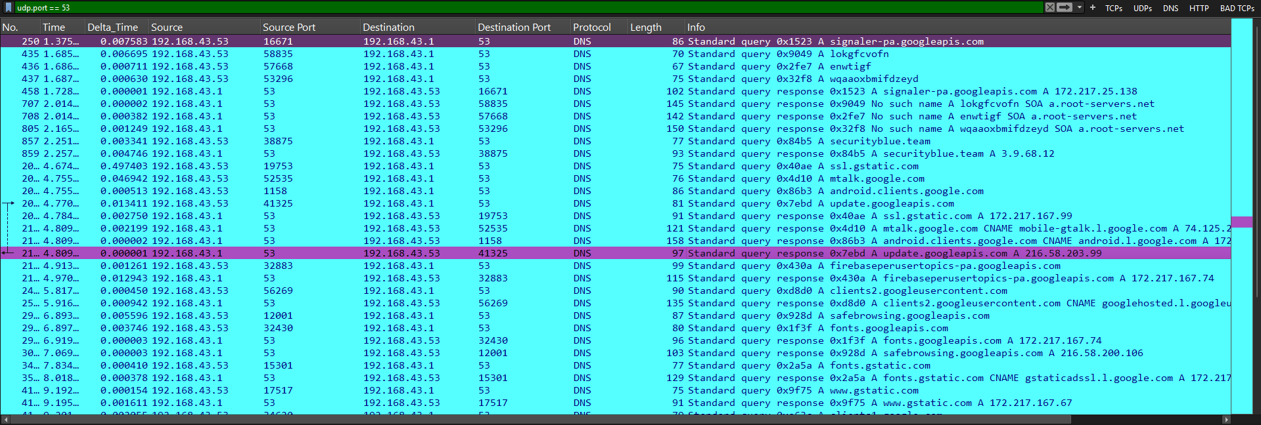

3.filtering out the port 443(HTTPS)

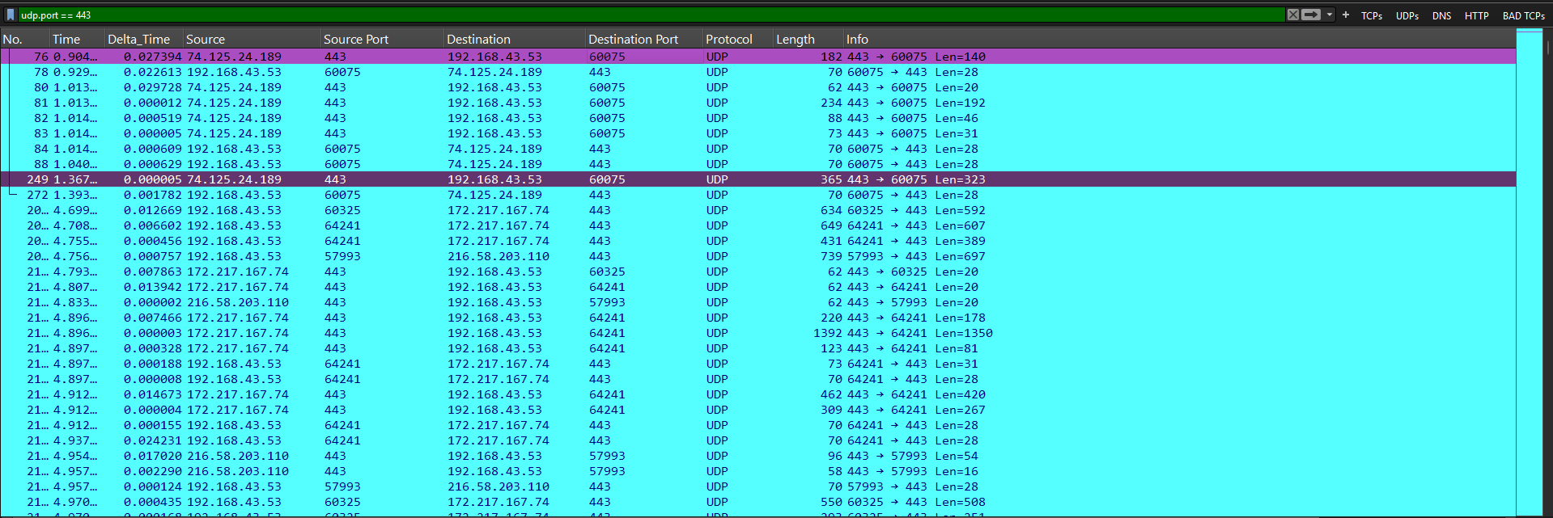

Analysis -

Capture has 3,290 packets of UDP in 7,241 packets. UDP ports 53 and 443 have been seen to have some traffic. The ports used and number of packets give an insight about the communication; however, on their own, they cannot indicate that all the traffic was good.
Suspicious activity was not detected from the results.

Conclusion -

Verdict – BENIGN / No obvious anomaly detected.

Lesson Learned -
Learned
- UDP doesn’t use Handshake during communication.
- UDP is fast compare to TCP .
- Display filters do not modify the original capture.
- Analysis of packet in detail

Improved
- UDP filtering
- Packet correlation
- Timeline construction

Still Need Practice
- UDP tunnelling
- Advanced Security analysis

References
- Wireshark User Guide
- Wireshark Display Filter Reference
- PCAP Online source
- ChatGPT

