# INVESTIGATION – 005 - DHCP Traffic Analysis

Analyst – Manas Kulkarni
Date – 2 / 09 / 2026
Tool – Wireshark
Capture – 2023-MTA-workshop-introduction.pcap
Objective – Analyse DHCP (D-O-R-A) Behaviour

Scenario -
- A workstation was generating DHCP traffic. The Objective is to identify the DHCP queries, response,& determine weather the behaviour appears normal or not.

Objective -
- who sent the discover flag?
- Who responded the discover query ?
- Which IP was Offered?
- What DHCP Server responded?
- what subnet info was provided?
- what is client MAC Address?
- were DORA query successful ?
- were any anomalous queries observed ?
- how many request total were sent ?

Evidence -
P cap -
- 2023-MTA-workshop-introduction.pcap
Time -
- 17858.032 seconds
Total Packets Captured -
- 6 DHCP Packets out of 51008 Total packets

Methodology -
1. Reviewed capture summary.
2. Examined protocol hierarchy.
3. Filtered DHCP traffic.
4. Identified client and DHCP server.
5. Analysed DHCP queries.
6. Analysed DHCP responses.
7. Investigated unusual responses.
8. Documented findings.

Key filters -

No. | Filters | Purpose | Result
1. | “dhcp” | This filters out all the packets with DHCP protocols. | This resulted in 6 packets out of 51008  captured.

Key Findings -

No. | Questions | Answers
1. | Who sent the discover? | 00:51:8a:93:d2:f6 (MAC)(client)
2. | What was the DHCP server identifier? | 172.16.1.16
3. | Offered IP | 172.16.1.141
4. | What DHCP responded | 172.16.1.16
5. | What subnet info. Was provided | 255.255.255.0
6. | What is the lease, renewal, rebinding time. | Lease = 7 days, Renewal = 3 days,12 hours, Rebinding = 6 days,3 hours.
7. | Initial IP of client | 0.0.0.0
8. | Did the server send a NAK (Negative Acknowledgement) flag? | Yes, server sent NAK flag for IP: 172.16.1.140
9. | What parameters did the client requested? | Parameter list :-  1. Subnet Mask  2. Router  3. Domain Name Server  4. Domain name  5. Perform Router Discover  6. Static Route  7. Vendor-Specific Information  8. Net-BIOS over TCP/IP name server, Node type, scope  9. Domain search  10. Classless static route  11. Private/Proxy autodiscovery
10. | Which transport protocol was used? | The protocol used is UDP (user datagram protocol)
11. | Does this discover sent over unicast/multicast/broadcast? | This discover is sent over the broadcast.
12. | Time elapsed from first discover to ACK | 39.40 ms.

Screenshot -
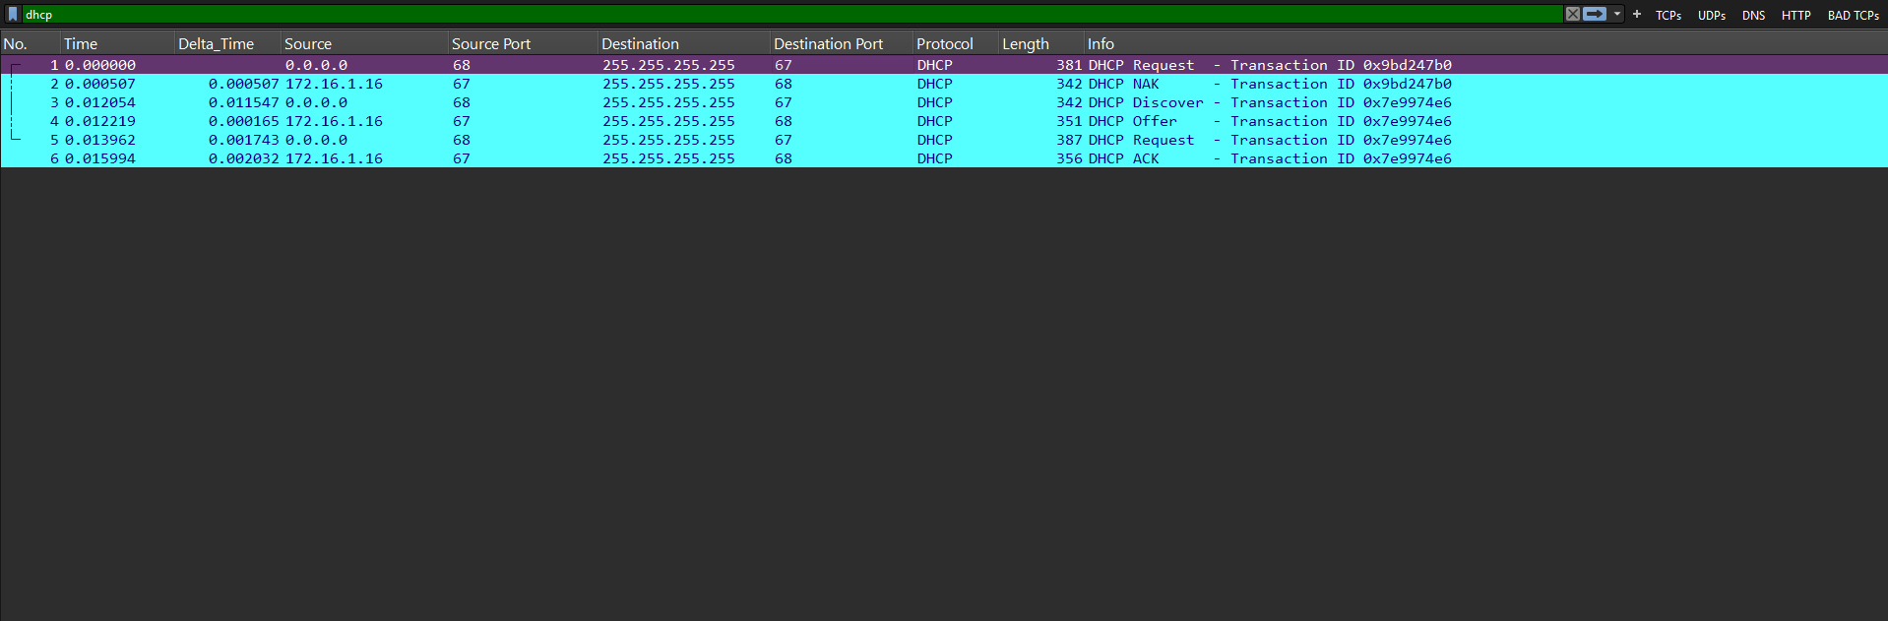
Analysis -
Through this capture what we have observed is that this traffic is normal and DHCP server is simply performing how it is intended to do with nothing suggesting the abnormal or suspicious activity, DORA(discover-offer-request-acknowledgment) working normal.
The capture contains six DHCP packets. The observed traffic includes DHCP communication involving server address 172.16.1.16 and an offered IP address of 172.16.1.141. A DHCPNAK relating to IP address 172.16.1.140 was also observed. The significance of this response depends on the surrounding DHCP exchange; the NAK alone does not establish malicious activity. .
Conclusion -
Verdict – BENIGN / No possible abnormal or suspicious activity found.

Lesson Learned -
Learned
- DHCP Use.
- Working of the DHCP protocol in depth.
- Display filters do not modify the original capture.
- Meaning of the DORA(discover-offer-request-acknowledgment)
- Analysis of packet in detail

Improved
- DHCP filtering
- Packet correlation
- Timeline construction

Still Need Practice
- DHCP advanced analysis and tunnelling.
- Advanced Security analysis

References
- Wireshark User Guide
- Wireshark Display Filter Reference
- PCAP source online
- ChatGPT

