# INVESTIGATION – 006 – HTTP + TCP Stream Investigation

Analyst – Manas Kulkarni
Date – 03 / 09 / 2026
Tool – Wireshark
Capture – 2023-MTA-workshop-introduction.pcap
Objective – Analyse HTTP and TCP Stream Behaviour

Scenario -
- A user accessed a website. Determine what happened during the HTTP session.

Objective -
- what is the client request?
- which server answered?
- what resource was requested?
- what http response was returned?
- were there any redirects?
- what information the user-agent reveal?
- was any suspicious content visible?
- what can you determine from stream that was not from individual packets?

Evidence -
P cap -
- 2023-MTA-workshop-introduction.pcap
Time -
- 817.814000 milliseconds
Total Packets Captured -
- 654 HTTP Packets out of 51008 Total Packets

Methodology -
1. Reviewed capture summary.
2. Examined protocol hierarchy.
3. Filtered HTTP traffic.
4. Identified client and HTTP communication.
5. Analysed HTTP queries.
6. Analysed HTTP responses.
7. Investigated unusual responses.
8. Documented findings.

Key filters -

No. | Filters | Purpose | Result
1. | “http” | This filters out the http protocol related packet from traffic. | Resulted in the 654 packets of http protocol.
2. | “http.request” | This filters out all the request sent from client to server . | This resulted in the 361 packets from the traffic.
3. | “http.response” | This filters out the all the response received from the server. | This resulted in the 327 packets from traffic.
4. | “tcp.port == <port_no.>” | filtering TCP packets with the specified source or destination port. | This resulted in the tcp handshake for specific port.

Key Findings -

TCP Communication (Three-way handshake) -

No. | Timeline | Source IP | Source Port | Destination IP | Destination Port | Protocol | Flag | Seq. No. | Request
1. | 1.050004 ms | 172.16.1.141 | 49682 | 13.107.4.52 | 80 | TCP | [SYN] | 0 | __
2. | 1.09638 ms | 13.107.4.52 | 80 | 172.16.1.141 | 49682 | TCP | [SYN,ACK] | 0 | __
3. | 1.09688 ms | 172.16.1.141 | 49682 | 13.107.4.52 | 80 | TCP | [ACK] | 1
4. | 1.116367  ms | 172.16.1.141 | 49682 | 13.107.4.52 | 80 | HTTP | GET | __ | /connecttest.txt HTTP/1.1
5. | 1.116482 ms | 13.107.4.52 | 80 | 172.16.1.141 | 49682 | TCP | [ACK] | 1 | __
6. | 1.160509  ms | 13.107.4.52 | 80 | 172.16.1.141 | 49682 | HTTP | __ | __ | HTTP/1.1 200 OK  (text/plain)
7. | 1.160570  ms | 13.107.4.52 | 80 | 172.16.1.141 | 49682 | TCP | [FIN,PSH,ACK] | 542 | __
8. | 1.162453  ms | 172.16.1.141 | 49682 | 13.107.4.52 | 80 | TCP | [ACK] | 543 | __
9. | 1.179702 ms | 172.16.1.141 | 49682 | 13.107.4.52 | 80 | TCP | [FIN,ACK] | 112 | __
10. | 1.179925 ms | 13.107.4.52 | 80 | 172.16.1.141 | 49682 | TCP | [ACK] | 113 | __

HTTP Findings -

No. | Questions | Findings
1. | Client IP | 172.16.1.141
2. | Client Port | 49682
3. | Server IP | 13.107.4.52
4. | Server Port | 80
5. | Request Version | HTTP/1.1
6. | Method | GET
7. | Host | www.msftconnecttest.com
8. | URI | /connecttest.txt
9. | User-Agent | Microsoft NCSI
10. | Status Code | 200 OK
11. | Response Size | 298 bytes
12. | No. of HTTP Request | 361
13. | No. HTTP Response | 327

Q. Was any suspicious content visible?
==> No, There was no suspicious content for this investigated IP

Q. What can you determine from stream that was not from individual packets?
==> Decoding a TCP stream makes it easy to understand the application data transfer in both directions as opposed to looking at individual packets.

Screenshots -

1.HTTP Traffic -

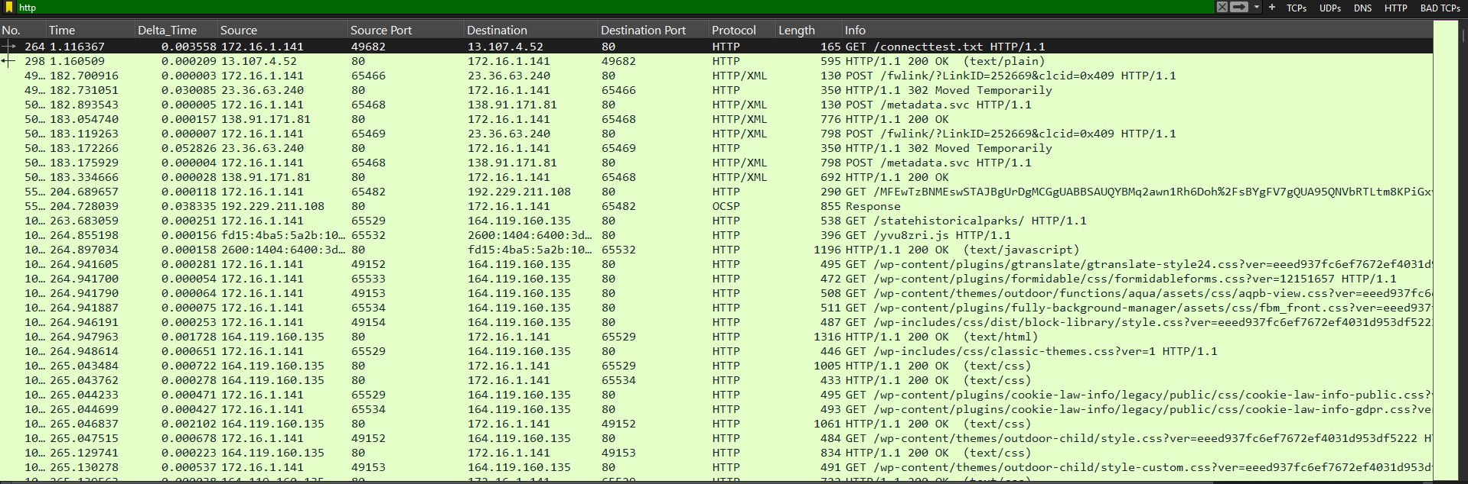
2. HTTP Response -

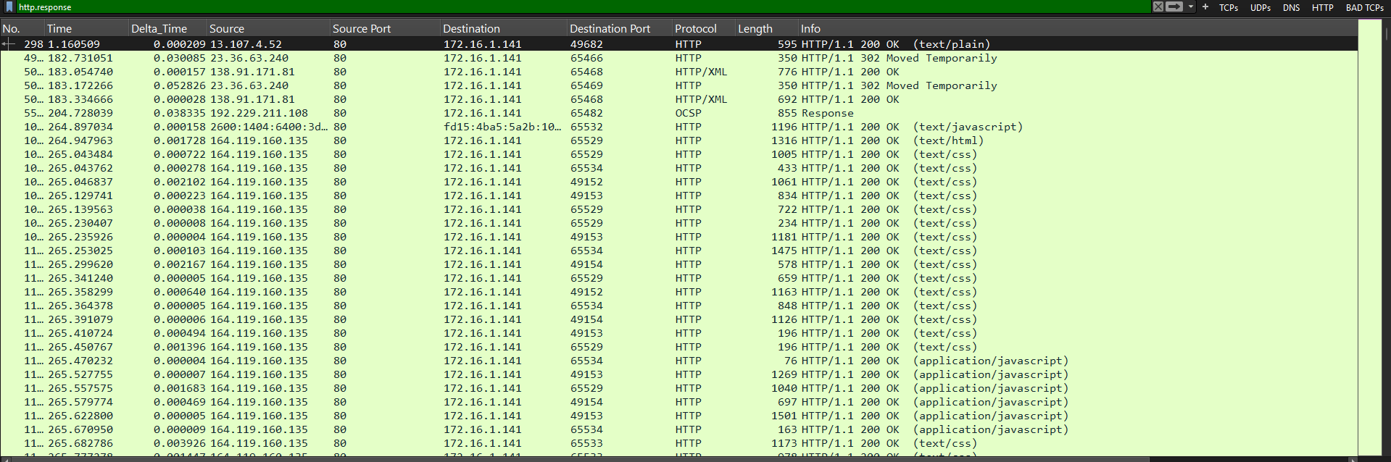

3. HTTP Requests -

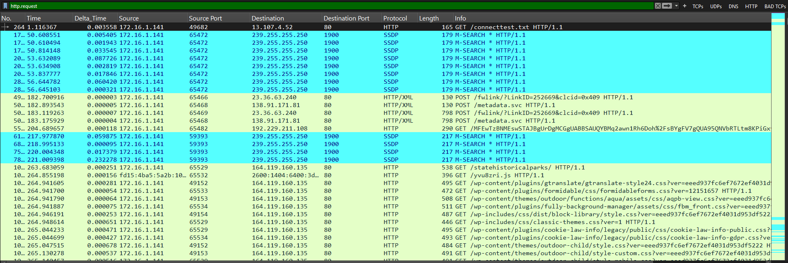
4. Analysed Communication -

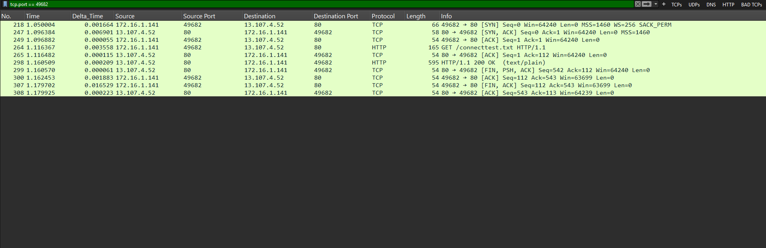

Analysis -

The observed traffic includes an HTTP/1.1 GET message to 13.107.4.52 from 172.16.1.141 requesting the resource /connecttest.txt and then an HTTP/1.1 200 OK reply. The host in the request was www.msftconnecttest.com, and the User-Agent was Microsoft NCSI. This is typical of an HTTP connectivity check request.

Conclusion -

Verdict: BENIGN — for the examined HTTP exchange. The documented request and response are consistent with an HTTP connectivity check. This finding does not establish that all traffic in the capture is benign.

Lesson Learned -
Learned
- HTTP/1.1 commonly uses TCP, while HTTP/3 uses QUIC over UDP.
- KRB5 Protocol Meaning and Working
- Display filters do not modify the original capture.
- Meaning Requests and Response Methods (GET, POST, PUT)
- Analysis of packet in detail

Improved
- HTTP filtering
- Packet correlation
- Timeline construction

Still Need Practice
- HTTP tunnelling analysis
- Advanced Security analysis

References
- Wire shark User Guide
- Wire shark Display Filter Reference
- PCAP source
- ChatGPT

