#INVESTIGATION – 007 - TLS + Network Anomaly Investigation

Analyst – Manas Kulkarni
Date – 04 / 09 / 2026
Tool – Wireshark
Capture – 2023-MTA-workshop-introduction.p cap
Objective – Analyse SSL/TLS Network Anomaly.

Scenario -
- A workstation is observed to generate a traffic which is to analysed for checking any abnormal activity and behaviour.

Objective -
- which host initiated TLS?
- which server responded?
- what TLS version was negotiated?
- what host name is visible?
- what can you determine?
- what can you not determine as payload is encrypted?
- were any anomalous queries observed ?
- how many total response were given ?

Evidence -
P cap -
- 2023-MTA-workshop-introduction.pcap

Total Packets Captured -
- 8337 TLS/SSH Packets out of 51008 Total Packets

Methodology -
1. Reviewed capture summary.
2. Examined protocol hierarchy.
3. Filtered TLS traffic.
4. Identified client HELLO and server HELLO.
5. Analysed TLS queries.
6. Analysed TLS responses.
7. Investigated unusual responses.
8. Documented findings.

Key Filter -

No. | Filter | Purpose | Result
1. | “tls” | This filters the TLS related packets from the traffic. | This resulted in the 8337 packets.
2. | “tls.handshake.type ==1” | This filters out the client hello packets which is sent by client. | This resulted in 520 packets from client.
3. | “tls.handshake.type ==2” | This filters out the packets from server which are server hello packets. | This resulted in the 519 packets from server .
4. | “tls.handshake.type ==11” | This filters out the packets which have information about certificate. | This resulted in the 351 packets consisting of the certificate related information.

Key Findings -

No. | Questions | Findings
1. | Which host initiated TLS and Port No | 172.16.1.141, 65363
2. | Which server responded and Port No | 20.44.10.122, 443
3. | what TLS version was negotiated? | TLS 1.2
4. | What host name is visible | self.events.data.microsoft.com
5. | Cipher suite negotiated | TLS_ECDHE_RSA_WITH_AES_256_GCM_SHA384
6. | Certificate Length | 4041 bytes
7. | Certificate issuer | DigiCert.com
8. | validity | Not Before: 2020-07-29 12:30:00  Not After: 2024-06-27 23:59:59
9. | Total No of Client Hello captured | 520
10. | Total No. Of Server Hello captured | 519
11. | Algorithm used | SHA256 With RSA
12. | Is OCSP stapling in use | Yes, Response is valid and recent
13. | OCSP signature Algorithm | SHA256 with RSA Encryption
14. | OCSP certificate name | AzureCA02 OCSP certificate

Screenshot -

1.TLS Captured -

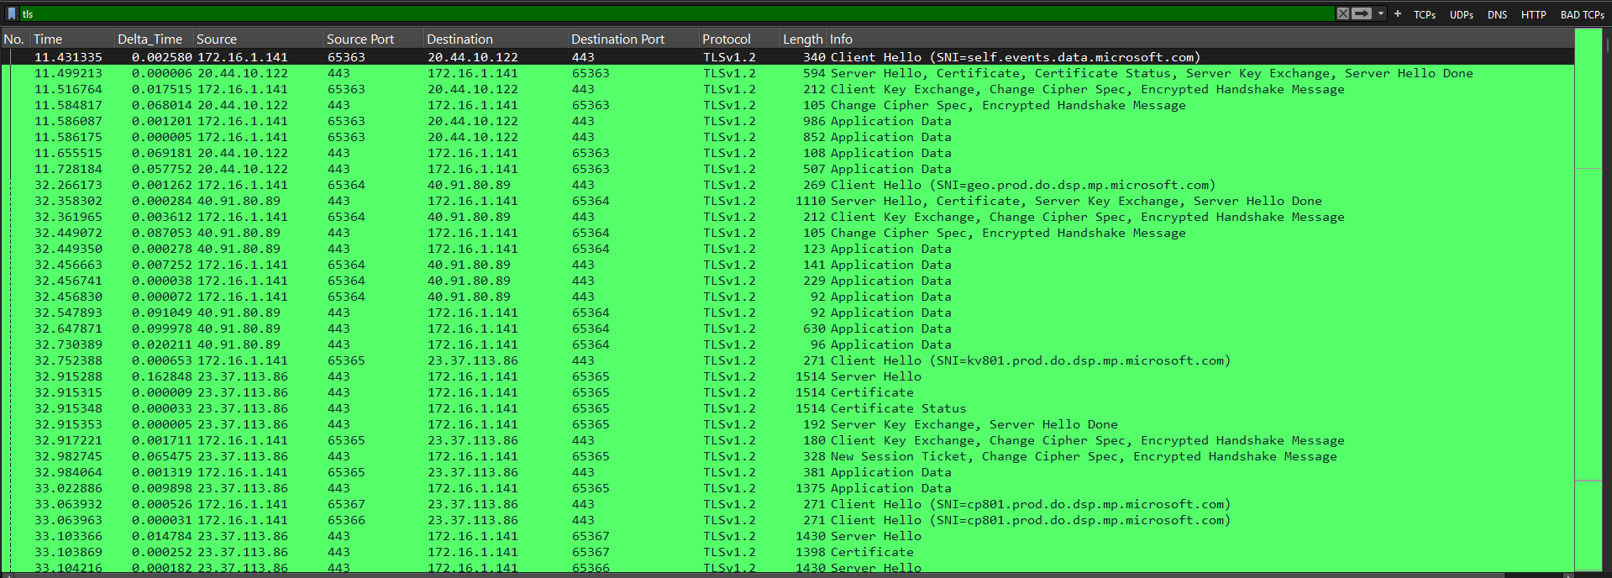
d

2.TLS Client Hello captured -

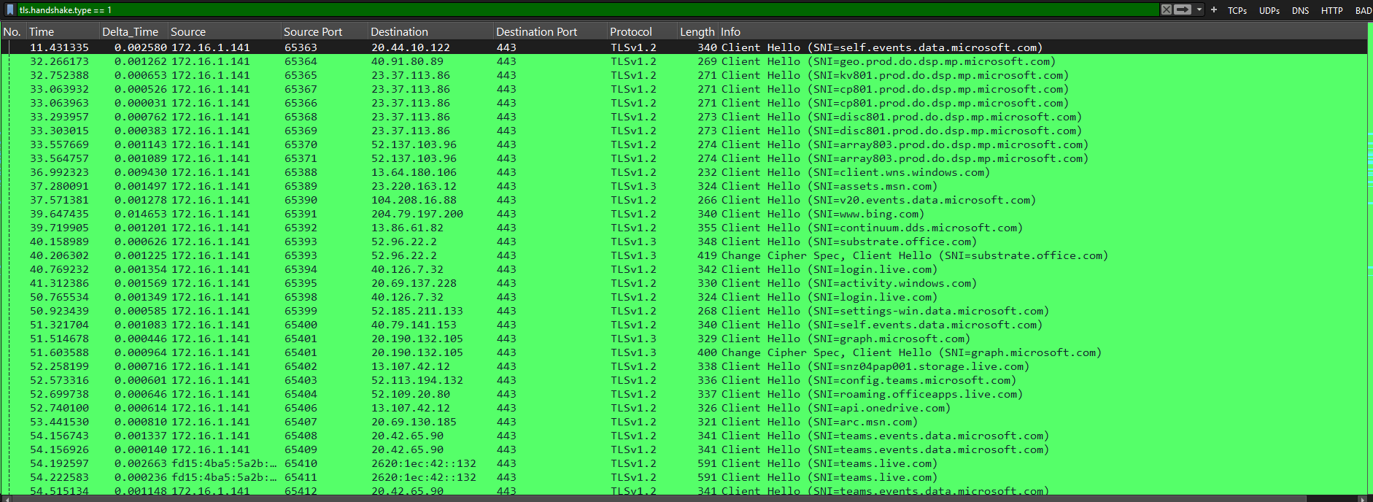
d

3.TLS Server Hello captured -

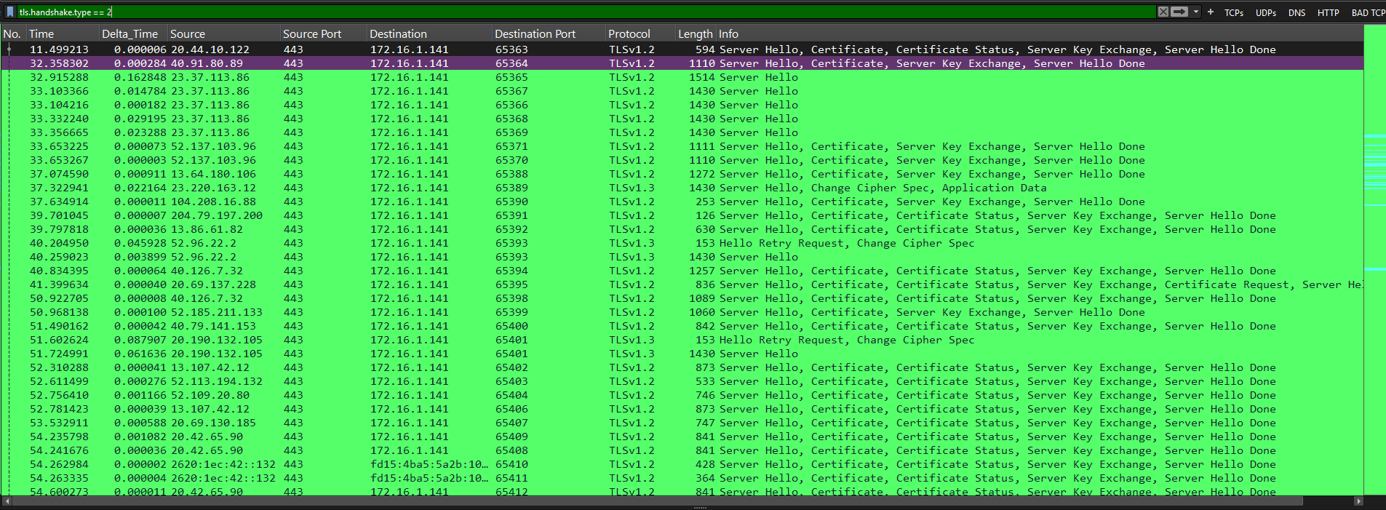

Analysis -
The TLS traffic under analysis involves ClientHello and ServerHello messages, negotiation of TLS parameters, and information about certificates. The existing observations are not enough to conclude that all TLS traffic captured is harmless. Validity of the certificates should be verified, and encrypted application data prevents access to the exchanged information.

Conclusion -
Assessment: No clear malicious activity was established from the TLS fields documented in this investigation. The certificate validity information requires verification, and encrypted payloads limit application-level analysis. This assessment is restricted to the traffic examined and does not establish that the entire capture is benign.

Lesson Learned -
Learned
- Meaning of Client and Server Hello
- what is the use of different hashing algorithm.
- Display filters do not modify the original capture.
- TLS Working in detail.
- Analysis of packet in detail

Improved
- TLS filtering
- Packet correlation
- Timeline construction

Still Need Practice
- Query tunnelling
- Advanced Security analysis

References
- Wire shark User Guide
- Wire shark Display Filter Reference
- Malware-Traffic-Analysis.net PCAP exercises source
- ChatGPT

