##INVESTIGATION – 009 – Port Scanning investigation

Analyst – Manas Kulkarni
Date – 11 / 09 / 2026
Tool – Wireshark
Capture – SS Scan.pcapng
Objective – Analyse Port Scanning behaviour

Scenario -
- A workstation was observed generating multiple connection to multiple ports possibly indicating port scanning or reconnaissance.
Objective -
- how initiated the traffic?
- who was the target?
- how many ports were contacted?
- were the ports sequentially contacted?
- Does traffic resembles reconnaissance ?
- how many total were there ?

Evidence -
P cap -
- SS Scan.pcapng
Time -
- 2 hours 37 minutes 12 seconds
Total Packets Captured -
- 203 packets

Methodology -
1. Reviewed capture summary.
2. Examined protocol hierarchy.
3. Filtered TCP traffic.
4. Investigated unusual responses.
5. Documented findings.

Key filter -

No. | Filter | Purpose | Result
1. | “ip.src == 192.168.12.235 ” | This filters out the packets where the IP provide in filter is source address | This resulted in the 103 packets in total.
2. | “tcp.flags.reset == 1” | This filter out the packets which have reset flag set | This resulted in 100 packets in total.
3. | “tcp.flags.syn ==1” | This filters out the packets which have this flag set | This resulted in the 103 packets in total.

Key Findings -

No. | Questions | Findings
1. | Who initiated the connection? | 192.168.12.235
2. | Who was the target? | 192.168.12.148
3. | How many ports were targeted? | 100 Unique Destination ports
4. | Were there ports sequentially contacted? | No, the ports randomly contacted.
5. | Which ports were found open and responded? | 80(HTTP),143,995
6. | Which service was majorly targeted? | TCP (Transmission Control Protocol).
7. | Which ports returned RST flag? | 3306,1720,1025,587,199,111,...
8. | What time the scanning started and ended? | Start time – 0.0000 seconds  end time – 0.01123 seconds
9. | How did the target responded? | SYN/ACK for open ports and RST for not open.
10. | Which TCP flag was used for probes? | SYN
11. | Total time required? | 2 hours 37 minutes 12 seconds.

Q. Does The traffic resembles reconnaissance if yes why?
==> Yes, it fits into the picture of port scanning because one source IP address (192.168.12.235) performed SYN scans on various ports for the same destination (192.168.12.148), which responded with SYN-ACK on ports 80, 143, and 995, whereas RST was the response for all the rest.

Q. Does the overall pattern resemble automated reconnaissance?
==> The traffic could suggest automated reconnaissance since there were probes to 100 different destination ports over a short time span. This is typical of automated scanning software like Nmap, although the packets do not provide information about the particular tool that was used.

Screenshots – 1. Findings
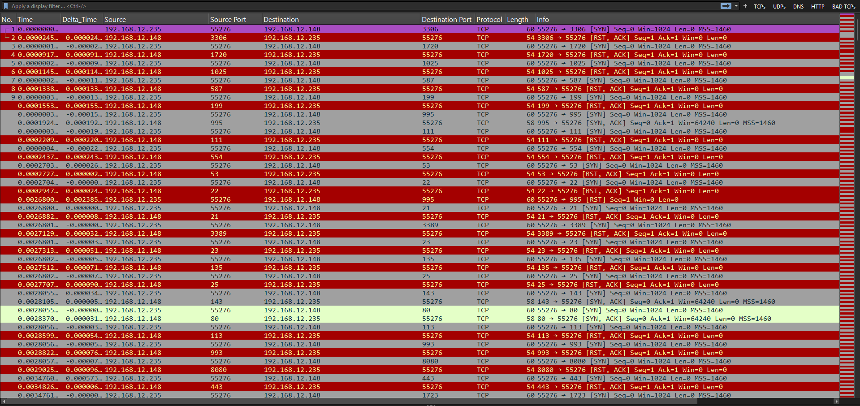

Lesson Learned -
Learned
- Port scanning and reconnaissance pattern recognition
- Display filters do not modify the original capture.
- Analysis of packet in detail

Improved
- Incident documentation
- Packet correlation
- Timeline construction

Still Need Practice
- Attack pattern recognition in depth.
- Advanced Security analysis

References
- Wire shark User Guide
- Wire shark Display Filter Reference
- PCAP online source
- ChatGPT

