##INVESTIGATION – 010 – Full SOC Investigation

Analyst – Manas Kulkarni
Date – 12 / 09 / 2026
Tool – Wireshark
Capture – 2026-02-28-traffic-analysis-exercise.pcap
Objective – Detailed Analysis of a possible Attack or malicious activity

Scenario -
- The Security Operations Center (SOC) team has been tasked with investigating a network packet.
The investigation involves analyzing captured network traffic using Wireshark to understand communication between internal hosts and external endpoints, examine protocol behaviour, and identify unusual connection patterns, failed requests, or potentially malicious activity.

Objective -
- who initiated the connection ?
- who was the target?
- how many ports were contacted?
- were the ports sequentially contacted?
- Does traffic resembles attack or malicious activity?
- which protocols were used ?

Evidence -
P cap -
- 2026-02-28-traffic-analysis-exercise.pcap
Time -
- 4 hours 21 minutes 29 seconds
Total Packets Captured -
- 15512

Methodology -
1. Reviewed capture summary.
2. Examined protocol hierarchy.
3. Filtered TCP, UDP, etc. traffic.
4. Investigated unusual responses.
5. Documented findings.

Key Filter

Sr No. | Filter | Purpose | Result
1. | “tcp” | This filters out the packets based on the TCP protocol | This resulted in the 12544 total packets to display
2. | “DNS” | This filters out the packets based on the DNS Protocol | This resulted in 828 packets in total to display
3. | “tcp.analysis.retransmission” | This filters out packets where retransmission is occured. | This resulted in 40 packets to displayed
4. | “Frame.number == <no. of the frame to search>” | This filters out packet whose frame number is searched | This resulted in packets and which search for and helped in investigation
5. | “nbns” | This filters and helps in finding the windows client | This resulted in the windows client which was infected.
6. | “Kerberos.CNameString” | This filters packets to find the name of user/host | This resulted in the brolf name string suggesting this is the user.

Key Findings

Initial Network Overview –

Internal IPs --
- 10.2.28.88
- 10.2.28.2

External IPs --
- 23.64.147.24
- 23.192.232.23
- 23.218.232.148

Most Talked hosts --

Source IP | Destination IP | No. of Packets | Data in Bytes
10.2.28.88 | 10.2.28.2 | 5069 | 1 MB
10.2.28.88 | 23.64.147.24 | 1268 | 1 MB
10.2.28.88 | 23.218.232.148 | 1130 | 1 MB

Capture Time frame --

First Packet Captured at | 2026/03/01 | 01:25:06
Last Packet Captured at | 2026/03/01 | 05:46:35

Elapsed Time – 04:21:29 hours

Major Protocols --
- TCP
- UDP
- DNS
- HTTPS
- DHCP
- ARP
- SSL/TLS
- DCE/RPC
- SMB2
- NETBIOS Session Service

TCP Analysis --

1.Normal File Operations

Date | 2026/02/28
Source IP | 10.2.28.88
Destination IP | 10.2.28.2
Source Port | 55991
Destination Port | 445
Protocol Used | TCP, SMB2
Share Name From Tree | \\EASYAS123-DC\Shared
Share Type | Physical Disk

Time Line --

NO. | Time | Event | Frame
1. | 19:55:23.2930 | SYN Flag Initiated | 356-358
2. | 19:55:23.2932 | Protocol Negotiation Request (SMB2) | 359-360
3. | 19:55:23.2968 | Session Setup request +  Response | 376-378
4. | 19:55:23.297673 | Tree Connect Request | 379-380
5. | 19:55:23.2978 | Ioctl Request (FSCTL_QUERY_NETWORK_INTERFACE_INFO) + Response | 381-382
6. | 19:55:24.5470 – 19:55:24.5485 | Read Desktop.ini and Auto.inf + Response Error (STATUS-OBJECT-NOT-FOUND) | 484-487
7. | 19:55:25.0532 – 19:55:32.0485 | Files Sharing Start | 508-1285
8. | 19:56:07.1380 | TCP Keep-alive (7 packets) | 2849-4037
9. | 19:58:55.9634 | Ioctl Request (FSCTL_QUERY_NETWORK_INTERFACE_INFO) + Response | 4136-4137

Session Summary:
A single SMB2 session was observed between internal host 10.2.28.88 (client) and 10.2.28.2 (server) over TCP port 445. The session exhibited the following behaviour:
1.Protocol negotiation and authentication — Standard SMB2 negotiate, session setup, and tree connect to a shared resource.
2.Directory browsing — Client requested desktop.ini from the share root; server returned STATUS_OBJECT_NAME_NOT_FOUND. This is expected Windows Explorer behaviour when no folder customisation file exists.
3.SMB Multichannel refresh — Periodic IOCTL requests (~every 10 minutes) with corresponding responses. This is the standard Windows client mechanism to maintain multichannel failover capability.
4.Idle periods — TCP Keep-Alive packets observed between active operations, indicating the session was maintained but not in active use.
Assessment: All observed traffic is consistent with a mapped network drive on a Windows workstation in an idle state. No anomalous file access, no lateral movement indicators, no unusual IOCTL codes, and no data exfiltration patterns were identified.
Verdict: BENIGN, No further investigation required for this session.

2.Network packet loss

Evidence Summary:

Date | 2026/02/28
Source IP | 10.2.28.88
Destination IP | 23.64.147.24
Source MAC | 00:19:d1:b2:4d:ad
Destination MAC | 00:05:00:41:ae:25
Source port | 51911
Destination Port | 443
Protocol Used | SSL/TLS, TCP
Duration | 53.0381 ms
TLS Version | TLSv1.3
Application Layer Protocol Used | HTTP
TLS Server Name | www.fmcsa.dot.gov
Cipher suite Selected | TLS_AES_256_GCM_SHA384

Time Line --

NO. | Time | Events | Frame
1. | 19:55:50.9748 – 19:55:50.9984 | 3 way handshake  (SYN – SYN/ACK – ACK) | 1357 – 1363
2. | 19:55:50.9990 | Client Hello | 1365
3. | 19:55:51.0532 | Server Hello | 1374
4. | 19:55:51.0917 – 19:55:51.3697 | Application Data Sent and data exchange begin | 1383 – 2534
5. | 19:55:51.3699 – 19:55:51.4033 | Retransmission cause previous segment was not captured | 2537 – 2572
6. | 19:55:51.4035 – 19:55:51.4182 | Retransmission of Out of order packets | 2575 – 2633
7. | 19:56:43.9548 | FIN Flag from Source to Destination | 3620
8. | 19:56:44.0127 – 19:56:44.0128 | Connection Request from Source and Destination | 3633 – 3635

Session Summary --

A single SSL/TLS Session has been observed between 10.2.28.88 and 23.64.147.24 over TCP pot 443. The Session stated following behaviour:

1.Connection setup: The Client Initiated a classic 3 Way Handshake with Server.

2.TLS Handshake: Performed an TLS Handshake (Client Hello --> Server Hello) with Encrypted Extensions and certificate with Cipher Suite as TLS_AES_256_GCM_SHA384.

3.Certificate: The server presented a Valid Certificate issued by digicert.com.

4.Data Exchange: Multiple Application Data Records were Observed with content Encrypted and no clear text analysis possible.

5.Retransmissions: Session performed multiple retransmission due to segment not captured and Duplicate data packet.

6.Session termination: Client initiated Fin Flag indicating termination with Followed FIN/ACK and RST Flags.

Final Verdict: BENIGN, As there is Evidence of Missing TCP segments from Client Side followed by Duplicate ACK’s and retransmission From Server, However, The “Previous segments not Captured” message means this may be packet capture issue rather than actual Network packet loss.

3. File Downloading
Evidence Summary:

Date | 2026/02/28
Source IP | 10.2.28.88
Destination Ip | 23.218.232.148
Source Port | 62035
Destination Port | 80
Protocol Used | TCP, HTTP
User Agent | Microsoft BITS / 7.8
Host | msedge.b.tlu.dl.delivery.mp.microsoft.com
Response | HTTP/1.1 206 (Partial Content)
Server | Microsoft-ITS/10.0
Request Method | GET
Requested Source | /filestreamingservice/files/...

Time Line --

No. | Time | Event | Frame
1. | 23:18:22.5146 – 23:18:22.5611 | Classic 3 way handshake Initiated | 12959 – 12962
2. | 23:18:22.5611 | GET Request to /filestreamingservice/files/.... | 12963
3. | 23:18:22.6082 – 23:18:33.3108 | Again GET request to same source and data exchange. | 12969-14081
4. | 23:18:22.6204 | Response from Server | 12966

Session summary --

A single HTTP session has been observed between client 10.2.28.88 and server 23.218.232.148 over TCP port 80 the behaviour is as followed:

1.Connection Establishment: The Client performed a normal Three way handshake with server establishing the connection.

2.Request method initiated: the client Requested A GET method to /filestreamingservice/files/...
platform.

3.Data Exchange: The File was accessed and data were to exchange.

Assessment: The windows machine is Downloading a file from Microsoft’s CDN using time limited & Cryptographically Signed URL.

Verdict: BENIGN, No further Assessment Needed.

Interesting Finding --

Evidence Summary --

Date | 2026/02/28
Source IP | 10.2.28.88
Destination IP | 45.131.214.85
Source Port | 51912
Destination Port | 443
Protocol Used | TCP, HTTP
HTTP Request Method | POST
User-Agent | Net Support Manager/1.5
Host | 45.131.214.85
Server response | HTTP/1.1 200 OK
Server Name | NetSupport Gateway/1.92
Repeated URL | /fakeurl.htm
Periodic Checking Command Used | CMD = POLL
Encoded/Encrypted-looking data Command Used | CMD = ENCD
Duration | 15637.3601 (4 hours approx)
Byte Transfer | 96 Kb
Total Packets Transfer | 550
Total retransmission | 9
Host name of Infected Windows Client | DESKTOP_TEYQ2NR
User Full Name | Becka Brolf

TIME LINE --

No. | Time | Events | Frame
1. | 19:55:51.3733 – 19:55:51.5236 | 3 way handshake Established | 2569 – 2637
2. | 19:55:51.5309 | Client initiated first POST Request Method to Server on /fakeurl.htm. | 2638
3. | 19:55:51.6781 | Server returned HTTP /1.1 200 OK | 2639
4. | 19:55:51.6798 | Client Again Initiate POST request on Server for same url again + get the response HTTP/1.1 200 OK | 2640 – 2641
5. | 19:55:52.0388 – 00:16:28.7333 | Client again Initiate POST Request to Server but without any response with some retransmissions for duplicate and out of order packets indicating possible malicious activity. | 2643 – 15500

Session Summary --

The Workstation generated a single HTTP connection between 10.2.28.88 and 45.131.214.85 on TCP port no. 443 and there behaviour is as followed:
1.Connection Establishment: Client initiate classic TCP 3 way handshake with Server.
2.Client sends a POST request Method to /fakeurl.htm for Host 45.131.214.85 with Request Version HTTP/1.1 and receives HTTP/1.1 200 OK Response from server.
3.This continues for long time and client continuously sends POST request to same /fakeurl.htm URL indicating possible automated Communication cause of repeated requests.
4.Due to this Continuos POST request for same URL this indicates C2 Beaconing.

Conclusion:
Confidence Level: High
Suspicious – Further Analysis Required. Attempts at communicating via multiple HTTP POST requests to /fakeurl.htm, User-Agent of NetSupport Manager/1.5, and POLL/ENCD commands appear to mimic NetSupport communication style. Nevertheless, the presence of such packets alone is insufficient for establishing any malicious activities or C&C activities. Ensure proper validation of authorization of the software first.

.

Screenshots --

1.Normal File Operation

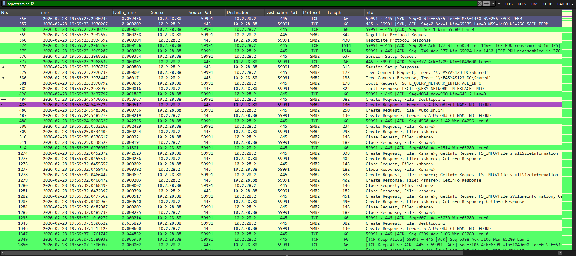

2.Network Packet Loss

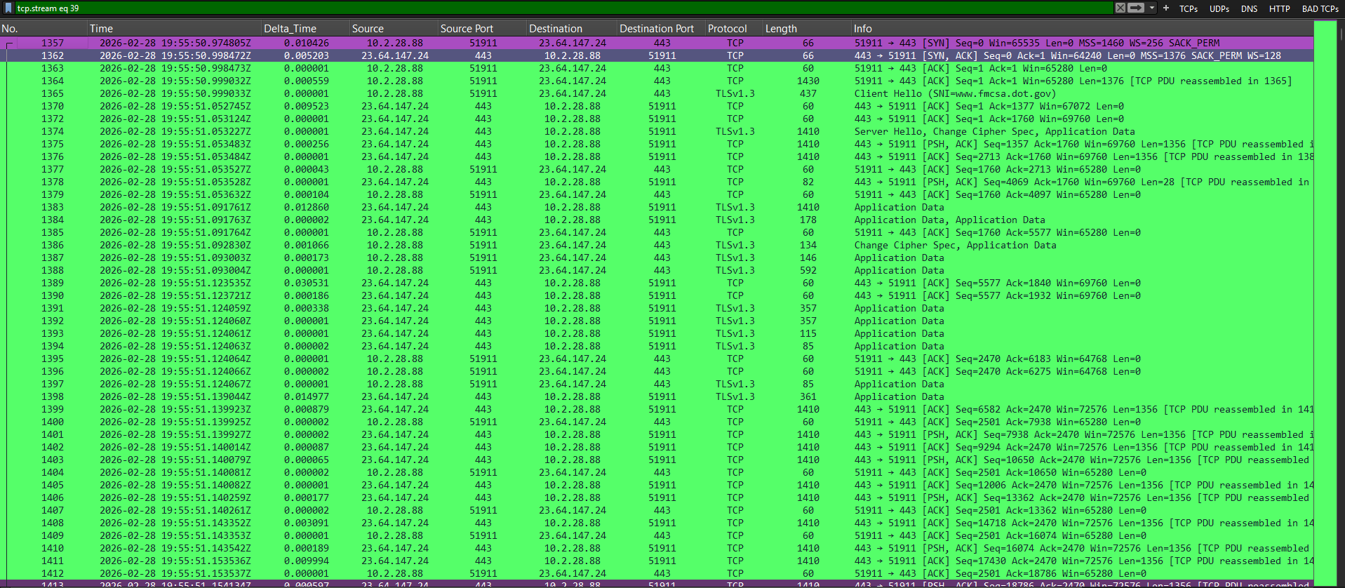
3.File Downloading and Data Transfer

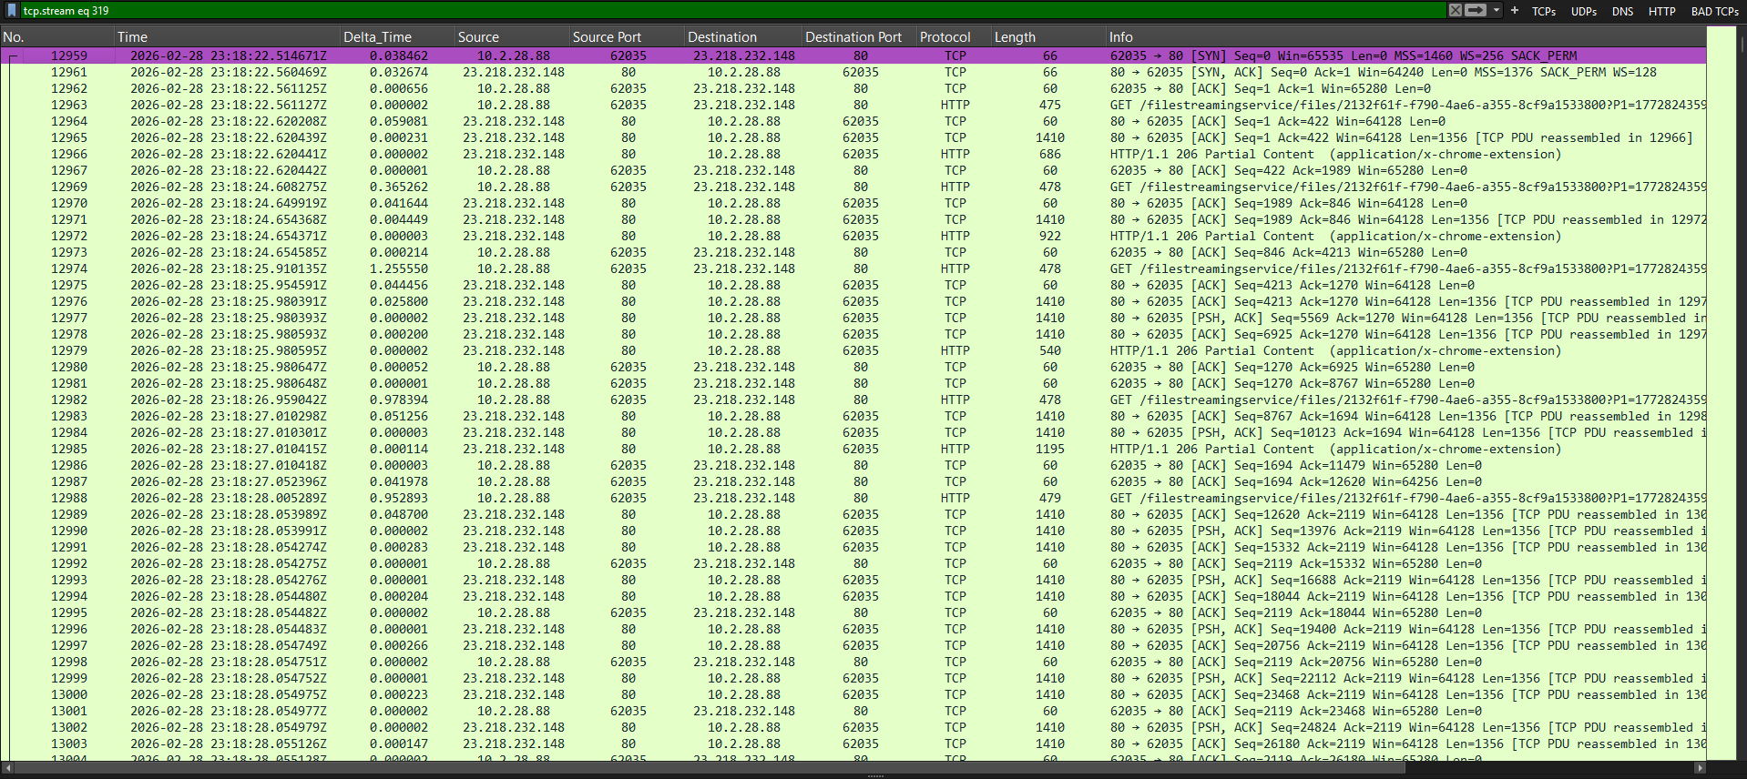
4.RAT C2 on NetSupport Manager

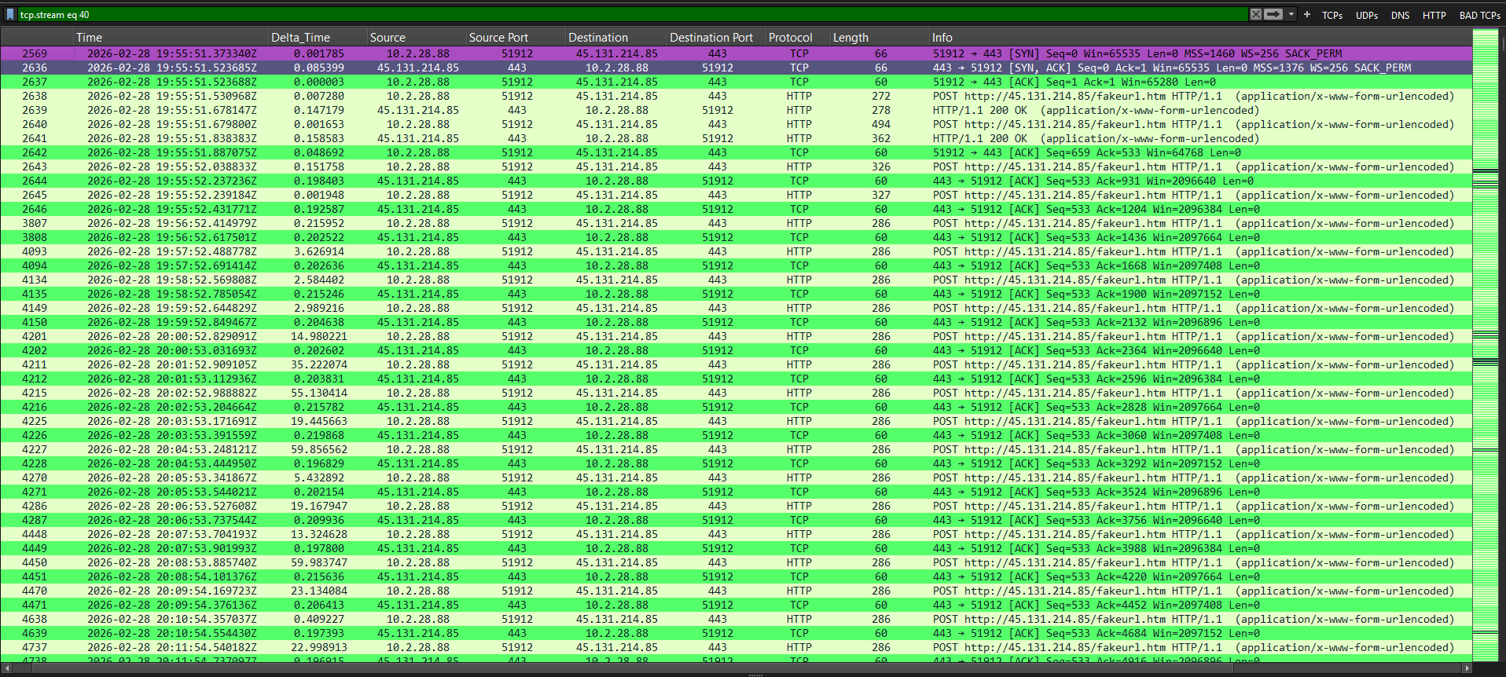

Lesson Learned -
Learned
- File related Operation’s Analysis,Port scanning , reconnaissance and Malicious Activity Detection pattern recognition
- Display filters do not modify the original capture.
- Analysis of packet in detail and in well strutured manner

Improved
- Incident documentation
- Packet correlation
- Timeline construction

Still Need Practice
- Attack pattern recognition in depth.
- Advanced Security analysis

References
- Wire shark User Guide
- Wire shark Display Filter Reference
- PCAP online source
- ChatGPT

