**Assignment 9: Pronominal anaphora resolution**

## About

The aim of the assignment was to:

## Explore issues in pronominal anaphora resolution.

## Gain familiarity with syntax-based resolution techniques.

## Analyze the effectiveness of the Hobbs algorithm by applying it to pairs of parsed sentences.

## Insights

The program uses EarleyChartParser as the parser to parse the grammar and its parse_one function to get a single parse for the sentence. The Hobbs algorithm is implemented manually to accept/reject proposed antecedents. Once an antecedent is “proposed” it is then checked for compatibility; agreement, semantic comparability, etc. If there’s no reason to reject it for those reasons, then the algorithm terminates, whether it’s correct or not.

Hobbs algorithm has a decent performance in the straightforward cases. However, it does not capture elements of binding theory (since for the purpose of this assignment we only considered agreement in number, person and gender), and recency within mentions in a single sentence and does not take into account more contextual information.

Successes and failures of the Hobbs algorithm

|  |  |  |  |  |
| --- | --- | --- | --- | --- |
|  | Number of Pronouns | Rejects | Incorrect Accepts | Correct Accepts |
| Sentence Tuple 1 | 1 | 0 | 0 | 1 |
| Sentence Tuple 2 | 1 | 1 | 0 | 1 |
| Sentence Tuple 3 | 1 | 0 | 0 | 1 |
| Sentence Tuple 4 | 2 | 0 | 1 | 1 |
| Sentence Tuple 5 | 1 | 0 | 1 | 0 |

For the given 5 sentence tuples, we see that the algorithm correctly accepts antecedents in 4/6 cases.

More specifically, it does a good job in cases where node X is the highest S node in the sentence and when we traverse the surface parse trees of previous sentences in the text in order of recency, the most recent first from L-R and propose as antecedent when an NP is encountered. While accepting a proposed antecedent agreement on person, number, gender is checked. This agreement enabled the correct antecedent acceptance in the sentence tuple ‘The immune response is alerted by dendritic cells. They capture infected cells and display fragments of the pathogen.’ Where for the pronoun ‘they’, the first proposed antecedent ‘The immune response’ is rejected due to non-agreement on number and the second proposed antecedent ‘dendritic cells’ is accepted.

While Hobbs approach does work in terms of sentence recency but fails to work in case of mention recency within the sentence itself. For example, in the sentence tuple “Scientists restored immunity in mice with a weak immune system. They were compromised by sepsis.” ,‘mice’ would be the correct antecedent however as per Hobbs algorithm ‘Scientists’ is chosen as an antecedent (Scientists and they also agree on person, number, gender) however looking at aspects of recency and context provided ‘mice’ would seem as the more obvious answer. Hobbs algorithm fails to capture this.

Having said that I feel this is a slightly more ambiguous sentence and the Neural Coreference Resolution by AllenNLP also fails to correctly resolve that sentence and accepts the same mention as an antecedent.

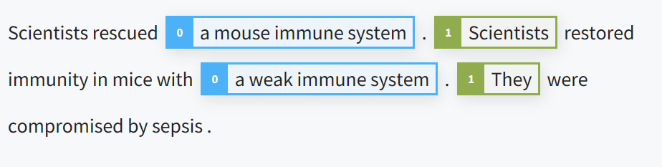

Another example where Hobbs algorithm fails is the sentence tuple “Scientists restored immunity in mice with a weak immune system. They injected them with a live vaccine.”. Here both pronouns ‘they’ and ‘them’ have ‘Scientists’ as proposed and accepted antecedents. Even though ‘Scientists’ is the correct antecedent for ‘They’, according to Binding theory, ‘them’ should not have been coreferenced with ‘Scientists’ . This is where Hobbs algorithm fails. By rule, Pronoun/Def. NP: can’t corefer with subject of clause. ‘Scientists’ would have been the right antecedent if the second pronoun was reflexive ‘themselves’. It is seen that AllenNLP does not perform the same mistake here :

