AWS Pointers
EC2:
- By default, an EBS volume is attached to an AWS EC2 instance at launch and deleted upon instance termination, though this behavior can be modified during creation.
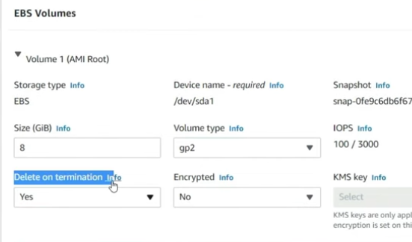

- The EC2 user_data script always runs with root user privileges by default.
- 🔒 AWS Security Groups
- Stateful: Return traffic is automatically allowed.
- Allow-only: You can only create allow rules (inbound or outbound).
- No deny rules: There’s no way to explicitly block specific IPs, ports, or protocols within a security group.
If you need to deny certain traffic, you must use other mechanisms like NACL.

Type | Billing Model | Use Case
On-Demand | Pay per second | Short-lived workloads
Reserved Instances | 1–3 year commitment | Predictable workloads
Spot Instances | Up to 90% cheaper | Fault-tolerant, batch jobs
Savings Plans | Flexible commitment | Consistent compute usage
“In AWS, instance types are categorized based on the workload they optimize — general-purpose (t, m), compute-optimized (c), memory-optimized (r, x), storage-optimized (i, d), and GPU-based (p, g).
For example, I use t3a or t4g for dev/test environments because they’re burstable and cost-effective. For production app servers, I prefer m6i or c6i based on whether CPU or memory is the bottleneck.
For in-memory databases like Redis, I’d go for r6g, and for ML workloads, I’d pick g5 or p4d.
I also leverage Graviton instances for cost and performance benefits and mix On-Demand with Spot Instances for CI/CD and autoscaling groups to optimize cost.”

How to recover if we lost key-pair for ec2 instance?
🟠 Method 1: Detach and Re-Attach Root Volume
Use this manual recovery method:
- Stop the instance (don’t terminate it).
- Detach the root volume (e.g., /dev/xvda).
- Attach the volume to another working EC2 instance as a secondary volume (say /dev/sdf).
- SSH into the helper instance and mount the volume:
sudo mkdir /mnt/recovery
sudo mount /dev/sdf1 /mnt/recovery
- Edit the authorized_keys file of the original user (e.g., ec2-user, ubuntu):
sudo nano /mnt/recovery/home/ec2-user/.ssh/authorized_keys
- Paste your new public key into it.
- Save and unmount:
sudo umount /mnt/recovery
- Detach the volume and re-attach it back to the original instance as the root volume.
- Start the instance again.
- SSH using your new private key.
✅ Works even when SSM is not enabled.

🟠 Method 2: Use EC2 User Data Script
- You can inject a new key at startup using user data.
- Stop the instance.
- Go to Actions → Instance Settings → Edit User Data.
- Add a script like:
#!/bin/bash
echo "ssh-rsa NEW_PUBLIC_KEY" >> /home/ec2-user/.ssh/authorized_keys
- Start the instance.
- After it boots, SSH using the new private key.

