Theory

Generally, L293D motor driver can control two motor at one time or called is a dual H-Bridge motor driver. By using this IC, it can interface DC motor which can be controlled in both clockwise and counter clockwise direction. The motor operations of two motors can be controlled by input logic at pins 2 & 7 and 10 & 15. Below shown the pin diagram of L293D motor driver

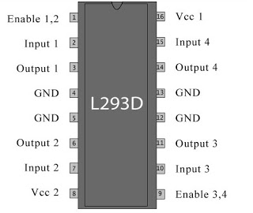

and the pin description of L293D motor driver

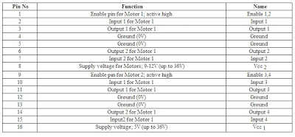

Besides that, with this L293D driver motor it will control four DC motors at one time but with fix direction of motion. L293D has output current of 600mA and peak output current of 1.2A per channel. Moreover for protection of circuit from back EMF output diode are included within the L293D. The output supply hich is external supply has a wide range from 4.5V to 36V which has made L293D a best choice for DC motor driver. A simple schematic for interfacing a DC gear motor using L293D driver motor is shown below:

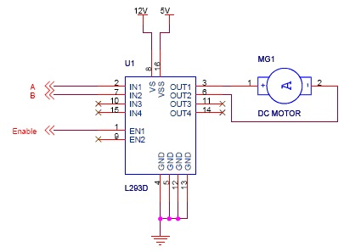

and below the truth table for L293D driver motor

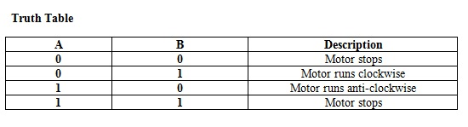

 For truth table above, the Enable has to be set to 1 and motor power used is 12V but it is depends on motor power that used (range 4.5V to 36V). The rotation of the DC motor can be control by combinations of A and B in programming assembling and from the truth table it is clear to explain the rotations of the motor. Picture below shown the connection of DC gear motor to L293D driver motor.