**LED’S**

A **light-emitting diode** (**LED**) is a semiconductor light source. LEDs are used as indicator lamps in many devices and are increasingly used for other lighting.

The LED consists of a chip of semiconducting material doped with impurities to create a *p-n junction*. As in other diodes, current flows easily from the p-side, or anode, to the n-side, or cathode, but not in the reverse direction. Charge-carriers—electrons and holes—flow into the junction from electrodes with different voltages. When an electron meets a hole, it falls into a lower energy level, and releases energy in the form of a photon.

The wavelength of the light emitted, and thus its color depends on the band gap energy of the materials forming the *p-n junction*. In silicon or germanium diodes, the electrons and holes recombine by a *non-radiative transition*, which produces no optical emission, because these are indirect band gap materials. The materials used for the LED have a direct band gap with energies corresponding to near-infrared, visible, or near-ultraviolet light.

LED development began with infrared and red devices made with gallium arsenide. Advances in materials science  have enabled making devices with ever-shorter wavelengths, emitting light in a variety of colors.

LEDs are usually built on an n-type substrate, with an electrode attached to the p-type layer deposited on its surface. P-type substrates, while less common, occur as well. Many commercial LEDs, especially GaN/InGaN, also use sapphire substrate.

Most materials used for LED production have very high refractive indices. This means that much light will be reflected back into the material at the material/air surface interface. Thus, light extraction in LEDs is an important aspect of LED production, subject to much research and development.

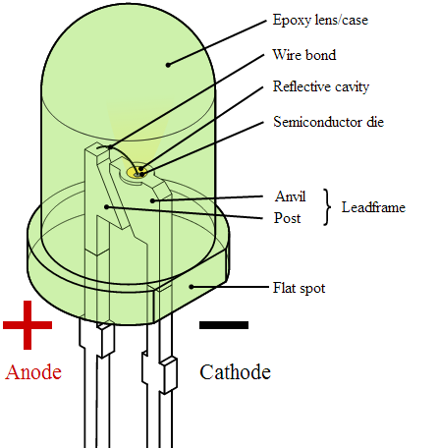

Parts of an LED. Although not directly labeled, the flat bottom surfaces of the anvil and post embedded inside the epoxy act as anchors, to prevent the conductors from being forcefully pulled out from mechanical strain or vibration