Bugs
- Lowend devices unable to access( unable to install)
- Unable to add new gmail and other details via admin panel in user management
- And why this mail is unable to send an magic link for some mails like(ex: pmanju352001@gmail.com)
- Students/teachers halfday leave update
- Add and should be Update CL(1 DAY LEAVE per MONTH-without any salary deduction)/LP(-₹500 from salary) for Leave for teachers
- Add and assign for LKg and UKG
- Connecting assigned class teachers for appropriate classes in time table whatever classes are assigned with an teacher it should be listed in time table in timetable setup in admin panel

Bugs FROM REAL LOGIN USERS:
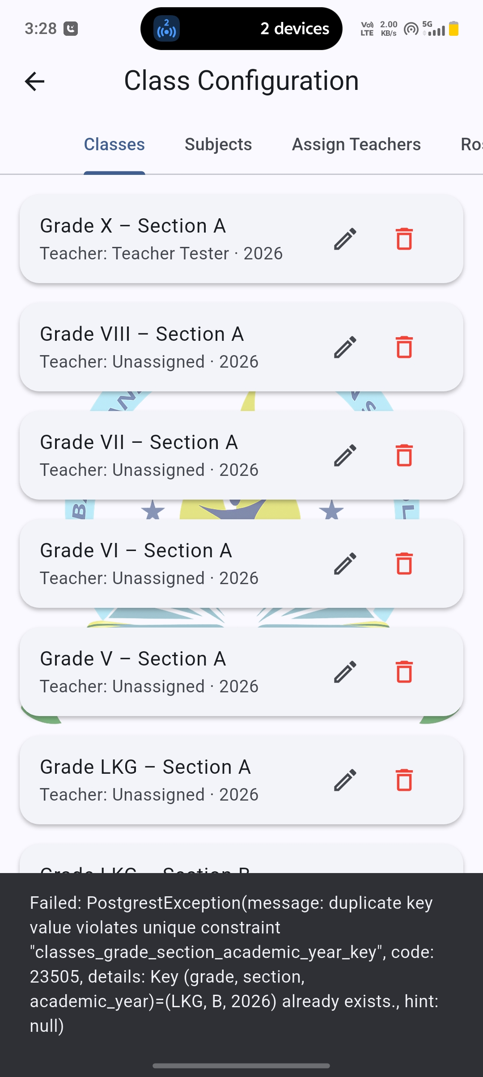

- Unable to register new users
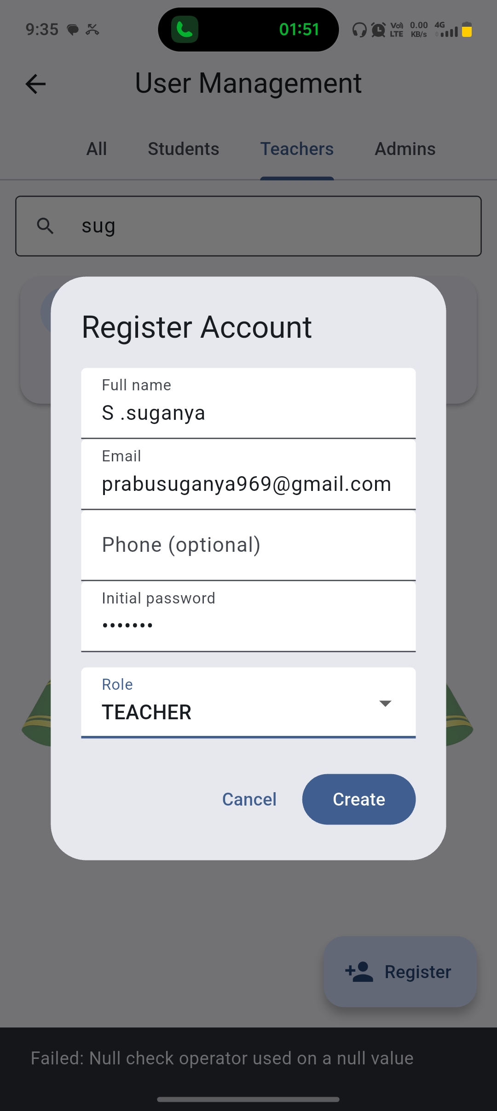

- Update the existing data of teachers entirely with this data


