Creating Account and Loan Microservices using Spring Boot

This guide explains how to create two separate Spring Boot microservices for a bank:  
- One microservice for handling Account details  
- One microservice for handling Loan details  
  
Each service is an independent Maven-based Spring Boot project with no database connectivity and runs on a different port.

# Account Microservice

## Step 1: Generate the Project

1. Open https://start.spring.io  
2. Fill in:  
 - Group: com.cognizant  
 - Artifact: account  
3. Add dependencies:  
 - Spring Web  
 - Spring Boot DevTools  
4. Click 'Generate' to download the ZIP file  
5. Extract and place the 'account' folder inside:  
 D:/<your_employee_id>/microservices/

## Step 2: Configure the Port

1. Open src/main/resources/application.properties  
2. Add:  
 server.port=8081

## Step 3: Create the Controller

package com.cognizant.account.controller;  
  
import org.springframework.web.bind.annotation.*;  
import java.util.*;  
  
@RestController  
@RequestMapping("/accounts")  
public class AccountController {  
  
 @GetMapping("/{number}")  
 public Map<String, Object> getDetails(@PathVariable String number) {  
 Map<String, Object> response = new HashMap<>();  
 response.put("number", number);  
 response.put("type", "savings");  
 response.put("balance", 234343);  
  
 return response;  
 }  
}

## Step 4: Create the Main Application Class

package com.cognizant.account;  
  
import org.springframework.boot.SpringApplication;  
import org.springframework.boot.autoconfigure.SpringBootApplication;  
  
@SpringBootApplication  
public class AccountApplication {  
 public static void main(String[] args) {  
 SpringApplication.run(AccountApplication.class, args);  
 }  
}

## Step 5: Run the Microservice

Use the following command to run:  
mvn spring-boot:run  
  
Once running, it will be accessible at:  
http://localhost:8081/accounts/00987987973432

## Step 6: Sample Response

{  
 "number": "00987987973432",  
 "type": "savings",  
 "balance": 234343  
}

Output:

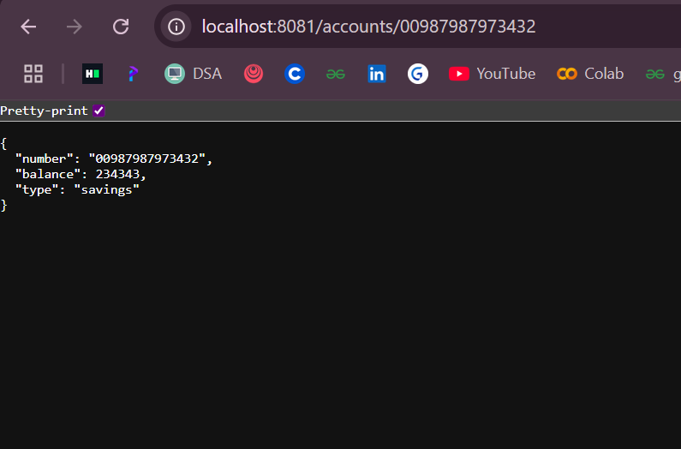

# Loan Microservice

## Step 1: Generate the Project

1. Open https://start.spring.io  
2. Fill in:  
 - Group: com.cognizant  
 - Artifact: loan  
3. Add dependencies:  
 - Spring Web  
 - Spring Boot DevTools  
4. Click 'Generate' to download the ZIP file  
5. Extract and place the 'loan' folder inside:  
 D:/<your_employee_id>/microservices/

## Step 2: Configure the Port

1. Open src/main/resources/application.properties  
2. Add:  
 server.port=8082

## Step 3: Create the Controller

package com.cognizant.loan.controller;  
  
import org.springframework.web.bind.annotation.*;  
import java.util.*;  
  
@RestController  
@RequestMapping("/loans")  
public class LoanController {  
  
 @GetMapping("/{number}")  
 public Map<String, Object> getDetails(@PathVariable String number) {  
 Map<String, Object> response = new HashMap<>();  
 response.put("number", number);  
 response.put("type", "car");  
 response.put("loan", 400000);  
 response.put("emi", 3258);  
 response.put("tenure", 18);  
 return response;  
 }  
}

## Step 4: Create the Main Application Class

package com.cognizant.loan;  
  
import org.springframework.boot.SpringApplication;  
import org.springframework.boot.autoconfigure.SpringBootApplication;  
  
@SpringBootApplication  
public class LoanApplication {  
 public static void main(String[] args) {  
 SpringApplication.run(LoanApplication.class, args);  
 }  
}

## Step 5: Run the Microservice

Use the following command to run:  
mvn spring-boot:run  
  
Once running, it will be accessible at:  
http://localhost:8082/loans/H00987987972342

## Step 6: Sample Response

{  
 "number": "H00987987972342",  
 "type": "car",  
 "loan": 400000,  
 "emi": 3258,  
 "tenure": 18  
}

Output:

