Laboratory Work №1

Topic: Introduction to UI/UX Design
Student: AAAAA BBBBB

Almaty 2025
- Theoretical Part UI design
UX/UI design is the process of creating digital products (websites, apps, dashboards, etc.) that are useful, easy to use, and visually appealing. It is all about buttons, textboxes, colours, layouts, elements design and, etc.
UX is about the experience the user has while using the product. UX designers focus on how the product works and feels.

Aspect | UX Design (User Experience) | UI Design (User Interface)
Focus | How the product works and how users feel using it | How the product looks and how users interact with it
Goal | Make the product easy, logical, and enjoyable to use | Make the product visually attractive and consistent
Main Concern | User journey, flow, usability | Colors, typography, buttons, layout
Involves | Research, wireframing, prototyping, testing | Visual design, branding, interactivity
Tools Used | Figma, Adobe XD, Miro, Notion, Maze | Figma, Sketch, Adobe XD, Photoshop
Deliverables | User personas, user flows, wireframes, prototypes | High-fidelity screens, style guides, design systems
Questions Asked | “Is this easy to use?” “Does it solve the user’s problem?” | “Does this look clean?” “Is this on-brand?”
Output Example | Flow diagram of how users complete a task | Final polished app or website design
2. Analytical Part

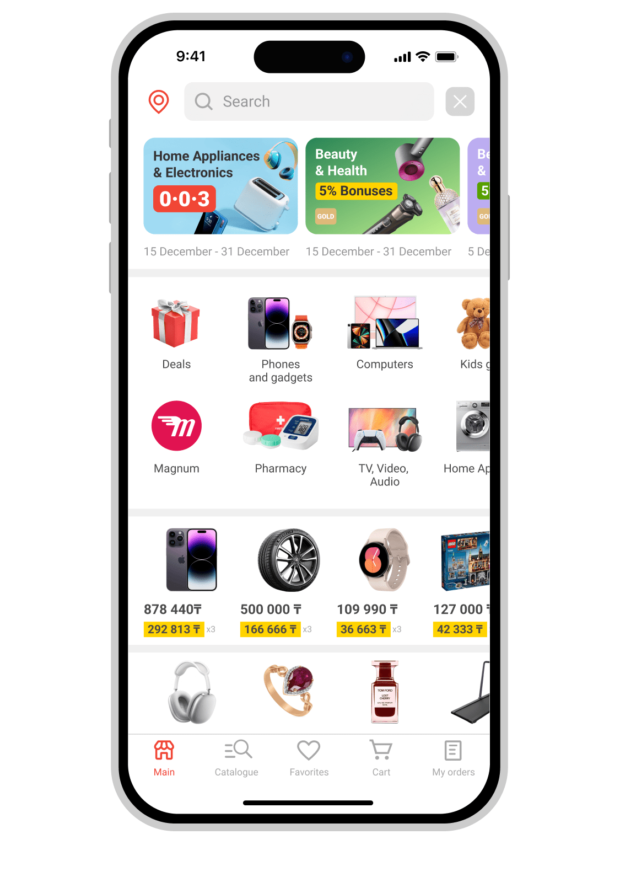

Strengths of design
- Simple and familiar interface for most users in Kazakhstan
- Fast payments, transfers, and marketplace access
- All main services (banking, shopping, QR payments) in one app
- Strong brand trust and consistent design

Weaknesses
- Too many features — hard to navigate for new users
- Occasional app lags or crashes
- No dark mode or advanced accessibility settings
- Some flows (like parking payment) take too many steps

Recommendations
- Simplify navigation and group main services clearly
- Optimize performance and reduce app crashes
- Add dark mode and accessibility options
- Shorten user flows for common actions (pay, shop, transfer)
- Improve visual polish with smoother animations and spacing

3. Practical part
Clinic App - UX/UI design

Goal
Help patients book doctor appointments, view departments, and get basic clinic info quickly and easily.
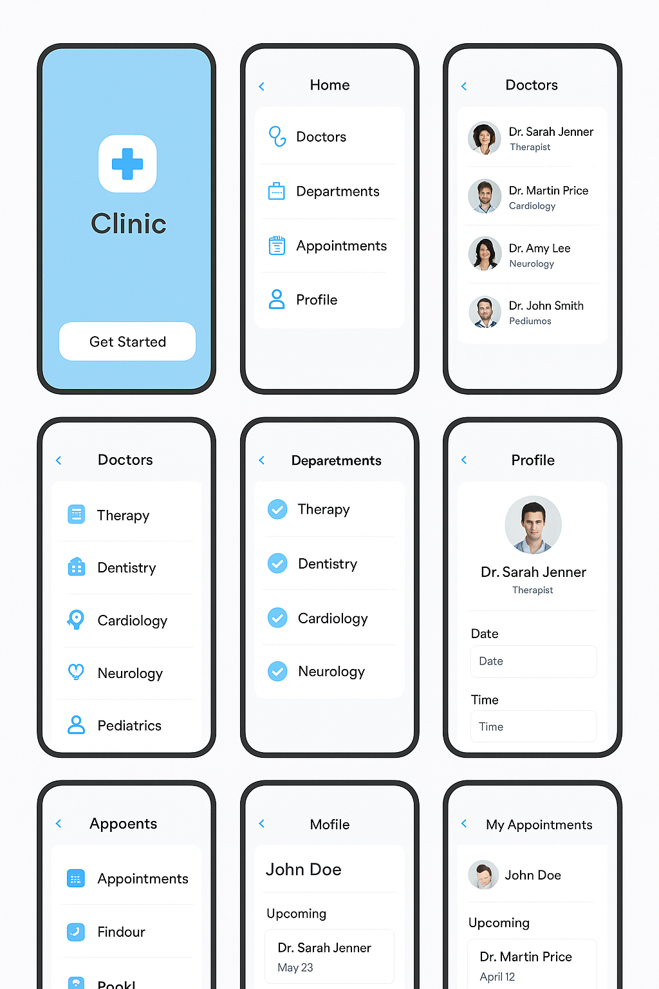

Design Description
The clinic app uses a light blue and white color palette, creating a clean and calm medical feel. Icons are simple and outlined, with rounded corners and plenty of white space. Fonts are clear and readable, and screens are structured in a straightforward list format easy for beginners to navigate.

Good Sides
- Simple layout and clear navigation
- Calm and clean colors light blue means trust, health
- Easy to understand for users of all ages
- Consistent icons and spacing
- Minimalist not overloaded with info

Weak Sides
- Feels too basic lacks visual depth or modern style
- Buttons and icons could be more interactive
- No clear hierarchy between main and secondary info
- Lacks personality (too generic medical look)
- Doesn’t show real images or branding elements

Conclusion

This clinic app design shows a solid foundation in UX/UI principles it’s clean, easy to navigate, and user-friendly. The color palette and layout create a calm and trustworthy atmosphere, which fits well for a medical app. However, as a junior-level project, it still needs improvement in visual depth, hierarchy, and interactive elements to make the experience more engaging and modern. Overall, the design successfully meets its main goal helping users easily find doctors, view departments, and book appointments while leaving room for future enhancement in visual style and user interaction. With further refinement, such as adding micro-animations, clearer button emphasis, and real clinic branding, this concept could evolve into a professional and fully functional app. It demonstrates good UX thinking and a growing understanding of clean, purposeful design.

