

International University of Information Technology

Department of Computer Engineering

Laboratory work № 2

Student: AAAA BBBBB

Almaty 2025

Procedure
For this lab, I took a sheet of paper and drew three versions of the main screen for my Clinic App.
The task was to design the Home Screen, where users can easily navigate between departments, doctors, and appointments.
Each version included labeled sections:
- Header: App name and logo
- Menu: Navigation bar at the bottom
- Main content: Cards for “Departments,” “Doctors,” “Appointments,” and “Profile”
- Action buttons: Quick “Book Appointment” and “Emergency Contact” buttons
I experimented with different layouts changing button positions, image placements, and navigation styles to see which design felt clearer and more balanced. After drawing all three, I compared them and selected the best version for future work in Figma.

Report Assignment

1. Why is sketching used in UX design?
Sketching is used in UX design to quickly visualize ideas and explore different layout options before creating detailed wireframes or prototypes. It helps designers think creatively, communicate early concepts, and gather feedback faster without focusing on visual perfection.

2. How are sketches different from wireframes?
Sketches are hand-drawn and rough, showing only general ideas and layout.
Wireframes are digital and structured, showing the exact placement of elements, spacing, and navigation. Sketches help generate ideas, while wireframes define how the interface will function.

3. What is the advantage of creating several different versions?
Creating several versions allows designers to test multiple layouts and compare usability. It helps find the best balance between aesthetics and functionality. This process encourages creativity and ensures the final design meets user needs before investing time in detailed design or prototyping.

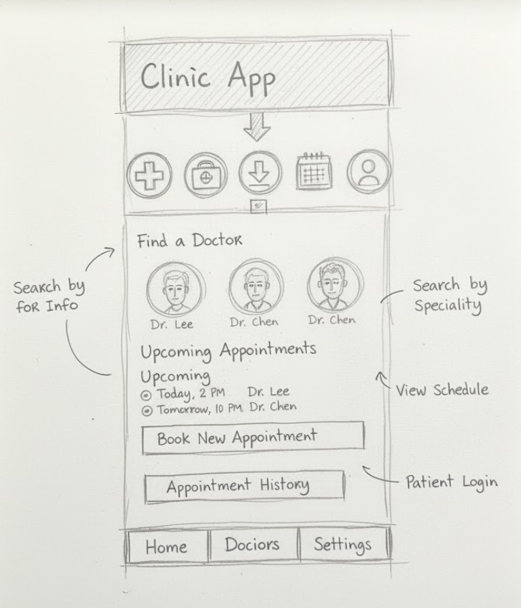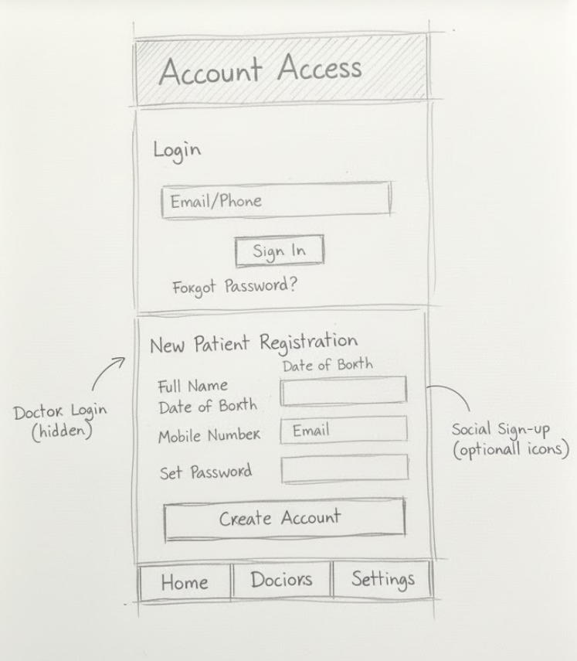
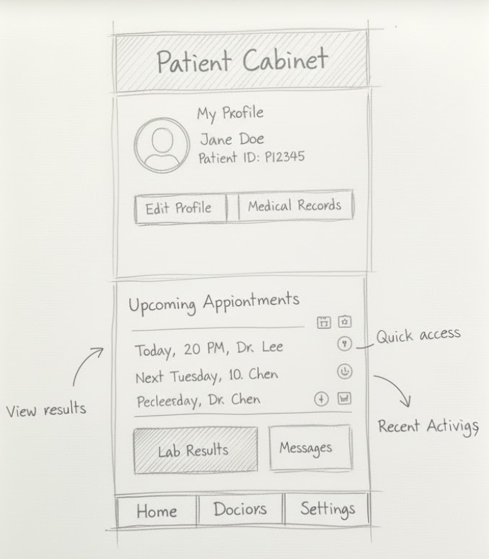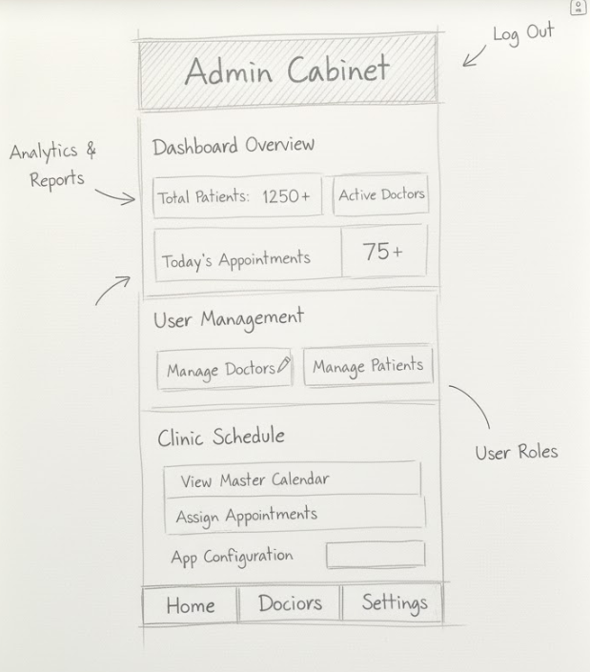
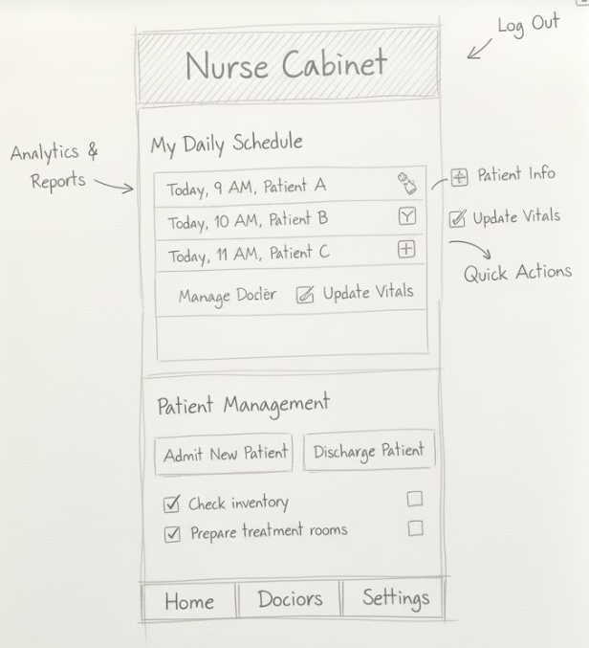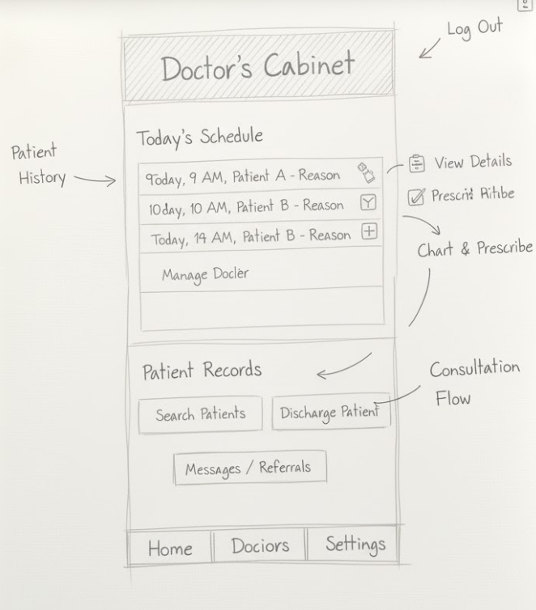

Conclusion
I chose the third version for further development because it looks cleaner and easier to use. In this version, I reorganized the layout, making the bottom navigation bar more functional and visually balanced. The Dark Mode button stayed the same using a small button instead of a switch fits better with the app’s minimalist design and doesn’t distract users. Overall, this version combines simplicity, comfort, and a modern look suitable for the Clinic App.

