Guest网络设置

2014/4/10

renyl

# 1 Bridge的设定

## 1.1 确认能ping通对联机

首先本机的一块物理网卡（以eth2为例）和对联机已经连接，确认和对联机能够ping通，假设对联机IP地址: 192.168.2.2

|  |
| --- |
| # vim /etc/sysconfig/network-scripts/ ifcfg-eth2  DEVICE="eth2"  HWADDR="00:23:26:F1:29:A4"  ONBOOT="yes"  BOOTPROTO="static"  IPADDR=192.168.2.1  # ifdown eth2;ifup eth2  # ping 192.168.2.2 |

## 1.2 添加br0

/etc/sysconfig/network-scripts/目录下添加ifcfg-br0文件，内容如下：

|  |
| --- |
| # vim /etc/sysconfig/network-scripts/ ifcfg-br0  DEVICE=br0  TYPE=Bridge ※1  BOOTPROTO=none  ONBOOT=yes |

※1：TYPE=Bridge 注意大小写敏感。

## 1.3 将eth2关联到br0

在eth2配置文件中添加BRIDGE=br0

|  |
| --- |
| # vim /etc/sysconfig/network-scripts/ ifcfg-eth2  DEVICE="eth2"  HWADDR="00:23:26:F1:29:A4"  ONBOOT="yes"  BOOTPROTO="static"  BRIDGE=br0 |

## 1.4 重启br0，并设置STP为yes

|  |
| --- |
| # ifdown br0;ifup br0  # brctl show  bridge name bridge id STP enabled interfaces  br0 8000.c80aa933505e no eth2  # brctl stp br0 yes  bridge name bridge id STP enabled interfaces  br0 8000.c80aa933505e yes eth2 |

## 1.5 将br0添加到guest中

### 1.5.1 在host中执行virt-manager命令

# virt-manager

### 1.5.2 为虚拟机添加虚拟网卡

点击Add Hardware，添加虚拟网卡，如下图

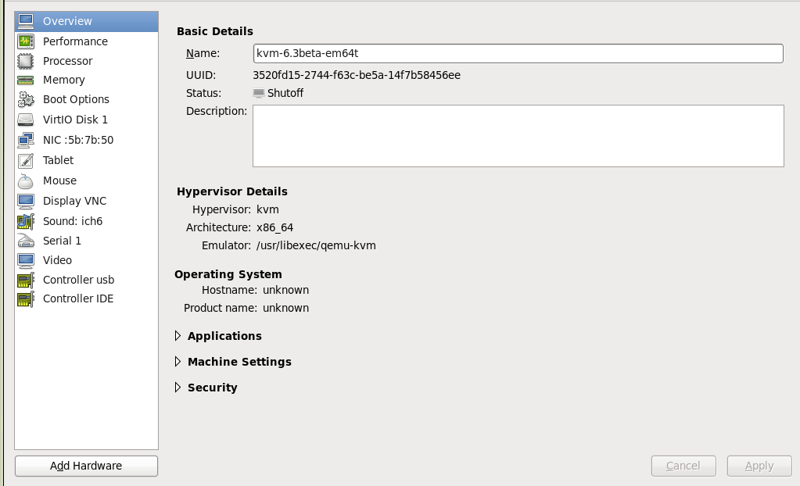

### 1.5.2 选择Network：Host device: br0，Device model: virtio

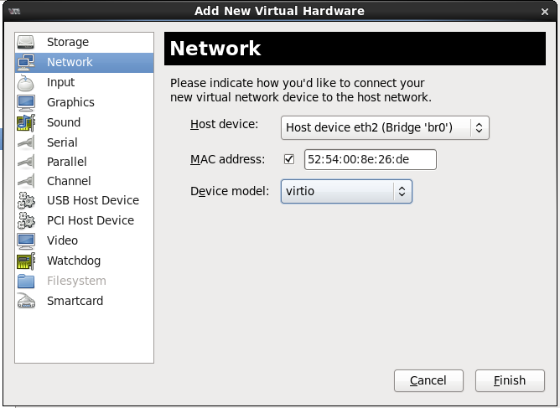

## 1.6 添加完虚拟网卡后，启动虚拟机

# virsh start 虚拟机名

## 1.7 在虚拟机中，设置IP地址

|  |
| --- |
| # vim /etc/sysconfig/network-scripts/ifcfg-eth1  DEVICE="eth1"  BOOTPROTO="static"  HWADDR="52:54:00:8e:26:de"  NM_CONTROLLED="yes"  ONBOOT="yes"  TYPE="Ethernet"  IPADDR=192.168.2.1 ※3 |

※3 与对联机同一网段的IP地址

## 1.8 在虚拟机中，重启网络

# /etc/rc.d/init.d/network restart

# ifconfig | grep eth1

## 1.9 在虚拟机中，和对联机ping确认

# ping 对联机的IP地址

|  |
| --- |
| # ping 192.168.2.2  PING 192.168.2.2 (192.168.2.2) 56(84) bytes of data.  64 bytes from 192.168.2.2: icmp_seq=1 ttl=64 time=0.337 ms  64 bytes from 192.168.2.2: icmp_seq=2 ttl=64 time=0.285 ms |

# 2 PCI passthrough的设定

## 2.1 host的设定

### 2.1.1 在grub.conf的kernel行添加intel_iommu=on

|  |
| --- |
| # vim /boot/efi/EFI/redhat/grub.conf  kernel /vmlinuz-2.6.32-262.el6.x86_64 ro root=UUID=5abe1186-9917-41ec-b057-641f08b0eba5 5rd_NO_LUKS rd_NO_LVM LANG=en_US.UTF-8 rd_NO_MD SYSFONT=latarcyrheb-sun16 crashkernel=128M KEYBOARDTYPE=pc KEYTABLE=us rd_NO_DM rhgb quiet intel_iommu=on |

### 2.1.2重启系统

# reboot

### 2.1.3 BIOS上有効性的确认

|  |
| --- |
| # dmesg | grep 'ACPI: DMAR'  ACPI: DMAR 0000000072bbb000 00048 (v01 FUJ PC 00000001 FJ 00000001) |

### 2.1.4 IOMMU驱动器有效性的确认

|  |
| --- |
| # dmesg | grep 'Virtualization Technology for Directed I/O'  PCI-DMA: Intel(R) Virtualization Technology for Directed I/O |

### 2.1.5 IOMMU驱动器有效性的确认

|  |
| --- |
| # lspci | grep Ethernet（网络）或者Fibre（光纤卡磁盘）  06:00.0 Ethernet controller: Intel Corporation 82576NS Gigabit Network Connection (rev 01)※4 |

※4 先頭の06:00.0为PCI番号，bus=0x06, slot=0x00, function=0x0。

### 2.1.6从 virsh nodedev-list指定特定设备

|  |
| --- |
| # virsh nodedev-list --tree | grep 06_00_0  pci_0000_06_00_0 ※5 |

### 2.1.7 从virsh dumpxml确认设备是否是FC卡

|  |
| --- |
| # virsh nodedev-dumpxml pci_0000_06_00_0  <device>  <name>pci_0000_06_00_0</name>  <parent>pci_0000_04_01_0</parent>  <driver>  <name>igb</name>  </driver>  <capability type='pci'>  <domain>0</domain>  <bus>6</bus>  <slot>0</slot>  <function>0</function>  <product id='0x150a'>82576NS Gigabit Network Connection</product>  <vendor id='0x8086'>Intel Corporation</vendor>  <capability type='virt_functions'>  </capability>  </capability>  </device> |

### 2.1.8在Host上做detach操作

|  |
| --- |
| # virsh nodedev-dettach pci_0000_06_00_0  Device pci_0000_06_00_0 dettached |

## 2.2 虚拟机添加PCI设备

### 2.2.1 在host中执行virt-manager命令

# virt-manager

### 2.2.2为虚拟机添加PCI设备

点击Add Hardware，添加PCI设备，如下图所示



### 2.2.3 选择PCI设备

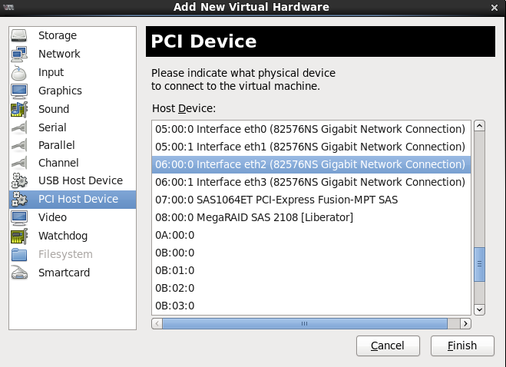

### 2.2.4 完成PCI设备的添加，如下图所示：

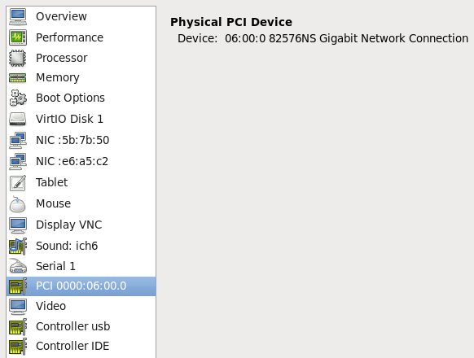

### 2.2.5 启动虚拟机

# virsh start 虚拟机名 ※7

※7 使用PCI passthrough时，不能把host全部的资源分配给虚拟机。

### 2.2.6 用lspci确认设备

|  |
| --- |
| # lspci | grep Ethernet  06:00.0 Ethernet controller: Intel Corporation 82576NS Gigabit Network Connection (rev 01) |

### 2.2.7 确认该设备的驱动器状态

|  |
| --- |
| # readlink /sys/bus/pci/devices/0000\:00\:06.0/driver  ../../../../bus/pci/drivers/igb |

### 2.2.8在虚拟机中，设置IP地址

|  |
| --- |
| # vim /etc/sysconfig/network-scripts/ifcfg-eth1  DEVICE="eth1"  BOOTPROTO="static"  HWADDR="52:54:00:8e:26:de"  NM_CONTROLLED="yes"  ONBOOT="yes"  TYPE="Ethernet"  IPADDR=192.168.2.1 ※9 |

※9与对联机同一网段的IP地址

### 2.2.8在虚拟机中，重启网络

# /etc/rc.d/init.d/network restart

# ifconfig | grep eth1

### 2.2.9在虚拟机中，和对联机ping确认

# ping 对联机的ip地址

|  |
| --- |
| # ping 192.168.2.2  PING 192.168.2.2 (192.168.2.2) 56(84) bytes of data.  64 bytes from 192.168.2.2: icmp_seq=1 ttl=64 time=0.337 ms  64 bytes from 192.168.2.2: icmp_seq=2 ttl=64 time=0.285 ms |