Kulshree Jagtap 25070521143

5.1.2 Student Grade Based on Aggregate

Algorithm:
Step 1: Start
Step 2: Input four integer marks: a,b,c,d.
Step 3: Calculate total marks: total = a,b,c,d.
Step 4: Calculate aggregate percentage:p = (total / 400) * 100.
Step 5: If aggregate > 75, assign grade = 'Distinction'.
Step 6: Else if aggregate >= 60, assign grade = 'First Division'.
Step 7: Else if aggregate >= 50, assign grade = 'Second Division'.
Step 8: Else if aggregate >= 40, assign grade = 'Third Division'.
Step 9: Else assign grade = 'Fail'.
Step 10: Print total marks.
Step 11: Print aggregate percentage (two decimal places).
Step 12: Print the grade.
Step 13: End.

Flowchart:

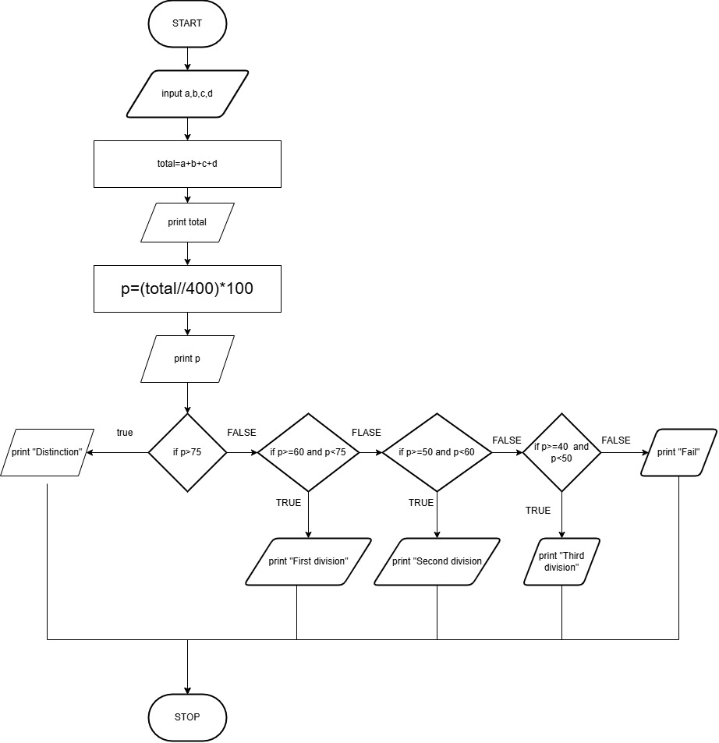

Execution:
