Kulshree Jagtap 25070521143

5.1.1 Leap Year Checker Program

Algorithm:
Step 1: Start
Step 2: Input the year from the user.
Step 3: Check if (year % 400 == 0) OR (year % 4 == 0 AND year % 100 != 0).
Step 4: If the condition is true, print "Leap year".
Step 5: Otherwise, print "Not a leap year".
Step 6: Stop
Flowchart: 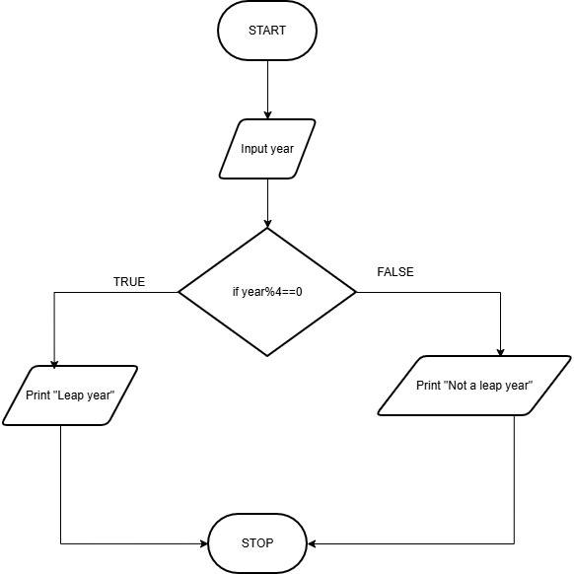
Execution:
