Kulshree Jagtap 25070521143

4.1.1 Set Operations

Algorithm:
Step 1: Start
Step 2: Read the values of SET A and SET B.
Step 3: Calculate
- Union: Combine all unique elements from both Set A and Set B (A | B).
- Intersection: Identify only the elements that exist in both Set A and Set B (A & B).
- Difference: Identify elements that are in Set A but not in Set B (A - B).
Step 4: Print
- Display the result of the Union.
- Display the result of the Intersection.
- Display the result of the Difference.
Step 5: Stop.

Flowchart: 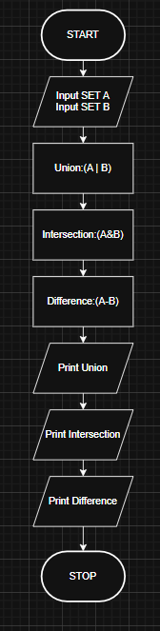

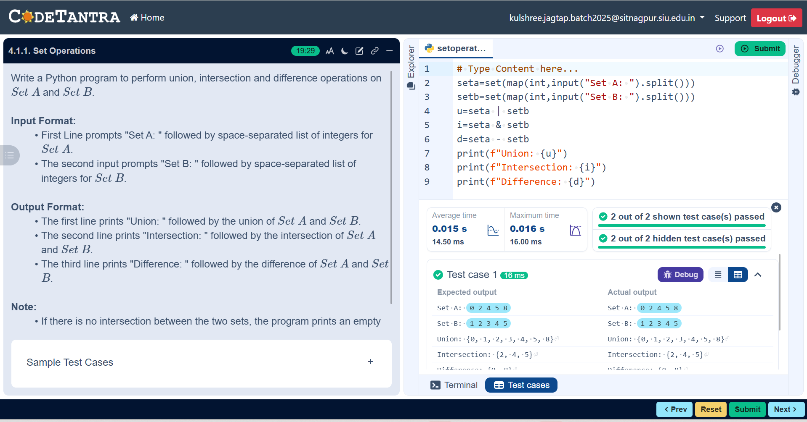

Execution:

