2.1.1 Roots of an Equation

Algorithm:
- Start.
- Read three space-separated integers a, b, and c.
- Calculate the discriminant.
D=b*b -4*a*c
- Check the value of discriminant.
- Case1: If D > 0 (Real and different roots)
Print: root1,root2.
- Case 2: If D == 0 (Real and same roots)
Print : root1=root2.
- Case 3: If D < 0 (Imaginary roots)
Print : Root = root 1 + imaginary
Root = root 2 + imaginary
- Stop.

Flowchart:
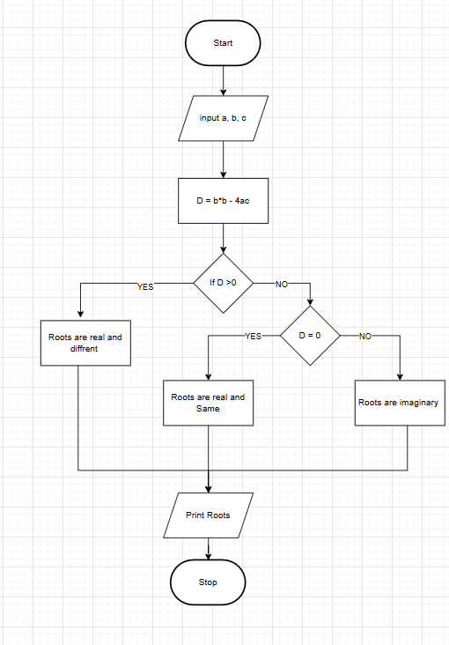

Execution :
