**_____________________**

**Software Requirements**

**Specification**

**for**

**LogicMaster**

**Prepared By:**

**Divyansh, Shivam, Baljeet, Sachin and Anmol**

**June 2020**

**Table of Contents**

**1. Introduction**

1.1 Purpose…………………………………………………………………………………………….…4

1.2 Document Convention……………………………………………………………………………....4

1.3 Intended Audience and Reading Suggestions……………………………………………………4

1.4 Product Scope…………………………………………………………………………………….….4

1.5 References…………………………………………………………………………………………....5

**2. Overall Description**

2.1 Product Perspective………………………………………………………………………………....5

2.2 Product Functions……………………………………………………………………………………5

2.3 Operating Environment…………………………..………………………………………………….6

2.4 Design and Implementation Constraints……………………………….………………………….6

2.5 User Documentation…………………………………………………………………………………6

**3. External Interface Requirements**

3.1 User Interfaces…………………………….…………………………………………………………7

3.2 Hardware Interfaces………………………………………………………………………………..10

**4. System Features**

4.1 Data Table…………………………………………….…………………………………………….11

4.2 Servlets……………………………………………….……………………………………..………12

4.3 JSP…………………………………………………………………………………………………..12

**5. Other Nonfunctional Requirements**

5.1 Performance Requirements……………………………………………………………………….12

5.2 Safety Requirements ………………………………………………………………………………12

5.3 Security Requirements ……………………………………………………………….……………13

5.4 Software Quality Attributes ………………………………………………………………………..13

**1. Introduction**

**1.1 Purpose.**

The purpose of this document is to present a detailed description of the web application LogicMaster. It will explain the purpose and features of the software, the interfaces of the software, what the software will do and the constraints under which it must operate. This document is intended for users of the software and also potential developers.

**1.2 Documentation Convention.**

This Document was created based on the IEEE template for System Requirement Specification Documents.

**1.3 Intended Audience and Reading Suggestions.**

•Typical Users, such as students, who want to use LogicMaster for learning technologies like Java, Hibernate, etc

•Advanced/Professional Users, such as engineers or researchers, who want to use LogicMaster to add to their skills by learning latest and trending technologies.

• Any user who wants to use LogicMaster to share queries and find solutions for one.

**1.4 Product Scope.**

* VCS (Virtual Classroom System) aims to promote a greater count of students to splurge into the field of Education. It integrates the benefits of a physical classroom with the convenience of a ‘no-physical-bar’ Virtual Classroom System, minus the commuting hazards and expenses. It will usher in the immense flexibility and sophistication in the existing learning platform structures.
* Software Requirements Specification for Virtual Classroom System

**1.5 References.**

* Udemy
* Unacademy
* Getbootstrap
* Quora
* And some other online E-learning websites.

**2. Overall Description**

**2.1 Product Perspective**

HTML HTML CLIENT CLIENT [Admin, [Admin, Management, Management, Faculty, Faculty, Student] Student] Application Application Server Server Database Database Server Server

HTTP/HTTPS

•The web pages (HTML/JSP) are present to provide the user interface on customer

**2.2 Product Functions**

* Create account.
* Delete account.
* Students can post Questions.
* Student can find answers here.
* It is based on E-Learning there is no barrier of natural calamities
* You can update your profile’
* End to end protection.
* Keep records on your learning

**Users registration**

User can register/sign-up into the LogicMaster web-app to explore more functionality. By signing up user can access the forum to post his/her doubts and will be able to see the queries asked and their solutions respectively.

**User access**

User can access the courses present in the web-app for free. In this web-app user can access Java core full course for free of cost.

**Forum**

This module works as an online chat to connect students. It allows publishing text messages for public view in real time. After publishing the queries anyone can answer those questions.

**2.3 Operating Environment**

• Windows 7

• Windows 8

• Windows 10

• Mac OS X

• Smartphone

**2.4 Design and Implementation Constraints**

LogicMaster is developed in Java. It has been built on top of the Eclipse Platform. It uses a modular design where every feature is wrapped into a separate module and the modules depend on each other through well-written JSPs.

* 1. **User Documentation**

There is a quick start guide will be available on the github.

We will share the github link soon. Basic way to use the website will be available on the Home page of website.

**3. External Interface Requirements**

* 1. **User interfaces**

1.LogicMaster’s Welcome Screen

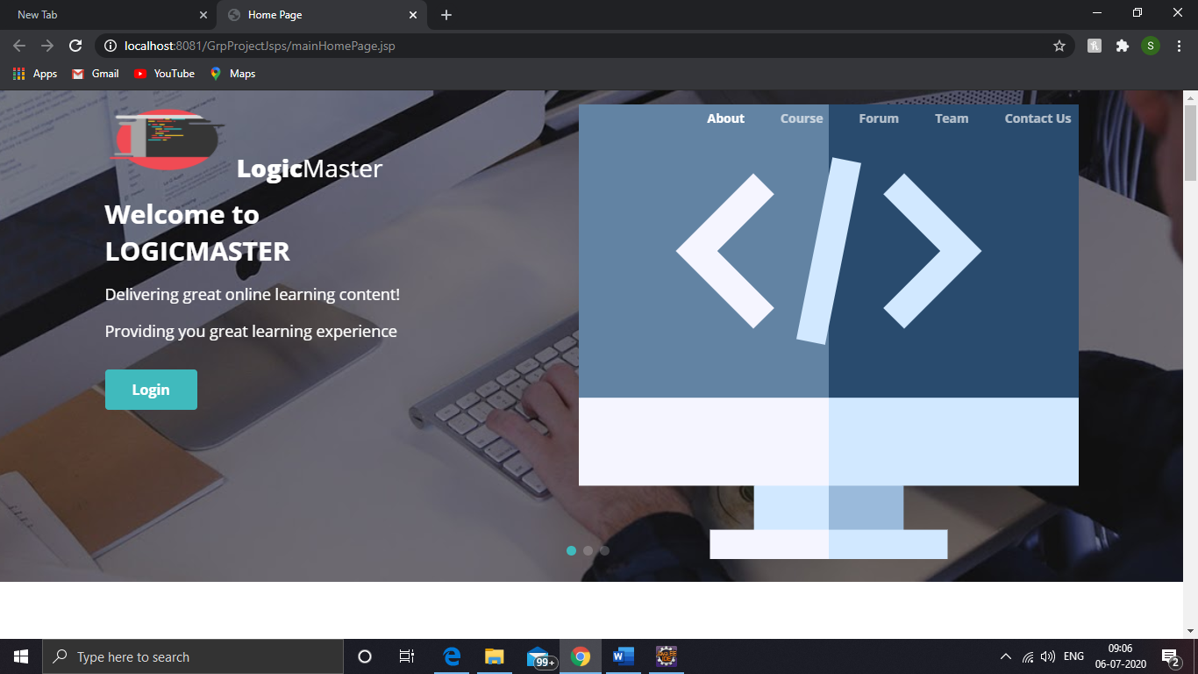

2.LogicMaster’s course screen

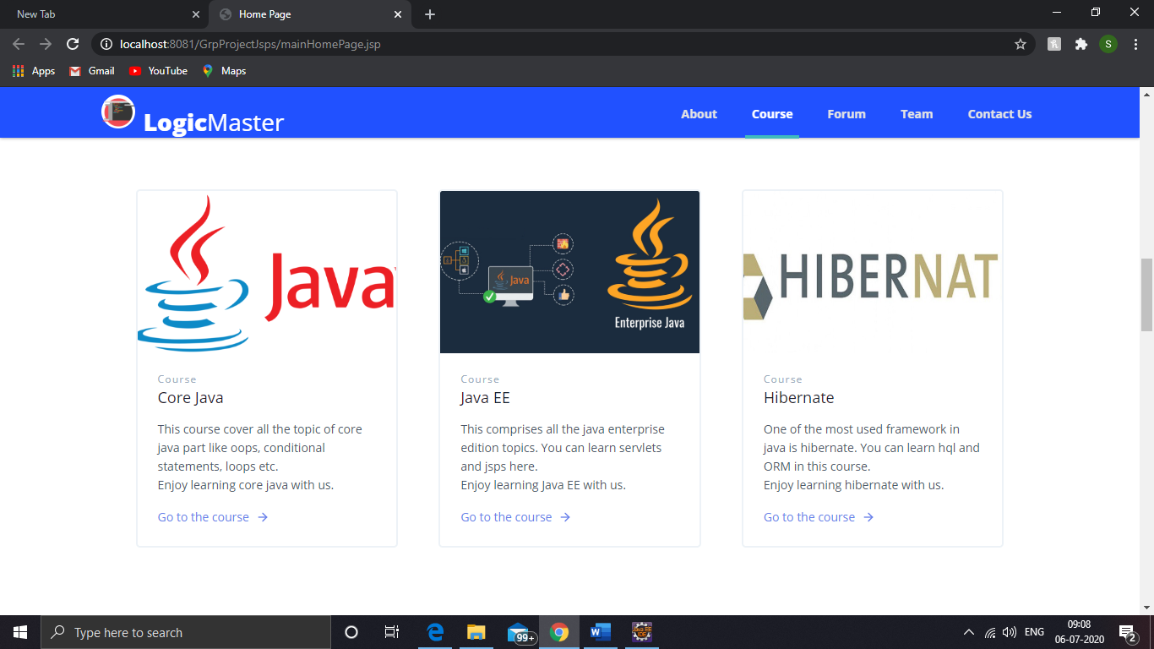

3.LogicMaster’s Forum screen

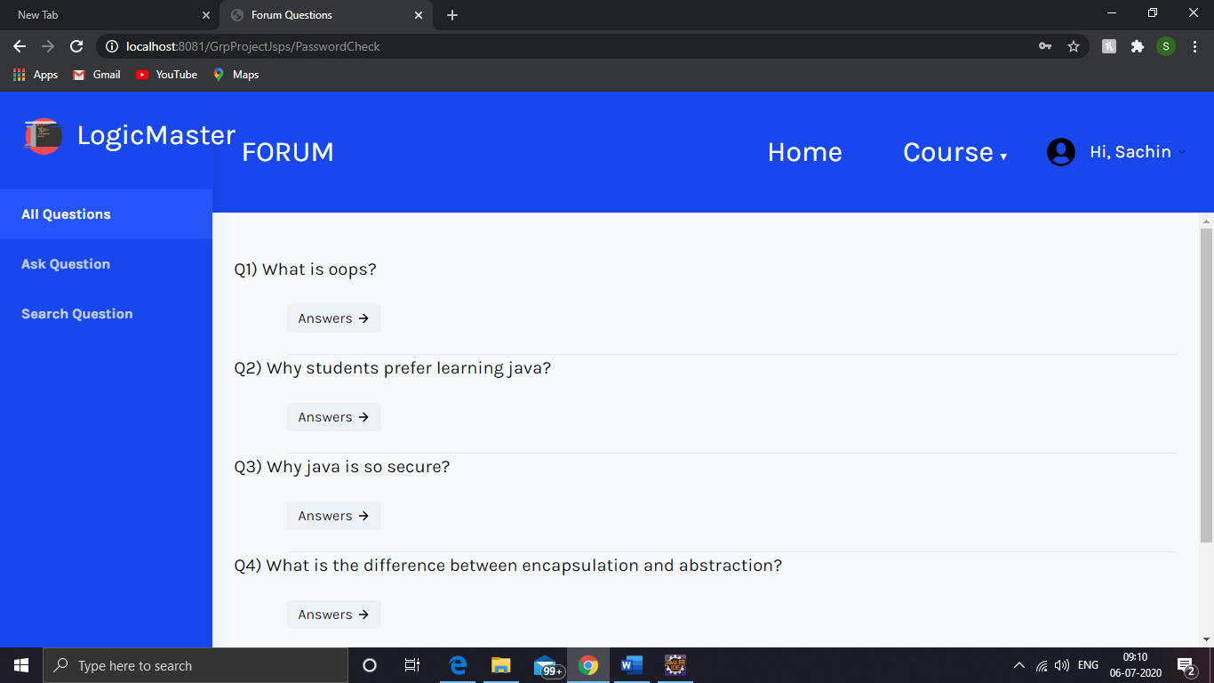

4. LogicMaster’s signin screen

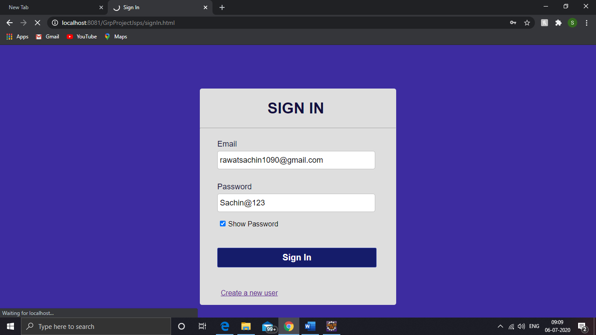

5. LogicMaster’s java course

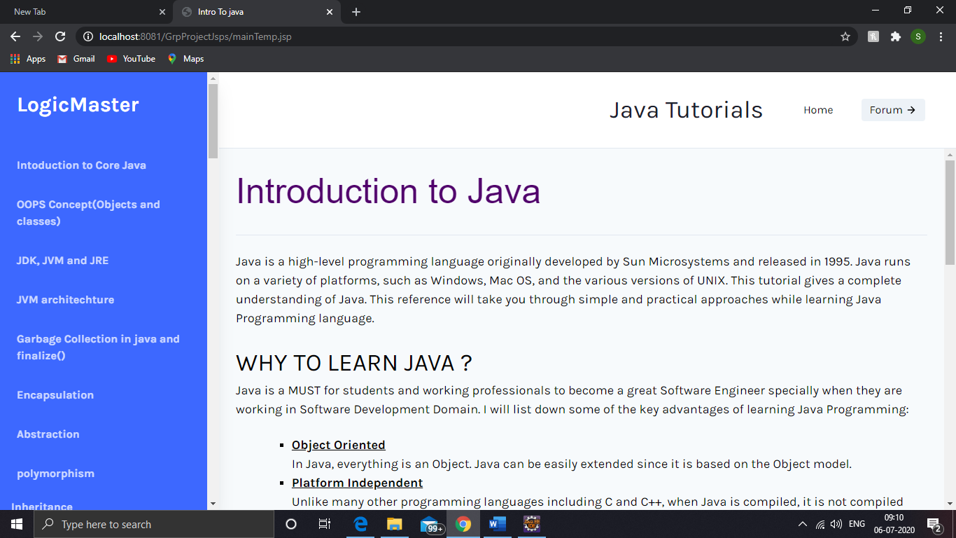

**3.2 Hardware Interfaces**

There is no direct hardware interface specifically for Logicmaster application. The web application runs on an application server hosted in-house on enterprise hardware.

**4. System Features**

**4.1 Data Table**

There are four tables:

1. user_table

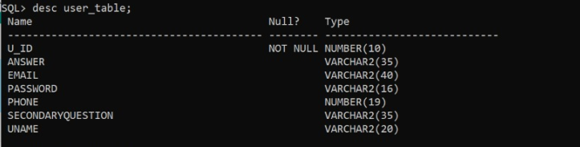

2. Question_table

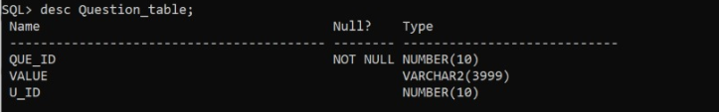

3. Answer_Table

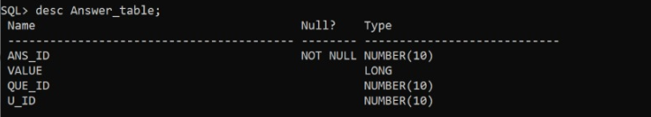

4. code

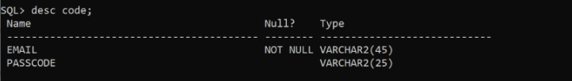

**4.2 Servlets**

We also use servlet in our web Application for validation purpose for redirection from one page to another and also we use servlet in forum.

**4.3 Jsp**

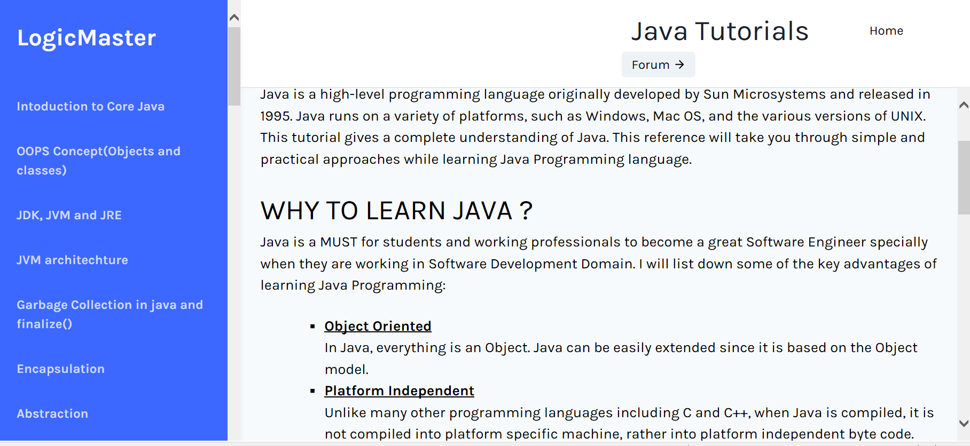

There are sixty nine jsp pages in Logicmaster which is used for UI(user interface).We use jsp pages because it help us in developing webpages that supports dynamic web content.It help us to add Java in HTML pages.

**5. Other Non-functional Requirements**

**5.1 Performance Requirements**

The following are the key performance requirements,

* All pages should load within 2 seconds .
* When you move from one topic to another topic then the results should be displayed within 1 second.

**5.2 Safety Requirements**

To ensure that no one of LogicMaster’s users loses any data while using LogicMaster (due to a crash or a bug of some kind) the developer team updates LogicMaster

regularly.

**5.3 Security Requirements**

LogicMaster does not have any security requirements but if you want to use additional features of LogicMaster then you must be login first.

**5.4 Software Quality Attributes**

LogicMaster provides the users with both simple and advanced features. Due to its well designed and easy to use interface it can be used by both experts and typical users.