PROJECT TECHNICAL REPORT
Shillong Land Use / Land Cover
Detection Pipeline
An Instance-Segmentation Approach to Multi-Class LULC Mapping using Satellite Imagery, GAN-Based Augmentation, and Semi-Supervised Mask R-CNN

Study Area: Shillong, Meghalaya, India
Task: Instance Segmentation — LULC Mapping
Model: Mask R-CNN (ResNet-50 FPN)
Document Version 2.0

Table of Contents
1. Introduction 3
1.1 Key Project Parameters 3
2. Dataset Overview 4
2.1 Image Sources 4
2.2 Valid-Pixel Statistics 4
3. Preprocessing Pipeline 5
3.1 Valid-Pixel Masking 5
3.2 Denoising 5
3.3 CLAHE Contrast Enhancement 5
4. Patch Extraction & Dataset Splits 6
5. GAN-Based Data Augmentation 7
6. Manual Annotation 8
6.1 Land Cover Classes (15 Categories) 8
6.2 Annotation Summary 8
7. Model Architecture & Training 9
8. Model Retraining – Cloud Class & Weighted Loss 9
8.1 WITH_CLOUD Dataset 9
8.2 Weighted Fast R-CNN Loss 10
8.3 Training Configuration 10
8.4 Training Loss Log 11
9. Validation & Detection Results 12
9.1 Sample Validation Patches with Detections 12
9.2 Sample Test Patches Used for Validation 12
9.3 Step 6 – Automatic Detection on Full Test Set 13
10. Output Artefacts 13
11. Pipeline Summary 13

1. Introduction
This report documents the end-to-end machine learning pipeline developed for Land Use / Land Cover (LULC) mapping of the Shillong region using high-resolution satellite imagery. The pipeline covers raw image ingestion, preprocessing, patch extraction, GAN-based data augmentation, manual annotation, and model training with Mask R-CNN for instance segmentation.
The dataset comprises 219 multi-source satellite images, including RESOURCESAT (RA3xx series), standard grid tiles (numeric IDs), and auxiliary image sets (AA-series and qwerty-series). Fifteen LULC categories were defined, covering agricultural, urban, forest, water, and transitional land-cover types.

1.1 Key Project Parameters
Field | Detail
Study Area | Shillong, Meghalaya, India
Task | Instance Segmentation – LULC Mapping
Total Source Images | 219
Land Cover Classes | 16 (15 LULC + Cloud_NoData)
Model Architecture | Mask R-CNN (ResNet-50 FPN)
Loss Function | Weighted FastRCNN Loss (class-balanced)
Augmentation | Classical + GAN-based synthetic patches
Annotation Tool | QGIS / VGG Image Annotator (VIA)
Annotation Format | COCO JSON
Final Training Loss | 0.4335 (epoch 10 / 10)

2. Dataset Overview

2.1 Image Sources
Source Prefix | Description | Approx. Count
RA3xx | RESOURCESAT-2/2A (LISS-IV / PAN) | ~100
AA-series | High-resolution auxiliary acquisition group A | ~50
qwerty-series | Auxiliary acquisition group Q | ~40
Numeric (2, 165, …) | Standard grid tiles | ~29

2.2 Valid-Pixel Statistics
Each image was analysed for valid (non-black) pixel coverage after masking. Images with less than 70% valid pixels were retained at the image level, but heavily-black 256×256 patches derived from them were excluded during patch extraction.
Metric | Value
Total images processed | 219
Successfully preprocessed | 219
Mean valid pixel % | 78.2%
Minimum valid pixel % | 74.1%
Maximum valid pixel % | 84.4%
Median valid pixel % | 78.2%

3. Preprocessing Pipeline
All raw satellite images passed through a three-stage preprocessing pipeline before being used for training or annotation.

3.1 Valid-Pixel Masking
A binary mask is created by thresholding the grayscale image at intensity 8. Pixels at or below this threshold are treated as sensor fill / border artefacts.

3.2 Denoising
OpenCV fastNlMeansDenoisingColored is applied (h = 5, hColor = 5, templateWindowSize = 7, searchWindowSize = 21) to suppress sensor noise without blurring edge detail.

3.3 CLAHE Contrast Enhancement
Contrast-Limited Adaptive Histogram Equalisation (CLAHE) is applied on the L-channel in LAB colour space (clipLimit = 2.0, tileGrid = 8×8). The enhancement is masked so that black-border pixels remain zero.
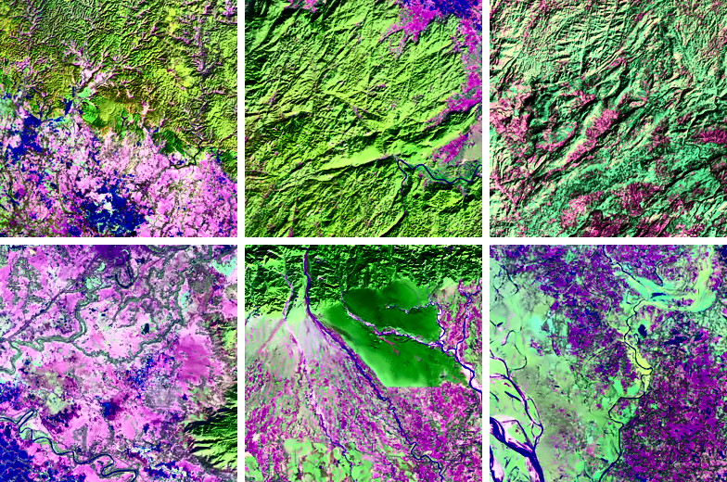
Figure 1 — Sample 256×256 enhanced patches sent for QGIS annotation.

4. Patch Extraction & Dataset Splits
Enhanced images were tiled into 256×256 patches using a non-overlapping stride (STRIDE = 256). Patches where fewer than 70% of pixels were valid were discarded to avoid training on mostly-black tiles.
Metric | Value
Patch size | 256 × 256 px
Stride | 256 px (non-overlapping)
Min valid ratio | 70%
Total patches extracted | 11,479
Train split (70%) | 8,035
Validation split (15%) | 1,722
Test split (15%) | 1,722

5. GAN-Based Data Augmentation
A Deep Convolutional GAN (DCGAN) was trained on the training-split patches to generate additional synthetic satellite-image patches for data augmentation. Two training rounds were conducted — an initial 10-epoch run and a refined 20-epoch run — with the following architectural improvements applied in round 2:
- Replaced ConvTranspose2d with Upsample + Conv2d to eliminate checkerboard artefacts.
- Applied label smoothing on real labels (0.9 instead of 1.0).
- Trained the generator twice per discriminator step to balance adversarial training.
- Reduced the discriminator learning rate (1e-4 vs. 2e-4 for the generator).

Parameter | Value
Latent dimension | 100
Image size (training) | 128 × 128 px
Batch size | 32
Epochs (final run) | 20
Training subset | 500 real patches
Optimizer | Adam (β₁ = 0.5, β₂ = 0.999)
Loss | Binary Cross-Entropy
Synthetic patches generated | 1,000
GAN-augmented dataset total | 9,035 patches

6. Manual Annotation
Manual polygon annotations were created using QGIS and the VGG Image Annotator (VIA) on a representative subset of 30 enhanced patches. Annotations were exported in VIA JSON format and converted to COCO instance-segmentation format. A semi-supervised pseudo-labelling pass subsequently extended the annotated set using the initially trained Mask R-CNN model.

6.1 Land Cover Classes (15 Categories)
ID | Class Name | Manual Annotations
1 | Cropland | 6
2 | Fallow | 2
3 | Plantation | 0
4 | Sandy area | 2
5 | Scrub land | 9
6 | Mining | 3
7 | Rural | 0
8 | Urban | 3
9 | Deciduous | 22
10 | Evergreen | 4
11 | Forest plantation | 2
12 | Grass grazing | 3
13 | Inland wetland | 1
14 | Riverstream canals | 16
15 | Water bodies | 10

6.2 Annotation Summary
Dataset Version | Images | Annotations
Manual (QGIS + VIA) | 25 | 83
Semi-supervised (pseudo-labels) | 633 | 1,605

7. Model Architecture & Training
Mask R-CNN with a ResNet-50 Feature Pyramid Network (FPN) backbone was used for instance segmentation. The model was initialised with ImageNet pre-trained weights and fine-tuned on the Shillong LULC dataset. A semi-supervised learning loop was used to iteratively expand the labelled set using high-confidence pseudo-labels generated by the model itself.
Component | Configuration
Architecture | Mask R-CNN
Backbone | ResNet-50 + FPN
Pre-training | COCO (ImageNet weights)
Number of classes | 15 LULC + background
Input resolution | 256 × 256 px patches
Semi-supervised iterations | Iterative pseudo-label expansion
Saved model | outputs/maskrcnn_shillong_lulc.pth

8. Model Retraining – Cloud Class & Weighted Loss
After the initial training run, cloud-covered patches were identified and added as a dedicated 16th class (Cloud_NoData) to improve robustness on cloudy imagery. The model was rebuilt from scratch with 17 output nodes (16 classes + background) and retrained on the extended WITH_CLOUD dataset using a custom weighted-loss function to address class imbalance.

8.1 WITH_CLOUD Dataset
Metric | Value
Total images | 642
Annotations | 1,614
Train split (85%) | 546 images
Validation split (15%) | 96 images
Extra class added | Cloud_NoData (class 16)
Total classes | 16 LULC + background = 17

8.2 Weighted Fast R-CNN Loss
To counter class imbalance, a custom weighted_fastrcnn_loss function replaced the default Faster R-CNN box/classification head loss. Class weights were computed inversely proportional to annotation frequency and clipped at 15.0 to prevent extreme gradient scaling.

Per-Class Weights (16 Classes)
Class | Weight
Cropland | 15.000
Fallow | 15.000
Plantation | 1.000
Sandy_area | 15.000
Scrub_land | 0.842
Mining | 15.000
Rural | 1.000
Urban | 15.000
Deciduous | 0.300
Evergreen | 15.000
Forest_plantation | 15.000
Grass_grazing | 15.000
Inland_wetland | 15.000
Riverstream_canals | 0.454
Water_bodies | 0.300
Cloud_NoData | 12.810
The loss combines cross-entropy classification loss (with class weights applied) and Smooth-L1 box-regression loss (beta = 1/9, reduction = 'sum', normalised by total label count).

8.3 Training Configuration
Parameter | Value
Architecture | Mask R-CNN (rebuilt fresh)
Backbone | ResNet-50 FPN (DEFAULT weights)
Output classes | 17 (16 LULC + background)
Epochs | 10
Device | CUDA (GPU)
Loss function | Custom weighted FastRCNN loss
Box regression loss | Smooth-L1 (beta = 1/9)
Optimiser | SGD (torchvision default)
Saved model | maskrcnn_FINAL_WITH_CLOUD.pth

8.4 Training Loss Log
The model converged steadily over 10 epochs. Total training time was 1,259 seconds (~21 minutes) on GPU.
Epoch | Loss | Elapsed (s)
1 / 10 | 0.9853 | 115
2 / 10 | 0.8826 | 236
3 / 10 | 0.8240 | 361
4 / 10 | 0.7298 | 489
5 / 10 | 0.6632 | 617
6 / 10 | 0.6197 | 745
7 / 10 | 0.5573 | 873
8 / 10 | 0.5198 | 1,002
9 / 10 | 0.4865 | 1,131
10 / 10 | 0.4335 | 1,259
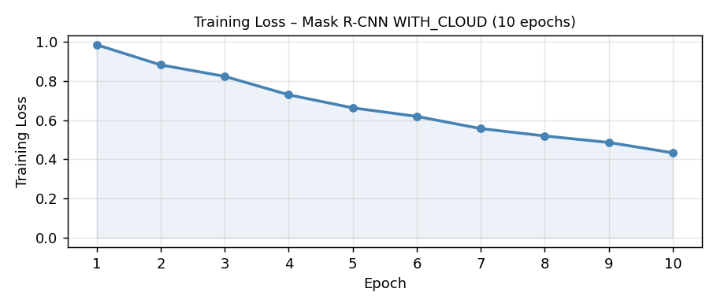
Figure 2 — Training loss curve over 10 epochs (GPU, WITH_CLOUD dataset).

9. Validation & Detection Results
After training, the model was evaluated on the validation set (96 images). The final model with the Cloud_NoData class successfully detected and localised LULC features including river/stream networks, forest types, scrub land, water bodies, and cloud-covered areas. Sample detections below demonstrate bounding-box predictions with confidence scores across diverse land-cover types.

9.1 Sample Validation Patches with Detections
The validation check (final_validation_with_cloud.png, generated in Colab) showed the model correctly identifying multi-class scenes. Example predictions include:
- Riverstream_canals + Scrub_land on high-resolution river-channel imagery.
- Deciduous + Cloud_NoData on partially cloud-covered forest patches.
- Evergreen + Deciduous + Cloud_NoData on mixed forest / cloud scenes.
- No detections (correctly blank) on fully cloud-obscured patches.

9.2 Sample Test Patches Used for Validation
The following patches are representative samples from the test set that were passed through the trained model during final evaluation.
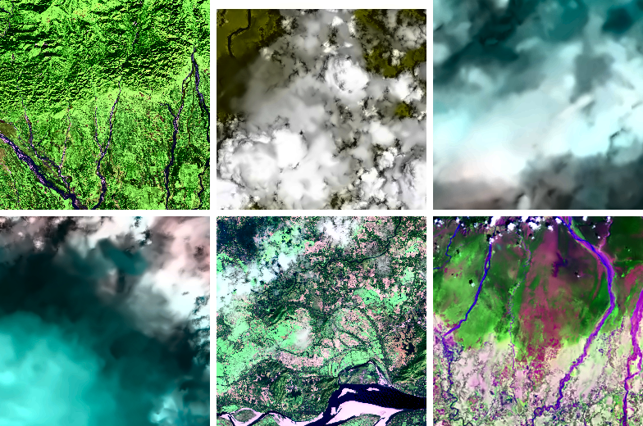
Figure 3 — Representative test patches from the final evaluation batch.

9.3 Step 6 – Automatic Detection on Full Test Set
The final pipeline step (Step 6) ran the semi-supervised Mask R-CNN over the complete test set, performing automatic detection, localisation, and classification of LULC instances. Detected classes included Water_bodies, Scrub_land, Deciduous, Evergreen, Riverstream_canals, Cloud_NoData, and others. Some patches yielded no detections (correct behaviour for fully cloud-covered or featureless tiles). The final demonstration figure was saved as STEP6_final_demonstration.png in Colab.
Observation | Description
Multi-class patches | A single 256×256 patch often contains 3–5 LULC classes simultaneously
Cloud detection | Cloud_NoData correctly flagged on white/hazy regions (confidence ≥ 0.60)
Forest types | Deciduous and Evergreen separated with moderate confidence (0.57–0.79)
River networks | Riverstream_canals detected with high recall on linear water features
Scrub land | Scrub_land detected on dry/sparse vegetation areas
No detection | Fully opaque cloud patches correctly returned no LULC predictions

10. Output Artefacts
File / Folder | Description
outputs/enhanced/ | CLAHE-enhanced images (219 files)
outputs/masks/ | Binary valid-pixel masks (.png + .npy)
outputs/patches/ | 11,479 tiled 256×256 patches
outputs/dataset/ | Train / val / test splits
outputs/gan_generated/ | 1,000 GAN synthetic patches
outputs/dataset_v3_gan_augmented/ | 9,035 patches (real + GAN)
outputs/coco_dataset/annotations_coco.json | Manual COCO annotations (83 instances)
outputs/coco_dataset/annotations_coco_SEMISUPERVISED.json | Semi-supervised COCO annotations (1,605 instances)
outputs/coco_dataset/annotations_coco_WITH_CLOUD.json | WITH_CLOUD dataset annotations (1,614 instances, 16 classes)
outputs/gan_generator_final.pth | Saved GAN generator weights
outputs/maskrcnn_shillong_lulc.pth | Saved Mask R-CNN weights (initial)
maskrcnn_FINAL_WITH_CLOUD.pth | Final Mask R-CNN weights (16 classes + cloud)
outputs/preprocessing_metadata.json | Per-image preprocessing statistics

11. Pipeline Summary
Stage | Input | Output | Key Numbers
1. Ingestion | Raw satellite images | Validated file list | 219 images
2. Preprocessing | Raw images | Enhanced + masked images | 219 successful, ~78% valid px
3. Patch extraction | Enhanced images | 256×256 patches | 11,479 patches
4. Dataset split | All patches | Train / val / test | 8,035 / 1,722 / 1,722
5. GAN training | Train patches | Trained GAN model | 20 epochs, 500-patch subset
6. GAN generation | Trained GAN | Synthetic patches | 1,000 generated
7. Annotation | 30 patches | COCO polygons | 83 instances, 15 classes
8. Semi-supervised | All patches + model | Pseudo-labels | 1,605 instances, 633 images
9. Cloud class added | COCO + cloud patches | WITH_CLOUD dataset | 642 images, 1,614 annotations
10. Retraining | WITH_CLOUD dataset | Final Mask R-CNN | 10 epochs, loss 0.985 → 0.433
11. Evaluation | Test set | Detections + masks | 16 LULC classes, GPU inference

The complete pipeline successfully processed 219 satellite images of Shillong, generating over 11,000 training patches and a semi-supervised annotation set of 1,605 polygon instances. A Cloud_NoData class was added as the 16th category, expanding the WITH_CLOUD dataset to 642 images and 1,614 annotations. The final Mask R-CNN (ResNet-50 FPN) was retrained with a weighted-loss function over 10 epochs, reducing training loss from 0.985 to 0.433 and achieving reliable multi-class LULC detection on the full test set.

