Visual programming

ATM System project report

Kulsoom Alias koonj

BS SE V

 CMS ID: 023-20-0104

**Introduction:**

ATM System is flexible and easy to use. It provides all the functionalities as ATM System and additional functionalities as well.

Following are the main functionalities:

* Cash withdraw
* Check balance
* Send money
* Pay their bills for utilities
* Learn about this system

**DESCRIPTION OF ATM System:**

1. **Login Account**: User can login into account. User have to enter Account pin for verification.

**Account Pin: 1234**

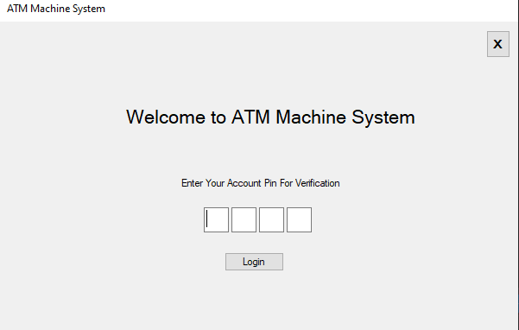

1. **ATM System**: (Form1) This form has the main functionalities. User can with draw the cash, check the balance and send the money any account and learn about the system.

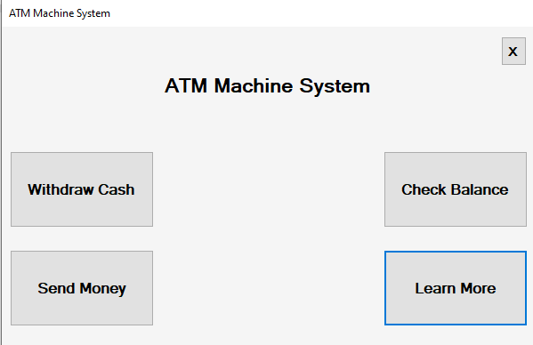

1. **Check Balance:** when user want to check the balance that how much amount he/ she have in account then they can check balance easily they have only to click the button of check balance then the system ask the account pin for verification only then they can easily check the balance when they enter the account pin after that they have open the screen and in that screen current amount are displayed that how much amount he/ she have in account.

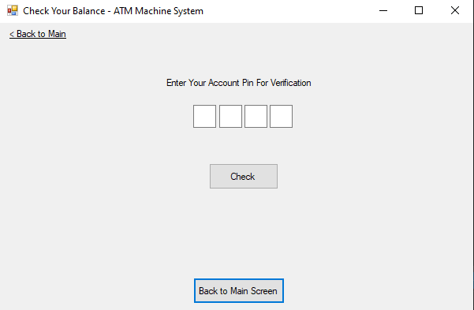

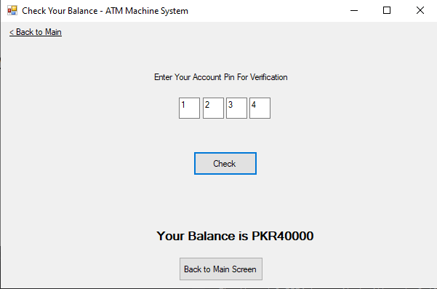

1. **Withdraw**: User can withdraw the cash any time as we normally do. User have to provide some option like 1000, 5000, 10000, Input amount manually that how much they want to withdraw amount after the select of amount are with draw the cash .

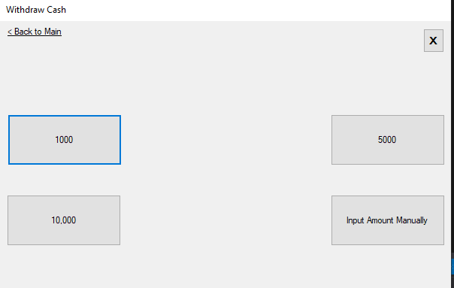

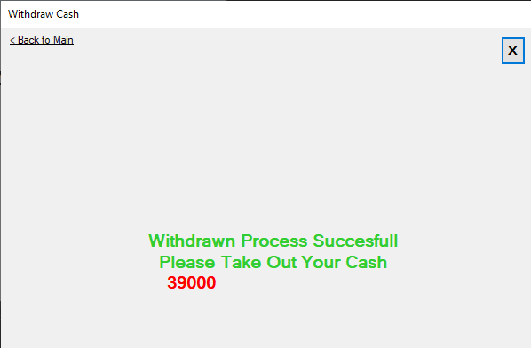

1. **send money:** user can send the money where they are they have only choose the bank then they have enter the account number which the user want to transfer amount then enter the amount which you want to send then click the proceed button after that you have to enter your have to enter the pin of your account, after that user have to click confirm button.

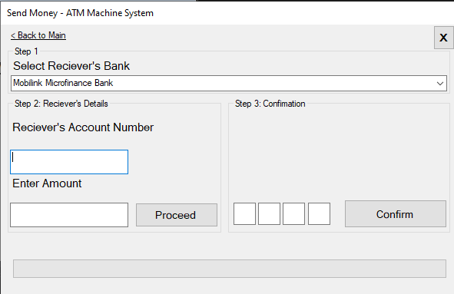

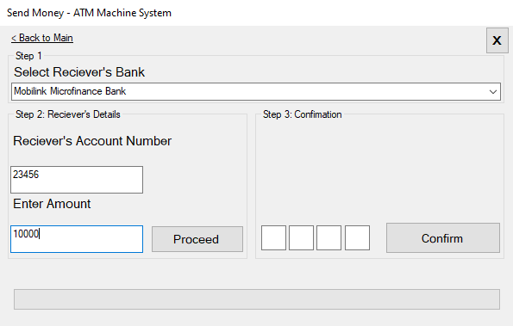

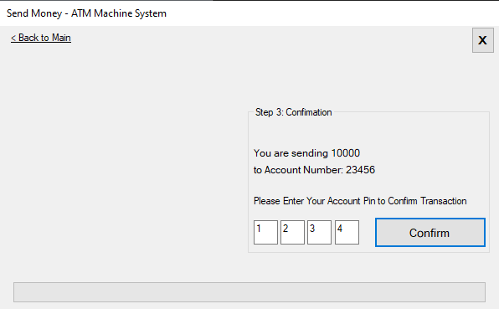

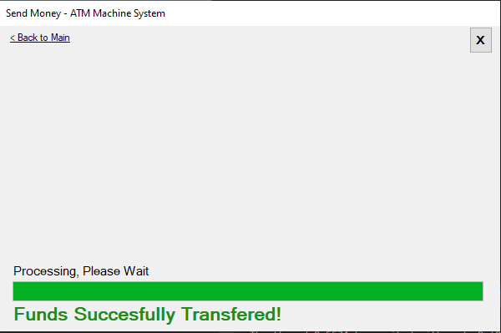

1. **Learn more:** In this option user have to learn about the functionality of the ATM System.

