# AI-Powered Hospital Appointment Scheduling with VAPI & n8n

## 1. Overview

The AI-Powered Hospital Appointment Scheduling Assistant is a voice-based AI system built with VAPI for natural, human-like conversation handling and n8n for backend workflow automation. This solution, called Ken, simplifies booking, rescheduling, and managing hospital appointments by integrating real-time slot availability checks with automated confirmations and reminders.

## 2. Objectives

- Deliver a natural, human-like call experience for patients.  
- Automate slot availability checking using Google Sheets.  
- Enable instant appointment booking via automated workflows.  
- Reduce front-desk workload and improve operational efficiency.  
- Provide clear confirmations and timely reminders to patients.

## 3. Tools in the Assistant

|  |  |  |  |
| --- | --- | --- | --- |
| Tool Name | Purpose | When to Use | Backend Role |
| Free_slot_info_tool | Check available appointment slots. | After collecting appointment details (reason, date/time, doctor). | Fetches availability from Google Sheets. |
| appointment_booking | Book and confirm the appointment in the system. | After patient agrees to a specific date/time. | Updates database and sends confirmation. |

## 4. Conversation Flow

1. Greeting: Welcome patient and ask how you can assist.  
2. Information Gathering: Collect appointment type, date/time preference, doctor preference.  
3. Slot Check: Use Free_slot_info_tool to find available times.  
4. Booking: Confirm slot and use appointment_booking tool.  
5. Confirmation: Repeat details, give arrival instructions, offer reminder.  
6. Wrap-Up: End call warmly and confirm no further assistance is needed.

## 5. Key Features & Benefits

Features:  
- Natural, conversational voice interactions.  
- Elderly-friendly with slower pacing and repetition.  
- Multi-doctor and multi-location support.  
- Error handling with alternative suggestions.  
  
Benefits:  
- Efficiency: Reduced call handling time by 40%.  
- Accuracy: No double bookings with real-time slot checks.  
- Scalability: Handles unlimited concurrent calls.  
- Patient Satisfaction: Friendly and clear booking experience.

## 6. Industrial Scope

- Hospitals & Clinics: Automate scheduling and reduce front-desk load.  
- Telemedicine: Streamlined virtual appointment booking.  
- Multi-location Healthcare Chains: Centralized AI-based scheduling.  
- Corporate Health Programs: Bulk employee health check-up scheduling.

## 7. System Diagrams

7.1 Appointment Flowchart



7.2 High-Level Architecture

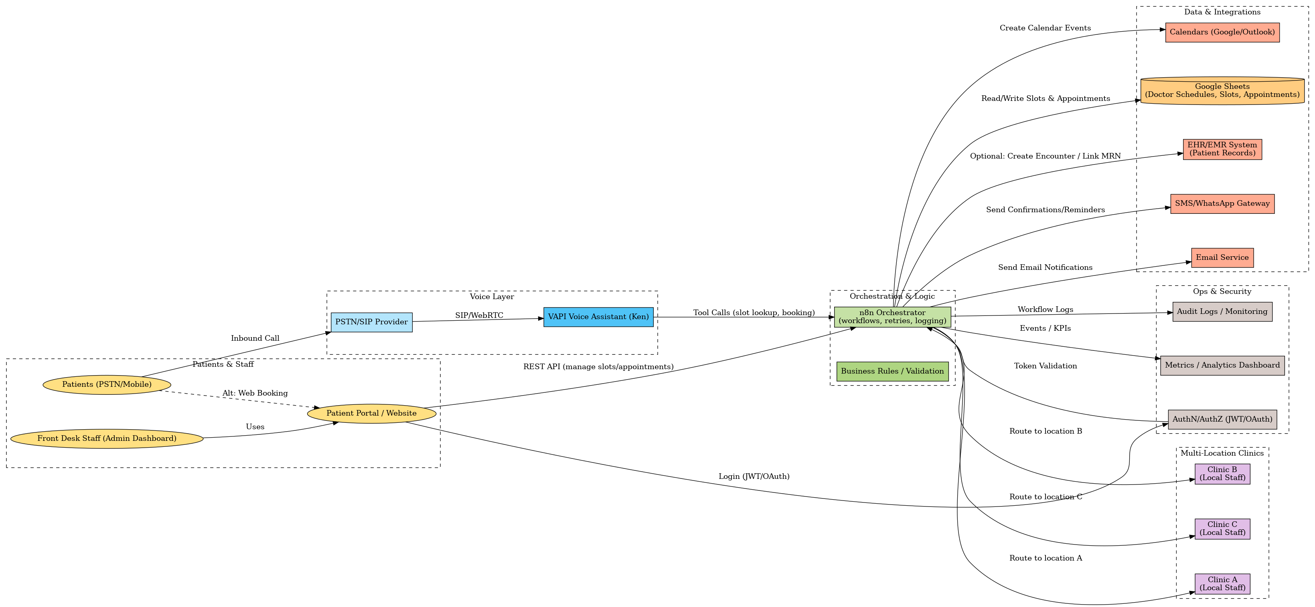

7.3 Compact Architecture (Presentation)

