CloudInfraAutomation — Architecture
  - Architecture and design — draft for review
2026-10-03
Contents

Status: Draft v2.10 for review. No code is written until this design is approved.
Date: 2026-10-03
Scope: A web feature where a user selects their Portfolio → Product/Platform (the project is the repo they are creating) and the AWS services they need. The platform then generates a CloudFormation template and a GitHub Actions pipeline, creates a new infrastructure repository, and deploys the stack through a series of environments, each in its own AWS account. The environments and their account numbers are configurable in the application (default set: Sandbox, DEV, TEST, QA/STAGE, PROD). What each project can touch in AWS is controlled by tags: a project can never change another project’s resources. Developers deploy their own code (Python, Java, Go, Rust, …) to ECS, Lambda, EKS and Step Functions from separate application repositories that read a published infrastructure contract (§9). Every solution is DR-capable: it can run in one region, as DR (us-east-1 active, us-east-2 standby) or as an HA pair (both active) (§10).
Revision history
Version | Changes
v1 | Initial architecture: system design, payload, CloudFormation engine, GitHub provisioning, OIDC pipeline.
v2 | added the org registry and tagging strategy (§4); permissions based on tags (§4.5–4.8); multi-account, five-environment model (§5); promotion pipeline (§8). Payload, provisioning, security and scaling sections are updated to match.
v2.1 | environment names, their order and their AWS account numbers can now be configured by platform admins in the application (§5.5). Nothing about environments is hardcoded.
v2.2 | the hierarchy is now three levels, Portfolio → Product/Platform → Project. The team level and the org:team tag are removed.
v2.3 | STAGE and PROD require GitHub reviewer approval before deployment, using a plan → approve → apply-reviewed-change-set flow that cannot be turned off (§8.3). Added a layered quality-gate strategy for STAGE and PROD (§8.4). Added the release console: promotion and approval workflow in the platform UI, with approvals submitted to GitHub as the reviewer (§8.5).
v2.4 | added developer consumption (§9): infrastructure contract published per environment, application repos linked to compute slots, golden-path build/deploy workflows per language and compute type (Lambda, ECS, EKS, Step Functions), and least-privilege application deploy roles. Sections 9–16 renumbered to 10–17.
v2.5 | infrastructure and solution code are now explicitly independent (§9.9): contract-first development, placeholder artifacts, expand → migrate → contract changes, optional bindings, local/ephemeral testing, and a responsibilities table. Product teams no longer have to sign off on infrastructure changes.
v2.6 | technology policy added: AWS + GitHub + open source only (§1). Commercial products removed or replaced (CMDB/ITSM, chat tools, paid GitHub security features). Approvals now work on any GitHub plan via platform-executed releases (§8.3.1); GitHub Enterprise features are optional.
v2.7 | runtime infrastructure is AWS services only; email notifications use Amazon SES (no SMTP option).
v2.8 | the catalog now covers every project-scoped AWS service, including all major databases, in every combination (§6.8). It is generated from AWS’s own schemas and authorization data, with curated secure blocks for common services, generic connection kinds, database defaults (network, Secrets Manager credentials, RDS Proxy, snapshots), layered stacks, and pairwise + real-deploy testing.
v2.9 | multi-region resilience (§10): every template is DR-capable. Projects choose single region, DR (deployed to us-east-1 and us-east-2, only us-east-1 active) or HA pair (both active). Adds per-service replication rules, a global stack, a two-region pipeline, failover/failback, DR drills and a multi-region control plane. Sections 10–17 renumbered to 11–18.
v2.10 | runtime isolation by tags (§4.10). Every component can only talk to resources with the same project and environment tag values, enforced by four layers generated into the template: the runtime role’s policy, the permissions boundary, a same-tag resource policy on the target, and an SCP.

1. Goals, non-goals and design principles

Goals
- A user picks their Portfolio → Product/Platform from dropdowns, names the project, selects services (for example, a Python Lambda triggered by an S3 bucket), and gets a working repository deployed in one click.
- Tags decide what a project may touch. Every resource is tagged with its portfolio, product, project and environment. The IAM roles a project uses can only create resources with their own tags and can only change resources that already carry their own tags.
- Configurable environments, one account each: environments (default: Sandbox, DEV, TEST, QA/STAGE, PROD) and their unique AWS account numbers are managed in the application by platform admins. A project is promoted through them in the configured order by a gated pipeline, using the same built artifact each time.
- Generated infrastructure is least-privilege by construction: no * actions or * resources in any IAM role the app template creates.
- Each push safely updates the existing stack, nothing is replaced unless intended, and failures are cleaned up or clearly reported.
- Supports many portfolios, products and projects at once without hitting GitHub or AWS API limits.

Non-goals (v1)
- Free-form CloudFormation authoring. Users compose from a catalog that covers every project-scoped AWS resource type (curated Tier 1 + schema-driven Tier 2, §6.8); account- and organization-wide resources are excluded.
- Creating new AWS accounts. The account landing zone (AWS Organizations / Control Tower) already exists; the platform only uses its accounts.
- Editing the Portfolio/Product lists in this UI. They come from the org registry (§4.2), which is the master; maintained in the platform admin screen or imported via CSV/REST.

Design principles
Principle | What it means here
Tags are the permission boundary, names are the backstop | Permissions are written once, using tag conditions, and reused by every project. At runtime, components can only talk to resources with the same project and environment tag values, enforced on both the caller’s role and the target’s resource policy (§4.10). Resource names are still prefixed by project, as a second line of defense for AWS actions that don’t support tag conditions.
The platform owns the tags, not the repo | The tag values a project may use are fixed on its IAM roles by the platform. A user who edits the repo to claim another product’s tags is denied by AWS.
Account per environment | PROD is separated from everything else by an account boundary, not just by tags.
Build once, deploy many | The same artifact (zip + template) moves DEV → TEST → STAGE → PROD. Only parameters change per environment.
Deterministic over generative | Templates and IAM come from a versioned, tested catalog of building blocks, never from free-form LLM output.
Short-lived credentials everywhere | OIDC for GitHub Actions → AWS, GitHub App installation tokens, STS AssumeRole between accounts. No long-lived keys by default.
Infrastructure and solution code are independent | Every solution has two parts: infrastructure (platform-owned) and solution code (product-owned). They live in separate repos with separate pipelines, versions, release schedules and approvals, joined only by a versioned contract. Neither team waits for the other (§9.9).
Async and safe to retry | Long-running provisioning is orchestrated as a series of steps, each safe to repeat (keyed by the request ID), with undo steps for anything that fails partway.

Technology policy: AWS + GitHub + open source only
The platform is built in-house. Its only commercial dependencies are the two systems it exists to automate: AWS (the target cloud, including its native services) and GitHub (source control and Actions). Every other component is either written by us or is open-source software. No other commercial product, SaaS or paid add-on is required.
AWS services only for runtime infrastructure: everything the platform runs on, and everything it creates, is an AWS service: compute, storage, database, workflow, email (Amazon SES), secrets, monitoring. No non-AWS infrastructure (mail servers, self-hosted databases, external SaaS) is created or required.
Rules: - No feature may require a paid GitHub tier. Features that only exist on GitHub Enterprise are optional add-ons, and every one of them has a built-in equivalent (§8.3.1). - Integrations with commercial tools (chat, ITSM, CMDB, portals) are never required. The platform exposes generic, signed outgoing webhooks and a REST API, so an organization can connect any tool it likes without the platform depending on it. - Open-source licenses allowed by default: Apache-2.0, MIT, BSD, MPL-2.0; LGPL as unmodified libraries. AGPL and “source-available” licenses (BSL, SSPL, Elastic, the Semgrep Rules License, etc.) are excluded unless approved (D26).
Open-source components chosen:
Purpose | Choice | License
Backend API / models | FastAPI, pydantic | MIT
GitHub client / AWS SDK / secret encryption | PyGithub, boto3, PyNaCl | LGPL-3.0 (library), Apache-2.0, Apache-2.0
Web UI | React, TypeScript | MIT, Apache-2.0
CloudFormation lint / policy | cfn-lint, cfn-guard | MIT-0, Apache-2.0
IaC security scan | Checkov | Apache-2.0
Gate policy engine (G4/G5 rules as code) | Open Policy Agent (OPA) / Conftest | Apache-2.0
SAST per language | bandit (Python), SpotBugs + Find Security Bugs (Java), gosec (Go), cargo-audit + clippy (Rust), eslint-plugin-security (Node.js) | Apache-2.0 / LGPL-2.1 / Apache-2.0 / Apache-2.0+MIT / Apache-2.0
Dependency / vulnerability scanning | OSV-Scanner, Trivy | Apache-2.0
SBOM | Syft | Apache-2.0
Secret scanning (PR check + pre-commit hook) | gitleaks | MIT
Artifact signing and provenance | cosign (Sigstore) with keys in AWS KMS (no dependency on public Sigstore services); SLSA/in-toto provenance format | Apache-2.0
Kubernetes GitOps / admission policy | Argo CD, Kyverno | Apache-2.0
Local AWS emulation | moto (server mode), AWS SAM CLI; LocalStack Community edition optional | Apache-2.0
Telemetry | OpenTelemetry (export to CloudWatch/X-Ray) | Apache-2.0
Developer portal (optional) | Backstage | Apache-2.0
Dependency update PRs | Dependabot (built into GitHub, free on all plans); Renovate as an alternative if license approved | — / AGPL-3.0
Removed or replaced compared with earlier drafts:
Earlier mention | Replaced by
ServiceNow / external CMDB as source of truth | Platform registry is the master, with CSV/REST import (§4.2)
ITSM change tickets | Built-in change record in the release console (§8.5); external ITSM optional via outgoing webhook
Slack / Microsoft Teams notifications | In-app inbox + email via Amazon SES + optional generic signed webhooks
CodeQL (needs paid GitHub Advanced Security for private repos) | Language SAST tools above
GitHub secret scanning push protection (paid for private repos) | gitleaks in PR checks and pre-commit hooks
GitHub artifact attestations (paid for private repos) | cosign + AWS KMS signatures, verified by the gate
GitHub environment required reviewers / custom deployment protection rules (Enterprise for private repos) | Built-in approval with platform-executed release (§8.3.1); GitHub features used additionally only if available

2. System architecture

2.0 Architecture overview
The diagram below shows the whole solution on one page: who uses it, the platform UI, the control plane (AWS services only), GitHub, the AWS Organization and the configurable environment accounts. The numbered flows are explained under the diagram.
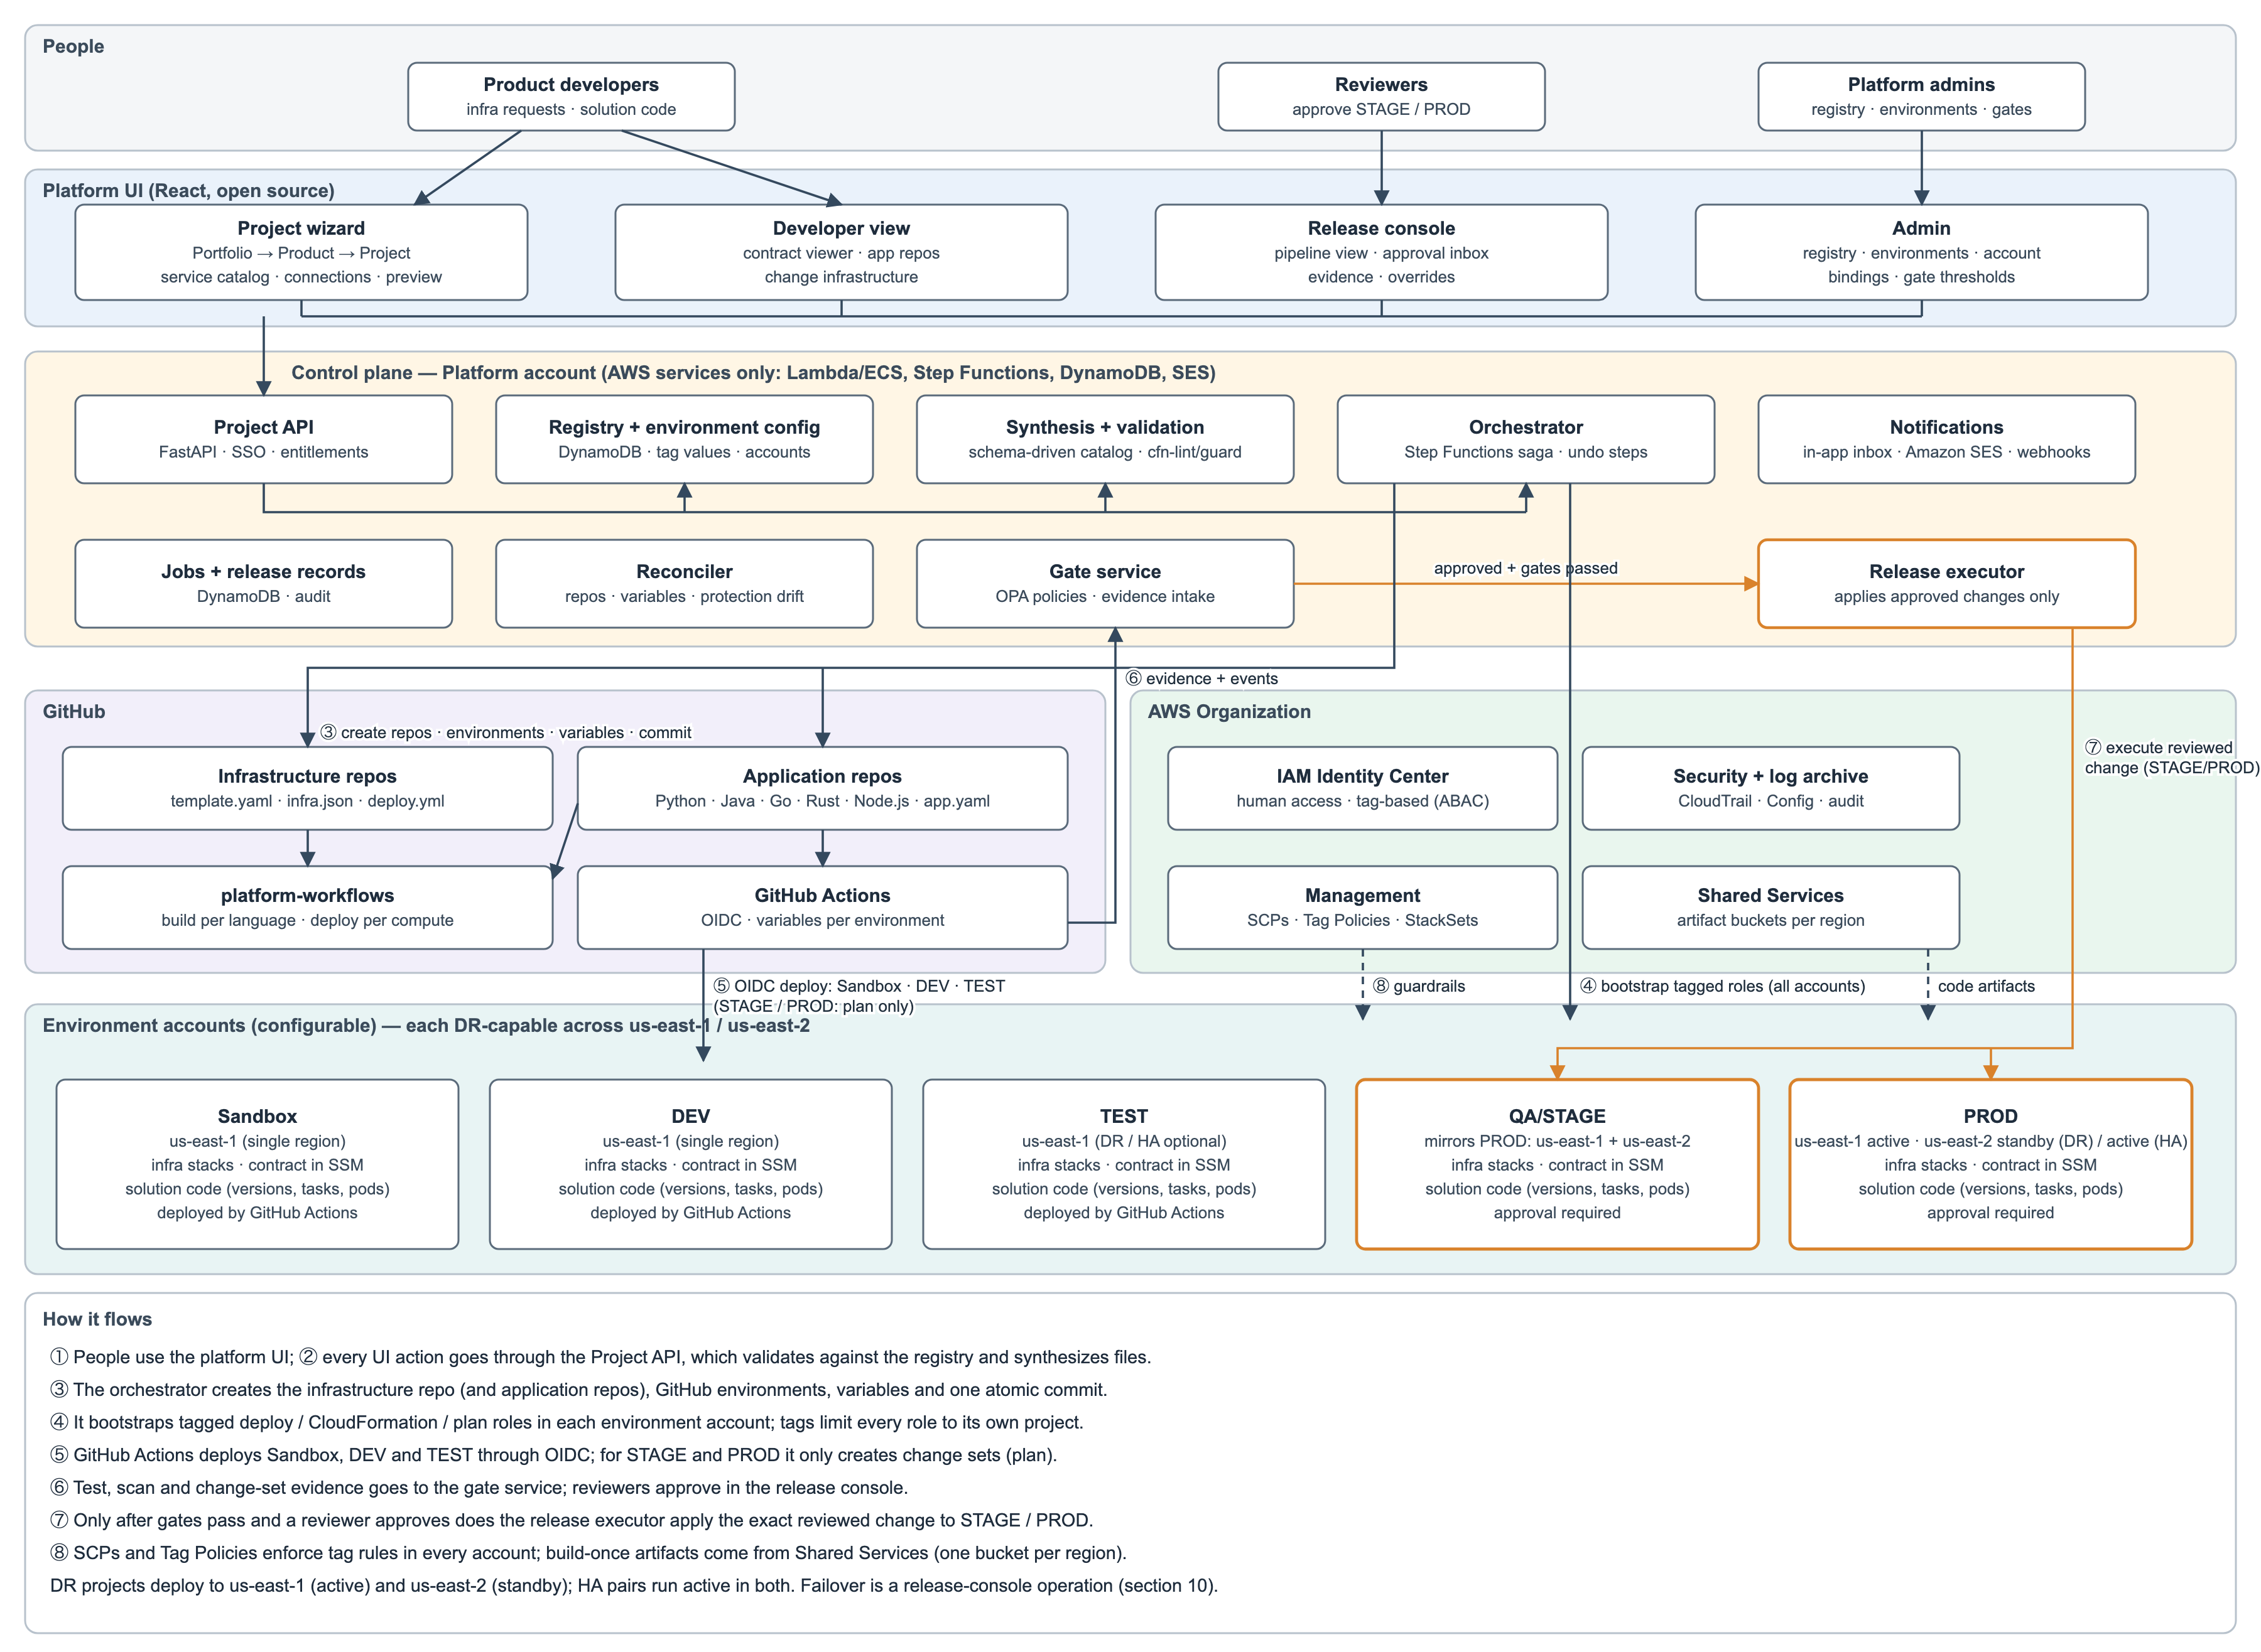
Figure 1. Architecture overview

2.1 Component diagram
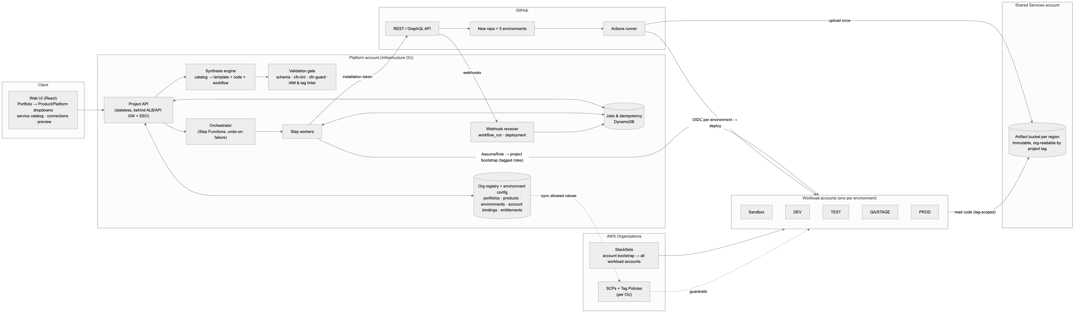
Figure 2. 2.1 Component diagram

2.2 End-to-end sequence
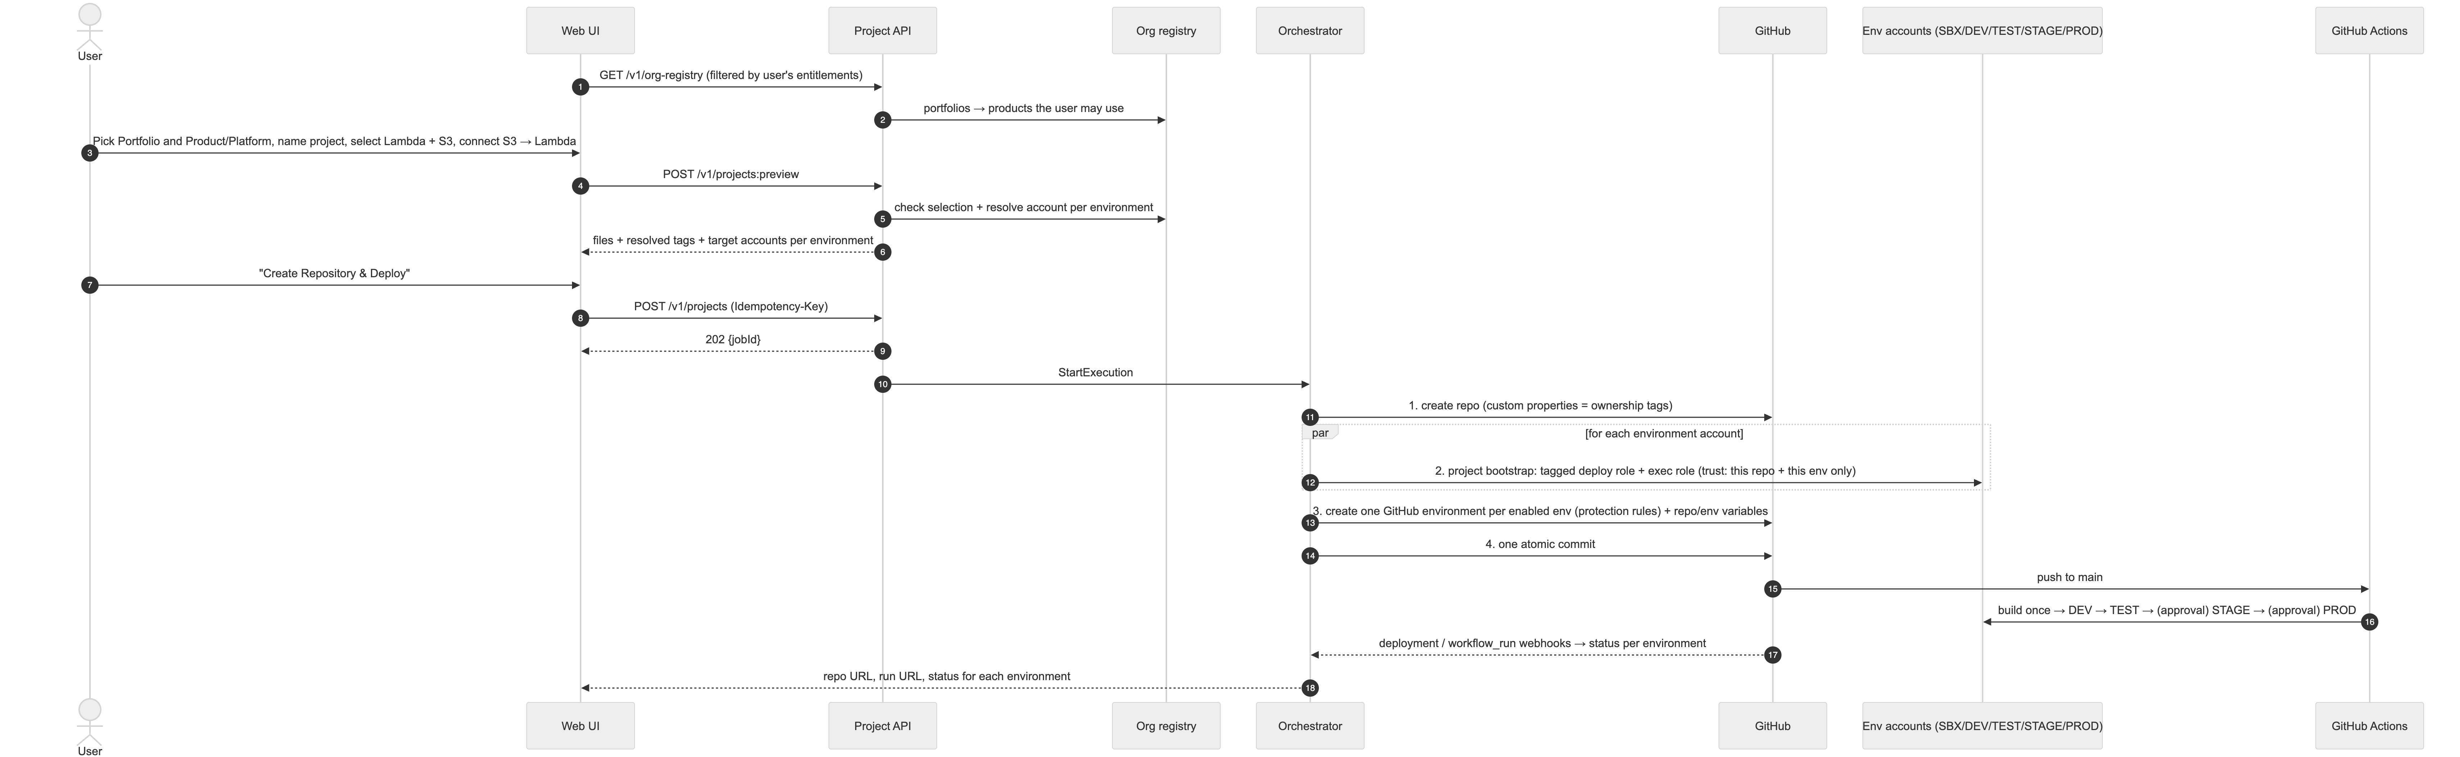
Figure 3. 2.2 End-to-end sequence

2.3 Component responsibilities
Component | Responsibility | Scaling
Web UI | Cascading ownership dropdowns, service catalog, connection editor, preview (files, tags, target accounts), job status per environment. | Static on CDN
Project API | Authentication, entitlement checks, validation, preview, job creation, idempotency. Keeps no state between requests. | Horizontal containers
Org registry | Source of the Portfolio → Product/Platform tree, projects, cost centers, entitlements, allowed tag values. | DynamoDB + cache; master data, CSV/REST import
Environment config | Admin-managed list of environments (name, order, tier, protection and guardrail profiles) and account bindings (environment + portfolio/product + region → AWS account ID). Validates and onboards accounts before they can be used (§5.5). | DynamoDB, versioned, audited
Synthesis engine | Payload → template, starter code, workflow, per-environment parameter files. Pure function with no I/O. | Runs in-process
Validation gate | Schema, connection rules, cfn-lint, cfn-guard (rules differ per environment), IAM least-privilege + tag linter. | Runs in-process
Orchestrator | Provisioning steps across GitHub and up to five accounts, with retries and undo steps. | Step Functions Standard
Org guardrails | SCPs and Tag Policies attached to OUs, enforcing the tag rules no matter which tool makes the call. | AWS Organizations
StackSets | Deploy the account bootstrap (OIDC provider, shared tag-based policies, provisioner role) to every workload account automatically, including new ones. | Service-managed StackSets
Artifact bucket | One per region in Shared Services. Workload accounts can read only their project’s prefix. | S3

2.4 API surface (contract only)
Method & path | Purpose
GET /v1/org-registry | Portfolio → Product/Platform tree, filtered to what the caller is entitled to. Drives the dropdowns.
GET /v1/catalog | Services that can be selected, their settings and valid connections.
GET /v1/environments | Active environments in promotion order (read-only for normal users).
GET/POST/PUT /v1/admin/environments | Admin: create, rename (display name), reorder, set profiles, deactivate environments.
GET/POST/PUT/DELETE /v1/admin/account-bindings | Admin: map an AWS account ID to an environment for a portfolio/product/region.
POST /v1/admin/account-bindings/{id}:validate | Admin: run the onboarding checks (§5.5.3) and report the result.
POST /v1/projects:preview | Validate + synthesize, no side effects. Returns files, resolved tags and target accounts per environment.
POST /v1/projects | Start provisioning (Idempotency-Key required) → 202 {jobId}.
GET /v1/jobs/{jobId} / …/events | Job + per-environment status (JSON / SSE).
GET /v1/projects/{id}/releases | Release console: pipeline view and history per environment (§8.5).
GET /v1/approvals?mine=true | Reviewer’s approval inbox.
POST /v1/approvals/{id}:approve / :reject | Approve/reject in the UI; the platform submits it to GitHub as the reviewer.
POST /v1/projects/{id}/environments/{env}:promote | Start promotion when the environment is in on-request mode.
POST /v1/overrides / POST /v1/overrides/{id}:decide | Request / decide a high-risk change override.
POST /v1/github/webhooks | GitHub App webhooks.

3. Request payload and data model

3.1 Design choices
- Ownership by ID, not by name: the UI sends registry IDs (pf-…, pr-…). The server checks them against the registry and the user’s entitlements. The UI is never trusted for ownership.
- No account IDs in the payload. The server works out the target account for each environment from the admin-configured account bindings (§5.5). Users cannot point a deploy at an account they don’t own.
- Graph-shaped: resources (nodes) and connections (edges). Permissions and event wiring come from the edges, so the user never writes IAM.
- Stable IDs supplied by the user become logical IDs and part of physical names; stable IDs are what make updates safe.

3.2 Example — Python Lambda + S3, owned by Payments → Invoicing → AP Automation
{
"schemaVersion": "2.0",
"requestId": "6f1c2a9e-4b7d-4a52-9d55-0d1f2b3c4e5f",
"catalogVersion": "2026.10.0",
"project": {
"name": "invoice-ingest",
"description": "Process invoices dropped into S3",
"github": { "owner": "acme-platform", "visibility": "private" }
},
"ownership": {
"portfolioId": "pf-payments",
"productId": "pr-invoicing",
"dataClassification": "confidential"
},
"environments": {
"enabled": ["sandbox", "dev", "test", "stage", "prod"],
"region": "us-east-1"
},
"resilience": {
"mode": "dr",
"primaryRegion": "us-east-1",
"secondaryRegion": "us-east-2",
"drStrategy": "pilot-light",
"targets": { "rtoMinutes": 60, "rpoMinutes": 5 }
},
"resources": [
{ "id": "uploads", "type": "s3.bucket",
"config": { "versioning": true, "expireNoncurrentDays": 30 } },
{ "id": "processor", "type": "lambda.python",
"config": { "runtime": "python3.13", "architecture": "arm64", "starterCode": "s3-event-logger" } }
],
"connections": [
{ "kind": "s3.notify", "source": "uploads", "target": "processor",
"config": { "events": ["s3:ObjectCreated:*"], "prefix": "incoming/" } }
],
"environmentOverrides": {
"prod": { "processor": { "memoryMb": 512, "reservedConcurrency": 50 } },
"sandbox": { "*": { "retainOnDelete": false } }
},
"deploy": { "auth": "oidc" }
}
What the server adds before synthesis (shown in the preview, read-only):
{
"resolvedTags": {
"org:portfolio": "pf-payments",
"org:product": "pr-invoicing",
"org:project": "invoice-ingest",
"org:cost-center": "CC-4410",
"org:data-classification": "confidential",
"org:managed-by": "cloudinfra"
},
"targets": {
"sandbox": { "accountId": "111111111111", "region": "us-east-1" },
"dev": { "accountId": "222222222222", "region": "us-east-1" },
"test": { "accountId": "333333333333", "region": "us-east-1" },
"stage": { "accountId": "444444444444", "region": "us-east-1" },
"prod": { "accountId": "555555555555", "region": "us-east-1" }
}
}
org:environment is added per account at deploy time (§4.3).

3.3 Schema rules (enforced by the validation gate)
Field | Rule | Reason
ownership.*Id | Must exist in the registry; product must belong to the portfolio; user must be entitled to the product | Stops users from claiming someone else’s product.
ownership.dataClassification | ≤ the product’s classification ceiling; restricted data not allowed in sandbox | Classification gates are enforced in SCPs too (§4.7).
environments.enabled | Subset of the active configured environments that have an onboarded account binding for this product; must include every environment the configuration marks as a required gate before a later one (e.g. prod requires stage); order comes from the configuration, not the payload | Promotion integrity.
project.name | ^[a-z][a-z0-9]*(-[a-z0-9]+)*$, 3–30 chars, no --, unique within the GitHub org and across the registry | org:project must identify exactly one project. -- is reserved as the name separator.
resources[].id | ^[a-z][a-z0-9-]{0,19}$, unique | Logical ID + physical name.
len(project.name) + len(id) for S3 | ≤ 31 | Bucket name {project}--{id}-{account}-{region} must stay ≤ 63 chars.
resilience | mode ∈ single/dr/ha, allowed by the environment’s policy; regions from the allowed pairs (default us-east-1 / us-east-2); in HA every data store must support active/active (§10.3) | DR-capable from the start; impossible combinations are rejected early.
environmentOverrides | Only settings the catalog marks as overridable, within per-environment ranges (e.g. prod log retention ≥ 90 days) | Environments differ in size, not in shape.
Connections | Source/target must exist; the pair of types must be allowed; no overlapping S3 notifications; no write access to a bucket that also triggers the same function on an overlapping prefix | Correctness + stops S3 ↔ Lambda infinite loops.
Catalog: - Resource types: any project-scoped AWS resource type. Tier 1 curated (including all major database engines) and Tier 2 schema-driven; see §6.8. - Connection kinds: generic kinds (iam.access, network.access, event.source, event.notify, event.rule, api.route, workflow.task, secret.binding, cdn.origin) that work across services (§6.8.4). The example payload’s s3.notify is the S3-specific form of event.notify.

3.4 Persistent model (DynamoDB, single table)
Entity | PK | SK | Key attributes
Portfolio | REG#PORTFOLIO | PF#{id} | displayName, status, owner group
Product/Platform | REG#PF#{portfolioId} | PR#{id} | displayName, kind (product|platform), costCenter, classification ceiling, allowed envs, entitled IdP groups, GitHub access team (repo maintain role), GitHub reviewer teams per env
Environment | CFG#ENV | ENV#{envId} | displayName, order, tier, OU, required-gate flag, protection profile, guardrail profile, status, version
Account binding | CFG#BIND#{envId} | {scope}#{scopeId}#{region} | accountId, status (pending/onboarded/failed/retired), last validation result, version
Account index (uniqueness) | CFG#ACCT#{accountId} | META | envId. Written in the same transaction as the binding, so one account ID can belong to only one environment
Project | PROJECT#{name} | META | ownership IDs, repo ID, enabled envs, bootstrap stack IDs per env, catalog version
Job | JOB#{jobId} | META / STEP#{n}#{name}#{env} | state, per-step / per-env status, errors, undo state
Idempotency | IDEMP#{requestId} | META | jobId, payloadHash
Job states: ACCEPTED → REPO_CREATED → AWS_BOOTSTRAPPED(per env) → ACTIONS_CONFIGURED → COMMITTED → PROMOTING → SUCCEEDED | DEPLOY_FAILED(env) | FAILED_ROLLED_BACK | FAILED_NEEDS_ATTENTION.

4. Org registry, tagging strategy and tag-based permissions

4.1 Hierarchy and how each level is used
Three levels: Portfolio → Product/Platform → Project. Who may act for a product (repo access, approvers, human AWS access) comes from IdP/GitHub groups attached to the product in the registry; it is not a level in the hierarchy and not a tag.
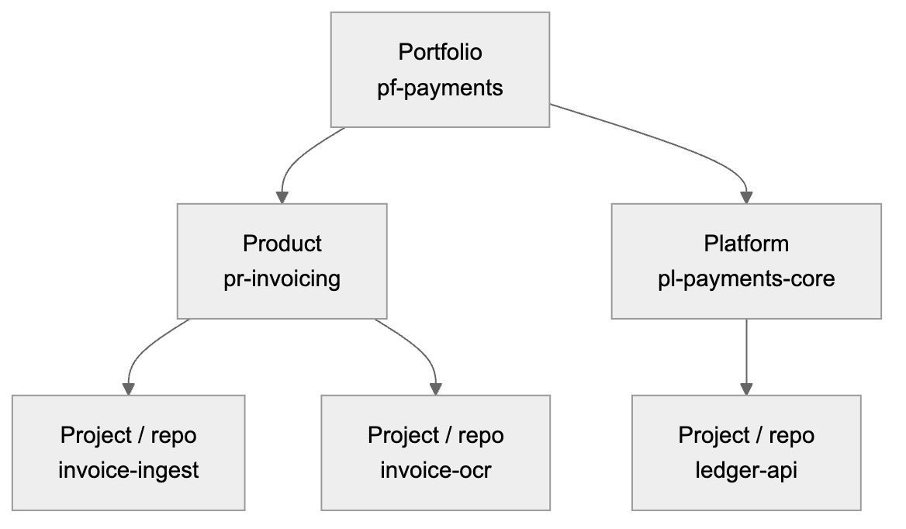
Figure 4. 4.1 Hierarchy and how each level is used
Level | Used for | Used in IAM permissions?
Portfolio | Cost roll-up, portfolio-level guardrails, account routing (§5.2) | Guardrail SCPs only (e.g. “this account only accepts portfolio X”)
Product / Platform | Cost, entitlements (who may create projects), optional sharing between projects in the same product | Yes, for opt-in sharing within a product (§4.6)
Project | The main isolation boundary. One repo = one project = one set of roles per environment | Yes, always
Environment | Which account / stage | Yes: must equal the account’s environment
Default isolation: a project can create, change and delete only resources tagged with its own org:project. Sharing within the same product is opt-in and read-only by default. Sharing across products is never automatic.

4.2 Org registry → UI dropdowns
- Source of truth: the platform registry is the master, maintained in the platform admin screen. Bulk changes can be imported via CSV or the REST API (so any existing inventory can feed it), but no external product is required. The UI never hardcodes the lists.
- Cascading dropdowns:
  - Portfolio: only portfolios where the user has at least one entitled product.
  - Product/Platform: filtered by the chosen portfolio and the user’s IdP groups. Shows a badge for kind (Product or Platform).
  - Project: a new name typed by the user (validated for format and uniqueness, §3.3), not a dropdown.
- Read-only fields shown after selection: cost center, classification ceiling, and target account per environment (from the account bindings). The user sees exactly where the project will deploy.
- Server-side re-check on preview and on create (registry + entitlement). This guards against a stale UI and against crafted requests.
- IDs are immutable; display names can change. Tag values are IDs (pr-invoicing), so renaming “Invoicing” to “AP Invoicing” changes nothing in AWS.
- Lifecycle: retiring a product blocks new projects, flags existing ones and does not delete anything.

4.3 Tag schema
The key prefix org: is a placeholder; choose your company prefix (D3). All values are registry IDs or validated slugs.
Key | Example | Set by | Required | Used for
org:portfolio | pf-payments | Platform (from registry) | Yes | Cost, guardrails
org:product | pr-invoicing | Platform | Yes | Cost, sharing within a product
org:project | invoice-ingest | Platform | Yes | Primary permission key
org:environment | dev | Platform (per account) | Yes | Must match the account’s environment
org:cost-center | CC-4410 | Platform (from product) | Yes | Billing (activated as a cost allocation tag)
org:data-classification | confidential | User (≤ product ceiling) | Yes | SCP gates (e.g. not in sandbox)
org:managed-by | cloudinfra | Platform | Yes | Marks resources only the platform pipeline may change
org:share-scope | product | Binder (opt-in) | No | Allows read by other projects in the same product (§4.6)
org:resilience | dr | Platform (project setting) | Yes | Reporting, cost, DR drill scheduling (§10)
org:region-role | primary / secondary | Platform (per region) | Yes | Operations and failover tooling (§10)
org:expires-on | 2026-11-01 | Platform (sandbox only) | Sandbox only | Automatic cleanup in sandbox
Where the tags are recorded:
Location | Tags | Purpose
IAM roles the platform creates per project per env (deploy role, CFN execution role) | All org:* keys | These role tags are the source of truth. Inside IAM policies they are read as aws:PrincipalTag/....
CloudFormation stack tags | Same values, passed by the pipeline | Propagated by CloudFormation to every resource that supports tags. AWS only accepts them if they match the role’s own tags (§4.5).
GitHub repo custom properties | portfolio, product, project | Discovery, rulesets, audit. Informational, not a security control.
infra.json in the repo | Ownership IDs | Regeneration. Not trusted for permissions.

4.4 Why a repo cannot forge tags
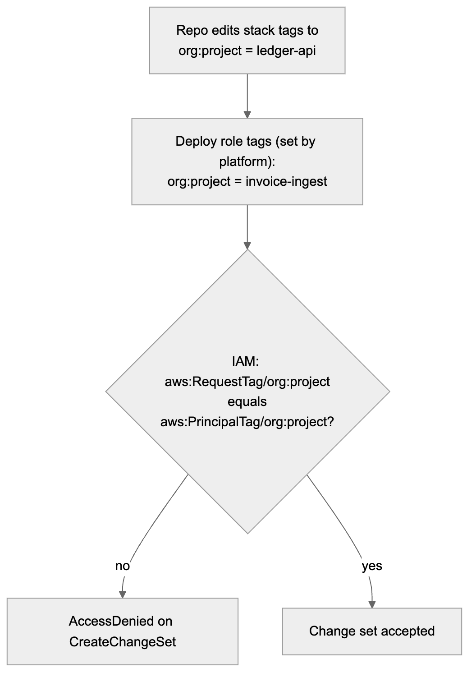
Figure 5. 4.4 Why a repo cannot forge tags
The role’s tags can be changed only by the platform’s provisioner role, and an SCP blocks changes to role tags by anyone else (§4.7). So a project can only ever act as itself.

4.5 Tag-based permissions (ABAC) design
One shared policy per role type per account, instead of one policy per project. The policies use ${aws:PrincipalTag/org:project}, so the same policy behaves differently for each project’s role. They are deployed once per account by StackSets. Project bootstrap only creates tagged roles that attach them. This is the main scalability gain: adding project number 500 adds no new policy documents.
Role (per project, per env account) | Trusted by | Attached shared policy | Tag rules
GitHubDeployRole | GitHub OIDC, sub = repo:{owner}/{repo}:environment:{env} | cloudinfra-deploy-abac | CloudFormation create/update/change-set actions only when aws:RequestTag/org:* = ${aws:PrincipalTag/org:*} for all required keys; describe/execute/delete only when aws:ResourceTag/org:project = own project. iam:PassRole only on roles where aws:ResourceTag/org:project = own project, passed to CloudFormation. Upload only to artifact-bucket/${aws:PrincipalTag/org:project}/*.
CfnExecutionRole | cloudformation.amazonaws.com (with aws:SourceAccount) | cloudinfra-exec-abac | Create: allowed only if request tags = own tags (and aws:TagKeys only from the allowed list). Change/delete: only if aws:ResourceTag/org:project = own project. IAM: CreateRole/PutRolePolicy only with the shared boundary attached and own tags. PassRole only on own-project roles, to Lambda.
App roles (e.g. the Lambda execution role, created by the stack) | lambda.amazonaws.com | Exact-ARN inline policy (from binders) + shared boundary cloudinfra-app-boundary | The boundary allows data access only to resources tagged with the same org:project (or same org:product with org:share-scope=product, read-only). The inline policy narrows it to exact ARNs.
Illustrative pattern (a design sketch, not final policy). The core rule of cloudinfra-exec-abac for Lambda:
[
{
"Sid": "CreateOnlyWithOwnTags",
"Effect": "Allow",
"Action": ["lambda:CreateFunction", "lambda:TagResource"],
"Resource": "arn:aws:lambda:*:${aws:PrincipalAccount}:function:${aws:PrincipalTag/org:project}--*",
"Condition": {
"StringEquals": {
"aws:RequestTag/org:project": "${aws:PrincipalTag/org:project}",
"aws:RequestTag/org:product": "${aws:PrincipalTag/org:product}",
"aws:RequestTag/org:environment": "${aws:PrincipalTag/org:environment}"
},
"ForAllValues:StringEquals": { "aws:TagKeys": ["org:portfolio","org:product","org:project","org:environment","org:cost-center","org:data-classification","org:managed-by","org:share-scope","org:resilience","org:region-role"] }
}
},
{
"Sid": "ManageOnlyOwnProject",
"Effect": "Allow",
"Action": ["lambda:UpdateFunctionCode","lambda:UpdateFunctionConfiguration","lambda:DeleteFunction","lambda:AddPermission","lambda:RemovePermission","lambda:GetFunction"],
"Resource": "arn:aws:lambda:*:${aws:PrincipalAccount}:function:${aws:PrincipalTag/org:project}--*",
"Condition": { "StringEquals": { "aws:ResourceTag/org:project": "${aws:PrincipalTag/org:project}" } }
}
]
Each rule checks both the tag condition and a name pattern built from the principal’s own tag. Each one alone would be enough; together they are defense in depth.

4.6 Tags + names: covering what tag conditions can’t
AWS support for aws:ResourceTag / aws:RequestTag varies by service and by action. The platform keeps a support matrix per catalog service, checked against the AWS Service Authorization Reference and tested in CI against a real sandbox account:
Situation | Control used
Action supports aws:RequestTag (create) and aws:ResourceTag (change) | Tag condition and name pattern
Action lacks tag-condition support (some describe/list calls, some bucket-configuration actions) | Name pattern ${aws:PrincipalTag/org:project}--* (still built from the role’s tag, so still tag-driven)
Action supports no resource scoping at all (e.g. some Describe* calls) | Allowed read-only, at account+region scope, only in platform-owned roles, never in generated app roles
Sharing within a product (opt-in): an iam.access connection to a resource in another project of the same product is allowed only if: 1. The target resource carries org:share-scope=product. 2. The access is read-only (unless an approved exception exists). 3. The boundary condition aws:ResourceTag/org:product = ${aws:PrincipalTag/org:product} holds.
Access across products is not offered by the platform; it goes through a separate exception process.

4.7 Organization guardrails (SCPs + Tag Policies)
SCPs apply to every principal in the account, including humans and other tools. So the tag rules hold even outside this platform.
Guardrail | Attached to | Rule
Protect ownership tags | All workload OUs | Deny TagResource/UntagResource (and service-specific equivalents) that add, change or remove org:* keys on a resource, unless the caller’s org:project matches the resource’s, or the caller is the platform provisioner / break-glass role.
Protect platform roles | All workload OUs | Deny changes (policy, trust, tags, boundary) to roles tagged org:managed-by=cloudinfra, except by the provisioner role. Deny iam:DeleteRolePermissionsBoundary everywhere.
Require tags on create | All workload OUs | For callers tagged org:managed-by=cloudinfra: deny create actions on catalog services if aws:RequestTag/org:project or org:environment is missing. Scoped to platform principals so other tooling isn’t broken.
Environment lock | Each environment OU | Deny create if aws:RequestTag/org:environment ≠ that OU’s environment (e.g. only prod in the Prod OU).
Classification gate | Sandbox OU | Deny create if aws:RequestTag/org:data-classification is confidential or restricted.
Region allow-list | All workload OUs | Only approved regions.
Tag Policies | Root | Allowed keys + allowed values for org:portfolio/org:product, generated from the registry and synced automatically; enforce letter case; enforce on resource types that support it.
Note: Tag Policies standardize values and report non-compliance; they enforce only for supported resource types. SCP + IAM conditions are the actual enforcement; Tag Policies are the consistency and reporting layer.

4.8 Human access uses the same tags
In IAM Identity Center, attributes for access control map an IdP attribute (product) to a session tag. Permission sets in shared environment accounts then use the same aws:ResourceTag/org:product = ${aws:PrincipalTag/org:product} pattern. Engineers can view and debug their product’s resources in DEV/TEST and get read-only access in PROD, with no per-product policies.

4.9 Compliance and drift
- AWS Config rules (required-tags + a custom rule) flag org:* tag values that don’t match the registry, per account, collected in the audit account.
- Resource Explorer / Tag Editor views per product.
- Cost Explorer + CUR grouped by org:portfolio / org:product / org:cost-center (activated as cost allocation tags in the management account).

4.10 Runtime isolation: components talk only to resources with the same tags
Rule: every component the platform creates (Lambda, ECS task, EKS pod, Step Functions state machine, Glue job, …) can read, write or invoke only resources carrying the same org:project and org:environment tag values. A Lambda in invoice-ingest / dev can use the invoice-ingest / dev S3 bucket because both are part of the same solution, and nothing else, even if someone pastes another bucket’s ARN into the code or the template.
This is generated into the CloudFormation template at creation time. Nobody writes it by hand, and it applies to every resource type in the catalog (§6.8).

4.10.1 How it is enforced (four layers)
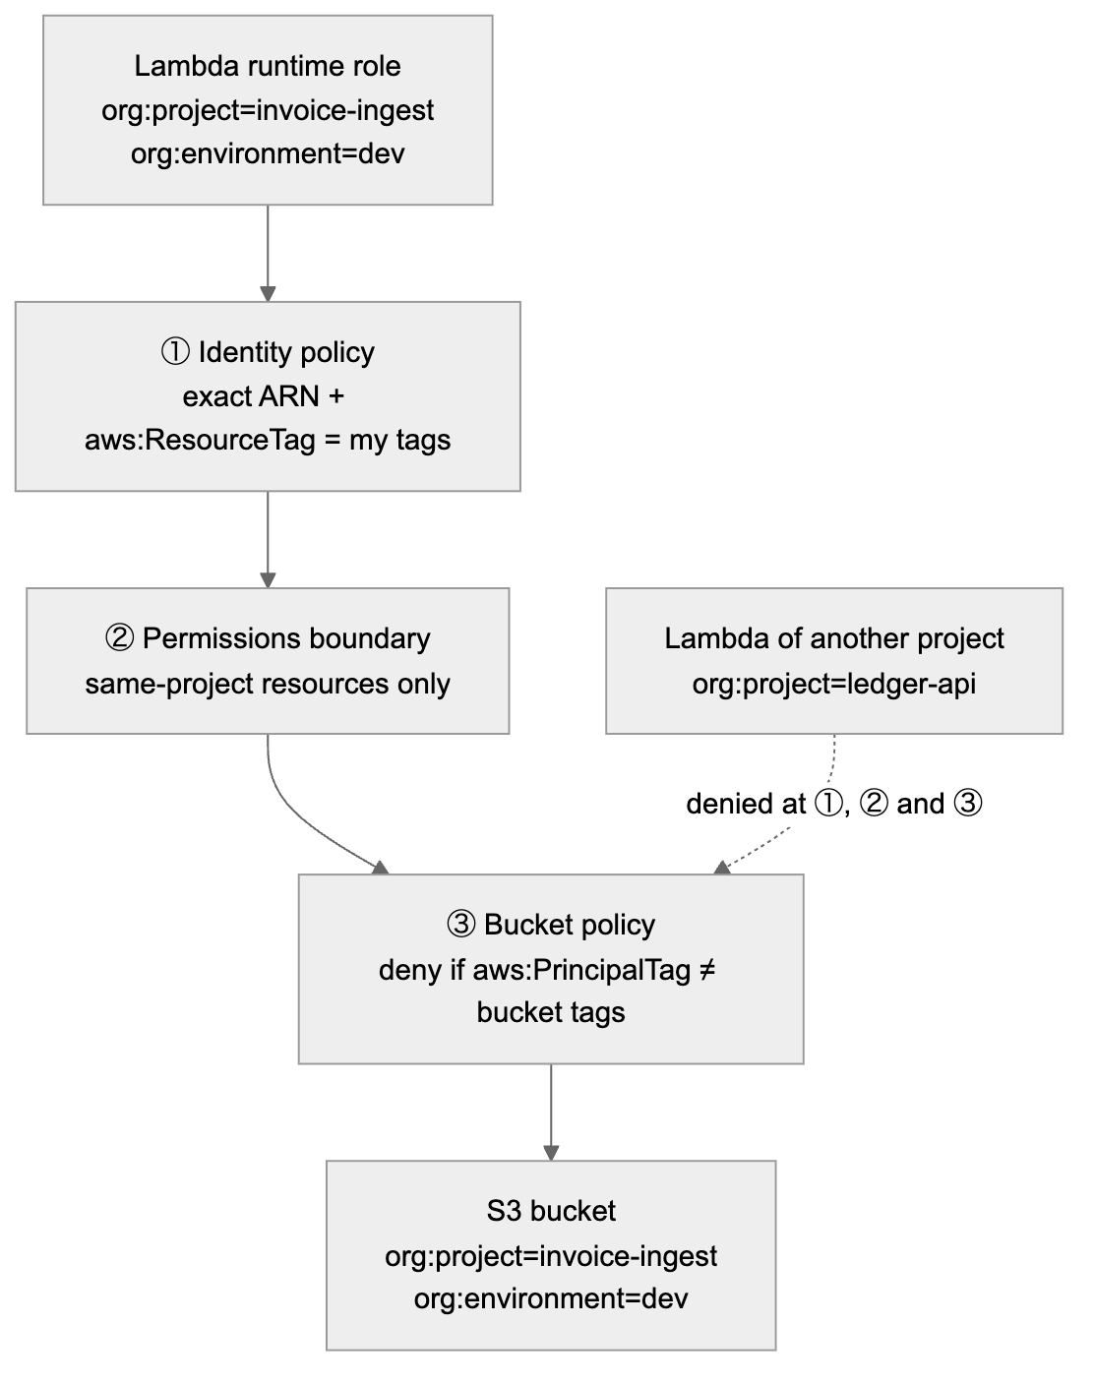
Figure 6. 4.10.1 How it is enforced (four layers)
Layer | Where | What it checks | Covers
1. Identity policy of the runtime role | Generated per component by the connection binders (§6.8.4) | Exact resource ARNs from the connections plus aws:ResourceTag/org:project = ${aws:PrincipalTag/org:project} and aws:ResourceTag/org:environment = ${aws:PrincipalTag/org:environment} on every action where AWS supports resource-tag conditions | Caller side
2. Shared permissions boundary (cloudinfra-app-boundary, §4.5) | Attached to every runtime role (required by the CFN execution role) | Same tag conditions for supported actions; for actions without tag support, only names built from the principal’s tag (${aws:PrincipalTag/org:project}--*) | Caller side, even if layer 1 had a bug
3. Resource policy on the target | Generated on every resource type that supports a resource policy: S3 buckets, SQS queues, SNS topics, KMS keys, Secrets Manager secrets, DynamoDB tables, ECR repositories, EventBridge buses, OpenSearch domains, API Gateway (private), Lambda (invocation), and so on | Deny any principal whose aws:PrincipalTag/org:project or aws:PrincipalTag/org:environment is not exactly this resource’s value. Works for all actions on the resource, including those that don’t support resource-tag conditions (e.g. S3 object operations). | Target side, independent of the caller’s policies
4. Organization guardrail (SCP) | Workload OUs (§4.7) | For principals tagged org:managed-by=cloudinfra: deny supported actions when aws:ResourceTag/org:project ≠ ${aws:PrincipalTag/org:project} | Whole account, including roles created outside the platform pattern
Because the runtime roles carry the same stack tags as the resources (propagated by CloudFormation, and required on iam:CreateRole by the CFN execution role, §4.5), “same tags and values” is something AWS checks on every request. It does not depend on naming conventions.

4.10.2 Example: the generated S3 bucket policy (illustrative)
{
"Version": "2012-10-17",
"Statement": [
{
"Sid": "DenyOtherProjects",
"Effect": "Deny",
"Principal": "*",
"Action": "s3:*",
"Resource": ["arn:aws:s3:::invoice-ingest--uploads-222222222222-us-east-1",
"arn:aws:s3:::invoice-ingest--uploads-222222222222-us-east-1/*"],
"Condition": {
"StringNotEquals": { "aws:PrincipalTag/org:project": "invoice-ingest" },
"BoolIfExists": { "aws:PrincipalIsAWSService": "false" },
"ArnNotLike": { "aws:PrincipalArn": ["arn:aws:iam::222222222222:role/aws-service-role/*",
"arn:aws:iam::222222222222:role/cloudinfra/break-glass-*"] }
}
},
{
"Sid": "DenyOtherEnvironments",
"Effect": "Deny",
"Principal": "*",
"Action": "s3:*",
"Resource": ["arn:aws:s3:::invoice-ingest--uploads-222222222222-us-east-1",
"arn:aws:s3:::invoice-ingest--uploads-222222222222-us-east-1/*"],
"Condition": {
"StringNotEquals": { "aws:PrincipalTag/org:environment": "dev" },
"BoolIfExists": { "aws:PrincipalIsAWSService": "false" },
"ArnNotLike": { "aws:PrincipalArn": ["arn:aws:iam::222222222222:role/aws-service-role/*",
"arn:aws:iam::222222222222:role/cloudinfra/break-glass-*"] }
}
},
{ "Sid": "DenyInsecureTransport", "Effect": "Deny", "Principal": "*", "Action": "s3:*",
"Resource": ["arn:aws:s3:::invoice-ingest--uploads-222222222222-us-east-1",
"arn:aws:s3:::invoice-ingest--uploads-222222222222-us-east-1/*"],
"Condition": { "Bool": { "aws:SecureTransport": "false" } } }
]
}
Design notes: - Project and environment are separate Deny statements. Several keys inside one StringNotEquals are combined with AND, which would deny only when both differ. Separate statements deny when either differs. - A principal with no tag is denied: a negated condition on a missing key evaluates to true. - Exceptions are explicit and minimal: - AWS service-linked roles, e.g. AWS Config reading the bucket configuration; - the audited break-glass role.
The CloudFormation execution role and the S3 replication role (§10) carry the project tags, so they pass without exceptions. - AWS service principals (e.g. S3 invoking Lambda, CloudFront reading S3) are not IAM roles and have no tags. They are allowed only through statements pinned to the specific same-project source with aws:SourceArn + aws:SourceAccount (the §6.3 pattern). The binder generates these only for connections drawn in the UI, so the source is always a resource with the same tags.

4.10.3 What this covers, and the honest edges
Situation | Behavior
Lambda → S3 / DynamoDB / SQS / SNS / Secrets / KMS of the same project + environment | Allowed (exact actions from the connection)
Lambda → same resource type of another project (ARN pasted in code) | Denied by layers 1, 2 and 3
DEV component → STAGE resource of the same project | Denied (environment tag differs; also a different account)
Opt-in sharing within a product (§4.6) | Resource policy gets one extra Allow-path exception: principals with the same org:product and the target tagged org:share-scope=product, read-only actions only, added only when such a connection exists
Humans (Identity Center) | Data access follows the environment policy: e.g. read for the product’s engineers in DEV/TEST via an explicit, read-only exception on org:product; no human data access in PROD except break-glass
Network paths (DB, cache, OpenSearch in a VPC) | Security groups only allow ingress from the security groups of same-project components (network.access, §6.8.4). Databases also use IAM auth / per-project secrets, which are themselves tag-protected
Service without resource policies and without tag-condition support | Layer 1 uses exact ARNs, layer 2 uses the principal-tag-derived name pattern, and the catalog marks the service “name-scoped”; such services need platform review before enablement (§6.8.2)

4.10.4 Verification
- Synthesis-time linter:
  - every resource in a project carries identical org:project / org:environment values;
  - every runtime role has the boundary and tag conditions;
  - every resource that supports a resource policy has the project/environment deny statements.
- A template missing any of these is rejected.
- CI cross-project tests (P1): two projects are deployed in the platform test account. Tests assert that project A’s Lambda cannot read, write or invoke project B’s bucket, queue, table, secret or function, even with the exact ARN, and can use its own.
- IAM Access Analyzer (external and internal access findings) runs in every account. Any access path to a project resource from a principal outside that project raises a finding to the platform.

5. Multi-account environment strategy

5.1 Organization structure
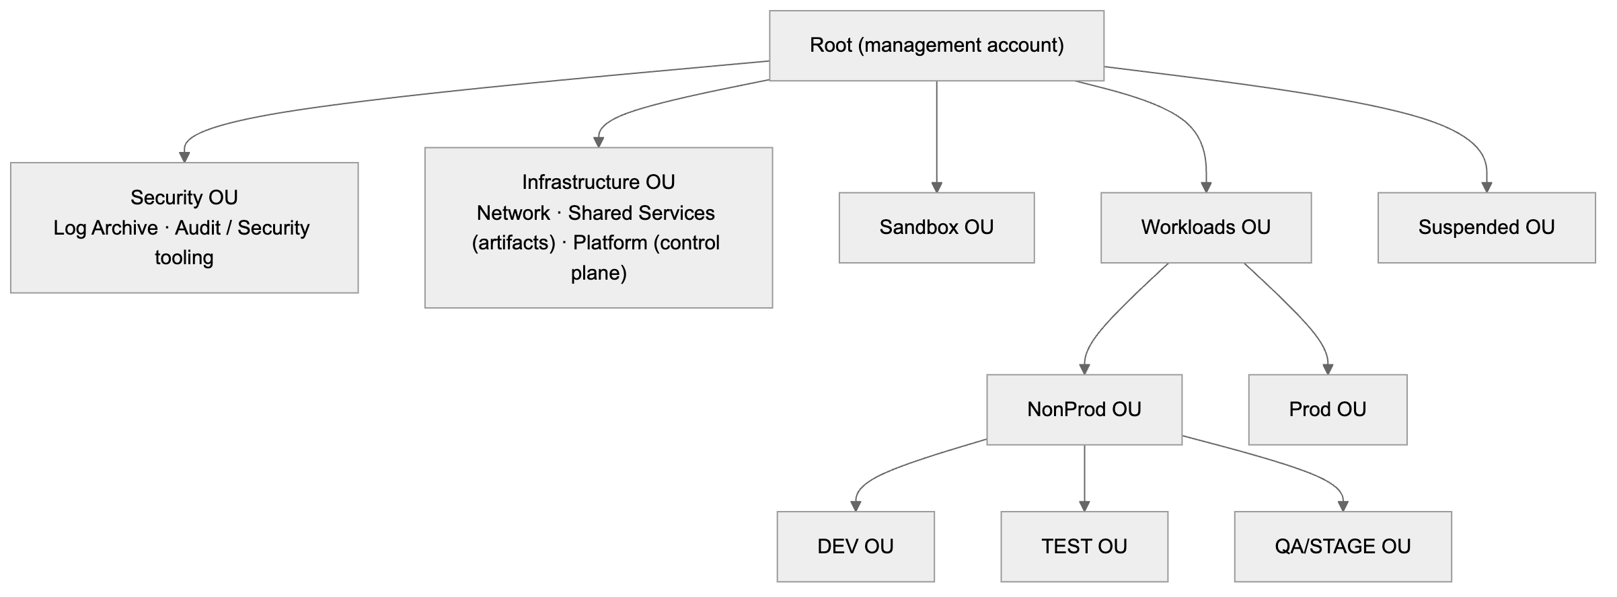
Figure 7. 5.1 Organization structure
Separate OUs per environment let each environment have its own SCPs (environment lock, classification, sandbox budget/cleanup, prod deletion protection).

5.2 Account granularity: options
Option | Accounts | Isolation between products | Main risk | When
A. One account per environment | 5 | Tags/ABAC only | Large blast radius; shared service quotas (e.g. Lambda’s default 1,000 concurrent executions per account per region shared by everyone) | Small orgs
B. One account per portfolio per environment (recommended) | 5 × portfolios | Account boundary between portfolios; ABAC between products/projects inside | Moderate number of accounts | Default
C. One account per product per environment | 5 × products | Account boundary per product | Account sprawl | Regulated or very large products
Recommendation: B, with C available per product. Account bindings (§5.5) decide per portfolio or product, so a product can move to dedicated accounts later without changing the generator, pipeline or policies. Only its binding changes. Tag-based isolation is required in all three options, because more than one project always shares an account.

5.3 Environment profiles
These are the default profiles for the five seeded environments. All of them can be changed per environment in the application (§5.5).
 | Sandbox | DEV | TEST | QA/STAGE | PROD
Purpose | Experiments, feature branches | Integration on main | Automated test suites | Production-like, UAT | Live
Deploy trigger | Manual dispatch from any branch | Auto on push to main | Auto after DEV succeeds | After TEST + approval | After STAGE + approval
GitHub env protection | None | Branch: main | Branch: main | main, required reviewer approval (QA; release console, GitHub identities), no self-approval | main/release tags, required reviewer approval (product owner + change mgmt; release console, GitHub identities), no self-approval, optional wait timer
Data classification allowed | ≤ internal | ≤ confidential (synthetic data) | ≤ confidential | as product ceiling | as product ceiling
retainOnDelete default | false | false | false | true | true (+ stack policy blocks replace/delete)
Log retention | 7 d | 14 d | 14 d | 90 d | ≥ 365 d
Cleanup | org:expires-on TTL (e.g. 14 days) + nightly cleanup job | — | — | — | Deletion denied by SCP except break-glass
Budget | Per-project budget alarm + hard SCP limits on expensive services | Budget alarm | Budget alarm | Budget alarm | Alarms + anomaly detection
Alarms | — | basic | basic | full | full + paging

5.4 Bootstrap at scale
Layer | What | Deployed by | When
Account bootstrap | GitHub OIDC provider; shared policies cloudinfra-deploy-abac, cloudinfra-exec-abac, cloudinfra-app-boundary; CloudInfraProvisioner role (trusted only by the Platform account, with aws:PrincipalOrgID); in gated accounts, the PlatformReleaseExecutor role (§8.3.1: execute reviewed change sets / release reviewed artifacts only; session tag org:project required) | Service-managed StackSet targeting the workload OUs, auto-deploying to new accounts | Once; updates roll out across the org
Shared Services | Artifact bucket per region; its bucket policy lets org accounts’ execution roles read ${aws:PrincipalTag/org:project}/* only (aws:PrincipalOrgID + principal-tag condition) | Platform IaC | Once per region
Project bootstrap | Per enabled environment: GitHubDeployRole + CfnExecutionRole, tagged with the project’s tags and attaching the shared policies. Small, because the policies already exist. | Orchestrator via CloudInfraProvisioner in each target account (in parallel, throttled per account) | Once per project per environment
Lambda requires the code bucket to be in the same region as the function; it can be in another account. Hence one artifact bucket per region in Shared Services.

5.5 Configurable environments and account numbers
Environments and their AWS account numbers are data in the application, not code. The five environments above are the default seed. Admins can rename, reorder, add (e.g. perf) or retire environments, and bind account numbers to them, without a code change or redeploy.

5.5.1 Environment definition (admin screen)
Field | Example | Notes
envId | stage | Immutable slug (^[a-z][a-z0-9]{1,15}$). Used as the GitHub environment name, the org:environment tag value and the OIDC sub suffix, so it cannot be renamed once a project uses it.
displayName | QA/STAGE | Free text, can change at any time.
order | 4 | Promotion order. Must be unique among active environments.
tier | sandbox | nonprod | prod | Selects default guardrails and which OU an account must be in.
requiredGate | true | If true, any later environment requires this one to be enabled (e.g. no prod without stage).
deployTrigger | manual-any-branch | auto-on-main | after-previous | after-previous-with-approval | Becomes the job wiring in the generated deploy.yml.
requiresApproval | true | GitHub required-reviewer approval before deployment. Locked to true for STAGE and all prod-tier environments (§8.3).
protectionProfile | branch rules, reviewer source, prevent self-review, wait timer | Applied to the GitHub environment (§7.2).
guardrailProfile | classification ceiling, retention minimums, retain defaults, TTL, stack policy | Feeds validation, cfn-guard rules and config/{env}.json defaults (§5.3 table = the default profiles).
status | active | retired | Retired environments are hidden for new projects; existing projects keep working until migrated.

5.5.2 Account bindings
An account binding says “for this environment, this portfolio (or product), in this region, deploy to this AWS account”.
Field | Example | Rule
envId | prod | Must be an active environment
scope | portfolio / product | A product binding overrides its portfolio’s binding (matches option B with C per product, §5.2)
scopeId | pf-payments | Must exist in the org registry
region | us-east-1 | Must be in the region allow-list
accountId | 555555555555 | 12 digits. Unique across environments: an account can belong to only one environment (enforced by a transactional uniqueness record). It may serve several portfolios only if the admin explicitly allows sharing (option A).
status | pending → onboarded / failed → retired | Only onboarded bindings can be selected for deploys
Resolution at preview time is: product binding → portfolio binding → error “no account configured for {env}”. The preview shows the resolved account for every environment before the user clicks Create.

5.5.3 Onboarding checks (run when a binding is saved or re-validated)
Check | How
Account belongs to the organization and is active | organizations:DescribeAccount from the Platform account (delegated admin)
Account is in the OU that matches the environment’s tier | organizations:ListParents
Account bootstrap is in place | StackSet instance status CURRENT for that account + region
Platform can reach it | Assume CloudInfraProvisioner and call sts:GetCallerIdentity; returned account must equal accountId
GitHub OIDC provider and shared tag-based policies exist | Read-only IAM checks through the provisioner role
Account not bound to a different environment | Uniqueness record
A binding that fails any check stays failed, with the reason shown in the admin screen.

5.5.4 Who can change it, and how changes propagate
- Permissions: only platform-admin can edit environments and bindings. Changes to prod-tier environments need a second admin’s approval (four-eyes) before they take effect. Every change is versioned and audited (who, when, before/after).
- New projects always use the current configuration.
- Existing projects are never silently re-pointed. When an environment is added or a binding changes, the platform lists the affected projects and, per project:
  - Bootstraps the new account (§5.4).
  - Updates the repo’s GitHub variables (§5.5.5).
  - Opens a “sync pipeline” PR if the environment list or order changed.
- Moving an existing stack to a different account is a migration (deploy in the new account, move data, retire the old stack). It is done on purpose and per project, never automatically.
- A reconciler compares each repo’s GitHub variables with the application configuration nightly. It reports drift and, if configured, repairs it.

5.5.5 GitHub variables (all pipeline configuration lives here)
Every value the pipeline needs is a GitHub Actions variable (vars.*), written by the platform. The workflow files contain no account numbers, ARNs, names or tags; they only reference variables. There are no GitHub secrets in OIDC mode, because no credentials are stored. A role ARN is an identifier, not a credential, so it is a variable too.
Variable | Level | Example | Source in the application
PROJECT_NAME | Repository | invoice-ingest | Project
ORG_PORTFOLIO | Repository | pf-payments | Ownership (registry ID)
ORG_PRODUCT | Repository | pr-invoicing | Ownership
ORG_COST_CENTER | Repository | CC-4410 | Registry (product)
ORG_DATA_CLASSIFICATION | Repository | confidential | Ownership
ENVIRONMENT_ORDER | Repository | sandbox,dev,test,stage,prod | Environment config (informational; the generated deploy.yml holds the actual job chain)
ENVIRONMENT_NAME | Environment | prod | envId
AWS_ACCOUNT_ID | Environment | 555555555555 | Resolved account binding
AWS_REGION | Environment | us-east-1 | Binding region (multi-region projects use AWS_PRIMARY_REGION / AWS_SECONDARY_REGION instead, §10.5)
AWS_ROLE_ARN | Environment | arn:aws:iam::555555555555:role/cloudinfra/invoice-ingest-deploy | Project bootstrap output
CFN_EXEC_ROLE_ARN | Environment | arn:aws:iam::555555555555:role/cloudinfra/invoice-ingest-cfn-exec | Project bootstrap output
ARTIFACT_BUCKET | Environment | cloudinfra-artifacts-999999999999-us-east-1 | Shared Services bucket for the binding’s region
- Plan environments (stage-plan, prod-plan) have their own copy of these environment variables, where AWS_ROLE_ARN points to the plan role (§8.3). The workflow uses the same variable name everywhere; GitHub supplies the right value per environment.
- Environment-level variables are visible only to jobs that run in that GitHub environment. So the DEV job never sees the PROD account number or role.
- GitHub’s precedence is environment → repository → organization. The platform writes each variable at exactly one level, so precedence never decides a value by accident.
- Who can edit them: the product’s GitHub access team (from the registry) gets the maintain role on the repo, not admin, so it cannot change variables or environment protection. Only the platform (GitHub App) and org admins can. This is a convenience control, not the security boundary.
- The security boundary is still AWS. If someone did change AWS_ACCOUNT_ID or a tag variable:
  - OIDC trust in each account only accepts this repo + this environment.
  - IAM only accepts stack tags equal to the deploy role’s own tags (§4.4).
  - The pipeline also checks that aws sts get-caller-identity returns vars.AWS_ACCOUNT_ID and that vars.ENVIRONMENT_NAME equals the job’s GitHub environment, and stops if not.
- A tampered variable can make a deploy fail; it cannot make it touch another project’s or another environment’s resources.
- Long-lived credentials mode (§8.7) is the only exception: access keys are credentials and are stored as GitHub environment secrets, never as variables.

6. CloudFormation generation engine

6.1 Approach: building blocks + connection binders
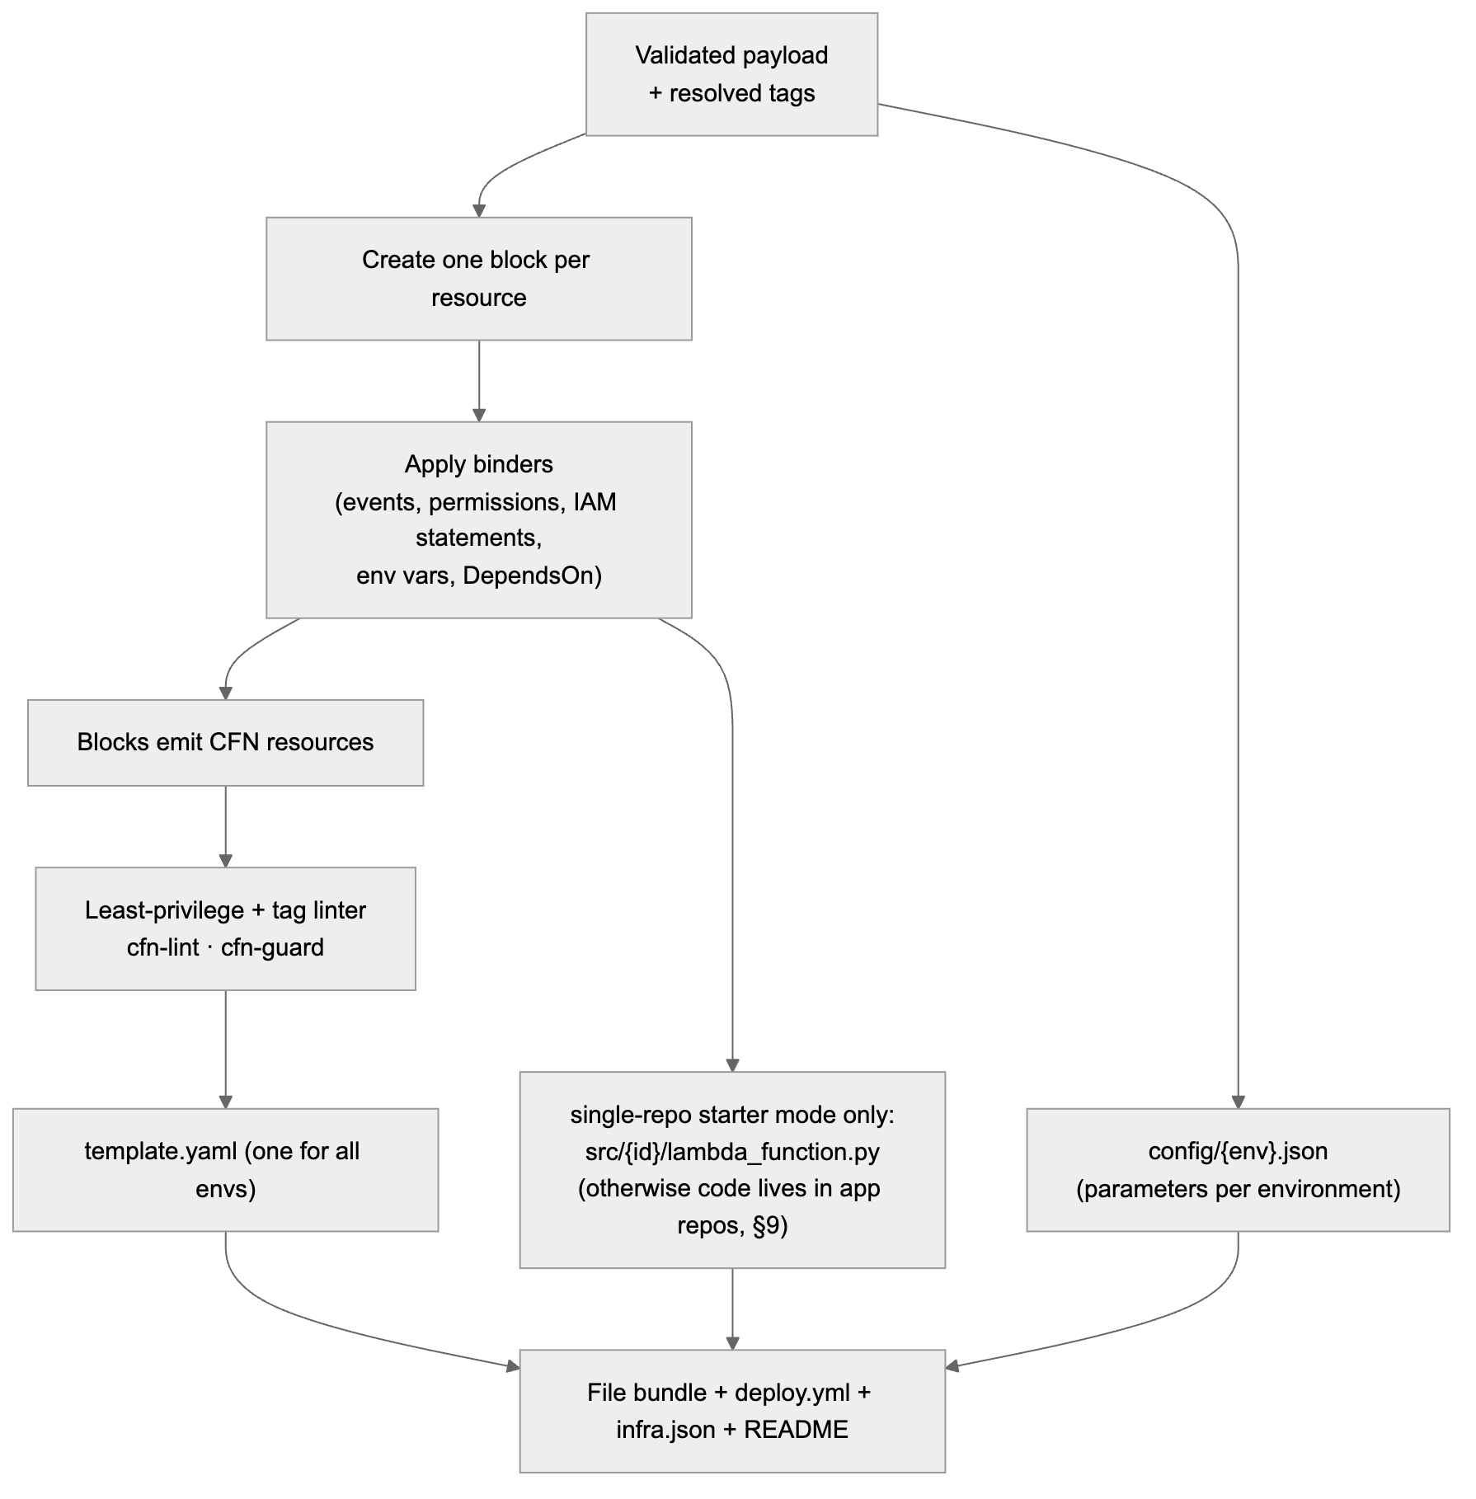
Figure 8. 6.1 Approach: building blocks + connection binders
- One template for all environments. Differences between environments are only parameter values in config/{env}.json (memory, retention, concurrency, retain flags), checked against per-environment ranges.
- Tags are not hardcoded per resource in the template. They are applied as stack tags by the pipeline and propagated by CloudFormation. The template itself stays environment-neutral and ownership-neutral. (A resource type that doesn’t receive propagated tags gets explicit Tags from parameters; the linter checks every taggable resource ends up tagged.)
- Output is deterministic (stable logical IDs, sorted keys, no timestamps), so regenerating gives an empty changeset.

6.2 Naming
Item | Pattern | Example
Stack | {project} (one per environment account) | invoice-ingest
Logical IDs | PascalCase(id) + type suffix | UploadsBucket, ProcessorFunction, ProcessorRole
S3 bucket | {project}--{id}-${AWS::AccountId}-${AWS::Region} | invoice-ingest--uploads-222222222222-us-east-1
Lambda / DynamoDB | {project}--{id} | invoice-ingest--processor
Log group | /aws/lambda/{project}--{id} | —
IAM roles | CloudFormation-generated name, Path /app/{project}/, tagged | —
Boundary | Shared cloudinfra-app-boundary per account | —
The account ID in bucket names keeps them unique across environments.

6.3 S3 → Lambda wiring (and the circular dependency trap)
The obvious template has a dependency loop: - The bucket’s notification needs the function ARN. - The Lambda::Permission needs the bucket ARN. - The bucket must wait for the permission, because S3 checks that it may invoke the function when the notification is saved.
Fix: 1. The bucket name is predictable (built with Fn::Sub). 2. Lambda::Permission.SourceArn and the function role’s s3:GetObject resource use a constructed ARN string, not Ref/GetAtt. 3. The bucket gets DependsOn on the permission. 4. The permission sets SourceAccount: ${AWS::AccountId}, so another account that owns a bucket with that name cannot invoke the function.
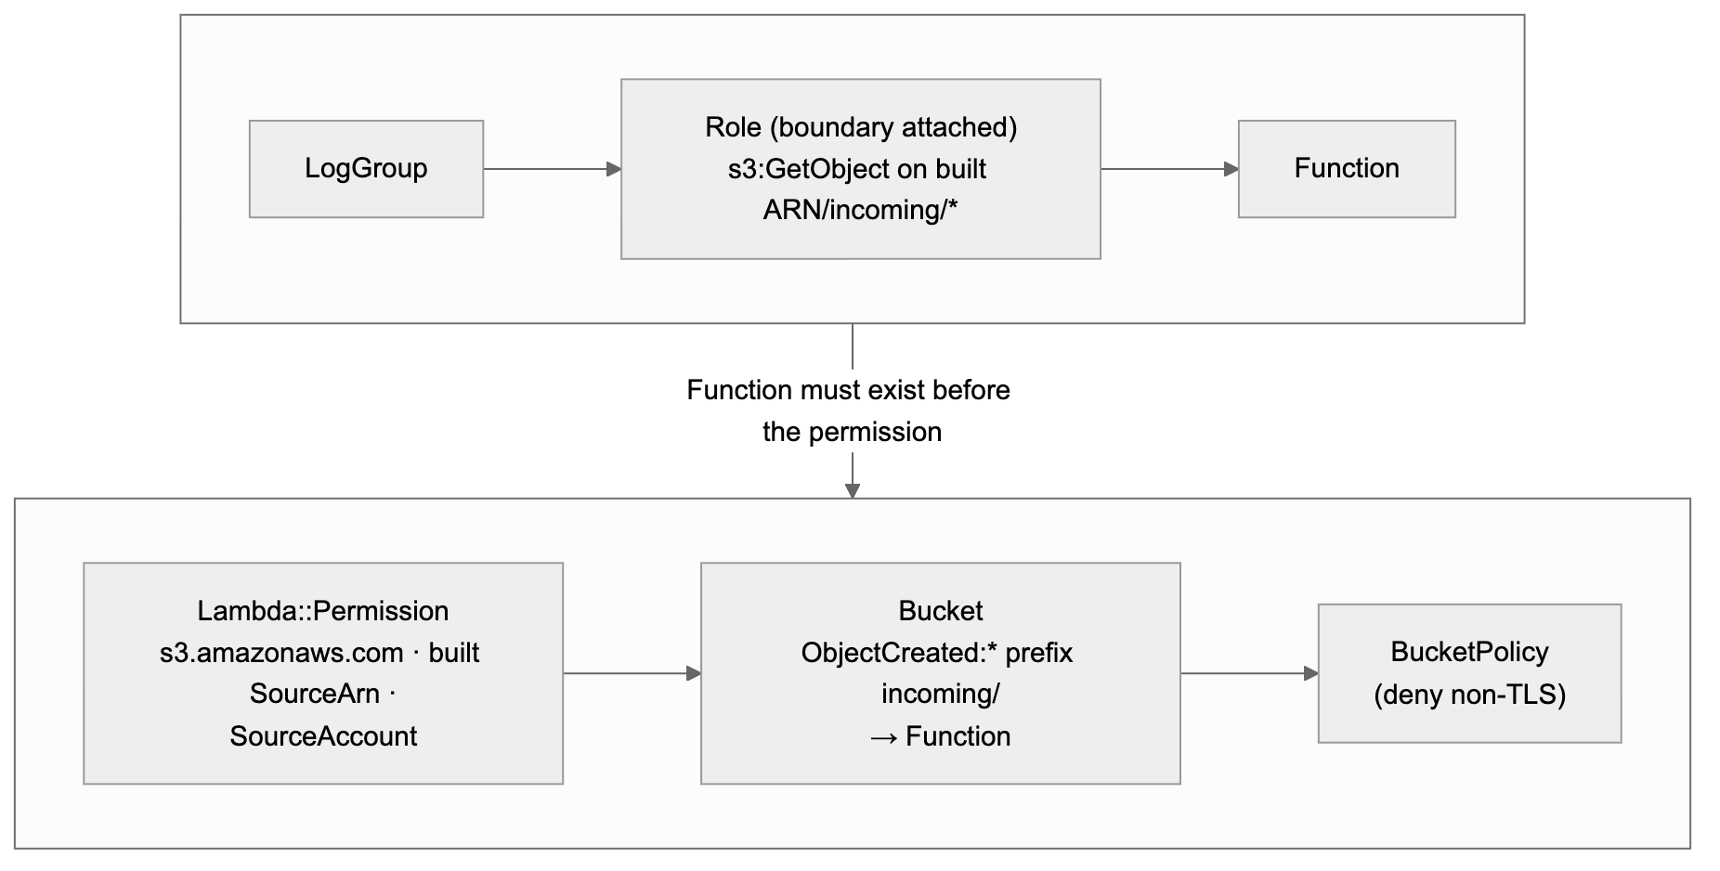
Figure 9. 6.3 S3 → Lambda wiring (and the circular dependency trap)

6.4 Defaults built into each block
- S3:
  - Public access blocked; ACLs off; encryption (SSE-S3, or SSE-KMS for confidential+).
  - Bucket policy: deny other projects and other environments by principal tag (§4.10.2), and deny non-TLS requests.
  - Versioning + lifecycle.
  - DeletionPolicy: RetainExceptOnCreate / UpdateReplacePolicy: Retain when retained (stage/prod by default).
- Lambda:
  - One execution role per function, with the shared boundary attached; exact-ARN inline policy (logs to its own log group + binder statements).
  - An explicit log group with retention per environment; JSON logging.
  - arm64.
  - Code: in the recommended split model (§9) the function is created with a platform bootstrap package and the application repo deploys the real code. In single-repo starter mode only, code comes from the regional artifact bucket at {project}/{tree-hash}/{id}.zip.
  - DLQ / on-failure destination recommended for S3 triggers.
- DynamoDB: on-demand billing, point-in-time recovery, encryption, deletion protection in stage/prod.

6.5 Template parameters
Parameter | Source
ProjectName | GitHub environment variable
EnvironmentName | GitHub environment variable (must equal the deploy role’s org:environment tag)
CodeS3Bucket, CodeS3Prefix | Bootstrap package location (split model, §9) or {project}/{tree-hash-of-src} (single-repo starter mode)
Per-resource settings (memory, retention, concurrency, retain) | config/{env}.json

6.6 Validation gate
- Schema + graph + registry/entitlement checks (§3.3).
- Least-privilege linter:
  - No Allow with * / service:* actions or * resources in generated roles.
  - No iam:*, sts:AssumeRole or iam:PassRole in app roles.
  - Every generated role has the boundary.
- Tag linter: every taggable resource will carry the required org:* keys (via propagation or explicit tags) with identical project/environment values. Every runtime role has the boundary and tag conditions, and every resource that supports a resource policy has the same-tag deny statements (§4.10).
- cfn-lint; cfn-guard rules per environment (e.g. prod: retain + alarms + retention ≥ 365 days).
- Golden-file tests for every catalog combination.

6.7 Idempotency of the template
- Stable logical IDs and predictable physical names.
- Retain policies on stateful resources; stack policy in prod.
- Code keys based on content (tree hash). A docs-only push gives an empty changeset (--no-fail-on-empty-changeset).
- No timestamps or request IDs in the template; deploys go through changesets.

6.8 Full AWS service coverage: every service and every combination, including databases
Goal: users can build any combination of AWS services that CloudFormation supports, including all database engines, with the same security, tagging, environment and approval guarantees as the Lambda + S3 example.
Why the hand-written approach must change: AWS has well over a thousand CloudFormation resource types and adds more every month. Hand-writing a block and binder for each one, and testing every combination by hand, does not scale. The engine therefore generates most of the catalog from AWS’s own machine-readable specifications and adds curated, opinionated blocks on top for the services people use most.

6.8.1 Two inputs published by AWS
Source | What it gives the platform | How it is used
CloudFormation resource provider schemas (JSON Schema for every resource type; aws cloudformation describe-type / published schema bundle per region) | Every property, its type, required/read-only/create-only fields, which properties force replacement, available GetAtt attributes, tagging support | Generates the UI form, payload validation, the replacement-risk classifier (§8.4.2) and correct Ref/GetAtt wiring for any resource type
AWS Service Authorization Reference (machine-readable JSON per service: actions, resource ARN formats, condition keys, access levels) | For every action: read/write/list/tagging level, ARN pattern, whether aws:ResourceTag / aws:RequestTag are supported | Generates least-privilege iam.access statements for any service, the tag-condition support matrix (§4.6) and the per-service parts of the shared tag-based policies (§4.5)
A nightly catalog sync job downloads both, diffs them against the current catalog version, and opens a PR on the platform repo with new and changed types. A platform engineer reviews it, the golden tests run, and it ships as a new catalogVersion. Nothing reaches users without review.
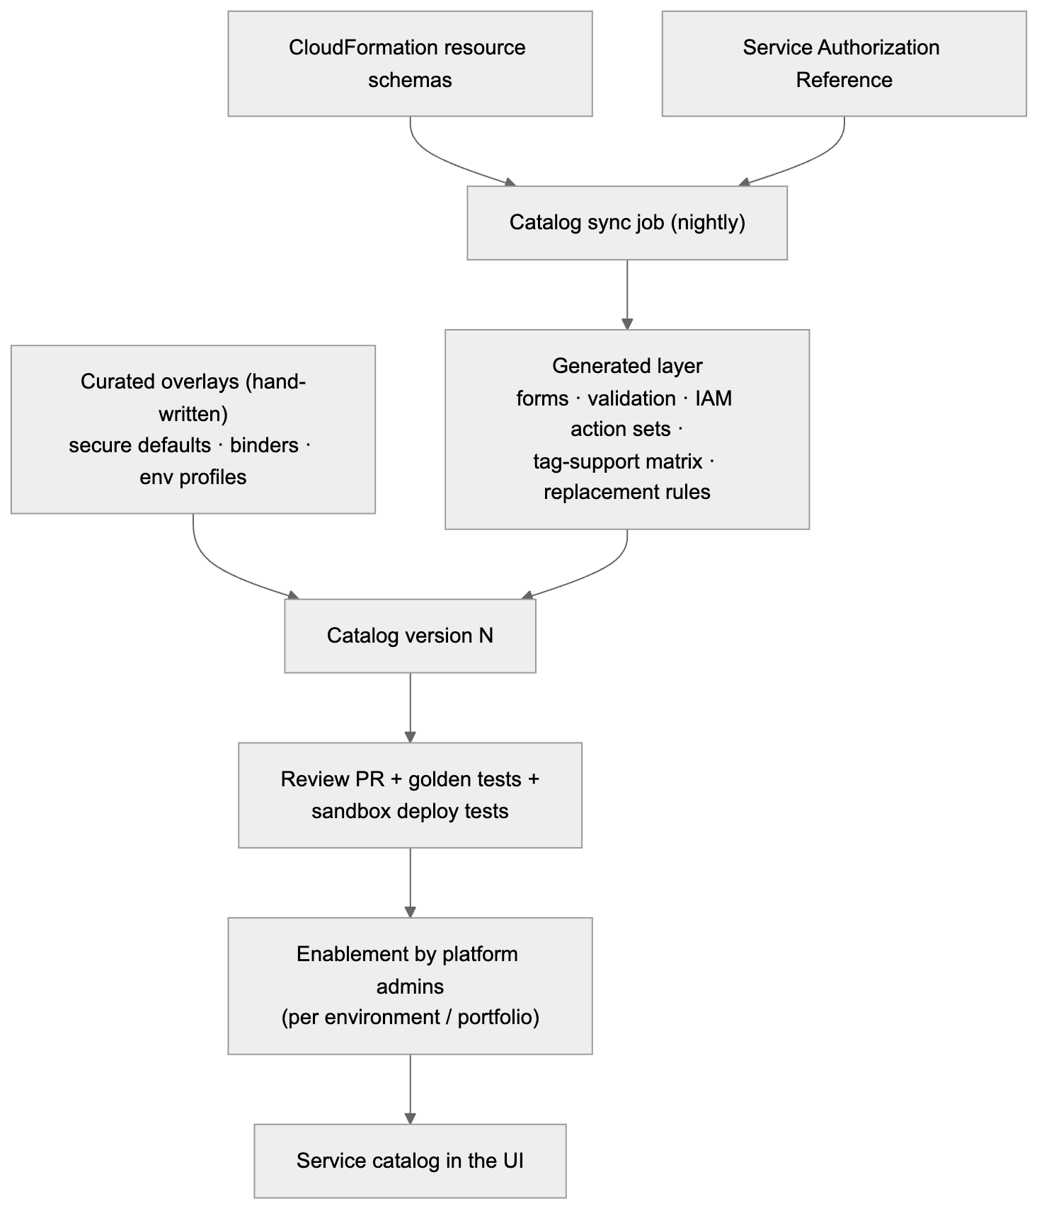
Figure 10. 6.8.1 Two inputs published by AWS

6.8.2 Catalog tiers
Tier | What | Defaults and wiring | Who can use it
Tier 1: Curated | The most-used services (list below) | Hand-written secure defaults per environment profile, binders for connections, tested combinations, reference patterns | All users
Tier 2: Schema-driven | Any other project-scoped CloudFormation resource type | Generated form + validation; mandatory guardrails applied to every type (naming, tags, encryption where the schema has it, deletion policies for stateful types); generic iam.access binder from the Service Authorization Reference | Enabled per service by platform admins after a short review (ABAC support, guard rules, cost); can be limited to sandbox/dev first
Excluded | Account-wide or organization-wide types (Organizations, Control Tower, IAM Identity Center, account settings, IAM users/groups, VPC creation where the landing zone owns the network, billing) and anything that can’t be scoped to one project | — | Not offered; managed by the landing zone / platform team
Promoting a Tier 2 service to Tier 1 is a normal catalog change: add a curated overlay and binders.
Tier 1 at launch (proposal, D27):
Category | Services
Compute | Lambda, ECS (Fargate), EKS workloads (shared clusters), App Runner, Batch
Integration | Step Functions, EventBridge (buses, rules, Scheduler, Pipes), SQS, SNS, Kinesis Data Streams, Amazon Data Firehose, Amazon MQ, MSK
API & edge | API Gateway (REST, HTTP, WebSocket), Application/Network Load Balancer (listener rules on shared or project ALB), CloudFront, AWS WAF (web ACL association)
Storage | S3, EFS
Databases | Aurora PostgreSQL / MySQL (incl. Serverless v2), RDS PostgreSQL / MySQL / MariaDB, DynamoDB, DocumentDB, Neptune, ElastiCache (Valkey / Redis OSS / Memcached), MemoryDB, Keyspaces, Timestream, Redshift Serverless, OpenSearch Service (incl. Serverless)
Analytics | Glue (jobs, crawlers, Data Catalog), Athena workgroups, Lake Formation permissions (project-scoped)
Security & config | KMS keys (project keys), Secrets Manager, SSM parameters, AppConfig, Cognito user pools
Observability | CloudWatch alarms, dashboards, log groups, X-Ray groups
Machine learning | SageMaker endpoints/models (project-scoped), Amazon Bedrock access (model invocation permissions)
Commercial database engines: RDS for Oracle and RDS for SQL Server include third-party vendor licenses. Because of the open-source/no-commercial-products policy (§1), they are excluded by default and can be enabled only by an explicit decision (D28).

6.8.3 Databases: what the platform adds
Databases need more than a resource: network placement, credentials, backups and engine-specific settings. The curated database blocks provide these automatically.
Concern | Built-in behavior
Network | Placed in the landing zone’s private database subnets (published to SSM by the network team, D23). A security group per database. Ingress is opened only by a connection (network.access, below) from a specific compute slot’s security group, on the engine port. Never public.
Credentials | No passwords in templates or repos. RDS/Aurora/DocumentDB/Redshift use AWS-managed master credentials in Secrets Manager (ManageMasterUserPassword) with rotation. App runtime roles get secretsmanager:GetSecretValue on that one secret only. IAM database authentication (rds-db:connect for a specific DB user) is offered where the engine supports it.
Connections from Lambda | RDS Proxy added automatically when a Lambda slot connects to RDS/Aurora (connection pooling + IAM auth)
Encryption | At rest with the project KMS key (stage/prod) or AWS-managed key (sandbox/dev); TLS required (parameter group require_secure_transport / rds.force_ssl)
Resilience per environment profile | Sandbox/dev: single-AZ, small instance or serverless minimum, 1-day backups. Stage/prod: Multi-AZ / Aurora replicas, longer backup retention, Performance Insights, enhanced monitoring
Data protection | DeletionProtection on stage/prod; DeletionPolicy: Snapshot (or RetainExceptOnCreate where snapshots don’t apply) and UpdateReplacePolicy: Snapshot. Any change that would replace a database is classified high risk and blocked without an override (§8.4.2).
Parameter groups | Generated per database from the engine family, with secure defaults; overridable settings limited to an allow-list
Contract exposes | Endpoint(s) (writer/reader), port, engine/version, database name, secret ARN, proxy endpoint, IAM auth user, security group ID
Schema migrations | Owned by the application repo (solution code), using open-source tools such as Flyway, Liquibase or Alembic. Run by the golden-path pipeline as a one-off ECS task or Lambda inside the VPC, before the new code version is released. Same approvals as the app deploy (§9.9 independence preserved).

6.8.4 Connection kinds that cover any combination
Combinations are built from a small set of generic connection kinds that work across services, not from a binder per pair of services:
Connection kind | Examples | What the binder generates
iam.access (read / write / readwrite / admin-data) | Lambda → DynamoDB, ECS → S3, Step Functions → Lambda, Glue → S3 | Least-privilege statements from the Service Authorization Reference for the target’s ARN; tag conditions where supported
network.access | ECS → Aurora (5432), Lambda → ElastiCache (6379), EKS workload → OpenSearch (443) | Security group ingress rule (source SG → target SG, engine port only); VPC config on the source if missing
event.source (poll-based) | SQS / Kinesis / DynamoDB Streams / MSK / Amazon MQ → Lambda | Event source mapping + the poller permissions on the source
event.notify (push-based) | S3 → Lambda/SQS/SNS/EventBridge, SNS → SQS/Lambda | Notification config + resource policy on the target with SourceArn/SourceAccount (the §6.3 pattern, generalized)
event.rule | EventBridge rule/schedule/pipe → any supported target | Rule/schedule/pipe + target role or resource policy
api.route | API Gateway / ALB → Lambda / ECS / Step Functions | Integration, route, permission/target group
workflow.task | Step Functions → Lambda / ECS / DynamoDB / SQS / SNS / Glue / Batch / Bedrock … | Task state substitution values + state machine role statements for that integration
secret.binding | Any compute → database secret / Secrets Manager secret / SSM parameter | GetSecretValue/GetParameter on that one ARN + KMS decrypt on its key; value name injected as env var
cdn.origin | CloudFront → S3 / ALB / API Gateway | Origin + origin access control and the matching bucket/resource policy
Each connection kind declares which source and target types it accepts, using capabilities from the generated layer (e.g. “can be a Lambda event source”, “has a security group”, “has an ARN”). So a new service is usable in combinations as soon as its schema and authorization data are in the catalog. The compatibility matrix shown in the UI is computed, not hand-maintained.

6.8.5 Scaling templates: layered stacks
Large combinations can exceed CloudFormation limits (500 resources per stack, 1 MB template) and mix very different change rates. The engine splits a project into layer stacks automatically when needed:
Stack | Contains | Change rate | Protection
{project}-data | Databases, buckets, tables, streams, KMS keys, secrets | Rare | Strongest: stack policy denies replace/delete; retain/snapshot policies
{project}-integration | Queues, topics, event buses, rules, APIs | Medium | Standard
{project}-compute | Lambda shells, ECS services, EKS namespace resources, state machine roles | Frequent | Standard
{project}-edge | CloudFront, WAF associations, DNS records | Rare | Standard
- Layers reference each other through SSM parameters, not CloudFormation exports (same reason as §9.4).
- They deploy in dependency order in the same pipeline run, each through its own change set, and STAGE/PROD reviewers approve all layer change sets together as one release.
- Small projects stay a single stack.

6.8.6 How “all combinations” are validated and tested
Exhaustive testing of every combination is impossible, so correctness rests on construction rules plus systematic sampling:
- By construction: every resource is validated against its AWS schema; every connection against the computed compatibility matrix; every IAM statement is generated from the authorization data and passes the least-privilege linter; every template passes cfn-lint and cfn-guard. A combination that passes these is valid by design.
- Golden tests: every Tier 1 block and every connection kind has reference templates in CI.
- Pairwise combination tests: CI generates pairwise (all-pairs) combinations of Tier 1 types × connection kinds × environment profiles. This covers every interaction between any two choices with a manageable number of cases. Each case is synthesized and linted on every change.
- Real deploy tests: a nightly job deploys a rotating sample of combinations (including every database engine at least weekly) into a dedicated platform test account, runs connectivity checks (e.g. Lambda → RDS Proxy → Aurora with IAM auth), then deletes them.
- Reference patterns: popular combinations are offered as one-click patterns in the UI, each fully deploy-tested. Examples:
  - REST API + Lambda + Aurora Serverless;
  - containerized service on ECS + ALB + RDS PostgreSQL + ElastiCache;
  - event pipeline (S3 → EventBridge → Step Functions → Lambda → DynamoDB);
  - streaming (Kinesis → Lambda → OpenSearch);
  - data lake (S3 + Glue + Athena + Lake Formation).

6.8.7 Governance for a large catalog
- Enablement: admins enable services per environment tier and per portfolio (e.g. Neptune allowed in sandbox only until reviewed). Disabled services are hidden in the UI and also denied by SCP, so the rule holds outside the platform too.
- Cost visibility: the preview shows an indicative monthly cost per environment for each resource. It is computed in-house from the AWS Price List API (AWS service, no third-party tool).
- Quotas: the preview warns when a combination would approach an account quota (e.g. VPC security groups, Lambda concurrency), using the Service Quotas API.
- Deprecations: when AWS deprecates a resource type, property or engine version, the catalog sync flags the affected projects and the platform opens upgrade PRs on their infrastructure repos.

7. GitHub repository provisioning

7.1 Identity: GitHub App (recommended)
1-hour installation tokens, per-installation rate limits, and an audit trail as a bot. Permissions:
Permission | Level | Used for
Administration | write | Create/delete repos, custom properties
Contents | write | Commit
Workflows | write | Required to commit anything under .github/workflows/
Secrets | write | Only for long-lived credentials mode (§8.7); not needed with OIDC
Variables | write | Actions variables
Environments | write | Create one GitHub environment per configured environment
Actions | read | Run status
Deployments | write | Run status; submit reviewer approvals from the release console (as the reviewer, via user-to-server token, §8.5)
Members | read | Resolve reviewer teams
Webhooks: workflow_run, deployment, deployment_status, deployment_review, deployment_protection_rule. GitHub Apps can create repos in organizations; personal-account repos are out of scope for v1.

7.2 Provisioning steps (each step is safe to retry)
# | Step | How | Retry / idempotency approach | Undo (before the commit)
1 | Create repo | POST /orgs/{org}/repos (auto_init: true). Set custom properties portfolio, product, project; grant the product’s GitHub access team (from the registry) the maintain role. | Name exists → check the ownership marker (custom property provision-request); resume if ours, otherwise fail with a name conflict | Delete the repo (only if this job created it)
2 | Bootstrap AWS per enabled environment (in parallel) | AssumeRole CloudInfraProvisioner in each target account → create/update cloudinfra-bootstrap-{project} (tagged roles, OIDC trust for repo:{owner}/{repo}:environment:{env}) | CloudFormation ClientRequestToken; create-or-update | Delete the bootstrap stack in each account where it was created
3 | GitHub environments | PUT /repos/{o}/{r}/environments/{env} for each enabled environment, with protection rules from that environment’s protection profile (§5.5) (branch policies; for STAGE and PROD: required reviewers from the registry, prevent self-review, plus a separate {env}-plan environment without reviewers, §8.3) | PUT can safely be repeated | Removed when the repo is deleted
4 | GitHub variables | Repository variables (project + ownership tags) and environment variables per enabled environment (ENVIRONMENT_NAME, AWS_ACCOUNT_ID, AWS_REGION, AWS_ROLE_ARN, CFN_EXEC_ROLE_ARN, ARTIFACT_BUCKET). Full list in §5.5.5. No secrets in OIDC mode. | Create-or-update (POST, then PATCH on 409) | Removed when the repo is deleted
5 | Atomic commit | Git Data API: create tree (all files) → create commit → fast-forward refs/heads/main (force: false) | Skip if main already has the job’s commit trailer | None. The repo is kept from here on
6 | Track promotion | deployment_status / workflow_run webhooks per environment; reconciler as a backup | Matched by head_sha + environment | —
Why variables are set before the commit: pushing deploy.yml starts the workflow at once.
Why the Git Data API: one commit appears all at once. The per-file contents endpoint would create N commits and N workflow runs.
Why environment-scoped values: each environment’s job sees only its own account’s role. A DEV job cannot even read the PROD role ARN.

7.3 Rate limits and API etiquette
- Honor x-ratelimit-remaining / reset and retry-after. Otherwise use exponential backoff with full jitter (1 s base, 60 s cap, 6 attempts).
- Content-creating calls are serialized per installation, at least 1 s apart (token bucket, §12.3).
- Webhooks instead of polling; conditional requests (304s are not counted against the limit).
- A project with 5 environments needs roughly 25–30 write calls. At 1 write/s per installation, that is about 30 s of GitHub time per project, which is why provisioning is async and queued.

8. Deployment pipeline (GitHub Actions + OIDC, configurable environments)

8.1 Trust model per environment
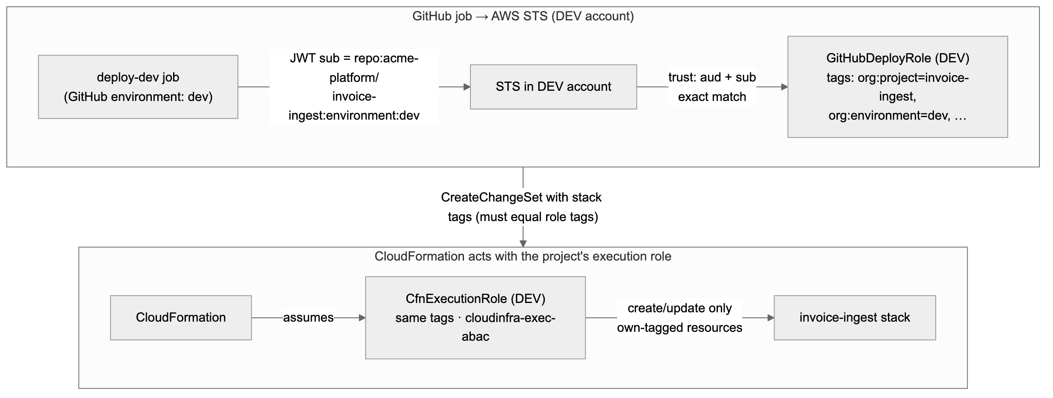
Figure 11. 8.1 Trust model per environment
- A token for environment:dev matches only the DEV account’s role trust. Separate accounts + exact sub matching mean no environment can reach another environment’s account.
- Hardening: customize the OIDC sub to include repository_id, so a deleted-and-recreated repo with the same name doesn’t inherit trust.

8.2 Promotion flow
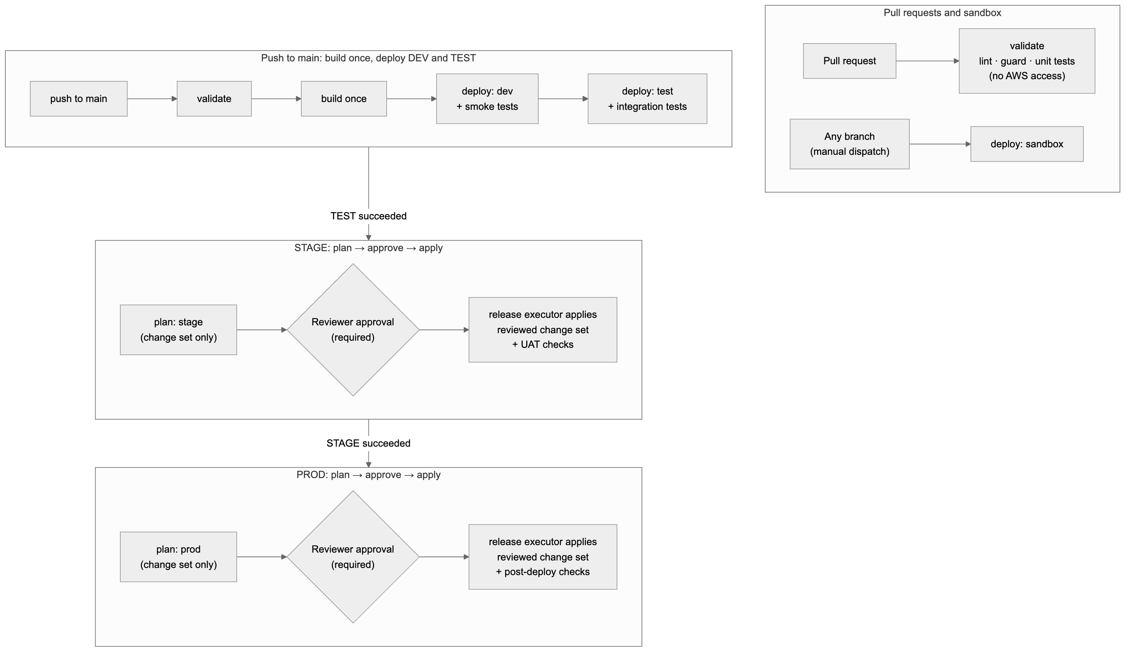
Figure 12. 8.2 Promotion flow
- Build once: one zip per function per commit, uploaded to the regional artifact bucket at a key based on content. Every environment deploys that exact key. No rebuilds between environments.
- Change set before approval: for STAGE and PROD, a plan job creates the change set and writes its summary (replacements and deletions highlighted) to the job summary. Reviewers approve with the exact change in front of them, and only that change set is executed (§8.3).
- Sandbox deploys can come from any branch via manual dispatch. Stacks get org:expires-on and are removed by the sandbox cleanup job.

8.3 Approval gates: STAGE and PROD require GitHub reviewer approval before deployment
Rule: nothing is deployed to STAGE or PROD until a GitHub reviewer approves. The approval happens before the deploy job starts. Until then the job has no OIDC token and no AWS access, so nothing in the account can change.
How it works: plan, approve, then apply the reviewed change set. The diagram and table below show the flow with GitHub environment reviewers (Mode B). In the default Mode A (§8.3.1) the steps are the same, except that approval happens in the release console and the platform release executor, not a GitHub job, executes the change set.
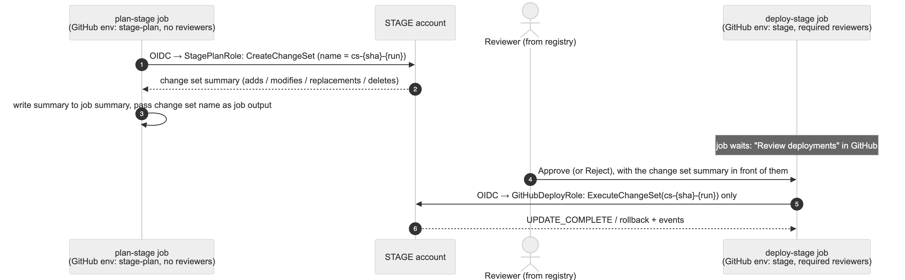
Figure 13. 8.3 Approval gates: STAGE and PROD require GitHub reviewer approval before deployment
Item | Design
GitHub environments | Two per gated stage: stage-plan / stage and prod-plan / prod. Only stage and prod have required reviewers. The plan environments have a branch rule (main) but no reviewers.
Plan role ({project}-plan, per gated account) | Trusted only for sub = repo:{owner}/{repo}:environment:{env}-plan. Can create, describe and delete change sets on its own stack (same tag rules as §4.5) and read the artifact. Cannot execute change sets or touch resources.
Deploy role in gated accounts | Mode A: there is no GitHub-assumable deploy role in STAGE/PROD; only the platform release executor can execute. Mode B: for STAGE and PROD it may only execute an existing change set (plus describe). It cannot create a new change set, so what runs is exactly what was reviewed. If the stack changed after the plan, execution fails and the pipeline re-plans; reviewers then approve the new plan.
Reviewers | Set on each environment from the registry: the product’s reviewer GitHub team(s) per environment (default: QA reviewers for STAGE; product owner group + change management for PROD). Up to 6 users/teams per environment; one approval releases the job.
Prevent self-review | Enabled on stage and prod: the person who triggered the run cannot approve it.
Branch rule | stage and prod deploy only from main (PROD optionally also from release tags).
Wait timer | Optional on prod (e.g. 15 min after approval), for a final cancel window.
Timeouts | A pending approval expires after 30 days (GitHub limit). The job is marked “Awaiting approval” in the platform UI until then; no AWS change happens. Rejection stops the promotion and leaves the environment untouched.
Audit | GitHub records who approved/rejected, when, and the comment. The platform stores it with the job (via deployment_status / deployment_review webhooks) next to the change set ID and the CloudTrail ExecuteChangeSet event.
The gate cannot be turned off - In the environment configuration (§5.5.1), requiresApproval is locked to true for STAGE and for every prod-tier environment. Admins can change who reviews, but cannot remove the gate. Any new environment of tier prod gets the gate automatically. - Approval is checked by the platform before the release executor runs (Mode A), so no repo setting can bypass it. In Mode B, the product’s GitHub team also has only the maintain role, so it cannot edit environment protection rules. - The reconciler checks every repo’s stage and prod environments nightly. Missing reviewers, disabled prevent-self-review or a changed branch rule is restored automatically and alerted. - AWS backs it up: in gated accounts, only the release executor (Mode A) or an execute-only deploy role (Mode B) can apply changes, and only to existing, reviewed change sets. Even a workflow edited to skip the plan job cannot deploy new changes to STAGE or PROD.

8.3.1 Approval enforcement modes (no paid GitHub features required)
GitHub’s environment required reviewers and custom deployment protection rules need GitHub Enterprise Cloud for private and internal repos. So the design does not depend on them. The default mode gives the same guarantee on any GitHub plan.
 | Mode A: platform-executed release (default, any GitHub plan) | Mode B: add GitHub environment protection (optional, Enterprise)
Plan | GitHub job creates the change set with the plan role (as above) | Same
Approval | Reviewers approve in the release console (§8.5). They sign in with their GitHub identity (OAuth); the platform checks live, via the GitHub API, that they are in the product’s reviewer GitHub team for that environment and not the person who triggered the run. | Mode A approval plus GitHub required reviewers on the stage/prod environments (submitted from the console as the reviewer)
Who executes | The platform’s release executor executes the exact reviewed change set (or, for application deploys, releases the exact reviewed artifact, §9.7). GitHub Actions holds no execute permission in STAGE/PROD accounts. | Same, or the GitHub deploy job executes it after GitHub approval
AWS-side guarantee | Only the executor role can execute change sets/releases in gated accounts. It is assumable only from the Platform account (aws:PrincipalOrgID + ExternalId), and only with a session tag org:project, so even the executor is limited by tags to one project per session. | Same
Record of approval | Release record (who, when, comment, evidence); also written back to GitHub as a deployment status and commit status on the SHA, so the approval is visible in GitHub | GitHub audit log as well
Mode A sequence (STAGE shown; PROD is identical): 1. plan-stage job (GitHub): creates change set cs-{sha}-{run}, posts the summary and evidence to the platform. 2. Gate service: evaluates G4 (§8.4). If it fails, stop. 3. Release console: reviewer approves. 4. Release executor: assumes PlatformReleaseExecutor in the STAGE account with session tag org:project=invoice-ingest, executes cs-{sha}-{run}, and waits for completion. 5. Status flows back to the GitHub run (the waiting release-stage job polls the platform API, or a repository_dispatch updates it) and to the release console.
Why this is at least as strong as GitHub reviewers alone: - The only identity that can change STAGE/PROD is the platform executor, and it acts only on approved, gate-passed change sets. - An edited workflow, a leaked GitHub token or a compromised runner cannot deploy to STAGE/PROD in either mode. - The gate rules live in the platform, not in repo YAML.

8.4 Quality gates for STAGE and PROD (recommended strategy)
Recommendation: build the quality gate as layered, evidence-based gates, with the final decision made by a central gate service in the platform that is plugged into GitHub as a custom deployment protection rule on the stage and prod environments. Human reviewer approval (§8.3) is the last layer, not the only one.
Why this approach: - The gate’s rules live in the platform, not in each repo’s YAML. A team cannot weaken them by editing the workflow, and changing a rule for all repos is one change in one place. - Decisions are based on evidence tied to the exact commit and artifact. “TEST passed” means TEST passed for this SHA and this artifact digest, not just the latest run. - Reviewers get the full evidence in one summary, so approval is an informed decision rather than a click. - AWS still has the final say. The gated deploy role can only execute a reviewed change set (§8.3).

8.4.1 The gate layers
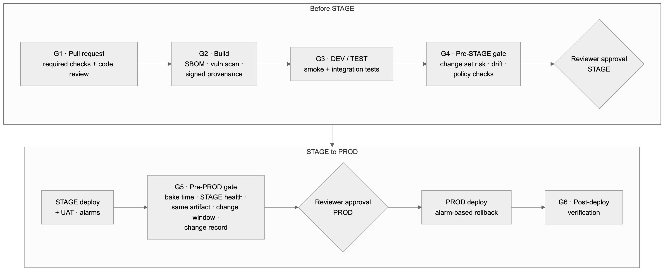
Figure 14. 8.4.1 The gate layers
Gate | When | Checks | Blocks on | Enforced by
G1 · Pull request | Before merge to main | cfn-lint; cfn-guard (all environment rule sets, so a PROD violation is caught early); IaC security scan (Checkov); unit tests + coverage threshold; SAST (bandit / SpotBugs+FindSecBugs / gosec / cargo-audit / eslint-plugin-security); dependency scan (OSV-Scanner); secret scanning (gitleaks); 1 code review from the product’s team (CODEOWNERS) | Any failure | GitHub ruleset on main (required status checks + required review), set by the platform at repo creation and checked by the reconciler
G2 · Build | Once per commit on main | SBOM (Syft); vulnerability scan of the bundle (Trivy / OSV-Scanner); signed provenance: cosign signature with an AWS KMS key plus a SLSA provenance statement binding the artifact digest to the commit and workflow run | Critical/high vulnerabilities without an approved exception; missing attestation | Build job; digest + results recorded as evidence
G3 · DEV / TEST | After each deploy | DEV: smoke tests. TEST: integration/contract tests against the deployed stack; results published as check runs | Any failed suite | needs: in the workflow + evidence record
G4 · Pre-STAGE | In plan-stage, before approval | Evidence check: G1–G3 passed for this SHA and digest. Attestation verified. Change set risk analysis (below). Drift detection on the STAGE stack. IAM Access Analyzer custom policy checks: no new access compared with the currently deployed template (CheckNoNewAccess) and no forbidden actions (CheckAccessNotGranted) | Any failed check; high-risk change without an explicit override | Gate service (Mode A: before the release executor; Mode B: also as a deployment protection rule)
Reviewer (STAGE) | After G4 passes | Human approval with the evidence summary | Rejection / no approval | GitHub required reviewers (§8.3)
G5 · Pre-PROD | In plan-prod, before approval | Everything in G4 for the PROD stack, plus: same artifact digest that ran in STAGE; STAGE bake time met (e.g. ≥ 24 h, set per environment); STAGE CloudWatch alarms green during the bake; UAT sign-off recorded; change window open / no freeze; optional change record approved (built-in; external ITSM only via webhook if an organization wants it); for DR/HA projects, a successful STAGE DR drill within the last 30 days and a healthy secondary region (§10.7) | Any failed check | Gate service (Mode A: before the release executor; Mode B: also as a deployment protection rule)
Reviewer (PROD) | After G5 passes | Human approval with the evidence summary | Rejection / no approval | GitHub required reviewers (§8.3)
G6 · Post-deploy | During and after the PROD deploy | CloudFormation rollback triggers (RollbackConfiguration with CloudWatch alarms and a monitoring window) roll the stack back automatically if alarms fire; post-deploy health checks | Alarm during the monitoring window → automatic rollback | CloudFormation + pipeline

8.4.2 Change set risk analysis (G4/G5)
The plan job sends the change set to the gate service, which classifies every change:
Risk | Examples | Default outcome
High | Replacement or deletion of a stateful resource (S3 bucket, DynamoDB table); deletion of a log group in PROD; removing DeletionPolicy: Retain; disabling encryption or versioning | Blocked, unless the change carries an explicit, separately approved override (e.g. a allow-destructive-change label approved by a platform admin). The override is recorded.
Medium | Any IAM policy or role change; new S3 notification or Lambda permission; runtime change | Allowed, but highlighted at the top of the reviewer summary
Low | Code-only update; memory/timeout change; tag change | Allowed

8.4.3 Where the evidence lives
- The gate service keeps a release record per commit SHA: artifact digest and attestation, test and scan results per environment, change set IDs and risk classification, drift result, approvals (who, when, comment), and deploy outcome.
- Workflows post results to the platform with the job’s OIDC token, so the platform can verify which repo, environment and run sent them.
- The same record feeds the reviewer summary, the platform UI and audit (§14).

8.4.4 How the gate plugs into GitHub
In Mode A (default) the gate is checked by the platform before the release executor runs, with no GitHub feature needed. In Mode B it is also connected to GitHub as follows:
- The platform’s GitHub App is registered as a custom deployment protection rule on every stage and prod environment, set at repo creation and checked by the reconciler.
- When a deploy-stage / deploy-prod job is about to start, GitHub sends a deployment_protection_rule event. The gate service evaluates G4/G5 and answers approve or reject, with a link to the evidence.
- The job starts only when both the gate service and a human reviewer approve. If the gate rejects, reviewers are never asked.
- Mode A (default, any plan): the gate service is evaluated by the platform itself before the release executor runs (§8.3.1). The deployment protection rule integration above applies only in Mode B (GitHub Enterprise).

8.4.5 Gate settings are configurable per environment
These thresholds are part of the environment’s guardrailProfile (§5.5.1) and are edited by platform admins: - coverage minimum; - allowed vulnerability severity; - bake time; - change windows / freeze calendar; - whether a change record is required; - which risk levels need an override.
The gates themselves cannot be disabled for STAGE or prod-tier environments; only their thresholds can be tuned.

8.4.6 Later improvement (not v1)
For PROD Lambda deployments, add gradual traffic shifting (Lambda alias + CodeDeploy canary, e.g. 10% for 10 minutes, then 100%) with alarm-based automatic rollback. This limits the impact of a bad release to a small share of traffic.

8.5 Release console: the approval workflow in the platform UI
Recommendation: the platform UI provides the whole promotion and approval workflow, and GitHub remains the record of approvals. When a reviewer clicks Approve in the platform, the platform calls GitHub’s review pending deployments API as that reviewer, using their own GitHub identity. So: - it is a real GitHub reviewer approval: the required-reviewer rule, prevent-self-review and GitHub’s audit log all still apply; - reviewers never need to leave the platform; - approving directly in GitHub still works, and the platform reflects it within seconds via webhooks.

8.5.1 Screens
Screen | Who | What it shows / does
Project pipeline view | Everyone entitled to the product | One column per environment in configured order. Each column shows: state, commit SHA, artifact digest, who triggered, when, gate results (G1–G6) as green/red chips, and links to the GitHub run and the CloudFormation stack.
My approvals (inbox) | Reviewers | All pending STAGE/PROD approvals across the products where the user is a reviewer, oldest first, with waiting time.
Approval detail | Reviewers | The evidence summary from the release record (§8.4.3), on one page: ; • change set diff grouped by risk, with high-risk items on top; • test and scan results; • drift result; • for PROD: STAGE bake time and alarm health, and confirmation that the artifact is the same one that ran in STAGE; • change ticket link; Plus a comment box and Approve / Reject buttons. Approve stays disabled until the automated gate (G4/G5) has passed.
Override requests | Requester → platform admin | Request an override for a high-risk change (§8.4.2) with a reason; a platform admin approves or rejects it in the UI. The override applies only to that change set.
Release history | Everyone entitled; auditors | Every promotion per environment: who requested, which gates passed, who approved/rejected and why, outcome, rollback events. Exportable.

8.5.2 Promotion state machine (per commit, per gated environment)
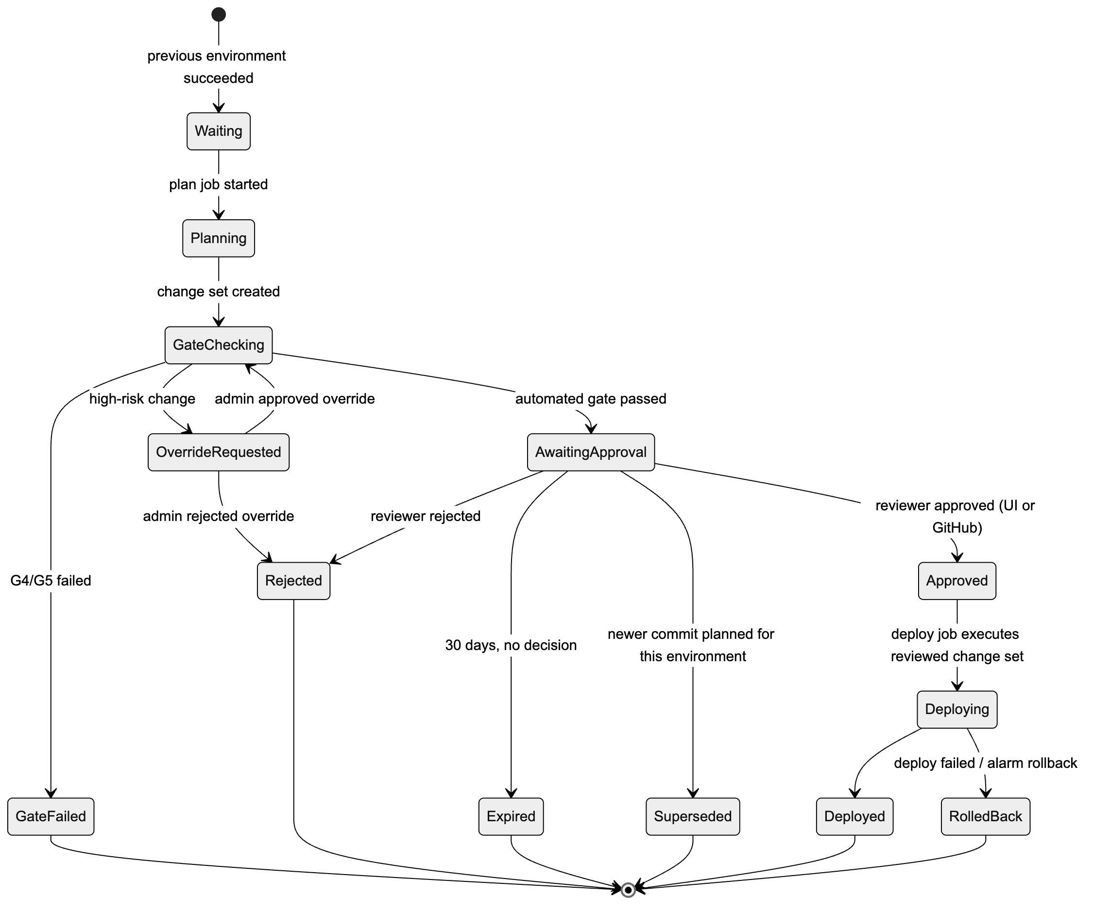
Figure 15. 8.5.2 Promotion state machine (per commit, per gated environment)
- Superseded: if a newer commit reaches the same gate, the older pending approval is closed automatically, so reviewers only see the latest candidate.
- The state is driven by GitHub webhooks (workflow_run, deployment, deployment_status, deployment_review, deployment_protection_rule) and the gate service, stored in the job/release tables (§3.4).

8.5.3 How an approval in the UI reaches GitHub (Mode B only)
In Mode A (default), an approval in the console goes straight to the release executor (§8.3.1), and the platform writes a deployment status and commit status back to GitHub. The sequence below applies only when GitHub environment reviewers are also enabled (Mode B).
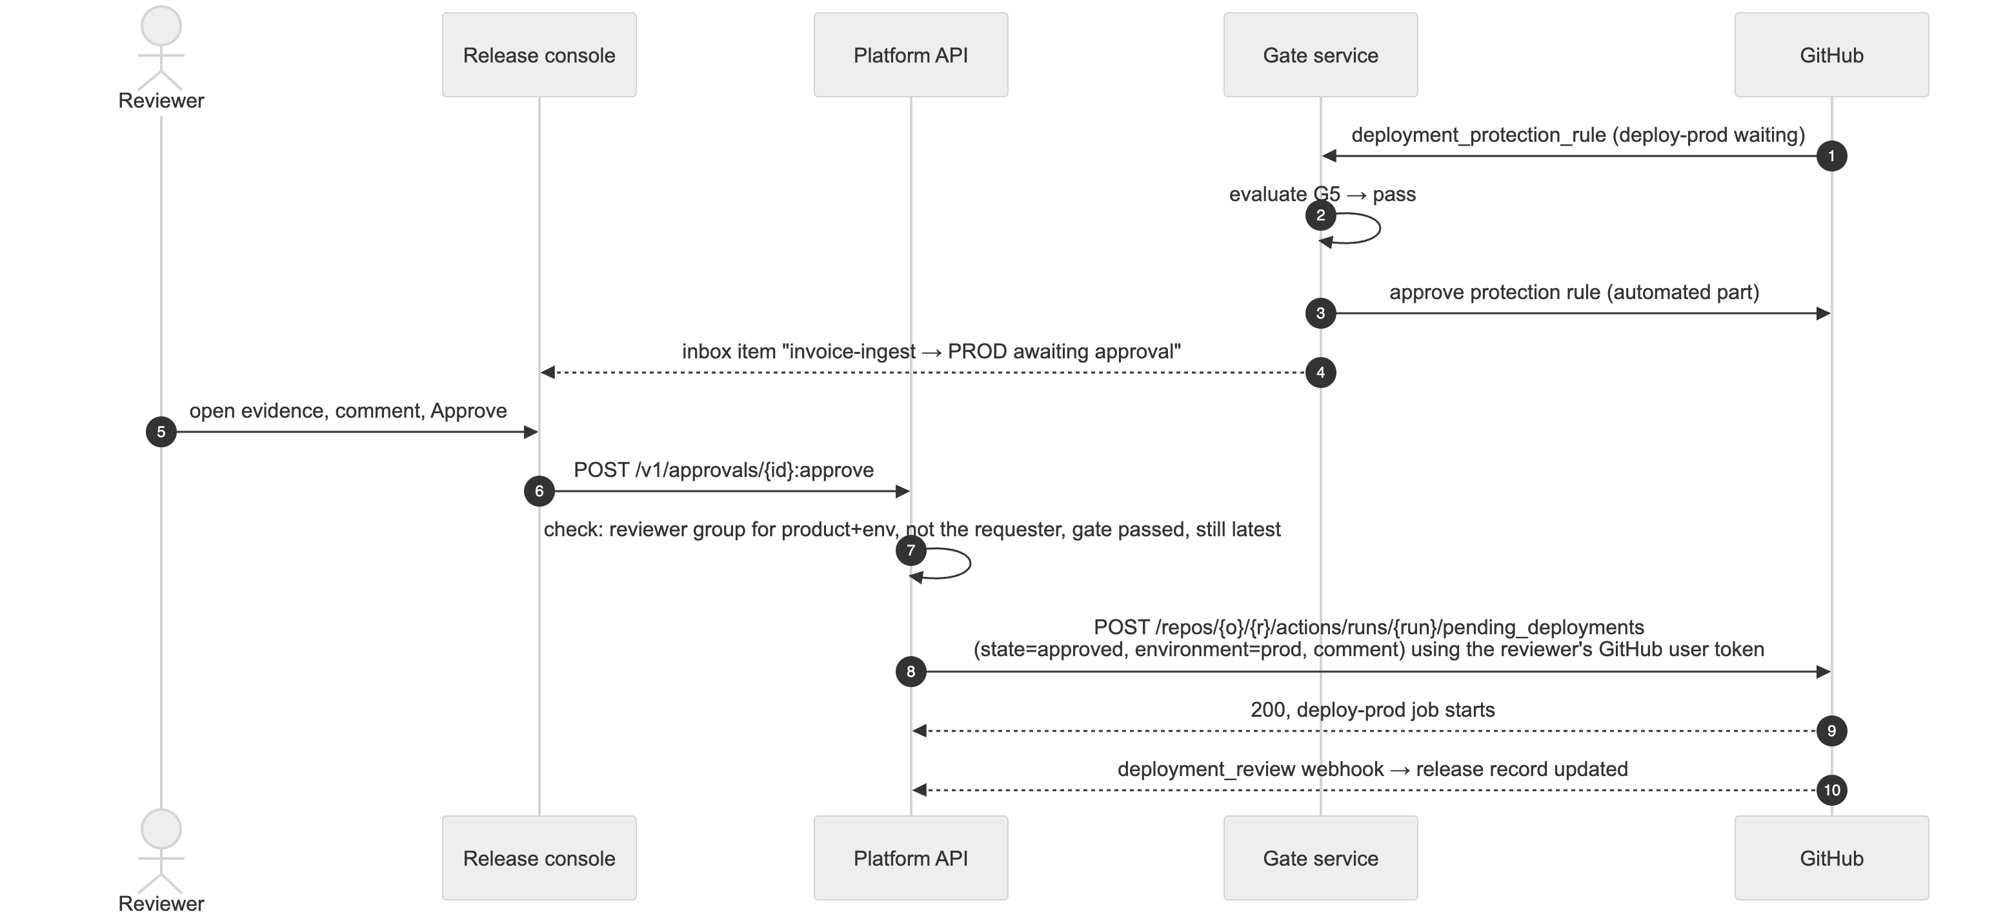
Figure 16. 8.5.3 How an approval in the UI reaches GitHub (Mode B only)
- Reviewer identity: each reviewer links their GitHub account once (GitHub App user authorization, OAuth). The platform stores the refresh token encrypted. It uses the token only to submit approvals, and only for runs in that reviewer’s own products.
- Double check on our side: before calling GitHub, the platform checks that the user is in the product’s reviewer group for that environment, is not the person who triggered the run, and that the automated gate passed. GitHub then enforces its own rules again.
- Notifications: new pending approvals, gate failures, rejections and rollbacks go to the in-app inbox and email via Amazon SES, with a deep link to the approval detail page. Generic signed outgoing webhooks let an organization forward events to any chat tool it uses, without the platform depending on that tool. Reminders go out after a configurable wait (e.g. 4 h).
- Promotion mode (configurable per environment, §5.5.1):
  - auto: STAGE plan starts automatically after TEST succeeds.
  - on-request: a user clicks Promote to STAGE/PROD in the UI, which starts the plan job via workflow_dispatch.
- Either way, the approval is still required.

8.5.4 Separation of duties
- Requester ≠ approver (platform check + GitHub prevent self-review).
- PROD can require two approvals from different groups (e.g. product owner and change management). The platform collects both in the UI and submits the GitHub approval only when both are in. This requires that only the platform’s approver identities be listed as GitHub reviewers; the alternative is GitHub’s own single-approval model.
- Platform admins can approve overrides but cannot approve their own requests.

8.6 deploy.yml — design (not code yet)
Aspect | Design
Triggers | push to main; pull_request (validate only); workflow_dispatch with an environment input (sandbox, or re-run any stage)
Permissions | id-token: write, contents: read
Structure | A reusable workflow deploy-env.yml (inputs: environment) holds all deploy steps and is identical in every repo. The caller deploy.yml is generated from the environment configuration: one job per enabled environment, chained in the configured order; gated environments (STAGE, PROD) get a plan-{env} job followed by a deploy-{env} job, with the quality gate (§8.4) and reviewer approval (§8.3) between them. If admins change the environment list later, the platform opens a “sync pipeline” PR in affected repos instead of changing them silently.
Concurrency | One group per environment (deploy-{env}), cancel-in-progress: false
Supply chain | Actions pinned to commit SHAs (only GitHub-owned actions/*, aws-actions/* and the platform’s own actions are allowed); Dependabot
Per-environment job steps | 1. OIDC credentials (role-to-assume: vars.AWS_ROLE_ARN, aws-region: vars.AWS_REGION, scoped to that GitHub environment); 2. Guard: caller account must equal vars.AWS_ACCOUNT_ID and vars.ENVIRONMENT_NAME must equal the job’s environment; 3. Pre-flight stack-state check (table below); 4. aws cloudformation deploy with --role-arn $CFN_EXEC_ROLE_ARN, --parameter-overrides from config/{env}.json + code prefix, --tags = the full org:* set built from GitHub variables (vars.ORG_*, vars.PROJECT_NAME, vars.ENVIRONMENT_NAME), --no-fail-on-empty-changeset (DEV/TEST/sandbox only; STAGE/PROD use the plan → approve → execute flow in §8.3); 5. Post-deploy checks; outputs to job summary; 6. On failure: failed stack events (resource, type, reason) to job summary, exit non-zero
Tags passed with --tags come from GitHub variables set by the platform (§5.5.5). Even if someone changes them, IAM denies any value that doesn’t match the deploy role’s tags (§4.4).
Stack status before deploy | Action
does not exist | create via changeset
CREATE_COMPLETE / UPDATE_COMPLETE / UPDATE_ROLLBACK_COMPLETE | update via changeset
ROLLBACK_COMPLETE (first create failed) | delete the empty stack, then create again (safe: RetainExceptOnCreate)
*_IN_PROGRESS | wait with timeout
UPDATE_ROLLBACK_FAILED / DELETE_FAILED | stop with a runbook link. Never automated.

8.7 Long-lived credentials mode (supported, not recommended)
Only where an account cannot have an OIDC provider: - A per-project, per-environment IAM user with the same shared policy, tagged identically. - Keys stored as environment secrets (the only secrets in the design; everything else stays a variable); ≤ 90-day rotation enforced by a platform job; warning shown in the UI.

9. Developer consumption: application repositories

9.1 The problem and the recommended model
The repos the platform generates (§7) are infrastructure repos: they define the AWS resources, the IAM roles and the event wiring for one project. Developers write their actual code (Python, Java, Go, Rust, Node.js, …) in application repos, and deploy it to ECS, Lambda, EKS or Step Functions on top of that infrastructure. Two things are needed: 1. a reliable way for application repos to find the infrastructure (names, ARNs, roles, endpoints) in every environment; 2. a safe way for them to deploy onto it, without being able to create IAM, change network or data resources, or touch other projects.
Recommendation: “infrastructure contract + golden-path pipelines”. - Each infrastructure repo publishes a versioned, machine-readable contract per environment: what it provides and how to reach it. - Application repos declare which project and which compute slots they deploy to, in one small file. - Application repos deploy through reusable, platform-owned GitHub workflows (one per language and compute type). These read the contract at deploy time, so no ARNs or account details are copied into application repos. - Application deploy roles use the same tag-based permission model (§4), but can only update the runnable artifacts of their bound slots. They can never create IAM roles or change data, network or trigger resources.
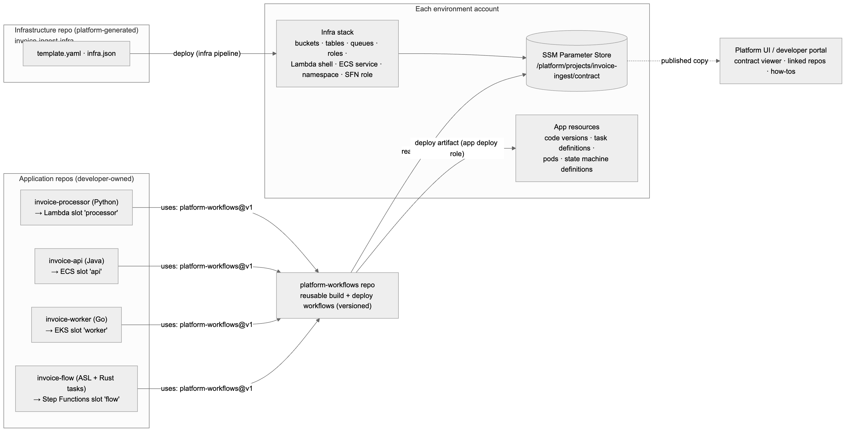
Figure 17. 9.1 The problem and the recommended model

9.2 Who owns what: infrastructure vs application
The rule: the infrastructure repo owns anything with identity, network, data or triggers. The application repo owns the runnable artifact and its runtime settings.
Compute type | Infrastructure repo owns (via the platform UI) | Application repo owns | How the app deploys
Lambda | Function “shell” (name, execution role, triggers such as S3 notifications, permissions, log group, concurrency, VPC config, binding env vars), a live alias, code-signing config in gated environments | Code, build, versions, which version live points to; app-level settings in AppConfig/SSM under the app path | Upload artifact → UpdateFunctionCode → PublishVersion → move live alias (later: CodeDeploy canary)
ECS (Fargate) | Cluster (per project, as clusters cost nothing), ECR repository, task role and task execution role, security groups, ALB target group/listener rule, log group, the ECS service (created with a platform placeholder image) | Dockerfile, image, task definition revisions (image digest, CPU/memory, env vars, health check) | Build image → push to ECR → register task definition (roles taken from the contract) → update service; ECS deployment circuit breaker with rollback
EKS | Shared cluster per portfolio per environment, run by the platform team (a cluster per project is too costly). Per project: namespace, ResourceQuota/LimitRange, NetworkPolicy, ServiceAccount + EKS Pod Identity association to a project role, ECR repository | Container image, Helm chart / Kustomize manifests limited to its namespace | Recommended: GitOps with Argo CD. The pipeline pushes the image and updates the image digest in the environment overlay; Argo CD syncs the namespace. Alternative: helm upgrade --atomic with a namespace-scoped role.
Step Functions | State machine execution role (allowed to call only the project’s Lambdas/ECS tasks/resources), log group, X-Ray settings | The state machine definition (ASL) and any task code (which deploys to its own Lambda/ECS slots) | Small app stack (CloudFormation) containing the state machine, with DefinitionSubstitutions filled from the contract; the definition is validated before deploy
Why this split: - Developers can ship code many times a day without touching security-sensitive resources. - Every new permission, trigger or data store still goes through the platform UI → infrastructure repo PR → quality gates (§8.4) → approvals. - Drift checks on the infrastructure stack ignore the fields owned by the application (Lambda code and alias version, ECS service task definition) so these updates are not flagged as drift.
Infrastructure repo changes (supersedes the single-repo starter code): in the recommended model, the infrastructure repo no longer contains application code. Lambda functions are created with a small platform bootstrap package for their runtime, and the infrastructure pipeline does not build code. A “single-repo starter” mode (code in src/ inside the infrastructure repo, as in §6) is kept for sandbox prototypes only.

9.3 Catalog additions for compute slots
A compute slot is a catalog resource that application code is deployed into. Each slot is bound to exactly one application repo; one application repo may serve several slots (a monorepo).
Type | Key settings | Contract exposes
lambda.function | runtime family (python, java, nodejs, go, rust, container), arch, memory, timeout, triggers via connections | function name/ARN, live alias ARN, runtime, handler convention, artifact location, signing profile
ecs.service | CPU/memory limits, desired count range, port, public/internal, health check path | cluster, service, task role ARN, execution role ARN, ECR URI, container name, log group, subnets/SGs (from the landing zone network via SSM), target group
eks.workload | target shared cluster, quota, service account | cluster name, namespace, service account, ECR URI, Argo CD application name
stepfunctions.workflow | type (standard/express), logging level | role ARN, log group ARN, substitution values for the project’s resources
ecr.repository | (created automatically for container slots) | repository URI; immutable tags + scan on push
Existing connection kinds still apply (e.g. s3.notify → lambda.function, iam.access from any slot’s runtime role to a bucket/table). The existing lambda.python becomes lambda.function with runtime: python.

9.4 The infrastructure contract
Published three ways after every successful infrastructure deploy, per environment:
Where | For | Notes
SSM Parameter Store in the environment account: /platform/projects/{project}/contract (JSON, advanced tier) plus one parameter per value under /platform/projects/{project}/... | Deploy pipelines and running code | Written as AWS::SSM::Parameter resources by the infrastructure stack itself, so it is always in sync with what is deployed. Readable only by roles tagged with the same project (ABAC on the path).
Platform API / developer portal: GET /v1/projects/{id}/contract?env=dev | Humans, tooling, local development | Copy recorded in the release record with the infra commit SHA
Infrastructure repo release (GitHub Release asset contract.{env}.json, tagged with the infra version) | Review and diffing | Lets reviewers see contract changes between versions
Why SSM, not CloudFormation exports: exports lock the exporting stack. A value that is imported elsewhere cannot be changed or removed, which would block infrastructure changes. SSM parameters keep stacks loosely coupled.
Example contract (DEV):
{
"contractVersion": "1",
"project": "invoice-ingest",
"environment": "dev",
"accountId": "222222222222",
"region": "us-east-1",
"infraVersion": "1.4.0",
"infraCommit": "4f78c64",
"compute": {
"processor": {
"type": "lambda.function", "runtime": "python3.13", "architecture": "arm64",
"functionName": "invoice-ingest--processor",
"aliasArn": "arn:aws:lambda:us-east-1:222222222222:function:invoice-ingest--processor:live",
"artifactBucket": "cloudinfra-artifacts-999999999999-us-east-1",
"artifactPrefix": "apps/invoice-ingest/processor/",
"boundRepo": "acme-platform/invoice-processor"
},
"api": {
"type": "ecs.service",
"cluster": "invoice-ingest--cluster", "service": "invoice-ingest--api",
"containerName": "app",
"ecrRepositoryUri": "222222222222.dkr.ecr.us-east-1.amazonaws.com/invoice-ingest/api",
"taskRoleArn": "arn:aws:iam::222222222222:role/app/invoice-ingest/workload/…",
"executionRoleArn": "arn:aws:iam::222222222222:role/app/invoice-ingest/workload/…",
"logGroup": "/ecs/invoice-ingest--api",
"boundRepo": "acme-platform/invoice-api"
}
},
"resources": {
"uploads": { "type": "s3.bucket", "name": "invoice-ingest--uploads-222222222222-us-east-1" }
},
"runtimeEnv": {
"processor": { "UPLOADS_BUCKET_NAME": "invoice-ingest--uploads-222222222222-us-east-1" },
"api": { "UPLOADS_BUCKET_NAME": "invoice-ingest--uploads-222222222222-us-east-1" }
}
}
Contract versioning and compatibility: - contractVersion changes only for schema changes. - Each infra change is classified by the gate service as additive (new slot/resource/value) or breaking (removed or renamed slot/resource, changed runtime family, changed container name). - Additive changes always flow freely. Breaking changes follow the expand → migrate → contract rule (§9.9.4), so the platform team never has to wait for a product team to sign off, and nothing a deployed application uses disappears from under it. - Application deploys check the contract in the target environment: - A required value that is missing stops that deploy with a clear message (“DEV infrastructure does not yet provide uploads”). Only the deploy stops; development carries on. - Optional values (§9.5) never block a deploy. - Infrastructure and applications are promoted independently.

9.5 Linking an application repo: .platform/app.yaml
Every application repo has one small, language-neutral file that says what it deploys and where:
apiVersion: platform/v1
project: invoice-ingest # the infrastructure project
components:
- slot: processor # compute slot in the infra contract
type: lambda.function
language: python # python | java | go | rust | nodejs | container
path: services/processor
requires: [uploads] # must exist in the target env, or this deploy waits
optional: [archive] # used if present; code handles absence (feature flag)
- slot: api
type: ecs.service
language: java
path: services/api
build: { tool: gradle }
- Binding is recorded in the platform, not trusted from this file. The platform links slot → repo when the app repo is created (or linked) in the UI. The app deploy role’s OIDC trust is limited to that repo, so a file in another repo claiming project: invoice-ingest gets AccessDenied.
- The file decides how to build and which slots to deploy. The contract decides where.

9.6 Golden-path pipelines (platform-workflows repo)
A central, versioned repo of reusable GitHub workflows. Application repos call them by tag; Dependabot pins and updates the commit SHAs. Builds are separate from deploys, so one artifact is built once and promoted through every environment, just like infrastructure (§8.2).
Build workflows (per language):
Language | Lambda artifact | Container artifact (ECS/EKS)
Python | zip with dependencies (pip install --target, arm64 wheels) → python3.x runtime | Docker image
Java | jar/zip via Maven/Gradle → java21 runtime (SnapStart optional) | Docker image (e.g. Jib or Dockerfile)
Go | bootstrap binary (GOOS=linux GOARCH=arm64) → provided.al2023 | Distroless image
Rust | bootstrap via cargo lambda build --arm64 → provided.al2023 | Distroless image
Node.js | bundled zip (esbuild) → nodejs22.x | Docker image
Every build: unit tests → SAST/dependency scan → SBOM → vulnerability scan → signed provenance (cosign + AWS KMS) → (Lambda) AWS Signer code signing → publish to the artifact bucket (zip) or ECR (image, by digest). This is the application version of gates G1–G2.
Deploy workflows (per compute type): deploy-lambda.yml, deploy-ecs.yml, deploy-eks.yml (GitOps update), deploy-sfn.yml. Each one: 1. Assumes the app deploy role for the environment via OIDC. 2. Reads the contract from SSM and checks requires. 3. Checks that the artifact’s runtime family matches the slot (a Go binary cannot go to a Python slot). 4. Deploys and waits until healthy. 5. Rolls back on failure: Lambda alias back to the previous version, ECS circuit breaker, Argo CD rollback, SFN previous definition. 6. Reports to the release record.
Application repos get the same environments, approvals and quality gates as infrastructure repos: - GitHub environments sandbox → PROD; - required reviewers and the gate service for STAGE/PROD; - the release console (§8.5) shows application promotions next to infrastructure promotions.
For application deploys, the “change set” the reviewer approves is a deploy diff: current vs new artifact digest, code/version hash, task definition diff and Kubernetes manifest diff.

9.7 Security for application deploys
App deploy role (per application repo, per environment, created by the platform): - Trust: OIDC sub = repo:{owner}/{app-repo}:environment:{env}. - Tags: same org:* tags as the project, so the same tag-based model applies (§4). - Shared policy: cloudinfra-appdeploy-abac, which allows only:
Allowed | Scope
lambda:UpdateFunctionCode, PublishVersion, UpdateAlias, GetFunction | Functions tagged with the same project and named after a slot bound to this repo
ecs:RegisterTaskDefinition (with own tags), ecs:UpdateService, ecs:Describe* | Services/task families of bound slots
iam:PassRole | Only roles under /app/{project}/workload/, only to ecs-tasks.amazonaws.com / states.amazonaws.com, as listed in the contract
ecr:*Image* push/pull actions | Repositories tagged with the same project
ssm:GetParameter* | /platform/projects/${aws:PrincipalTag/org:project}/*
cloudformation:*ChangeSet* on app stacks {project}-app-* | With the cloudformation:ResourceTypes condition limited to an allow-list (e.g. AWS::StepFunctions::StateMachine, AWS::Lambda::Version, AWS::CloudWatch::Dashboard)
s3:PutObject | artifact-bucket/apps/{project}/*
eks:DescribeCluster | Shared cluster (for GitOps, nothing else; Kubernetes access goes through Argo CD)
Gated environments (STAGE/PROD), Mode A: the app deploy role only prepares a release: it uploads the artifact, publishes a Lambda version, registers a task definition revision, or proposes a GitOps commit. The platform release executor performs the traffic-affecting step after approval: moving the live alias, updating the ECS service, merging/syncing the GitOps change, or executing the app stack change set.
Never allowed: iam:Create*/Put*/Attach*, any change to buckets/tables/queues/VPC/security groups/triggers, any resource of another project.
Extra safeguards: - A CloudFormation Guard Hook in every account rejects IAM, network and data resource types in stacks named *-app-*. - Artifact provenance in gated environments (an AWS-side check in addition to GitHub approvals): - Lambda functions in STAGE/PROD have a code signing config that accepts only code signed by the platform build. - ECR repositories use immutable tags and deploys pin images by digest. - EKS admission policy (e.g. Kyverno) admits only images with a valid signature/attestation. - Runtime access: running code uses the slot’s runtime role (Lambda execution role, ECS task role, Pod Identity role, SFN role). Like every component, it can reach only resources with the same project and environment tags (§4.10). These are created by the infrastructure stack with exact-ARN policies and the shared boundary (§4.5), so application code has exactly the access drawn as connections in the platform UI.

9.8 How developers use it day to day
Need | How
Start a new service | Platform UI → project → “Create application repo”: choose slot(s), language and compute type. The platform creates the repo with a language template, .platform/app.yaml, a workflow that calls the golden path, environments, protection rules and variables, using the same provisioning steps as §7. Or link an existing repo.
Find resource names/ARNs | Platform UI contract viewer per environment (copy buttons, diff between environments); platform CLI: platform contract get invoice-ingest --env dev
Use resources in code | Read the environment variables the deploy injects (UPLOADS_BUCKET_NAME, …). This works the same way in every language, with no platform SDK. The language templates include small examples (boto3, AWS SDK for Java v2, AWS SDK for Go v2, AWS SDK for Rust).
Get a new bucket/table/permission | Platform UI → “Change infrastructure” → the platform regenerates the template and opens a PR on the infrastructure repo → gates and approvals → infra promotes → the contract updates → the app can use it
Run or test locally | IAM Identity Center access to sandbox/DEV, with tag-based access to the product’s resources (§4.8); platform env export --env dev writes the contract values as local env vars
Discover what exists | Platform UI project page (infra repo, bound app repos per slot, environments, versions). Each repo also gets a catalog-info.yaml so an open-source Backstage portal can show the same view, if you choose to run one (optional).
GitHub variables in application repos (§5.5.5 rules apply). These are the only variables an application repo needs; everything else comes from the contract at deploy time:
Variable | Level
PROJECT_NAME | Repository
ENVIRONMENT_NAME | Environment
AWS_ACCOUNT_ID | Environment
AWS_REGION | Environment
AWS_ROLE_ARN (the app deploy role) | Environment
CONTRACT_PARAMETER (/platform/projects/{project}/contract) | Repository
Repo visibility: infrastructure repos are internal (readable by everyone in the GitHub org, writable only through the platform), so developers can read the template and the contract. Application repos follow the product’s normal policy.

9.9 Working in parallel: how platform and product teams stay independent
Every solution has two parts: 1. Infrastructure: owned by the platform team. It is generated and changed through the platform and lives in the infrastructure repo. 2. Solution code: owned by the product team. It is written by developers in application repos and deployed onto the infrastructure.
The goal is that neither team ever waits for the other. The design achieves this with six mechanisms.

9.9.1 Separate everything except the contract
 | Infrastructure | Solution code
Repo | {project}-infra (platform-generated) | one or more application repos
Owner | Platform team (product team can request changes via the UI) | Product team
Pipeline | Infra pipeline (§8) | Golden-path app pipelines (§9.6)
Version | infraVersion (semver, tagged in the infra repo) | each app’s own version
Release schedule | Independent | Independent
Approvals/gates | Own GitHub environments + gates | Own GitHub environments + gates
AWS role | Infra deploy role + CFN execution role | App deploy role (only bound slots’ artifacts)
Shared | The contract only (§9.4) | The contract only
- Neither pipeline ever triggers the other. An infra deploy never redeploys code; an app deploy never changes infrastructure.
- Each side owns its own fields, enforced by IAM, not by convention. Infra deploys never touch app-owned fields (Lambda code/alias version, ECS task definition, Kubernetes manifests, ASL definitions). App deploy roles cannot touch infra-owned fields (§9.7). Drift checks ignore the other side’s fields.

9.9.2 Contract first: product teams can start before infrastructure exists
The contract exists in two forms:
Form | When it exists | Used for
Declared contract | As soon as the project (or a change) is designed in the platform UI. It is generated from infra.json before anything is deployed. | Developers code against slot names, env var names and value types on day one
Deployed contract | Per environment, after each infra deploy (SSM, §9.4) | Actual values used by deploys and running code
The platform UI shows both, side by side per environment (“declared, not yet deployed in TEST”). A product team can build, unit-test and even merge code that uses a resource the platform team has not deployed yet.

9.9.3 Placeholders: infrastructure can ship before any solution code
Every compute slot is created with a platform placeholder artifact: - a bootstrap Lambda package for each runtime that returns a clear “no application deployed” response; - a placeholder container image with a health endpoint.
So the platform team can deploy, test and promote infrastructure to every environment with no application code present, and alarms and health checks still pass. When the product team’s first deploy lands, it simply replaces the placeholder.

9.9.4 Changing the contract without blocking anyone (expand → migrate → contract)
Change | What happens | Who waits
Additive (new resource, slot, value, permission) | Deploys and appears in the contract; apps start using it when they’re ready | Nobody
Rename / replace | Expand: the new value is added next to the old one; the old one is marked deprecated (with a removal-not-before date) in the contract. Migrate: product teams switch on their own schedule; the platform UI and PR comments remind them. Contract: the old value is removed automatically once no deployed app version in that environment still requires it. | Nobody. Removal waits for usage to reach zero, not for a person.
Remove | Same as above: deprecate → removal when unused | Nobody
Emergency removal (e.g. security issue) | Platform admin override, recorded; affected app owners notified | Explicit exception
The platform knows exactly which value each deployed app version requires, because every app deploy records its requires list in the release record per environment. “Unused” is therefore a fact the platform can check, not a guess.

9.9.5 Developing and testing solution code without the real infrastructure
Need | Mechanism
Unit tests | Language templates include fakes/mocks for the AWS SDK calls they use; tests read the same env vars the deploy injects
Local integration | platform dev up starts open-source emulators (moto server; AWS SAM CLI for Lambda; LocalStack Community optional) configured from the declared contract: same bucket/table/queue names and env vars
Real AWS without waiting | Ephemeral sandbox environments: the platform deploys the declared infrastructure into the sandbox account with a TTL (org:expires-on) for a feature branch, without touching shared environments
Contract tests | The golden-path build checks the app’s requires/optional against the declared contract (catches typos and stale names before any deploy)

9.9.6 Requests between teams are asynchronous
- Product team needs new infrastructure: “Change infrastructure” in the platform UI creates a change request. It immediately produces an updated declared contract (so developers can carry on) and a PR on the infra repo for the platform team. The app uses the new value as optional (behind a feature flag) until it is deployed, then switches it to requires.
- Platform team improves infrastructure (new runtime version, encryption change, shared cluster upgrade): it ships when ready. Additive changes need no coordination. Anything that affects apps goes through §9.9.4.
- Visibility for both sides: a per-project compatibility view in the platform UI shows, for each environment, the deployed infra version, the deployed app versions, and whether each app’s needs are met, waiting or deprecated.

9.9.7 Responsibilities
Activity | Platform team | Product team
Catalog, building blocks, golden-path workflows, language templates | Owns | Consulted
Infra repo for a project (template, roles, wiring) | Owns / approves | Requests changes via UI
Contract schema and deprecation policy | Owns | Informed
Solution code, build, tests, app releases | Informed | Owns
App deploy approvals (STAGE/PROD) | — | Owns (product reviewers)
Infra deploy approvals (STAGE/PROD) | Owns (with product reviewers optional) | Consulted
Incident: app bug | Supports | Owns
Incident: infra/platform fault | Owns | Supports

10. Multi-region resilience: DR and HA

10.1 Resilience modes
Every project chooses a resilience mode in the project wizard. Every template the platform generates is multi-region capable from the start, so a project can move from single-region to DR or HA later without redesign.
Mode | Regions deployed | Regions active | Typical RTO / RPO | When to use
Single region | Primary only | Primary | Hours (redeploy from code + backups) / backup age | Sandbox, DEV, non-critical tools
DR (active / standby) | Primary + secondary | Primary only. Secondary is deployed, data replicates continuously, compute and event sources are inactive | Minutes to < 1 h / seconds to minutes (replication lag) | Business-critical workloads that can tolerate a short failover
HA pair (active / active) | Primary + secondary | Both | Near zero / near zero (depends on data store) | Customer-facing, always-on workloads
Default regions: primary us-east-1, secondary us-east-2. Platform admins can change the defaults and the allowed region pairs in the environment configuration (§5.5); the region allow-list SCP (§4.7) must include both regions.
DR strategy (DR mode only):
Strategy | Secondary compute while standby | RTO | Cost
Pilot light (default) | Scaled to zero / disabled | Longer (scale-up time) | Lowest
Warm standby | Minimal capacity running, no traffic | Shorter | Moderate

10.2 What “deployed but inactive” means
The same template is deployed to both regions. Three parameters, set by the pipeline per region, decide the behavior:
Parameter | Values | Set from
ResilienceMode | single | dr | ha | Project setting
RegionRole | primary | secondary | Which region the stack is in
ActivationState | active | standby | DR: primary active, secondary standby. HA: both active. Flipped only by a failover (§10.6).
The engine wraps every activation-sensitive setting in CloudFormation conditions (IsActive, IsPrimary, IsHA), so standby is a configuration of the same resources, not different resources. Activating a region changes parameters, not the template.
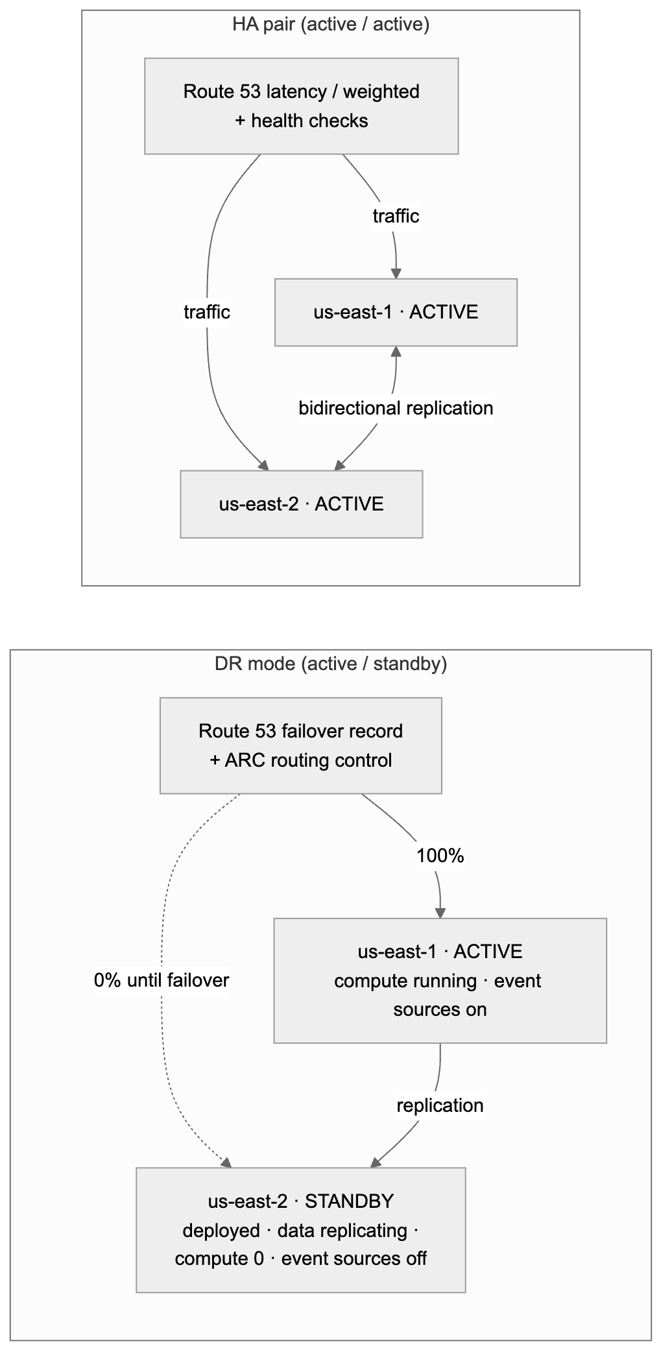
Figure 18. 10.2 What “deployed but inactive” means

10.3 Per-service behavior
Every catalog entry (§6.8) declares a multi-region capability: native-global, replicated, regional or not-supported. The engine uses it to wire replication and standby behavior automatically, and the validation gate uses it to reject combinations that cannot meet the chosen mode.
Service | DR: secondary in standby | HA: both active | Replication / global mechanism
Lambda | Deployed; reserved concurrency 0 (pilot light) or minimal (warm); event source mappings Enabled: false; S3/EventBridge triggers not attached | Deployed and triggered in both regions | Code uploaded to both regional artifact buckets
ECS / Fargate | Service deployed with desired count 0 (pilot light) or minimum (warm) | Desired count per region | ECR replication (push once, available in both regions)
EKS workloads | Argo CD app synced with replicas 0 (or minimum) | Replicas per region | Shared cluster must exist in both regions; ECR replication
API Gateway / ALB | Deployed; receives no traffic (Route 53 failover secondary) | Both in Route 53 latency/weighted set with health checks | Route 53 records + health checks in the global stack
SQS / SNS | Deployed, idle | Each region processes its own messages | Producers send to the active region(s)
EventBridge | Rules and schedules DISABLED | Enabled in both; optional global endpoints for event ingestion | Rules in both regions
Step Functions | Deployed; schedules/triggers disabled | Enabled in both | —
S3 | Replica bucket receives cross-region replication | Two-way replication with replica-modification sync | Bucket names already include the region (§6.2)
DynamoDB | Global table replica in the secondary (data current, unused) | Global table, writes in both regions (last-writer-wins: app must be idempotent) | AWS::DynamoDB::GlobalTable
Aurora (PostgreSQL / MySQL) | Aurora Global Database; secondary cluster (headless in pilot light, one reader in warm standby) | Global Database; single writer in primary, write forwarding from the secondary; reads local | AWS::RDS::GlobalCluster + regional clusters
RDS (non-Aurora) | Cross-region read replica, promoted on failover | Not supported (single writer, no forwarding): validation offers Aurora or DynamoDB instead | Cross-region replica
ElastiCache (Valkey / Redis OSS) | Global Datastore secondary | Global Datastore (writes to primary) or independent regional caches | Global Datastore
DocumentDB / Neptune | Global cluster secondary | Single writer: reads local, writes to primary | Global clusters
OpenSearch | Cross-cluster replication follower | Two domains, app writes to both or replicates | Cross-cluster replication
Secrets Manager | Secret replicated to secondary | Replicated | Multi-region secrets
KMS | Multi-Region keys for anything replicated, so replicas decrypt locally | Multi-Region keys | MultiRegion: true
SSM contract (§9.4) | Written in both regions, with regionRole and activationState | Both | Each regional stack writes its own
CloudFront / WAF / Route 53 | Global services: deployed once, in the global stack | Same | Origin groups for origin failover
Cognito user pools | Limited: no native replication; flagged in the preview with a documented pattern (or excluded from DR/HA projects) | Same | —
Validation examples: - HA with RDS PostgreSQL → rejected: “RDS PostgreSQL can be active in only one region. Use Aurora PostgreSQL Global Database (write forwarding) or DynamoDB global tables.” - DR with a service marked not-supported → warning with the expected RTO, and the service is redeployed from code during recovery.

10.4 Stack layout across regions
Stack | Deployed in | Contains
{project}-global | Primary region only | Global or once-only resources: Route 53 records and health checks, ARC routing controls, CloudFront, WAF, AWS::DynamoDB::GlobalTable, AWS::RDS::GlobalCluster, Multi-Region KMS primary keys
{project}-data, {project}-integration, {project}-compute, {project}-edge (§6.8.5) | Both regions (same template, RegionRole/ActivationState parameters) | Regional resources and replicas
- IAM is global. The project’s deploy, plan and CFN execution roles (§4.5) are created once per account and used for both regions; the app execution roles created by regional stacks get CloudFormation-generated names, so the two regions never collide.
- Both regions of one environment use the same AWS account by default. A separate DR account per environment is an option (D31); the account bindings (§5.5.2) already carry a region per binding.
- During a primary-region outage, the global stack cannot be changed (its CloudFormation control plane is in the primary region). That is why failover never depends on it: data-plane controls (ARC, Global Database failover) are used instead, and the global stack is reconciled after recovery.

10.5 Pipeline: deploying to both regions
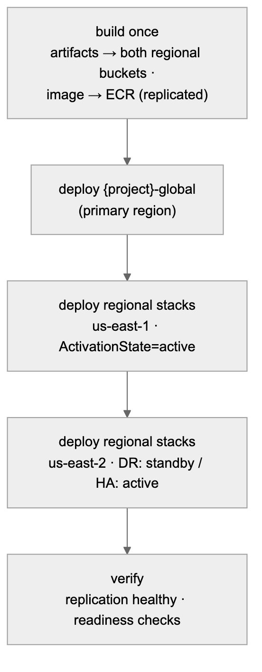
Figure 19. 10.5 Pipeline: deploying to both regions
- Order per environment: global stack → primary region → secondary region → readiness checks (replication lag, Route 53 ARC readiness, health checks).
- STAGE / PROD: the plan job creates change sets for every stack in both regions. Reviewers approve one release covering all of them (§8.3), and the release executor applies them in the order above.
- Failure handling: if the secondary region fails to deploy, the primary keeps running the new version. The release is marked “secondary out of sync” and blocks the next promotion until fixed, because a DR region on an old version is not a valid DR target.
- Application repos (§9) follow the same pattern: artifacts are published to both regions, and code is deployed to both. In DR standby, the code is updated but stays inactive, so the standby always runs the same version as the primary.
- Per-environment policy (environment configuration §5.5.1), defaults:
Environment | Default resilience
Sandbox, DEV | Single region always (cost)
TEST | Single region (DR/HA optional)
QA/STAGE | Mirrors PROD’s mode, so failover can be tested before PROD
PROD | As selected by the project
New GitHub variables (§5.5.5 rules apply):
Variable | Level | Example
RESILIENCE_MODE | Environment | dr
AWS_PRIMARY_REGION | Environment | us-east-1 (replaces AWS_REGION)
AWS_SECONDARY_REGION | Environment | us-east-2 (empty for single-region)
ARTIFACT_BUCKET_PRIMARY / ARTIFACT_BUCKET_SECONDARY | Environment | regional Shared Services buckets
ACTIVATION_STATE_SECONDARY | Environment | standby (DR) / active (HA); changed only by failover

10.6 Failover and failback (DR mode)
Failover is a platform operation started from the release console, not a code change.
Step | Action | Depends on primary region?
1. Declare | Incident lead clicks Fail over to us-east-2 in the release console; two approvers (break-glass fast path, separate from release approvals) | No
2. Data | Aurora Global Database: managed failover (planned) or detach-and-promote (unplanned). RDS replica promoted. DynamoDB global tables, S3, secrets: already current | No
3. Compute | Release executor sets ActivationState=active on the secondary regional stacks only (scale up, enable event sources and rules) | No
4. Traffic | Flip Route 53 Application Recovery Controller routing control to us-east-2 (data plane, highly available) | No
5. Verify | Health checks, smoke tests, contract in us-east-2 shows activationState=active | No
6. Record | Release record + GitHub variable ACTIVATION_STATE_* updated, so the next pipeline run keeps the new state | No
Failback reverses the steps once the primary is healthy: re-establish replication toward us-east-1, sync, a planned switchover, flip traffic back, and set us-east-2 to standby. It is scheduled, approved like a PROD release, and never automatic.
HA mode: no failover action is needed. Route 53 health checks remove an unhealthy region automatically. Single-writer data stores (Aurora) follow their managed failover; the platform shows the writer location in the release console.

10.7 Continuous DR assurance
- Readiness checks: Route 53 ARC readiness checks confirm the secondary matches the primary (capacity settings, versions, replication). Drift is shown in the release console and blocks promotion.
- DR drills: a scheduled failover and failback in QA/STAGE (default monthly) for every DR/HA project, run by the platform with the steps above.
- Gate G5 addition (§8.4): a PROD release of a DR/HA project requires a successful STAGE DR drill within the last N days (default 30) and a healthy secondary in PROD.
- Measured, not assumed: each drill records the achieved RTO/RPO against the targets set in the wizard, shown per project.

10.8 Platform control plane is multi-region too
Failover must work when us-east-1 is down, so the platform itself runs active/standby across the same region pair: - DynamoDB global tables for registry, jobs and release records; - Step Functions, API and release executor deployed in both regions; - the UI and API behind Route 53 failover; - CloudInfraProvisioner / PlatformReleaseExecutor roles are global IAM, assumable from either region.

11. Security model
Threat | Mitigation
A project changes another project’s resources | Tag conditions on every create/change action (aws:RequestTag / aws:ResourceTag = principal tag) + name patterns built from the principal’s tag + per-project roles + SCP protecting ownership tags
A repo forges tags to impersonate another product | Role tags are platform-owned and SCP-protected; request tags must equal principal tags (§4.4)
Generated IAM grants too much | Exact-ARN policies; least-privilege linter; shared tag-scoped boundary; exec role can only create roles with the boundary attached
A DEV/sandbox pipeline reaches PROD | Separate accounts; OIDC sub per environment; environment-scoped variables (a DEV job cannot see PROD’s account or role); caller-account guard in the pipeline; environment-lock SCP
Unapproved change reaches STAGE or PROD | GitHub required reviewers before the deploy job starts (no AWS access until approved); prevent self-review; gated deploy role can only execute the reviewed change set; reconciler restores removed protection rules
Sensitive data in sandbox | Classification gate SCP + sandbox data rules
Removing the boundary or tags after creation | SCP denies DeleteRolePermissionsBoundary and org:* tag changes except by platform roles
Confused deputy | SourceAccount on the Lambda permission, aws:SourceAccount on the CFN trust, aws:PrincipalOrgID + ExternalId on the provisioner role
Platform GitHub credential leak | App private key in Secrets Manager (KMS); installation tokens per job, never stored
S3 ↔ Lambda infinite loop | Validation rule + Lambda’s built-in recursive-loop detection
Platform authN/authZ: - SSO via the org IdP. - Entitlements come from IdP group → product mapping in the registry. - Roles: viewer (preview), creator (provision for entitled products), approver (mirrored into GitHub environment reviewers), platform-admin.

12. Scalability and multi-tenancy

10.1 Where the load is
Synthesis is cheap. The real limits are GitHub API quotas per installation, CloudFormation / IAM API throttling per account, and wall-clock time (a five-environment promotion takes tens of minutes plus approval time). So the effort goes into async orchestration, throttling that respects quotas, and keeping policy count flat.

10.2 Scaling each layer
Layer | Strategy
UI | Static on CloudFront (includes the release console); registry responses cached per user with a short TTL
API | Stateless containers, autoscaled
Registry | DynamoDB; read-heavy, cached; admin edits and imports are event-driven
Orchestration | Step Functions Standard (durable, holding many jobs open costs no compute); per-environment bootstrap runs as a Map state with a concurrency cap
Workers | Lambda with reserved concurrency per worker type
Status | Webhooks → DynamoDB Streams → SSE/WebSocket; reconciler for missed events
IAM footprint | Shared tag-based policies. Per project, only small tagged roles are added. No per-project policy documents, so the account-level limits on managed policies are never approached.
Account onboarding | Service-managed StackSets auto-bootstrap new accounts in the workload OUs

10.3 Throttling that respects quotas
- Per GitHub installation: a token bucket (DynamoDB conditional writes) for write calls; a job waits in a Step Functions Wait state rather than failing.
- Per AWS account: a cap on concurrent bootstrap stack operations (IAM and CloudFormation are the bottlenecks).
- Per product/tenant: fair-share limits; an SQS queue in front of StartExecution absorbs bursts.
- Account quotas: under option A/B, many projects share Lambda concurrency and other account quotas. Track per-account usage and alert. A product that outgrows its share moves to option C by changing its account binding only.

10.4 Catalog and registry growth
- New service = block + binders + tag-support matrix entry + additions to the shared policies (rolled out via StackSets) + golden tests. No UI-protocol or orchestrator changes.
- New portfolio/product = registry entry (admin screen or import). Tag Policy allowed values update automatically. No IAM changes.
- New account = joins an OU, is bootstrapped automatically, then an admin binds it to an environment in the application.
- New environment (e.g. adding perf between TEST and STAGE) = admin creates it in the application, binds accounts, and approves. New projects pick it up at once; existing projects get a sync-pipeline PR.

13. Error handling, idempotency and rollback

11.1 Failure matrix
Failure | Handling | User sees
Invalid payload / not entitled to product | 422 / 403 before any side effect | Inline error on the exact field
GitHub rate limit | Backoff honoring headers; job waits | “Waiting for GitHub capacity…”
Repo name taken (not ours) | Fail fast, nothing to clean up | Name conflict + suggestion
Bootstrap fails in one environment account | Stack auto-rolls back; job undoes all environments + repo | Which account/environment failed and why (CFN events)
Provisioner role missing in an account (not bootstrapped) | Fail before any GitHub writes (checked during preview) | “Account {env} not onboarded” + admin link
Commit ref rejected (non-fast-forward) | Rebuild on the new parent, retry once | Nothing
Deploy fails in an environment | Repo kept; CloudFormation rolls back that environment only; later environments don’t run; first-create failures are cleaned up by the next run’s pre-flight | DEPLOY_FAILED(env) + run link + failed resources
AccessDenied from tag conditions | Treated as a policy violation, not retried; message names the tag key that didn’t match | “Tag org:project mismatch on …”
UPDATE_ROLLBACK_FAILED | Never automated; runbook | FAILED_NEEDS_ATTENTION
Approval not given in time | Job stays in PROMOTING (the GitHub environment times out after 30 days); no AWS change | “Awaiting approval for stage/prod”
Missed webhook | Reconciler every 5 min queries runs/deployments by head_sha | Status resolves late, not never

11.2 Idempotency layers
- API: Idempotency-Key → same job; same key with a different payload → 409.
- Orchestrator: execution name = jobId.
- Each step: ownership marker on the repo, CloudFormation ClientRequestToken, PUT semantics, commit trailer check.
- Infrastructure: deterministic template + content-keyed artifacts → empty changesets on re-run.

11.3 Undo policy
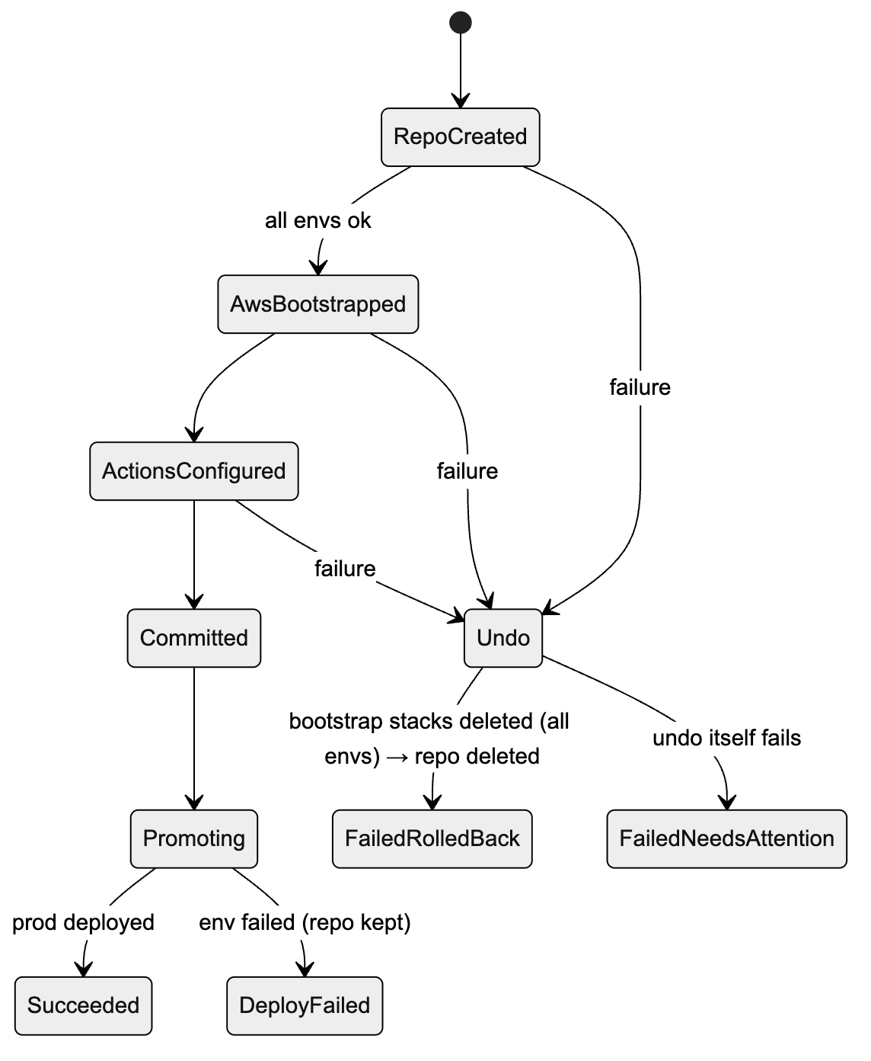
Figure 20. 11.3 Undo policy
- Before the commit: undo steps run in reverse order across all environment accounts. The repo is deleted only if this job created it.
- After the commit: nothing is deleted automatically. The user fixes and pushes, or uses “retry deploy” (workflow_dispatch).

14. Observability
Signal | What
Logs | Structured, with jobId, projectId, portfolio, product, env, step, attempt, x-github-request-id, stackId
Traces | OpenTelemetry/X-Ray: API → Step Functions → workers
Metrics | Jobs by state; time from click to DEV and to PROD; deploy failure rate by environment and catalog combination; GitHub rate-limit headroom per installation; AccessDenied from tag conditions (could indicate misuse)
Cost | CUR / Cost Explorer by org:portfolio → org:product → org:project → org:environment
Compliance | AWS Config tag compliance per account → audit account; dashboard of non-compliant resources per product
Alerts | Spike in FAILED_NEEDS_ATTENTION; any attempt to change org:* tags (CloudTrail → EventBridge); bootstrap drift; rate-limit headroom below 10%

15. Where an LLM fits (and where it must not)
Use | Allowed? | Guardrails
Natural language → draft payload (services + connections) | Yes | Same validation; ownership still chosen from dropdowns, never inferred
Handler business logic in starter code | Optional | Limited to src/; linted; shown in preview
CloudFormation resources, IAM policies, tags | No | Deterministic blocks only
Explaining a failed deploy from stack events | Yes | Read-only summary next to the raw events

16. Proposed repository layout
For your review. Nothing is created until you approve.
CloudInfraAutomation/
├── docs/
│ ├── ARCHITECTURE.md
│ ├── TAGGING-STANDARD.md ← tag keys, values, ownership rules (from §4)
│ └── runbooks/
├── backend/
│ ├── api/ ← FastAPI, auth, entitlements, idempotency
│ ├── registry/ ← org registry model, CSV/REST import, tag-policy sync
│ ├── synth/ ← models, blocks, binders, linters, starters, env profiles
│ ├── provisioning/ ← github/, aws/ (multi-account), saga/
│ ├── webhooks/ ← workflow_run / deployment_status + reconciler
│ └── tests/ ← unit, golden, ABAC policy tests (IAM policy simulator)
├── org/
│ ├── scp/ ← tag protection, env lock, classification, regions
│ ├── tag-policies/ ← generated from registry
│ └── stacksets/account-bootstrap.yaml ← OIDC, shared ABAC policies, provisioner role
├── bootstrap/
│ └── project-bootstrap.yaml ← tagged deploy role + exec role (per env)
├── platform-workflows/ ← reusable build (per language) + deploy (per compute) workflows; published as its own repo
├── app-templates/ ← language templates for application repos (python, java, go, rust, nodejs)
├── generated-repo-skeleton/
│ └── .github/workflows/{deploy.yml, deploy-env.yml}
├── infra/ ← platform control plane IaC
└── frontend/ ← React UI with cascading ownership dropdowns
Proposed stack: - Python 3.12+ (FastAPI, pydantic v2, PyGithub 2.x, boto3, PyNaCl). - Step Functions + Lambda + DynamoDB. - React + TypeScript. - ABAC policies are tested with the IAM policy simulator and with real allow/deny tests in a sandbox account in CI.

17. Decisions needed from you
# | Decision | Recommendation
D1 | Backend language | Python
D2 | GitHub identity | GitHub App (organizations only in v1)
D3 | Tag key prefix | Your company prefix, e.g. acme:. Placeholder in this document: org:
D4 | Main isolation level | Project (default) with opt-in read sharing within a product
D5 | Hierarchy | Decided: three levels, Portfolio → Product/Platform → Project. No team level or team tag.
D6 | Account granularity | B: per portfolio per environment, with C available per product
D7 | Registry source of truth | Decided: the platform registry is the master (CSV/REST import available)
D8 | Sandbox model | Shared sandbox account per portfolio with 14-day TTL, or per-product sandbox accounts?
D9 | Approvers | Decided: STAGE and PROD require GitHub reviewer approval before deployment. Open: which groups review each (default QA for STAGE; product owner + change management for PROD), and is a built-in change record required for PROD?
D10 | Regions | Single region in v1, or multi-region from the start?
D11 | Onboarded today? | Do Control Tower / OUs per environment already exist, or does org/ need to create the OU structure too?
D12 | LLM | Exclude from v1, or NL → draft payload only?
D13 | Who can configure environments and accounts | Platform admins only, with a second-person approval for changes to production-tier environments. Normal users see environments read-only. (If you meant every user should configure them, note that whoever binds an account decides where code deploys.)
D14 | Binding scope | Bind accounts per portfolio by default, with a per-product override (matches D6), or per product only?
D15 | GitHub plan | Not a blocker: Mode A works on any plan. If you have GitHub Enterprise, should Mode B (GitHub environment reviewers in addition) be turned on?
D16 | Quality-gate thresholds | Coverage minimum (e.g. 80%), vulnerability policy (block critical/high), STAGE bake time before PROD (e.g. 24 h), change windows / freeze calendar, built-in change record required for PROD?
D17 | PROD approvals | One GitHub approval (simplest), or two approvals from different groups collected in the release console (§8.5.4)?
D18 | Notifications | Decided: in-app inbox + email via Amazon SES + optional signed webhooks
D19 | Application repo granularity | One repo per compute slot (simplest permissions), or allow monorepos serving several slots?
D20 | EKS deploy model | Argo CD GitOps (recommended) or pipeline-driven helm upgrade? Does a shared EKS cluster per portfolio per environment already exist, and who runs it?
D21 | Languages in v1 | Python, Java, Go, Rust, Node.js all at once, or start with two (e.g. Python + Java)?
D22 | Developer portal | Platform UI only (default), or also open-source Backstage (catalog-info.yaml generated either way)?
D23 | Networking for ECS/EKS | Shared VPC from the landing zone (subnets/SGs published to SSM by the network team)?
D24 | Deprecation window | Minimum time a deprecated contract value stays after it becomes unused in an environment (e.g. 0 days in DEV/TEST, 14 days in STAGE/PROD)?
D25 | Infra approvals | Should product reviewers also approve infra deploys to STAGE/PROD, or the platform team only?
D26 | Open-source license policy | Allow Apache-2.0, MIT, BSD, MPL-2.0 and LGPL (as libraries); exclude AGPL and source-available licenses unless approved?
D27 | Tier 1 services at launch | Confirm the proposed curated list (§6.8.2), or start smaller (e.g. compute + integration + Aurora/RDS PostgreSQL + DynamoDB) and grow?
D28 | Commercial DB engines | Exclude RDS for Oracle / SQL Server (default, per open-source policy), or allow them?
D30 | Default region pair | us-east-1 (primary) / us-east-2 (secondary) as default; any other allowed pairs?
D31 | DR account model | Same account for both regions of an environment (default), or a separate DR account per environment?
D32 | DR defaults | Pilot light (default) or warm standby for DR projects? QA/STAGE mirrors PROD’s mode (default)? DR drill frequency (default monthly) and G5 recency (default 30 days)?
D33 | Cognito and other non-replicating services | Exclude from DR/HA projects, or allow with a documented recovery pattern?
D29 | Network ownership | Does the landing zone provide shared VPCs with database/private subnets per environment account, or must the platform create project VPCs?

18. Implementation phases (after approval)
Phase | Deliverable | Exit criteria
P0 — Standards | TAGGING-STANDARD.md, registry schema, tag-support matrix for S3/Lambda/DynamoDB/Logs/IAM | Signed off by security / cloud governance
P1 — Org guardrails | SCPs, Tag Policies, account-bootstrap StackSet with shared ABAC policies, same-tag resource policy patterns (§4.10) | In a sandbox: project A’s runtime roles cannot reach project B’s S3/SQS/DynamoDB/secrets/functions even with exact ARNs (§4.10.4); project A’s roles are denied on project B’s resources and on forged tags; allowed on their own (automated allow/deny test suite)
P2 — Engine | Payload schema, synthesis (S3, Lambda, DynamoDB, binders), linters, per-environment parameter files, golden tests | Lambda + S3 template passes lint/guard for all 5 environments; regeneration gives identical output
P3 — Pipeline | project-bootstrap.yaml, deploy.yml + deploy-env.yml, G1–G3 gates, plan → approve → execute for STAGE/PROD | Manual repo promotes sandbox → prod with reviewer approvals; STAGE/PROD cannot deploy without approval; second push = empty changesets; failure in TEST stops promotion and the next push recovers
P4 — Provisioning | GitHub App client, multi-account bootstrapper, saga, CLI | One command creates a repo that bootstraps 5 accounts and deploys DEV; failures injected at each step undo cleanly
P5 — API + UI | Registry API, environment & account admin screens, release console (pipeline view, approval inbox, approval detail), cascading dropdowns, preview, status per environment | Click-to-DEV in the browser; entitlement filtering verified; an admin can add/reorder an environment and bind an account, and onboarding checks block an invalid account
P5b — Quality gate service | Release record, deployment protection rule app, change set risk analysis, Access Analyzer checks, G4/G5 | A high-risk change set is blocked; PROD is refused if the artifact differs from STAGE or bake time is not met
P5c — Application golden paths | Compute slot catalog types, contract publishing (SSM + API), platform-workflows (build per language, deploy per compute type), app deploy roles, “Create application repo” flow, contract viewer | A Python Lambda app and a Java ECS app deploy from their own repos to DEV and promote to PROD with approvals; an app repo cannot create IAM or touch another project; an app deploy stops cleanly when the contract lacks a required value
P5d — Full service catalog | Catalog sync job (CFN schemas + Service Authorization Reference), Tier 2 generator, generic connection kinds, database blocks (Aurora/RDS/DynamoDB first), layered stacks, pairwise CI, nightly deploy tests, reference patterns | Any enabled resource type can be composed and passes all gates; pairwise suite green; every database engine deploy-tested weekly
P5e — Multi-region DR/HA | Resilience modes in wizard and payload, conditions in generated templates, global stack, per-service replication wiring, two-region pipeline, failover/failback operations, ARC readiness, DR drills, multi-region control plane | A DR project deploys to us-east-1 (active) and us-east-2 (standby); a STAGE drill fails over and back within target RTO/RPO; an HA project serves traffic from both regions
P6 — Production control plane | Step Functions, webhooks, reconciler, quotas, observability, Config compliance | 100 concurrent jobs on one installation complete without failing on rate limits; tag compliance dashboard live
Next step: review this document, answer §17, and approve a phase to start. No code will be written until then.

